Supporting Information
Breath figure templated self-assembly of surface-acylated cellulose nanowhiskers confined as honeycomb films
Huan Liu, Bo Pang, Kai Zhang*

Sustainable Materials and Chemistry. Dept. Wood Technology and Wood-based Composites, Georg-August-University of Goettingen, Büsgenweg 4, Göttingen 37077, Germany

*Corresponding author:
Prof. Dr. Kai Zhang
Dept. Wood Technology and Wood-based Composites
Georg-August-University of Goettingen
Büsgenweg 4
D-37077 Göttingen, Germany
Tel.: 0049 551394505
Fax: 0049 551399646
E-mail: kai.zhang@uni-goettingen.de
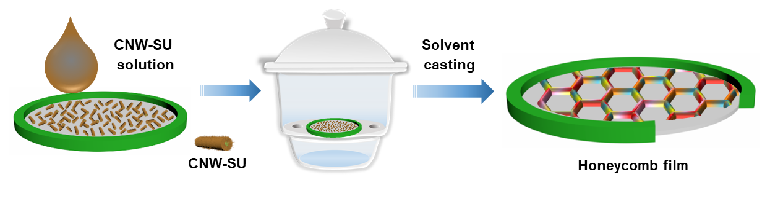
Figure S1. Schematic representation for the fabrication of CNW-SU honeycomb film with breath figure method.

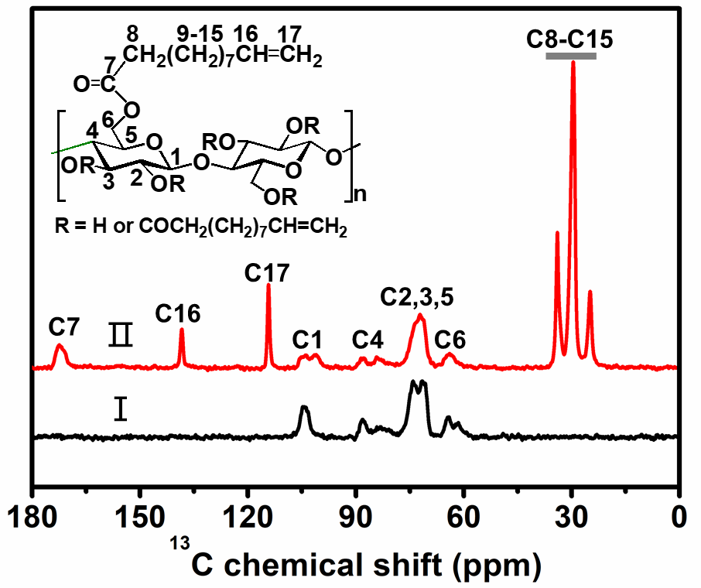
Figure S2. Solid-state CP-MAS ¹³C NMR spectra of (I) MCC, and (II) CNWs-SU.
The signals between 55 and 110 ppm are ascribed to the carbons of anhydroglucose units of cellulose. After the esterification, new signals emerged within the spectrum of CNWs-SU. The signals between 40 and 10 ppm are attributed to the carbon atoms of the aliphatic groups and the peak at 173 ppm is ascribed to the carbon from the ester linkages. The signals at 114 and 139 ppm are attributed to carbons in terminal olefin groups.

Figure S3. FTIR spectra of (I) MCC, and (II) CNWs-SU.
Typical FTIR bands of cellulose are visible, such as the bands attributed to vibrations of O-H (3000-3600 and 1300-1450 cm⁻¹), C-H (2900 cm⁻¹), and C-O groups (950-1200 cm⁻¹).
Compared with MCC, the intensities of signals at 2926 and 2856 cm⁻¹ strongly increased, which are due to asymmetric and symmetric stretching vibrations of C-H groups of alkyl chains, respectively. The peak at 3342 cm⁻¹ attributed to stretching vibrations of hydroxyl groups at cellulose backbone strongly decreased due to the derivatisation by acyl groups.
Within the FTIR spectrum of CNWs-SU, new bands emerge at 3076, 1745, 1641 and 908 cm⁻¹, which are attributed to stretching vibrations of CH₂=CH₂, stretching vibrations of C=O, stretching vibrations of C=C, and deformation vibrations of alkene C-H groups, respectively.

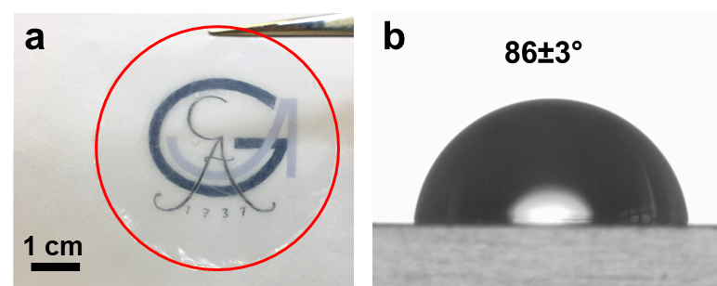
Figure S4. (a) Photo image of the dried film fabricated with CNWs-SU via solvent casting in the air under ambient conditions. (b) Static water contact angle of the dried film fabricated with CNWs-SU.

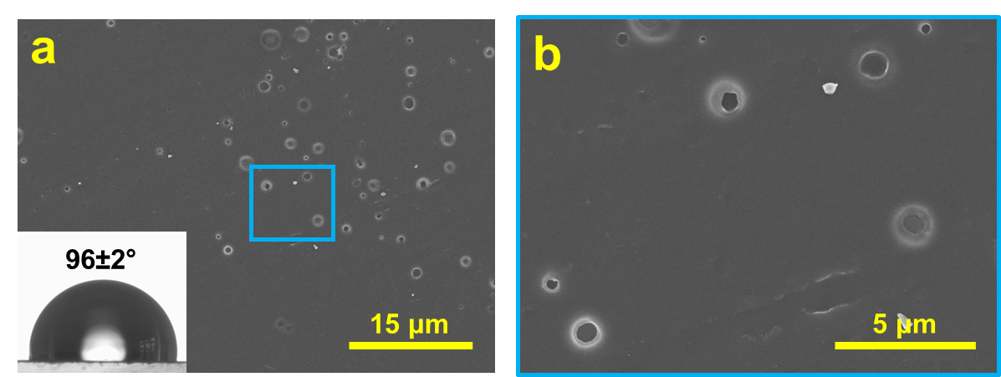
Figure S5. SEM image of the bottom side of the honeycomb film fabricated with CNWs-SU.

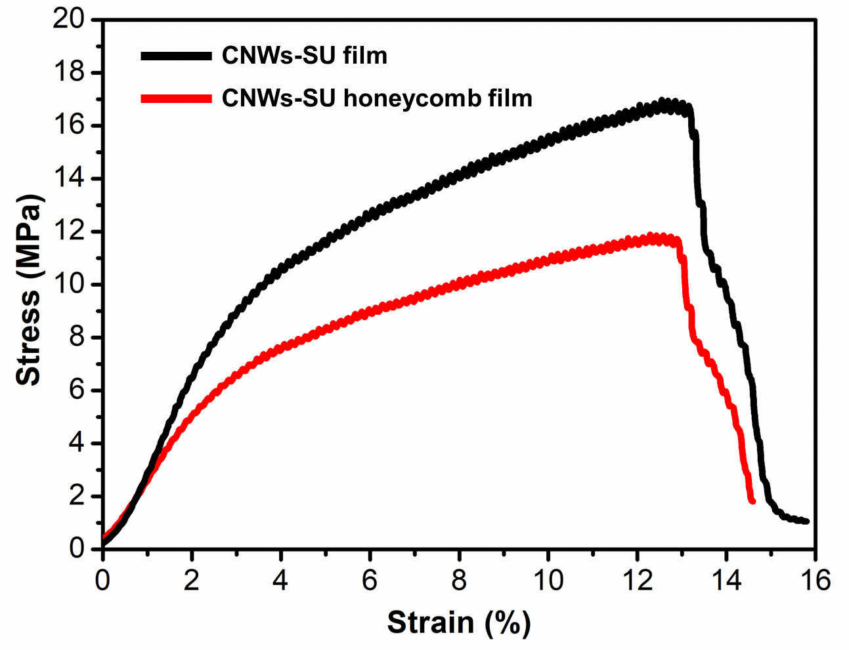
Figure S6. The stress-strain curves of dried film fabricated with CNWs-SU via solvent casting in the air under ambient conditions (black line) and CNW-SU honeycomb film (red line).

Table S1. Mechanical properties of CNW-SU film and CNW-SU honeycomb film.
 | Tensile strength (MPa) | Young’s modulus (MPa) | Tensile strain at break (%)
CNW-SU film | 16.8 | 369 | 12.9
CNWs-SU honeycomb film | 11.7 | 255 | 12.5

The mechanical properties of CNW-SU films and CNW-SU honeycomb films were measured. The results are summarized in Figure S6 and Table S1. One can see that the mechanical properties of CNW-SU honeycomb films were smaller than the CNW-SU films. This is mainly due to some small defects (such as small pores) are easily formed in the interior part or the rims of honeycomb films during the fabrication process.

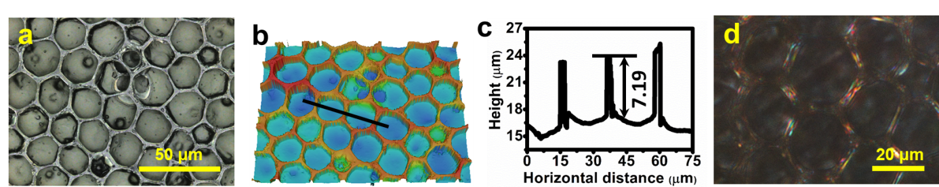
Figure S7. (a) LSM image, (b) 3D LSM image, and (c) height profile of the honeycomb film fabricated with CNWs-SU at the concentration of 7mg/mL. (d) PLM image of the honeycomb film fabricated with CNWs-SU at the concentration of 7 mg/mL.

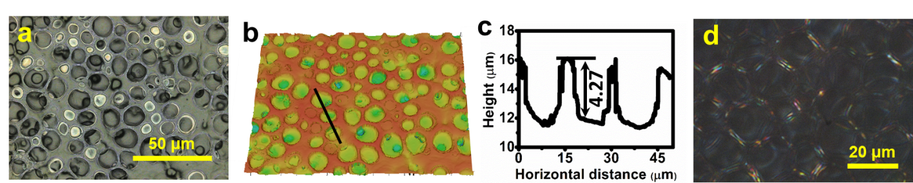
Figure S8. (a) LSM image, (b) 3D LSM image, and (c) height profile of the honeycomb film fabricated with CNWs-SU at the relative humidity of 60%. (d) PLM image of the honeycomb film fabricated with CNWs-SU at the relative humidity of 60%.

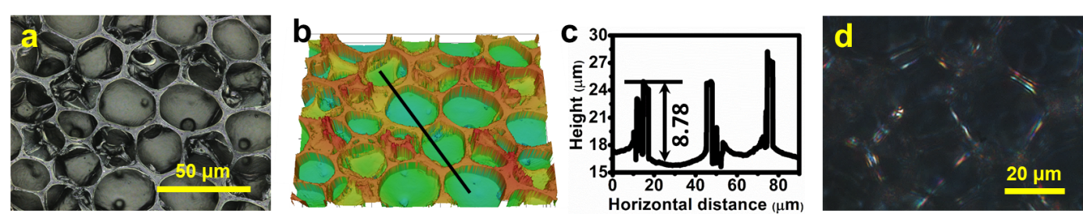
Figure S9. (a) LSM image, (b) 3D LSM image, and (c) height profile of the honeycomb film fabricated with CNWs-SU at the relative humidity of 96%. (d) PLM image of the honeycomb film fabricated with CNWs-SU at the relative humidity of 96%.

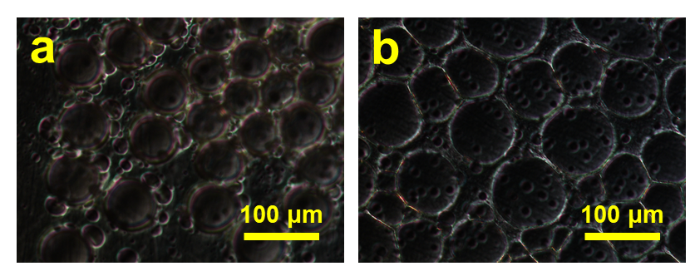
Figure S10. PLM image of the porous film fabricated with (a) CNWs-SU-C18, and (b) CNWs-SU-F.

