Development of Ni/HTA/Hβ alkane isomerization catalyst with improved selectivity for multi branched isoparaffins

Lijun Zhu ^{a*}, Guosheng Huang ª, Shuo Liu ª, Xiaohui Jing ª, Junwei Yang ^{a*}, Daohong Xia ª
a State Key Laboratory of Heavy Oil Processing, College of Chemistry and Chemical Engineering, China University of Petroleum (East China), 66 Changjiang West Road, Qingdao, Shandong 266580, China
* Corresponding author. E-mail address: zhulijun@upc.edu.cn (L. Zhu) , yangjwupc@126.com (J. Yang).

1. Characterization and evaluation methods for samples
（1）The catalyst samples were analyzed by XRD using a D/max IIIA X-ray diffractometer from Japan. The sample was ground fine in an agate mortar, and then pressed into a sample rack for characterization. The Fourier transform infrared spectra (FT-IR) of sample was analyzed using Nicolet 6700 Fourier transform infrared spectrometer with a DTGS KBr detector.
（2）The pyridine adsorbed Fourier transformed infrared (Py-FTIR)spectroscopy was used to determine the surface acidity of the samples by A Nicolet 6700 FTIR Fourier. The sample was contacted with gaseous pyridine at ambient temperature via a separate cell containing pyridine under vacuum for 24 h. Subsequently, the samples were outgassed for 2 h under vacuum conditions to remove the physically adsorbed pyridine. The transform infrared (FTIR) spectra at different temperature was measured and the KBr technique was used to confirm the structure of the catalyst.
Programmed Temperature Reduction (H2-TPR)
The reduction performance of the catalyst was investigated using a NH3-TPD-TPR experimental device in a nitrogen atmosphere containing 10% hydrogen gas. The 50 mg sample was loaded into a quartz reaction tube with an inner diameter of 4.0mm, and the thermocouple was placed at the location of the sample. The sample was pretreated for 30 minutes at 200 ºC in a helium flow (30mL/min). Then reduce the temperature to below 70 ºC, switch to a mixture of hydrogen and nitrogen, and operate at 70 ºC to stabilize the baseline. Then, the temperature is programmed at a rate of 10 ºC /min, and the current of the thermal conductivity detector is 100mA. The temperature range is 70~700 ºC.
Temperature programmed desorption (TPD)
The NH3-TPD experimental device was used to investigate the acid and acid strength distribution of the catalyst. 50mg samples are installed in a quartz reaction tube with a diameter of 4.0mm. The thermocouple is placed in the position of the sample. Among the 30ml/min, under the condition of 200 degrees, the sample was pre -processed for 30 minutes. Then reduce the temperature to 70 °C, turn into ammonia several times to reach the sample adsorption saturation. And then continue to sweep the sample with helium to the baseline. Then start heating at a rate of 10 ° C/min, 100mA thermal current, and the range of temperature testing is 150-700 ° C.
（3）Nitrogen adsorption-desorption isotherms
nitrogen adsorption-desorption isotherms were measured to characterize the surface areas and porosity, using a Quantachrome Autosorb-1MP volumetric adsorption analyzer (USA) at −196 ◦C (77 K) with nitrogen as the analysis gas. Samples were degassed at 150 ◦C overnight, followed by 200 ◦C for 6 h before sorption measurements. The surface area was calculated using the Brunauer-Emmett-Teller (BET) method. And the pore size distributions and cumulative pore volumes were obtained using the Density Functional Theory (DFT) methods.
（4）Topography analysis
The morphology of catalyst surface was studied by S-4800 SEM (Hitachi Company, Japan). The state of aggregation and diameters of catalyst nanoparticles of catalysts were confirmed by transmission electron microscopy (TEM) micrographs. And a JEM-2100UHR electron microscopy (Japan) with an acceleration voltage of 200 kV was used to record the micrographs.
（5）X-ray photoelectron spectroscopy (XPS)
The XPS analysis is analyzed using the Escalab250 X -ray optoelectronics spectrum analyzer from THERMO Scientific. The excitation source is AL K αX rays, with 1486.6 EV energy, and the power is 150 W. The binding energies correction was performed by assigning a value of 284.6 eV for the C1s line.
（6）Catalyst performance evaluation process
The reaction tube was placed in the heating furnace, and the thermocouple was placed in the reaction tube. The reaction pressure of the whole system was controlled by the pressure regulator and the back pressure valve, and the hydrogen flow was controlled by the gas mass flowmeter. The reaction material was pumped into the reactor by a pulseless plunger pump at a set flow rate. The liquid raw material and gas contacted on the catalyst in the reaction tube, and the isomerization reaction occured in the hydrogen atmosphere. The reaction product was carried out of the catalyst bed with hydrogen, cooled and separated by a gas-liquid separator, and then the liquid phase is obtained.
(7) Analysis methods for catalytic reaction products
The products were analyzed by a 6820 GC equipped with a FID and a dimethyl poly siloxane column (column length: 100m, inner diameter: 0.25mm, film thickness: 0.50 μ m). The relative retention was used as qualitative analysis, and the area normalization method was used as the quantitative analysis.
When a single alkane was used as raw material, the catalytic performance of the catalyst was evaluated by the conversion X of the raw material, the yield Yi of isoparaffins, and the selectivity Si of isoparaffins. The calculation method was given in formulas (1), (2) and (3).
Specifically, ∑Ai represented the total area of all peaks in the chromatogram, An-C₆ represented the area of n-hexane, and Ai represented the area of isoparaffins.
$X=(\sum{A_{i}-A_{n-C6}})/\sum{A_{i}×100\%}$ (1)
$S_{i}=\frac{A_{i}}{\sum{A_{i}-A_{n-C6}}}×100\%$ (2)
$Y_{i}=X×S_{i}×100\%$ (3)
2. Characterization of catalyst by XRD
After evaluating the performance of multiple series of catalysts, it was found that catalysts with 20% heteropoly acid and 2% nickel addition had the best conversion rate and multi branched isoparaffins selectivity. The prepared catalyst Ni-HTA/Hβ (HTA 20%, Ni 2%.) was subjected to phase analysis by XRD. In order to compare the catalyst structure, the XRD of the β zeolite, heteropoly acid and precursor of Ni-HTA/Hβ (Before hydrogen reduction) were also tested. The results are shown in Fig. 1.
Fig. S1 The comparison chart of XRD of Hβ and Ni-HTA/Hβ
As can be seen from Fig. 1, the HTA has strong diffraction peaks in the 4 ranges of 9°~11°, 15°~ 23°, 26°~ 30°, and 35°~ 38°, which is consistent with the characterization of heteropoly acids in literature ^{[1]}, indicating that this compound has the skeleton characteristics of Keggin structure. The XRD patterns of oxidation state and reduction state of Ni-HTA/Hβ and the Hβ are compared, and no obvious diffraction peaks of HTA and NiO are found in the XRD patterns of the Ni-HTA/Hβ, which indicates that the nickel active components and HTA are uniformly dispersed on the surface of the carrier, rather than existing in the form of crystals.
3. Supplement Figures of SEM and TEM

Fig S2. The SEM of image of Ni-HTA/Hβ with scale of 100 nm

Fig S3. The SEM of image of Ni-HTA/Hβ with scale of 1 μm
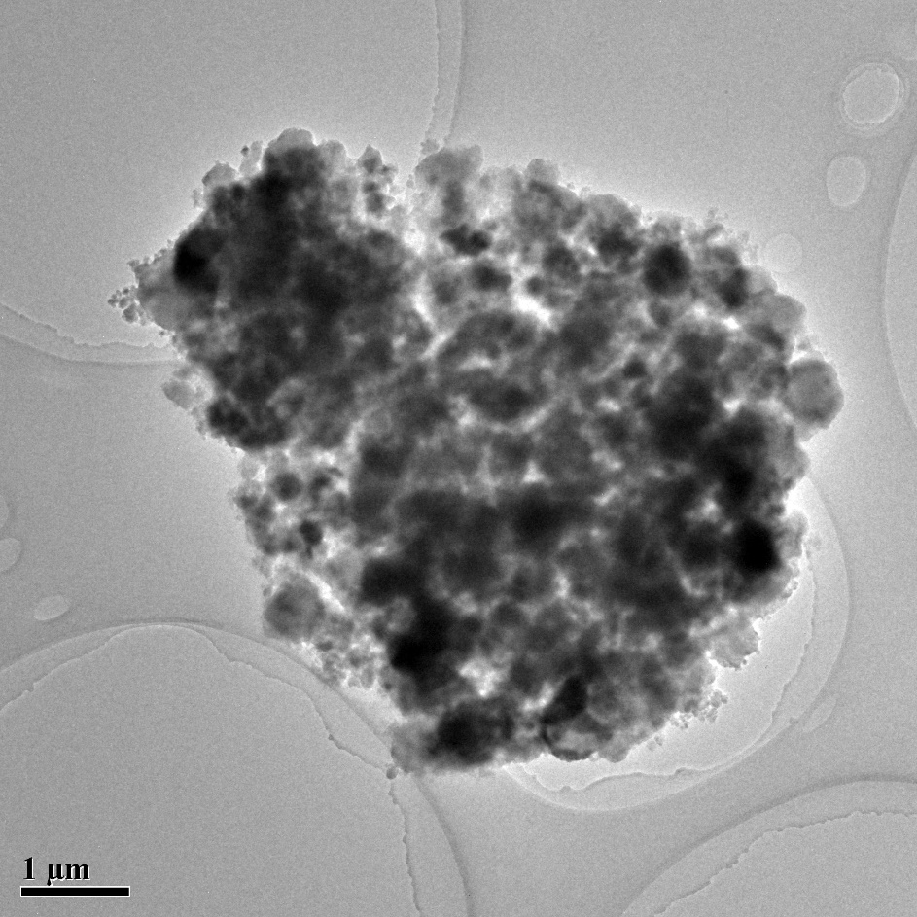
Fig S4. The TEM of image of Ni-HTA/Hβ with scale of 1 μm

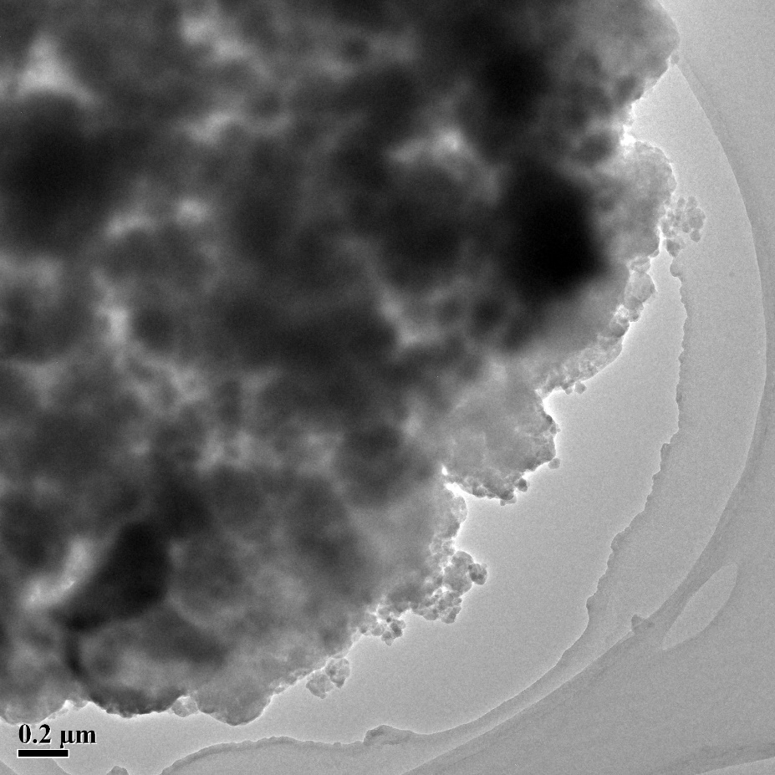
Fig S5. The TEM of image of Ni-HTA/Hβ with scale of 0.2 μm

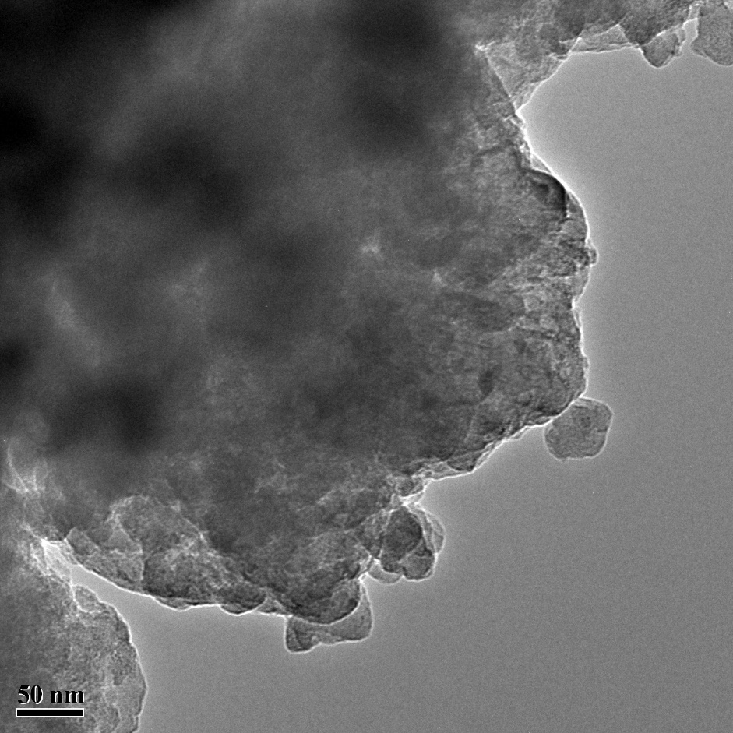
Fig S6. The TEM of image of Ni-HTA/Hβ with scale of 50 nm
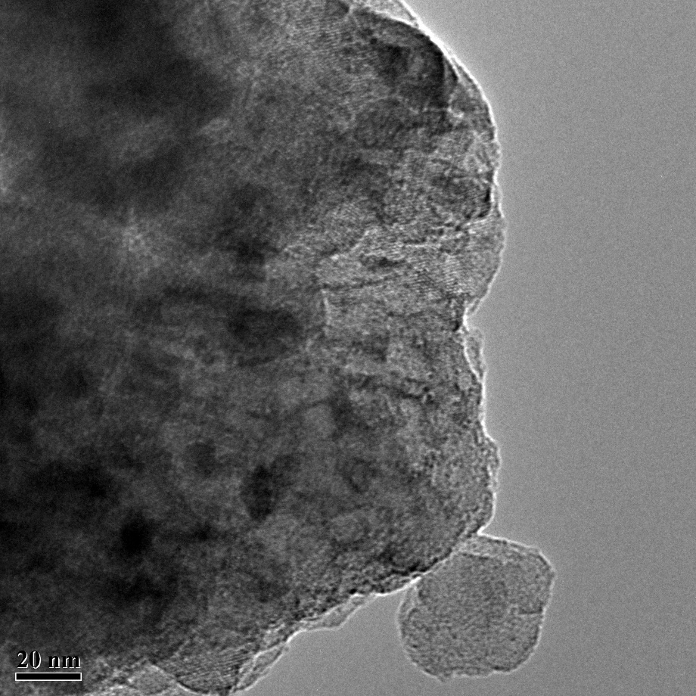
Fig S7. The TEM of image of Ni-HTA/Hβ with scale of 20 nm

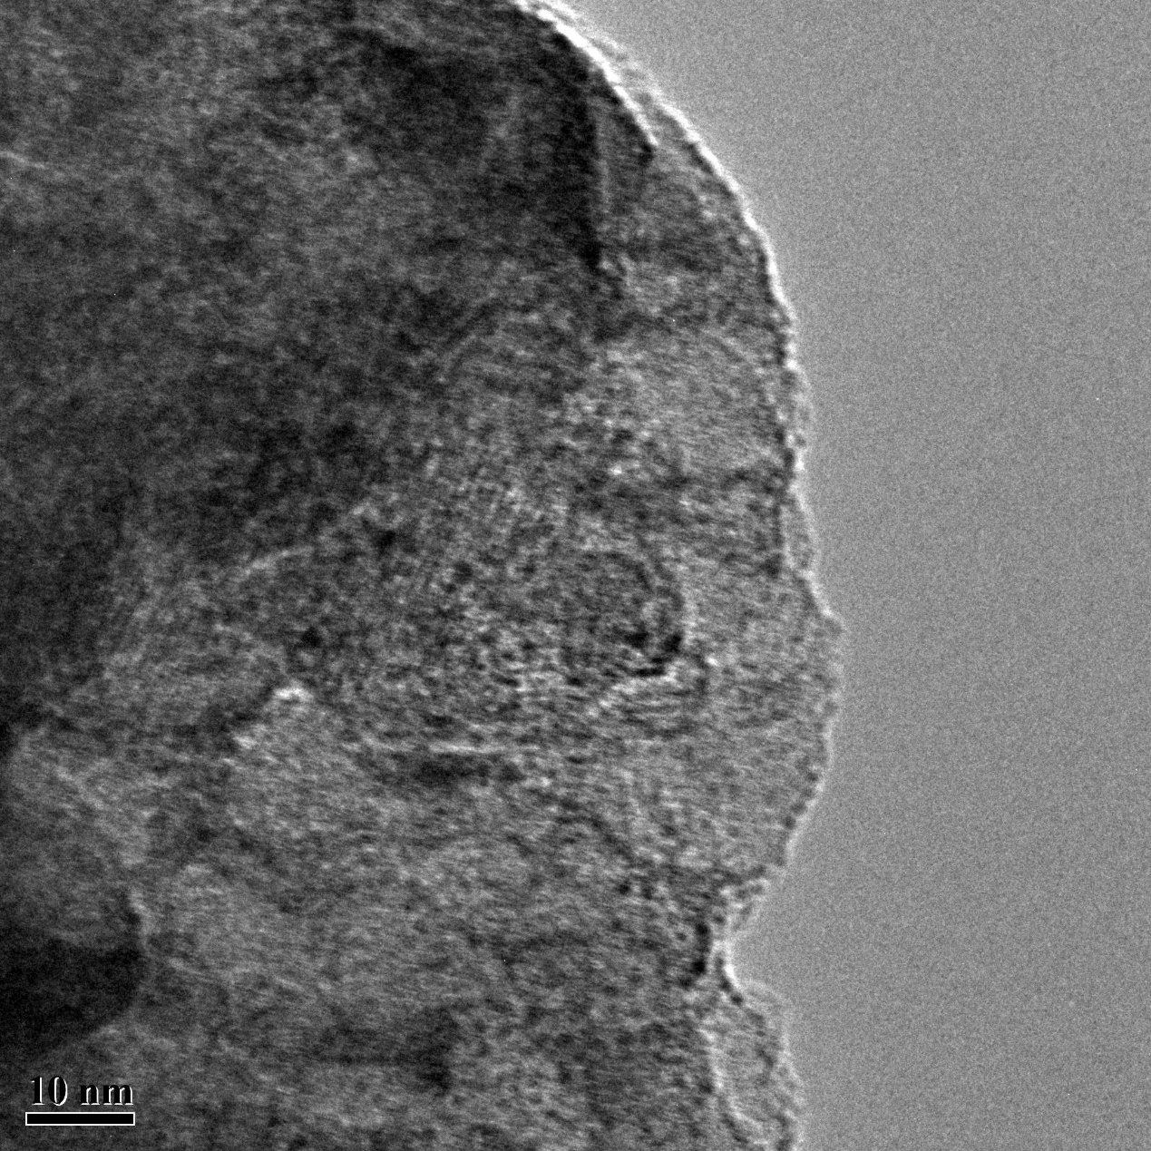
Fig S8. The TEM of image of Ni-HTA/Hβ with scale of 10 nm
4. Supplement tables
Table S1 The research Octane Number (RON) of typical hydrocarbons
Carbon number | type | hydrocarbon | RON
5 | Alkane | N-pentane | 62
5 | Alkane | 2-Methylbutane | 92
5 | Alkane | 2,2-dimethylpropane | 85
5 | Olefin | 1-Pentene | 98
6 | Alkane | hexane | 25
6 | Alkane | 2-methylpentane | 73
6 | Alkane | 2,2-dimethylbutane | 92
6 | Olefin | 1-hexene | 99
6 | Olefin | 4-Methyl-2-pentene | 99
6 | Aromatics | benzene | >100
7 | Alkane | heptane | 0
7 | Alkane | 2,2-dimethylpentane | 93
7 | Alkane | 2,2,3-dimethylbutane | 112
7 | Olefin | heptene | 98
7 | Aromatics | toluene | >100

Table S2 Texture analysis results
sample | BET/(m²/g) | Vmp.ª/(cm³/g) ª | VT.^{b}/(cm³/g) | Median pore width /nm
Hβ | 645.29 | 0.23 | 0.39 | 0.880
Ni/Hβ | 490.74 | 0.18 | 0.33 | 0.823
Ni-HTA/Hβ | 311.53 | 0.12 | 0.21 | 0.642
ª Micropore volume as determined by t-plot and normalized per gram of support.
^{b} Total pore volume.

Table S3 Atomic concentration table from XPS
Name | Peak BE | Atomic % | Individual atomic weight | Atomic weight | mass fraction /%
W4f | 35.42 | 0.86 | 183 | 157.38 | 7.4
Si2p | 102.4 | 25.99 | 28 | 727.72 | 34.3
P2p | 134.0 | 0.13 | 31 | 4.03 | 0.2
Mo3d | 231.2 | 0.79 | 96 | 75.84 | 3.6
C1s | 284.8 | 7.01 | 12 | 84.12 | 4.0
O1s | 531.9 | 64.51 | 16 | 1032.16 | 48.6
Ni2p | 856.2 | 0.72 | 59 | 42.48 | 2.0

Reference
[1] Han X.X, Jiang S.C, Chen Z.Y, et al. Highly active sulfonic ionic liquid modified heteropoly acid composite catalysts for efficient production of ethyl palmitate. Renewable Energy 2023; 215: 118918.

