Supplementary Material
PD-1 blockade plus capecitabine as curative-intent treatment for tumor mutational burden-high multi-metastatic pancreatic ductal adenocarcinoma: A case report
Luyao Ma^{1,#}, Yuejun Han^{2,#}, Xingxing Yu^{3,#}, Ketao Jin^{2,*}, Jinfang Xu^{4,*}
* Correspondence: Dr. Ketao Jin, jinketao2001@zju.edu.cn

1 Supplementary Data

The methods of NGS were shown as follows:

DNA extraction and library preparation
Tissue DNA and blood controls were extracted using the QIAamp Genomic DNA kit (QIAGEN, Hilden, Germany) according to the manufacturer's instructions, The quantification and quality of the DNA were assessed using Qubit 2.0 fluorimeter with ds DNA HS assay kit (Thermo Fisher Scientific, Inc.) and the Agilent 2100 BioAnalyzer (Agilent Technologies, Inc.). The sequencing libraries were generated according to the manufacturer's instructions (Illumina Inc).

Next-generation sequencing
The libraries were enriched using an Acornmed 808 gene panel. The captured libraries were pooled and sequenced on a NovaSeq6000 system (Illumina Inc). After removing low-quality sequencing data, Burrows-Wheeler Aligner software (BWA, version 0.5.9) was used to align reads to the hg19 version of the human reference genome. Base recalibration was performed using GATK v3.8. The HaplotypeCaller on Genome Analysis Toolkit (GATK; version 3.8) was used to identify variant calling of SNPs and INDELs. Copy number variant calling was conducted using CONTRA v2.1.0.

Tumor mutational burden (TMB) estimation
TMB is defined as the number of somatic mutations per Mb, including SNV and INDEL. Variants include synonymous mutations and non-synonymous mutations are filtered. Variants with a mutant allele frequency (MAF) of >1% in the Exome Aggregation Consortium or 1000 Genomes databases were excluded.

2 Supplementary Figures

Figure 1.Comparison of imaging data before and after treatment. (A1-3) Imaging data of the patient admitted on May 7, 2022. (A1) Upper abdominal magnetic resonance imaging (MRI). White arrows indicate pancreatic tail tumour, with invasion adjacent to the splenic artery and vein, as well as the spleen. (A2) Upper abdominal MRI. White areas indicate three metastatic nodules in the right liver, with a maximum diameter of approximately 13 mm. (A3) Lung computed tomography (CT). Black arrows indicate multiple metastatic nodules in both lungs, with a maximum diameter of approximately 12 mm. (B1-3) Imaging therapy after 4 months of capecitabine combined with nintedanib treatment. (B1-2) Upper abdominal MRI showed that pancreatic tumour lesions were smaller than those in May, liver metastases were smaller than before, with a maximum diameter of approximately 10 mm. (B3) Lung CT showed that bilateral lung metastases were smaller than before, with a maximum diameter of approximately 8 mm. (C1-3) Imaging therapy after 9 months of capecitabine combined with nintedanib treatment. (C1-2) Upper abdominal MRI showed that pancreatic tumour lesions were smaller than those in September. No obvious metastatic nodules were observed in the liver, and (C3) lung CT showed that bilateral lung metastases were smaller than before, with a maximum diameter of approximately 7 mm. (D1-3) Imaging therapy after 12 months of capecitabine combined with nintedanib treatment. (D1-2) Upper abdominal MRI showed that pancreatic tumour lesions were smaller than those in September. No obvious metastatic nodules were observed in the liver, and (D3) lung CT showed that bilateral lung metastases were smaller than before, with a maximum diameter of approximately 5 mm.

Figure 2. Trend plots of tumour parameters after treatment: (A) CEA decreased from 14.81 ng/mL to 3.39 ng/mL and (B) CA19-9 decreased from 208.89 U/mL to 23.61 U/mL. (C) Haematoxylin and eosin (H&E) staining after fine needle aspiration of liver metastases showed pancreatic ductal adenocarcinoma metastasis at 200 × magnification. IHC showed that the tumour immune microenvironment (TIME) was positive for CD8⁺ (D) and CD4⁺ (E) T cells.

3 Supplementary Table1
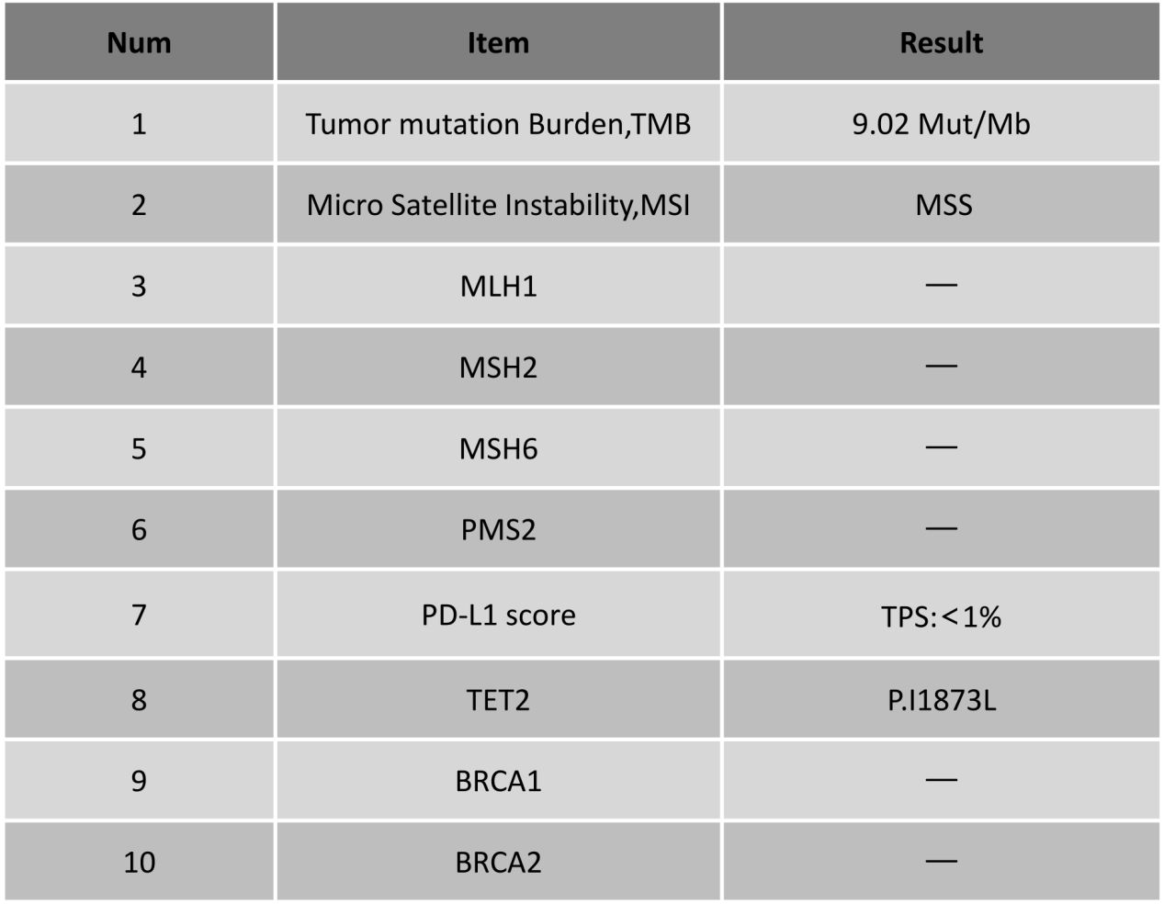
Analysis of next-generation sequencing (NGS) of tumour tissue.

