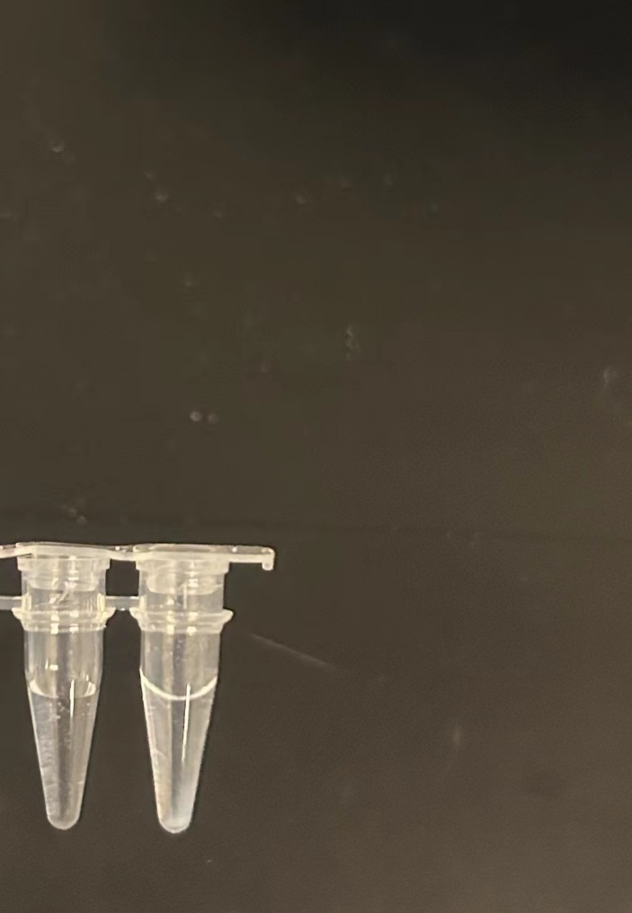
Fig. S1 The products without (left) or with (right) adding HER2were centrifuged under 11000 rpm for 1 min.

Table S1 Oligonucleotide sequence used in this study

Oligonucleotide chain | 5’-3’Sequence
HER2 Aptamer | AA CCG CCC AAA TCC CTA AGA GTC TGC ACT TGT CAT TTT GTA TAT GTA TTT GGT TTT TGG CTC TCA CAG ACA CAC TAC ACA CGC ACA
Trigger DNA | TGT GCG TGT GTA GTG TGT CTG TGA GAG CCA AAA ACC AAA TAC ATA TAC AAA ATG ACA AGT GCA GAC TCT TAG GGA TTT GGG CGG TT AGG AAG TTT
NLH1 | TTT （FAM)CTT CCT AAC CGC TCT TCC CGA GGC GTA CCC CCC CGA GCT ACG AAG-BHQ
NLH2 | FAM-ATG CTA CAA AAC GGA CTT CGT AGC TCG GGG TTT AAA ATG AGC CAT-BHQ
NLH3 | TTT (FAM) GAA GGA TTG GCG AGA ATG GCT CAT TTT AAA GGC CTC GGA AAA TTC-BHQ
NLH4 | FAM-TCC GTT TTG GTT TCC GAA TTT TCC GAG GCC GGG TAC GCC TCG GGA-BHQ
LH1 | CTT CCT(BHQ) AAC CGC CCA CAA AGT TCA GCG GGG-FAM
LH2 | TTT (FAM)TGG GCG GTT AGG AAG CCC CGC TGA A(BHQ)CT TTG

