Supplemental Figure 1: Utilization of adjuvant chemotherapy by year of diagnosis

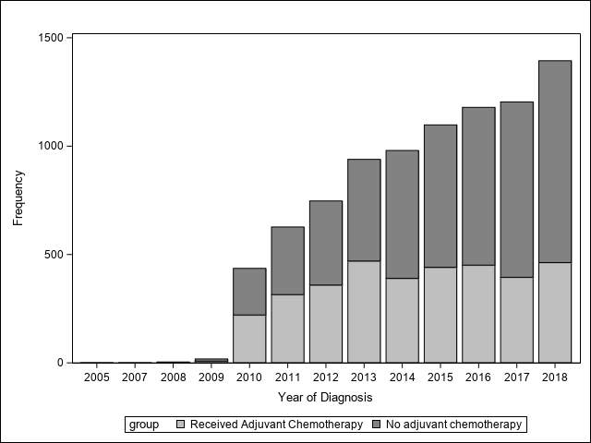

Supplemental Figure 2. Forest plot of odds ratios (95% CI) from multivariate logistic regression modeling the likelihood of receiving adjuvant chemotherapy.
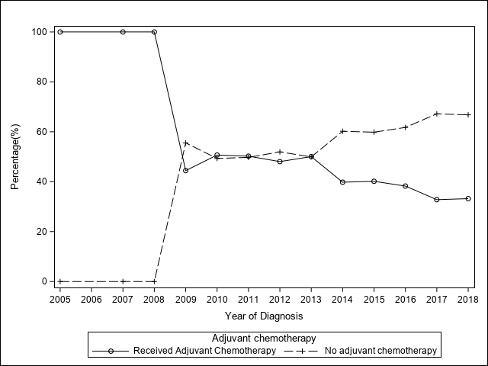

Supplemental Table 1. Odds ratios (95% CI) from multivariate logistic regression modeling the likelihood of receiving adjuvant chemotherapy.

Effect/Comparison | Odds Ratio | 95% CI | p value
ANALYTIC_STAGE Stage II vs Stage I | 1.825 | 1.598,2.084 | <.0001
ANALYTIC_STAGE Stage III vs Stage I | 3.199 | 1.593,6.426 | 0.0011
ERPR ER Positive, PR Negative vs ER Positive, PR Positive | 1.647 | 1.108,2.449 | 0.0137
GRADE Moderately differentiated, moderately well differentiated, intermediate differentiation vs Well differentiated | 1.467 | 1.301,1.655 | <.0001
GRADE Poorly differentiated vs Well differentiated, | 2.261 | 1.886,2.711 | <.0001
GRADE Cell type not determined, not stated not applicable, unknown primaries, high grade dysplasia vs Well differentiated | 1.819 | 1.355,2.441 | <.0001
Radiation received vs No Radiation received | 1.758 | 1.544,2.002 | <.0001
Age range in years 40-50 vs 18-40 | 0.684 | 0.542,0.863 | 0.0013
Facility type Academic/Research Program vs Community Cancer Program | 1.111 | 0.984,1.255 | 0.0896
Facility type Integrated Network Cancer Program vs Community Cancer Program | 1.164 | 1.009,1.344 | 0.0376
Facility Unknown vs Community Cancer Program | 1.361 | 1.039,1.783 | 0.0254
Hormonal therapy usage Not used vs Hormonal Therapy was used | 0.667 | 0.524,0.849 | 0.0010
Hormonal therapy usage Unknown vs Hormonal Therapy was used | 1.299 | 0.714,2.364 | 0.3920
Insurance Private Insurance vs Not Insured | 0.832 | 0.593,1.167 | 0.2858
Insurance Government vs Not Insured | 0.725 | 0.505,1.042 | 0.0822
Insurance Unknown vs Not Insured | 0.927 | 0.517,1.662 | 0.7994
OncotypeDx RS 12-25 vs 0-11 | 2.325 | 2.065,2.618 | <.0001
Surgery type Mastectomy vs Partial mastectomy | 1.668 | 1.469,1.894 | <.0001
AJCC Pathologic T stage T2 vs T1 | 0.967 | 0.859,1.088 | 0.5740
AJCC Pathologic T stage T2 T3 vs T1 | 0.832 | 0.425,1.627 | 0.5905
Race African-american vs caucasian | 0.777 | 0.647,0.934 | 0.0072
Race Others vs caucasian | 0.834 | 0.693,1.004 | 0.0554
Area Urban vs Metro | 0.887 | 0.752,1.047 | 0.1576
Lymph node status N2N3 vs N1 | 2.688 | 1.423,5.079 | 0.0023

Supplemental Table 2. Kaplan-Meier survival curves

KM survival for overall cohort
 |  | N (%) | N (%) | P value
 | Total | 3056 | 4178
 | Censored (%) | 2994(97.97) | 4082(97.70)
Survival rate% at months (95% CI) | 12 | 100.0(99.8,100.0) | 99.9(99.7,99.9)
Survival rate% at months (95% CI) | 24 | 99.8(99.6,99.9) | 99.6(99.3,99.8)
Survival rate% at months (95% CI) | 36 | 99.6(99.3,99.8) | 99.3(99.0,99.5)
Survival rate% at months (95% CI) | 48 | 99.4(99.0,99.6) | 98.4(97.9,98.8)
Survival rate% at months (95% CI) | 60 | 98.7(98.1,99.1) | 97.7(97.0,98.2)
Survival rate% at months (95% CI) | 72 | 97.2(96.2,97.9) | 97.0(96.1,97.6)
Survival rate% at months (95% CI) | 84 | 96.1(94.8,97.0) | 95.6(94.4,96.6)
Survival rate% at months (95% CI) | 96 | 95.5(94.0,96.6) | 93.0(90.8,94.7)
Survival rate% at months (95% CI) | 108 | 93.0(89.8,95.2) | 91.0(87.9,93.4)
Survival rate% at months (95% CI) | 120 | 93.0(89.8,95.2) | 91.0(87.9,93.4)
Survival rate% at months (95% CI) | 132 | 93.0(89.8,95.2) | NA
Survival rate% at months (95% CI) | 144 | 93.0(89.8,95.2) | NA
Test of equality | Log-Rank |  |  | 0.025
KM survival for age 18-40 years
 |  | N (%) | N (%)
 | Total | 718 | 602
 | Censored (%) | 700(97.49) | 581(96.51)
Survival rate% at months (95% CI) | 12 | 100.0(100.0,100.0) | 100.0(100.0,100.0)
Survival rate% at months (95% CI) | 24 | 100.0(100.0,100.0) | 99.8(98.8,100.0)
Survival rate% at months (95% CI) | 36 | 99.7(98.7,99.9) | 99.4(98.0,99.8)
Survival rate% at months (95% CI) | 48 | 99.3(98.0,99.7) | 98.2(96.3,99.2)
Survival rate% at months (95% CI) | 60 | 98.4(96.5,99.2) | 96.3(93.4,97.9)
Survival rate% at months (95% CI) | 72 | 97.1(94.5,98.5) | 95.0(91.4,97.1)
Survival rate% at months (95% CI) | 84 | 95.0(91.0,97.3) | 92.1(86.6,95.4)
Survival rate% at months (95% CI) | 96 | 93.3(88.2,96.2) | 89.1(81.7,93.6)
Survival rate% at months (95% CI) | 108 | 86.0(72.6,93.1) | 82.8(70.0,90.5)
Survival rate% at months (95% CI) | 120 | 86.0(72.6,93.1) | 82.8(70.0,90.5)
Survival rate% at months (95% CI) | 132 | 86.0(72.6,93.1) | NA
Survival rate% at months (95% CI) | 144 | 86.0(72.6,93.1) | NA
Test of equality | Log-Rank |  |  | 0.070
KM survival for age 41-50 years
 |  | N (%) | N (%)
N | Total | 2338 | 3576
 | Censored (%) | 2294(98.12) | 3501(97.90)
Survival rate% at months (95% CI) * | 12 | 100.0(99.7,100.0) | 99.9(99.7,99.9)
 | 24 | 99.8(99.5,99.9) | 99.6(99.3,99.7)
 | 36 | 99.6(99.3,99.8) | 99.3(98.9,99.5)
 | 48 | 99.4(98.9,99.7) | 98.4(97.9,98.8)
 | 60 | 98.8(98.1,99.2) | 97.9(97.2,98.4)
 | 72 | 97.2(96.0,98.0) | 97.3(96.4,97.9)
 | 84 | 96.3(94.9,97.3) | 96.2(94.9,97.1)
 | 96 | 96.0(94.5,97.2) | 93.6(91.3,95.3)
 | 108 | 94.7(91.9,96.5) | 92.2(88.9,94.6)
 | 120 | 94.7(91.9,96.5) | 92.2(88.9,94.6)
 | 132 | 94.7(91.9,96.5) | NA
 | 144 | 94.7(91.9,96.5) | NA
Test of equality | Log-Rank |  |  | 0.062
 | Wilcoxon |  |  | 0.033

Supplemental Table 3. Hazard ratios (95% CI) comparison between factors from multivariate Cox model

Comparison | Hazard Ratio | 95% CI | p value
Chemo+ vs Chemo- | 0.560 | 0.399,0.787 | 0.0008
Stage II vs Stage I | 1.227 | 0.771,1.953 | 0.3879
Stage III vs Stage I | 0.770 | 0.146,4.068 | 0.7578
ERPR ER Positive, PR Negative vs ER Positive, PR Positive | 1.518 | 0.615,3.748 | 0.3652
GRADE Moderately differentiated, moderately well differentiated, intermediate differentiation vs Well differentiated | 1.225 | 0.817,1.838 | 0.3265
GRADE Poorly differentiated vs Well differentiated | 2.569 | 1.567,4.212 | 0.0002
GRADE Cell type not determined, not stated not applicable, unknown primaries, high grade dysplasia vs Well differentiated | 1.700 | 0.745,3.877 | 0.2073
Radiation received vs No Radiation received | 0.793 | 0.521,1.205 | 0.2768
Age range 40-50 vs 18-40 years | 0.848 | 0.412,1.745 | 0.6540
Facility Academic/Research Program vs Community Cancer Program | 0.873 | 0.594,1.282 | 0.4871
Facility Integrated Network Cancer Program vs Community Cancer Program | 0.595 | 0.355,0.998 | 0.0492
Facility Unknow vs Community Cancer Program | 1.121 | 0.499,2.516 | 0.7818
Hormonal therapy Not used vs Hormonal Therapy was used | 1.538 | 0.887,2.667 | 0.1251
Hormonal therapy Unknown vs Hormonal Therapy was used | 1.491 | 0.206,10.779 | 0.6923
Insurance Private Insurance vs Not Insured | 0.929 | 0.339,2.542 | 0.8852
Insurance Government vs Not Insured | 2.563 | 0.914,7.188 | 0.0736
Insurance Unknown vs Not Insured | 1.452 | 0.265,7.967 | 0.6675
OncotypeDx RS 12-25 vs 0-11 | 1.549 | 1.031,2.329 | 0.0352
Surgery type Mastectomy vs Partial mastectomy | 0.923 | 0.603,1.412 | 0.7120
AJCC Pathologic T stage T2 vs T1 | 1.466 | 1.016,2.116 | 0.0408
AJCC Pathologic T stage T2 T3 vs T1 | 1.666 | 0.397,6.995 | 0.4857
Race African-american vs caucasian | 1.875 | 1.232,2.852 | 0.0033
Race Others vs caucasian | 0.330 | 0.121,0.899 | 0.0301
Area Urban vs Metro | 1.297 | 0.812,2.072 | 0.2766
Lymph node status N2N3 vs N1 | 3.695 | 0.821,16.623 | 0.0885

Supplemental Figure 3. Hazard ratios (95% CI) comparison between factors from multivariate Cox model

