Supporting Information

Dual-mode 0D/2D Spatial Asymmetry Optoelectronic Device Enabled by in situ Microzone Femtosecond Laser Deposition

Zehua Li ^{1,2}, Guisheng Zou^{1,2}, Jinpeng Huo^{1,2,*}, Jin Peng^{1,2}, Tianming Sun^{1,2}, Yu Xiao³, Jiali Huo⁴, Bin Feng^{1,2}, Lei Liu^{1,2,*}
¹ State Key Laboratory of Clean and Efficient Turbomachinery Power Equipment, Department of Mechanical Engineering, Tsinghua University, Beijing, 100084, China
² Key Laboratory for Advanced Materials Processing Technology, Ministry of Education, Beijing 100084, China
³ School of Chemistry and Chemical Engineering, Frontiers Science Center for Transformative Molecules, Center of Hydrogen Science, Shanghai Key Lab of Electrical Insulation & Thermal Aging, Shanghai Jiao Tong University, Shanghai 200240, P. R. China
⁴ Department of Electrical and Computer Engineering, National University of Singapore, 4 Engineering Drive 3, Singapore 117583, Singapore.
Email address:
Zehua Li: li-zh22@mails.tsinghua.edu.cn; Guisheng Zou: zougsh@tsinghua.edu.cn; Jinpeng Huo: huojp@tsinghua.edu.cn; Jin Peng: pj23@mails.tsinghua.edu.cn ; Tianming Sun: suntianming1997@tsinghua.edu.cn; Yu Xiao: xiaoyu24@sjtu.edu.cn; Jiali Huo: jiali_h@nus.edu.sg; Bin Feng: bin.fengfb@outlook.com; Lei Liu: liulei@tsinghua.edu.cn
* Correspondence:
Lei Liu: liulei@tsinghua.edu.cn, +86 18610814123.
Jinpeng Huo: huojp@tsinghua.edu.cn, +86 18800101565.
¹ State Key Laboratory of Clean and Efficient Turbomachinery Power Equipment, Department of Mechanical Engineering, Tsinghua University, Beijing, 100084, China
² Key Laboratory for Advanced Materials Processing Technology, Ministry of Education, Beijing 100084, China

1. Supplementary Figures:
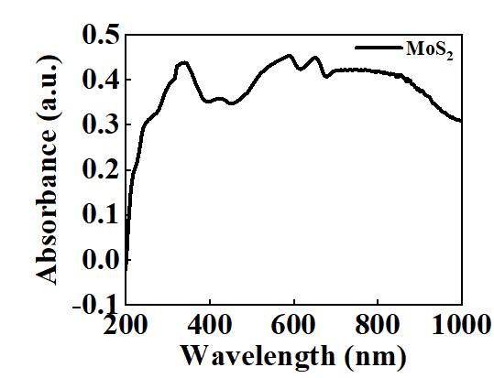
Fig. S1. Adsorption spectrum of MoS₂.
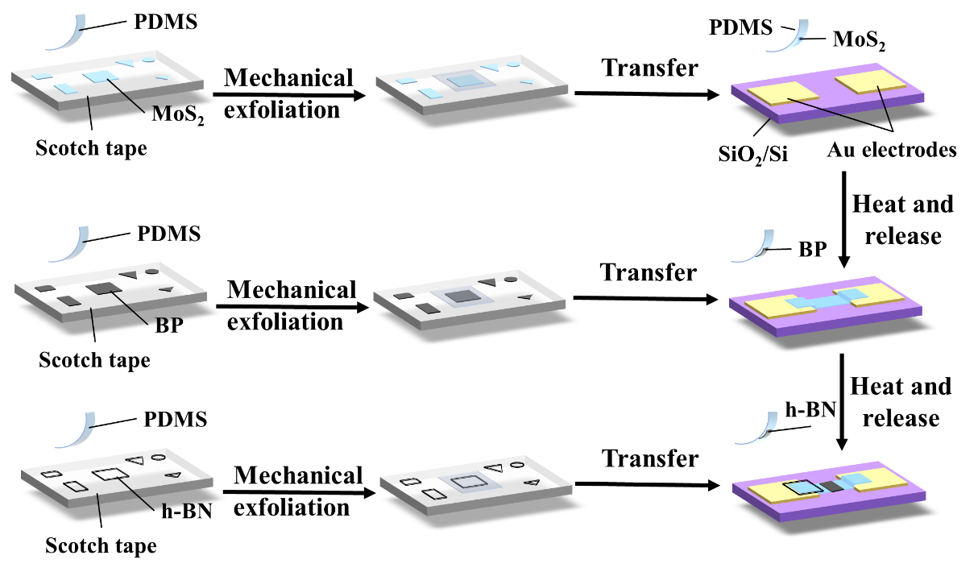
Fig. S2. Transfer method of device.

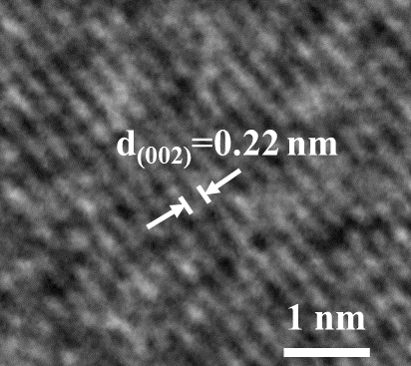
Fig. S3. High-resolution TEM (HGTEM) of BP.
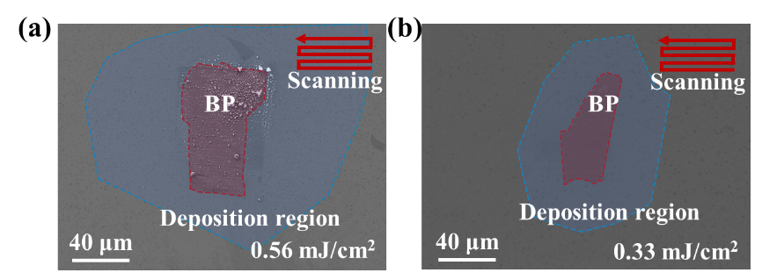
Fig. S4. SEM image of BP after M-PLD under the frequency of 0.56 mJ/cm². (a) and 0.33 mJ/cm² (b).
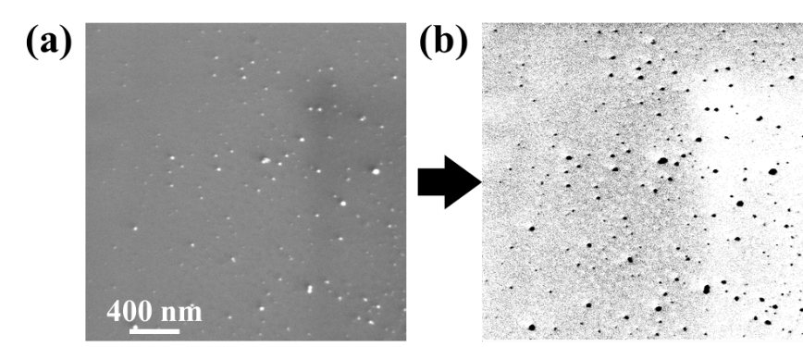
Fig. S5. Preprocessing of BP NPs SEM images. (a) SEM image of BP NPs. (b) Binarization of SEM image.
The equivalent diameter can be calculated as follows:
$$\begin{aligned}D_{e}=\sqrt{\frac{S}{π}}∙2\#\left(Equ. S3\right)\end{aligned}$$
where S is the area of the particles.
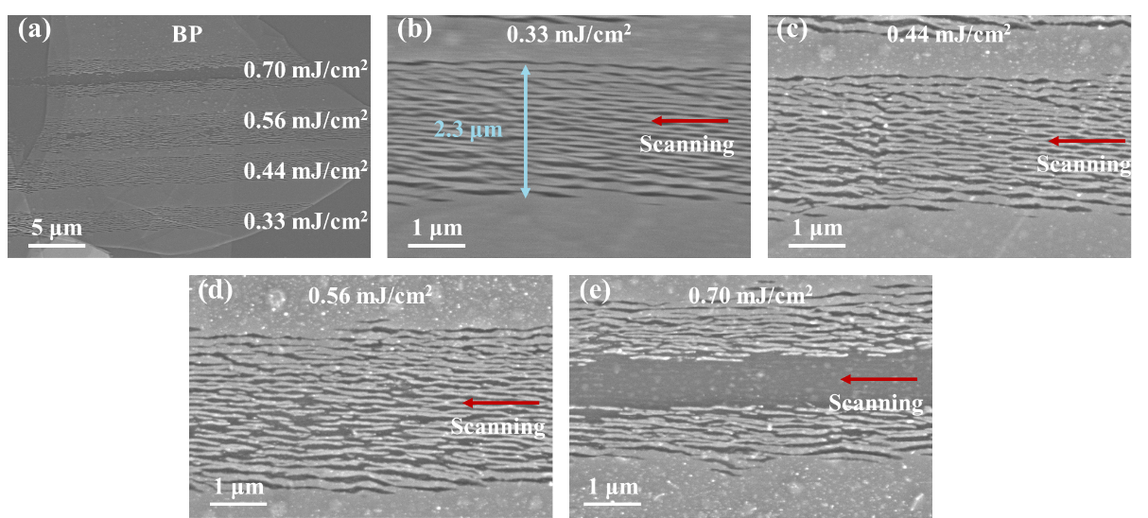
Fig. S6. Effect of laser fluence on the ablation morphology of black phosphorus in a single scanning line. (a) SEM image of BP film after being ablated by different laser fluences. (b)-(e) The image of BP under laser fluence of 0.33 mJ/cm² (b), 0.44 mJ/cm² (c), 0.56 mJ/cm² (d), 0.70 mJ/cm² (e).
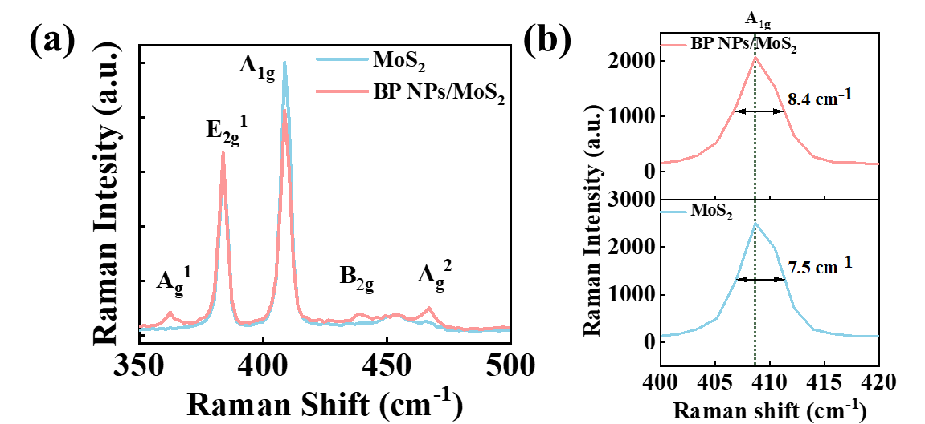
Fig. S7. Raman spectroscopy. (a) Raman spectroscopy of MoS₂ before and after deposition of BP NPs. (b)Raman spectroscopy of A_{1g} peak of MoS₂ before and after deposition of BP NPs.
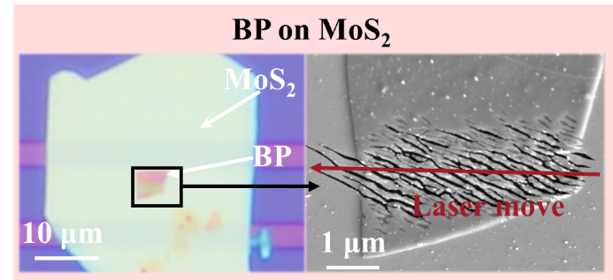
Fig. S8. Characterization of BP ablation under different fs laser energies.
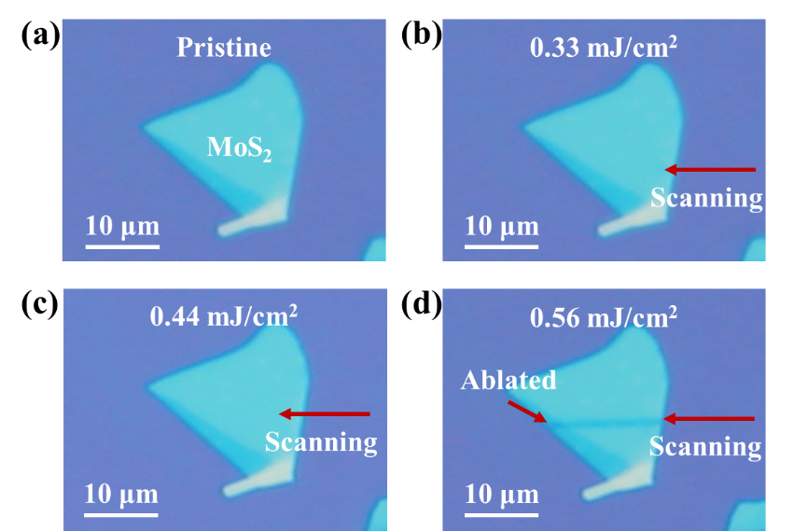
Fig. S9. Test procedure of MoS₂ ablated by fs laser. (a) Pristine morphology. (b) Laser fluence of 0.33 mJ/cm². (c) Laser fluence of 0.44 mJ/cm². (d) Laser fluence of 0.56 mJ/cm².
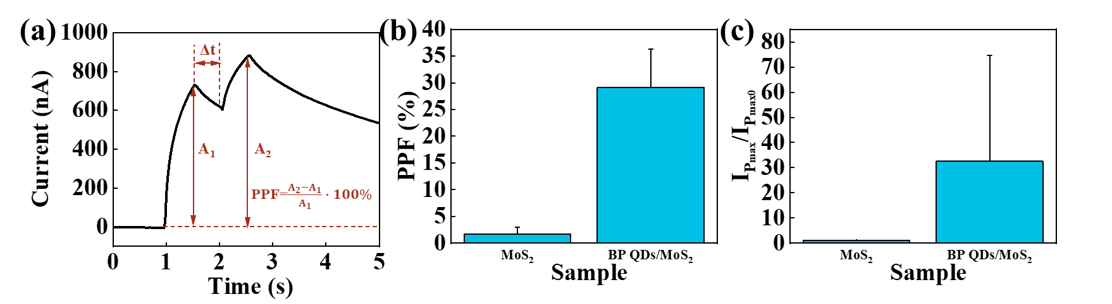
Fig. S10. Statistics of optoelectronic performance with 7 samples. (a) Schematic diagram of the PPF index. (b) Statistical graph of PPF index (V_{ds} = 1 V, white light, 0.5 s on, 1 Hz). (c) Statistical graph of relative maximum photocurrent (V_{ds} = 1 V, white light, 0.5 s on, 1 Hz).
The PPF index can be calculated as follows:
$$\begin{aligned}PPF=\frac{A_{2}-A_{1}}{A_{1}}∙100\%\#\left(Equ. S1\right)\end{aligned}$$
where A₁ and A₂ represent the current after the first and second light pulse, respectively.
The relative maximum photocurrent can be calculated as follows:
$$\begin{aligned}Relative=\frac{I_{pmax}}{I_{pmax0}}\#\left(Equ. S2\right)\end{aligned}$$
where I_{pmax} is the max current after light irradiation of BP QDs/MoS₂, and I_{pmax0} is the max current after light irradiation of MoS₂.
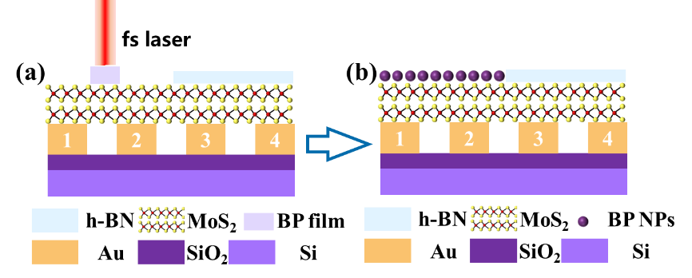
Fig. S11. Fabrication of dual-mode optoelectronic device. (a) Schematic diagram of MPLD process. (b) Schematic diagram of different kinds of 0D/2D heterostructures.
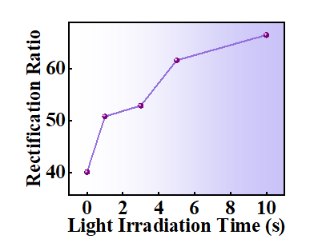
Fig. S12. Change in rectification ratio of the device after white light irradiation.
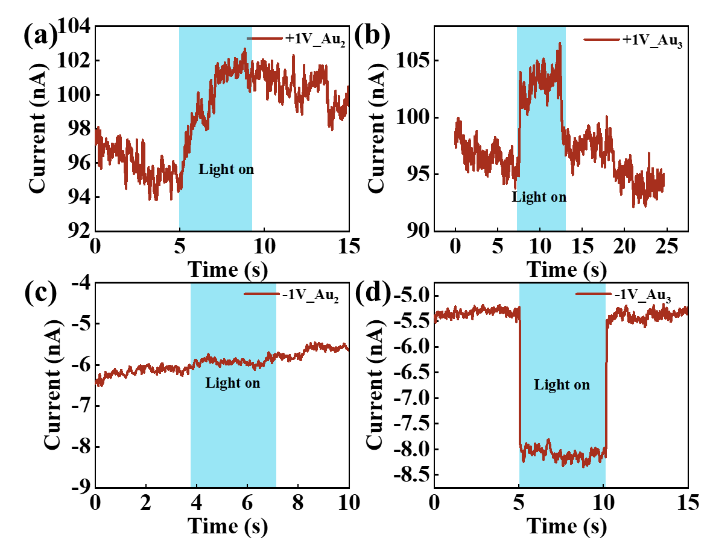
Fig. S13. Photo response of different regions. (a) Photo response in area not protected by h-NB, V_{ds}=+1 V. (b) Photo response in area protected by h-NB, V_{ds}=+1 V. (c) Photo response in area not protected by h-NB, V_{ds}=-1 V. (d) Photo response in area protected by h-NB, V_{ds}=-1 V.
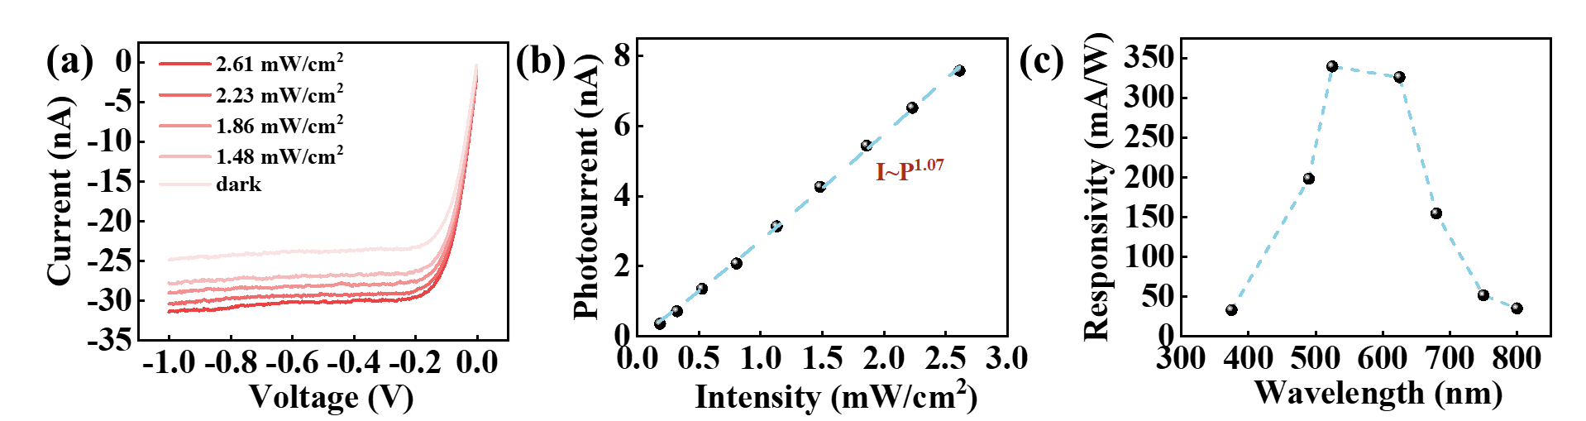
Fig. S14. Basic optoelectronic performance of the PD. (a) Light intensity dependence of photocurrent for asymmetric device under negative bias, 525nm light. (b) Fitting of photocurrent versus light intensity, 525 nm light. (c) Wavelength dependence of photoresponsivity for asymmetric device under negative bias at -1 V.
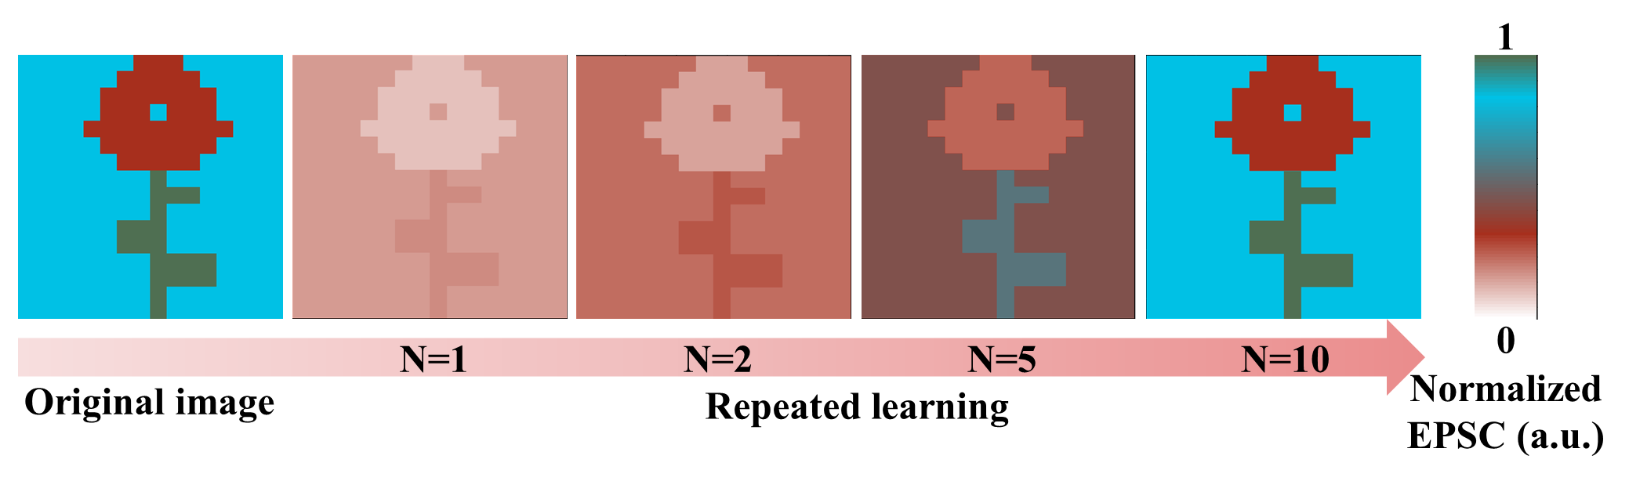
Fig. S15. Emulation of the image memory application of human vision.
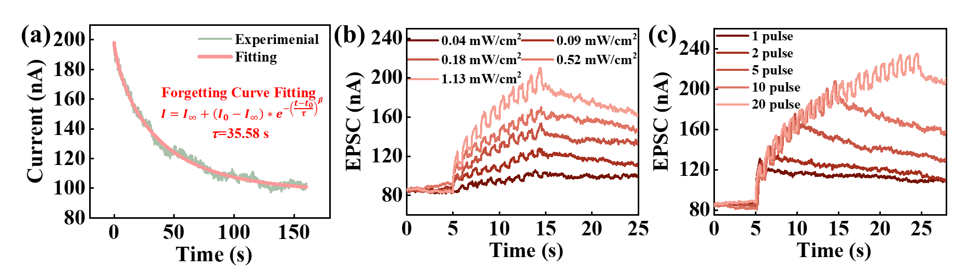
Fig. S16. Basic optoelectronic performance of the NVS. (a) Ebbinghaus forgetting characteristic curve fitting, irradiated with 525 nm light (1Hz, 0.5s width, 10pulse), V_{ds}=+1 V. (b) Effect of pulse intensity under 525 nm irradiation (1 Hz, 0.5 s width, 10 pulse) on the memory pattern V_{ds}=+1 V. (c) Effect of pulse number under 525 nm irradiation (1.13 mW/cm², 1 Hz, 0.5 s width) on the memory pattern, V_{ds}=+1 V.
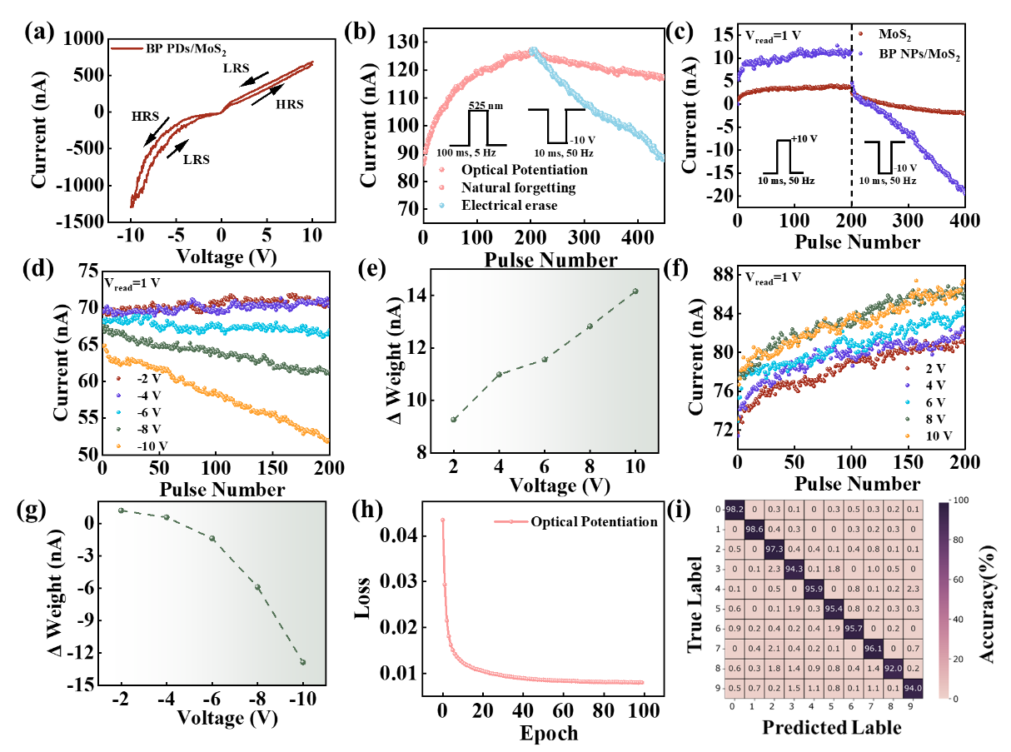
Fig. S17. Effect of two-terminal electrical stimulation on device current. (a) I_{D}-V_{D} curve of BP NPs/MoS₂. (b) Optical memory erased by electrical stimuli. (c) LTP/LTD of MoS₂ before and after deposition of BP nanoparticle. (d)-(e) Depression of the device by different magnitudes of negative voltage pulse (10 ms, 50Hz). (f)-(g) Facilitation of the device by different magnitudes of positive voltage pulse (10 ms, 50Hz). h) Loss function during training. (i) Confusion matrix after training.
In order to characterize the influence of the BP NPs to modulate the resistance and current values, the effect of a high voltage pulse on the current at a reading voltage of 1 V is compared (Fig. S17b). After deposition of BP NPs, the device exhibits more significant current modulation effect. In addition, compared to the initial sample, the post-MPLD sample exhibits a more linear erasure process to the current (with nonlinearity changing from -2.13 to nearly 0). The enhanced electrical modulation performance may be related to the low field mobility and the sulfur vacancy migration barrier due to the BP NPs. Subsequently, excitatory and inhibitory effects at different voltages are tested (Fig. S17c-f). Current can be quantitatively modulated by controlling the magnitude of the voltage stimulus, which provides the basis for dynamic modulation of synaptic excitability.

2. Supplementary Tables:
Tab. S1. Statistics of dual-mode conversion of photodetector and optoelectronic synapse
Device | Method | Wavelength Range | Feature | Ref.
β-Ga₂O₃ | V_{ds} magnitude | 254 nm | Narrow band | [1]
GaN/Ga₂O₃/GaN | V_{ds} magnitude | 254-365 nm | Narrow band | [2]
ITO/CuSCN/active layer/PDINO/Al | V_{ds} direction | 450 nm-940 nm | Complex material systems | [3]
MoS₂/Al₂O₃/ITO | V_{g} | White light | Three-terminal | [4]
BHJ/ZnO | V_{g} | 488 nm-1064 nm | Three-terminal | [5]
Graphene PQD | V_{g} | 430 nm-440 nm | Three-terminal | [6]
BP/MoS₂/h-BN | V_{ds} direction | 375 nm-800 nm |  | This work

References:
1. Wang, X. et al. Two-in-one functionality in a 28 × 28 β-Ga₂O₃ array: bias-voltage switching between photodetection and neuromorphic vision. Opt. Express. 32: 39515 (2024).
2. Feng, S. et al. Dual‐Mode Conversion of Photodetector and Neuromorphic Vision Sensor via Bias Voltage Regulation on a Single Device. Adv. Mater. 35 (2023).
3. Liu, T. et al. Multifunctional Organic Vertical Photodiodes for Photo‐Detection and Photo‐Synapse Enabled by Modulation of the Interface Energy Barrier. Adv. Opt. Mater. 10 (2022).
4. Li, N. et al. Gate-tunable large-scale flexible monolayer MoS₂ devices for photodetectors and optoelectronic synapses. Nano Res. 15: 5418-5424 (2022).
5. Han, J. et al. Near-infrared heterojunction field modulated phototransistors with distinct photodetection/photostorage switching features for artificial visuals. J. Mater. Chem. C. 10: 9198-9207 (2022).
6. Pradhan, B. et al. Ultrasensitive and ultrathin phototransistors and photonic synapses using perovskite quantum dots grown from graphene lattice. Sci. Adv. 6: eaay5225-eaay5225 (2020).

