Supplementary Materials for

Metastable Hexagonal Ir Based Porous Transport Electrode for Durable and Efficient Oxygen Evolution Reaction in Acidic Media

Contents

- Supplementary Note 1. 5
- Supplementary Note 2. 5
- Supplementary Note 3. 5
- Supplementary Note 4. 6
- Supplementary Note 5. 6
- Supplementary Note 6. 6
- Supplementary Figure 1. Bulk structure of c-Ir, h-Ir 8
- Supplementary Figure 2. FE-SEM images of nickel and iridium before and after electrodeposition 9
- Supplementary Figure 3. FE-SEM images of c-Ir(Ni) and h-Ir(Ni,Re) 10
- Supplementary Figure 4. LSV polarization curves as a function of elemental composition control for OER 11
- Supplementary Figure 5. XRD pattern of h-Ir(Ni,Re) 12
- Supplementary Figure 6. HAADF-STEM & BF-STEM image of c-Ir(Ni) 13
- Supplementary Figure 7. HAADF-STEM & EDX of c-Ir(Ni) 14
- Supplementary Figure 8. Morphology and structure of c-Ir(Ni) 15
- Supplementary Figure 9. HAADF-STEM & BF-STEM image of h-Ir(Ni,Re) 16
- Supplementary Figure 10. HAADF-STEM & EDX of h-Ir(Ni) 17
- Supplementary Figure 11. Morphology and structure of post-OER c-Ir(Ni) 18
- Supplementary Figure 12. HAADF-STEM & EDX of post-OER c-Ir(Ni) 19
- Supplementary Figure 13. HAADF-STEM & BF-STEM image of post-OER c-Ir(Ni) 20
- Supplementary Figure 14. HR-TEM image and SADP of post-PER OER h-Ir(Ni,Re) 21
- Supplementary Figure 15. HAADF-STEM & EDX of post-OER h-Ir(Ni,Re) 22
- Supplementary Figure 16. HAADF-STEM & BF-STEM image of post-OER h-Ir(Ni,Re) 23
- Supplementary Figure 17. HR-TEM image of post-OER h-Ir(Ni,Re) 24
- Supplementary Figure 18. ABF-STEM image of post-OER h-Ir(Ni,Re) 25
- Supplementary Figure 19. HAADF-STEM & EDX of post-OER h-Ir(Ni,Re) 26
- Supplementary Figure 20. Morphology of s-Ni and s-Ir 27
- Supplementary Figure 21. OER polarization curves measured over a wide voltage range 28
- Supplementary Figure 22. Tafel plots of c-Ir(Ni) and h-Ir(Ni,Re) before and after OER 29
- Supplementary Figure 23. Nyquist plots (Z´ vs -Z´´) of c-Ir(Ni), h-Ir(Ni,Re), and s-Ir 30
- Supplementary Figure 24. Current density difference 31
- Supplementary Figure 25. CV scans for calculating C_{dl} of catalysts 32
- Supplementary Figure 26. Comparison of turn over frequency 33
- Supplementary Figure 27. TOF measurements of catalysts 34
- Supplementary Figure 28. OER polarization curves measured at various temperatures of catalyst 35
- Supplementary Figure 29. Activation energy for the acidic OER 36
- Supplementary Figure 30. Catalyst’s temporal variation in deposition amount and performance 37
- Supplementary Figure 31. Faradaic efficient of catalysts 38
- Supplementary Figure 32. Morphology of post-OER catalysts 39
- Supplementary Figure 33. Chronopotentiometry of s-Ir 40
- Supplementary Figure 34. Re 4f XPS spectra of catalysts 41
- Supplementary Figure 35. XANES spectra of Re L₃-edge for catalysts 42
- Supplementary Figure 36. Ni 2p XPS spectra of catalysts 43
- Supplementary Figure 37. XANES spectra of O K-edge for catalysts 44
- Supplementary Figure 38. XANES spectra of O K-edge for h-Ir(Ni,Re) compared to c-Ir(Ni) 45
- Supplementary Figure 39. Side view of atomic configurations for metallic Ir slab models 46
- Supplementary Figure 40. Pourbaix diagram for metallic Ir surfaces 47
- Supplementary Figure 41. Schematic illustration of the different OER reaction pathway 48
- Supplementary Figure 42. Atomic configurations of OER intermediates adsorbed on Ir (11$\overline{2}$0) surface following AEM 49
- Supplementary Figure 43. HAADF-STEM & BF-STEM image of post-OER h-Ir(Ni,Re) 50
- Supplementary Figure 44. Top view and side view of optimized IrO₂ (110) structure 51
- Supplementary Figure 45. Re doping formation energy 52
- Supplementary Figure 46. Cross-sectional HAADF-STEM image of post-OER h-Ir(Ni,Re) and c-Ir(Ni) 53
- Supplementary Figure 47. Optimized atomic configurations of IrO₂ (110) with Ir vacancies 54
- Supplementary Figure 48. Pourbaix diagram of IrO₂ (110) surfaces 55
- Supplementary Figure 49. Bader charge analysis for IrO₂ (110) and Re-IrO₂ (110) surfaces 56
- Supplementary Figure 50. ICOHP analysis of catalysts 57
- Supplementary Figure 51. Charge-transfer energy of catalysts 58
- Supplementary Figure 52. PDOS analysis of catalysts 59
- Supplementary Figure 53. LSV polarization curves of h-Ir(Ni,Ir)for HER 60
- Supplementary Figure 54. Two-electrode polarization and chronopotentiometry curves 61
- Supplementary Figure 55. LSV polarization curves of h-Ir(Ni,Ir) in various electrolytes for OER and HER 62
- Supplementary Table 1. Calculated lattice constant and cohesive energy of Ir-Ni alloy 63
- Supplementary Table 2. Elemental compositions of Ir, Ni, and Re in c-Ir(Ni) and h-Ir(Ni,Re) quantified by ICP-OES & MS 64
- Supplementary Table 3. Experimental Crystallographic information 65
- Supplementary Table 4. Theoretical Crystallographic information 66
- Supplementary Table 5. Comparing OER activity of h-Ir(Ni,Re) 67
- Supplementary Table 6. The overpotential changes over time for catalyst 69
- Supplementary Table 7. XPS results of the c-Ir(Ni), c-Ir(Ni) after OER, h-Ir(Ni,Re), h-Ir(Ni,Re) after OER samples 70
- Supplementary Table 8. Theoretical OER pathways 73
- Supplementary Table 9. The calculated overpotential with respect to the structure and plane of metal iridium 74
- Supplementary Table 10. The calculated lattice parameters of Rutile IrO₂ 75
- Supplementary Table 11. The calculated overpotential for OER of IrO₂ (110) 76
- Supplementary Table 12. Comparing PEMWE performance of h-Ir(Ni,Re) 77
- Supplementary References 79
Supplementary Notes
Supplementary Note 1. Calculation of electrochemical surface area (ECSA)
CV scan was performed in a non-Faradic potential range (e.q., 1.06 ~ 1.2 V_{RHE}) at different scan rates (5-30 mV/s) in a 0.1M HClO₄ electrolyte to estimate double-layer capacitance (C_{dl}) of catalysts. The difference between anodic and cathodic currents (ΔJ = J_{anodic}-J_{cathodic}) at the middle of potential (1.13 V_{RHE}) was plotted against the scan rate, where the slope corresponds to twice of C_{dl} of the catalyst. The equation used for calculating C_{dl} is as follow,
C_{dl} = $\frac{j_{a{- j}_{c}}}{2 ×v}$ = $\frac{j_{a}+\left|j_{c}\right|}{2 ×v}$ = $\frac{∆j}{2 ×v}$ (8)
where, j_{a} and j_{c} represent the anodic and cathodic current densities, respectively, recorded at the midpoint of potential, 𝜐 is a scan rate. The ECSA of the samples were attained from the measured C_{d}, in which a flat surface area of 1 cm² in the catalyst is approximately corresponding to a specific capacitance of about 40 μF cm⁻². Then, the ECSA of catalyst can be expressed using the following equation.
ECSA = $\frac{C_{dl} of the catalyst (mF {cm}^{-2})}{0.04 (mF {cm}^{-2}) }$ (9)

Supplementary Note 2. Calculation of Ir mass activity
For the calculation of Ir mass activity, a current at an overpotential of 250 mV was divided by the mass of Ir in the samples, determined from the ICP-OES results. The Ir mass activity was then calculated using the following equation.
$Mass activity (A/g_{Ir})=\frac{Current}{Iridium amount}$ (10)

Supplementary Note 3. Calculation of turnover frequency (TOF)
TOFs of the samples for OER was calculated using the following equation¹⁸⁻²¹,
$Turnover frequency(TOF)=\frac{j×N_{A}}{4×F×N_{s}}$ (11)
, where j is a current density at an overpotential of 250 mV, N_{A} is the Avogadro number (6.02 x 10²³), F is the Faradaic constant (96,458 C mol⁻¹), and N_{s} is the concentration of active sites (mol cm⁻²). The Ns was calculated via CV measurements using a scan rate of 10mV/s, where the oxidative area currents are directly related with the number of active sites. As the oxidation of Ir³⁺ to Ir⁴⁺ is a single electron transfer reaction, the number of electrons for oxidative currents is equal to the number of active sites.

Supplementary Note 4. Calculation of activation energy (E_{a})
Activation energies of the samples were obtained from the LSV curves measured at different temperature of 27, 37, 47and 57°C. The E_{a} was then determined using the Arrhenius equation,
$\frac{∂ log⁡(j)}{∂ (1/T)}=-\frac{E_{a}}{2.303R}$ (12)
, where j is a current density at an overpotential of 250 mV, T is the temperature (K), R is the ideal gas constant (8.314 J·K⁻¹mol⁻¹), respectively.

Supplementary Note 5. Calculation of Faradaic efficiency (FE) calculation using gas chromatography (GC)
Faradaic efficiency (FE) of the samples for OER was calculated using a lab-fabricated H-Cell connected to GC equipment (ChroZen GC; Youngin Chromass Corp.). Chronopotentiometry was performed at 100 mAcm⁻² under acidic media, while a thermal conductivity detector (TCD) was utilized to quantify the evolved oxygen gas during OER. Of note, calibration curves were attained using the O₂ standard gas (0.5, 1, and 2 cmol/mol) to convert peak areas to moles of O₂. Faradaic efficiency (FE) was obtained using the following equation,
FE(%) = $\frac{O_{2} gas (experimental)}{O_{2} gas (theoretical)}×100$ =$n/{\frac{Q}{zF}}$ = $\frac{4×n×F}{I×t}$ (13)
, where I, t, n, z, Q and F are the current (A), time (s), the amount of gas measured (mol), 4 for OER, total charge, and the Faradaic constant (96458.33C mol⁻¹)

Supplementary Note 6. Calculation of stability number (S-number)
S-number was determined from the amount of dissolved Ir during chronopotentiometry at 100 mAcm⁻² under acidic media. The electrolytes were collected at different time intervals, where the dissolved Ir was determined by inductively coupled plasma-mass spectroscopy (ICP-MS). The S-numbers of samples were calculated using the below equation,
S-number =$\frac{n_{O_{2}}}{n_{disolved Ir}}$ (14)
,where n_{O2} is the moles of oxygen evolved during OER, and n_{disolved Ir} is the moles of Ir in the electrolyte after OER for specific time.

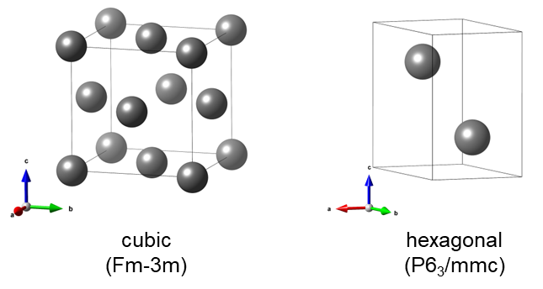
Supplementary Figure 1. Bulk structure of c-Ir, h-Ir.

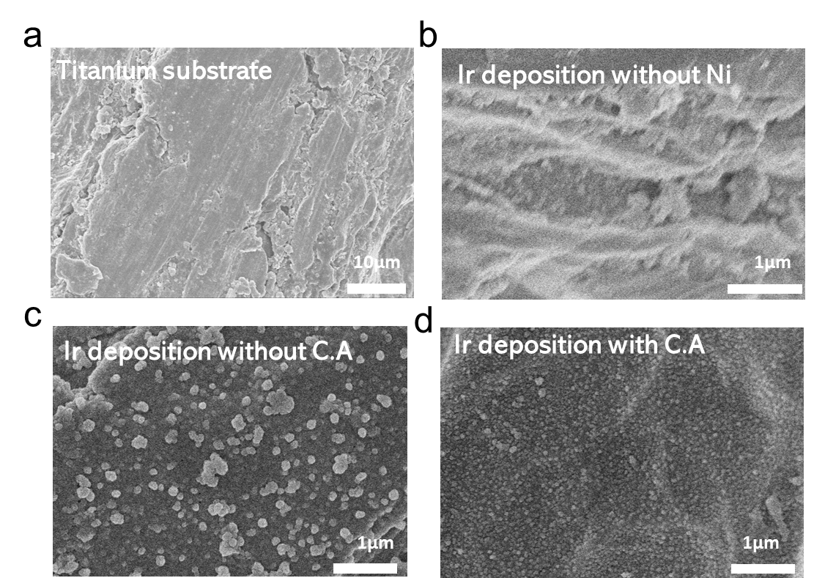
Supplementary Figure 2. FE-SEM images of (a) titanium substrate, (b) s-Ni, (c) s-Ir without citric acid, and (d) s-Ir with citric acid.

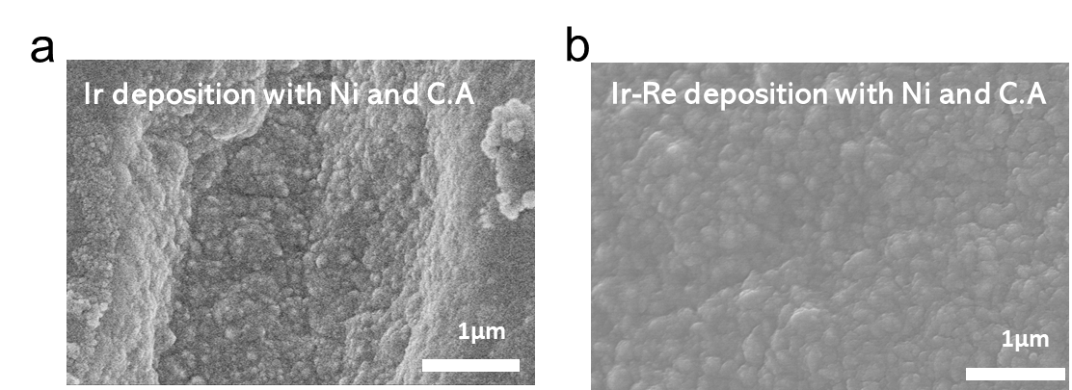
Supplementary Figure 3. FE-SEM images of (a) c-Ir(Ni) and (b) h-Ir(Ni,Re).

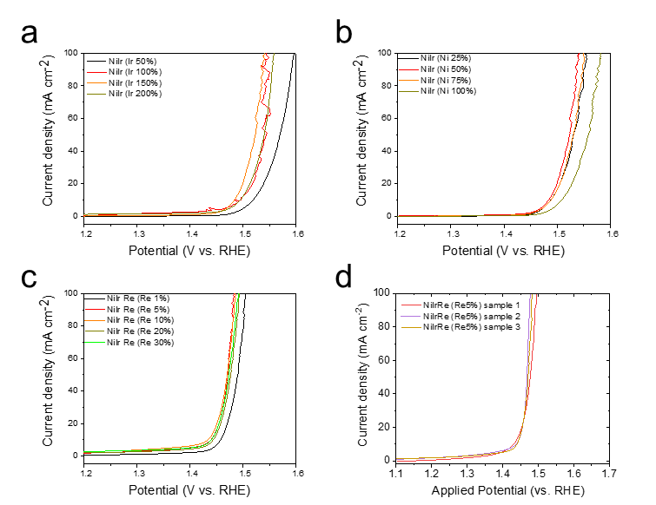
Supplementary Figure 4. The OER polarization curves for Ir(Ni,Re) with (a) different Ir amounts, (b) different Ni amounts, and (c) different Re amounts. (d) Reproducibility test for the Ir(Ni,Re) with the optimal Ir, Ni, Re content.

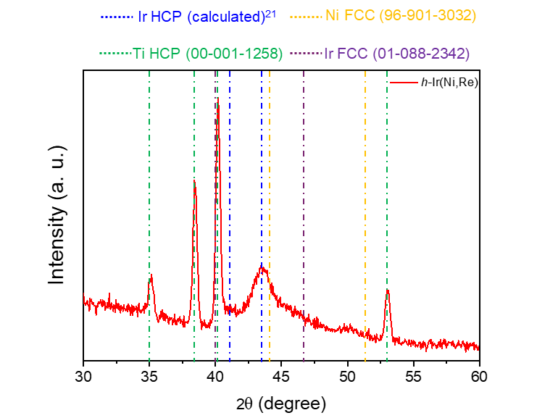

Supplementary Figure 5. XRD pattern of h-Ir(Ni,Re)²².

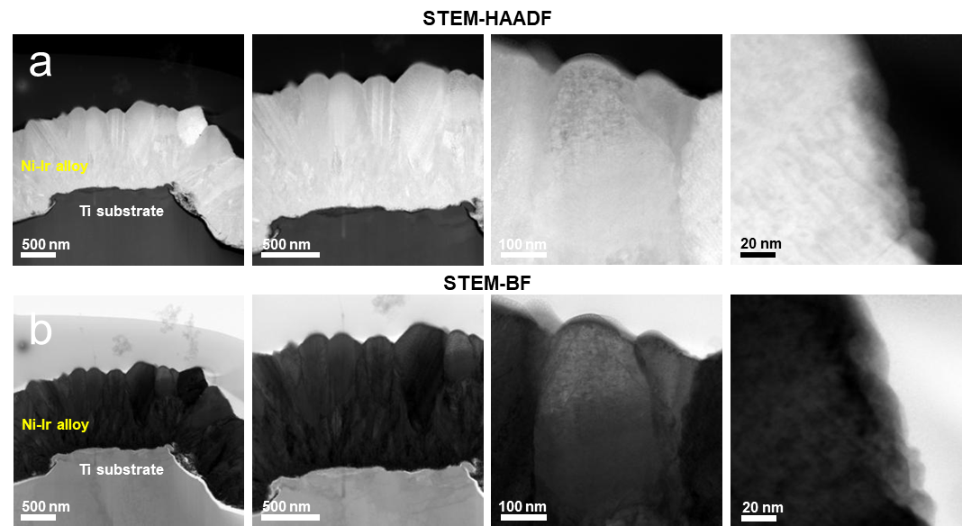
Supplementary Figure 6. (a) High angle annular dark field-STEM and (b) bright field-STEM image of for the cross section of as-prepared c-Ir(Ni) without dealloying process.

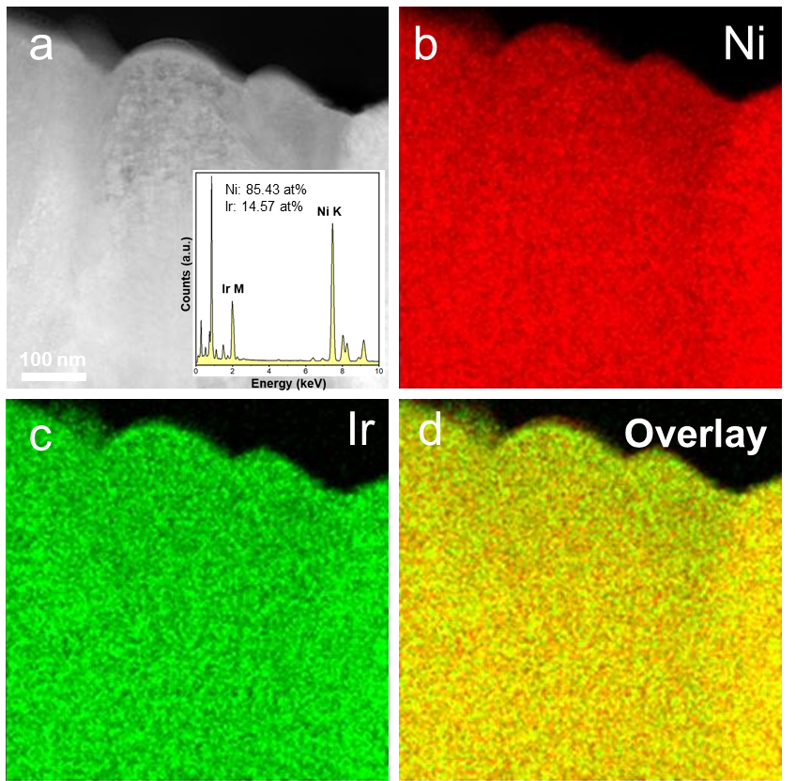
Supplementary Figure 7. (a) Dark field-STEM image of as-prepared c-Ir(Ni) without dealloying process. The inset shows quantitative elemental analysis for SEM-EDX spectra. STEM-EDX mapping images of c-Ir(Ni) for (b) Ni, (c) Ir, (d) overlay maps.

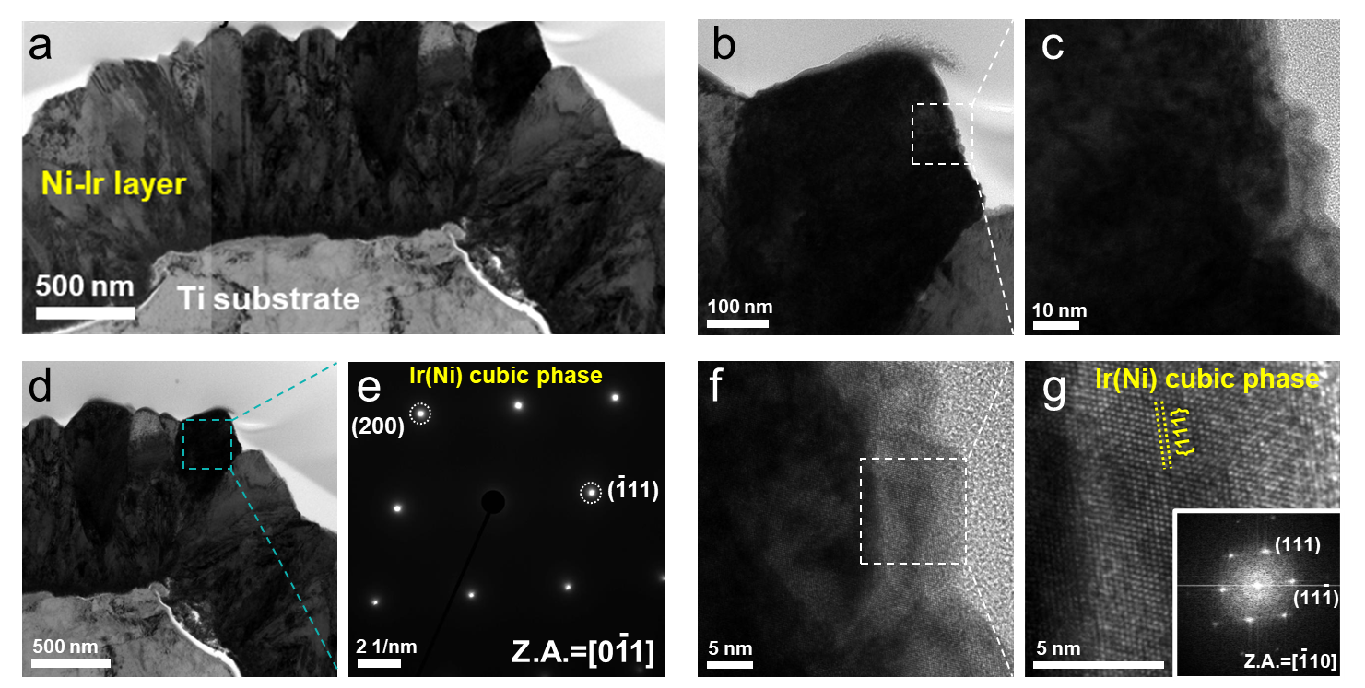
Supplementary Figure 8. (a-d) Cross-sectional BF-STEM images of as-prepared c-Ir(Ni) without dealloying process, (e) corresponding SADP, and (f, g) HR-TEM image with the inset of the FFT image.

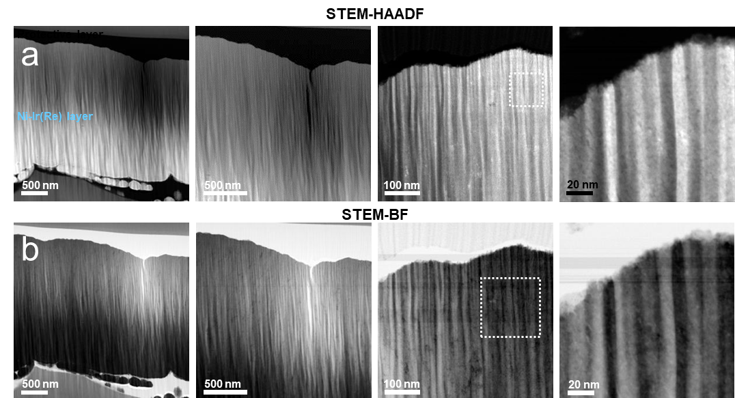
Supplementary Figure 9. (a) High angle annular dark field-STEM and (b) bright field-STEM image of the cross section of as-prepared h-Ir(Ni,Re) without dealloying process.

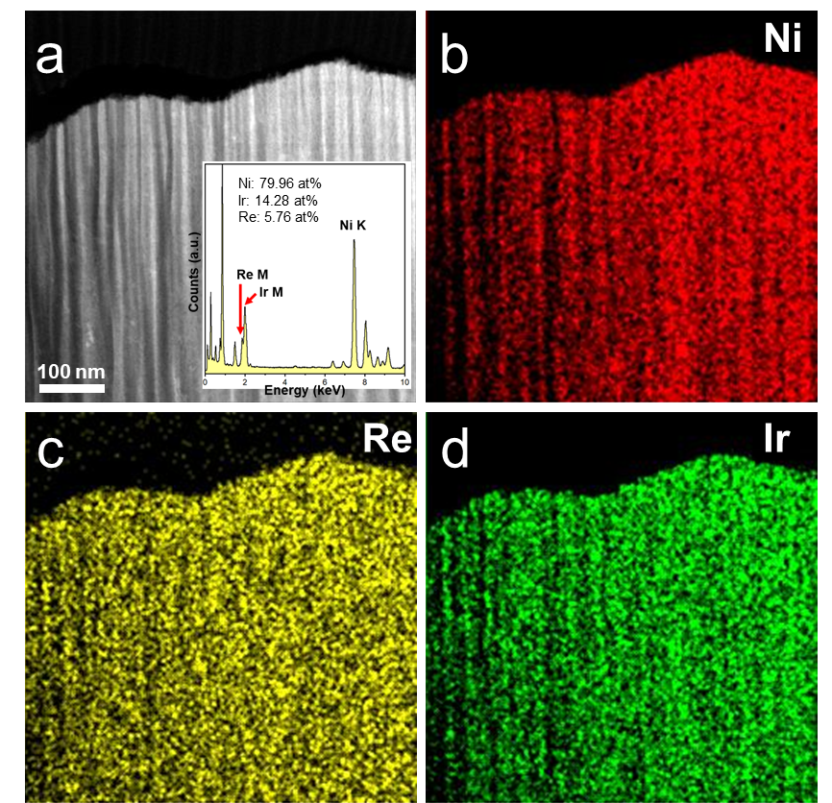
Supplementary Figure 10. (a) Dark field-STEM image of as-prepared h-Ir(Ni,Re) without dealloying process. The inset shows quantitative elemental analysis for STEM-EDX spectra. STEM-EDX mapping images of h-Ir(Ni,Re) for (b) Ni, (c) Re, and (d) Ir.
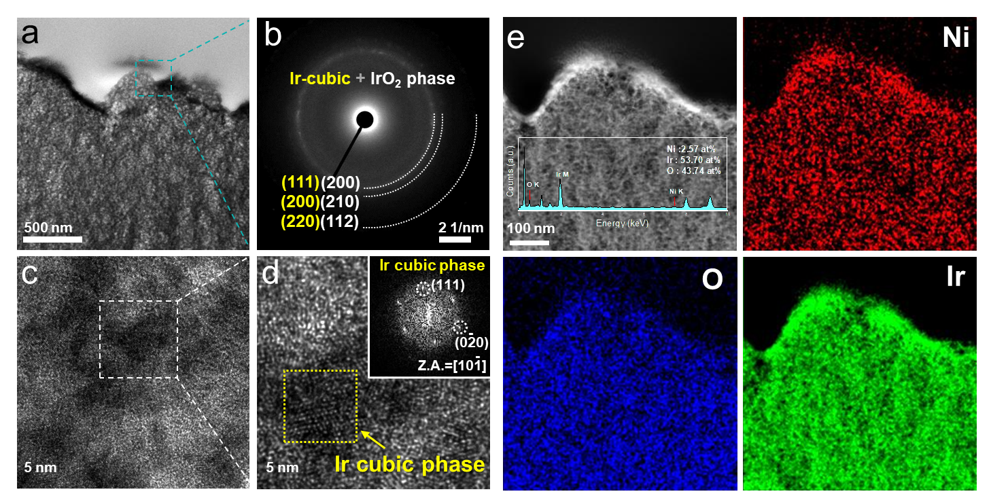

Supplementary Figure 11. (a) TEM images of c-Ir(Ni) after 100 h OER at 300mAcm⁻². (b) SADP of c-Ir(Ni) after 100 h OER at 300mAcm⁻².. (c, d) HR-TEM images of c-Ir(Ni) after 100 h OER at 300mAcm⁻² revealing a cubic Ir phase. (e) STEM-EDX mapping images of the post-OER c-Ir(Ni) for Ni, Ir, and O, respectively. The inset shows quantitative elemental analysis for SEM-EDX spectra.

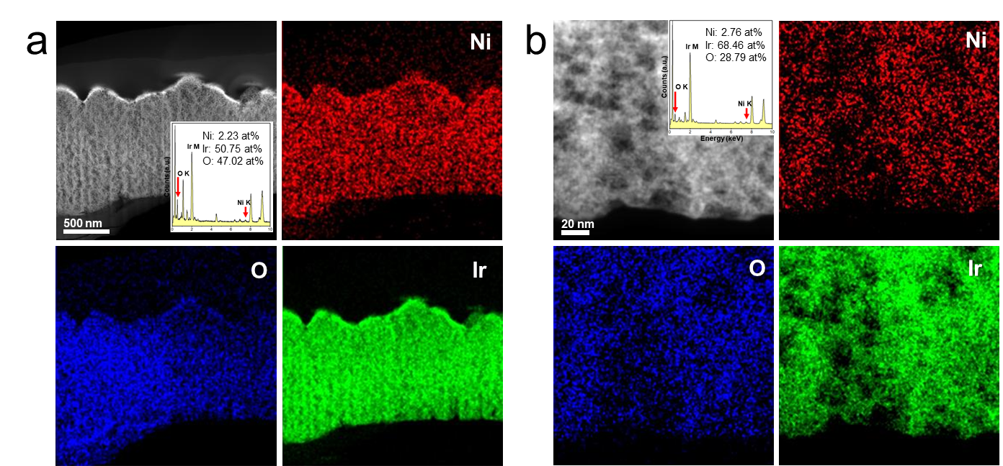
Supplementary Figure 12. (a, b) Dark field-STEM image of post-OER c-Ir(Ni). The inset shows quantitative elemental analysis for STEM-EDX spectra. STEM-EDX mapping images of c-Ir(Ni) for Ni, O, and Ir.

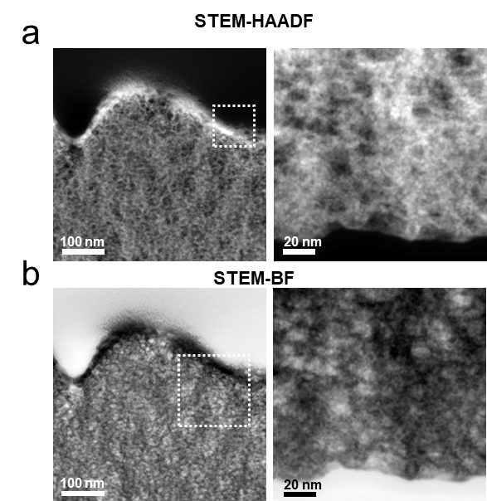
Supplementary Figure 13. (a) High angle annular dark field and (b) bright field cross sectional STEM images of post-OER c-Ir(Ni).

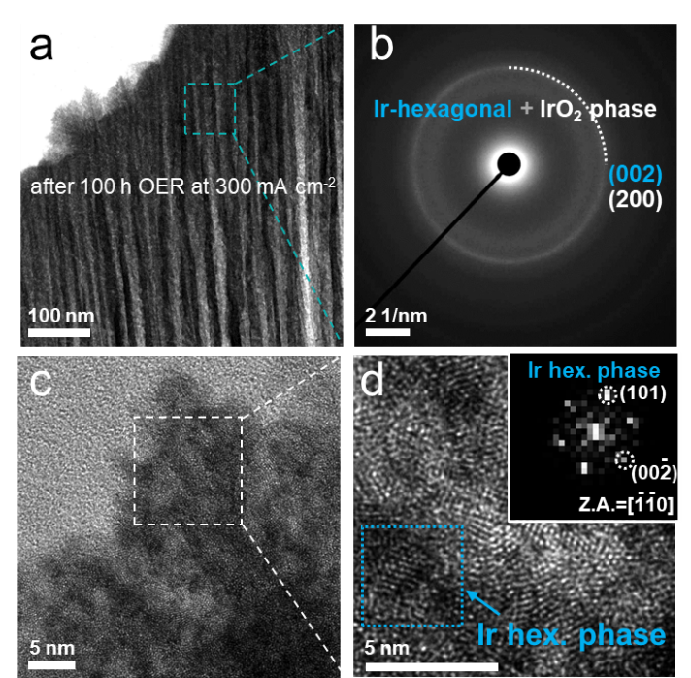
Supplementary Figure 14. (a) TEM images of h-Ir(Ni,Re) after 100 h OER at 300mAcm⁻². (b) SADP of h-Ir(Ni,Re) after 100 h OER at 300mAcm⁻². (c, d) HR-TEM images of h-Ir(Ni,Re) after 100 h OER at 300mAcm⁻² revealing a hexagonal Ir phase.
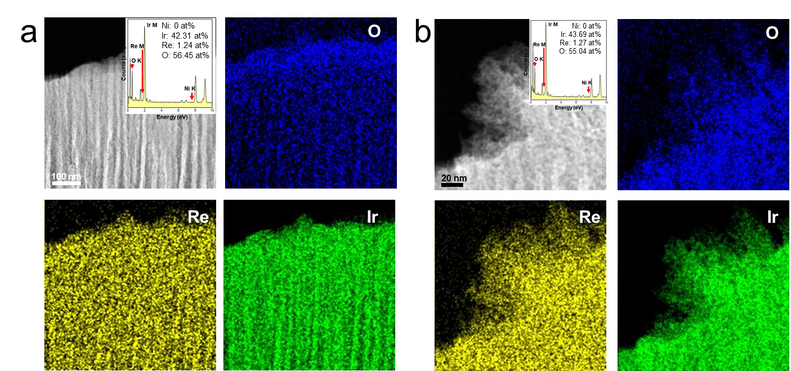
Supplementary Figure 15. (a, b) Dark field-STEM image of post-OER h-Ir(Ni,Re). The inset shows quantitative elemental analysis for STEM-EDX spectra. STEM-EDX mapping images of post-OER h-Ir(Ni,Re) for O, Re and Ir.
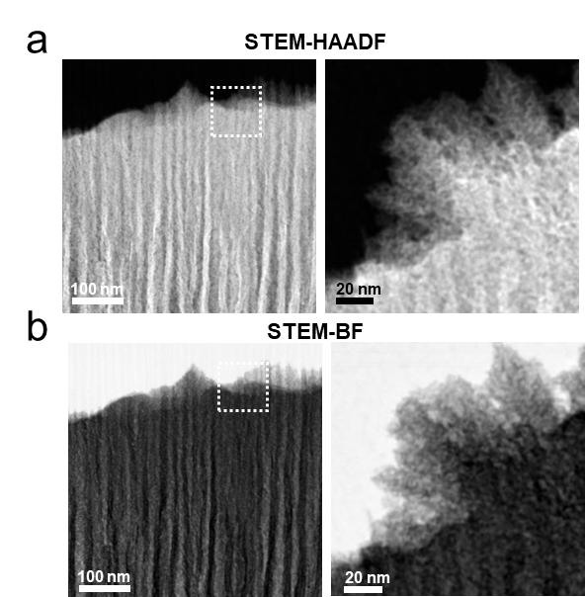
Supplementary Figure 16. (a) High angle annular dark field and (b) bright field cross sectional STEM images of post-OER h-Ir(Ni,Re).
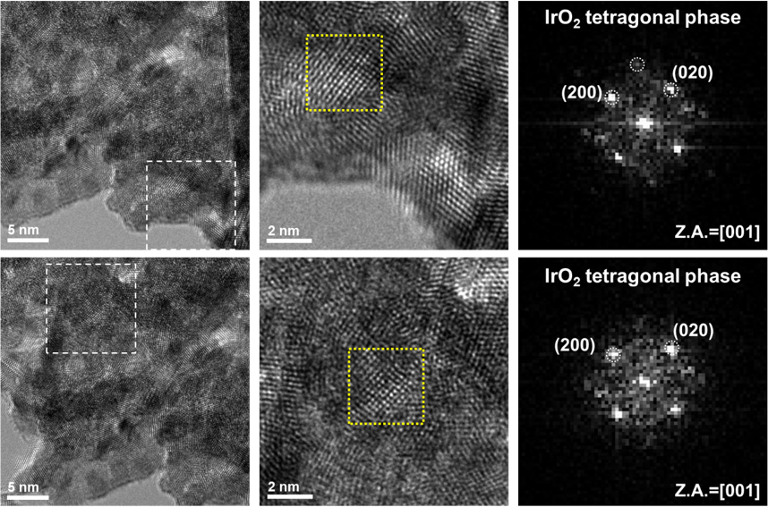
Supplementary Figure 17. HR-TEM images of h-Ir(Ni,Re) after 100 h OER at 300 mA cm⁻² showing the IrO₂ tetragonal phase is persistent.

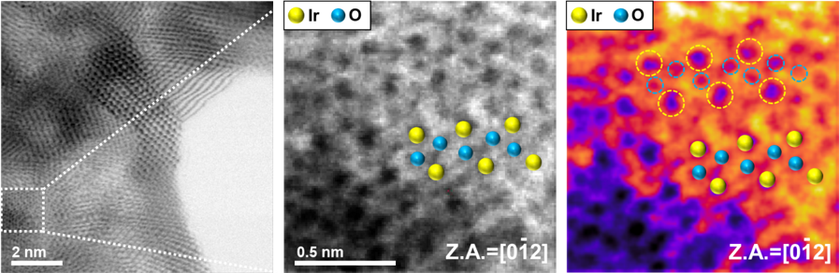
Supplementary Figure 18. Atomic-scale ABF-STEM image of IrO_{x} phase in h-Ir (Ni, Re) after surface reconstruction.

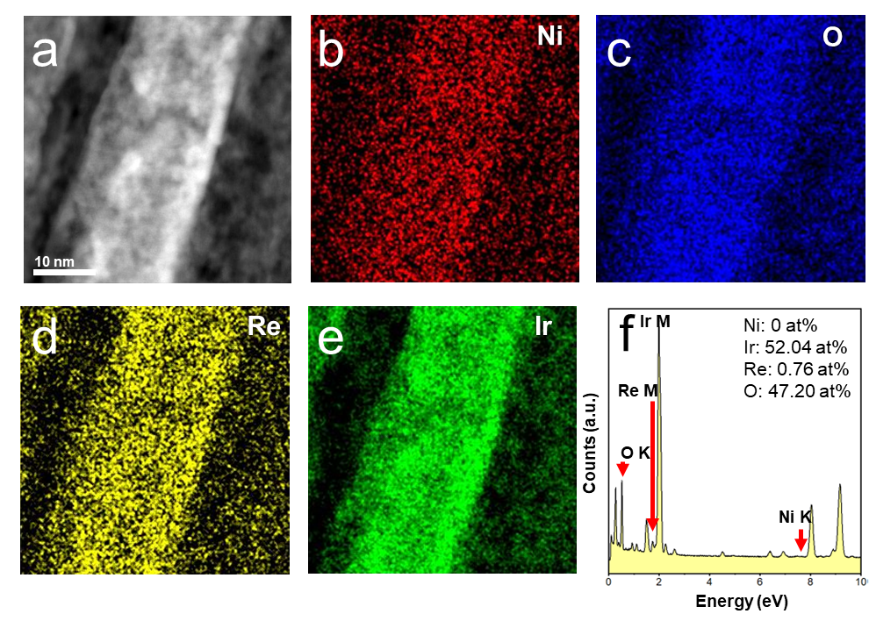
Supplementary Figure 19. (a) Dark field-STEM image of one-dimensional rod-like grains of post-OER h-Ir(Ni,Re). STEM-EDX mapping images of post-OER h-Ir(Ni,Re) for (b) Ni, (c) O, (d) Re and (e) Ir. (f) Quantitative elemental analysis for SEM-EDX spectra.

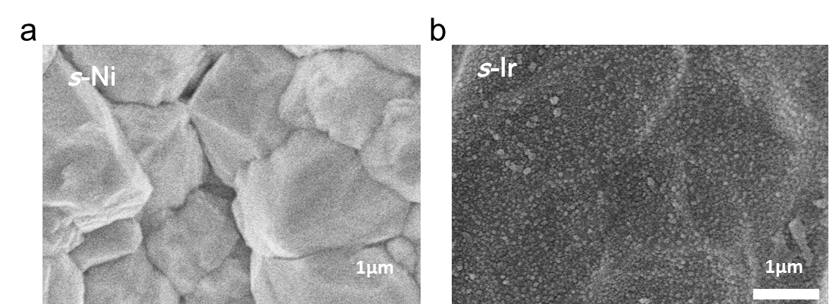
Supplementary Figure 20. Morphology of self-standing (a) s-Ni and (b) s-Ir.
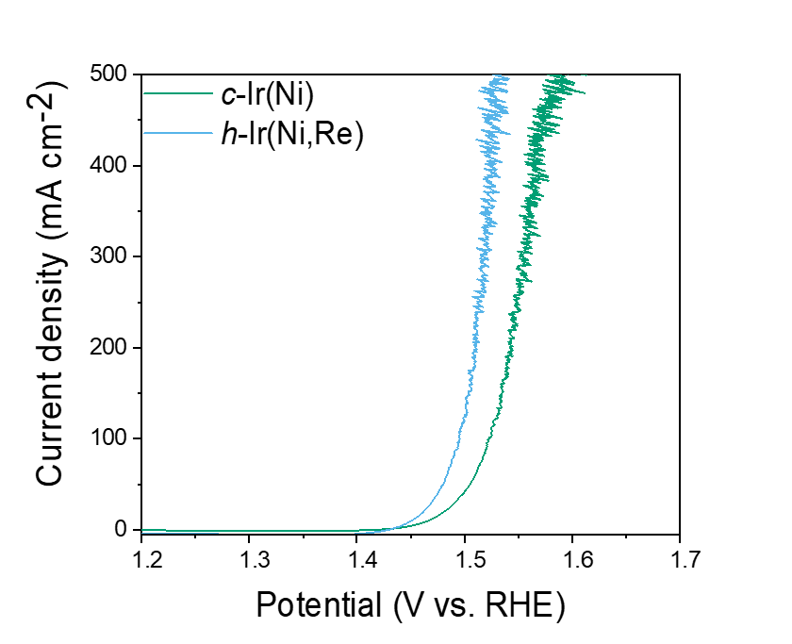
Supplementary Figure 21. The OER polarization curves for catalysts over a wide voltage range.
Supplementary Figure 22. Tafel plots of c-Ir(Ni) and h-Ir(Ni,Re) before and after OER.
Supplementary Figure 23. Nyquist plots (Z´ vs -Z´´) of c-Ir(Ni), h-Ir(Ni,Re), and s-Ir.
Supplementary Figure 24. Current density difference at a middle of potential in cyclic voltammetry curves (Fig. S23), where the slope is proportional to a double layer capacitance.

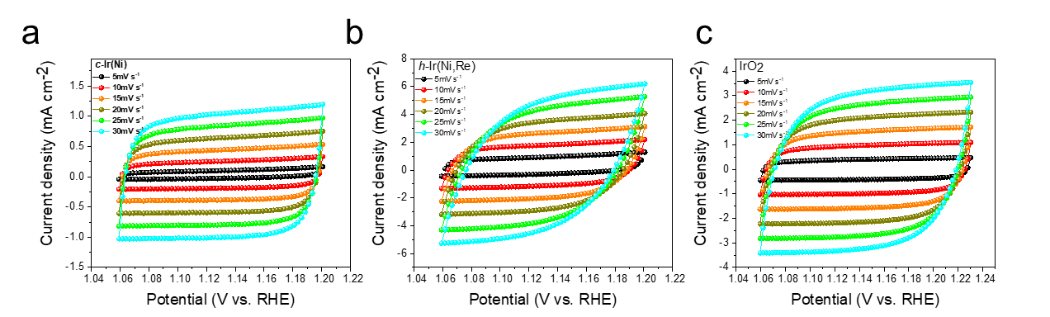
Supplementary Figure 25. CV Scans for calculating C_{dl} of (a-c) c-Ir(Ni), h-Ir(Ni) and IrO₂ , respectively, measured at the scan rates of 5, 10, 15, 20, 25 and 30 mV s⁻¹.

Supplementary Figure 26. Comparison of turn over frequency for h-Ir(Ni,Re), c-Ir(Ni), and a benchmark IrO2 catalysts at an overpotential of 250 mV.

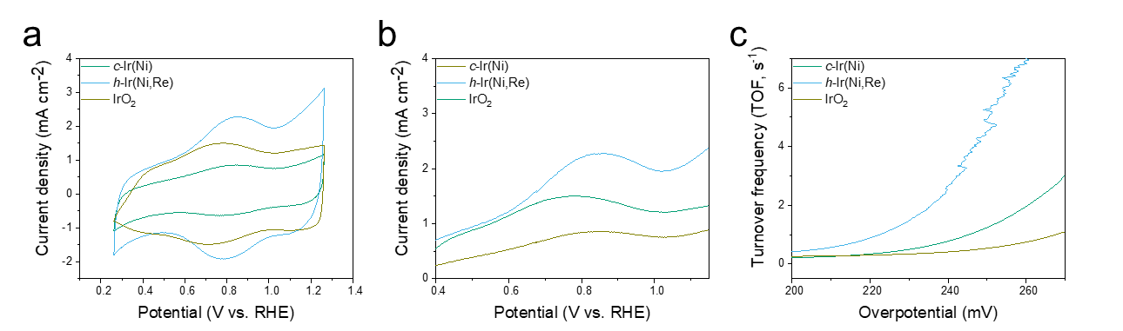
Supplementary Figure 27. (a) CV curves of electrocatalysts where (b) the oxidation peak is employed for area integration to calculate the surface-active sites of electrocatalysts. (c) TOFs of electrocatalysts for acidic OER as a function of overpotential.

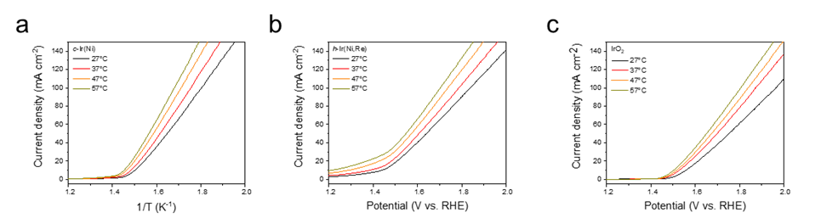
Supplementary Figure 28. OER polarization curves measured at various temperatures for (a) c-Ir(Ni), (b) h-Ir(Ni,Re) and (c) IrO_{2 ,}respectively.

Supplementary Figure 29. Activation energy for the acidic OER at an overpotential of 250 Mv.

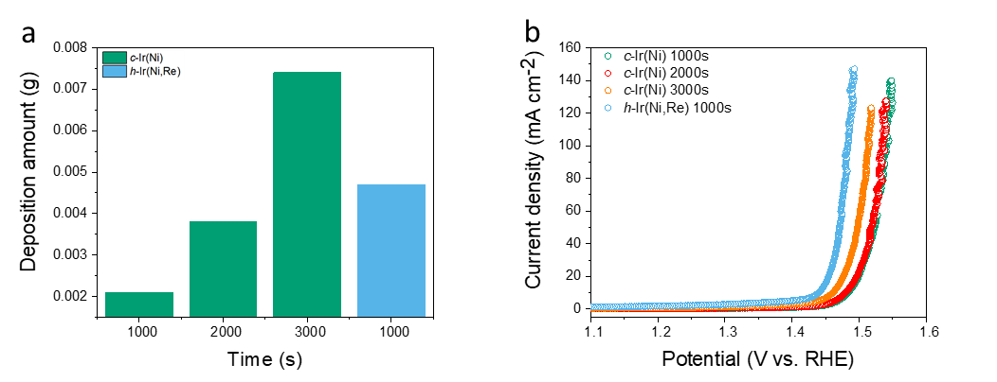
Supplementary Figure 30. (a) Mass variations of c-Ir(Ni) and h-Ir(Ni,Re) after different electrodeposition times. (b) Comparison of OER performance of the samples prepared with different deposition time.

Supplementary Figure 31. Faradaic efficient of h-Ir(Ni,Re) calculated by measuring evolved O₂ gas amounts during OER using gas-chromatography.

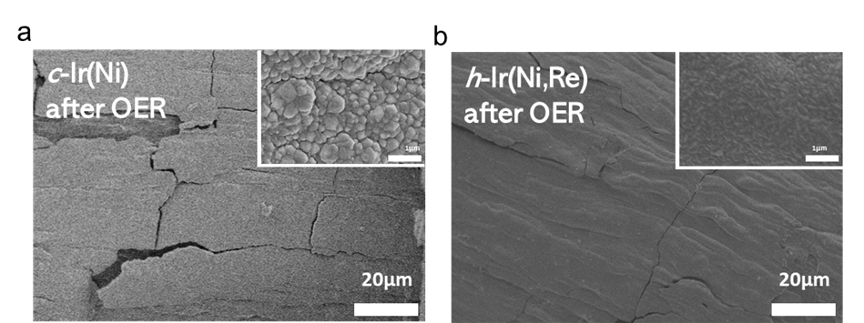
Supplementary Figure 32. FE-SEM images of (a) c-Ir(Ni) and (b) h-Ir(Ni,Re) after OER (CP at 300 mA cm⁻² for 100 hrs).

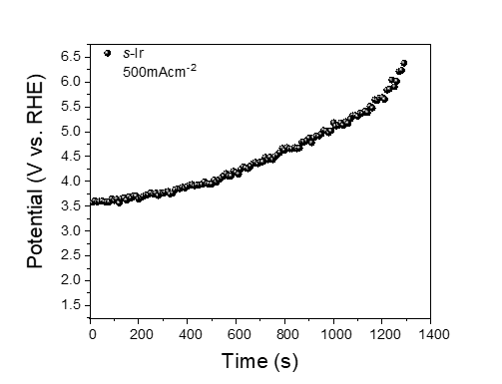
Supplementary Figure 33. Chronopotentiometry of s-Ir at 500mAcm⁻² (without IR-compensation).
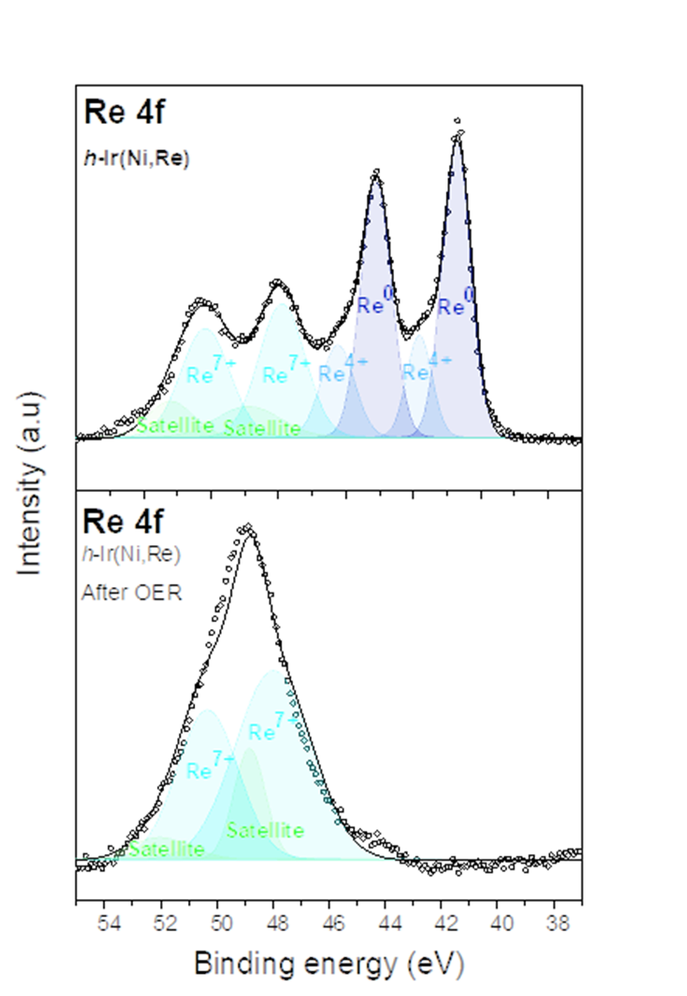
Supplementary Figure 34. Re 4f XPS spectra of h-Ir(Ni,Re) and post-OER h-Ir(Ni,Re) in acidic electrolyte.

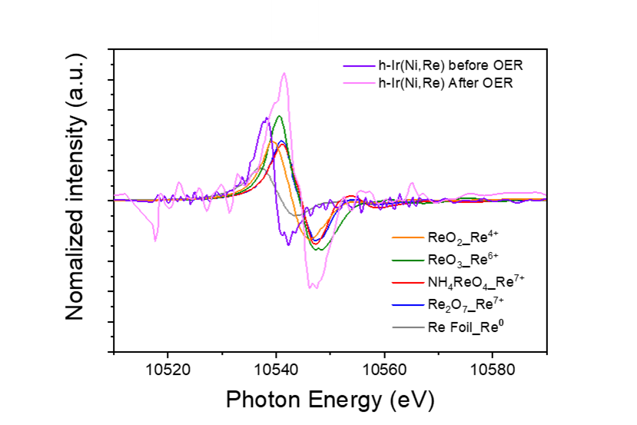
Supplementary Figure 35. The first derivative XANES spectra of Re L₃-edges.
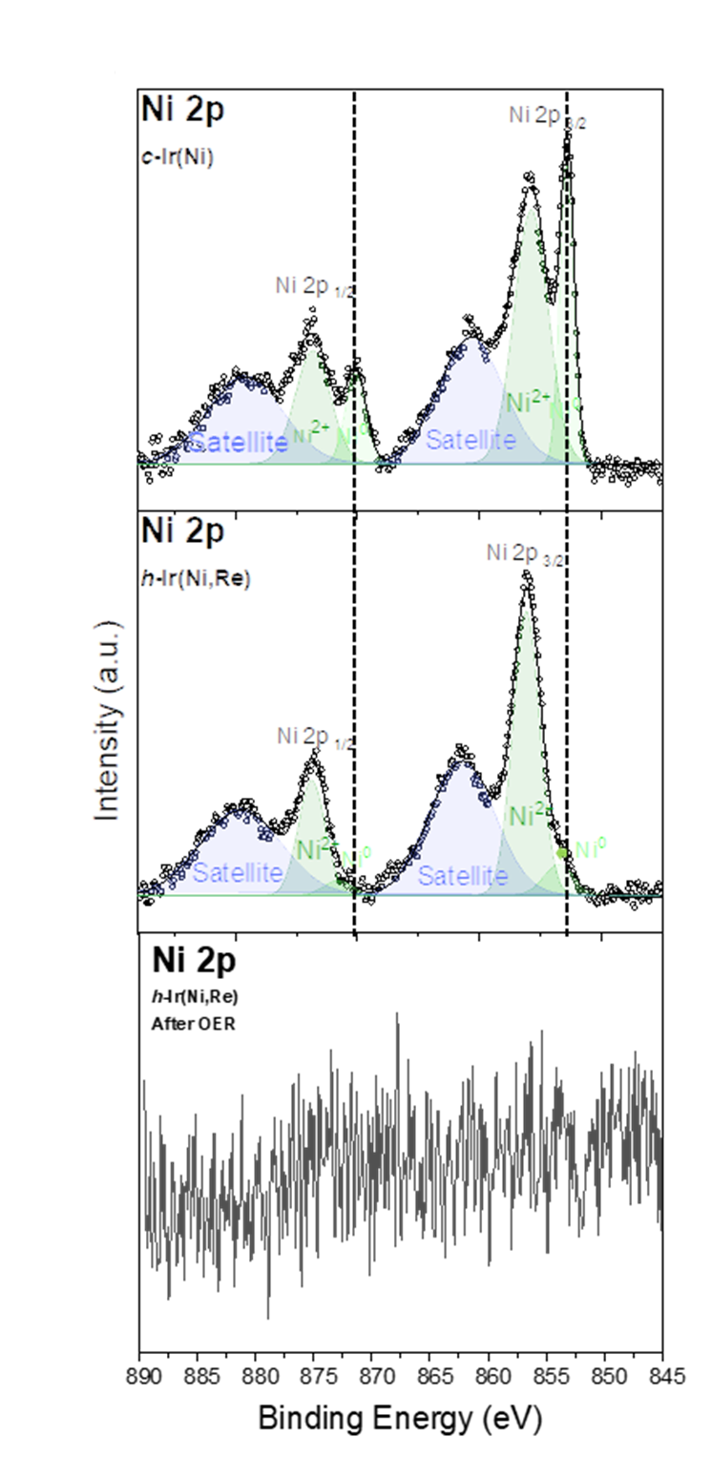
Supplementary Figure 36. Ni 2p XPS spectra of c-Ir(Ni) , h-Ir(Ni,Re) and post-OER h-Ir(Ni,Re) in acidic electrolyte.
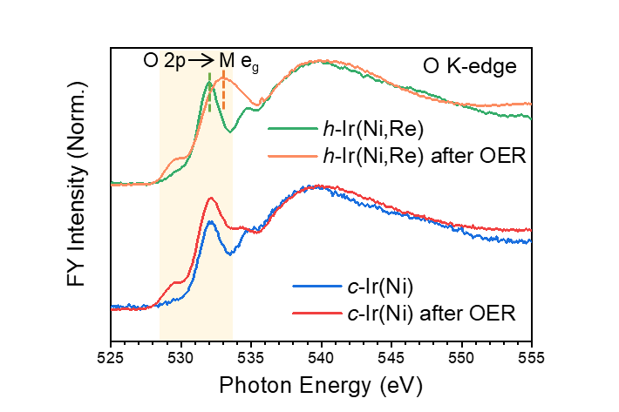
Supplementary Figure 37. XANES spectra of O K-edge for c-Ir(Ni), post-OER c-Ir(Ni), h-Ir(Ni,Re) and post-OER h-Ir(Ni,Re).

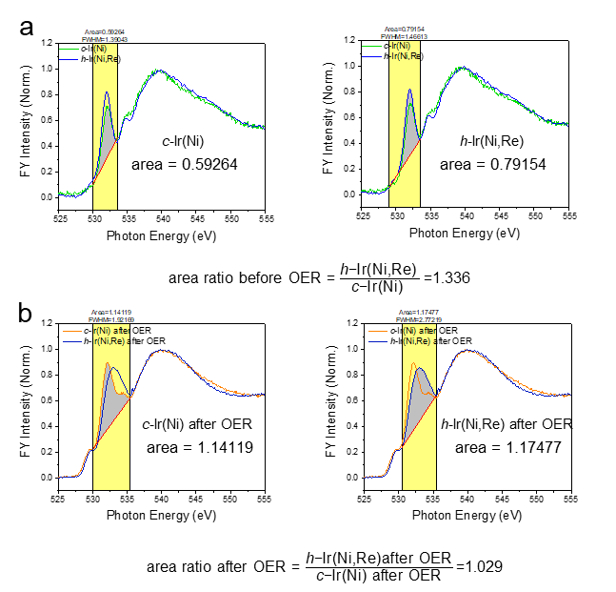
Supplementary Figure 38. XANES spectra of O K-edge for (a) c-Ir(Ni) and h-Ir(Ni,Re), (b) post-OER c-Ir(Ni) and h-Ir(Ni,Re). The marked peak area is related to the O 1s to O 2p – M 5d (528 – 530 eV) transition.

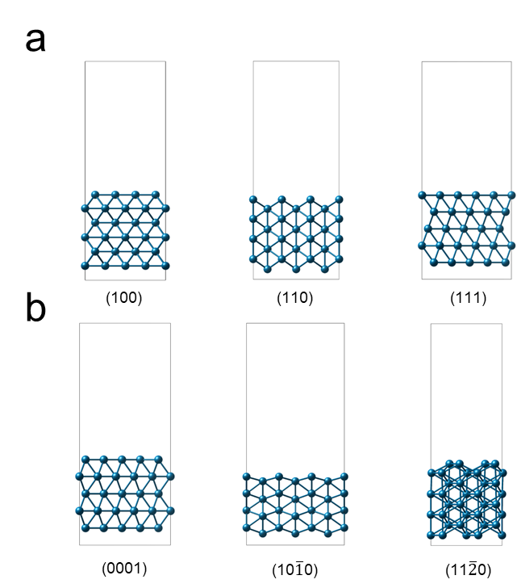
Supplementary Figure 39. Side view of atomic configurations for metallic Ir slab models. (a) (100), (110), and (111) surfaces in the cubic structure. (b) (0001), (101 ̅0), and (112 ̅0) surfaces in the hexagonal structure.

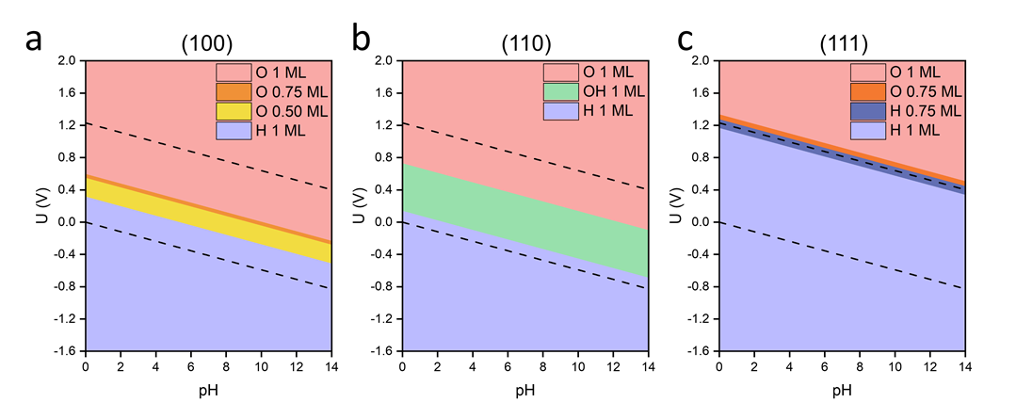
Supplementary Figure 40. Pourbaix diagram for metallic Ir surfaces. (a-c) (100), (110), and (111) surfaces, respectively.

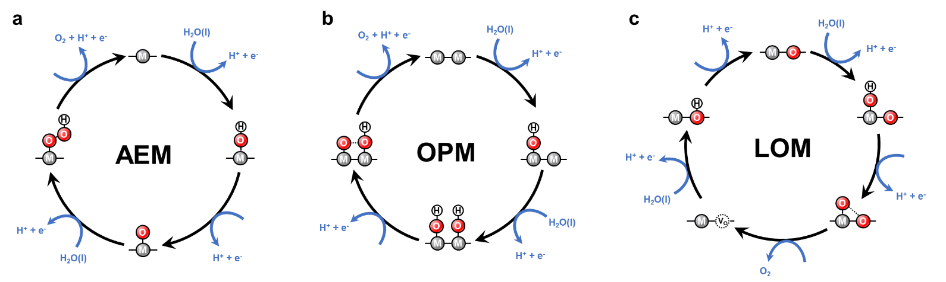
Supplementary Figure 41. Schematic illustration of the different OER reaction pathway, including (a-c) AEM, OPM and LOM, respectively.

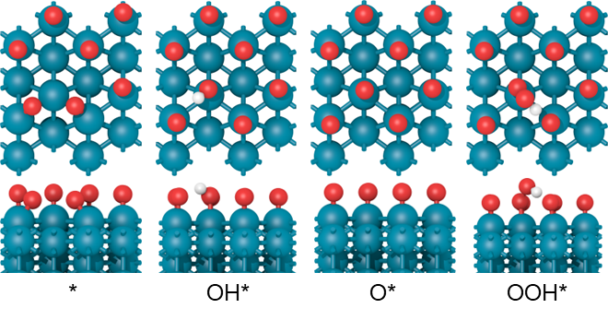
Supplementary Figure 42. Atomic configurations of OER intermediates adsorbed on Ir (11$\overline{2}$0) surface following AEM. The cyan, red, and white balls represent Ir, O, and H atoms, respectively.

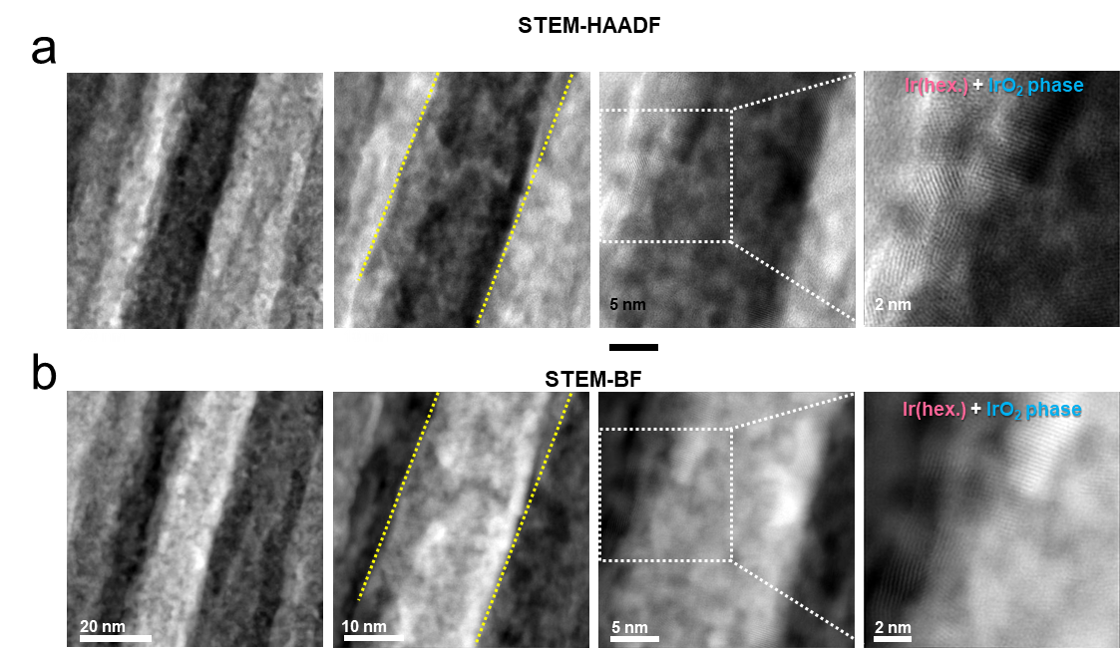
Supplementary Figure 43. (a) High angle annular dark field-STEM and (b) bright field-STEM images for the post-OER h-Ir(Ni,Re).

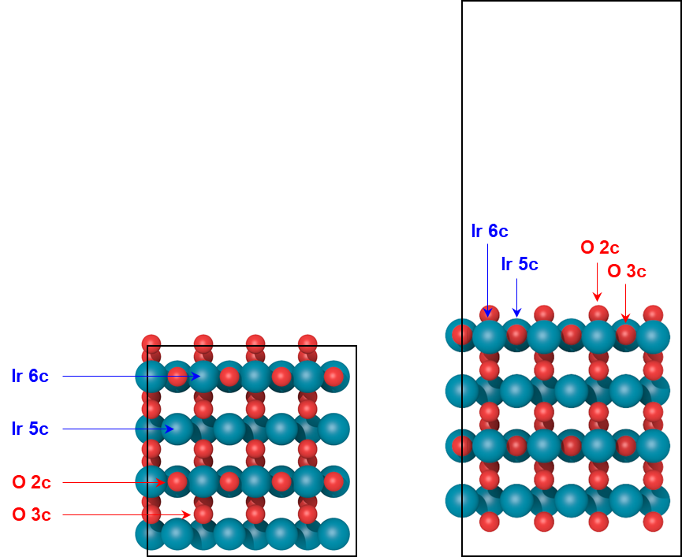
Supplementary Figure 44. Top view and side view of optimized IrO₂ (110) structure. Color codes are the same as those in Figure S42.

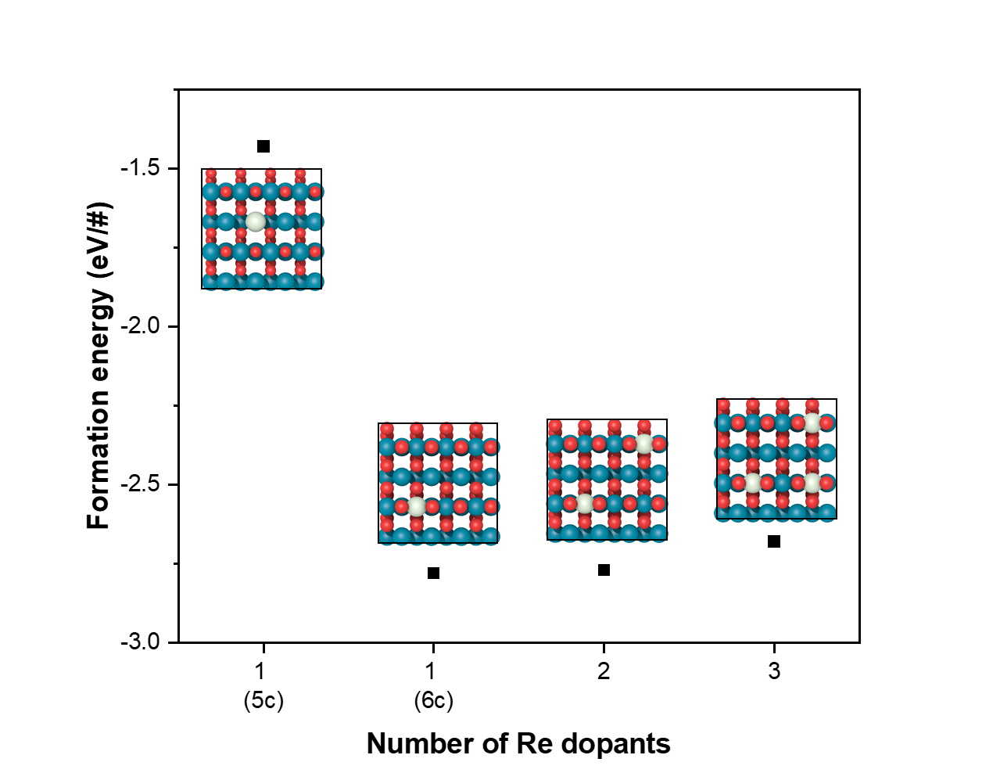
Supplementary Figure 45. Re doping formation energy. Color codes are the same as those in Figure S42. The aquamarine ball represents Re atom.

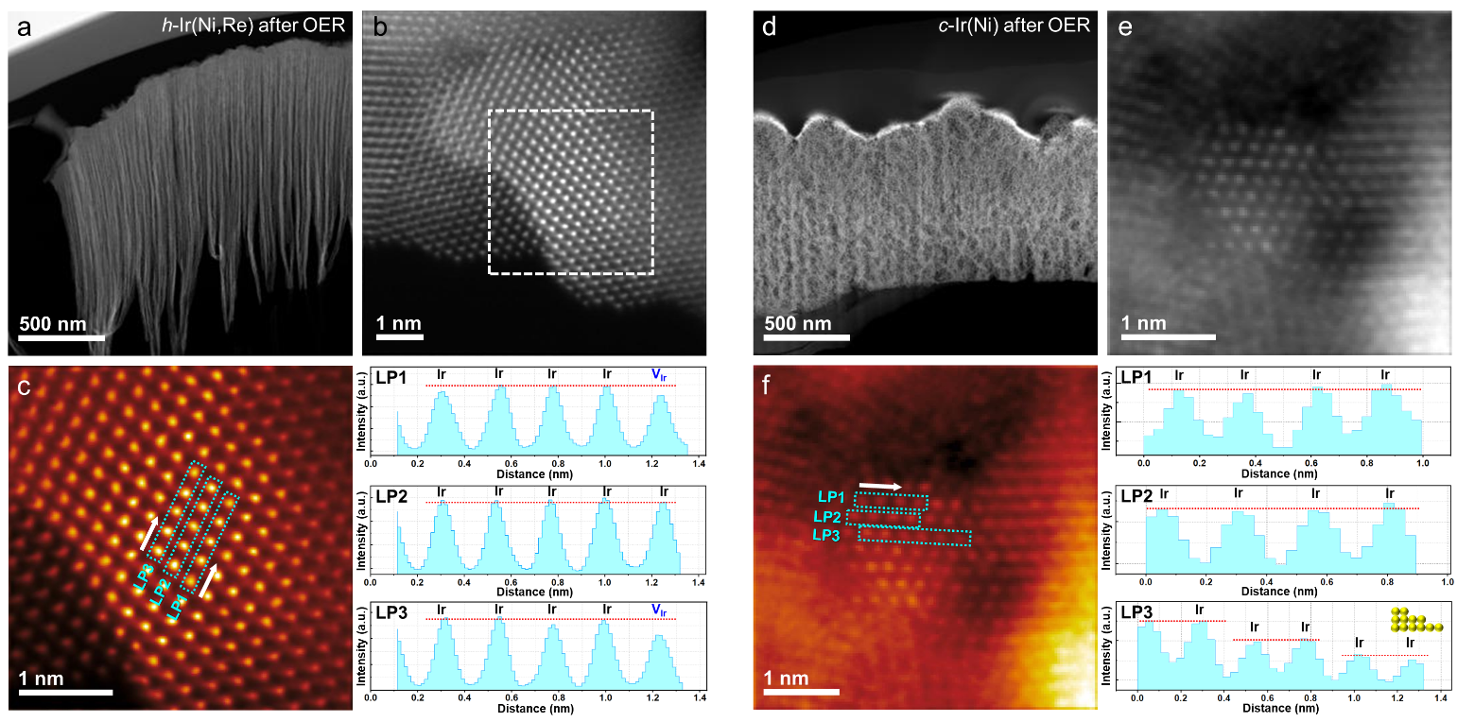
Supplementary Figure 46. Cross-sectional HAADF-STEM image of post-OER h-Ir(Ni,Re). (a) low-magnification HAADF-STEM, (b) high-resolution HAADF-STEM image with viewed along the [010]-zone axis and (c) enlarged HAADF-STEM image with line profiles for Ir atomic intensity at marked regions in (c). The cross-sectional HAADF-STEM image of post-OER c-Ir(Ni). (d) low-magnification HAADF-STEM, (e) high-resolution HAADF-STEM image with viewed along the [010]-zone axis and (f) enlarged HAADF-STEM image with line profiles for Ir atomic intensity at marked regions in (f).

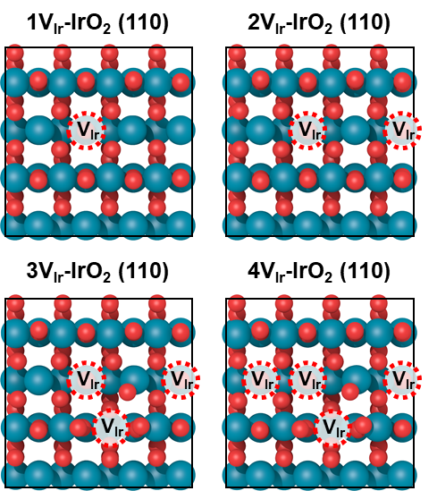
Supplementary Figure 47. Optimized atomic configurations of IrO₂ (110) with Ir vacancies. Color codes are the same as those in Figure S42.
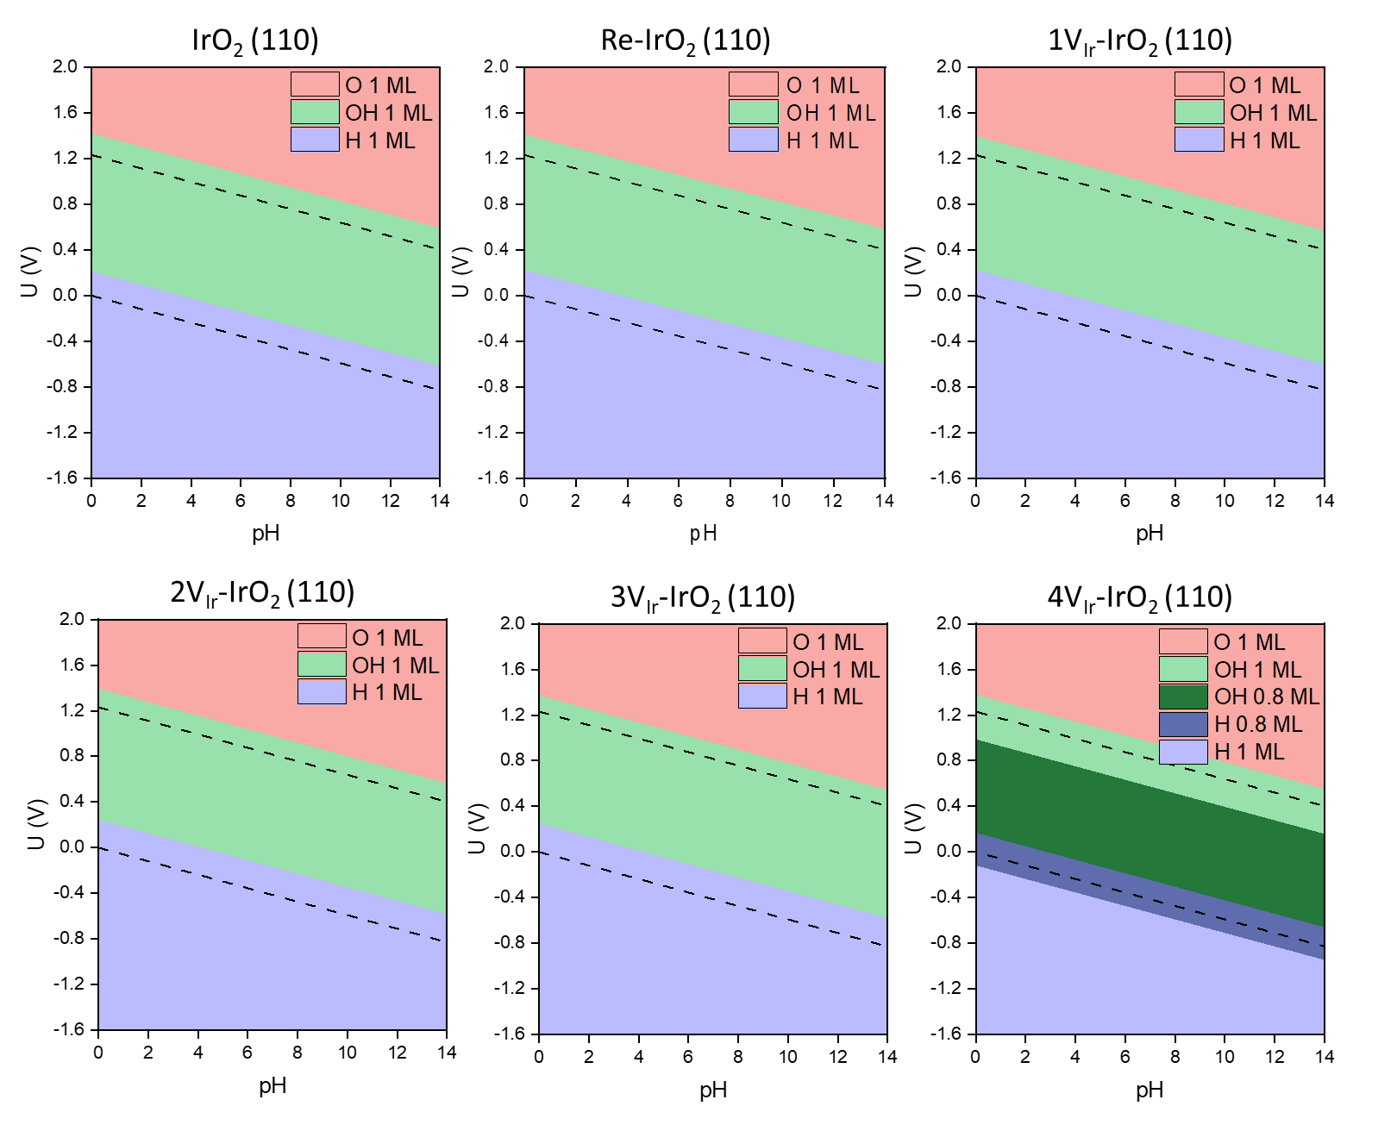
Supplementary Figure 48. Pourbaix diagram of IrO₂ (110) surfaces.
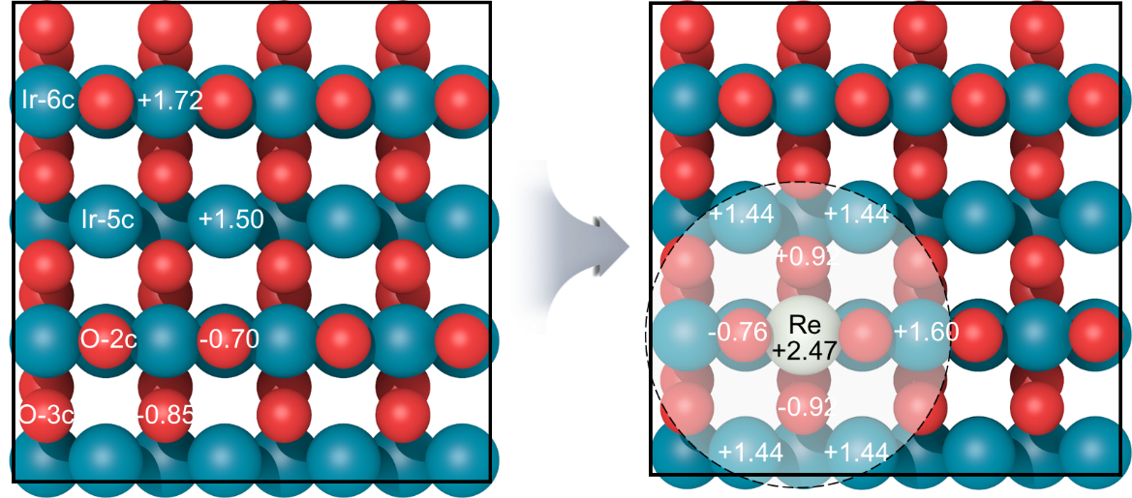
Supplementary Figure 49. Bader charge analysis for IrO₂ (110) and Re-IrO₂ (110) surfaces. The cyan, red, and aquamarine balls represent Ir, O, and Re atoms, respectively.
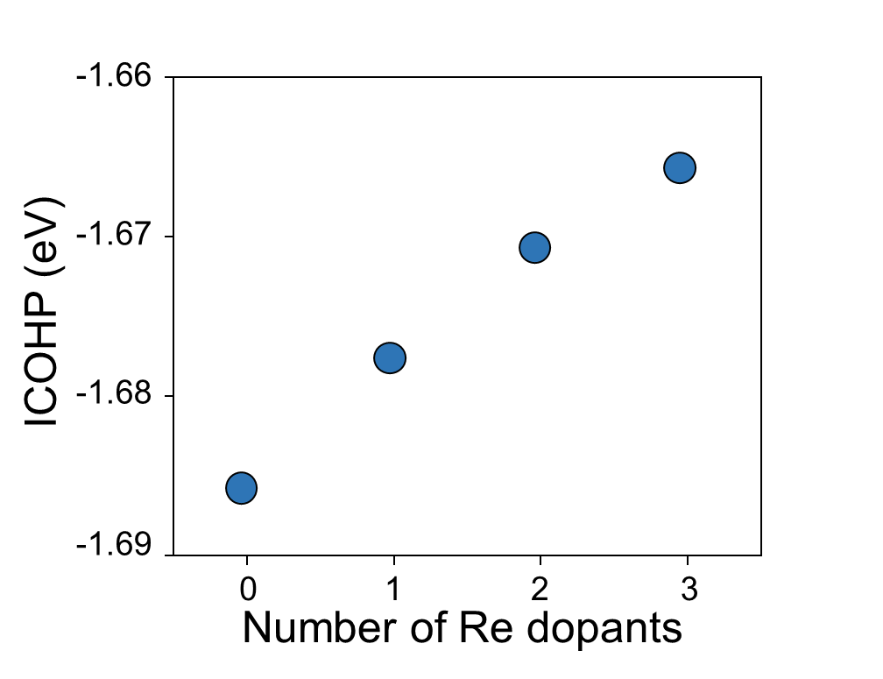
Supplementary Figure 50. The integrated crystal orbital Hamilton population (ICOHP) of IrO₂ (110) surfaces.
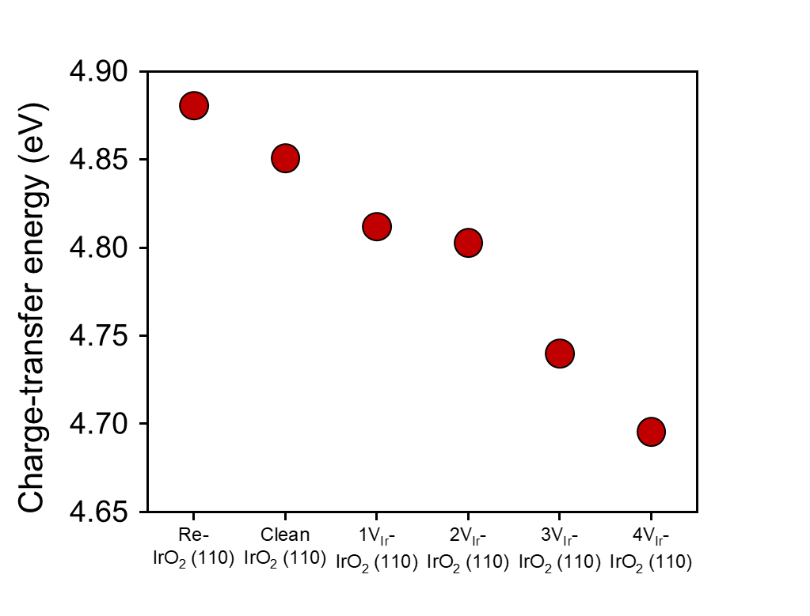
Supplementary Figure 51. Calculated charge-transfer energies of IrO₂ (110) surfaces.
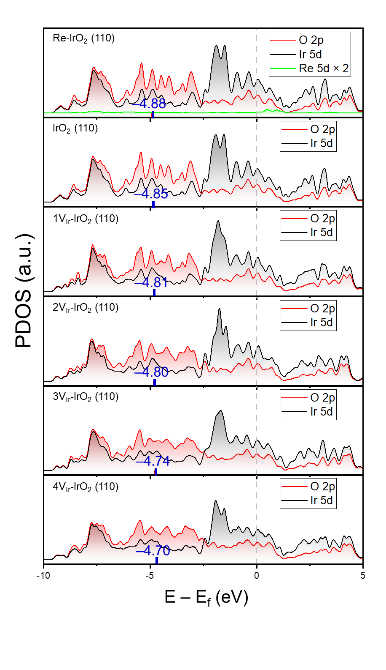
Supplementary Figure 52. Projected density of states (PDOS) of O 2p, Ir 5d, and Re 5d for IrO₂ (110) surfaces. The gray dashed line represents the Fermi level, and the vertical bold-red line indicates the O 2p-band center.

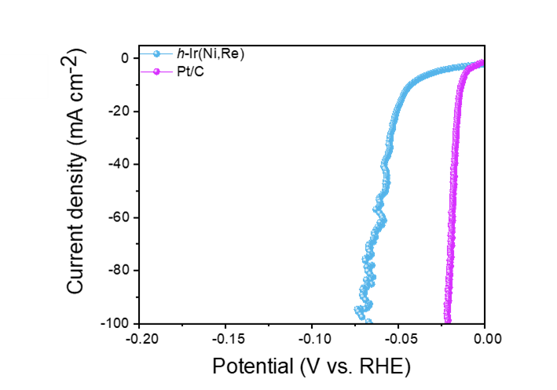
Supplementary Figure 53. LSV polarization curve of h-Ir(Ni,Re) and Pt/C for HER using a scan rate of 5 mV s⁻¹ in 0.1 M HClO₄.
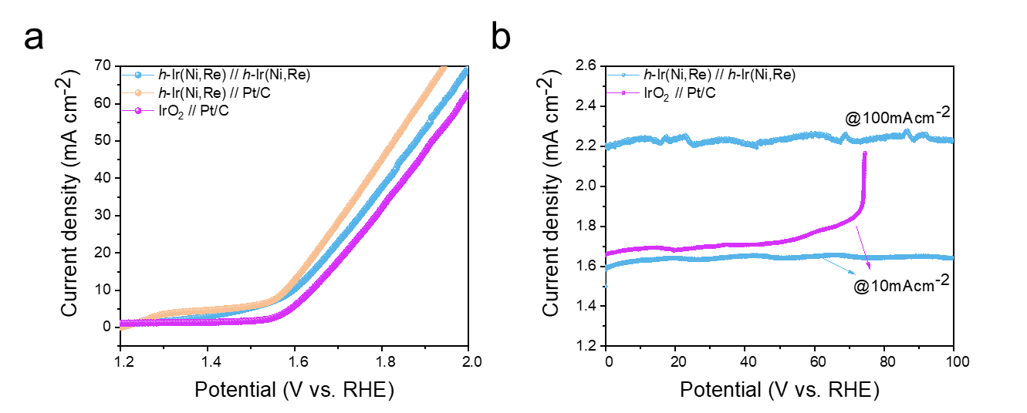
Supplementary Figure 54. (a) Two-electrode polarization and (b) chronopotentiometry curves for
overall water splitting measured in 0.1 M HClO₄.

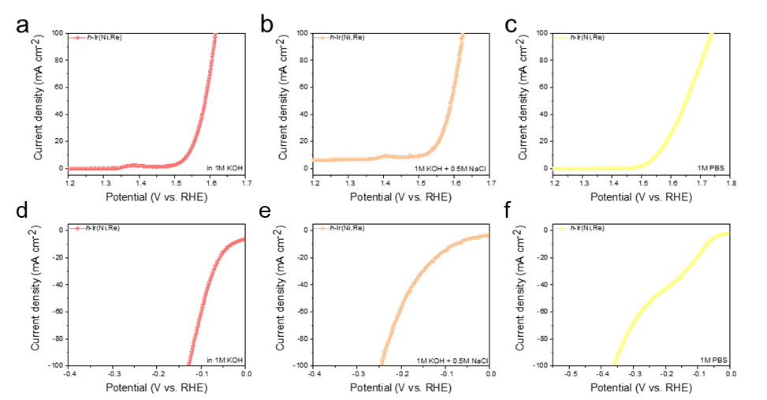
Supplementary Figure 55. LSV polarization curves of h-Ir(Ni,Re) for OER and HER in (a, d) 1M KOH, (b, e), 1M KOH + 0.5M NaCl and (c, f) 1M PBS electrolytes using a scan rate of 5 mV s⁻¹.

Table S1. Calculated lattice constant and cohesive energy of metal Ir, consistent with prior studies.
Method | Structure | Lattice constant |  | |E_{coh}| (eV/atom) | Reference
Method | Structure | a₀ (Å) | c(Å) | |E_{coh}| (eV/atom) | Reference
GGA | cubic | 3.87 | - | 7.35 | This work
GGA | hexagonal | 2.75 | 4.47 | 7.28 | This work
LDA | cubic | 3.85 | - | 9.35 | ²³
LDA | cubic | 3.86 | - | - | ²⁴
LDA | cubic | 3.81 | - | 10.31 | ²⁵
Exp. | cubic | 3.84 | - | - | ²⁶
Exp. | cubic | 3.84 | - | - | ²⁷
Exp. | cubic | - | - | 6.94 | ²⁸
Exp. | cubic | 3.83 | - | - | ²⁹

Table S2. Elemental compositions (at%) of Ir, Ni, and Re in c-Ir(Ni) and h-Ir(Ni,Re) before and after OER.
Samples | Ir (At%) | Ni (At%) | Re (At%)
c-Ir(Ni) | 16.6 | 83.4 | N.A
c-Ir(Ni) after OER | 99.3 | 0.7 | N.A
h-Ir(Ni,Re) | 13.47 | 81.14 | 5.39
h-Ir(Ni,Re) after OER | 99 | 0.3 | 0.7

Table S3. Crystallographic information on experimental d-spacing and degree to spot #1 from the FFT pattern corresponding to the HR-TEM micrographs.

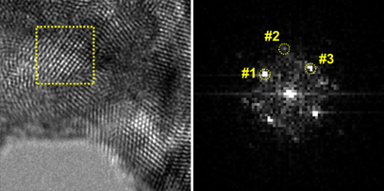 | Spot# | d-value (nm) | Degree to Spot #1
 | #1 | 2.219 | 0.00
 | #2 | 1.620 | 44.6
 | #3 | 2.234 | 89.1

Table S4. Theoretical crystallographic data for IrO₂ phase, Ir-hexagonal phase and Ir-cubic phase.
Name: IrO₂ phase  Crystal system: Tetragonal  Space group: P 42/mnm |  | Name: Ir phase  Crystal system: Hexagonal  Space group: P 63/mmc |  | Name: Ir phase  Crystal system: Cubic  Space group: Fm-3m
h k l | d-value (Å) | h k l | d-value (Å) | h k l | d-value (Å)
110 | 3.186 | 100 | 2.38 | 111 | 2.241
101 | 2.586 | 002 | 2.23 | 200 | 1.940
200 | 2.253 | 101 | 2.10 | 220 | 1.372
111 | 2.243 | 102 | 1.63 | 311 | 1.170
210 | 2.015 | 110 | 1.38 | 222 | 1.120
211 | 1.699 | 103 | 1.26
220 | 1.593
002 | 1.579
310 | 1.425

Table S5. Comparison of OER activity of h-Ir(Ni,Re) with previously reported catalysts under an acidic environment.
Samples | Overpotential(mV)  @10mAcm⁻² | Stability@10mAcm⁻²  (S-number) | Electrolyte | References
h-Ir(Ni,Re) | 210 | 475h@500mAcm⁻²  (3.47 x 10⁵) | 0.1M HClO₄ | This work
SrIrO₃ | 243 | 20h  (6 x 10³) | 0.05M H₂SO₄ | ³⁰
Lu_{1.25}IrO_{x}OH_{y} | 295 | 11h  1 x 10⁵ | 0.1M HClO₄ | ³¹
DNP-IrNi | 248 | 50h | 0.5M H₂SO₄ | ³²
IrOx-50- AC/Ti | 256 | 190h  (2.3 x 10⁵) | 0.1M HClO₄ | ³³
SZIO | 240 | 30h | 0.1M HClO₄ | ³⁴
INC-50 | 285 | 5.55h | 0.1M HClO₄ | ³⁵
Ir-doped WO₃ | 258 | 12h@100mAcm⁻² | 0.5M H₂SO₄ | ³⁶
IrO₂/GCN | 276 | 4h@20mAcm⁻² | 0.5M H₂SO₄ | ³⁷
W-Ir-B | 300 | 120h@100mAcm⁻²  2.49 x 10⁵ | 0.5M H₂SO₄ | ³⁸
IrO2 NN-L | 313 | 2h | 1M H₂SO₄ | ³⁹
Li-IrO_{x} | 290 | 70h | 0.1M HClO₄ | ⁴⁰
Ir@WO_{3-x}(H₂) | 280 | 110h | 0.5M H₂SO₄ | ⁴¹
Ag₁/IrOx SAC | 224 | 50h | 0.5M H₂SO₄ | ⁴²
Ir-Co₃O₄ | 236 | 30h | 0.5M H₂SO₄ | ⁴³
Ir/CuTiONx/C | 280 | N.A  (7.8 x 10⁴) | 0.1M HClO₄ | ⁴⁴
La3IrO7-SLD | 296 | 16.67 | 0.1M HClO₄ | ⁴⁵
PN-IN frame/C | 308 | 5h | 0.1M HClO₄ | ⁴⁶
α-H_{x}IrO₃ | 245 | 12h | 0.5M H₂SO₄ | ⁴⁷
IrO₂@TaB₂ | 288 | 130h  (5.2 x 10⁴) | 0.1M HClO₄ | ⁴⁸
3D Ir superstructure | 270 | 8h | 0.1M HClO₄ | ⁴⁹
SrIr₂O₆ | 303 | 300h | 0.1M HClO₄ | ⁵⁰
UF-Ir/IrO_{x} | 299 | 200h | 0.5M H₂SO₄ | ⁴⁹

Table S6. Changes in overpotential over time for c-Ir(Ni), h-Ir(Ni,Re) and IrO₂ in Figure 2d.
Samples | Stability  (@ current density) | Initial overpotential (V) | Final overpotential (V)
c-Ir(Ni) | 100h (@300mAcm⁻²) | 1.33  (without iR correction) | 1.29  (without iR correction)
c-Ir(Ni) | 92h (@500 mAcm⁻²) | 2.00  (without iR correction) | 2.71  (without iR correction)
h-Ir(Ni,Re) | 100h (@300mAcm⁻²) | 1.21  (without iR correction) | 1.14  (without iR correction)
h-Ir(Ni,Re) | 475h (@500mAcm⁻²) | 1.91  (without iR correction) | 1.91  (without iR correction)
IrO₂ | 46h (@10mAcm⁻²) | 0.300  (with iR correction) | 0.89  (with iR correction)

Table S7. XPS results of the c-Ir(Ni), c-Ir(Ni) after OER, h-Ir(Ni,Re), h-Ir(Ni,Re) after OER samples. Peaks are calibrated with reference of carbon 1s.
Samples |  | Position (eV) | Area (a.u.) | Atomic percentage (%)
Ni⁰ 2p_{3/2}  (eV)/(at.%) | c-Ir(Ni) | 852.76 | 1103.28 | 12.17
Ni⁰ 2p_{3/2}  (eV)/(at.%) | h-Ir(Ni,Re) | 853.39 | 278.31 | 3.36
Ni⁰ 2p_{3/2}  (eV)/(at.%) | h-Ir(Ni,Re)  after OER | N.A | N.A | N.A
Ni²⁺ 2p_{3/2}  (eV)/(at.%) | c-Ir(Ni) | 855.67 | 2357.85 | 26.00
Ni²⁺ 2p_{3/2}  (eV)/(at.%) | h-Ir(Ni,Re) | 856.07 | 2264.25 | 27.32
Ni²⁺ 2p_{3/2}  (eV)/(at.%) | h-Ir(Ni,Re)  after OER | N.A | N.A | N.A
Ni 2p_{3/2}  satellite  (eV)/(at.%) | c-Ir(Ni) | 860.68 | 2250.60 | 24.82
Ni 2p_{3/2}  satellite  (eV)/(at.%) | h-Ir(Ni,Re) | 861.37 | 2627.78 | 31.70
Ni 2p_{3/2}  satellite  (eV)/(at.%) | h-Ir(Ni,Re)  after OER | N.A | N.A | N.A
Ni⁰ 2p_{1/2}  (eV)/(at.%) | c-Ir(Ni) | 870.11 | 491.51 | 5.42
Ni⁰ 2p_{1/2}  (eV)/(at.%) | h-Ir(Ni,Re) | 871.53 | 121.66 | 1.47
Ni⁰ 2p_{1/2}  (eV)/(at.%) | h-Ir(Ni,Re)  after OER | N.A | N.A | N.A
Ni²⁺ 2p_{1/2}  (eV)/(at.%) | c-Ir(Ni) | 873.60 | 1076.45 | 11.87
Ni²⁺ 2p_{1/2}  (eV)/(at.%) | h-Ir(Ni,Re) | 873.69 | 915.96 | 11.05
Ni²⁺ 2p_{1/2}  (eV)/(at.%) | h-Ir(Ni,Re)  after OER | N.A | N.A | N.A
Ni 2p_{1/2}  satellite  (eV)/(at.%) | c-Ir(Ni) | 879.22 | 1788.86 | 19.73
Ni 2p_{1/2}  satellite  (eV)/(at.%) | h-Ir(Ni,Re) | 879.55 | 2081.14 | 25.11
Ni 2p_{1/2}  satellite  (eV)/(at.%) | h-Ir(Ni,Re)  after OER | N.A | N.A | N.A
Re⁰ 4f_{7/2}  (eV)/(at.%) | h-Ir(Ni,Re) | 40.70 | 6309.37 | 23.0
Re⁰ 4f_{7/2}  (eV)/(at.%) | h-Ir(Ni,Re)  after OER | N.A | N.A | N.A
Re⁴⁺ 4f_{7/2}  (eV)/(at.%) | h-Ir(Ni,Re) | 41.80 | 1910.71 | 7.0
Re⁴⁺ 4f_{7/2}  (eV)/(at.%) | h-Ir(Ni,Re)  after OER | N.A | N.A | N.A
Re⁷⁺ 4f_{7/2}  (eV)/(at.%) | h-Ir(Ni,Re) | 45.86 | 4560.58 | 16.6
Re⁷⁺ 4f_{7/2}  (eV)/(at.%) | h-Ir(Ni,Re)  after OER | 47.93 | 8732.83 | 50.7
Re 4f_{7/2}  Satellite  (eV)/(at.%) | h-Ir(Ni,Re) | 46.86 | 1461.03 | 5.3
Re 4f_{7/2}  Satellite  (eV)/(at.%) | h-Ir(Ni,Re)  after OER | 48.79 | 2123.78 | 12.3
Re⁰ 4f_{5/2}  (eV)/(at.%) | h-Ir(Ni,Re) | 43.07 | 5794.16 | 21.1
Re⁰ 4f_{5/2}  (eV)/(at.%) | h-Ir(Ni,Re)  after OER | N.A | N.A | N.A
Re⁴⁺ 4f_{5/2}  (eV)/(at.%) | h-Ir(Ni,Re) | 44.22 | 2287.70 | 8.3
Re⁴⁺ 4f_{5/2}  (eV)/(at.%) | h-Ir(Ni,Re)  after OER | N.A | N.A | N.A
Re⁷⁺ 4f_{5/2}  (eV)/(at.%) | h-Ir(Ni,Re) | 48.16 | 3913.81 | 14.3
Re⁷⁺ 4f_{5/2}  (eV)/(at.%) | h-Ir(Ni,Re)  after OER | 50.31 | 5557.27 | 32.3
Re 4f_{5/2}  Satellite  (eV)/(at.%) | h-Ir(Ni,Re) | 49.19 | 1208.14 | 4.4
Re 4f_{5/2}  Satellite  (eV)/(at.%) | h-Ir(Ni,Re)  after OER | 52.01 | 801.278 | 4.7
O 1s  O-H  (eV)/(at.%) | c-Ir(Ni) | 529.11 | 10449.11 | 6.4
O 1s  O-H  (eV)/(at.%) | c-Ir(Ni)  after OER | 528.78 | 27052.13 | 13.0
O 1s  O-H  (eV)/(at.%) | h-Ir(Ni,Re) | 529.73 | 9395.98 | 7.9
O 1s  O-H  (eV)/(at.%) | h-Ir(Ni,Re)  after OER | 529.68 | 9764.193 | 6.3
O 1s  O_{L}  (eV)/(at.%) | c-Ir(Ni) | 530.98 | 111778.06 | 68.3
O 1s  O_{L}  (eV)/(at.%) | c-Ir(Ni)  after OER | 531.11 | 74912.08 | 36.0
O 1s  O_{L}  (eV)/(at.%) | h-Ir(Ni,Re) | 531.47 | 83546.62 | 69.9
O 1s  O_{L}  (eV)/(at.%) | h-Ir(Ni,Re)  after OER | 531.01 | 72478.59 | 46.4
O 1s  V_{O}  (eV)/(at.%) | c-Ir(Ni) | 532.17 | 41313.19 | 25.3
O 1s  V_{O}  (eV)/(at.%) | c-Ir(Ni)  after OER | 531.28 | 105936.11 | 51.0
O 1s  V_{O}  (eV)/(at.%) | h-Ir(Ni,Re) | 532.77 | 26719.98 | 22.3
O 1s  V_{O}  (eV)/(at.%) | h-Ir(Ni,Re)  after OER | 531.88 | 73829.35 | 47.3

Table S8. The OER steps with each step generating one proton and one electron depending on different mechanisms.
Step | AEM | OPM | LOM
1 | * +H₂O(l)OH*+H⁺+e– | 2*+H₂O(l)*+OH*+H⁺+e– | *+ H₂O(l)OH*+H⁺+e–
2 | OH*O*+ H⁺+e– | *+OH*+H₂O(l)2OH*+H⁺+e– | OH*O*+ H⁺+e–
3 | O*+H₂O(l)OOH*+ H⁺+e– | 2OH*O*+OH*+H⁺+e– | O*+H₂O(l)V_{O}+OH*+ O₂(g)+H⁺+e–
4 | OOH**+O₂(g)+H⁺+e– | O*+OH*2*+O₂(g)+H⁺+e– | V_{O}+OH**+ H⁺+e–

Table S9. The calculated overpotential with respect to the structure and plane of metal Ir.
Sample | Mechanism | ΔG₁ (eV) | ΔG₂ (eV) | ΔG₃ (eV) | ΔG4 (eV) | η (V)
Ir (100) | AEM | 0.12 | 0.93 | 2.28 | 1.58 | 1.05
Ir (100) | OPM | 0.49 | -0.55 | 1.42 | 3.55 | 2.33
Ir (110) | AEM | 0.52 | 0.70 | 2.20 | 1.49 | 0.97
Ir (110) | OPM | 0.06 | -0.03 | 1.16 | 3.73 | 2.50
Ir (111) | AEM | 2.21 | 0.59 | 1.94 | 0.18 | 0.98
Ir (111) | OPM | 1.65 | 1.98 | 1.13 | 0.15 | 0.75
Ir (0001) | AEM | 0.20 | 1.16 | 1.94 | 1.62 | 0.72
Ir (0001) | OPM | 0.33 | -0.31 | 1.82 | 3.08 | 1.85
Ir (10$\overline{1}$0) | AEM | 0.56 | 0.76 | 2.13 | 1.47 | 0.90
Ir (10$\overline{1}$0) | OPM | 0.37 | 0.15 | 1.08 | 3.32 | 2.09
Ir (11$\overline{2}$0) | AEM | 0.97 | 0.99 | 1.57 | 1.39 | 0.34
Ir (11$\overline{2}$0) | OPM | 0.90 | 0.28 | 1.51 | 2.22 | 0.99

Table S10. The calculated lattice parameters of Rutile IrO₂, consistent with prior studies.
Method | Lattice constant |  |  |  | Reference
Method | a (Å) | b (Å) | c(Å) | u | Reference
GGA | 4.54 | 4.54 | 3.19 | 0.31 | This work
GGA+DF | 4.54 | 4.54 |  | 0.31 | ⁵¹
GGA | 4.54 | 4.54 |  | - | ⁵²
GGA+U | 4.55 | 4.55 | 3.19 | 0.31 | ⁵³
Exp. | 4.50 | 4.50 | 3.15 | - | ⁵⁴
Exp. | 4.51 | 4.51 | 3.16 | 0.31 | ⁵⁵

Table S11. The calculated overpotential for OER of IrO₂ (110) surfaces.
Sample | Mechanism | Gibbs free energy |  |  |  | Overpotential
Sample | Mechanism | ΔG₁ (eV) | ΔG₂ (eV) | ΔG₃ (eV) | ΔG4 (eV) | η (V)
IrO₂  (110) | AEM | -0.04 | 1.45 | 1.39 | 2.11 | 0.88
IrO₂  (110) | OPM | -0.29 | -0.35 | 1.73 | 3.83 | 2.60
IrO₂  (110) | LOM | -0.04 | 1.45 | 3.44 | 0.06 | 2.21
Re-IrO₂ (110) | AEM | -0.34 | 1.41 | 1.63 | 2.23 | 1.00
Re-IrO₂ (110) | OPM | -0.20 | -0.67 | 2.05 | 3.74 | 2.51
Re-IrO₂ (110) | LOM | -0.34 | 1.41 | 3.55 | 0.31 | 2.32
1V_{Ir}-IrO₂ (110 | AEM | 0.29 | 1.33 | 1.25 | 2.04 | 0.81
1V_{Ir}-IrO₂ (110 | OPM | 0.13 | -0.72 | 2.29 | 3.22 | 1.99
1V_{Ir}-IrO₂ (110 | LOM | 0.29 | 1.33 | 2.06 | 1.24 | 0.83
2V_{Ir}-IrO₂ (110) | AEM | 0.36 | 1.52 | 1.09 | 1.96 | 0.73
2V_{Ir}-IrO₂ (110) | OPM | 0.33 | -0.33 | 2.23 | 2.69 | 1.46
2V_{Ir}-IrO₂ (110) | LOM | 0.36 | 1.52 | 1.68 | 1.36 | 0.45
3V_{Ir}-IrO₂ (110) | AEM | 0.83 | 1.50 | 1.18 | 1.41 | 0.27
3V_{Ir}-IrO₂ (110) | OPM | 0.88 | -0.40 | 2.20 | 2.24 | 1.01
3V_{Ir}-IrO₂ (110) | LOM | 0.83 | 1.50 | 1.09 | 1.49 | 0.27
4V_{Ir}-IrO₂ (110) | AEM | 0.95 | 1.45 | 1.24 | 1.28 | 0.22
4V_{Ir}-IrO₂ (110) | OPM | N/A | N/A | N/A | N/A | N/A
4V_{Ir}-IrO₂ (110) | LOM | 0.95 | 1.45 | 1.08 | 1.44 | 0.22
Table S12. Comparison of PEMWE performance for h-Ir(Ni,Re) with previously reported Ir-based anodes (reference for Fig. 5h).
MEA |  |  | Temperature  (°C) | Flow rate  (ml/min) | Current density  (Acm⁻²@1.7V) | Current density  (Acm⁻²@1.8V) | Cell voltage  (V_{Cell}@2Acm⁻²) | Reference
Anode  (loading amount) | Membrane | Cathode  (loading amount)
h-Ir(Ni,Re)  on Ti felt  (1.136mg_{Ir}cm⁻²) | Nafion 212 | Pt/C  (0.4mg_{pt} cm⁻²) | 80 | 5 | 2.061 | 3.13 | 1.689 | This work
Ir₈₈Ru₁₂@CM  on Ti felt  (1mg_{metal} cm⁻²) | Nafion 212 | Pt/C  (0.4mg_{pt} cm⁻²) | 90 | 10 | 1.645 | 2.38 | 1.756 | ⁵⁶
DNP-IrNi  on Ti felt  (0.67mg_{Ir}cm⁻² | Nafion 212 | Pt/C  (0.4mg_{pt} cm⁻²) | 90 | 15 | 1.42 | 2 | 1.794 | ³²
IrRu/TG₁₀  (1.0mg_{IrRu}cm-2) | Nafion 212 | Pt/C  (0.2mg_{pt} cm⁻²) | 80 | 15 | 1.821 | 2.40 | 1.729 | ⁵⁷
Ir-ND  on Au coated Ti foam  (1mgcm⁻²) | Nafion 212 | Pt/C  (N.A) | 80 | 1.5 | 1.109 | 1.50 | 1.92 | ⁵⁸
IrRuOx  on Ti&Au coated stainless steel  (1.8mgcm⁻²) | Nafion 115 | Pt/C  (0.5mg_{pt} cm⁻²) | 80 | 3.33 | 1.197 | 1.71 | 1.90 | ⁵⁹
Ir/TiO2-MoOx  on Ti felt  (0.5mg_{Ir}cm⁻²) | Nafion 115 | Pt/C  (0.5mg_{pt} cm⁻²) | 80 | 50 | 1.051 | 1.43 | 1.93 | ⁶⁰
Ru @Ir  on Ti sheet  (0.1mg_{Ir}cm⁻²) | Nafion 117 | Pt/C  (0.5mg_{pt} cm⁻²) | 80 | 5 | 0.9622 | 1.44 | 1.90 | ⁶¹
IrO₂@TiO₂  on Ti  (1.2mg_{Ir}cm⁻²) | Nafion 212 | Pt/C  (0.5mg_{pt} cm⁻²) | 80 | 40 | 1.244 | 2.14 | 1.78 | ⁶²
IrO2-ATO  (2.0mgcm⁻²) | Nafion  115 | Pt/C  (0.5mg_{pt} cm⁻²) | 80 | N.A | 0.865 | 1.307 | 1.94 | ⁶³
Ir/B₄C  (0.5mg_{Ir}cm⁻²) | Nafion 212 | Pt/C  (0.4mg_{pt} cm⁻²) | 80 | N.A | 1.436 | 2.0 | 1.8 | ⁶⁴
Ir black  (0.4mg_{Ir}cm⁻²) | Aquvion | Pt/C  (0.1mg_{pt} cm⁻²) | 90 | 4 | 0.796 | 1.20 | 1.96 | ⁶⁵
IrO₂ nanoneedles  (4mgcm⁻²) | Nafion 117 | Pt/C  (4mg_{pt} cm⁻²) | 80 | 0.1 | 0.70 | 0.969 | 2.158 | ³⁹
IrO₂/TiO₂  on Ti  (0.6mg_{Ir}cm⁻²) | Nafion 115 | Pt black  (3mg_{pt}cm⁻²) | 80 | 50 | 0.799 | 1.296 | 1.9 | ⁶⁶
Ir-IrOx  on Ti  (1.5mgcm⁻²) | Nafion  117 | Pt/C  (0.7mg_{pt} cm⁻²) | 80 | N.A | 0.883 | 1.625 | 1.77 | ⁶⁷

Supplementary References
18 Singh, B. & Indra, A. Tuning the properties of CoFe-layered double hydroxide by vanadium substitution for improved water splitting activity. Dalton Transactions 50, 2359-2363, doi:10.1039/D0DT04306K (2021).
19 Anantharaj, S. & Kundu, S. Do the Evaluation Parameters Reflect Intrinsic Activity of Electrocatalysts in Electrochemical Water Splitting? ACS Energy Letters 4, 1260-1264, doi:10.1021/acsenergylett.9b00686 (2019).
20 Anantharaj, S. et al. Precision and correctness in the evaluation of electrocatalytic water splitting: revisiting activity parameters with a critical assessment. Energy & Environmental Science 11, 744-771, doi:10.1039/C7EE03457A (2018).
21 Enkhtuvshin, E. et al. Surface reconstruction of Ni–Fe layered double hydroxide inducing chloride ion blocking materials for outstanding overall seawater splitting. Advanced Functional Materials 33, 2214069 (2023).
22 Geng, S. et al. Homogeneous metastable hexagonal phase iridium enhances hydrogen evolution catalysis. Advanced Science 10, 2206063 (2023).
23 Grussendorff, S., Chetty, N. & Dreysse, H. Theoretical studies of iridium under pressure. Journal of Physics: Condensed Matter 15, 4127 (2003).
24 Filippetti, A. & Fiorentini, V. Reconstructions of Ir (110) and (100): an ab initio study. Surface science 377, 112-116 (1997).
25 Boisvert, G., Lewis, L. J., Puska, M. J. & Nieminen, R. M. Energetics of diffusion on the (100) and (111) surfaces of Ag, Au, and Ir from first principles. Physical Review B 52, 9078 (1995).
26 Sawabe, A., Fukuda, H., Suzuki, T., Ikuhara, Y. & Suzuki, T. Interface between CVD diamond and iridium films. Surface science 467, L845-L849 (2000).
27 Cerenius, Y. & Dubrovinsky, L. Compressibility measurements on iridium. Journal of Alloys and Compounds 306, 26-29 (2000).
28 Wiley, J. Introduction to solid state physics. New York, 185 (1986).
29 Touloukian, Y., Kirby, R., Taylor, R. & Desai, P. Thermophysical Properties of Matter, Thermal Expansion: Metallic Elements and Alloys vol 12 (New York: IFI/Plenum). (1975).
30 Yang, L. et al. An ultrathin two-dimensional iridium-based perovskite oxide electrocatalyst with highly efficient {001} facets for acidic water oxidation. Journal of Energy Chemistry 66, 619-627 (2022).
31 Ma, C.-L. et al. Achieving Active and Stable Amorphous IrVO x OH y for Water Splitting. ACS Applied Materials & Interfaces 14, 28706-28715 (2022).
32 Yeo, K.-R., Lee, K.-S., Kim, H., Lee, J. & Kim, S.-K. A highly active and stable 3D dandelion spore-structured self-supporting Ir-based electrocatalyst for proton exchange membrane water electrolysis fabricated using structural reconstruction. Energy & Environmental Science 15, 3449-3461, doi:10.1039/D2EE01042A (2022).
33 Zhao, R. et al. Self-supported amorphous iridium oxide catalysts for highly efficient and durable oxygen evolution reaction in acidic media. Electrochimica Acta 391, 138955, doi:https://doi.org/10.1016/j.electacta.2021.138955 (2021).
34 Liang, X. et al. Perovskite‐type solid solution nano‐electrocatalysts enable simultaneously enhanced activity and stability for oxygen evolution. Advanced Materials 32, 2001430 (2020).
35 Zaman, W. Q. et al. Ni–Co codoping breaks the limitation of single-metal-doped IrO2 with higher oxygen evolution reaction performance and less iridium. ACS Energy Letters 2, 2786-2793 (2017).
36 Li, P., Duan, X., Kuang, Y. & Sun, X. Iridium in Tungsten Trioxide Matrix as an Efficient Bi‐Functional Electrocatalyst for Overall Water Splitting in Acidic Media. Small 17, 2102078 (2021).
37 Chen, J. et al. Low‐coordinate iridium oxide confined on graphitic carbon nitride for highly efficient oxygen evolution. Angewandte Chemie International Edition 58, 12540-12544 (2019).
38 Li, R. et al. IrW nanochannel support enabling ultrastable electrocatalytic oxygen evolution at 2 A cm−2 in acidic media. Nature Communications 12, 3540, doi:10.1038/s41467-021-23907-1 (2021).
39 Lim, J. et al. Ultrathin IrO2 nanoneedles for electrochemical water oxidation. Advanced Functional Materials 28, 1704796 (2018).
40 Ruiz Esquius, J. et al. Lithium-directed transformation of amorphous iridium (oxy) hydroxides to produce active water oxidation catalysts. Journal of the American Chemical Society 145, 6398-6409 (2023).
41 Ma, X. et al. Oxygen-vacancy-rich tungsten oxide boosted ultrasmall iridium nanoparticles for acidic oxygen evolution. International Journal of Hydrogen Energy 48, 36776-36783 (2023).
42 Zhang, F.-F. et al. Iridium oxide modified with silver single atom for boosting oxygen evolution reaction in acidic media. ACS Energy Letters 6, 1588-1595 (2021).
43 Zhu, Y. et al. Iridium single atoms incorporated in Co3O4 efficiently catalyze the oxygen evolution in acidic conditions. Nature Communications 13, 7754 (2022).
44 Lončar, A. et al. Sacrificial Cu layer mediated the formation of an active and stable supported iridium oxygen evolution reaction electrocatalyst. ACS catalysis 11, 12510-12519 (2021).
45 Qin, Q. et al. Gettering La effect from La3IrO7 as a highly efficient electrocatalyst for oxygen evolution reaction in acid media. Advanced Energy Materials 11, 2003561 (2021).
46 Choi, S. et al. Pt dopant: controlling the Ir oxidation states toward efficient and durable oxygen evolution reaction in acidic media. Advanced Functional Materials 30, 2003935 (2020).
47 Qi, J. et al. Electrochemical Preparation of Crystalline Hydrous Iridium Oxide and Its Use in Oxygen Evolution Catalysis. ACS Applied Materials & Interfaces 15, 15269-15278 (2023).
48 Wang, Y. et al. Nano-metal diborides-supported anode catalyst with strongly coupled TaOx/IrO2 catalytic layer for low-iridium-loading proton exchange membrane electrolyzer. Nature Communications 14, 5119 (2023).
49 Pi, Y., Zhang, N., Guo, S., Guo, J. & Huang, X. Ultrathin laminar Ir superstructure as highly efficient oxygen evolution electrocatalyst in broad pH range. Nano letters 16, 4424-4430 (2016).
50 Wang, L. et al. Structurally robust honeycomb layered strontium iridate as an oxygen evolution electrocatalyst in acid. ACS Catalysis 13, 7322-7330 (2023).
51 Pham, T. L. M., Nachimuthu, S., Kuo, J.-L. & Jiang, J.-C. A DFT study of ethane activation on IrO2 (110) surface by precursor-mediated mechanism. Applied Catalysis A: General 541, 8-14 (2017).
52 Liang, Z., Li, T., Kim, M., Asthagiri, A. & Weaver, J. F. Low-temperature activation of methane on the IrO2 (110) surface. Science 356, 299-303 (2017).
53 Sen, F. et al. Towards accurate prediction of catalytic activity in IrO 2 nanoclusters via first principles-based variable charge force field. Journal of Materials Chemistry A 3, 18970-18982 (2015).
54 Weaver, J. F. Surface chemistry of late transition metal oxides. Chemical reviews 113, 4164-4215 (2013).
55 Bolzan, A. A., Fong, C., Kennedy, B. J. & Howard, C. J. Structural studies of rutile-type metal dioxides. Acta Crystallographica Section B: Structural Science 53, 373-380 (1997).
56 Huynh, T. N. et al. Ir–Ru Electrocatalysts Embedded in N‐Doped Carbon Matrix for Proton Exchange Membrane Water Electrolysis. Advanced Functional Materials 33, 2301999 (2023).
57 Kim, I. G. et al. Leveraging metal alloy-hybrid support interaction to enhance oxygen evolution kinetics and stability in proton exchange membrane water electrolyzers. Journal of Power Sources 501, 230002 (2021).
58 Oh, H.-S., Nong, H. N., Reier, T., Gliech, M. & Strasser, P. Oxide-supported Ir nanodendrites with high activity and durability for the oxygen evolution reaction in acid PEM water electrolyzers. Chemical Science 6, 3321-3328, doi:10.1039/C5SC00518C (2015).
59 Faustini, M. et al. Hierarchically structured ultraporous iridium‐based materials: a novel catalyst architecture for proton exchange membrane water electrolyzers. Advanced Energy Materials 9, 1802136 (2019).
60 Kim, E.-J. et al. Stabilizing role of Mo in TiO2-MoOx supported Ir catalyst toward oxygen evolution reaction. Applied Catalysis B: Environmental 280, 119433 (2021).
61 Yasutake, M. et al. Ru-core Ir-shell electrocatalysts deposited on a surface-modified Ti-based porous transport layer for polymer electrolyte membrane water electrolysis. International Journal of Hydrogen Energy 49, 169-183, doi:https://doi.org/10.1016/j.ijhydene.2023.07.048 (2024).
62 Pham, C. V. et al. IrO2 coated TiO2 core-shell microparticles advance performance of low loading proton exchange membrane water electrolyzers. Applied Catalysis B: Environmental 269, 118762, doi:https://doi.org/10.1016/j.apcatb.2020.118762 (2020).
63 Puthiyapura, V. K., Mamlouk, M., Pasupathi, S., Pollet, B. G. & Scott, K. Physical and electrochemical evaluation of ATO supported IrO2 catalyst for proton exchange membrane water electrolyser. Journal of Power Sources 269, 451-460, doi:https://doi.org/10.1016/j.jpowsour.2014.06.078 (2014).
64 Islam, J. et al. Enhancing the activity and durability of iridium electrocatalyst supported on boron carbide by tuning the chemical state of iridium for oxygen evolution reaction. Journal of Power Sources 512, 230506, doi:https://doi.org/10.1016/j.jpowsour.2021.230506 (2021).
65 Siracusano, S. et al. The influence of iridium chemical oxidation state on the performance and durability of oxygen evolution catalysts in PEM electrolysis. Journal of Power Sources 366, 105-114, doi:https://doi.org/10.1016/j.jpowsour.2017.09.020 (2017).
66 Doan, T. L. et al. Influence of IrO2/TiO2 coated titanium porous transport layer on the performance of PEM water electrolysis. Journal of Power Sources 533, 231370, doi:https://doi.org/10.1016/j.jpowsour.2022.231370 (2022).
67 Gu, F. et al. Tuning amorphous Ir-IrOx oxygen evolution catalyst via precursor complexation for efficient and durable water electrolysis. Applied Surface Science 606, 155008, doi:https://doi.org/10.1016/j.apsusc.2022.155008 (2022).

