Supplementary Material
Table of Content

Supplementary Methods and Results
1. Inclusion and exclusion in UKBB
2. Extracting independent components using NeuroMark
3. Cognition measures in UKBB
4. Emotion measures in UKBB
5. Symptom severity measures in AURORA
6. Dynamic functional connectivity

Supplementary Tables
Supplementary Table 1: Participant demographics and behavioral information in UKBB
Supplementary Table 2: Participant demographics and clinical information in AURORA
Supplementary Table 3. Peak Coordinates of Components of Interest in NeuroMark
Supplementary Table 3. Resting-state fMRI scan sequence parameters by site in UKBB and AURORA datasets

Supplementary Figures
Supplementary Figure 1. STROBE flowchart reporting numbers of subjects and scans in UKBB dataset
Supplementary Figure 2. STROBE flowchart reporting numbers of subjects and scans in AURORA dataset
Supplementary Figure 3. The NeuroMark independent components
Supplementary Figure 4. Distributions in UK Biobank Samples
Supplementary Figure 5. Distributions in AURORA Samples
Supplementary Figure 6. Link between PROMIS Depression Short Form 8b scale raw score and T-score
Supplementary Figure 7: Dynamic functional connectivity analytic pipeline
Supplementary Figure 8. Representative state vectors from k-means clustering on dynamic functional connectivity

Supplementary References

Supplementary Methods and Results

Inclusion and exclusion in UKBB: We used the UK Biobank (UKBB) as our reference healthy sample cohort to identify brain networks associated with cognitive measures (e.g., reaction time and numeric memory) and emotion dysregulation measures (e.g., neuroticism and anhedonia). We focused on participants aged 45–85 who met MRI imaging quality criteria. Individuals were excluded if they had a primary or secondary diagnosis of any of the following ICD-10-coded conditions (field ID 40002): delirium not induced by alcohol or other psychoactive substances (F05); other mental disorders due to brain damage, dysfunction, or physical disease (F06); personality and behavioral disorders due to brain disease, damage, or dysfunction (F07); unspecified organic or symptomatic mental disorder (F09); mental and behavioral disorders due to psychoactive substance use (F10–F19); schizophrenia, schizotypal, and delusional disorders (F20–F29); manic episodes (F30); or bipolar affective disorder (F31). We also excluded individuals who had sought care from a general practitioner or psychiatrist for issues related to “nerves, anxiety, tension, or depression.” Further details on this exclusion process are provided in the Supplementary Information. After applying these criteria, the final cohort included 14,047 participants (6,362 males and 7,685 females) with a mean age of 64.22 ± 7.54 years. This cohort was then used to identify brain networks associated with the measures of interest in a healthy population.
Additionally, since a dimensional measure of anhedonia was unavailable in the UKBB dataset, we identified a total of 4,379 participants with anhedonia. The inclusion criteria included participants who had either seen a general practitioner (field ID 2090) or a psychiatrist (field ID 2100) for nerves, anxiety, tension, or depression, and who reported feeling unenthusiastic or disinterested for two weeks or longer based on field ID 5375. Supplementary Figure 1 shows STROBE flowchart reporting numbers of subjects and scans in UKBB dataset.

Extracting independent components using NeuroMark: In this study, we used robust network priors to extract comparable components across subjects from the UKBB and AURORA datasets. These priors were derived using the NeuroMark pipeline, which conducted group ICA on two datasets: the Human Connectome Project (HCP2, 823 subjects) and the Genomics Superstruct Project (GSP3, 1005 subjects). Independent components (ICs) from these datasets were compared based on their group-level spatial maps; those with a spatial correlation above the threshold of 0.4 were deemed reproducible. A total of 53 pairs of ICs were identified as meaningful and were classified into seven functional domains based on anatomical and functional knowledge: subcortical (SCN), auditory (AUD), sensorimotor (SMN), visual (VSN), cognitive control (CCN), default-mode (DMN), and cerebellar networks (CBN). The less noisy ICs from the GSP dataset were selected as the spatial network priors for back-reconstructing spatial maps and time courses for each subject. Additionally, to minimize noise and artifacts in the time course signals before calculating dynamic functional network connectivity (dFNC), we applied several post-processing steps: detrending linear, quadratic, and cubic trends; regressing out six realignment parameters and their temporal derivatives; de-spiking detected outliers; and applying a low-pass filter with a cutoff frequency of 0.15 Hz. Supplementary Fig.3 illustrates these seven networks, and Supplementary Table 3 lists all 53 ICs extracted via the NeuroMark pipeline in this study.

Cognition measures in UKBB: In this study, we evaluated two measures of cognition in the UKBB data. The first, known as the "Snap" test, is conducted at the UKBB Assessment Centers to assess reaction time via a touch-screen interface. Participants are required to quickly identify matching card pairs displayed on the screen and react by pressing a button using their dominant hand. The test consists of 12 rounds, and we focus on the mean reaction time for correct responses. This specific measure was chosen because reaction time, particularly in choice-based tasks, is reliably linked to IQ ¹, which is a marker of overall cognitive function. Supplementary Fig.4a illustrates the distribution of mean correct reaction times in the UKBB dataset. The data for this measure, corresponding to Data-Field 20023, was sourced from the first imaging visit (instance 2). The second cognitive function measure is the UKBB’s Numeric Memory test, aimed at assessing working memory and number recall. During the test, the participant is shown a 2-digit number, which is displayed for 2000 ms plus (the number of digits [i.e. 2] x 500 ms). During this time, the on-screen keyboard is inactive. The number then disappears and, after a wait period of 3000 ms, the participant is asked to enter the remembered number using a keyboard. The length of the numbers increases with each correct recall, progressively challenging the participant’s memory limit up to 12 digits. This test measures memory capacity and evaluates concentration and performance under time pressure. Data collected includes the longest number sequence recalled, accuracy of responses, and the overall duration of the test. Supplementary Fig.4b displays the distribution of Numeric Memory scores in the UKBB dataset. The data for this measure, corresponding to Data-Field 4282, was sourced from the first imaging visit (instance 2).

Emotion measures in UKBB: In the UKBB study, neuroticism was assessed using a questionnaire designed to measure emotional instability and a tendency to experience negative emotions. This evaluation included twelve questions, corresponding to specific field IDs: 1920, 1930, 1940, 1950, 1960, 1970, 1980, 1990, 2000, 2010, 2020, and 2030. The questions aimed at identifying neurotic traits: Does your mood often go up and down? Do you ever feel 'just miserable' for no reason? Are you an irritable person? Are your feelings easily hurt? Do you often feel 'fed-up'? Would you call yourself a nervous person? Are you a worrier? Would you call yourself tense or 'highly strung'? Do you worry too long after an embarrassing experience? Do you suffer from 'nerves'? Do you often feel lonely? Are you often troubled by feelings of guilt? The response options were Yes, No, Do Not Know, or Prefer Not to Answer. The neuroticism score for each participant was computed by counting the number of "Yes" responses. Neuroticism was assessed at the baseline assessment only, and further details on this measure can be found under field ID 20127. Supplementary Fig.2c shows the distribution of neuroticism scores for female and male group.

Symptom severity measures in AURORA: The PTSD Checklist for DSM-5 (PCL-5) was administered at the time of neuroimaging to assess PTSD symptom severity. Participants rated how much they had been bothered by each symptom in the past two weeks using a 5-point Likert scale ranging from 0 (“Not at all”) to 4 (“Extremely”), with additional options for refusal (-7) and uncertainty (-8). Items assessed included intrusive memories, distressing dreams, flashbacks, psychological and physiological reactivity to trauma reminders, avoidance of internal and external reminders, memory impairment, negative beliefs, self-blame, negative emotions, diminished interest in activities, emotional detachment, irritability or aggression, reckless behavior, hypervigilance, exaggerated startle response, concentration difficulties, and sleep disturbances. A total symptom severity score was calculated by summing responses to all 20 items, yielding a score range of 0–80. Supplementary Fig.5a shows the distribution of PCL-5 scores for female and male group in AURORA.

In the AURORA study, anxiety is measured using items from the PROMIS Anxiety Bank, a validated instrument for assessing anxiety symptoms. Participants respond to four key items evaluating their experience of anxiety: (1) "Feel anxious?" (2) "Worry about things?" (3) "Have trouble relaxing?" and (4) "Feel tense?" Responses are recorded on a five-point Likert scale ranging from 1 (“None of the time”) to 5 (“All or almost all of the time)”, with additional response options for refusal (-7) or uncertainty (-8). Two of these items, “Feel anxious” and “Feel tense,” are included in the PROMIS Anxiety Short Form 7a, a standardized measure of anxiety severity. While the original PROMIS Anxiety Short Form 7a utilizes a T-score conversion algorithm for scoring, the PROMIS guidelines require that at least 50% of the items be completed for a valid score. Given the modified item selection in AURORA, responses are summed across the four selected items to generate a total anxiety score, recognizing that this score is not directly comparable to standard PROMIS Anxiety Short Form scores. This composite measure is used to assess constructs related to the AURORA domain of Anxiety/Potential Threat and aligns with Research Domain Criteria (RDoC) constructs, including Acute Threat, Sustained Threat, Reward Learning, and Arousal. Supplementary Fig.5b shows the distribution of PROMIS anxiety scores for females and males in AURORA.

To measure depression, the PROMIS Depression scale was used, assessing participants’ feelings. Participants responded to questions about how often they felt worthless, had nothing to look forward to, felt helpless, felt sad, felt like a failure, felt depressed, felt unhappy, or felt hopeless. Responses were recorded as 0 (“No”) or 1 (“Yes”), with missing responses coded as ‘.’. Scoring followed the PROMIS Depression Short Form 8b guidelines: responses were summed, and a raw score was calculated by multiplying the sum by the total number of items in the short form (8) and dividing by the number of non-missing responses. The raw score was rounded up to the nearest integer and converted to a T-score using a standardized table, where a higher T-score indicates greater severity of depression. In this scale, a T-score of 60 is one standard deviation (SD) worse than average, while a T-score of 40 is one SD better than average. At least four responses (or 50% of the items, whichever is greater) must be completed for a valid score. If four or more responses were missing, the raw and T-scores were set to missing ('.'). Otherwise, the T-score was assigned based on the raw score, and its standard error (SE) was determined. A binary depression indicator was then assigned: if the T-score was 60 or higher, the value was set to 1; otherwise, it was set to 0. Supplementary Fig.5c shows the distribution of PROMIS depression scores for females and males in AURORA. Also, Supplementary Fig.6 shows the link between raw scores and T-scores.

Dynamic functional connectivity: Traditionally, it was believed that brain functional connectivity remains stable or unchanged over extended periods, prompting many earlier studies to concentrate exclusively on static functional connectivity. This view has been challenged by the emergence of dynamic functional connectivity—a concept recognizing that even within the relatively brief duration of resting-state fMRI scans, connectivity patterns vary over time ^{2–6}. This dynamic perspective underscores the need to examine temporal changes in connectivity ⁷. Compared to static connectivity, dynamic functional connectivity is more sensitive to spontaneous neural adjustments linked to different cognitive and mental states ⁸. Reflecting this shift, recent studies have investigated dynamic functional connectivity in the context of stress ^{5,6,9,10}, anxiety^{11,12} , and depression ^{5,6,9,10}.The dynamic functional connectivity of the cognition and emotion network was estimated using a sliding window approach, as illustrated in Supplementary Fig. 7. We employed a tapered window created by convolving a rectangular window (size = 20 TRs = 47.2 s) with a Gaussian (σ = 3) to localize the data at each time point. Prior research suggests that a window size between 30 and 60 seconds is effective for capturing variations in dynamic functional connectivity ¹³. Therefore, we chose a window size of 47.2 seconds as appropriate. Within each window, Pearson correlation was used to assess functional connectivity among all regions of interest. Overall, for each participant we dynamic functional connectivity for 210 windows.

We then combined the dynamic functional connectivity data from all participants and applied k-means clustering to the resulting connectivity windows to group them into distinct clusters, each representing a transient connectivity “state” (as illustrated in Step 2 of Supplementary Fig. 7) ^{4–6,14}. The optimal number of clusters was determined using the elbow method, which evaluates the ratio of within-cluster to between-cluster distances. By varying the number of clusters (k) from 2 to 9, we identified three as the optimal number ⁵. K-means clustering was performed using Euclidean distance as the similarity metric and run for 1000 iterations. This analysis revealed three distinct connectivity states across the 306 participants, along with an individual-specific state vector capturing the temporal evolution of dynamic functional connectivity (see Supplementary Fig. 8). For each participant, we then calculated the occupancy rate (OCR), defined as the percentage of time spent in each state. Specifically, the OCR for a given state was computed by dividing the number of windows in that state assigned to the participant by 210 (the total number of windows), yielding three OCR values per individual—one for each identified state.

Supplementary Tables

Supplementary Table 1.

Participant Demographics and Behavioral Information in UKBB
Characteristics | Mean (SD) or N (%)
Demographic characteristics
Healthy Cohort
Age (years) | 64.22 (7.54)
Sex assigned at birth, male/female | 7685 (53.70%)/6362 (45.30%)
Anhedonic Cohort
Age (years) | 61.88(7.15)
Sex assigned at birth, male/female | 1536 (35%)/2834 (65%)
Behavioral data
Reaction time* | 592.70 (104.37)
Numeric Memory** | 6.78 (1.27)
Neuroticism | 2.70 (2.63)

* Reaction time in ms
** Longest remembered digit

Supplementary Table 2.

Participant Demographics and Clinical Information in AURORA

Characteristics | Mean (SD) or N (%)
Demographic characteristics
Age (years) | 34.33 (12.78)
Sex assigned at birth, male/female | 108 (35.30%)/198 (64.70%)
Years of education | 15.14 (2.30)
Income level
<$19,000 | 75 (24.50%)
$19,001-$35,000 | 86 (28.10%)
$35,001-$50,000 | 40 (13.07%)
$50,001-$75,000 | 30 (9.80%)
$75,001-$100,000 | 17 (5.55%)
> $100,000 | 20 (6.53%)
Missing | 38 (12.45%)
Trauma Type
Motor Vehicle Collision | 220 (71.89%)
Physical Assault | 32 (10.45%)
Fall < 10 feet or from unknown height | 16 (5.23%)
Non-motorized Collision | 12 (3.93%)
Animal-related | 8 (2.61%)
Fall ≥10 Feet | 5 (1.63%)
Sexual Assault | 2 (0.66%)
Burns | 1 (0.33%)
Incident Causing Traumatic  Stress Exposure to Many People | 1 (0.33%)
Poisoning * | 0 (0%)
Other | 9 (2.94%)
Clinical characteristics
PCL-5 score | 30.12 (17.58)**
Anxiety | 7.98 (4.40)***
Depression | 55.08 (10.07)****

*None of the participants involved in this study experienced poisoning trauma, although poisoning has been noted in the full AURORA dataset, accounting for about 2% of cases.
** Number of missing data: 43 (14.05%)
*** Number of missing data: 29 (9.47%)
**** Number of missing data: 31 (10.13%)

Supplementary Table 3.

NeuroMark Networks and Subregions

 | Selected Components as Regions of Interest | X | Y | Z
 | Subcortical network (SC)
1 | Caudate (1) | 6.5 | 10.5 | 5.5
2 | Subthalamus/hypothalamus (2) | -2.5 | -13.5 | -1.5
3 | Putamen (3) | -26.5 | 1.5 | -0.5
4 | Caudate (4) | 21.5 | 10.5 | -3.5
5 | Thalamus (5) | -12.5 | -18.5 | 11.5
 | Auditory network (AUD)
6 | Superior temporal gyrus ([STG], 6) | 62.5 | -22.5 | 7.5
7 | Middle temporal gyrus ([MTG], 7) | -42.5 | -6.5 | 10.5
 | Sensorimotor network (SM)
8 | Postcentral gyrus ([PoCG], 8) | 56.5 | -4.5 | 28.5
9 | Left postcentral gyrus ([L PoCG], 9) | -38.5 | -22.5 | 56.5
10 | Paracentral lobule ([ParaCL], 10) | 0.5 | -22.5 | 65.5
11 | Right postcentral gyrus ([R PoCG], 11) | 38.5 | -19.5 | 55.5
12 | Superior parietal lobule ([SPL], 12) | -18.5 | -43.5 | 65.5
13 | Paracentral lobule ([ParaCL], 13) | -18.5 | -9.5 | 56.5
14 | Precentral gyrus ([PreCG], 14) | -42.5 | -7.5 | 46.5
15 | Superior parietal lobule ([SPL], 15) | 20.5 | -63.5 | 58.5
16 | Postcentral gyrus ([PoCG], 16) | -47.5 | -27.5 | 43.5
 | Visual network (VIS)
17 | Calcarine gyrus ([CalcarineG], 17) | -12.5 | -66.5 | 8.5
18 | Middle occipital gyrus ([MOG], 18) | -23.5 | -93.5 | -0.5
19 | Middle temporal gyrus ([MTG], 19) | 48.5 | -60.5 | 10.5
20 | Cuneus (20) | 15.5 | -91.5 | 22.5
21 | Right middle occipital gyrus ([R MOG], 21) | 38.5 | -73.5 | 6.5
22 | Fusiform gyrus (22) | 29.5 | -42.5 | -12.5
23 | Inferior occipital gyrus ([IOG], 23) | -36.5 | -76.5 | -4.5
24 | Lingual gyrus ([LingualG], 24) | -8.5 | -81.5 | -4.5
25 | Middle temporal gyrus ([MTG], 25) | -44.5 | -57.5 | -7.5
 | Cognitive-control network (CC)
26 | Inferior parietal lobule ([IPL], 26) | 45.5 | -61.5 | 43.5
27 | Insula (27) | -30.5 | 22.5 | -3.5
28 | Superior medial frontal gyrus ([SMFG], 28) | -0.5 | 50.5 | 29.5
29 | Inferior frontal gyrus ([IFG], 29) | -48.5 | 34.5 | -0.5
30 | Right inferior frontal gyrus ([R IFG], 30) | 53.5 | 22.5 | 13.5
31 | Middle frontal gyrus ([MiFG], 31) | -41.5 | 19.5 | 26.5
32 | Inferior parietal lobule ([IPL], 32) | -53.5 | -49.5 | 43.5
33 | Right inferior parietal lobule ([R IPL], 33) | 44.5 | -34.5 | 46.5
34 | Supplementary motor area ([SMA], 34) | -6.5 | 13.5 | 64.5
35 | Superior frontal gyrus ([SFG], 35) | -24.5 | 26.5 | 49.5
36 | Middle frontal gyrus ([MiFG], 36) | 30.5 | 41.5 | 28.5
37 | Hippocampus ([HiPP], 37) | 23.5 | -9.5 | -16.5
38 | Left inferior parietal lobule ([L IPL], 38) | -47.5 | 5.5 | 22.5
39 | Middle cingulate cortex ([MCC], 39) | -15.5 | 20.5 | 37.5
40 | Inferior frontal gyrus ([IFG], 40) | 39.5 | 44.5 | -0.5
41 | Middle frontal gyrus ([MiFG], 41) | -26.5 | 47.5 | 5.5
42 | Hippocampus ([HiPP], 42) | -24.5 | -36.5 | 1.5
 | Default-mode network (DM)
43 | Precuneus (43) | -8.5 | -66.5 | 35.5
44 | Precuneus (44) | -12.5 | -54.5 | 14.5
45 | Anterior cingulate cortex ([ACC], 45) | -2.5 | 35.5 | 2.5
46 | Posterior cingulate cortex ([PCC], 46) | -5.5 | -28.5 | 26.5
47 | Anterior cingulate cortex ([ACC], 47) | -9.5 | 46.5 | -10.5
48 | Precuneus (48) | -0.5 | -48.5 | 49.5
49 | Posterior cingulate cortex ([PCC], 49) | -2.5 | 54.5 | 31.5
 | Cerebellar network (CB)
50 | Cerebellum ([CB], 50) | -30.5 | -54.5 | -42.5
51 | Cerebellum ([CB], 51) | -32.5 | -79.5 | -37.5
52 | Cerebellum ([CB], 52) | 20.5 | -48.5 | -40.5
53 | Cerebellum ([CB], 53) | 30.5 | -63.5 | -40.5
Supplementary Table 4.

Scan Sequence Details from AURORA and UKBB

 | AURORA
Parameters | Site1 | Site2 | Site3 | Site4 | Site5 | UKBB
Scanner type | Siemens TIM 3T Trio  (12 Channel Head Coil) | Siemens TIM 3T Trio  (12 Channel Head Coil) | Siemens MAGNETOM 3T Prisma  (20 Channel Head Coil) | Siemens  3T Verio  (12 Channel Head Coil) | Siemens MAGNETOM 3T Prisma  (20 Channel Head Coil) | Siemens  3T Skyra  (32-channel phased-array)
TR (ms) | 2360 | 2360 | 2360 | 2360 | 2360 | 735
TE (ms) | 30 | 30 | 29 | 30 | 29 | 39
Flip angle (°) | 70 | 70 | 70 | 70 | 90 | 52
FOV (mm) | 212 | 212 | 212 | 212 | 210 | 212
Slices | 44 | 44 | 44 | 42 | 44
Voxel size (mm³) | 3×2.72×2.72 | 3×3×3 | 3×2.72×2.72 | 3×2.72×2 | 3×3×2.5 | 2.4×2.4×2.4
Duration (min) | 9 | 9 | 9 | 9 | 9 | 6

Supplementary Figures

Supplementary Figure 1.

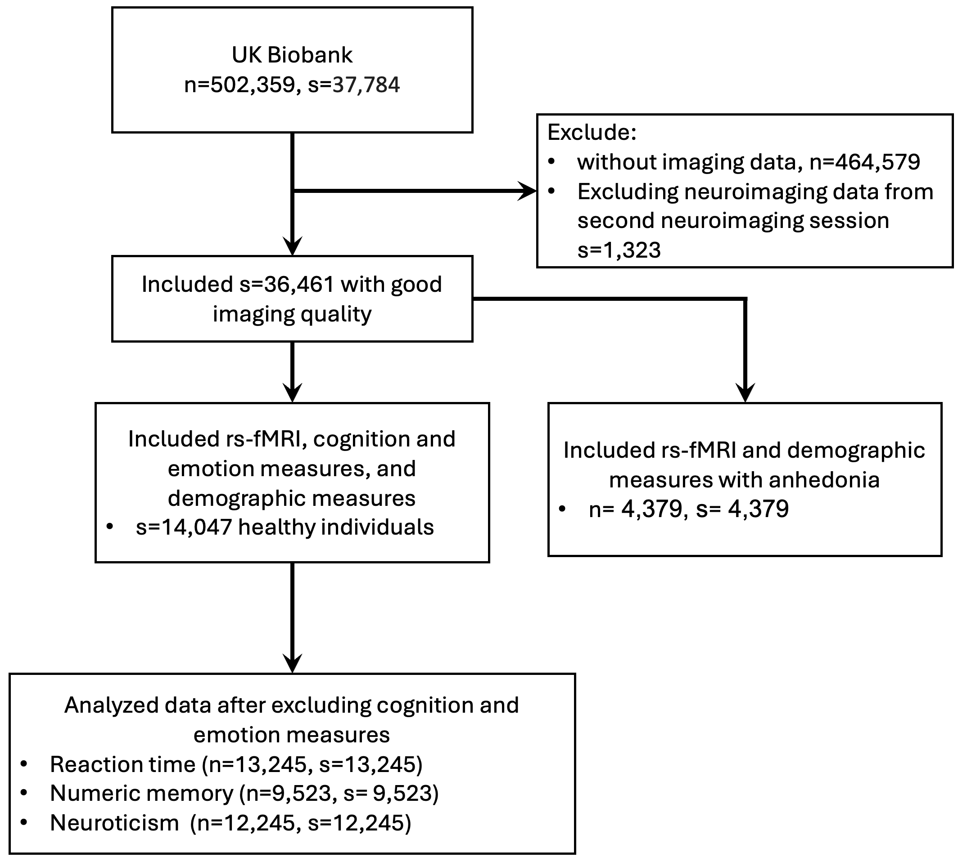

Supplementary Figure 1. STROBE flowchart reporting numbers of subjects and scans in UKBB dataset. The symbol 's' represents the number of resting-state fMRI scans, and 'n' indicates the number of individuals included in the analysis.

Supplementary Figure 2.

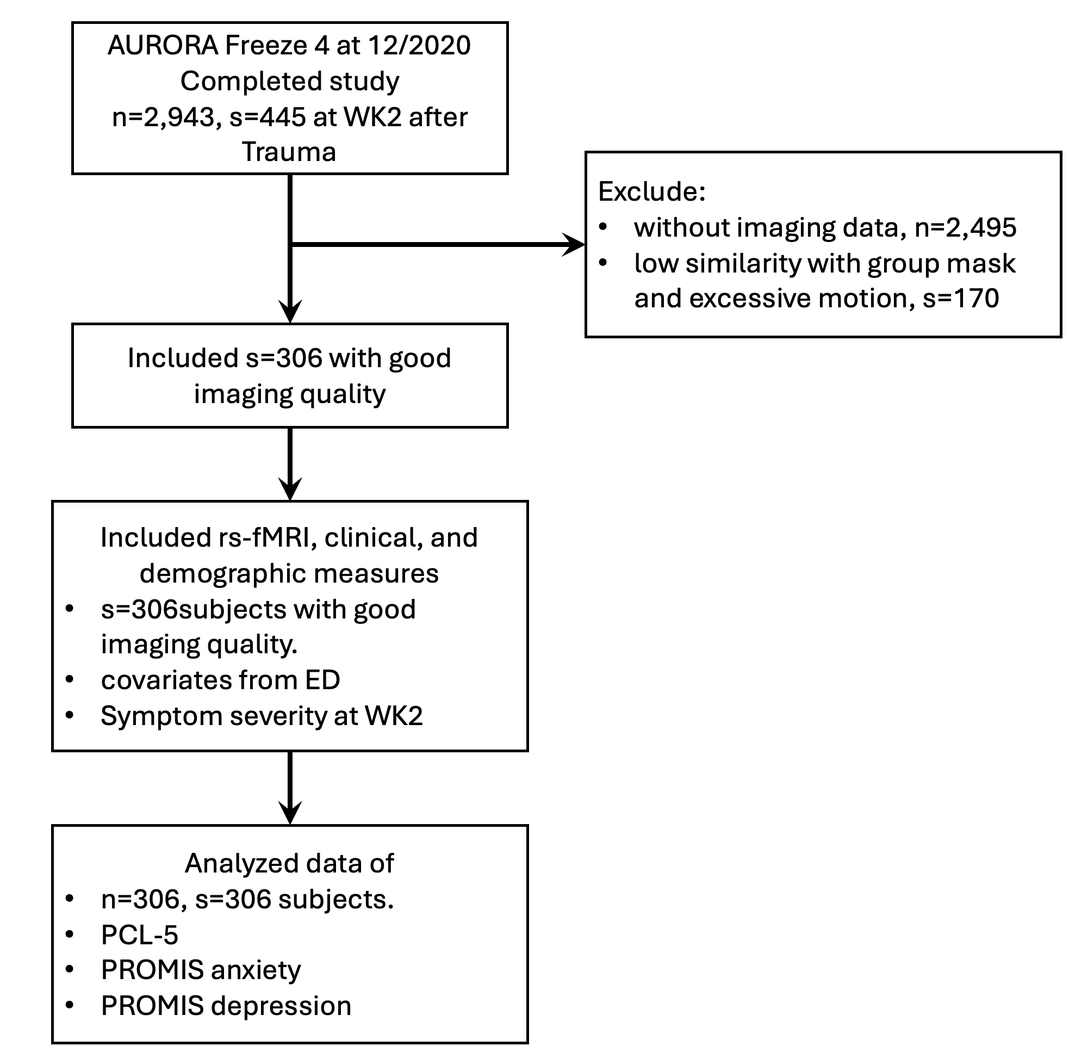
Supplementary Figure 2. STROBE flowchart reporting numbers of subjects and scans in AURORA dataset. The symbol 's' represents the number of resting-state fMRI scans, and 'n' indicates the number of individuals included in the analysis.

Supplementary Figure 3.

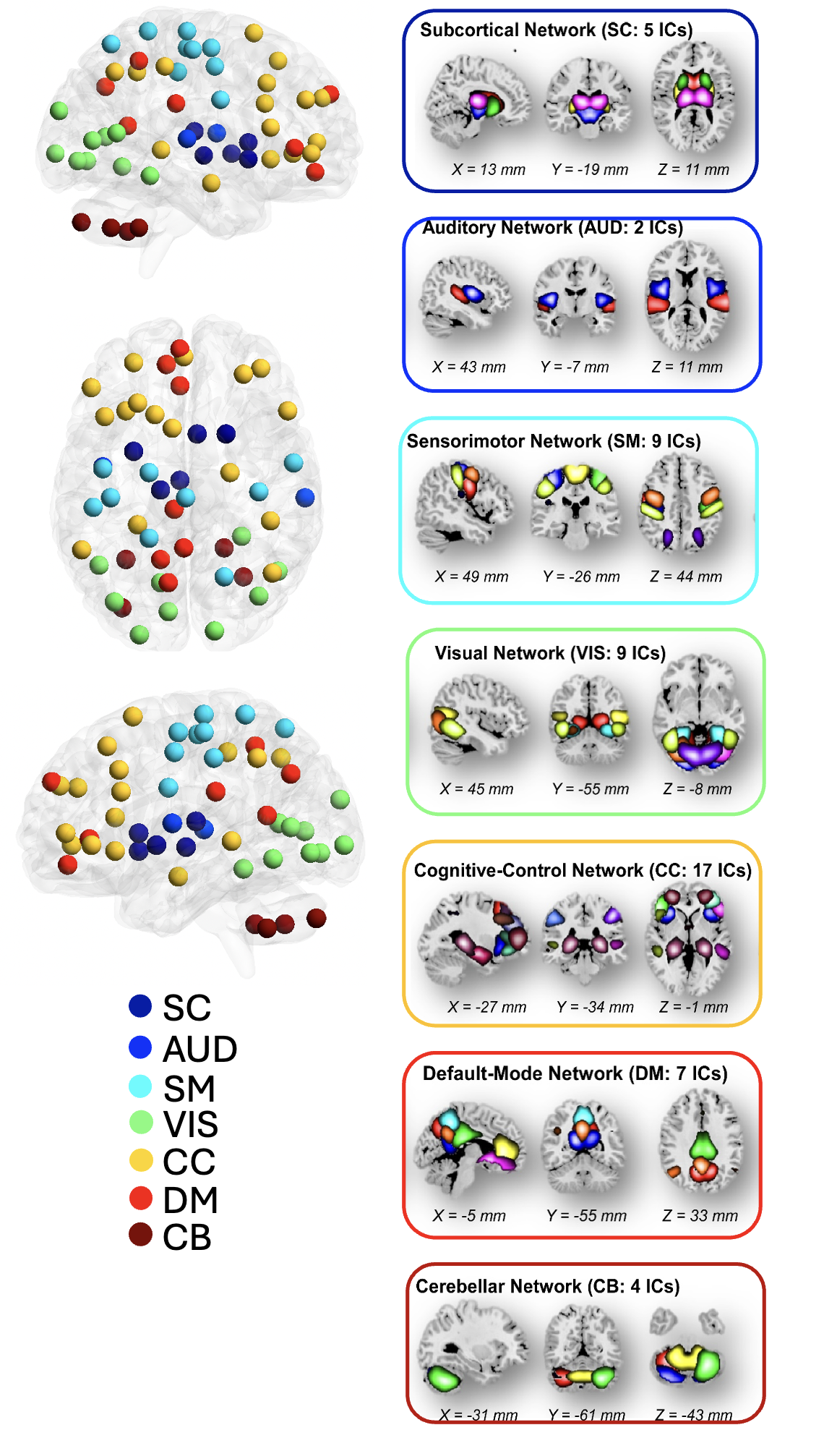
Supplementary Figure 3. The NeuroMark independent components: We utilized the NeuroMark pipeline to identify reliable intrinsic connectivity networks (ICNs), capturing 53 components that are consistent across independent datasets. These 53 independent components were organized into seven distinct networks: subcortical (SC), auditory (AUD), visual sensory (VSN), sensorimotor (SM), cognitive control (CC), default mode DM), and cerebellar (CB).

Supplementary Figure 4.

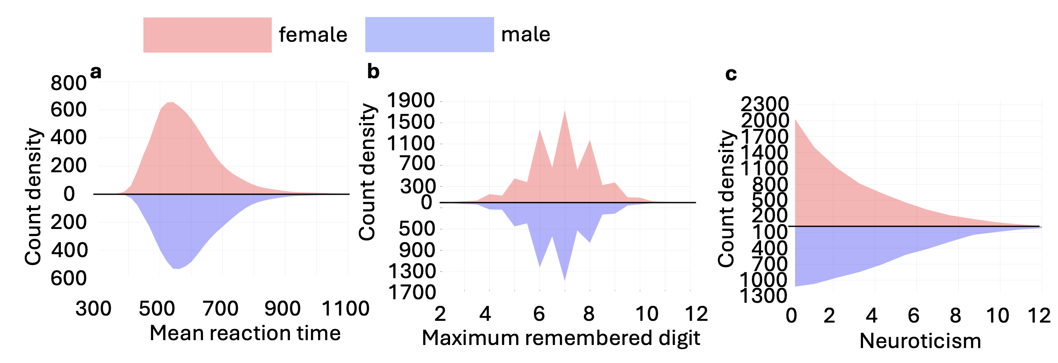
Supplementary Figure 4. Distributions in UK Biobank Samples. a) Mean reaction time in the “SNAP” task for males and females. b) Numeric memory scores for males and females. c) Neuroticism measures for males and females.

Supplementary Figure 5.

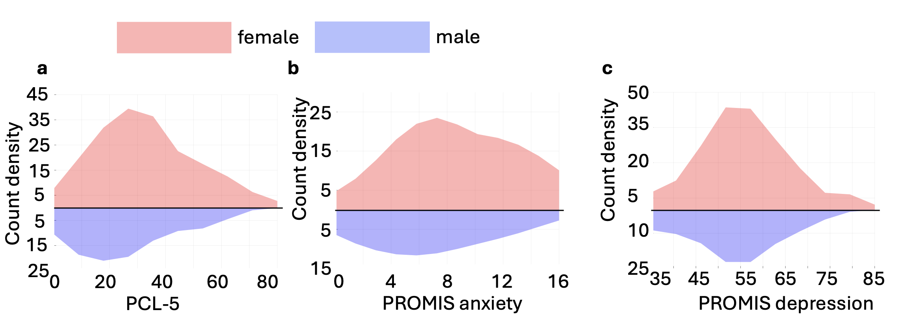
Supplementary Figure 5. Distributions in AURORA Samples. a) PCL-5 scores, b) PROMIS anxiety scores, and c) PROMIS depression scores, all for males and females.

Supplementary Figure 6.

Supplementary Figure 6. Link between PROMIS Depression Short Form 8b scale raw score and T-score.

Supplementary Figure 7.

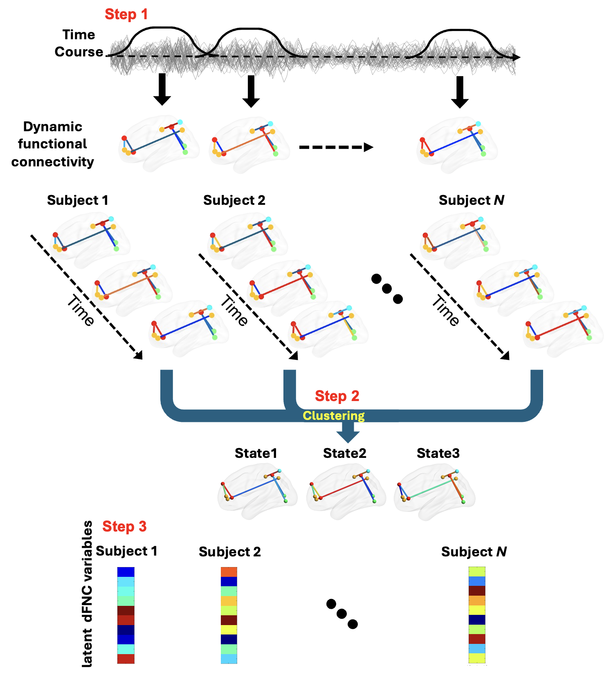

Supplementary Figure 7: Dynamic functional connectivity analytic pipeline. Step 1: We calculated the dynamic functional connectivity using sliding window approach. Each subject yielded 210 windows and functional connectivity’s. Step 2: To cluster the dynamic functional connectivity into three distinct groups, the functional connectivity were vectorized and concatenated, followed by k-means clustering with correlation as the distance metric. Step 3: From the state vector, occupancy rate (OCR) was computed for each subject, resulting in three OCR variables for each subject. To investigate the relationship between OCRs with the clinical measure (i.e., PCL-5, PROMIS anxiety, PROMIS depression), we used GLM to compute associations, taking into account factors such as age, sex, age², age × sex, income, years of education, site, and type of trauma. The resulting t-statistics from this analysis were then converted to correlation (r) values.
Supplementary Figure 8.

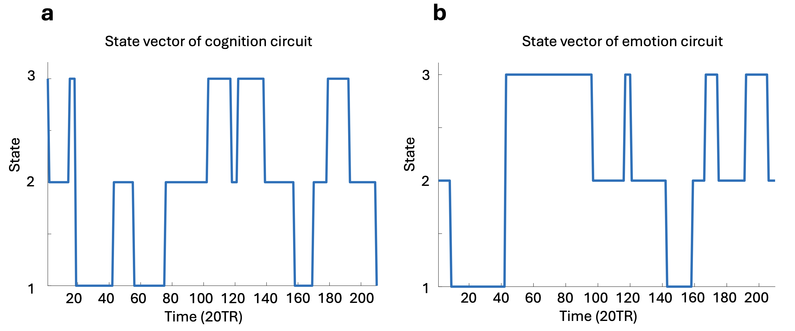
Supplementary Figure 8. Representative state vectors from k-means clustering on dynamic functional connectivity. a) State vector derived from clustering of the cognition circuit's dynamic functional connectivity. b) State vector derived from clustering of the emotion circuit's dynamic functional connectivity.

Supplementary References
1. Jensen, A. R. The theory of intelligence and its measurement. Intelligence vol. 39 171–177 Preprint at https://doi.org/10.1016/j.intell.2011.03.004 (2011).
2. Schumacher, J. et al. Dynamic functional connectivity changes in dementia with Lewy bodies and Alzheimer’s disease. Neuroimage Clin 22, 101812 (2019).
3. Rabany, L. et al. Dynamic functional connectivity in schizophrenia and autism spectrum disorder: Convergence, divergence and classification. Neuroimage Clin 24, 101966 (2019).
4. Sendi, M. S. E. et al. Aberrant Dynamic Functional Connectivity of Default Mode Network in Schizophrenia and Links to Symptom Severity. Front Neural Circuits 15, 1–14 (2021).
5. Dini, H. et al. Dynamic Functional Connectivity Predicts Treatment Response to Electroconvulsive Therapy in Major Depressive Disorder. Front Hum Neurosci 15, 1–11 (2021).
6. Sendi, M. S. E. et al. Aberrant dynamic functional connectivity of default mode network predicts symptom severity in major depressive disorder. Brain Connect 11, 838–849 (2021).
7. Allen, E. A. et al. Tracking whole-brain connectivity dynamics in the resting state. Cerebral Cortex 24, 663–676 (2014).
8. Preti, M. G., Bolton, T. A. & Van De Ville, D. The dynamic functional connectome: State-of-the-art and perspectives. Neuroimage 160, 41–54 (2017).
9. Fu, Z. et al. Cerebro-cerebellar functional neuroplasticity mediates the effect of electric field on electroconvulsive therapy outcomes. Transl Psychiatry 13, (2023).
10. Fu, Z. et al. Whole-Brain Functional Connectivity Dynamics Associated With Electroconvulsive Therapy Treatment Response. Biol Psychiatry Cogn Neurosci Neuroimaging 7, 312–322 (2022).
11. Tian, T. et al. Dynamic effective connectivity among large-scale brain networks mediates risk of anxiety. Hum Brain Mapp 44, 3730–3743 (2023).
12. Wen, Z., Seo, J., Pace-Schott, E. F. & Milad, M. R. Abnormal dynamic functional connectivity during fear extinction learning in PTSD and anxiety disorders. Mol Psychiatry 27, 2216–2224 (2022).
13. Yaesoubi, M., Adalı, T. & Calhoun, V. D. A window-less approach for capturing time-varying connectivity in fMRI data reveals the presence of states with variable rates of change. Hum Brain Mapp 39, 1626–1636 (2018).
14. Sendi, M. S. E. et al. The link between static and dynamic brain functional network connectivity and genetic risk of Alzheimer’s disease. Neuroimage Clin 37, (2023).

