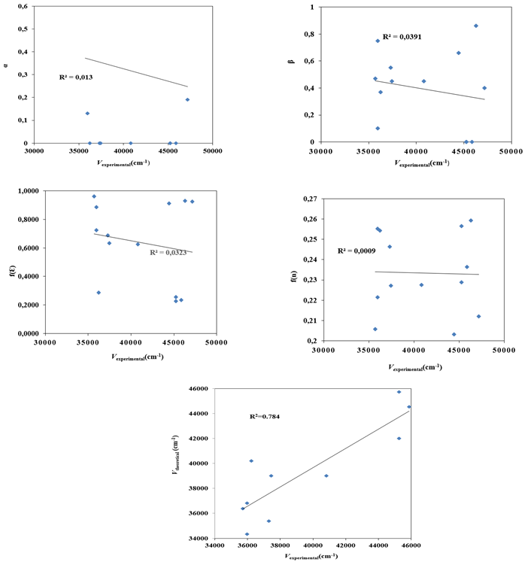
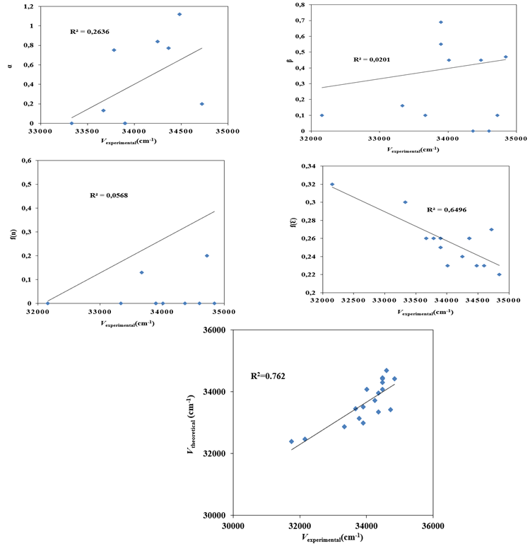
(a)
(b)

Figure 1S. Correlation plots between KAT parameters and experimental absorption maxima (HOBC1 (a) and HOBC2 (b)). Significant influence observed from β and f(n).

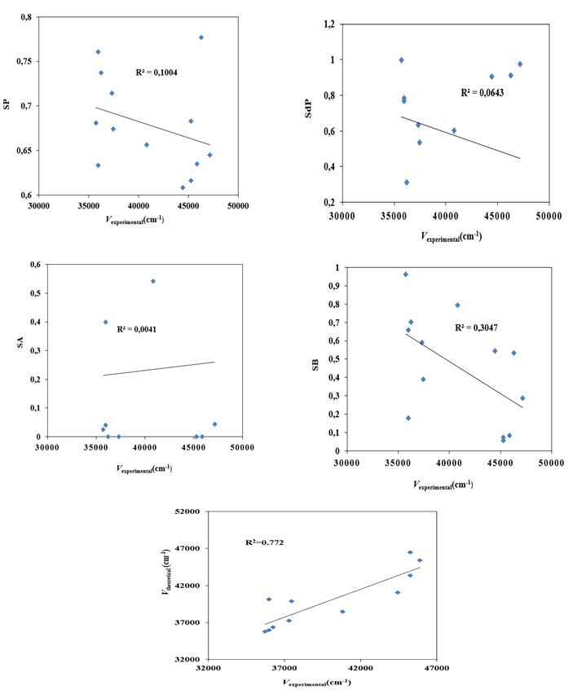
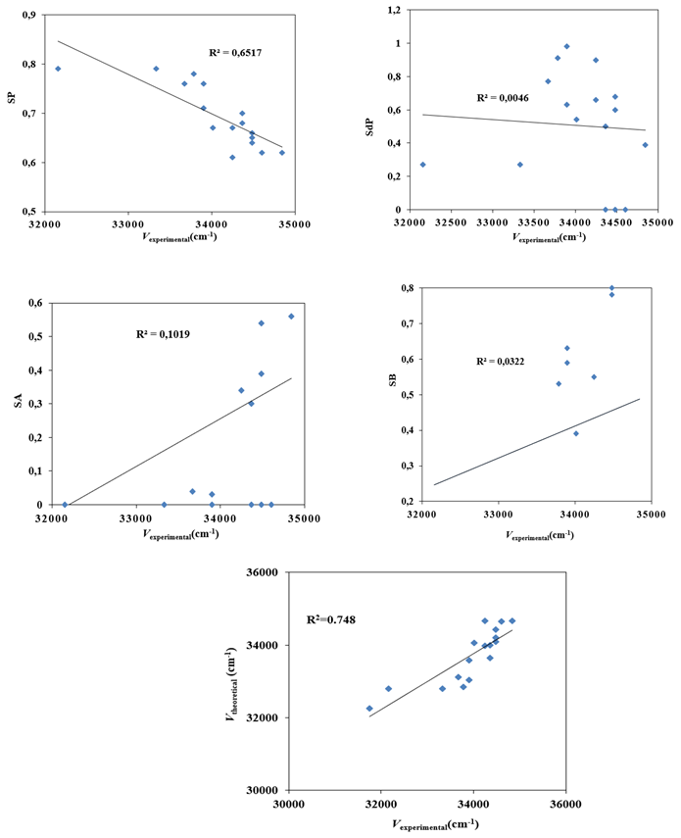
(a)
(b)

Figure 2S. Correlations between CAT parameters and absorption maxima of HOBC1 and HOBC2. SP and SdP are key descriptors in solvent-dependent shifts.
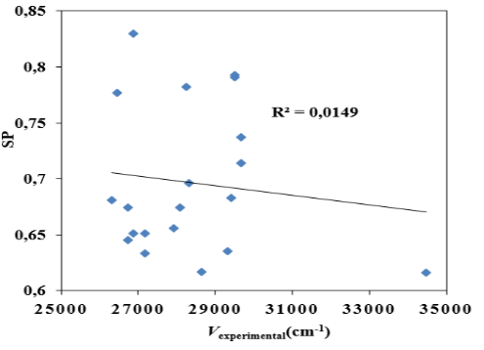
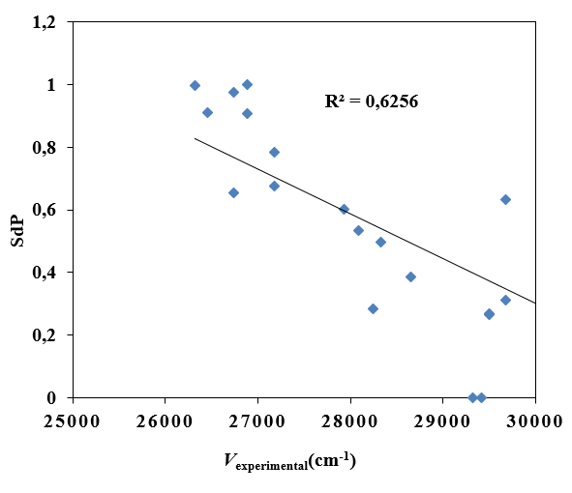
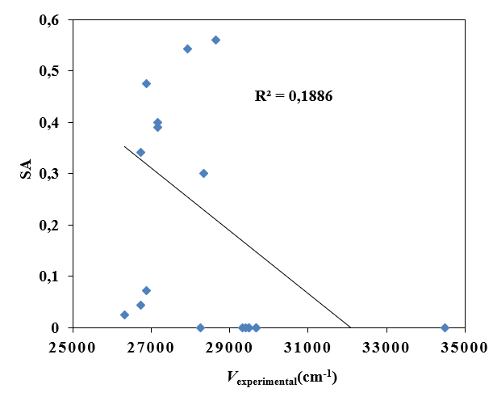
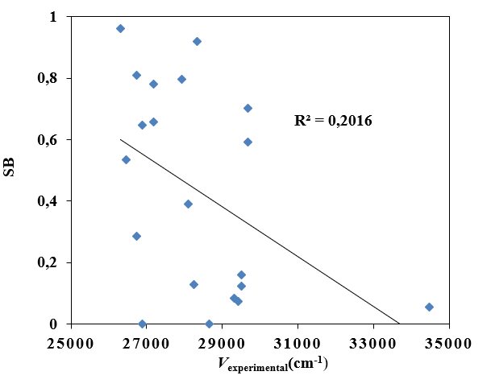
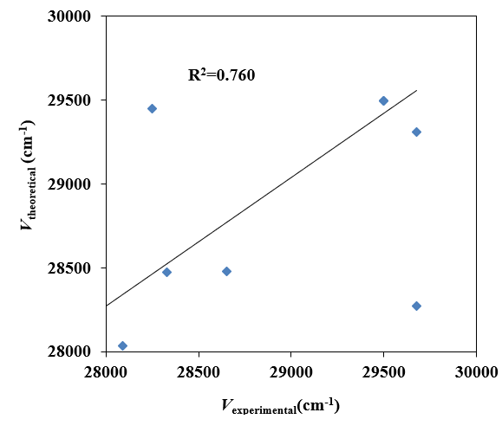
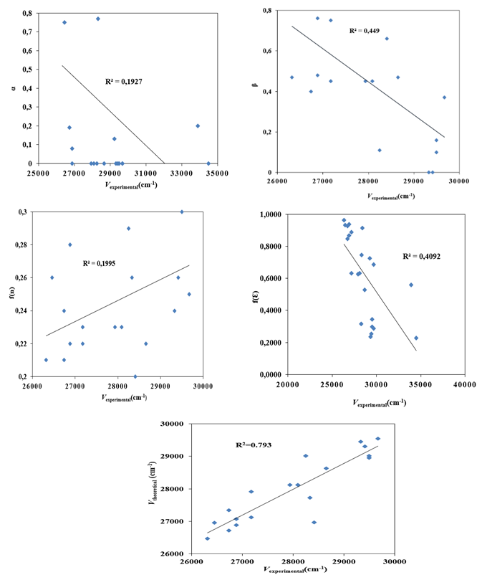
(a)
(b)

Figure 3S. Correlation of maximum fluorescence frequencies of HOBC with KAT and CAT parameters. f(ε) and SB are influential in emission behavio

Table 1S. List of all used parameters and functions[4-18].
Solvents | ε^{a,b} | n^{a,b} | β^{a,b} | α^{a,b} | f(ε)^{a,b} | f(n)^{a,b} | SP^{c} | SdP^{c} | SA^{c} | SB^{c} | f(ε,n)^{d,e,f} | g(n)^{d,e,f} | f(ε,n)+2g(n)^{d,e,f} | F_{L-M}(ε,n)^{g,h} | F_{B}(ε,n)^{ı} | F_{K-C-V}(ε,n)^{i} | $E_{N}^{T}$^{b}
n-Hexane | 1.88 | 1.3749 | 0 | 0 | 0.2268 | 0.616 | 0.616 | 0 | 0 | 0.056 | -0.00253 | 0.25505 | 0.507572 | -0.00136 | -0.00253 | 0.253786 | 0.009
n-Heptane | 1.92 | 1.3889 | 0 | 0 | 0.2347 | 0.635 | 0.635 | 0 | 0 | 0.083 | -0.00218 | 0.264411 | 0.526644 | -0.00115 | -0.00218 | 0.263322 | 0.012
Cyclohexane | 2.02 | 1.4266 | 0 | 0 | 0.2537 | 0.683 | 0.683 | 0 | 0 | 0.073 | -0.00353 | 0.289447 | 0.575364 | -0.00178 | -0.00353 | 0.287682 | 0.006
1.4Dioxane | 2.21 | 1.4224 | 0.37 | 0 | 0.2874 | 0.737 | 0.737 | 0.312 | 0 | 0.701 | 0.041496 | 0.286671 | 0.614837 | 0.020486 | 0.041496 | 0.307418 | 0.164
Benzene | 2.27 | 1.5589 | 0.1 | 0 | 0.2974 | 0.793 | 0.793 | 0.27 | 0 | 0.124 | -0.0336 | 0.374933 | 0.716265 | -0.0148 | -0.0336 | 0.358132 | -
O-Xylene | 2.57 | 1.5054 | 0.16 | 0 | 0.3435 | 0.791 | 0.791 | 0.266 | 0 | 0.16 | 0.060615 | 0.340849 | 0.742313 | 0.026828 | 0.060615 | 0.371156 | 0.111
Diethylether | 4.34 | 1.3497 | 0.47 | 0 | 0.5268 | 0.617 | 0.617 | 0.385 | 0.56 | 0 | 0.378848 | 0.238121 | 0.85509 | 0.168082 | 0.378848 | 0.427545 | 0.117
Ethylacetate | 6.02 | 1.3724 | 0.45 | 0 | 0.6259 | 0.656 | 0.656 | 0.603 | 0.542 | 0.795 | 0.489081 | 0.253375 | 0.995831 | 0.199635 | 0.489081 | 0.497916 | 0.228
n-Butylacetate | 6.17 | 1.3719 | 0.45 | 0 | 0.6328 | 0.674 | 0.674 | 0.535 | 0.689 | 0.39 | 0.497736 | 0.25304 | 1.003815 | 0.202403 | 0.497736 | 0.501908 | 0.241
Acedic acide | 6.17 | 1.3719 | 0.45 | 1.12 | 0.6328 | 0.651 | 0.651 | 0.676 | 0.39 | 0.781 | 0.497736 | 0.25304 | 1.003815 | 0.202403 | 0.497736 | 0.501908 | 0.648
THF | 7.58 | 1.4072 | 0.55 | 0 | 0.6868 | 0.714 | 0.714 | 0.634 | 0 | 0.591 | 0.549078 | 0.276596 | 1.10227 | 0.209572 | 0.549078 | 0.551135 | 0.207
DCM | 8.93 | 1.4242 | 0.1 | 0.13 | 0.7255 | 0.761 | 0.761 | 0.769 | 0.04 | 0.178 | 0.590293 | 0.287861 | 1.166014 | 0.217103 | 0.590293 | 0.583007 | 0.309
1-Octanol | 9.8 | 1.429 | 0.81 | 0.77 | 0.7458 | 0.696 | 0.696 | 0.496 | 0.3 | 0.92 | 0.613759 | 0.291031 | 1.195822 | 0.222223 | 0.613759 | 0.597911 | 0.537
1-Butanol | 17.4 | 1.399 | 0.84 | 0.84 | 0.8454 | 0.674 | 0.674 | 0.655 | 0.341 | 0.809 | 0.749445 | 0.271143 | 1.291732 | 0.263326 | 0.749445 | 0.645866 | 0.586
Ethanol | 24.55 | 1.3614 | 0.75 | 0.86 | 0.8870 | 0.633 | 0.633 | 0.783 | 0.4 | 0.658 | 0.812933 | 0.245993 | 1.304918 | 0.288746 | 0.812933 | 0.652459 | 0.654
Methanol | 32.66 | 1.3284 | 0.66 | 0.98 | 0.9134 | 0.608 | 0.608 | 0.904 | 0.605 | 0.545 | 0.85461 | 0.22374 | 1.302089 | 0.30856 | 0.85461 | 0.651045 | 0.762
DMF | 36.71 | 1.4305 | 0.69 | 0 | 0.9225 | 0.759 | 0.759 | 0.977 | 0.031 | 0.631 | 0.835593 | 0.292021 | 1.419635 | 0.274386 | 0.835593 | 0.709818 | 0.386
Acetonitrile | 38.8 | 1.3442 | 0.4 | 0.19 | 0.9265 | 0.645 | 0.645 | 0.974 | 0.044 | 0.286 | 0.865962 | 0.234414 | 1.334789 | 0.306031 | 0.865962 | 0.667395 | 0.46
Ethylene glycol | 41.4 | 1.4318 | 0.86 | 0.75 | 0.9309 | 0.777 | 0.777 | 0.91 | 0.717 | 0.534 | 0.845734 | 0.292879 | 1.431491 | 0.276212 | 0.845734 | 0.715746 | 0.79
DMSO | 46.45 | 1.4793 | 0.76 | 0 | 0.9381 | 0.83 | 0.83 | 1 | 0.072 | 0.647 | 0.840013 | 0.323973 | 1.48796 | 0.263009 | 0.840013 | 0.74398 | 0.444
Water | 78.36 | 1.333 | 0.47 | 1.17 | 0.9627 | 0.681 | 0.681 | 0.997 | 0.025 | 0.962 | 0.912678 | 0.226851 | 1.36638 | 0.319886 | 0.912678 | 0.68319 | 1

ªM.J. Kamlet. J.L.M. Abboud. M.H. Abraham. R.W. Taft. Linear Solvation Energy Relationships. J Org Chem 48 (1983) 2877-2888.
^{b}C. Reichardt. Solvents and Solvent Effects in Organic Chemistry. Third ed. Weinheim. Germany:Wiley-VCH. 2005.
^{c}J. Catalán. Toward a generalized treatment of the solvent effect based on four empirical scales: dipolarity (SdP. a New Scale). polarizability (SP). acidity (SA). and basicity (SB) of the medium. J Phy Chem B 113. (17) (2009) 5951–5960.
^{d}L. Bilot. A. Kawski. Zur Theorie des Einflusses von Lösungsmitteln auf die Elektronenspektren der Moleküle. Zeitschrift für Naturforschung A 17 (1962) 621-627.
^{e}A. Kawski. Zur Lösungsmittelabhängigkeit der Wellenzahl von Elektronenbanden Lumineszierender Moleküle und über die Bestimmung der Elektrischen Dipolmomente im Anregungszustand. Acta Phys Polon 29 (1966) 507-518.
^{f}E. Lippert. Dipol moment und Elektronen struktur von angeregten Molekülen. Zeitschrift für Naturforschung A 10 (1955) 541-545.
^{g}N. Mataga. Y. Kaifu and M. Koizumi. Solvent effects upon fluorescence spectra and the dipole moments of excited molecules. Bul of the Chem Soc 29 (1956) 465-470.ğ^{ı}N. G. Bakhshiev. Universal intermolecular interactions and their effect on the position of the electronic spectra of molecules in two component solutions. Opt Spect 16 (1964) 821-832.
^{h}A. Chamma. P. Viallet. Determination du moment dipolaire d’une molcule dans un tat excit singule. Comptes rendus de l’Académie des Sciences 270 (1970) 1901-1904.

