Supplementary information
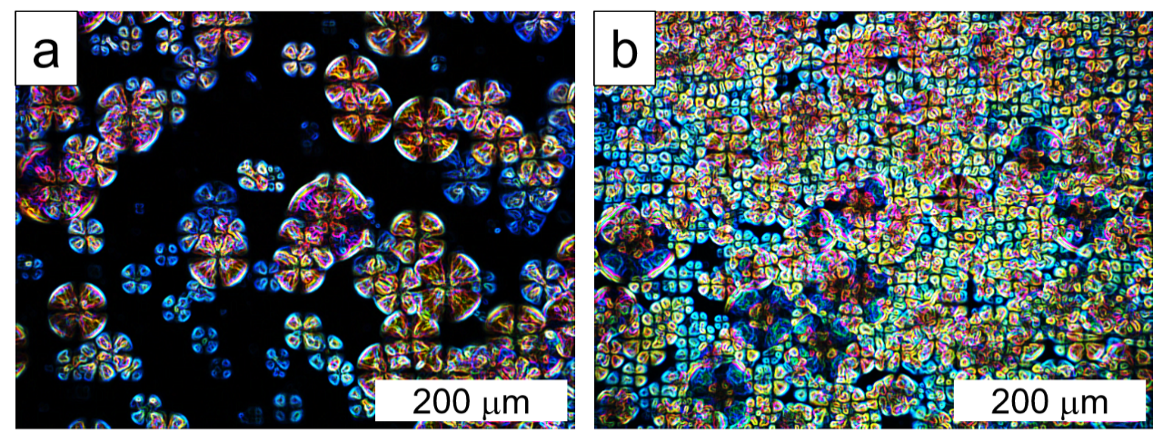
Fig. 1 Polarization microscope images (POM) at room temperature. a Pure PLA. b PLA/DF composites.
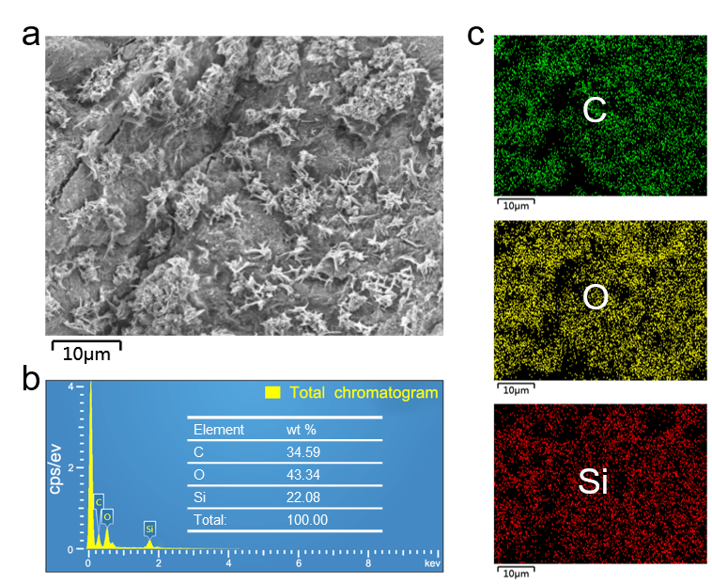
Fig. 2 Energy dispersive spectroscopy (EDS) analysis. a SEM image. b Total chromatogram. Inset table: element composition ratio. c Distribution maps of elements including C, O and Si.
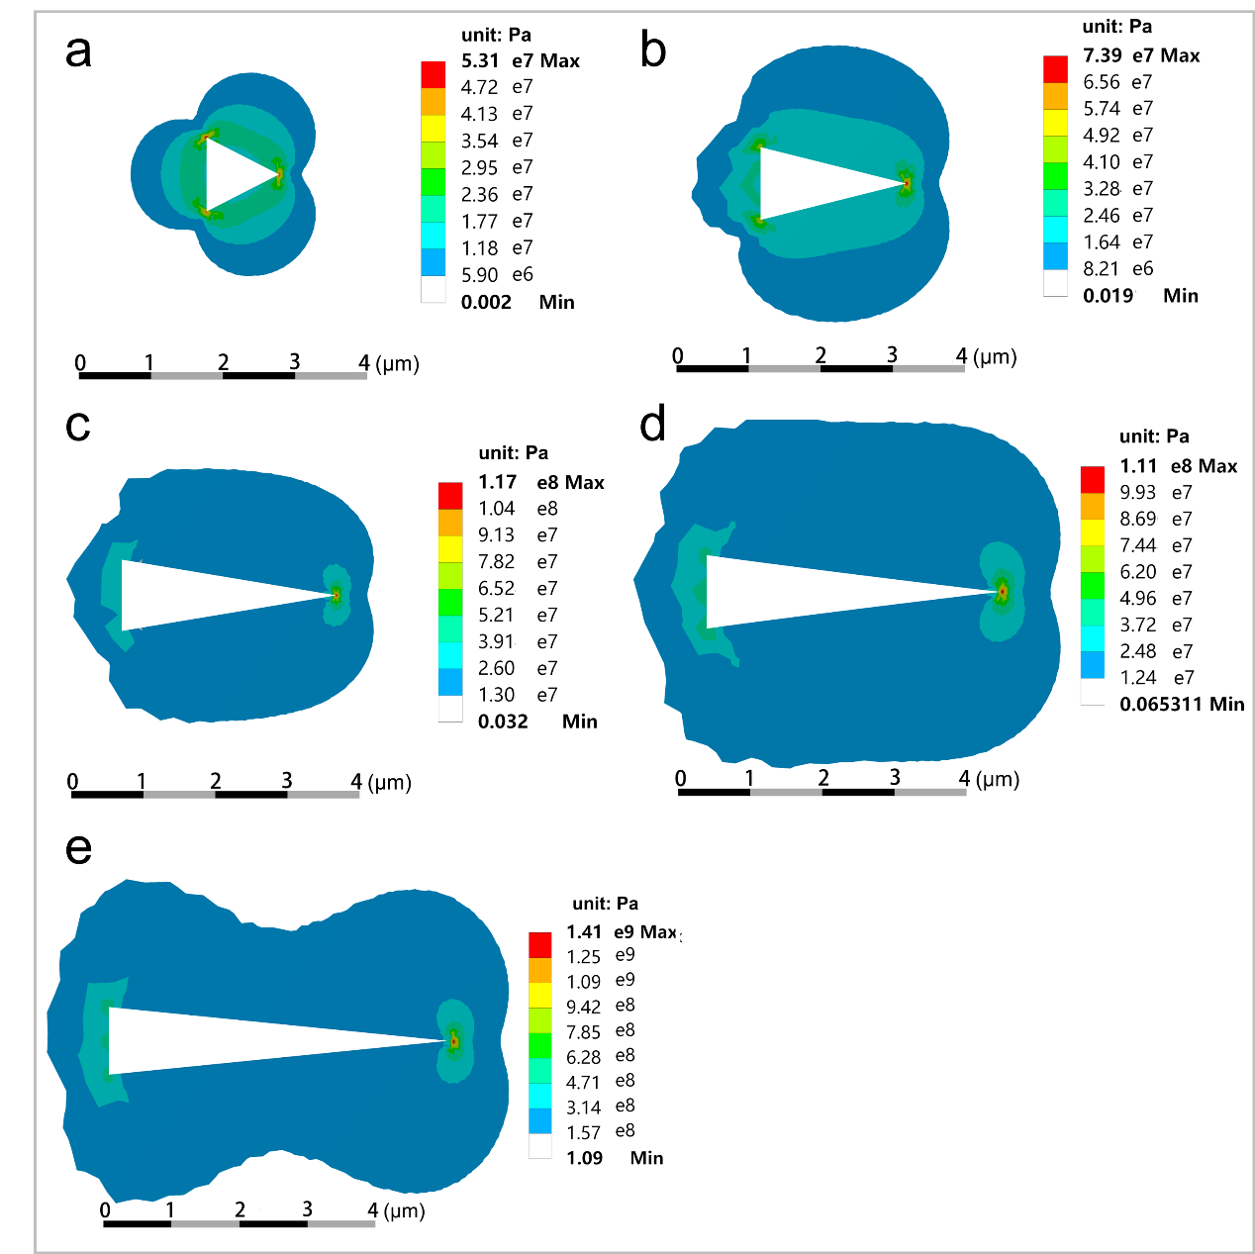
Fig. 3 Stress nephograms under inter stress of 10 MPa with different crack length. a-e Crack length is 1 μm, 2 μm, 3 μm, 4 μm and 5 μm, respectively.

