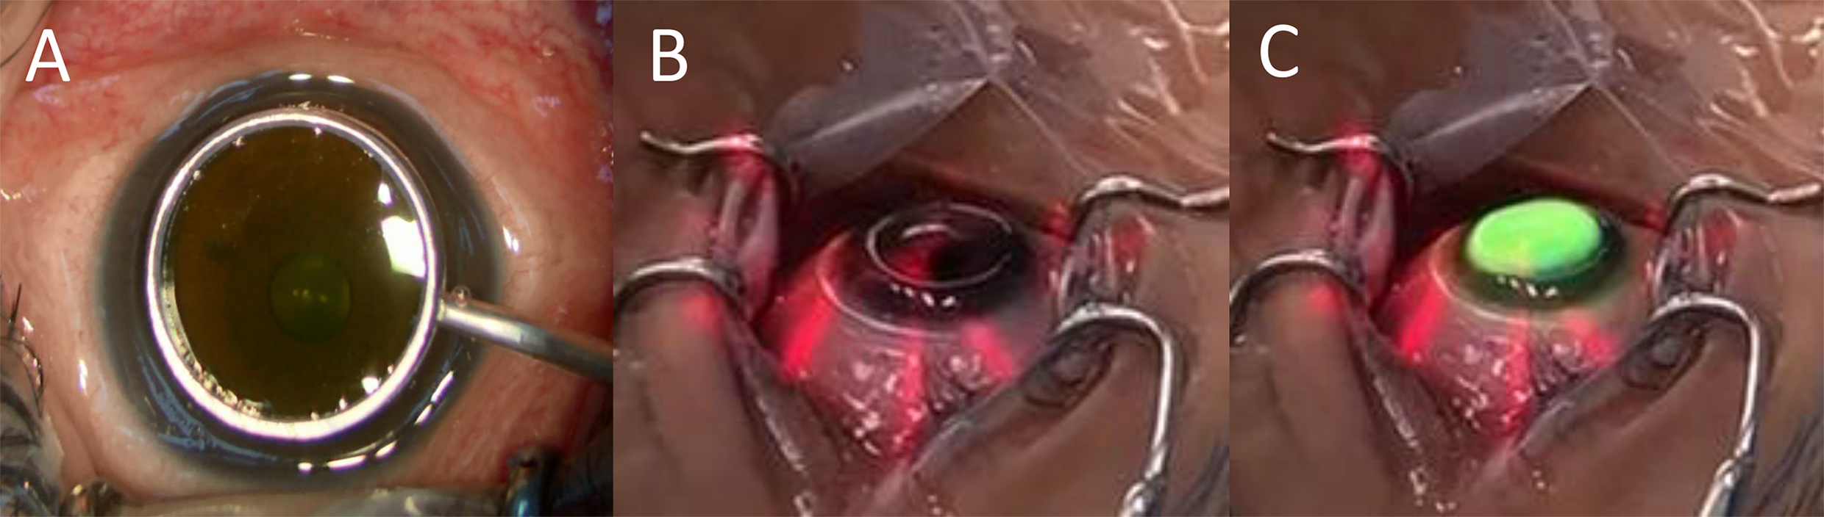
Supplementary Figure S1. Riboflavin is contained inside a retention ring during the application for ten minutes (A). A trephined silicone hydrogel bandage contact lens is applied during UV irradiation (B, C)

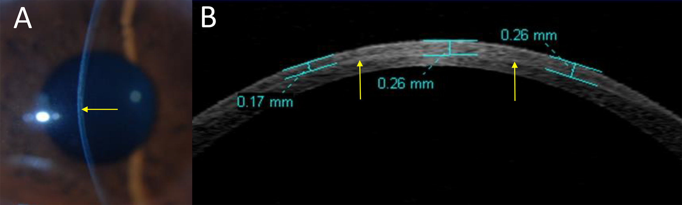
Supplementary Figure S2. Slit-lamp biomicroscopy exam after a month of modified pulsed-light accelerated cross-linking demonstrated a demarcation line (A, yellow arrow). Anterior segment optical coherence tomography-assisted measurement of demarcation line depth (B, yellow arrow)

