Ecological risk assessment of pharmaceuticals and personal care products in the water environment of 15 cities in Japan
Takahiro Nishino^{1*}, Mika Kato¹, Yoshitaka Miyazawa¹, Toshiki Tojo², Daichi Asakawa², Masanori Okata², Chisato Matsumura³, Yuki Haga³, Takuya Kakoi³, Hitomi Hasegawa⁴, Tetsuro Okamura⁵, Atsushi Sawai⁵
¹ Tokyo Metropolitan Research Institute for Environmental Protection, 1-7-5 Shinsuna, Koto, Tokyo, Japan
² Osaka City Research Center of Environmental Sciences, 8-34 Tojocho, Tennoji, Osaka, Osaka, Japan
³ Hyogo Prefectural Institute of Environmental Sciences, 3-1-18 Yukihira, Suma, Kobe, Hyogo, Japan
⁴ Nagoya City Environmental Science Research Institute, 5-16-8 Toyoda Minami, Nagoya, Aichi, Japan
⁵ IDEA Consultants, Inc, Institute of Environmental Ecology, 1334-5 Riemon, Yaizu, Shizuoka, Japan
*Corresponding author
Takahiro Nishino,
Tokyo Metropolitan Research Institute for Environmental Protection,
1-7-5 Shinsuna, Koto, Tokyo, Japan.
E-mail address: nishino-t@tokyokankyo.jp
Tel: +81-3-3699-1380; Fax: +81-3699-1345

Table S1. LC-MS/MS analysis conditions for pharmaceuticals and phosphate ester flame retardants (PFRs).

LC
Model name | Waters AQUITY UPLC H-Class
Column | Waters CORETECSTM UPLC®C18⁺  (Φ2.1 mm × 100 mm, particle size 1.6 μm)
Column for retention gap | Waters UPLC® BEH C18  (Φ2.1 mm × 50 mm, particle size 1.7 μm)
Mobile phase | A: 0.1% formic acid solution; B: methanol; C: acetonitrile
Mobile phase | 0→2 min: A, 80→60%; B, 20→40%; linear gradient
Mobile phase | 2→3.5 min: A, 60→25%; B, 40→75%; linear gradient
Mobile phase | 3.5→8 min: A, 25→0%; B, 75→100%; linear gradient
Mobile phase | 8→10.5 min: A, 0%; B, 100%
Mobile phase | 10.51 min: A, 0→80%; B, 100→20%
Mobile phase | 10.51→18 min: A, 80%; B, 20%
Mobile phase  (for PFRs) | A: 1 mM ammonium acetate; B: Methanol
Mobile phase  (for PFRs) | 0→0.5 min: A, 70%; B, 30%
Mobile phase  (for PFRs) | 0.5→7 min: A, 70→1%; B, 30→99%; linear gradient
Mobile phase  (for PFRs) | 7→10.5 min: A, 1%; B, 99%
Mobile phase  (for PFRs) | 10.51 min: A, 1→70%; B, 99→30%
Mobile phase  (for PFRs) | 10.51→15 min: A, 70%; B, 30%
Flow rate | 0.2 mL min⁻¹（0.15 mL min⁻¹ for PFRs）
Column temperature | 40 °C (50 °C for PFRs）
Injection volume | 1 μL
MS
Model name | Waters Xevo-TQS
Ionization mode | ESI（Positive Mode）
Monitoring mode | Multiple Reaction Monitoring (MRM)
Capillary voltage | 2.0 kV（0.8 kV for PFRs）
Desolvation gas temperature | 550 °C

Table S2. Sampling points of this study (managed by four institutes participating in this joint research project).
Number | City or Prefecture | River name | Sampling point
1 | Osaka Cª. | Daini Neyagawa R^{c}. | Shigino-ohashi Bridge
2 | Osaka Cª. | Daini Neyagawa R^{c}. | Shimoshiromi Bridge
3 | Hyogo P^{b}. | Kakogawa R. | Banzai Bridge
4 | Hyogo P^{b}. | Kakogawa R. | Kamisho Bridge
5 | Hyogo P^{b}. | Mukogawa R. | Upstream of Mukogawa STP^{d}
6 | Hyogo P^{b}. | Mukogawa R. | Downstream of Mukogawa STP
7 | Hyogo P^{b}. | Inagawa R. | Inagawa Bridge
8 | Hyogo P^{b}. | Inagawa R. | Tokura Bridge
9 | Nagoya C. | Horikawa R. | Johoku Bridge
10 | Nagoya C. | Horikawa R. | Nakatsuchito Bridge
11 | Nagoya C. | Yamazakigawa R. | Chuji Bridge
12 | Nagoya C. | Yamazakigawa R. | Hosei Bridge
13 | Nagoya C. | Shinhorikawa R. | Maizuru Bridge
14 | Tokyo P. | Tamagawa R. | Nagata Bridge
15 | Tokyo P. | Tamagawa R. | Hino Bridge
16 | Tokyo P. | Tamagawa R. | Sekido Bridge
17 | Tokyo P. | Tamagawa R. | Tamagawara Bridge
18 | Tokyo P. | Asakawa R. | Takahata Bridge
19 | Tokyo P. | Ogurigawa R. | Houon Bridge
20 | Tokyo P. | Hiraigawa R. | Tasai Bridge
21 | Tokyo P. | Akikawa R. | Hiagashiakikawa Bridge
22 | Tokyo P. | Zanborigawa R. | Tappi Bridge
23 | Tokyo P. | Yachigawa R. | Shinasahi Bridge
24 | Tokyo P. | Arakawa R. | Ogi-ohashi Bridge
25 | Tokyo P. | Arakawa R. | Horikiri Bridge
26 | Tokyo P. | Sumidagawa R. | Odai Bridge
27 | Tokyo P. | Sumidagawa R. | Ryogoku Bridge
28 | Tokyo P. | Nakagawa R. | Shiodome Bridge
29 | Tokyo P. | Nakagawa R. | Heiwa Bridge
a: City, b: Prefecture, c: River, d: Sewage treatment plant.

Table S3 Concentrations of pharmaceuticals and personal care products (PPCPs) in water environment samples for the four institutes participating in this joint research project.
Number | City or Prefecture | River name | Chemical  Sampling point | Clari  thro  mycin | 14-hydroxy  clarithromycin | erythromycin | trime  thoprim | dicro  fenac | 5-hydroxy  diclo  fenac | sulpi  ride | carba  maze  pine | 2-hydroxy  carbamazepine | 3-hydroxy  carbamazepine | carba  mazepine10,11  epoxide | fexofe  nadine | epina  stine | ketoti  fen | diphen  hydra  mine | diphenyl sulfone
1 | Osaka Cª. | Daini Neya  gawa R^{c}. | Shigino-ohashi Bridge | 600 | 580 | 100 | 70 | 45 | 73 | 890 | 42 | 30 | 30 | 30 | 2500 | 130 | (0.56) | 340 | 1200
2 | Osaka Cª. | Daini Neya  gawa R^{c}. | Shimoshiromi Bridge | 570 | 510 | 370 | 71 | 45 | 72 | 760 | 36 | 26 | 27 | 25 | 2200 | 120 | 0.67 | 270 | 970
3 | Hyogo P^{b}. | Kako  gawa R. | Banzai Bridge | (1.7) | 2.6 | N.D.^{d} | N.D. | N.D. | N.D. | 20 | 2.1 | (0.48) | N.D. | (1.6) | 18 | N.D. | N.D. | N.D. | N.D.
4 | Hyogo P^{b}. | Kako  gawa R. | Kamisho Bridge | 4.6 | 7.1 | N.D. | (5.5) | N.D. | N.D. | 71 | 5.8 | 1.7 | 1.8 | 3.8 | 120 | 10 | N.D. | (4.4) | N.D.
5 | Hyogo P^{b}. | Muko  gawa R. | Upstream of Mukogawa STP | N.D. | (0.42) | N.D. | N.D. | N.D. | N.D. | 5.1 | 2.7 | (0.38) | (0.59) | (1.8) | (3.8) | N.D. | N.D. | N.D. | N.D.
6 | Hyogo P^{b}. | Muko  gawa R. | Downstream of Mukogawa STP | 71 | 32 | (3.4) | 12 | (2.2) | 25 | 223 | 43 | 6.6 | N.D. | 11 | 690 | 43 | N.D. | 23 | 11
7 | Hyogo P^{b}. | Inagawa R. | Inagawa Bridge | N.D. | N.D. | 57 | N.D. | N.D. | N.D. | 4.1 | 4.8 | N.D. | N.D. | N.D. | N.D. | N.D. | N.D. | N.D. | (2.5)
8 | Hyogo P^{b}. | Inagawa R. | Tokura Bridge | 470 | 470 | 57 | 73 | 70 | 92 | 1000 | 51 | 34 | 36 | 37 | 3500 | 180 | 1.2 | 120 | 76
9 | Nagoya C. | Horikawa R. | Johoku Bridge | 340 | 330 | 23 | 62 | 17 | 65 | 400 | 22 | 20 | 22 | 17 | 2400 | 120 | (0.53) | 56 | 83
10 | Nagoya C. | Horikawa R. | Nakatsuchito Bridge | 400 | 390 | 25 | 71 | 27 | 68 | 470 | 26 | 26 | 26 | 18 | 2900 | 150 | 0.66 | 71 | 83
11 | Nagoya C. | Yamazakigawa R. | Chuji Bridge | 97 | 110 | N.D. | 27 | 11 | 5.5 | 140 | 7.1 | 5.1 | 6.3 | 5.5 | 730 | 55 | N.D. | 8.7 | 35
12 | Nagoya C. | Yamazakigawa R. | Hosei Bridge | 240 | 310 | N.D. | 110 | 32 | 16 | 390 | 19 | 16 | 20 | 13 | 2200 | 170 | 0.65 | 33 | 87
13 | Nagoya C. | Shinhori  kawa R. | Maizuru Bridge | 530 | 570 | 26 | 87 | 36 | 100 | 610 | 31 | 25 | 28 | 20 | 4600 | 270 | 0.87 | 72 | 150
14 | Tokyo P. | Tama  gawa R. | Nagata Bridge | N.D. | N.D. | N.D. | N.D. | N.D. | N.D. | N.D. | (0.11) | N.D. | N.D. | N.D. | N.D. | N.D. | N.D. | N.D. | N.D.
15 | Tokyo P. | Tama  gawa R. | Hino Bridge | 180 | 220 | 30 | 22 | 29 | (4.4) | 360 | 39 | 19 | 24 | 29 | 1700 | 88 | (0.22) | 98 | 47
16 | Tokyo P. | Tama  gawa R. | Sekito Bridge | 130 | 170 | 21 | 17 | 28 | (3.8) | 370 | 43 | 17 | 21 | 30 | 1400 | 86 | N.D. | 80 | 52
17 | Tokyo P. | Tama  gawa R. | Tamagawara Bridge | 130 | 230 | 36 | 18 | 35 | 8.0 | 370 | 45 | 19 | 21 | 32 | 1700 | 96 | (0.31) | 82 | 56
18 | Tokyo P. | Asa  kawa R. | Takahata Bridge | 15 | 25 | N.D. | N.D. | (1.3) | N.D. | 58 | 11 | 1.7 | 1.8 | 5.7 | 240 | 13 | N.D. | 13 | 16
19 | Tokyo P. | Ooguri  gawa R. | Hoon Bridge | 2.3 | 1.6 | N.D. | N.D. | N.D. | N.D. | (2.3) | 2.1 | N.D. | N.D. | N.D. | 8.0 | N.D. | N.D. | N.D. | 11
20 | Tokyo P. | Hirai  gawa R. | Tasai Bridge | N.D. | (0.26) | N.D. | N.D. | N.D. | N.D. | N.D. | 2.7 | N.D. | N.D. | (1.4) | (3.3) | N.D. | N.D. | N.D. | (4.5)
21 | Tokyo P. | Akikawa R. | Hiagashiakikawa Bridge | 7.3 | 2.7 | N.D. | N.D. | N.D. | N.D. | N.D. | 0.78 | N.D. | N.D. | N.D. | N.D. | N.D. | N.D. | N.D. | (3.9)
22 | Tokyo P. | Zanborigawa R. | Tappi Bridge | N.D. | (0.50) | N.D. | N.D. | N.D. | N.D. | N.D. | 2.1 | N.D. | N.D. | N.D. | (3.2) | N.D. | N.D. | N.D. | 7.6
23 | Tokyo P. | Yachi  gawa R. | Shinasahi Bridge | 4.1 | 5.3 | N.D. | N.D. | N.D. | N.D. | 61 | 53 | 6.1 | 4.3 | 22 | 17 | 6.4 | N.D. | (4.1) | 7.5
24 | Tokyo P. | Arakawa R. | Ogi-ohashi Bridge | 250 | 340 | 40 | 38 | 84 | 24 | 450 | 28 | 19 | 22 | 19 | 1400 | 79 | (0.21) | 25 | 480
25 | Tokyo P. | Arakawa R. | Horikiri Bridge | 190 | 260 | 39 | 38 | 70 | 19 | 390 | 27 | 15 | 18 | 19 | 1100 | 61 | N.D. | 17 | 340
26 | Tokyo P. | Sumida  gawa R. | Odai Bridge | 350 | 450 | 59 | 68 | 130 | 64 | 580 | 38 | 26 | 29 | 23 | 2000 | 120 | (0.25) | 67 | 160
27 | Tokyo P. | Sumida  gawa R. | Ryogoku Bridge | 190 | 220 | 26 | 36 | 46 | 23 | 360 | 21 | 13 | 14 | 12 | 1100 | 65 | N.D. | 47 | 140
28 | Tokyo P. | Naka  gawa R. | Shiodome Bridge | 160 | 240 | 23 | 46 | 48 | 34 | 460 | 33 | 15 | 18 | 21 | 1000 | 62 | N.D. | 17 | 94
29 | Tokyo P. | Naka  gawa R. | Heiwa Bridge | 140 | 190 | 25 | 33 | 39 | 12 | 360 | 27 | 12 | 16 | 16 | 880 | 54 | N.D. | 15 | 160
Method Detection Limit (MDL) |  |  |  | 0.8 | 0.2 | 3.3 | 3.1 | 1.2 | 2.0 | 1.2 | 0.1 | 0.4 | 0.2 | 1.1 | 1.7 | 1.3 | 0.20 | 1.9 | 1.9
Method Quantification Limit (MQL) |  |  |  | 2.2 | 0.7 | 8.7 | 8.2 | 3.3 | 5.2 | 3.3 | 0.2 | 0.9 | 0.6 | 3.0 | 4.6 | 3.3 | 0.53 | 5.1 | 5.0
Predicted No-Effect Concentration (PNEC) |  |  |  | 20 | 270 | 20 | 1000 | 66 | ― | >100000 | 30 | ― | ― | ― | 300000 | ― | 2200 | 880 | 3500

Number | City or Prefecture | River name | Chemical  Sampling point | telmisartan | irbesar  tan | olme  sartan | val  sartan | losartan | cande  sartan | crota  miton | DEET^{e} | TEP^{f} | TCEP^{g} | TCPP^{h} | TDCPP^{i} | TPhP^{j} | TBP^{k} | TBOEP^{l} | TCP^{m}
1 | Osaka C. | Daini Neyagawa R. | Shigino-ohashi Bridge | 860 | 430 | 530 | 440 | 110 | 160 | 1300 | 100 | 130 | 220 | 550 | 87 | 32 | 500 | 660 | 4.6
2 | Osaka C. | Daini Neyagawa R. | Shimoshiromi Bridge | 810 | 380 | 490 | 420 | 100 | 130 | 1100 | 100 | 150 | 230 | 560 | 78 | 29 | 270 | 630 | 7.5
3 | Hyogo P. | Kakogawa R. | Banzai Bridge | 38 | 12 | 19 | 8.4 | 1.1 | 10 | 32 | (3.1) | 4.9 | 93 | (11) | 2.6 | N.D. | 410 | 89 | 3.5
4 | Hyogo P. | Kakogawa R. | Kamisho Bridge | 86 | 38 | 47 | 13 | 4.2 | 18 | 100 | 6.4 | 5.1 | 89 | 34 | 6.7 | N.D. | 180 | 72 | 2.2
5 | Hyogo P. | Mukogawa R. | Upstream of Mukogawa STP | 8.8 | 3.2 | (3.7) | N.D. | 0.85 | (2.9) | 14 | (3.4) | (1.1) | N.D. | 13 | (1.6) | (2.1) | 3.2 | 200 | 9.3
6 | Hyogo P. | Mukogawa R. | Downstream of Mukogawa STP | 190 | 75 | 190 | 33 | 12 | 57 | 290 | 20 | 3.8 | 25 | 81 | 19 | 3.5 | 20 | 26 | 17
7 | Hyogo P. | Inagawa R. | Inagawa Bridge | (2.2) | N.D. | N.D. | N.D. | N.D. | N.D. | 7.8 | N.D. | 1.7 | N.D. | (9.8) | (1.6) | N.D. | 1.1 | N.D. | 3.4
8 | Hyogo P. | Inagawa R. | Tokura Bridge | 1300 | 530 | 570 | 180 | 140 | 200 | 1600 | 26 | 23 | 150 | 300 | 88 | 9.1 | 40 | 260 | 1.9
9 | Nagoya C. | Horikawa R. | Johoku Bridge | 600 | 220 | 250 | 1100 | 80 | 120 | 750 | 63 | 24 | 190 | 480 | 82 | 24 | 45 | 660 | 6.1
10 | Nagoya C. | Horikawa R. | Nakatsuchito Bridge | 730 | 250 | 280 | 1100 | 95 | 110 | 890 | 73 | 23 | 83 | 200 | 46 | 10 | 180 | 530 | 4.6
11 | Nagoya C. | Yamazaki  gawa R. | Chuji Bridge | 200 | 81 | 87 | 300 | 26 | 36 | 170 | 47 | 25 | 91 | 240 | 56 | 13 | 210 | 680 | 3.1
12 | Nagoya C. | Yamazaki  gawa R. | Hosei Bridge | 540 | 220 | 230 | 1000 | 76 | 120 | 440 | 110 | 10 | 58 | 250 | 14 | 10 | 16 | 280 | 3.5
13 | Nagoya C. | Shinhori  kawa R. | Maizuru Bridge | 730 | 350 | 340 | 530 | 110 | 120 | 760 | 190 | 18 | 76 | 600 | 39 | 25 | 43 | 530 | 7.4
14 | Tokyo P. | Tamagawa R. | Nagata Bridge | N.D. | N.D. | N.D. | N.D. | N.D. | N.D. | N.D. | N.D. | N.D. | N.D. | N.D. | N.D. | N.D. | 0.80 | N.D. | ー*
15 | Tokyo P. | Tamagawa R. | Hino Bridge | 620 | 210 | 300 | 130 | 43 | 95 | 510 | 18 | 9.3 | 98 | 200 | 44 | 4.4 | 22 | 170 | 3.0
16 | Tokyo P. | Tamagawa R. | Sekito Bridge | 580 | 220 | 300 | 100 | 35 | 110 | 600 | 46 | 11 | 71 | 210 | 35 | 3.2 | 16 | 100 | (0.59)
17 | Tokyo P. | Tamagawa R. | Tamagawara Bridge | 670 | 230 | 290 | 78 | 38 | 130 | 680 | 30 | 13 | 120 | 220 | 37 | 4.3 | 15 | 140 | (0.30)
18 | Tokyo P. | Asakawa R. | Takahata Bridge | 74 | 46 | 45 | 12 | 4.8 | 17 | 100 | 12 | 4.0 | 30 | 110 | 6.9 | N.D. | 2.6 | 77 | 2.7
19 | Tokyo P. | Oogurigawa R. | Hoon Bridge | 5.9 | 1.6 | 4.4 | (5.4) | 0.54 | N.D. | 15 | 8.0 | 5.5 | 420 | 50 | 2.4 | (2.2) | 2.0 | 29 | 3.0
20 | Tokyo P. | Hiraigawa R. | Tasai Bridge | (3.0) | 1.1 | 4.4 | N.D. | N.D. | N.D. | (6.3) | N.D. | (0.77) | N.D. | N.D. | (1.0) | N.D. | N.D. | (2.7) | 1.5
21 | Tokyo P. | Akikawa R. | Higashiakikawa Bridge | (2.5) | 0.63 | (1.7) | N.D. | N.D. | N.D. | N.D. | N.D. | (0.67) | N.D. | N.D. | N.D. | N.D. | 1.4 | N.D. | 4.0
22 | Tokyo P. | Zanbori  gawa R. | Tappi Bridge | 8.6 | (0.37) | N.D. | N.D. | (0.38) | N.D. | N.D. | (2.8) | 1.4 | N.D. | N.D. | (1.0) | (1.4) | N.D. | (4.9) | 2.2
23 | Tokyo P. | Yachigawa R. | Shinasahi Bridge | 20 | 30 | 42 | N.D. | 0.63 | 14 | 19 | 39 | 5.7 | 52 | 60 | 4.2 | (1.4) | N.D. | 440 | 1.6
24 | Tokyo P. | Arakawa R. | Ogi-ohashi Bridge | 550 | 260 | 310 | 360 | 65 | 120 | 900 | 39 | 18 | 120 | 260 | 49 | 4.9 | 39 | 320 | 1.3
25 | Tokyo P. | Arakawa R. | Horikiri Bridge | 450 | 220 | 290 | 320 | 58 | 110 | 770 | 44 | 18 | 120 | 250 | 41 | 5.3 | 36 | 300 | 1.3
26 | Tokyo P. | Sumida  gawa R. | Odai Bridge | 900 | 350 | 400 | 470 | 90 | 170 | 1100 | 46 | 19 | 130 | 330 | 62 | 7.9 | 34 | 400 | 1.8
27 | Tokyo P. | Sumida  gawa R. | Ryogoku Bridge | 380 | 180 | 240 | 270 | 50 | 87 | 590 | 39 | 15 | 91 | 200 | 32 | 4.5 | 22 | 220 | 1.5
28 | Tokyo P. | Nakagawa R. | Shiodome Bridge | 590 | 250 | 350 | 230 | 55 | 120 | 910 | 56 | 18 | 91 | 300 | 58 | 5.9 | 27 | 210 | 3.0
29 | Tokyo P. | Nakagawa R. | Heiwa Bridge | 400 | 190 | 270 | 260 | 47 | 99 | 690 | 57 | 17 | 93 | 230 | 43 | 7.1 | 29 | 170 | 1.6
Method Detection Limit (MDL) |  |  |  | 2.1 | 0.19 | 1.4 | 3.1 | 0.15 | 2.5 | 2.5 | 2.2 | 0.42 | 5.4 | 4.1 | 0.89 | 0.86 | 0.23 | 2.6 | 0.27
Method Quantification Limit (MQL) |  |  |  | 5.6 | 0.51 | 3.7 | 8.1 | 0.40 | 6.6 | 6.7 | 5.9 | 1.1 | 14 | 11 | 2.4 | 2.3 | 0.61 | 6.8 | 0.71
Predicted No-Effect Concentration (PNEC) |  |  |  | 1600 | ― | ― | ― | ― | >1000000 | 3500 | 5200 | 632000 | 100000 | 420000-640000 | 200 | 3000 | 11000 | 21000 | 32
a: City, b: Prefecture, c: River, d: not detected, e: N,N-diethyl-m-toluamide, f: triethyl phosphate, g: tris(2-chloroethyl) phosphate, i: tris(2-chloroisopropyl) phosphate, j: tris(1,3-dichloro-2-propyl) phosphate, k: tributyl phosphate, l: tris(2-butoxyethyl) phosphate, m: tricresyl phosphate; ＊The data of TCP at Nagata Bridge in Tamagawa River was missing because of reliability problems.

Table S4 Concentrations of pharmaceuticals and personal care products (PPCPs) in water environment samples for the 11 institutes cooperating in this joint research project.
Institute | Chemical  Sampling point | clarithro  mycin | 14-hydroxy  clarithro  mycin | erythro  mycin | trime  thoprim | dicro  fenac | 5-hydroxy  diclofenac | sulpiride | carbama  zepine | 2-hydroxy  carbama  zepine | 3-hydroxy  carbama  zepine | carbama  zepine  10,11  epoxide | fexofenadine | epina  stine | ketotifen | diphen  hydra  mine | diphenyl  sulfone
A | A-1 | 35 | 39 | 40 | N.D.ª | (1.9) | N.D. | 56 | 5.1 | 2.6 | 2.3 | (2.0) | 180 | 7.6 | N.D. | 9.0 | 14
A | A-2 | 160 | 230 | 39 | 30 | 19 | 18 | 220 | 13 | 10 | 11 | 11 | 1600 | 100 | (0.28) | 39 | 63
A | A-3 | 100 | 150 | 59 | 18 | 18 | N.D. | 170 | 17 | 7.5 | 8.1 | 11 | 920 | 26 | N.D. | 14 | 50
B | B-1 | 21 | 24 | 57 | N.D. | (1.7) | (2.0) | 42 | 3.7 | 1.4 | 1.4 | (1.6) | 82 | 6.1 | N.D. | (4.5) | 19
B | B-2 | 21 | 30 | N.D. | (4.6) | 7.4 | (2.1) | 110 | 9.2 | 4.7 | 5.7 | 3.9 | 180 | 10 | N.D. | 11 | 23
B | B-3 | 200 | 240 | N.D. | 27 | 21 | 29 | 480 | 21 | 15 | 15 | 15 | 1100 | 120 | N.D. | 54 | 62
C | C-1 | (1.8) | 3.3 | N.D. | N.D. | N.D. | N.D. | 15 | 0.6 | N.D. | N.D. | N.D. | 26 | N.D. | N.D. | (2.2) | 8.3
C | C-2 | (1.8) | 3.7 | (3.6) | N.D. | (2.0) | N.D. | 14 | 0.8 | (0.59) | (0.57) | N.D. | 24 | (2.6) | N.D. | (2.7) | 10
C | C-3 | N.D. | N.D. | N.D. | N.D. | N.D. | N.D. | N.D. | N.D. | N.D. | N.D. | N.D. | N.D. | N.D. | N.D. | N.D. | (3.2)
C | C-4 | 750 | 910 | 370 | 170 | 140 | 120 | 1200 | 72 | 53 | 52 | 39 | 3600 | 470 | 1.1 | 660 | 120
D | D-1 | 6.2 | 6.9 | N.D. | N.D. | (1.3) | N.D. | 11 | 1.4 | N.D. | (0.46) | N.D. | 21 | N.D. | N.D. | N.D. | 8.2
D | D-2 | 15 | 20 | (3.4) | N.D. | 4.4 | N.D. | 43 | 5.5 | 1.8 | N.D. | (2.4) | 67 | (2.3) | N.D. | (2.4) | 19
D | D-3 | 360 | 390 | 57 | 44 | 69 | 39 | 480 | 38 | 22 | 22 | 24 | 1300 | 77 | N.D. | 150 | 56
E | E-1 | 510 | 540 | 57 | 79 | 120 | 95 | 970 | 60 | 37 | 39 | 37 | 2100 | 120 | 0.90 | 210 | 74
E | E-2 | 58 | 59 | 9.8 | 18 | (2.8) | N.D. | 100 | 10 | 1.9 | 1.3 | 7.3 | 230 | 18 | N.D. | 23 | 26
F | F-1 | 79 | 88 | N.D. | 19 | 25 | 18 | 220 | 37 | 9.0 | 10 | 20 | 550 | 35 | N.D. | 31 | 23
F | F-2 | 96 | 120 | 15 | 19 | 14 | N.D. | 220 | 27 | 9.2 | 9.4 | 15 | 650 | 37 | N.D. | 51 | 20
F | F-3 | 47 | 62 | (8.1) | 11 | 6.8 | N.D. | 130 | 15 | 4.0 | 3.2 | 7.8 | 310 | 19 | N.D. | 34 | 16
F | F-4 | 380 | 420 | 57 | 95 | 82 | 80 | 840 | 49 | 38 | 37 | 28 | 2700 | 210 | (0.39) | 400 | 99
F | F-5 | 25 | 28 | 1.8 | (3.3) | 5.1 | N.D. | 22 | 4.4 | 1.1 | N.D. | 5.2 | 130 | (1.9) | N.D. | 16 | 18
G | G-1 | 9.5 | 10 | N.D. | N.D. | 5.6 | N.D. | 19 | 5.7 | 1.1 | 1.6 | N.D. | 44 | (2.2) | N.D. | (3.9) | N.D.
H | H-1 | 72 | 75 | (3.8) | 10 | 12 | N.D. | 81 | 6.2 | 3.6 | 2.4 | 3.9 | 320 | 7.2 | N.D. | 8.4 | 14
H | H-2 | 310 | 290 | 11 | 51 | 43 | 39 | 300 | 39 | 18 | 19 | 16 | 1200 | 47 | 0.55 | 160 | 41
H | H-3 | 20 | 13 | N.D. | N.D. | (2.7) | N.D. | 13 | 2.6 | N.D. | N.D. | (2.3) | 37 | N.D. | N.D. | N.D. | (3.6)
I | I-1 | 9.1 | 12 | N.D. | 7.7 | 4.5 | N.D. | 59 | 6.2 | 2.4 | 3.7 | 3.2 | 99 | 10 | N.D. | (3.0) | 6.7
I | I-2 | 28 | 34 | (5.1) | 29 | 25 | 25 | 230 | 22 | 10 | 7.8 | 13 | 520 | 48 | N.D. | 10 | 17
J | J-1 | 3.0 | 3.0 | N.D. | N.D. | 4.9 | N.D. | 43 | 5.0 | 1.5 | 2.1 | 5.2 | 48 | 3.4 | N.D. | N.D. | N.D.
J | J-2 | 860 | 900 | 80 | 150 | 220 | 250 | 1400 | 75 | 63 | 67 | 53 | 3200 | 210 | 0.68 | 750 | 160
K | K-1 | 2.4 | 2.3 | N.D. | N.D. | N.D. | N.D. | 6.2 | 4.4 | N.D. | N.D. | N.D. | 23 | (1.3) | N.D. | N.D. | (4.1)
K | K-2 | 430 | 430 | 53 | 67 | 79 | 89 | 750 | 62 | 32 | 35 | 34 | 2300 | 81 | N.D. | 48 | 57
Method Detection Limit (MDL) |  | 0.8 | 0.2 | 3.3 | 3.1 | 1.2 | 2.0 | 1.2 | 0.1 | 0.4 | 0.2 | 1.1 | 1.7 | 1.3 | 0.20 | 1.9 | 1.9
Method Quantification Limit (MQL) |  | 2.2 | 0.7 | 8.7 | 8.2 | 3.3 | 5.2 | 3.3 | 0.2 | 0.9 | 0.6 | 3.0 | 4.6 | 3.3 | 0.53 | 5.1 | 5.0
Predicted No-Effect Concentration (PNEC) |  | 20 | 270 | 20 | 1000 | 66.3 | ― | >100000 | 29.7 | ― | ― | ― | 300000 | ― | 2200 | 880 | 3500
Institute | Chemical  Sampling point | telmi  sartan | irbe  sartan | olme  sartan | valsartan | losartan | cande  sartan | crota  miton | DEET^{b} | TEP^{c} | TCEP^{d} | TCPP^{e} | TDCPP^{f} | TPhP^{g} | TBP^{h} | TBOEP^{i} | TCP^{j}
A | A-1 | 61 | 20 | 51 | 98 | 6.9 | 18 | 210 | 26 | 7.8 | 150 | 66 | 8.9 | 3.5 | 6.8 | 55 | 6.3
A | A-2 | 270 | 110 | 180 | 78 | 42 | 51 | 460 | 36 | 11 | 150 | 170 | 26 | 3.9 | 10 | 110 | 4.4
A | A-3 | 230 | 93 | 170 | 170 | 32 | 37 | 450 | 36 | 40 | 300 | 190 | 26 | 3.9 | 9.5 | 120 | 4.3
B | B-1 | 69 | 13 | 25 | 66 | 5.9 | 12 | 190 | 49 | 35 | 620 | 100 | 6.9 | 6.7 | 10 | 91 | 7.4
B | B-2 | 130 | 59 | 81 | 240 | 21 | 20 | 210 | 40 | 9.8 | 200 | 140 | 15 | 5.2 | 8.8 | 300 | 3.4
B | B-3 | 670 | 210 | 250 | 370 | 89 | 66 | 650 | 58 | 14 | 88 | 180 | 41 | 11 | 23 | 410 | 9.1
C | C-1 | 14 | 7.7 | 8.5 | 26 | 2.0 | (2.8) | 15 | 95 | (0.92) | N.D. | (6.7) | (1.4) | N.D. | 0.68 | 14 | N.D.
C | C-2 | 11 | 8.8 | 10 | 32 | 2.3 | N.D. | 16 | 100 | (0.57) | N.D. | (8.5) | (1.8) | (0.88) | 2.8 | 19 | N.D.
C | C-3 | N.D. | (0.45) | N.D. | N.D. | (0.18) | N.D. | N.D. | 25 | N.D. | N.D. | N.D. | N.D. | N.D. | N.D. | N.D. | N.D.
C | C-4 | 2300 | 880 | 860 | 3300 | 340 | 300 | 1500 | 180 | 54 | 99 | 550 | 110 | 14 | 37 | 1200 | 2
D | D-1 | (2.3) | 4.7 | 13 | 24 | 3.0 | N.D. | 32 | 7.5 | 2.1 | 18 | 20 | 2.5 | (2.2) | 2.8 | 12 | 1.7
D | D-2 | 50 | 21 | 44 | 77 | 6.2 | 11 | 120 | 21 | 11 | 43 | 93 | 9.5 | N.D. | 4.7 | 130 | 1.6
D | D-3 | 820 | 280 | 350 | 260 | 61 | 120 | 1100 | 34 | 77 | 100 | 370 | 68 | (1.3) | 25 | 510 | 2.4
E | E-1 | 1300 | 550 | 540 | 240 | 120 | 250 | 1700 | 38 | 22 | 120 | 480 | 92 | 5.3 | 73 | 240 | N.D.
E | E-2 | 200 | 39 | 39 | 100 | 8.0 | 38 | 290 | 29 | 5.0 | 51 | 88 | 19 | (2.2) | 7.9 | 71 | N.D.
F | F-1 | 290 | 120 | 140 | 53 | 16 | 98 | 470 | 7.8 | 5.8 | 55 | 130 | 23 | 2.9 | 11 | 47 | 1.2
F | F-2 | 290 | 120 | 150 | 49 | 19 | 60 | 470 | 12 | 6.4 | 64 | 140 | 24 | 2.4 | 9.0 | 150 | 4.1
F | F-3 | 170 | 60 | 74 | 53 | 10 | 42 | 250 | 8.9 | 7.1 | 42 | 92 | 15 | (2.1) | 17 | 41 | 4.5
F | F-4 | 1300 | 330 | 520 | 420 | 76 | 150 | 1500 | 66 | 18 | 120 | 510 | 75 | 9.1 | 32 | 260 | 5.3
F | F-5 | 62 | 17 | 20 | 100 | 4.5 | 15 | 140 | 19 | 31 | 66 | 100 | 13 | (1.3) | 9.8 | 120 | 6.5
G | G-1 | 49 | 11 | 16 | 37 | 2.5 | 15 | 69 | N.D. | 1.6 | (6.8) | 23 | 3.1 | (0.90) | 2.3 | 18 | 1.6
H | H-1 | 130 | 34 | 51 | 110 | 14 | 34 | 280 | 35 | 10 | 30 | 110 | 24 | 2.4 | 9.7 | 120 | 4.5
H | H-2 | 490 | 120 | 200 | 180 | 59 | 95 | 680 | 250 | 160 | 210 | 300 | 81 | 5.3 | 24 | 130 | 3.0
H | H-3 | 18 | 6.5 | 26 | 9.2 | 1.0 | (5.0) | 50 | 62 | 11 | (6.3) | 36 | 4.2 | 4.1 | 3.4 | 130 | ー*
I | I-1 | 87 | 48 | 40 | (7.2) | 2.9 | 19 | 110 | 9.1 | 7.0 | 63 | 110 | 16 | 4.2 | 5.6 | 36 | 5.8
I | I-2 | 400 | 140 | 180 | 59 | 34 | 77 | 460 | 47 | 14 | 140 | 280 | 50 | 13 | 30 | 120 | 15
J | J-1 | 39 | 34 | 23 | 18 | 1.7 | N.D. | 47 | N.D. | 4.4 | 16 | 37 | 5.8 | 12 | 4.2 | 12 | 17
J | J-2 | 2200 | 660 | 780 | 3000 | 330 | 330 | 1500 | 76 | 67 | 220 | 820 | 180 | 68 | 61 | 1100 | 9.6
K | K-1 | (4.3) | 3.9 | N.D. | 22 | 0.69 | N.D. | 7.2 | N.D. | 5.9 | 20 | 30 | 43 | 2.7 | 3.2 | 46 | N.D.
K | K-2 | 810 | 300 | 390 | 280 | 65 | 180 | 1000 | 34 | 27 | 290 | 340 | 45 | 13 | 16 | 160 | 20
Method Detection Limit (MDL) |  | 2.1 | 0.19 | 1.4 | 3.1 | 0.15 | 2.5 | 2.5 | 2.2 | 0.42 | 5.4 | 4.1 | 0.89 | 0.86 | 0.23 | 2.6 | 0.27
Method Quantification Limit (MQL) |  | 5.6 | 0.51 | 3.7 | 8.1 | 0.40 | 6.6 | 6.7 | 5.9 | 1.1 | 14 | 11 | 2.4 | 2.3 | 0.61 | 6.8 | 0.71
Predicted No-Effect Concentration (PNEC) |  | 1600 | ― | ― | ― | ― | >1000000 | 3500 | 5200 | 632000 | 100000 | 420000-640000 | 200 | 3000 | 11000 | 21000 | 32
a: not detected, b: N,N-diethyl-m-toluamide, c: triethyl phosphate, d: tris(2-chloroethyl) phosphate, e: tris(2-chloroisopropyl) phosphate, f: tris(1,3-dichloro-2-propyl) phosphate, g: triphenyl phosphate, h: tributyl phosphate, i: tris(2-butoxyethyl) phosphate, j: tricresyl phosphate;＊The data of TCP at H-3 was missing because of reliability problems.

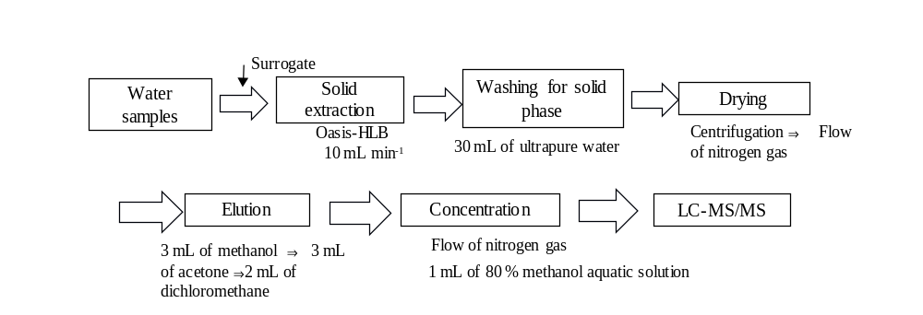
Fig. S1. Analysis procedure for pharmaceuticals.

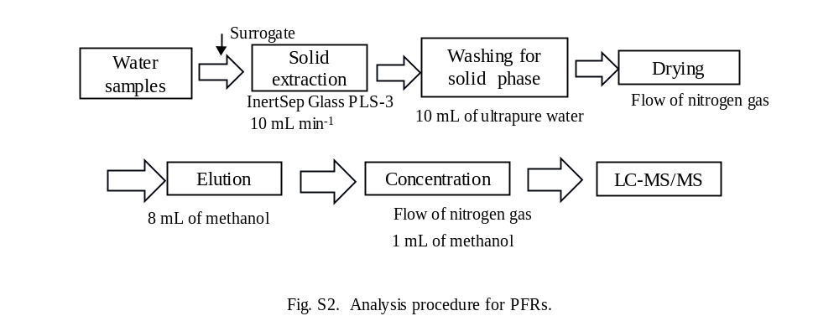

Fig. S2. Analysis procedure for phosphate ester flame retardants (PFRs).

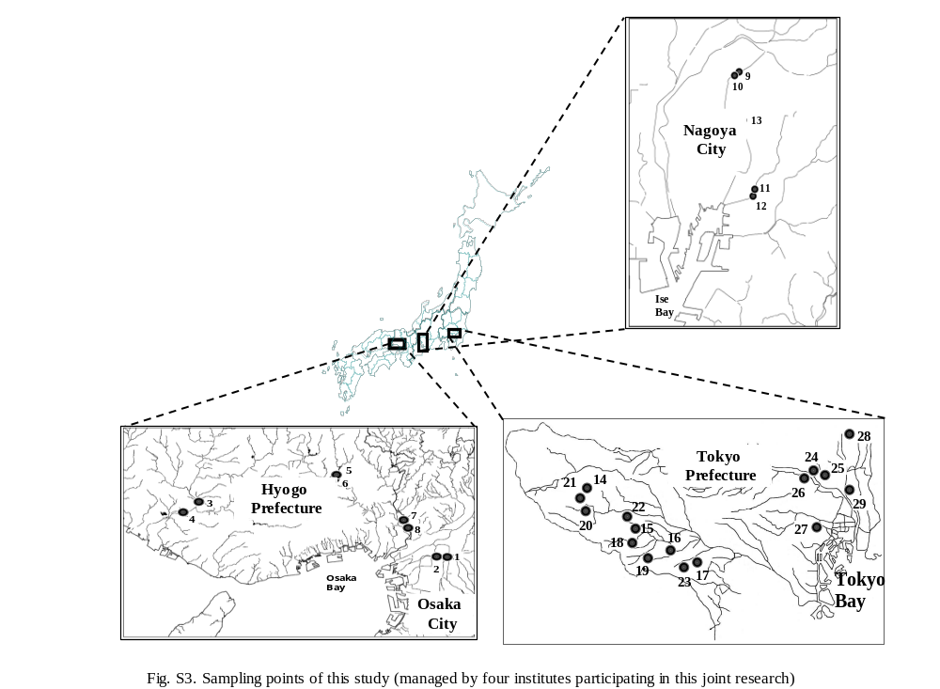

Fig. S3. Sampling points of this study (managed by four institutes participating in this joint research)

