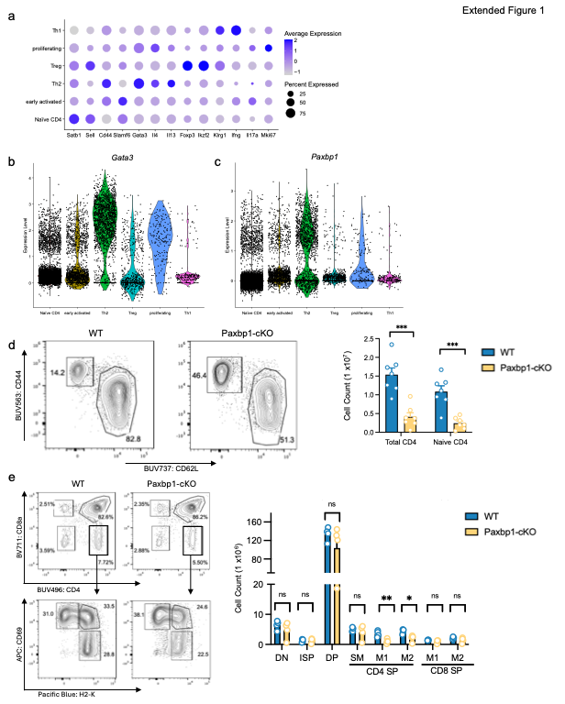
Extended Data Figure 1: The impact of Paxbp1 deletion on T cells in the thymus and the periphery
a, Dotplot showing the expression of representative lineage specifying genes across CD4⁺ T cell populations from GSE131996. b,c, Violin plots of (b) Gata3 and (c) Paxbp1 expression across CD4⁺ T cell populations from GSE131996. d, (On left) Representative FACS plots depicting CD62L and CD44 surface expression on splenic CD4⁺ T cells from WT and Paxbp1-cKO mice. (n=7) (On right) Bar graphs displaying pooled data calculated as the absolute numbers of total CD4⁺ and naïve T cells isolated from spleens. T cells were gated on Live TCRβ⁺ CD4⁺ Cd8a⁻ Foxp3⁻. (n=7) e, (On left) Representative FACS plots depicting thymocytes from WT and Paxbp1^{fl/fl} Cd4-Cre⁺ mice. CD4 and CD8a surface expression is shown in upper panels with H-2K and CD69 surface expression in thymic CD4⁺/CD8a⁻ cells in lower panels (black gates in the corresponding upper panel). Subsets of CD4 single positive (SP) cells were identified as follows; H-2K⁻/CD69⁺ SM cells, H-2K⁺/CD69⁺ M1 cells and H-2K⁺/CD69⁻ cells M2 cells. Abbreviations for subsets in graphs: DN (double-negative; CD4⁻CD8⁻), ISP (immature single-positive; CD4⁻CD8⁺TCRβ⁻), DP (double-positive; CD4⁺CD8⁺), SM (semi-mature), M1 (mature 1), M2 (mature 2). (On right) The pooled results shown as absolute numbers of the indicated cells in thymus. (4 mice each for WT and Paxbp1-cKO).

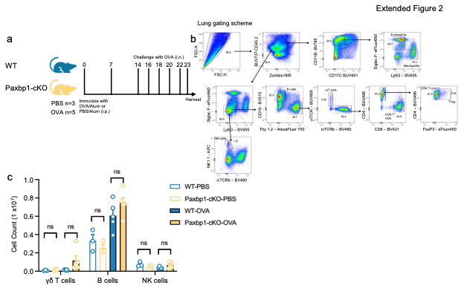
Extended Data Figure 2: Paxbp1-deficiency impairs the Th2 response to OVA. a, Experimental protocol for allergic airway inflammation using OVA peptides. WT and Paxbp1-cKO mice were immunized intraperitoneally (i.p.) with 250μg of OVA and challenged intranasally (i.n.) with 100μg of OVA. b, Gating strategy for analyzing FACS cells isolated from the lungs of WT or Paxbp1-cKO mice responding to OVA. c, Pooled results of absolute cell number of cells from γδT cells, B cells, or NK cells isolated from the lungs of WT and Paxbp1-cKO mice responding to OVA. Data are shown as the mean SEM with p values indicated (n.s. = not significant, by an unpaired student t test). Cells were gated as outlined in Extended Fig. 2b) PBS: n=3 OVA: n=5 for either genotype.

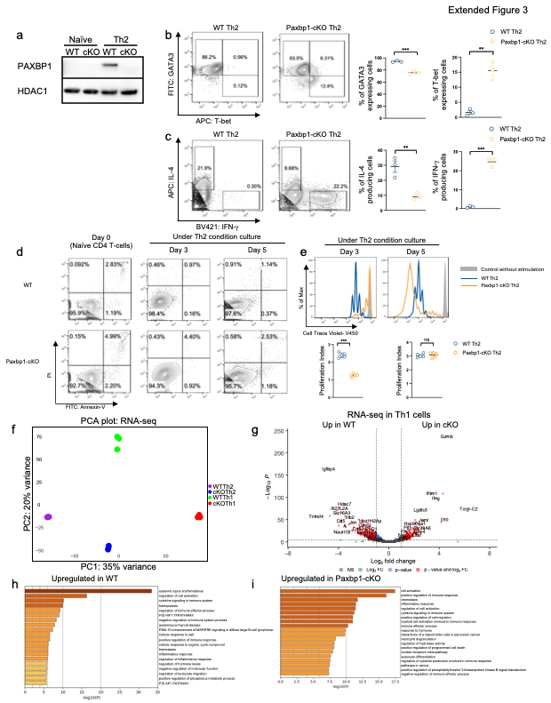

Extended Data Figure 3: Paxbp1 deletion leads to increased expression of a cytotoxic program in T cells. a, Western blot showing expression of PAXBP1 (upper) and HDAC1 (lower) proteins in WT or Paxbp1-cKO from naïve and in vitro cultured Th2 cells. b, (Left panel) Representative flow cytometry plots showing T-bet and GATA3 expression in WT or Paxbp1-cKO Th2 cells. (Right panel) Pooled data showing the percentages of indicated TFs in WT and Paxbp1-cKO cells (n=3 each for WT and Paxbp1-cKO). c, Representative flow cytometry plots of IFN-γ and IL-4 expression in polarized Th2 cells after restimulation with PMA and Ionomycin for 4 hours. Pooled data showing the percentage of indicated cytokines (n=3 each for WT and Paxbp1-cKO). d, Representative FACS plots of Annexin V and propidium iodide (PI) staining comparing WT (upper panels) and Paxbp1-cKO (lower panels). Naïve CD4⁺ T cells (left) and Th2 cells harvested day 3 (middle) or day 5 (right) are shown. n=2 for naïve, n = 3 for Day 3 and Day 5 CD4⁺ T cells from WT or Paxbp1-cKO. e, Representative histograms of CellTrace Violet during Th2 culture (day 3 and day 5) comparing WT and Paxbp1-cKO (upper panels). WT (blue), Paxbp1-cKO (yellow), and control naïve CD4⁺ T cell without stimulation (grey). Pooled data were used to calculate the proliferation index (total number of divisions/cells that went into division) by FlowJo (lower panel). f, Principal-component analysis of genes from bulk RNA-seq of naïve CD4⁺ T cells isolated from WT or Paxbp1-cKO mice and polarized in either Th1 or Th2 conditions. n=3. g, Volcano plot depicting differential gene expression analysis of bulk RNAseq performed on WT and Paxbp1-cKO Th1 cells polarized in vitro. n=3. h,i, Bar plots depicting the top pathways enriched from differentially expressed genes in (h) WT or (i) Paxbp1-cKO Th1 cells. Data are shown as the mean ± SD with *P < 0.01, **P < 0.001, ***P < 0.0001; n.s. = not significant, by unpaired student’s t test.

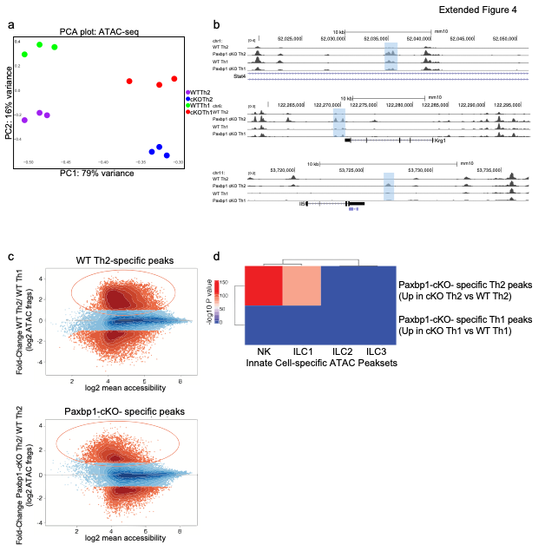
Extended Data Figure 4: Deletion of Paxbp1 in Th2 cells aberrantly increases the chromatin accessibility of innate lymphoid cell programs. a, Principal-component analysis of peaks from bulk ATAC-seq of in vitro polarized Th1 and Th2 cells isolated from WT and Paxbp1-cKO mice. n=3. b, Genome browser view of ATAC-seq tracks for example gene loci displaying differential accessibility between WT and Paxbp1-cKO in vitro polarized Th1 and Th2 cells. One replicate of three is displayed. Differential ATAC peaks are highlighted by blue boxes. c, Scatter plot visualizing the log2 fold change of normalized ATAC-seq peaks comparing either (top) WT Th2 vs Paxbp1-cKO to identify WT Th2-specific peaks or (bottom) Paxbp1-cKO Th2 vs WT Th2 to identify Paxbp1-cKO- specific peaks. d, Heatmap displaying the comparison of Paxbp1-cKO Th2 or Th1-specific ATAC peaks to innate cell populations ATAC peaks.

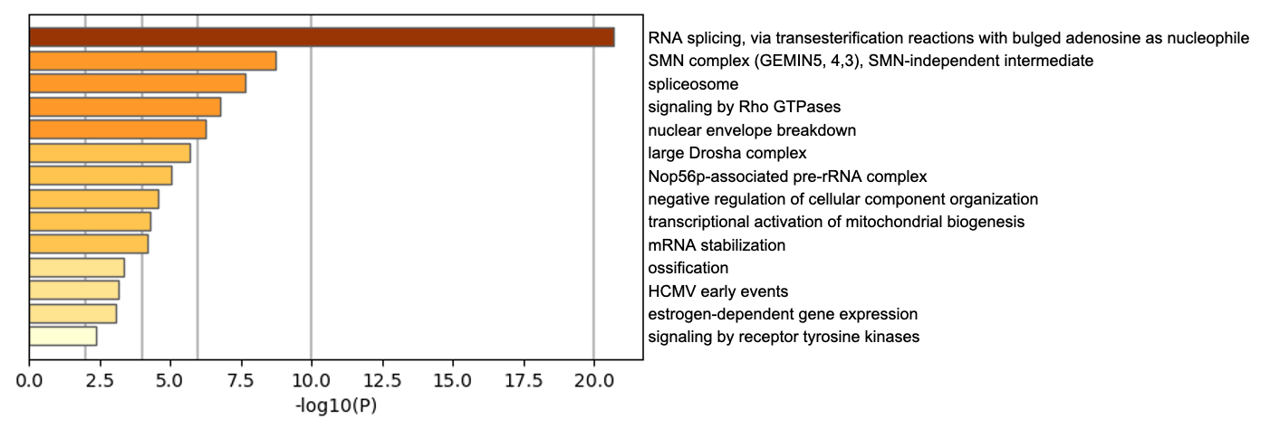
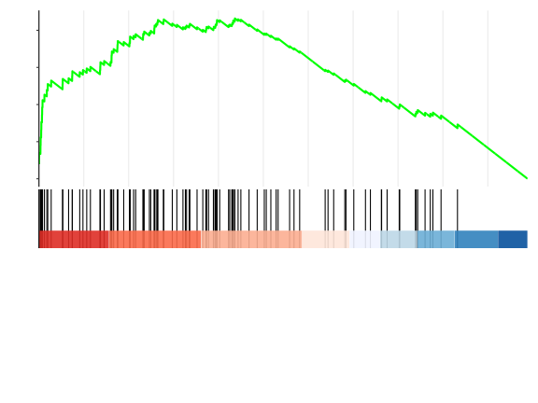
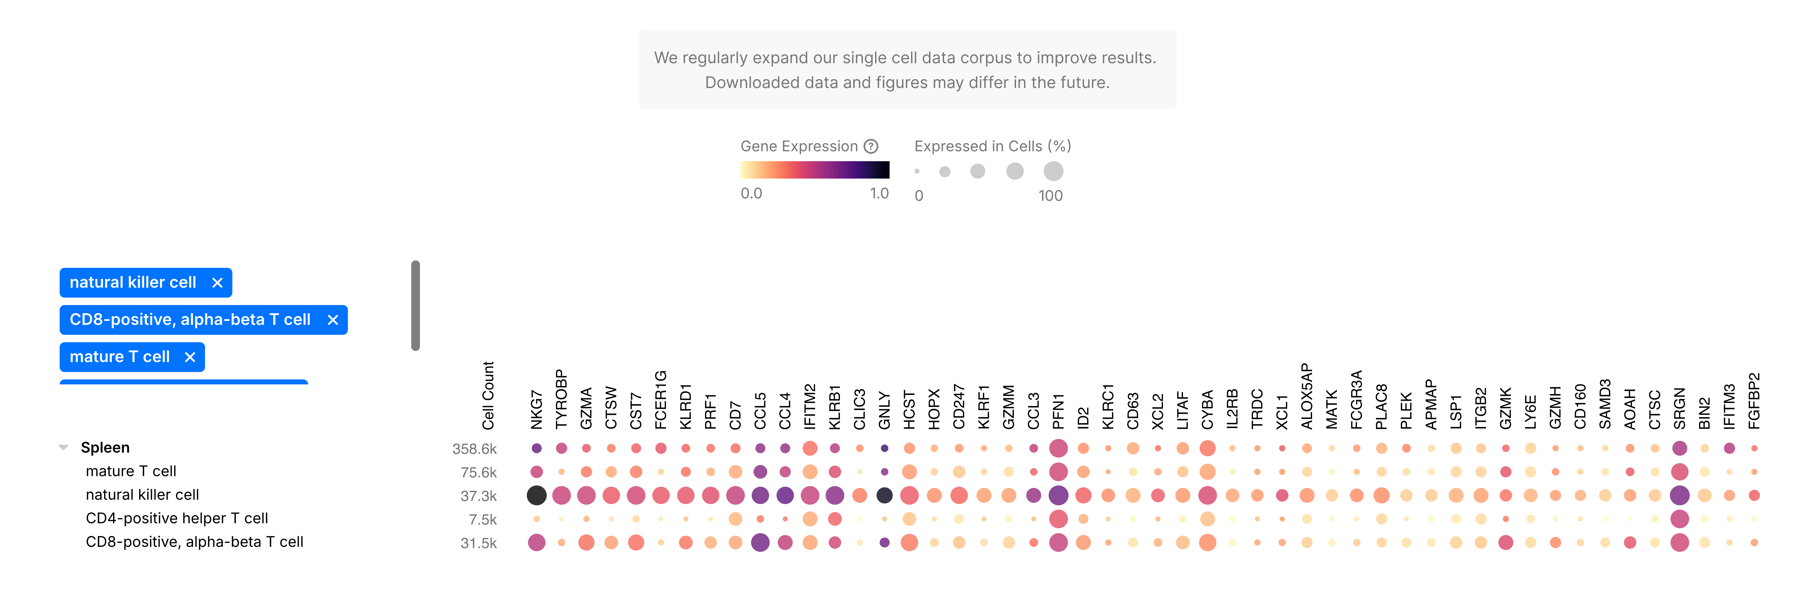
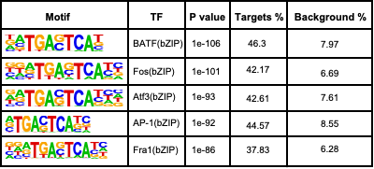
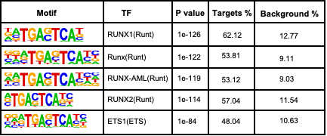
b
c
Running Enrichment Score
0.0
0.1
0.2
0.3
0.4
Li et. al. NK cell induced by ablation of Bcl11b
Extended Figure 5
Proteins identified in mass spec
RNAseq in Th1 cells
a
mature T cell
natural killer cell
CD4-positive helper T cell
CD8-positive, alpha-beta T cell
Spleen
e
Motifs associated with WT peaks
Motifs associated with Paxbp1-cKO peaks
d
NES: 2.55
pvalue: 3.74 x 10⁻⁹
Genes ranked by log2fold change
(Paxbp1-cKO Th1)
Extended Data Figure 5: Deletion of Paxbp1 perturbs Bcl11b activity. a, Dotplot of scRNAseq datasets from the CellXGene database for human mature T cells, NK cells, CD4⁺ T helper cells, and CD8⁺ αβ T cells of the top 50 genes in NK cells. b, Bar plots depicting the Metascape-identified pathways enriched in proteins identified from Paxbp1 co-immunoprecipitation coupled with mass spectrometry performed in Jurkat T cells. c, Pre-ranked GSEA analysis of genes induced in Paxbp1-cKO Th1 cells compared to WT Th1 cells. Pre-ranked genes were determined by DESeq2. d,e, Transcription factor motif enrichment of differentially accessible open chromatin regions (DORCS) that intersect with Bcl11b Th2 ChIP-seq peaks (GSE108633) from (d) WT and (e) Paxbp1-cKO Th2 cells.

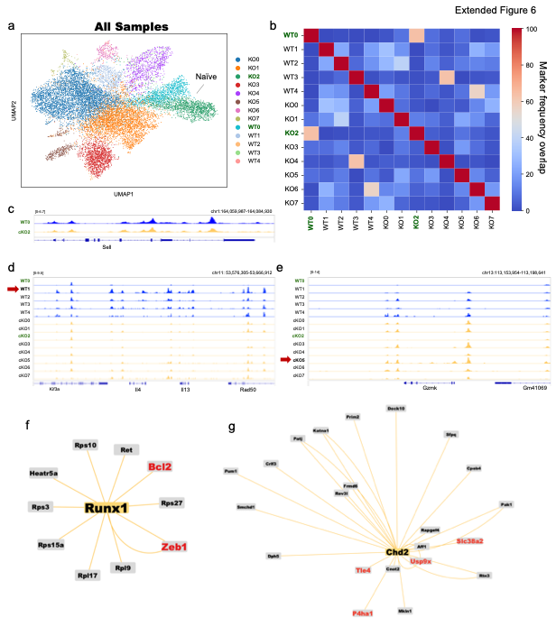
Extended Data Figure 6: Gene expression of chromatin accessibility in CD4⁺ T cells responding to N. brasiliensis.
a, Combined UMAP of WT and Paxbp1-cKO samples displayed by genotype. b, Heatmap depicting the frequency of marker overlap between clusters from single nuclei multiomics performed in WT and Paxbp1-cKO samples. Naïve clusters from WT and Paxbp1-cKO are highlighted in green. c, Genome browser views of ATAC-seq tracks at Sell from single nuclei multiomics of the “naïve” clusters from WT (WT0) and Paxbp1-cKO (KO2). d,e, Genome browser views of ATAC-seq tracks of (d) the Type 2 cytokine loci and (e) Gzmk of all WT and Paxbp1-cKO clusters from single nuclei multiomic data. f,g, Network visualization of eGRN identified by SCENIC+ for (f) Runx1 and (g) Chd2 in Paxbp1-cKO “naïve” clusters (KO2). Genes identified in eGRN were visualized using cytoscape.

