Appendix:

Are you 18 years of age or older?
- Yes
- No

Have you had any wounds related to drug use at any point in the past year?
- Yes
- No

What is your age group?
- Under 25 years
- 25-35 years
- 36-45 years
- 46-55 years
- Over 55 years

What is your gender identity?
- Man
- Woman
- Transgender
- Non-binary
- Other

What is your race? [select all that apply]
- American Indian or Alaska Native
- Asian
- Black
- Native Hawaiian or other Pacific Islander
- White
- Prefer not to say

What is your ethnicity?
- Hispanic
- Non-Hispanic

Do you currently live in a shelter or have no steady place to sleep at night?
- Yes
- No

Do you have a primary care provider?
- Yes
- No

In the past 90 days, about how often have you used the following substances?
Heroin/Fentanyl
Non-prescribed opioids (dilaudid, morphine, oxycodone, percocet)
Cocaine (crack and/or powder)
Non-prescribed methamphetamines and/or amphetamines (crystal meth, ice, speed)
- None
- Once a month or less
- A few times a month
- Once a week
- A few times a week
- Daily

In the past 90 days, how did you use the following substances? [select all that apply]
Heroin/Fentanyl
Non-prescribed opioids (dilaudid, morphine, oxycodone, percoset)
Cocaine (crack and/or powder)
Non-prescribed methamphetamines and/or amphetamines (crystal meth, ice, speed)
- Do not use
- Oral (swallowing)
- Nasal (snorting/sniffing)
- Anal (boofing/per rectally)
- Smoking
- Injection (intravenous)

In the past 90 days, have you taken any medications for treatment of opioid use disorder that were prescribed specifically to you (buprenorphine, Suboxone, Subutex, Sublocade, naltrexone, Vivitrol, methadone)?
- Yes
- No

If yes, - Which ones have you taken? [select all that apply]
- Buprenorphine tabs (subutex)
- Buprenorphine-naloxone films (suboxone or zubsolv)
- Buprenorphine injection (sublocade/brixadi)
- Methadone
- Naltrexone (Revia)
- Naltrexone injection (vivatrol)

Have you ever been exposed to, or used xylazine?
- Yes
- No
- I do not know

In the past 90 days, what is the main way you use your drugs?
- Oral (swallowing)
- Nasal (snorting/sniffing)
- Anal (boofing/per rectally)
- Smoking
- Injection (intravenous)

In the past 90 days, where on the body have you injected?
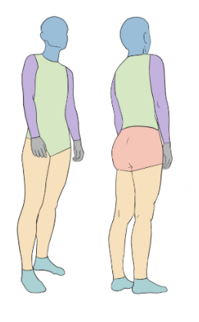
On average, how many times do you inject yourself with drugs a day?
- 1-5
- 6-10
- 11-15
- >16

On average, how many times do you reuse a needle on yourself before using a new one?
- I always use a new needle everytime I inject
- 2-3x
- 4-5x
- >5x

In the past 90 days, have you injected under your skin (skin pop rather than into the vein)?
- Yes
- No

In the past 90 days, have you injected into your muscle (muscling)?
- Yes
- No

If Yes. How do you know you were exposed to, or using xylazine? [select all that apply]
- I wanted to use xylazine
- I used a xylazine test strip
- I had my drugs tested at a community drug checking site
- I had a urine drug test that showed xylazine
- I got a new type of wound
- Other __________________

If No or I do not know. How do you know you were not exposed to, or using xylazine? [select all that apply]
- I used a xylazine test strip
- I had my drugs tested at a community drug checking site
- I had a urine drug test that did not show xylazine
- I got a new type of wound
- Other __________________

If you tested your drugs and found that they have xylazine mixed in with them, what would you do? [Select all that apply]
- Nothing
- I wouldn’t use them
- I would use less that I usually use
- I would use more than I usually use
- I would buy from a differed dealer
- I would use with others
- Would change the route I used it
- Other __________________

In the past 90 days, have you had any of the following NEW symptoms? [Select all that apply]
- Feeling very sleepy after using
- Passing out after using
- Ulcers in nose
- Sinus pain or sinus infection
- Coughing up dark mucus
- Dry mouth
- Low red blood cell counts (anemia)
- High or low blood sugar
- Ulcers in rectum or anus
- Ulcer like wounds
- None of the above
- Other ____________________

In the past 90 days, label all the areas where you had a drug-use related wound.

In the past 90 days, have you had any wounds that appear like any of the following? [select all that apply]
- Purple red blister
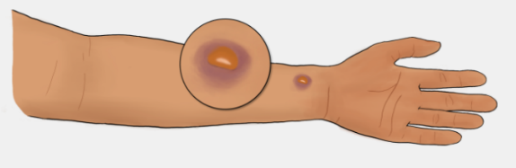
- Small ulcer with or without dark scabbing
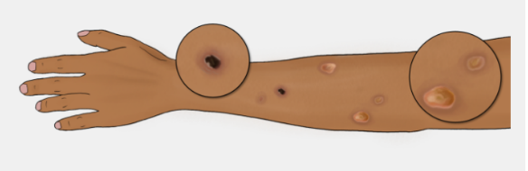

- Larger ulcer with or without dark scabbing
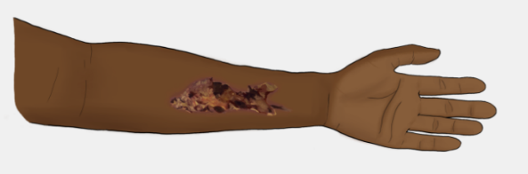
- None of the above

In the past 90 days, have you ever gotten wounds in places where you DID NOT inject?
- Yes
- No
- I don’t know
- I do not inject my drugs

In the past 90 days, have you ever gotten wounds in places where you DID NOT inject?
- Yes
- No

Is there anything else you would like to tell us about your experience with xylazine? Please type your response
_________________________________________________________________________________________________________________________________________________________________________________________________________________________________________________________________________________________________________________________________________________________________________________________________________________________________________________________________________________

