Supplementary materials
Table 1
List of indicators taken from the literature and adapted with the research team (Arroyave et al., 2021; Chukwuma et al., 2017; Dettrick et al., 2016; Joshi et al., 2014; Kyei et al., 2012; Raru et al., 2022)
- Early initiation of ANC Visit
- Regular follow-up ANC
- Medical procedures
  - Realize tests
  - Receive treatment or medication
- Receive information/advice from healthcare staff
- Looking after baby at birth
- Take care of mother at birth
- Help with breastfeeding (especially primiparous mothers)
- Health staff should be informed about the woman's health and the risk factors for complications.
- Take care of the mother after birth
- Experience childbirth
- Ease of telephone communication with health staff
- Availability of emergency transport
  - Ability to use
- Continuous electrical power supply/guarantee
- Availability of running water in the structure
- Respect for confidentiality during ANC/delivery consultations
- Accessibility of clean toilets
- Availability of health staff
- Cleanliness of premises
- Health staff take good precautionary hygiene measures
- Distance from maternity hospital
- General costs associated with ANC, childbirth, postnatal care
  - Costs associated with quality of care
- Provider-patient relationship
  - Negative or
  - Positive
- Dishonesty of health personnel
- Very strict guidelines
- History of the mother's delivery or pregnancy

Table 2: Adjacency matrix of the full category map before the map.

Code | C01 | C02 | C03 | C04 | C05 | C06 | C07 | C08 | C09 | C10 | C11 | C12 | C13 | C14 | C15 | C16 | C17 | C18 | C19 | C20 | C21 | C22
C01 | 0.0 | 0.0 | 0.0 | 0.0 | 0.0 | 0.0 | 0.0 | 0.0 | 0.0 | 0.0 | 0.0 | 0.0 | 0.0 | 0.0 | 0.0 | 0.0 | 0.0 | 0.0 | 0.0 | 0.0 | 0.0 | 0.0
C02 | 0.2 | 0.1 | 0.0 | 0.0 | 0.0 | 0.0 | 0.0 | 0.0 | 0.0 | 0.0 | 0.0 | 0.0 | 0.0 | 0.0 | 0.0 | 0.0 | 0.0 | 0.0 | 0.0 | 0.0 | 0.0 | 0.0
C03 | 0.1 | 0.0 | 0.0 | 0.1 | 0.0 | -0.1 | 0.1 | -0.1 | 0.0 | 0.0 | 0.0 | 0.0 | 0.2 | 0.0 | 0.0 | 0.0 | 0.0 | 0.0 | 0.0 | 0.0 | 0.1 | 0.0
C04 | 0.5 | 0.0 | 0.0 | 0.1 | 0.0 | 0.0 | 0.1 | 0.0 | 0.0 | 0.0 | -0.1 | 0.0 | 0.1 | 0.0 | 0.1 | -0.1 | 0.0 | 0.0 | 0.0 | 0.0 | 0.2 | 0.0
C05 | -0.3 | 0.0 | 0.0 | 0.0 | 0.0 | 0.0 | -0.1 | 0.0 | 0.0 | 0.0 | 0.0 | 0.0 | -0.1 | 0.0 | 0.0 | 0.0 | 0.0 | 0.0 | 0.0 | 0.0 | -0.1 | 0.0
C06 | -0.6 | 0.0 | 0.0 | 0.0 | 0.0 | 0.2 | -0.2 | 0.0 | 0.0 | 0.0 | 0.0 | 0.0 | -0.2 | 0.0 | -0.1 | 0.0 | -0.1 | 0.0 | 0.0 | 0.0 | -0.2 | 0.0
C07 | 0.5 | 0.0 | 0.0 | 0.0 | 0.0 | 0.0 | 0.1 | 0.0 | 0.0 | -0.1 | 0.0 | 0.0 | 0.1 | 0.0 | 0.1 | 0.0 | 0.0 | 0.0 | 0.0 | 0.0 | 0.2 | 0.0
C08 | 0.6 | 0.0 | 0.0 | 0.1 | -0.1 | 0.0 | 0.1 | 0.2 | 0.0 | 0.0 | 0.0 | 0.0 | 0.1 | 0.0 | 0.0 | 0.0 | 0.2 | 0.3 | 0.1 | 0.0 | 0.2 | 0.0
C09 | 0.0 | 0.0 | 0.0 | 0.0 | 0.0 | 0.0 | 0.0 | 0.0 | 0.0 | 0.0 | 0.0 | 0.0 | 0.0 | 0.0 | 0.0 | 0.0 | 0.0 | 0.0 | 0.0 | 0.0 | 0.0 | 0.0
C10 | -0.1 | 0.0 | 0.0 | 0.0 | 0.0 | 0.0 | 0.0 | 0.0 | 0.0 | 0.0 | 0.0 | 0.0 | 0.0 | 0.0 | 0.0 | 0.0 | 0.0 | 0.0 | 0.0 | 0.0 | -0.1 | 0.0
C11 | -1.0 | 0.0 | 0.0 | -0.1 | 0.0 | 0.0 | 0.0 | 0.0 | 0.0 | 0.1 | 0.5 | 0.0 | 0.0 | 0.0 | 0.0 | 0.0 | 0.0 | 0.0 | 0.1 | 0.0 | -0.1 | 0.0
C12 | -0.5 | 0.0 | 0.0 | 0.0 | 0.0 | 0.0 | 0.0 | 0.0 | 0.0 | 0.0 | 0.0 | 0.0 | 0.0 | 0.0 | -0.1 | 0.0 | 0.0 | 0.0 | 0.0 | 0.0 | 0.0 | 0.0
C13 | 0.9 | 0.0 | 0.0 | 0.3 | 0.0 | -0.1 | 0.1 | 0.0 | 0.0 | -0.1 | 0.0 | 0.0 | 0.8 | 0.0 | 0.1 | 0.0 | 0.0 | 0.0 | 0.0 | 0.0 | 0.6 | 0.0
C14 | -0.2 | 0.0 | 0.0 | 0.0 | 0.0 | 0.1 | 0.0 | 0.0 | 0.0 | 0.0 | 0.1 | 0.0 | -0.1 | 0.1 | 0.0 | 0.0 | 0.0 | 0.0 | 0.1 | 0.0 | 0.0 | 0.0
C15 | 0.8 | 0.0 | 0.0 | 0.0 | 0.0 | 0.0 | 0.0 | 0.0 | 0.0 | 0.0 | 0.0 | -0.1 | 0.0 | 0.0 | 0.5 | 0.0 | 0.0 | 0.0 | 0.0 | 0.0 | 0.0 | 0.0
C16 | -0.3 | 0.0 | 0.0 | -0.1 | 0.0 | 0.0 | 0.0 | 0.0 | 0.0 | -0.1 | 0.0 | 0.0 | 0.0 | 0.0 | 0.0 | 0.0 | 0.0 | 0.0 | 0.0 | 0.0 | -0.1 | 0.0
C17 | 0.4 | 0.0 | 0.0 | 0.1 | -0.1 | -0.1 | 0.1 | 0.0 | 0.0 | 0.0 | 0.0 | 0.0 | 0.1 | 0.0 | 0.1 | 0.0 | 0.1 | 0.0 | 0.0 | 0.0 | 0.0 | 0.0
C18 | 0.1 | 0.0 | 0.0 | 0.1 | 0.0 | 0.0 | 0.0 | 0.0 | 0.0 | 0.0 | 0.0 | 0.0 | 0.1 | -0.1 | 0.0 | 0.0 | 0.2 | 0.0 | 0.0 | 0.0 | 0.1 | 0.0
C19 | 0.1 | 0.0 | 0.0 | 0.0 | 0.0 | 0.0 | 0.0 | 0.0 | 0.0 | 0.0 | 0.1 | 0.0 | 0.0 | 0.0 | 0.0 | 0.0 | 0.0 | 0.0 | 0.1 | 0.0 | 0.0 | 0.0
C20 | 0.0 | 0.0 | 0.0 | 0.0 | 0.0 | 0.0 | 0.0 | 0.0 | 0.0 | 0.0 | 0.0 | 0.0 | 0.0 | 0.0 | 0.0 | 0.0 | 0.0 | 0.0 | 0.0 | 0.0 | 0.0 | 0.0
C21 | 0.4 | 0.0 | 0.0 | 0.1 | 0.0 | 0.0 | 0.0 | 0.0 | 0.0 | 0.0 | 0.0 | 0.0 | 0.2 | 0.0 | 0.1 | 0.0 | 0.0 | 0.0 | 0.0 | 0.0 | 0.3 | 0.0
C22 | 0.2 | 0.0 | 0.0 | 0.0 | 0.0 | 0.0 | 0.0 | 0.0 | 0.0 | 0.0 | -0.1 | 0.0 | 0.0 | 0.0 | 0.0 | 0.0 | 0.0 | 0.0 | 0.0 | 0.0 | 0.0 | 0.0

Figure 1: Category maps of perception of women of reproductive age on what influences quality of maternal care in Burkina Faso. Legend: This map illustrates the category-level relationships prior to the prompt. It features 20 out of the 22 categories, excluding one category absent after transitive closure due to the relationship disappearing (C20) and another introduced post-prompt. Bolder lines indicate stronger relationships. Dashed lines indicate negative relationships. To ensure proper visualization, we have labelled only the 8 categories with the eight strongest relationships with quality of maternal care; for the others, refer to Table 3.
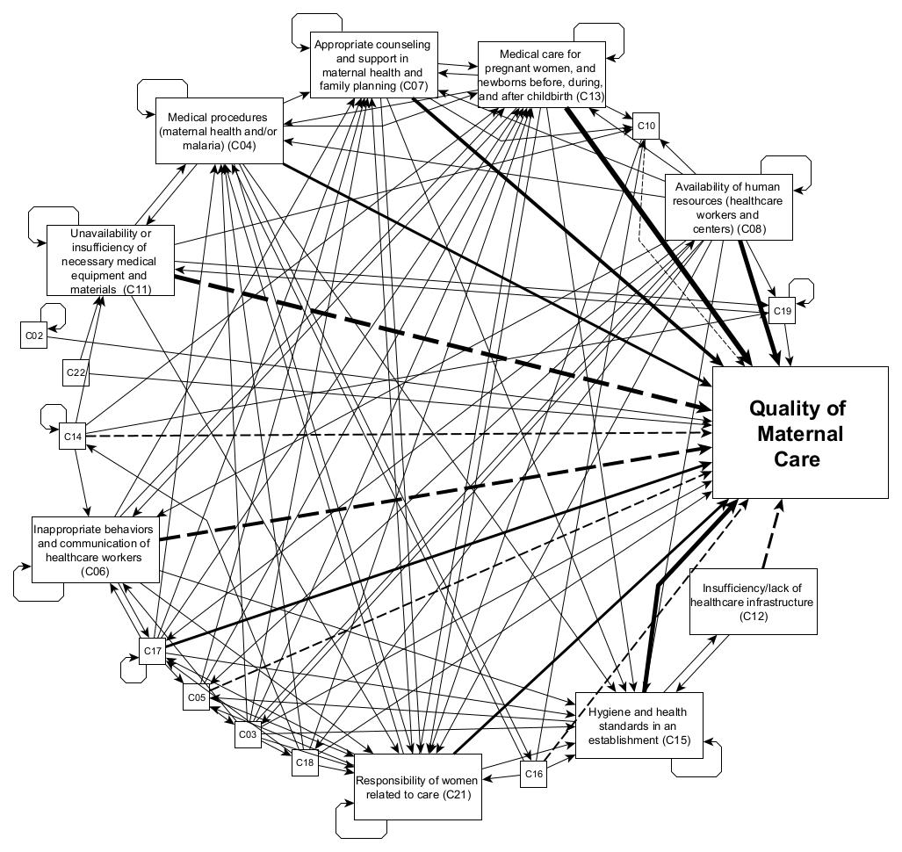
Figure 2: Perception of women of reproductive age on factors influencing quality of maternal care (after prompting questions)- composite results of 8 fuzzy cognitive mapping sessions in Burkina Faso.
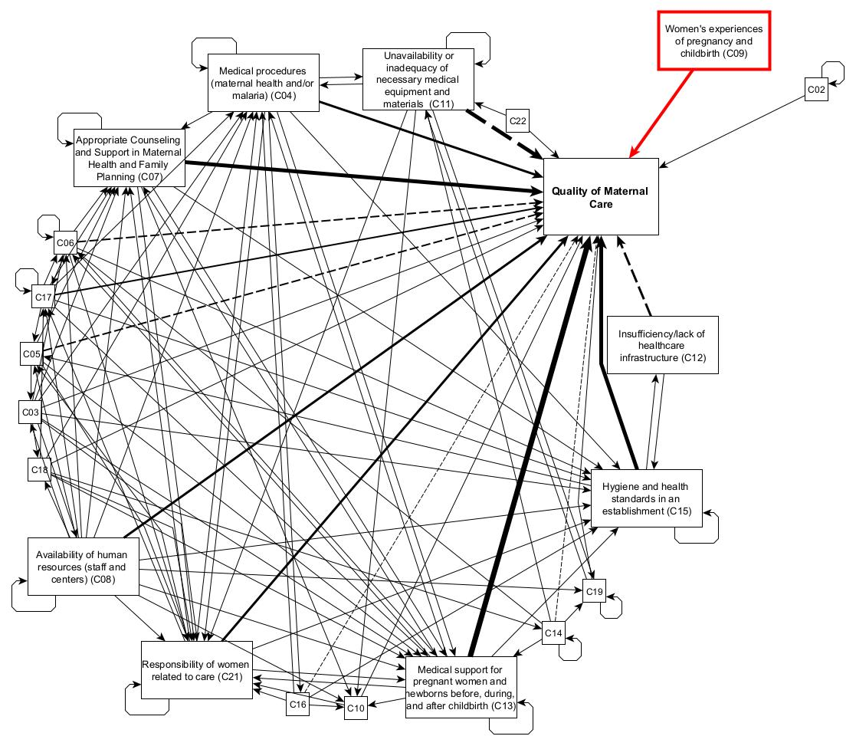
Legend: This map illustrates the category-level relationships after the prompting question, focusing on the categories with the strongest associaiton with the quality of maternal care. It features 21 out of 22 categories, excluding one category absent after transitive closure. The new category is highlighted in red. Bolder lines indicate stronger relationships.

