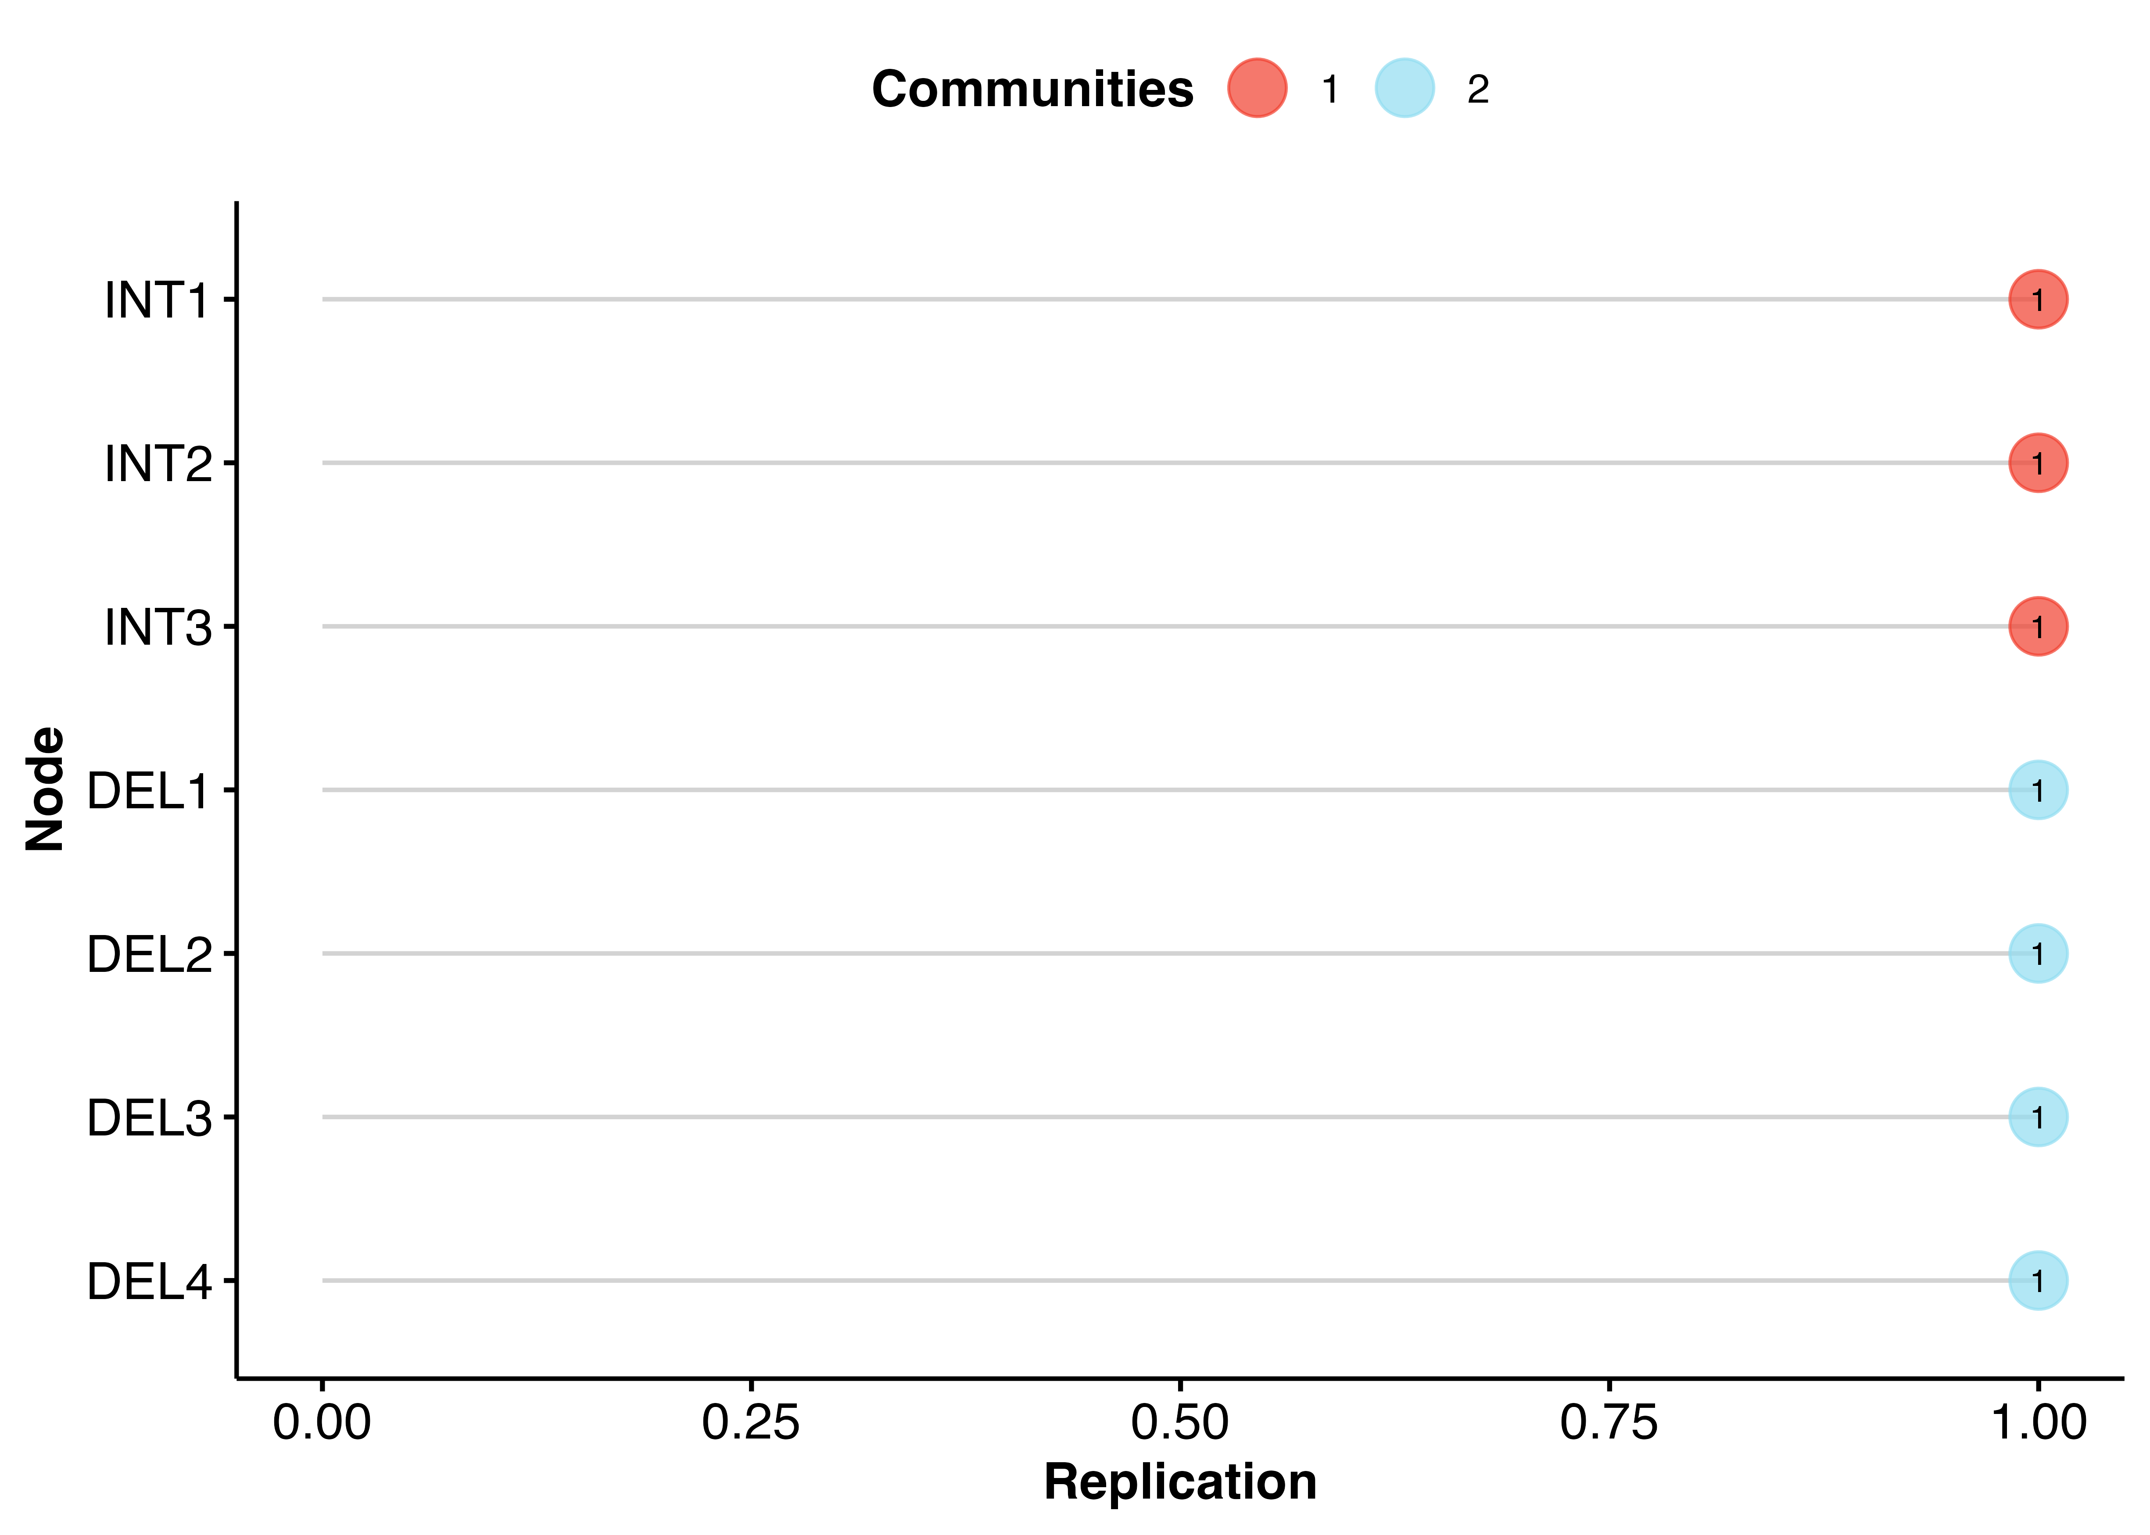
Figure S 1 Item Replication of the EGA structure

