Table 1 presents the key characteristics of Platform-Bound Reputation Systems (PBRS) and how LCS can address the trust-related gaps
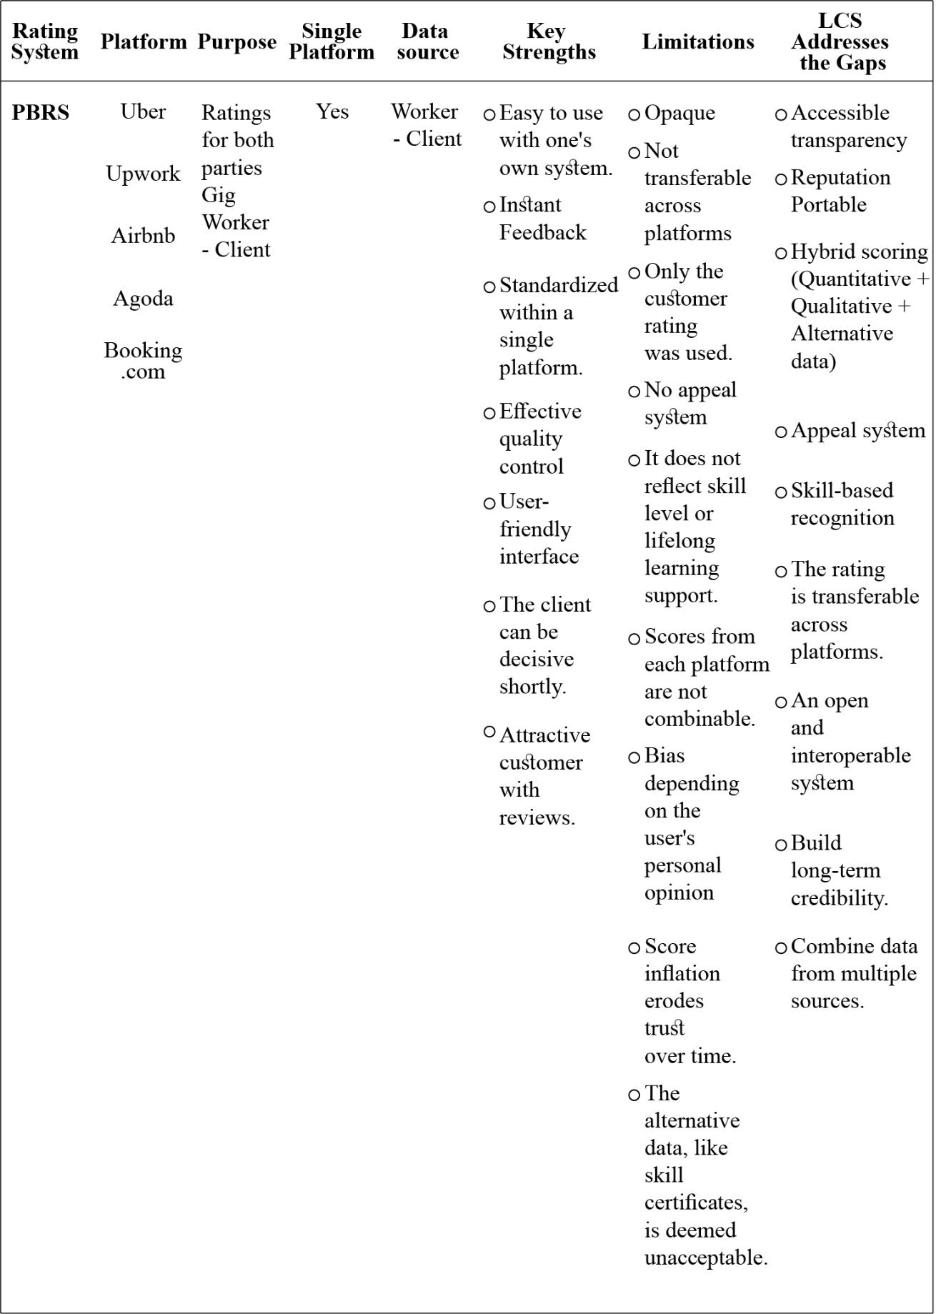
Table 2 compares the characteristics of AI-based rating systems like Amazon Flex with LCS.

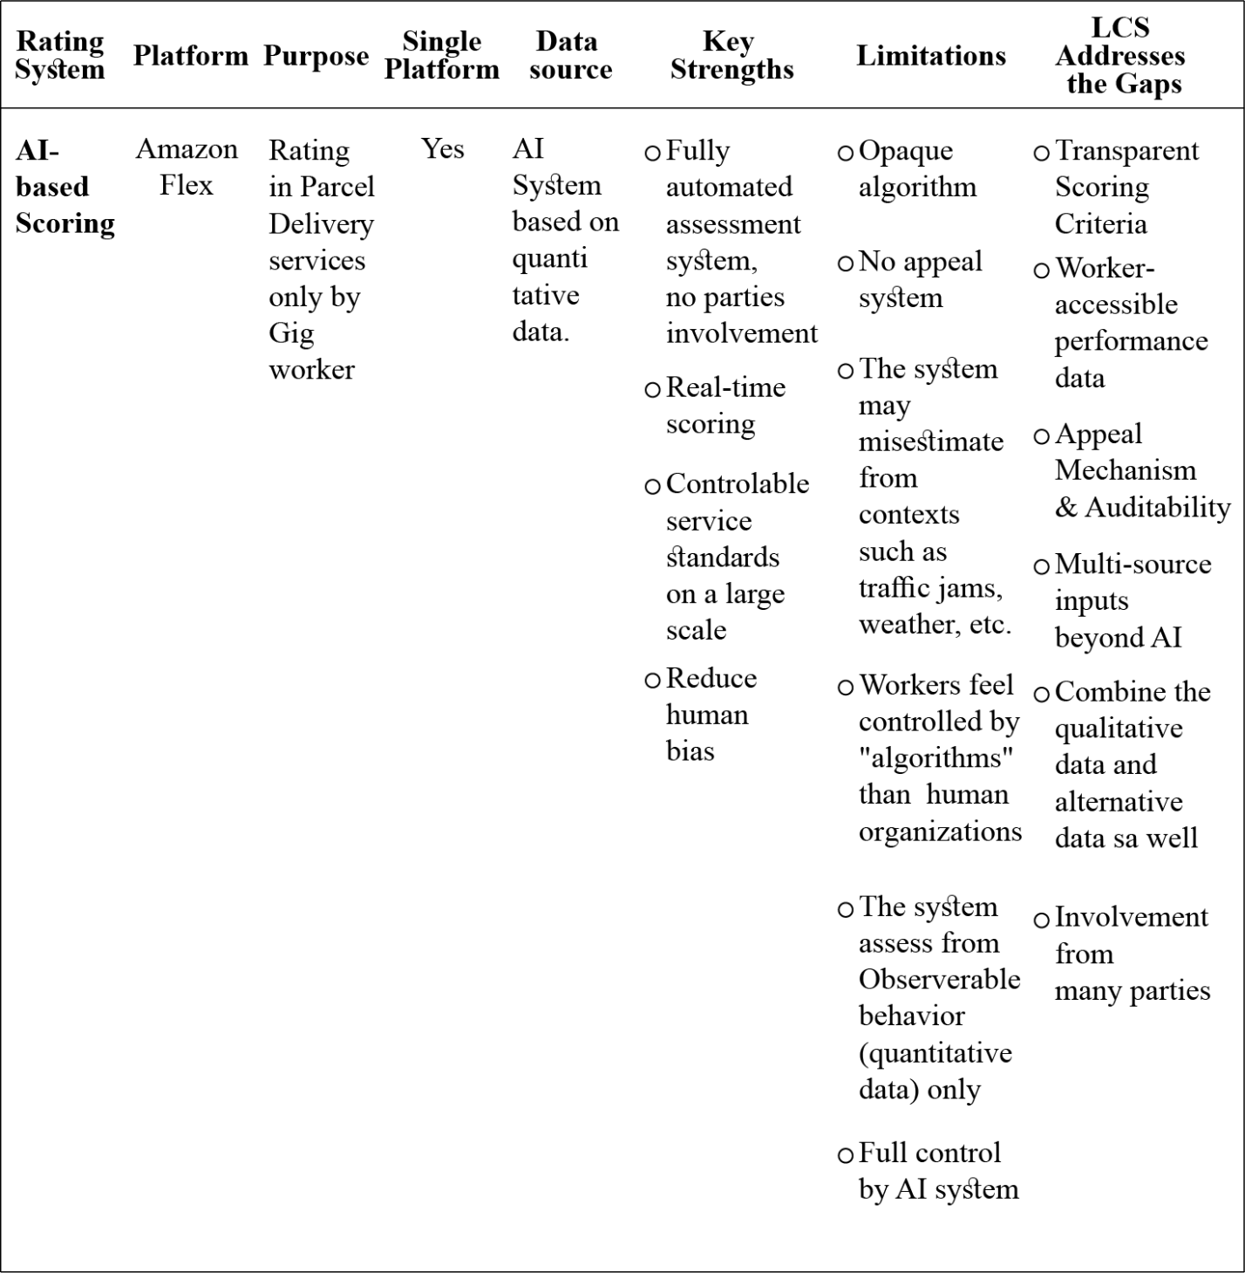
Table 3 examines blockchain-based reputation models with LCS that address these gaps.

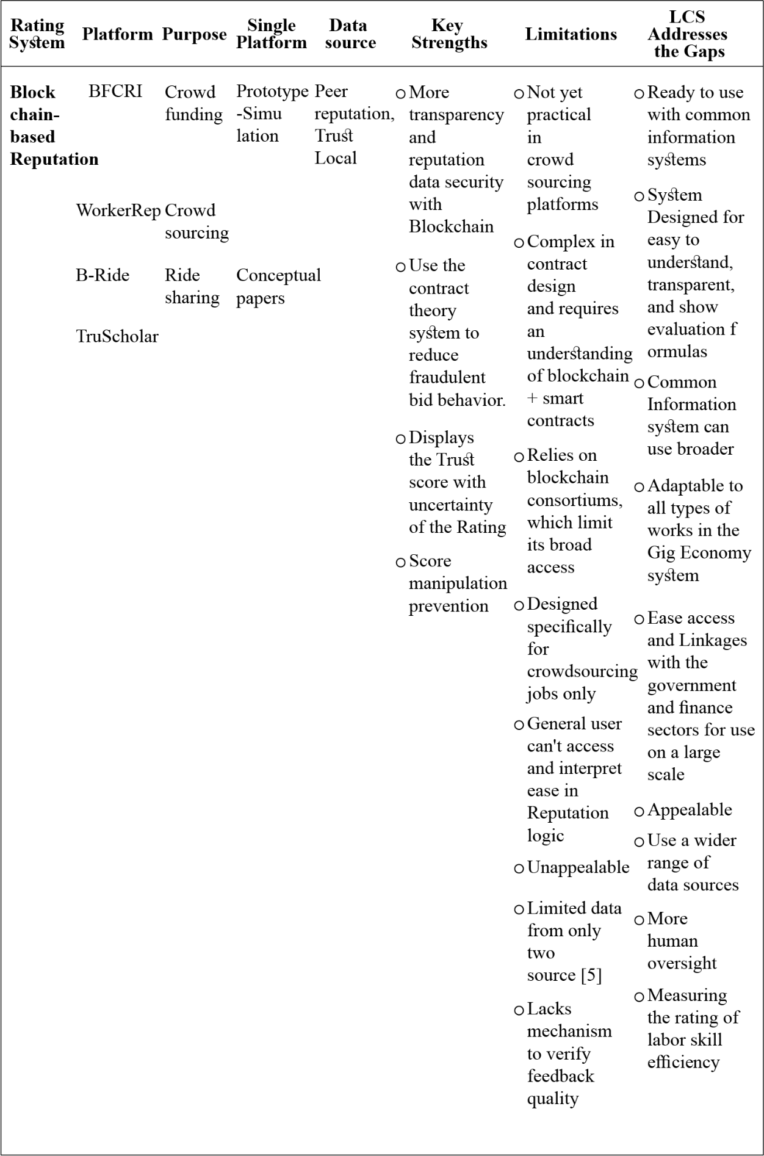
Table 4 presents alternative credit scoring systems with LCS that address these gaps.

