Supplementary Material 2.

Crossing through danger: Spatial drivers of roadkill risk for felids in the fragmented Middle Magdalena valley

Julián Arango-Lozano¹*, Karime Angarita-Corzo²

¹Maestría en Ciencias Biológicas, Universidad de Caldas, Manizales, Colombia
²Escuela de Medicina Veterinaria. Facultad de Ciencias Agrarias. Universidad de Antioquia, Carrera 75 # 65-87, 050034, Medellín, Colombia.

* Corresponding author: arangolozanoj1@gmail.com

Data collection of felid species occurrences.
A comprehensive database was built using Presence records of felid species obtained from public platforms such as iNaturalist, covering a time frame from 2018 to 2025. Each record was reviewed to ensure spatial accuracy and appropriate use; and Roadkill records, collected through systematic field surveys conducted between 2022 and 2025 along different sections of the Ruta del Sol. In total we recorded 15 roadkill events as follows: 9 of Leopardus pardalis, 5 of Herpailurus yagouaroundi and 1 of Puma concolor (Table 2) by surveying and 169 observation events from opportunistic encounters (camera trap) and iNaturalist records (mainly by camera traps) in all the 5 recognized felid species in the Middle Magdalena Valley (Table 2).
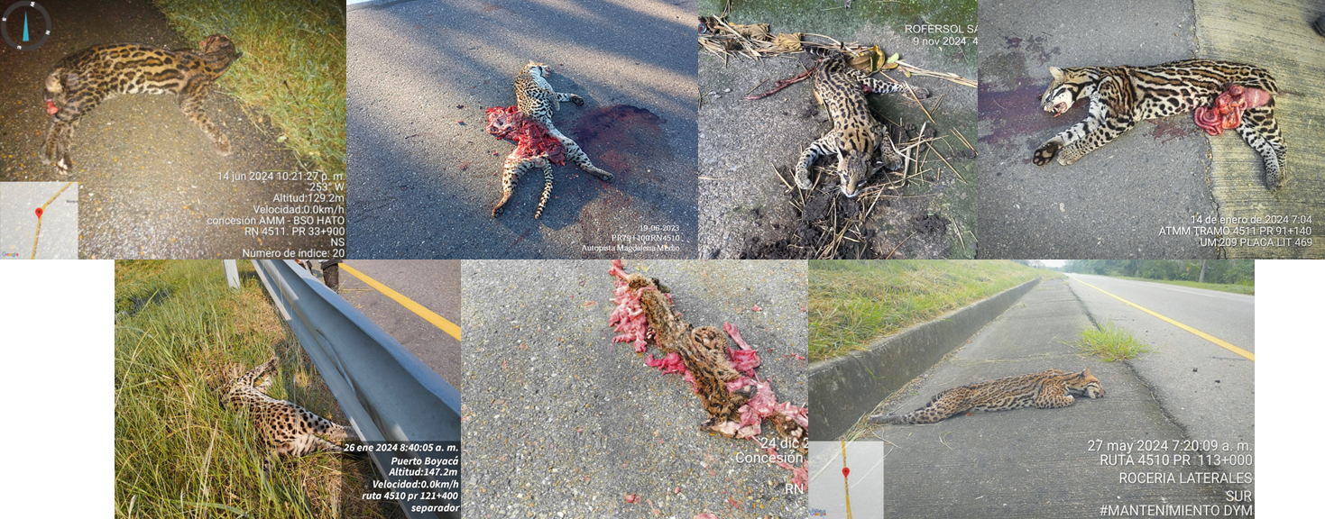
Figure 1. different records of Leopardus pardalis roadkilled.
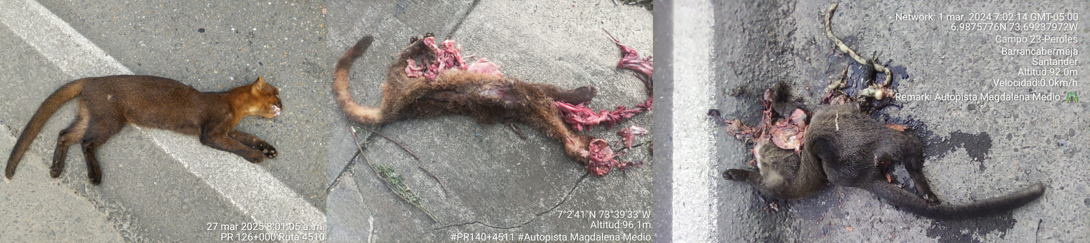
Figure 2. different records of Herpailurus yagouaroundi roadkilled.

Table 2. Description of the roadkilled felid species in the ruta del sol Highway. PK = Kilometer marker point, NR = National route.
Species | Event | X | Y | Source
Herpailurus_yagouaroundi | Atropellamiento | -74,256577 | 6,478132 | Authors
Herpailurus_yagouaroundi | Atropellamiento | -73,658974 | 7,045297 | Authors
Herpailurus_yagouaroundi | Atropellamiento | -73,686071 | 6,998461 | Authors
Herpailurus_yagouaroundi | Atropellamiento | -73,71403 | 6,938518 | Authors
Herpailurus_yagouaroundi | Atropellamiento | -74,561862 | 6,184405 | Authors
Leopardus_pardalis | Observación | -73,918143 | 6,579374 | Authors
Leopardus_pardalis | Observación | -73,921384 | 6,698685 | Authors
Leopardus_pardalis | Observación | -73,727598 | 6,838931 | Authors
Leopardus_pardalis | Observación | -73,70817 | 6,818191 | Authors
Leopardus_pardalis | Observación | -73,747647 | 7,077884 | Authors
Leopardus_pardalis | Atropellamiento | -74,488075 | 6,260016 | Authors
Leopardus_pardalis | Atropellamiento | -74,642408 | 5,482914 | Authors
Leopardus_pardalis | Atropellamiento | -73,871522 | 6,743528 | Authors
Leopardus_pardalis | Atropellamiento | -74,320371 | 6,432846 | Authors
Leopardus_pardalis | Atropellamiento | -73,930012 | 6,666792 | Authors
Leopardus_pardalis | Atropellamiento | -74,101242 | 6,521126 | Authors
Leopardus_pardalis | Atropellamiento | -74,553307 | 6,096157 | Authors
Leopardus_pardalis | Atropellamiento | -74,551989 | 6,072828 | Authors
Leopardus_pardalis | Atropellamiento | -73,82105 | 6,778662 | Authors
Panthera_onca | Observación | -74,67272 | 6,096083 | Authors
Puma_concolor | Atropellamiento | -74,622717 | 5,722991 | Authors
Herpailurus_yagouaroundi | Observación | -73,692169 | 7,071933 | iNaturalist
Herpailurus_yagouaroundi | Observación | -73,736801 | 7,072615 | iNaturalist
Herpailurus_yagouaroundi | Observación | -73,748646 | 7,080717 | iNaturalist
Herpailurus_yagouaroundi | Observación | -74,678578 | 6,069502 | iNaturalist
Herpailurus_yagouaroundi | Observación | -74,210861 | 6,805333 | iNaturalist
Herpailurus_yagouaroundi | Observación | -73,45821 | 6,975458 | iNaturalist
Herpailurus_yagouaroundi | Observación | -73,403376 | 7,104182 | iNaturalist
Herpailurus_yagouaroundi | Observación | -73,872079 | 7,089485 | INaturalist
Herpailurus_yagouaroundi | Observación | -73,403376 | 7,104182 | iNaturalist
Herpailurus_yagouaroundi | Observación | -73,679822 | 6,809017 | iNaturalist
Herpailurus_yagouaroundi | Observación | -74,711941 | 5,47015 | iNaturalist
Leopadus_wiedii | Observación | -74,177879 | 6,459947 | iNaturalist
Leopadus_wiedii | Observación | -74,168232 | 6,416974 | iNaturalist
Leopadus_wiedii | Observación | -74,119244 | 6,525333 | iNaturalist
Leopadus_wiedii | Observación | -74,088909 | 6,556896 | iNaturalist
Leopadus_wiedii | Observación | -73,891082 | 6,592056 | iNaturalist
Leopadus_wiedii | Observación | -73,768439 | 6,749895 | iNaturalist
Leopadus_wiedii | Observación | -73,688757 | 6,789981 | iNaturalist
Leopadus_wiedii | Observación | -73,994749 | 6,159889 | iNaturalist
Leopadus_wiedii | Observación | -73,845658 | 6,528015 | iNaturalist
Leopadus_wiedii | Observación | -73,812233 | 6,528824 | iNaturalist
Leopadus_wiedii | Observación | -74,162327 | 6,231705 | iNaturalist
Leopadus_wiedii | Observación | -74,993021 | 5,717035 | iNaturalist
Leopadus_wiedii | Observación | -74,972222 | 5,669248 | iNaturalist
Leopadus_wiedii | Observación | -74,938135 | 5,619882 | iNaturalist
Leopadus_wiedii | Observación | -74,998438 | 5,600871 | iNaturalist
Leopadus_wiedii | Observación | -74,914751 | 5,776978 | iNaturalist
Leopadus_wiedii | Observación | -74,825624 | 5,662999 | iNaturalist
Leopadus_wiedii | Observación | -74,825624 | 5,776121 | iNaturalist
Leopadus_wiedii | Observación | -74,939604 | 5,692136 | iNaturalist
Leopadus_wiedii | Observación | -74,042709 | 6,234612 | iNaturalist
Leopadus_wiedii | Observación | -74,12573 | 6,325667 | iNaturalist
Leopadus_wiedii | Observación | -74,187327 | 6,325667 | iNaturalist
Leopadus_wiedii | Observación | -74,190005 | 6,372534 | iNaturalist
Leopadus_wiedii | Observación | -74,104305 | 6,39128 | iNaturalist
Leopadus_wiedii | Observación | -73,994503 | 6,455555 | iNaturalist
Leopadus_wiedii | Observación | -73,931568 | 6,414044 | iNaturalist
Leopadus_wiedii | Observación | -73,932907 | 6,521168 | iNaturalist
Leopadus_wiedii | Observación | -73,772221 | 6,610884 | iNaturalist
Leopardus_pardalis | Observación | -74,678134 | 6,068845 | iNaturalist
Leopardus_pardalis | Observación | -74,523563 | 6,057343 | iNaturalist
Leopardus_pardalis | Observación | -74,14183 | 6,463589 | iNaturalist
Leopardus_pardalis | Observación | -73,665428 | 6,839807 | iNaturalist
Leopardus_pardalis | Observación | -73,691164 | 6,803085 | iNaturalist
Leopardus_pardalis | Observación | -73,747647 | 7,077884 | iNaturalist
Leopardus_pardalis | Observación | -74,547051 | 6,042448 | iNaturalist
Leopardus_pardalis | Observación | -73,768787 | 6,856745 | iNaturalist
Leopardus_pardalis | Observación | -73,921521 | 6,705069 | iNaturalist
Leopardus_pardalis | Observación | -73,921055 | 6,702952 | iNaturalist
Leopardus_pardalis | Observación | -73,874357 | 6,734441 | iNaturalist
Leopardus_pardalis | Observación | -73,870041 | 6,735517 | iNaturalist
Leopardus_pardalis | Observación | -73,870646 | 6,735185 | iNaturalist
Leopardus_pardalis | Observación | -73,78941 | 6,821999 | iNaturalist
Leopardus_pardalis | Observación | -74,283605 | 6,45287 | iNaturalist
Leopardus_pardalis | Observación | -74,282455 | 6,452394 | iNaturalist
Leopardus_pardalis | Observación | -74,282085 | 6,453037 | iNaturalist
Leopardus_pardalis | Observación | -73,561179 | 7,13785 | iNaturalist
Leopardus_pardalis | Observación | -74,472285 | 6,274262 | iNaturalist
Leopardus_pardalis | Observación | -74,255898 | 6,038311 | iNaturalist
Leopardus_pardalis | Observación | -74,609133 | 5,777273 | iNaturalist
Leopardus_pardalis | Observación | -74,959035 | 5,602877 | iNaturalist
Leopardus_pardalis | Observación | -74,846844 | 5,776162 | iNaturalist
Leopardus_pardalis | Observación | -74,847955 | 5,801711 | iNaturalist
Leopardus_pardalis | Observación | -74,826849 | 5,933896 | iNaturalist
Leopardus_pardalis | Observación | -74,669249 | 6,06266 | iNaturalist
Leopardus_pardalis | Observación | -74,644196 | 6,548128 | iNaturalist
Leopardus_pardalis | Observación | -74,513161 | 6,591351 | iNaturalist
Leopardus_pardalis | Observación | -74,10123 | 6,413851 | iNaturalist
Leopardus_pardalis | Observación | -73,907862 | 6,324276 | iNaturalist
Leopardus_pardalis | Observación | -73,903938 | 6,545398 | iNaturalist
Leopardus_pardalis | Observación | -74,206775 | 6,767248 | iNaturalist
Leopardus_pardalis | Observación | -74,20561 | 6,83131 | iNaturalist
Leopardus_pardalis | Observación | -74,20561 | 6,798114 | iNaturalist
Leopardus_pardalis | Observación | -73,689185 | 6,829763 | iNaturalist
Leopardus_pardalis | Observación | -73,854544 | 7,072866 | iNaturalist
Leopardus_pardalis | Observación | -73,68037 | 7,115521 | iNaturalist
Leopardus_pardalis | Observación | -73,617099 | 7,027368 | iNaturalist
Panthera_onca | Observación | -73,914537 | 6,61745 | iNaturalist
Panthera_onca | Observación | -73,951134 | 6,706471 | iNaturalist
Panthera_onca | Observación | -73,607943 | 7,016607 | iNaturalist
Panthera_onca | Observación | -73,713304 | 7,048847 | iNaturalist
Panthera_onca | Observación | -73,654929 | 7,061005 | iNaturalist
Panthera_onca | Observación | -73,603126 | 7,111734 | iNaturalist
Panthera_onca | Observación | -73,789211 | 7,154343 | iNaturalist
Panthera_onca | Observación | -73,498756 | 7,226266 | iNaturalist
Panthera_onca | Observación | -73,921055 | 6,702952 | iNaturalist
Panthera_onca | Observación | -73,944057 | 6,354693 | iNaturalist
Panthera_onca | Observación | -74,512172 | 6,458918 | iNaturalist
Panthera_onca | Observación | -74,292622 | 6,6791 | iNaturalist
Panthera_onca | Observación | -74,337487 | 6,68025 | iNaturalist
Panthera_onca | Observación | -74,360494 | 6,744672 | iNaturalist
Panthera_onca | Observación | -74,292622 | 6,742371 | iNaturalist
Panthera_onca | Observación | -74,510044 | 6,765379 | iNaturalist
Panthera_onca | Observación | -74,271409 | 6,809507 | iNaturalist
Panthera_onca | Observación | -74,272882 | 6,827913 | iNaturalist
Panthera_onca | Observación | -74,29276 | 6,853682 | iNaturalist
Panthera_onca | Observación | -74,251531 | 6,854418 | iNaturalist
Panthera_onca | Observación | -74,204411 | 6,854418 | iNaturalist
Panthera_onca | Observación | -74,007328 | 6,742371 | iNaturalist
Panthera_onca | Observación | -73,948659 | 6,702108 | iNaturalist
Panthera_onca | Observación | -73,745042 | 7,004657 | iNaturalist
Panthera_onca | Observación | -73,681771 | 7,028815 | iNaturalist
Panthera_onca | Observación | -73,616524 | 7,008068 | iNaturalist
Panthera_onca | Observación | -73,639142 | 7,028272 | iNaturalist
Panthera_onca | Observación | -73,595113 | 7,028876 | iNaturalist
Panthera_onca | Observación | -73,616524 | 7,052398 | iNaturalist
Panthera_onca | Observación | -73,746499 | 7,051191 | iNaturalist
Panthera_onca | Observación | -73,770021 | 7,073206 | iNaturalist
Panthera_onca | Observación | -73,703413 | 7,093844 | iNaturalist
Panthera_onca | Observación | -73,683151 | 7,094786 | iNaturalist
Panthera_onca | Observación | -73,660534 | 7,074525 | iNaturalist
Panthera_onca | Observación | -73,660063 | 7,114105 | iNaturalist
Panthera_onca | Observación | -73,634618 | 7,138136 | iNaturalist
Panthera_onca | Observación | -73,61954 | 7,138607 | iNaturalist
Panthera_onca | Observación | -73,592682 | 7,137665 | iNaturalist
Panthera_onca | Observación | -73,617655 | 7,092902 | iNaturalist
Panthera_onca | Observación | -73,682209 | 7,160754 | iNaturalist
Panthera_onca | Observación | -73,661476 | 7,160754 | iNaturalist
Panthera_onca | Observación | -73,638388 | 7,181957 | iNaturalist
Panthera_onca | Observación | -73,683151 | 7,202219 | iNaturalist
Panthera_onca | Observación | -73,748176 | 7,182429 | iNaturalist
Panthera_onca | Observación | -73,7298 | 7,180073 | iNaturalist
Panthera_onca | Observación | -73,726972 | 7,161225 | iNaturalist
Panthera_onca | Observación | -73,746291 | 7,117875 | iNaturalist
Panthera_onca | Observación | -73,87964 | 7,203632 | iNaturalist
Panthera_onca | Observación | -74,359344 | 6,937935 | iNaturalist
Panthera_onca | Observación | -74,293772 | 6,918379 | iNaturalist
Panthera_onca | Observación | -74,274216 | 6,917229 | iNaturalist
Panthera_onca | Observación | -74,231652 | 6,917229 | iNaturalist
Panthera_onca | Observación | -74,229351 | 7,006958 | iNaturalist
Panthera_onca | Observación | -74,184486 | 7,004657 | iNaturalist
Puma_concolor | Observación | -74,047008 | 6,372047 | iNaturalist
Puma_concolor | Observación | -74,232065 | 6,617651 | iNaturalist
Puma_concolor | Observación | -73,605556 | 7,041692 | iNaturalist
Puma_concolor | Observación | -73,606293 | 7,098346 | iNaturalist
Puma_concolor | Observación | -73,750131 | 7,061351 | iNaturalist
Puma_concolor | Observación | -73,707184 | 7,141767 | iNaturalist
Puma_concolor | Observación | -74,244254 | 6,66374 | iNaturalist
Puma_concolor | Observación | -74,235896 | 6,641369 | iNaturalist
Puma_concolor | Observación | -74,019192 | 6,284073 | iNaturalist
Puma_concolor | Observación | -73,952909 | 6,24114 | iNaturalist
Puma_concolor | Observación | -74,62553 | 6,436222 | iNaturalist
Puma_concolor | Observación | -74,779186 | 6,437729 | iNaturalist
Puma_concolor | Observación | -74,362206 | 6,656251 | iNaturalist
Puma_concolor | Observación | -74,381971 | 6,677462 | iNaturalist
Puma_concolor | Observación | -74,319785 | 6,720847 | iNaturalist
Puma_concolor | Observación | -74,272062 | 6,699637 | iNaturalist
Puma_concolor | Observación | -74,274954 | 6,676016 | iNaturalist
Puma_concolor | Observación | -74,253743 | 6,699155 | iNaturalist
Puma_concolor | Observación | -74,207466 | 6,743986 | iNaturalist
Puma_concolor | Observación | -74,315929 | 6,766643 | iNaturalist
Puma_concolor | Observación | -74,361724 | 6,810992 | iNaturalist
Puma_concolor | Observación | -74,362329 | 6,874264 | iNaturalist
Puma_concolor | Observación | -74,295245 | 6,962531 | iNaturalist
Puma_concolor | Observación | -74,205801 | 6,962531 | iNaturalist
Puma_concolor | Observación | -74,363506 | 6,983715 | iNaturalist
Puma_concolor | Observación | -73,594379 | 6,91602 | iNaturalist
Puma_concolor | Observación | -73,638819 | 7,068923 | iNaturalist
Puma_concolor | Observación | -73,835408 | 7,135959 | iNaturalist

These animals have not only been found roadkilled, but also live on the road:
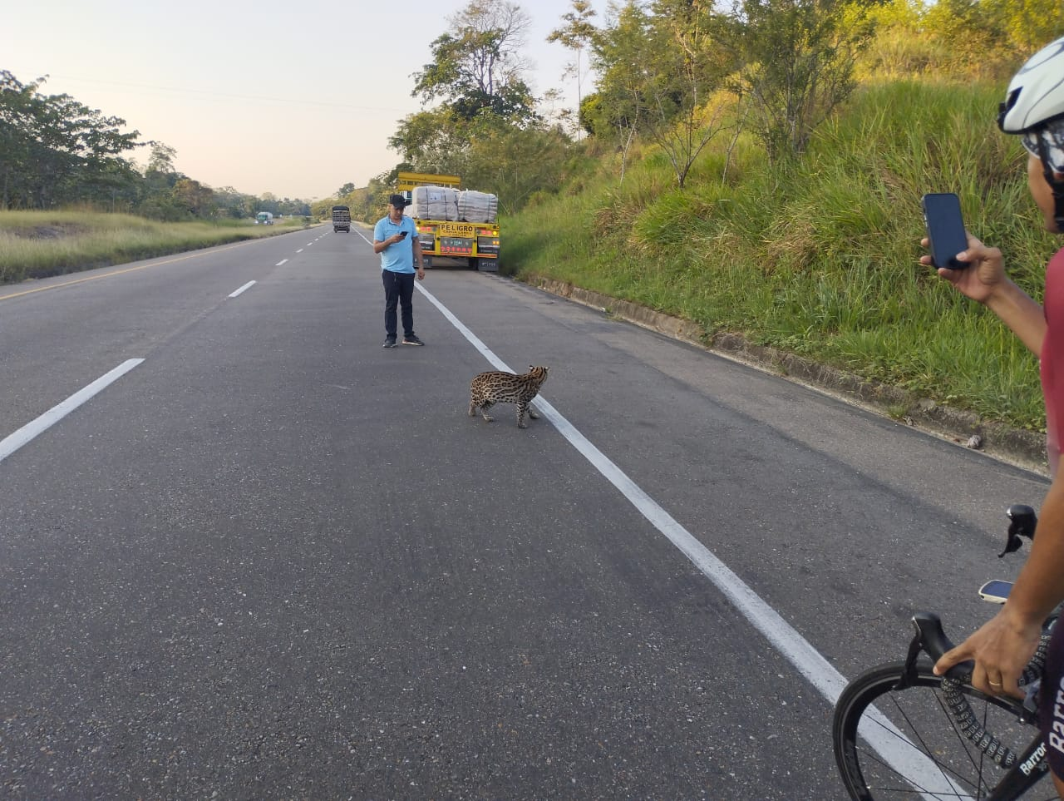
Photograph 1. Records of a living Leopardus pardalis crossing in the road being filmed by people May 27 of 2024. The precise location on the ruta del sol highway is unknown.

