Supplementary Material 1.

Crossing through danger: Spatial drivers of roadkill risk for felids in the fragmented Middle Magdalena valley

Julián Arango-Lozano¹*, Karime Angarita-Corzo²

¹Maestría en Ciencias Biológicas, Universidad de Caldas, Manizales, Colombia
²Escuela de Medicina Veterinaria. Facultad de Ciencias Agrarias. Universidad de Antioquia, Carrera 75 # 65-87, 050034, Medellín, Colombia.

* Corresponding author: arangolozanoj1@gmail.com

General roadkill database.
From December 2022 to March 2025, we collected 395 roadkill events of vertebrates in the ruta del sol highway (Puerto Salgar – Barrancabermeja extension). The records were collected with a periodic survey of 2 times per week one person in a car at 70 km/h searching for carcasses. However, given that the highway spans more than 250 km, we also incorporated data provided by residents who submitted photographs of roadkilled animals along with precise geographic coordinates. When possible, for verification purposes, we asked contributors to specify the exact kilometer marker point (PK) which also is indicated along the roadside every kilometer. We only included roadkill records based on our own direct observations and reports from residents that included clearly identifiable carcasses’ photographs and locations.
A total of 396 roadkill events were recorded, distributed across four major taxonomic classes. Mammals were the most affected group, with 244 individuals (61.6% of the total), followed by reptiles with 88 (22.2%), birds with 63 (15.9%), and a single record of an amphibian (Rhinella marina). At the species level, Tamandua mexicana showed the highest incidence, with 81 individuals killed, followed by Procyon cancrivorus (42), Cerdocyon thous (41), Hydrochoerus isthmius (25), and Caiman crocodilus (23).
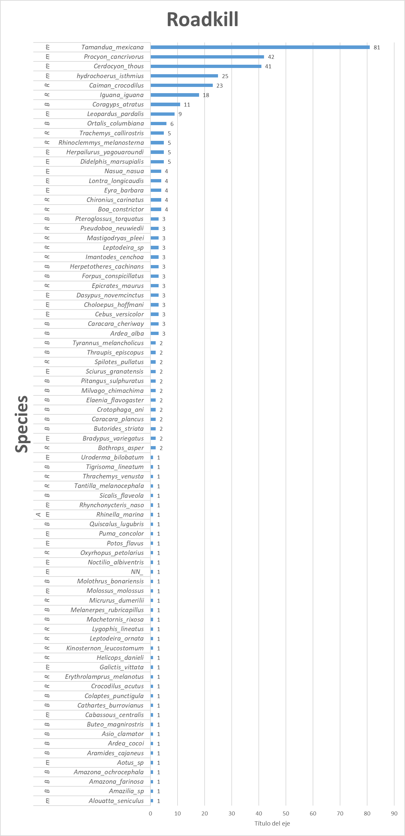
Figure 1. Summary of the roadkills by species
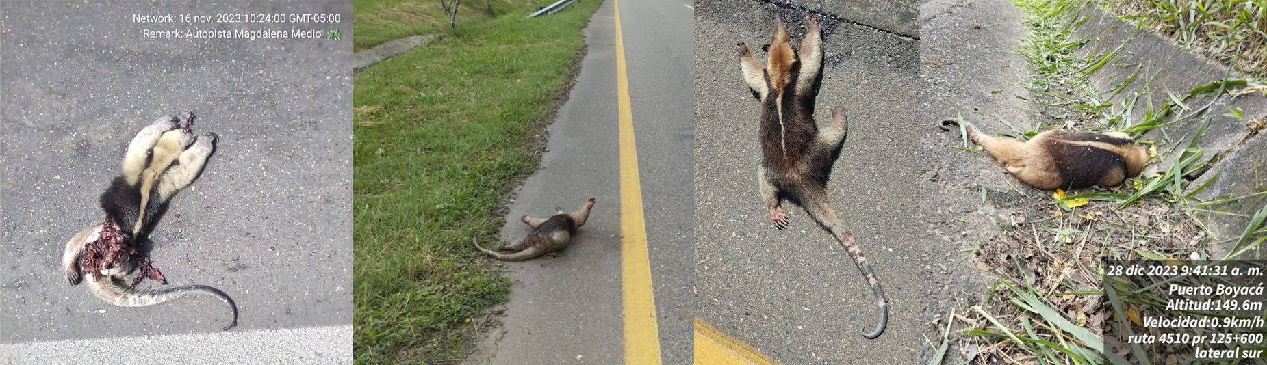
Figure 2. Photographic collage of Tamandua mexicana individuals recorded as roadkill
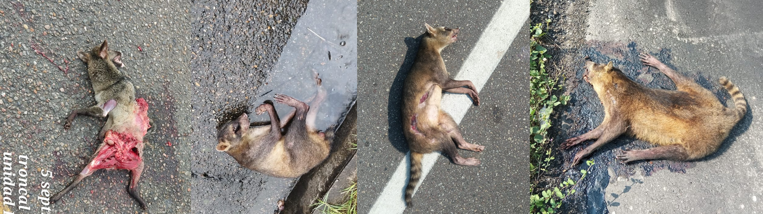
Figure 3. Photographic collage of Procyon cancrivorus individuals recorded as roadkill
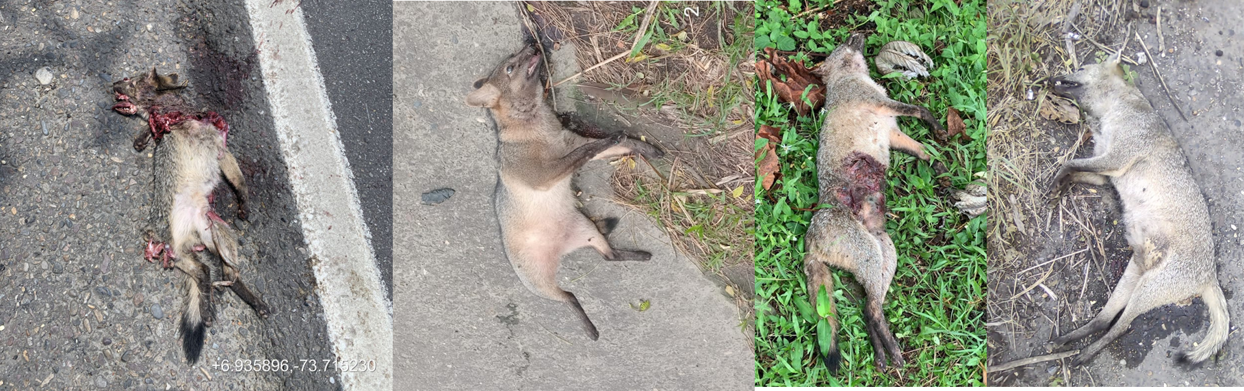
Figure 4. Photographic collage of Cerdocyon thous individuals recorded as roadkill
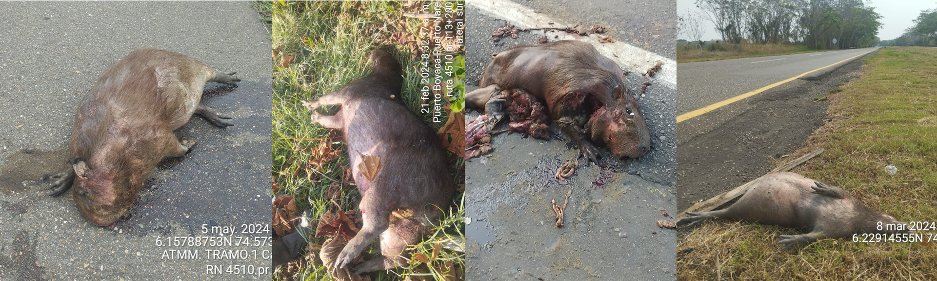
Figure 5. Photographic collage of Hydrochoerus isthmius individuals recorded as roadkill

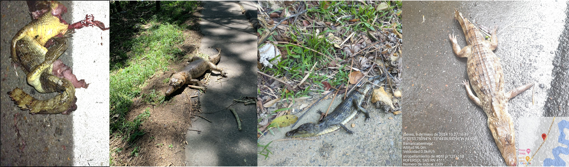
Figure 6. Photographic collage of Caiman crocodilus individuals recorded as roadkill

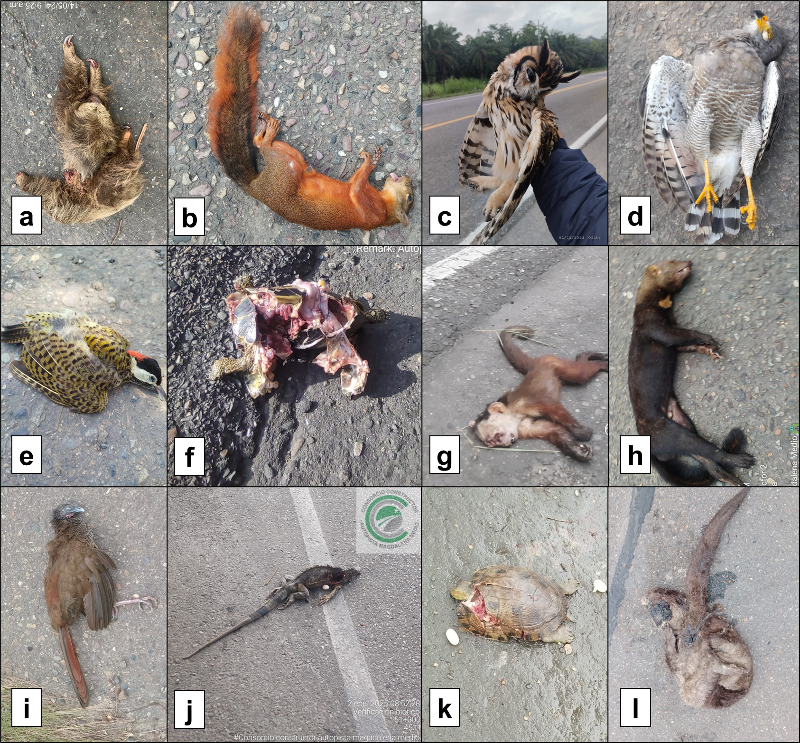
Figure 6. Photographic collage of different individuals recorded as roadkill. a = choloepus hoffmanni, b = Sciurus granatensis, c = Asio clamator, d = Rupornis magnirostris, e = Colaptes punctigula, f = Rhinoclemmys melanosterna, g = Cebus versicolor, h = Eyra barbara, i = Ortalis Columbiana, j = Iguana iguana, k = Trachemys callirostris, l = Lontra longicaudis.

Table 1. Extended information about roadkill surveys in the ruta de sol highway between 2022-2025. PK = point reference in the kilometer, RN = National route, X-Y geographical coordinates (GWS84)
DATE | CLASS | FAMILY | SPECIES | PK | NR | X | Y
21/12/2022 | Mammalia | Canidae | Cerdocyon_thous | 125+300 | 4510 | -73,5596 | 7,146918
17/01/2023 | Mammalia | Procyonidae | Procyon_cancrivorus | 65+000 | 4510 | -73,5662 | 7,12968
21/02/2023 | Mammalia | Myrmecophagidae | Tamandua_mexicana | 65+000 | 4510 | -73,5794 | 7,125981
28/02/2023 | Reptilia | Iguanidae | Iguana_iguana | 111+000 | 4510 | -73,5808 | 7,125317
6/03/2023 | Mammalia | Procyonidae | Procyon_cancrivorus | 91+000 | 4510 | -73,5808 | 7,125317
16/03/2023 | Mammalia | Myrmecophagidae | Tamandua_mexicana | 98+100 | 4510 | -73,5813 | 7,125218
18/03/2023 | Reptilia | Crocodylidae | Caiman_crocodilus | 103+000 | 4510 | -73,6401 | 7,076583
21/03/2023 | Mammalia | Myrmecophagidae | Tamandua_mexicana | 88+000 | 4510 | -73,6401 | 7,076583
22/03/2023 | Reptilia | Colubridae | Pseudoboa_neuwiedii | 65+920 | 4510 | -73,6401 | 7,076583
27/03/2023 | Mammalia | Myrmecophagidae | Tamandua_mexicana | 112+000 | 4510 | -73,6622 | 7,039397
27/03/2023 | Mammalia | Myrmecophagidae | Tamandua_mexicana | 97+300 | 4510 | -73,6941 | 6,983968
30/03/2023 | Mammalia | Procyonidae | Procyon_cancrivorus | 97+300 | 4510 | -73,6942 | 6,984401
8/04/2023 | Mammalia | Canidae | Cerdocyon_thous | 76+640 | 4510 | -73,6959 | 6,981797
12/04/2023 | Mammalia | Procyonidae | Procyon_cancrivorus | 67+000 | 4510 | -73,7008 | 6,965999
17/04/2023 | Mammalia | Mustelidae | Eyra_barbara | 43+700 | 4511 | -74,2461 | 6,474232
17/04/2023 | Mammalia | Myrmecophagidae | Tamandua_mexicana | 37+100 | 4513 | -73,7434 | 6,898474
20/04/2023 | Mammalia | Mustellidae | Galictis_vittata | 104+300 | 4510 | -73,7837 | 6,832486
21/04/2023 | Reptilia | Crocodylidae | Caiman_crocodilus | 62+500 | 4510 | -73,8355 | 6,764435
24/04/2023 | Mammalia | Procyonidae | Nasua_nasua | 44+950 | 4510 | -73,8355 | 6,764435
25/04/2023 | Reptilia | Crocodylidae | Caiman_crocodilus | 105+900 | 4510 | -73,8801 | 6,715984
26/04/2023 | Reptilia | Colubridae | Chironius_carinatus | 52+300 | 4510 | -73,8839 | 6,708932
26/04/2023 | Mammalia | Procyonidae | Procyon_cancrivorus | 86+900 | 4510 | -73,8839 | 6,708932
28/04/2023 | Mammalia | Myrmecophagidae | Tamandua_mexicana | 4+250 | 4511 | -73,8839 | 6,708932
2/05/2023 | Reptilia | Crocodylidae | Caiman_crocodilus | 111+080 | 4510 | -73,8919 | 6,697207
2/05/2023 | Mammalia | Procyonidae | Procyon_cancrivorus | 50+250 | 4510 | -73,8979 | 6,694598
4/05/2023 | Mammalia | Procyonidae | Procyon_cancrivorus | 88+700 | 4510 | -73,9178 | 6,67801
5/05/2023 | Mammalia | Canidae | Cerdocyon_thous | 39+200 | 4510 | -73,9398 | 6,658186
8/05/2023 | Reptilia | Crocodylidae | Crocodilus_acutus | 37+240 | 4510 | -74,0721 | 6,533019
9/05/2023 | Reptilia | Colubridae | Leptodeira_sp | 110+040 | 4510 | -74,0774 | 6,527755
9/05/2023 | Mammalia | Procyonidae | Procyon_cancrivorus | 95+300 | 4510 | -74,0774 | 6,527755
12/05/2023 | Mammalia | Canidae | Cerdocyon_thous | 120+100 | 4510 | -74,1067 | 6,518485
13/05/2023 | Mammalia | Procyonidae | Procyon_cancrivorus | 30+500 | 4510 | -74,144 | 6,503903
15/05/2023 | Mammalia | Procyonidae | Procyon_cancrivorus | 41+050 | 4511 | -74,144 | 6,503903
16/05/2023 | Reptilia | Crocodylidae | Caiman_crocodilus | 92+000 | 4511 | -74,144 | 6,503903
23/05/2023 | Reptilia | Colubridae | Pseudoboa_neuwiedii | 102+800 | 4510 | -74,2559 | 6,478002
27/05/2023 | Aves | Psittacidae | Forpus_conspicillatus | 20+500 | 4511 | -74,3742 | 6,385392
27/05/2023 | Mammalia | Caviidae | hydrochoerus_isthmius | 9+950 | 4511 | -74,3818 | 6,381832
27/05/2023 | Reptilia | Kinosternidae | Kinosternon_leucostomum | 16+800 | 4511 | -74,3844 | 6,381113
27/05/2023 | Mammalia | Procyonidae | Procyon_cancrivorus | 20+500 | 4511 | -74,3904 | 6,379448
6/06/2023 | Mammalia | Myrmecophagidae | Tamandua_mexicana | 4+100 | 4511 | -74,4072 | 6,374418
6/06/2023 | Mammalia | Myrmecophagidae | Tamandua_mexicana | 6+000 | 4513 | -74,466 | 6,282258
7/06/2023 | Reptilia | Iguanidae | Iguana_iguana | 98+100 | 4510 | -74,4438 | 6,31393
7/06/2023 | Mammalia | Procyonidae | Procyon_cancrivorus | 98+000 | 4510 | -74,4265 | 6,354073
7/06/2023 | Reptilia | Geoemydidae | Rhinoclemmys_melanosterna | 03+050 | 4511 | -74,466 | 6,282258
9/06/2023 | Aves | Ardeidae | Butorides_striata | 22+800 | 4511 | -74,4674 | 6,281559
9/06/2023 | Reptilia | Colubridae | Chironius_carinatus | 85+000 | 4510 | -74,4488 | 6,304988
9/06/2023 | Reptilia | Geoemydidae | Rhinoclemmys_melanosterna | 128+300 | 4510 | -74,4674 | 6,281559
14/06/2023 | Mammalia | Procyonidae | Potos_flavus | 96+700 | 4510 | -74,4536 | 6,299078
16/06/2023 | Reptilia | Crocodylidae | Caiman_crocodilus | 38+700 | 4511 | -74,4555 | 6,296481
16/06/2023 | Mammalia | Mustelidae | Eyra_barbara | 120+800 | 4510 | -74,475 | 6,270846
16/06/2023 | Mammalia | Myrmecophagidae | Tamandua_mexicana | 128+300 | 4510 | -74,4646 | 6,283691
18/06/2023 | Mammalia | Myrmecophagidae | Tamandua_mexicana | 121+900 | 4510 | -74,4765 | 6,269431
19/06/2023 | Mammalia | Felidae | Leopardus_pardalis | 79+100 | 4510 | -74,4881 | 6,260016
20/06/2023 | Mammalia | Canidae | Cerdocyon_thous | 96+740 | 4510 | -74,4871 | 6,260855
20/06/2023 | Aves | Psittacidae | Forpus_conspicillatus | 132+000 | 4511 | -74,4987 | 6,250595
20/06/2023 | Mammalia | Procyonidae | Procyon_cancrivorus | 39+500 | 4510 | -74,4951 | 6,254281
20/06/2023 | Mammalia | Myrmecophagidae | Tamandua_mexicana | 51+200 | 4510 | -74,4987 | 6,250595
21/06/2023 | Reptilia | Colubridae | Leptodeira_sp | 134+080 | 4510 | -74,5438 | 6,029539
21/06/2023 | Aves | Cracidae | Ortalis_columbiana | 123+800 | 4510 | -74,5465 | 6,023883
21/06/2023 | Aves | Ramphastidae | Pteroglossus_torquatus | 124+800 | 4510 | -74,5199 | 6,234485
22/06/2023 | Aves | Ramphastidae | Pteroglossus_torquatus | 111+400 | 4510 | -74,5467 | 6,023904
30/06/2023 | Aves | Ardeidae | Ardea_cocoi | 20+400 | 4511 | -74,5467 | 6,023979
4/07/2023 | Mammalia | Myrmecophagidae | Tamandua_mexicana | 90+000 | 4510 | -74,5498 | 6,044485
7/07/2023 | Aves | Cracidae | Ortalis_columbiana | 69+620 | 4510 | -74,5536 | 6,099102
7/07/2023 | Aves | Ramphastidae | Pteroglossus_torquatus | 95+780 | 4510 | -74,5539 | 6,024278
7/07/2023 | Mammalia | Myrmecophagidae | Tamandua_mexicana | 8+200 | 4513 | -74,5561 | 6,140568
10/07/2023 | Reptilia | Colubridae | Pseudoboa_neuwiedii | 70+520 | 4510 | -74,557 | 6,205586
11/07/2023 | Mammalia | Procyonidae | Procyon_cancrivorus | 111+900 | 4511 | -74,557 | 6,205564
12/07/2023 | Mammalia | Myrmecophagidae | Tamandua_mexicana | 122+200 | 4510 | -74,5567 | 6,066377
14/07/2023 | Aves | Falconidae | Caracara_cheriway | 105+100 | 4510 | -74,5571 | 6,065762
14/07/2023 | Mammalia | NN | NN_ | 105+100 | 4510 | -74,5574 | 6,065052
14/07/2023 | Mammalia | Procyonidae | Procyon_cancrivorus | 105+100 | 4510 | -74,5574 | 6,06501
17/07/2023 | Mammalia | Myrmecophagidae | Tamandua_mexicana | 92+600 | 4511 | -74,5578 | 6,143524
18/07/2023 | Mammalia | Procyonidae | Procyon_cancrivorus | 75+700 | 4510 | -74,5579 | 6,143757
19/07/2023 | Mammalia | Canidae | Cerdocyon_thous | 6+000 | 4511 | -74,5598 | 5,979397
19/07/2023 | Reptilia | Iguanidae | Iguana_iguana | 97+300 | 4510 | -74,5588 | 6,144804
19/07/2023 | Mammalia | Mustelidae | Lontra_longicaudis | 5+700 | 4511 | -74,5593 | 6,145241
21/07/2023 | Reptilia | Viperidae | Bothrosp_asper | 85+730 | 4511 | -74,5599 | 6,012116
21/07/2023 | Mammalia | Canidae | Cerdocyon_thous | 115+000 | 4510 | -74,5608 | 5,977819
21/07/2023 | Reptilia | Colubridae | Chironius_carinatus | 100+780 | 4511 | -74,5598 | 5,979371
21/07/2023 | Mammalia | Myrmecophagidae | Tamandua_mexicana | 122+700 | 4510 | -74,5609 | 6,056687
24/07/2023 | Mammalia | Myrmecophagidae | Tamandua_mexicana | 91+500 | 4510 | -74,5614 | 6,015445
25/07/2023 | Mammalia | Myrmecophagidae | Tamandua_mexicana | 132+500 | 4511 | -74,5628 | 5,910425
27/07/2023 | Aves | Psittacidae | Forpus_conspicillatus | 130+900 | 4510 | -74,5652 | 5,973035
27/07/2023 | Reptilia | Iguanidae | Iguana_iguana | 131+000 | 4510 | -74,5637 | 6,181082
1/08/2023 | Mammalia | Canidae | Cerdocyon_thous | 112+400 | 4511 | -74,5653 | 5,918656
4/08/2023 | Reptilia | Iguanidae | Iguana_iguana | 107+600 | 4511 | -74,5656 | 5,97256
5/08/2023 | Mammalia | Caviidae | hydrochoerus_isthmius | 128+200 | 4510 | -74,5659 | 5,954712
5/08/2023 | Mammalia | Caviidae | hydrochoerus_isthmius | 128+200 | 4510 | -74,5658 | 5,868598
5/08/2023 | Mammalia | Caviidae | hydrochoerus_isthmius | 128+200 | 4510 | -74,5662 | 5,967433
8/08/2023 | Mammalia | Procyonidae | Procyon_cancrivorus | 68+920 | 4510 | -74,5668 | 6,175814
14/08/2023 | Mammalia | Caviidae | hydrochoerus_isthmius | 39+500 | 4511 | -74,5671 | 5,930729
14/08/2023 | Mammalia | Procyonidae | Procyon_cancrivorus | 26+800 | 4511 | -74,5665 | 5,968773
17/08/2023 | Reptilia | Boidae | Boa_constrictor | 112+000 | 4510 | -74,5672 | 5,871012
18/08/2023 | Mammalia | Choloepodidae | Choloepus_hoffmani | 97+900 | 4511 | -74,5673 | 5,898324
22/08/2023 | Mammalia | Canidae | Cerdocyon_thous | 90+000 | 4510 | -74,5676 | 5,923337
23/08/2023 | Mammalia | Myrmecophagidae | Tamandua_mexicana | 4+200 | 4511 | -74,5686 | 5,945788
24/08/2023 | Aves | Psittacidae | Amazona_ochrocephala | 115+500 | 4510 | -74,5685 | 5,88164
24/08/2023 | Mammalia | Dasypodidae | Dasypus_novemcinctus | 146+000 | 4511 | -74,5688 | 5,931799
25/08/2023 | Aves | Cuculidae | Crotophaga_ani | 101+600 | 4510 | -74,5688 | 5,893924
25/08/2023 | Mammalia | Myrmecophagidae | Tamandua_mexicana | 104+100 | 4510 | -74,569 | 5,931971
28/08/2023 | Reptilia | Colubridae | Imantodes_cenchoa | 105+600 | 4510 | -74,569 | 5,932137
28/08/2023 | Mammalia | Myrmecophagidae | Tamandua_mexicana | 64+800 | 4511 | -74,569 | 5,932184
29/08/2023 | Mammalia | Procyonidae | Procyon_cancrivorus | 120+560 | 4510 | -74,5694 | 5,942152
30/08/2023 | Reptilia | Colubridae | Spilotes_pullatus | 143+100 | 4511 | -74,5694 | 5,942152
31/08/2023 | Reptilia | Crocodylidae | Caiman_crocodilus | 130+260 | 4511 | -74,5703 | 6,168416
1/09/2023 | Aves | Falconidae | Herpetotheres_cachinans | 92+900 | 4511 | -74,5735 | 6,158774
1/09/2023 | Aves | Falconidae | Milvago_chimachima | 112+100 | 4510 | -74,5728 | 6,154126
1/09/2023 | Mammalia | Myrmecophagidae | Tamandua_mexicana | 143+700 | 4511 | -74,578 | 5,83823
2/09/2023 | Mammalia | Bradipodidae | Bradypus_variegatus | 115+00 | 4510 | -74,5867 | 5,819828
2/09/2023 | Mammalia | Cebidae | Cebus_versicolor | 146+000 | 4511 | -74,5937 | 5,809148
2/09/2023 | Reptilia | Colubridae | Oxyrhopus_petolarius | 3+000 | 4511 | -74,5895 | 5,816821
2/09/2023 | Mammalia | Procyonidae | Procyon_cancrivorus | 114+200 | 4510 | -74,5851 | 5,82832
7/09/2023 | Mammalia | Myrmecophagidae | Tamandua_mexicana | 21+200 | 4511 | -74,5959 | 5,801642
8/09/2023 | Mammalia | Caviidae | hydrochoerus_isthmius | 44+250 | 4511 | -74,619 | 5,629457
8/09/2023 | Mammalia | Myrmecophagidae | Tamandua_mexicana | 62+250 | 4511 | -74,6172 | 5,704535
11/09/2023 | Mammalia | Myrmecophagidae | Tamandua_mexicana | 61+600 | 4511 | -74,6208 | 5,614196
12/09/2023 | Reptilia | Crocodylidae | Caiman_crocodilus | 115+950 | 4510 | -74,6215 | 5,604315
12/09/2023 | Mammalia | Canidae | Cerdocyon_thous | 101+500 | 4510 | -74,623 | 5,726149
12/09/2023 | Aves | Tyrannidae | Machetornis_rixosa | 97+000 | 4510 | -74,6219 | 5,595688
13/09/2023 | Mammalia | Myrmecophagidae | Tamandua_mexicana | 80+000 | 4510 | -74,623 | 5,726193
15/09/2023 | Mammalia | Canidae | Cerdocyon_thous | 107+540 | 4510 | -74,6235 | 5,768806
15/09/2023 | Mammalia | Canidae | Cerdocyon_thous | 107+700 | 4510 | -74,623 | 5,583617
15/09/2023 | Mammalia | Dasypodidae | Dasypus_novemcinctus | 72+000 | 4510 | -74,6236 | 5,734504
16/09/2023 | Aves | Psittacidae | Amazona_farinosa | 93+700 | 4510 | -74,6259 | 5,743903
16/09/2023 | Reptilia | Crocodylidae | Caiman_crocodilus | 92+200 | 4510 | -74,6259 | 5,743906
16/09/2023 | Mammalia | Myrmecophagidae | Tamandua_mexicana | 92+900 | 4510 | -74,6269 | 5,748308
16/09/2023 | Mammalia | Myrmecophagidae | Tamandua_mexicana | 110+900 | 4510 | -74,6266 | 5,548111
17/09/2023 | Reptilia | Crocodylidae | Caiman_crocodilus | 28+950 | 4511 | -74,6302 | 5,764295
18/09/2023 | Mammalia | Myrmecophagidae | Tamandua_mexicana | 143+100 | 4511 | -74,6301 | 5,532521
19/09/2023 | Mammalia | Aotidae | Aotus_sp | 72+700 | 4511 | -74,635 | 5,523978
19/09/2023 | Mammalia | Didelphidae | Didelphis_marsupialis | 101+450 | 4511 | -74,635 | 5,523978
21/09/2023 | Aves | Cathartidae | Coragyps_atratus | 102+700 | 4510 | -74,6354 | 5,519463
21/09/2023 | Mammalia | Procyonidae | Procyon_cancrivorus | 107+750 | 4510 | -74,6351 | 5,523915
22/09/2023 | Aves | Tyrannidae | Elaenia_flavogaster | 106+000 | 4510 | -74,6378 | 5,499176
26/09/2023 | Mammalia | Canidae | Cerdocyon_thous | 140+050 | 4511 | -74,6385 | 5,50179
27/09/2023 | Mammalia | Felidae | Leopardus_pardalis | 22+100 | 4511 | -74,6424 | 5,482914
27/09/2023 | Reptilia | Emydidae | Thrachemys_venusta | 122+250 | 4511 | -73,5804 | 7,126014
28/09/2023 | Mammalia | Canidae | Cerdocyon_thous | 26+500 | 4511 | -73,5808 | 7,125317
28/09/2023 | Mammalia | Mustelidae | Lontra_longicaudis | 133+750 | 4511 | -73,5803 | 7,12568
3/10/2023 | Mammalia | Canidae | Cerdocyon_thous | 114+700 | 4510 | -73,6159 | 7,117881
5/10/2023 | Reptilia | Colubridae | Erythrolamprus_melanotus | 89+200 | 4510 | -73,6221 | 7,106739
9/10/2023 | Mammalia | Canidae | Cerdocyon_thous | 94+300 | 4510 | -73,6257 | 7,099513
9/10/2023 | Mammalia | Caviidae | hydrochoerus_isthmius | 36+600 | 4511 | -73,6315 | 7,091462
9/10/2023 | Mammalia | Procyonidae | Procyon_cancrivorus | 78+900 | 4510 | -73,6287 | 7,095174
9/10/2023 | Mammalia | Myrmecophagidae | Tamandua_mexicana | 35+100 | 4511 | -73,625 | 7,100906
10/10/2023 | Reptilia | Crocodylidae | Caiman_crocodilus | 35+100 | 4511 | -73,6322 | 7,089894
10/10/2023 | Reptilia | Boidae | Epicrates_maurus | 24+300 | 4511 | -73,642 | 7,073548
10/10/2023 | Reptilia | Colubridae | Imantodes_cenchoa | 82+900 | 4511 | -73,6323 | 7,089732
11/10/2023 | Mammalia | Canidae | Cerdocyon_thous | 38+920 | 4511 | -73,6446 | 7,068775
12/10/2023 | Reptilia | Crocodylidae | Caiman_crocodilus | 75+900 | 4510 | -73,6446 | 7,068775
13/10/2023 | Mammalia | Myrmecophagidae | Tamandua_mexicana | 101+100 | 4510 | -73,6445 | 7,068747
17/10/2023 | Aves | Falconidae | Herpetotheres_cachinans | 48+500 | 4511 | -73,6524 | 7,055531
17/10/2023 | Mammalia | Mustelidae | Lontra_longicaudis | 126+830 | 4510 | -73,6532 | 7,054546
17/10/2023 | Mammalia | Myrmecophagidae | Tamandua_mexicana | 30+500 | 4511 | -73,6511 | 7,057783
21/10/2023 | Mammalia | Procyonidae | Procyon_cancrivorus | 84+000 | 4510 | -73,6532 | 7,054262
23/10/2023 | Mammalia | Felidae | Herpailurus_yagouaroundi | 133+580 | 4510 | -73,659 | 7,045297
26/10/2023 | Mammalia | Canidae | Cerdocyon_thous | 59+300 | 4510 | -73,6642 | 7,036425
31/10/2023 | Aves | Cracidae | Ortalis_columbiana | 103+800 | 4510 | -73,6684 | 7,027967
2/11/2023 | Mammalia | Canidae | Cerdocyon_thous | 31+300 | 4511 | -73,6855 | 6,99928
10/11/2023 | Mammalia | Caviidae | hydrochoerus_isthmius | 4+500 | 4511 | -73,6877 | 6,996069
10/11/2023 | Mammalia | Procyonidae | Nasua_nasua | 96+000 | 4510 | -73,689 | 6,993521
11/11/2023 | Aves | Ardeidae | Butorides_striata | 110+200 | 4510 | -73,6942 | 6,983983
13/11/2023 | Reptilia | Crocodylidae | Caiman_crocodilus | 20+500 | 4511 | -73,7004 | 6,967547
13/11/2023 | Aves | Cathartidae | Cathartes_burrovianus | 28+500 | 4511 | -73,6958 | 6,981785
13/11/2023 | Mammalia | Caviidae | hydrochoerus_isthmius | 9+500 | 4511 | -73,6989 | 6,976756
13/11/2023 | Reptilia | Iguanidae | Iguana_iguana | 109+200 | 4510 | -73,6952 | 6,982646
13/11/2023 | Mammalia | Myrmecophagidae | Tamandua_mexicana | 26+500 | 4511 | -73,6958 | 6,981878
14/11/2023 | Reptilia | Colubridae | Mastigodryas_pleei | 93+870 | 4510 | -73,7041 | 6,956473
16/11/2023 | Aves | Cathartidae | Coragyps_atratus | 119+700 | 4510 | -73,7223 | 6,927633
16/11/2023 | Mammalia | Procyonidae | Procyon_cancrivorus | 2+500 | 4511 | -73,7191 | 6,931854
16/11/2023 | Mammalia | Myrmecophagidae | Tamandua_mexicana | 65+500 | 4511 | -73,7195 | 6,93125
16/11/2023 | Mammalia | Myrmecophagidae | Tamandua_mexicana | 84+800 | 4510 | -73,7228 | 6,926893
16/11/2023 | Mammalia | Myrmecophagidae | Tamandua_mexicana | 41+500 | 4510 | -73,7228 | 6,926893
20/11/2023 | Mammalia | Canidae | Cerdocyon_thous | 80+400 | 4511 | -73,7354 | 6,911023
20/11/2023 | Mammalia | Myrmecophagidae | Tamandua_mexicana | 23+900 | 4511 | -73,7376 | 6,908204
21/11/2023 | Reptilia | Colubridae | Chironius_carinatus | 132+000 | 4511 | -73,7416 | 6,90302
21/11/2023 | Reptilia | Colubridae | Helicops_danieli | 94+050 | 4511 | -73,7412 | 6,903731
1/12/2023 | Mammalia | Myrmecophagidae | Tamandua_mexicana | 102+500 | 4510 | -73,7693 | 6,856122
2/12/2023 | Aves | Strigidae | Asio_clamator | 102+500 | 4511 | -73,7721 | 6,851264
2/12/2023 | Reptilia | Iguanidae | Iguana_iguana | 102+500 | 4511 | -73,7802 | 6,838229
4/12/2023 | Mammalia | Myrmecophagidae | Tamandua_mexicana | 120+940 | 4511 | -73,7882 | 6,824897
18/12/2023 | Mammalia | Bradypodidae | Bradypus_variegatus | 132+000 | 4511 | -73,8002 | 6,80347
18/12/2023 | Mammalia | Canidae | Cerdocyon_thous | 23+000 | 4511 | -73,8196 | 6,780648
18/12/2023 | Reptilia | Iguanidae | Iguana_iguana | 102+500 | 4511 | -73,7911 | 6,818956
18/12/2023 | Reptilia | Iguanidae | Iguana_iguana | 120+490 | 4510 | -73,8 | 6,803749
18/12/2023 | Reptilia | Iguanidae | Iguana_iguana | 77+600 | 4510 | -73,8294 | 6,770283
18/12/2023 | Reptilia | Colubridae | Lygophis_lineatus | 7+850 | 4511 | -73,8284 | 6,771723
18/12/2023 | Mammalia | Myrmecophagidae | Tamandua_mexicana | 22+000 | 4511 | -73,8276 | 6,772222
19/12/2023 | Mammalia | Choloepodidae | Choloepus_hoffmani | 89+000 | 4511 | -73,8387 | 6,761112
19/12/2023 | Aves | Cathartidae | Coragyps_atratus | 44+700 | 4511 | -73,8354 | 6,764452
19/12/2023 | Mammalia | Didelphidae | Didelphis_marsupialis | 139+400 | 4511 | -73,8413 | 6,757736
19/12/2023 | Reptilia | Iguanidae | Iguana_iguana | 64+600 | 4511 | -73,8383 | 6,761789
19/12/2023 | Reptilia | Colubridae | Leptodeira_sp | 64+600 | 4511 | -73,8387 | 6,761112
20/12/2023 | Mammalia | Caviidae | hydrochoerus_isthmius | 112+200 | 4511 | -73,8445 | 6,754256
24/12/2023 | Mammalia | Felidae | Leopardus_pardalis | 23+600 | 4511 | -73,8715 | 6,743528
28/12/2023 | Mammalia | Canidae | Cerdocyon_thous | 80+000 | 4511 | -73,8565 | 6,742833
28/12/2023 | Mammalia | Caviidae | hydrochoerus_isthmius | 38+000 | 4511 | -73,8715 | 6,743528
28/12/2023 | Mammalia | Myrmecophagidae | Tamandua_mexicana | 125+600 | 4510 | -73,856 | 6,743522
1/01/2024 | Reptilia | Iguanidae | Iguana_iguana | 0+300 | 4513 | -73,8734 | 6,742222
1/01/2024 | Mammalia | Procyonidae | Procyon_cancrivorus | 114+100 | 4510 | -73,8734 | 6,742222
2/01/2024 | Mammalia | Sciuridae | Sciurus_granatensis | 83+700 | 4511 | -73,8578 | 6,74088
3/01/2024 | Mammalia | Procyonidae | Procyon_cancrivorus | 141+500 | 4511 | -73,8628 | 6,735549
9/01/2024 | Mammalia | Canidae | Cerdocyon_thous | 88+000 | 4511 | -73,8687 | 6,729297
9/01/2024 | Mammalia | Canidae | Cerdocyon_thous | 125+000 | 4511 | -73,8865 | 6,703602
9/01/2024 | Aves | Falconidae | Milvago_chimachima | 93+700 | 4511 | -73,8717 | 6,726062
9/01/2024 | Mammalia | Procyonidae | Procyon_cancrivorus | 28+060 | 4511 | -73,8636 | 6,735004
9/01/2024 | Mammalia | Procyonidae | Procyon_cancrivorus | 26+600 | 4511 | -73,8686 | 6,729389
9/01/2024 | Amphibia | Bufonidae | Rhinella_marina | 93+700 | 4511 | -73,8723 | 6,725562
9/01/2024 | Mammalia | Myrmecophagidae | Tamandua_mexicana | 114+600 | 4511 | -73,8865 | 6,703603
10/01/2024 | Reptilia | Crocodylidae | Caiman_crocodilus | 73+300 | 4510 | -73,9247 | 6,671692
10/01/2024 | Aves | Falconidae | Caracara_cheriway | 64+600 | 4510 | -73,9002 | 6,693134
10/01/2024 | Mammalia | Canidae | Cerdocyon_thous | 128+000 | 4510 | -73,9002 | 6,693134
10/01/2024 | Aves | Cuculidae | Crotophaga_ani | 56+500 | 4510 | -73,926 | 6,670458
10/01/2024 | Reptilia | Iguanidae | Iguana_iguana | 49+950 | 4510 | -73,8898 | 6,698728
10/01/2024 | Reptilia | Iguanidae | Iguana_iguana | 110+800 | 4510 | -73,9044 | 6,690304
10/01/2024 | Mammalia | Procyonidae | Nasua_nasua | 62+600 | 4510 | -73,9253 | 6,671079
10/01/2024 | Mammalia | Procyonidae | Procyon_cancrivorus | 46+500 | 4510 | -73,8884 | 6,699925
10/01/2024 | Mammalia | Procyonidae | Procyon_cancrivorus | 46+500 | 4510 | -73,9002 | 6,693134
10/01/2024 | Mammalia | Procyonidae | Procyon_cancrivorus | 101+500 | 4510 | -73,9044 | 6,690304
10/01/2024 | Mammalia | Myrmecophagidae | Tamandua_mexicana | 59+990 | 4510 | -73,8898 | 6,698728
10/01/2024 | Mammalia | Myrmecophagidae | Tamandua_mexicana | 97+300 | 4510 | -73,9187 | 6,677146
10/01/2024 | Mammalia | Myrmecophagidae | Tamandua_mexicana | 77+500 | 4510 | -73,9192 | 6,676934
10/01/2024 | Reptilia | Emydidae | Trachemys_callirostris | 64+600 | 4511 | -73,9002 | 6,693134
13/01/2024 | Mammalia | Felidae | Leopardus_pardalis | 33+300 | 4511 | -73,93 | 6,666792
14/01/2024 | Mammalia | Felidae | Leopardus_pardalis | 91+140 | 4511 | -73,93 | 6,666792
14/01/2024 | Mammalia | Procyonidae | Procyon_cancrivorus | 123+860 | 4510 | -73,93 | 6,666792
19/01/2024 | Mammalia | Caviidae | hydrochoerus_isthmius | 42+500 | 4511 | -73,9373 | 6,660019
22/01/2024 | Aves | Ardeidae | Ardea_alba | 112+150 | 4510 | -73,9863 | 6,614179
22/01/2024 | Mammalia | Procyonidae | Procyon_cancrivorus | 26+550 | 4511 | -73,9863 | 6,614179
22/01/2024 | Reptilia | Geoemydidae | Rhinoclemmys_melanosterna | 3+600 | 4511 | -73,9863 | 6,614179
22/01/2024 | Aves | Ardeidae | Tigrisoma_lineatum | 30+760 | 4511 | -73,9863 | 6,614179
22/01/2024 | Reptilia | Emydidae | Trachemys_callirostris | 39+400 | 4511 | -73,9863 | 6,614179
23/01/2024 | Reptilia | Crocodylidae | Caiman_crocodilus | 28+100 | 4511 | -73,9872 | 6,613259
24/01/2024 | Mammalia | Myrmecophagidae | Tamandua_mexicana | 93+110 | 4510 | -74,0768 | 6,528583
25/01/2024 | Mammalia | Myrmecophagidae | Tamandua_mexicana | 41+200 | 4511 | -74,0962 | 6,524383
26/01/2024 | Mammalia | Felidae | Leopardus_pardalis | 121+400 | 4510 | -74,1012 | 6,521126
30/01/2024 | Mammalia | Caviidae | hydrochoerus_isthmius | 125+100 | 4510 | -74,2056 | 6,483243
5/02/2024 | Mammalia | Procyonidae | Procyon_cancrivorus | 48+500 | 4511 | -74,2615 | 6,480548
20/02/2024 | Mammalia | Procyonidae | Nasua_nasua | 102+050 | 4511 | -74,2614 | 6,480483
20/02/2024 | Reptilia | Emydidae | Trachemys_callirostris | 108+450 | 4510 | -74,2614 | 6,480489
21/02/2024 | Mammalia | Caviidae | hydrochoerus_isthmius | 113+200 | 4510 | -74,2567 | 6,478341
21/02/2024 | Mammalia | Caviidae | hydrochoerus_isthmius | 113+200 | 4510 | -74,2566 | 6,478132
24/02/2024 | Mammalia | Atelidae | Alouatta_seniculus | 120+850 | 4510 | -74,2566 | 6,478132
1/03/2024 | Mammalia | Felidae | Herpailurus_yagouaroundi | 134+100 | 4511 | -74,2566 | 6,478132
1/03/2024 | Mammalia | Felidae | Herpailurus_yagouaroundi | 134+000 | 4511 | -73,714 | 6,938518
1/03/2024 | Mammalia | Caviidae | hydrochoerus_isthmius | 145+900 | 4511 | -74,2564 | 6,478121
1/03/2024 | Mammalia | Myrmecophagidae | Tamandua_mexicana | 145+900 | 4511 | -74,2564 | 6,478121
2/03/2024 | Aves | Picidae | Melanerpes_rubricapillus | 8+900 | 4511 | -74,2564 | 6,478121
8/03/2024 | Mammalia | Caviidae | hydrochoerus_isthmius | 132+240 | 4511 | -74,2566 | 6,47787
13/03/2024 | Reptilia | Viperidae | Bothrosp_asper | 108+500 | 4511 | -74,3088 | 6,443673
15/03/2024 | Reptilia | Emydidae | Trachemys_callirostris | 86+200 | 4511 | -74,2418 | 6,47521
17/03/2024 | Mammalia | Didelphidae | Didelphis_marsupialis | 126+400 | 4511 | -74,5551 | 6,214685
17/03/2024 | Aves | Thraupidae | Sicalis_flaveola | 84+700 | 4510 | -74,5636 | 5,866527
18/03/2024 | Aves | Cathartidae | Coragyps_atratus | 100+400 | 4511 | -74,2891 | 6,460394
18/03/2024 | Aves | Cathartidae | Coragyps_atratus | 99+200 | 4511 | -74,2891 | 6,460391
18/03/2024 | Mammalia | Didelphidae | Didelphis_marsupialis | 141+300 | 4511 | -74,3166 | 6,436042
18/03/2024 | Mammalia | Myrmecophagidae | Tamandua_mexicana | 86+000 | 4511 | -74,2984 | 6,449144
26/03/2024 | Mammalia | Canidae | Cerdocyon_thous | 114+800 | 4511 | -74,3508 | 6,413312
26/03/2024 | Aves | Cathartidae | Coragyps_atratus | 105+100 | 4511 | -74,3509 | 6,413594
27/03/2024 | Mammalia | Canidae | Cerdocyon_thous | 38+000 | 4510 | -74,3442 | 6,411425
1/04/2024 | Aves | Picidae | Colaptes_punctigula | 103+800 | 4511 | -74,3292 | 6,411262
2/04/2024 | Mammalia | Myrmecophagidae | Tamandua_mexicana | 124+500 | 4511 | -74,3297 | 6,410195
10/04/2024 | Aves | Falconidae | Caracara_cheriway | 96+700 | 4511 | -74,3583 | 6,403136
10/04/2024 | Mammalia | Canidae | Cerdocyon_thous | 111+200 | 4511 | -74,3587 | 6,402482
17/04/2024 | Mammalia | Myrmecophagidae | Tamandua_mexicana | 4+350 | 4513 | -74,3889 | 6,37972
18/04/2024 | Mammalia | Mustelidae | Eyra_barbara | 129+000 | 4511 | -74,4438 | 6,31393
23/04/2024 | Mammalia | Myrmecophagidae | Tamandua_mexicana | 124+000 | 4510 | -74,4447 | 6,312407
27/04/2024 | Reptilia | Crocodylidae | Caiman_crocodilus | 98+000 | 4511 | -74,4549 | 6,297502
27/04/2024 | Reptilia | Colubridae | Spilotes_pullatus | 100+970 | 4511 | -74,4592 | 6,291654
28/04/2024 | Mammalia | Noctilionidae | Noctilio_albiventris | 42+600 | 4511 | -74,4609 | 6,288332
28/04/2024 | Aves | Icteridae | Quiscalus_lugubris | 42+600 | 4511 | -74,4634 | 6,284667
28/04/2024 | Aves | Thraupidae | Thraupis_episcopus | 42+600 | 4511 | -74,4634 | 6,284667
2/05/2024 | Mammalia | Canidae | Cerdocyon_thous | 122+600 | 4511 | -74,4853 | 6,262198
3/05/2024 | Mammalia | Mustelidae | Eyra_barbara | 97+500 | 4511 | -74,4876 | 6,260293
3/05/2024 | Mammalia | Myrmecophagidae | Tamandua_mexicana | 87+800 | 4511 | -74,4922 | 6,256575
5/05/2024 | Mammalia | Caviidae | hydrochoerus_isthmius | 123+000 | 4511 | -74,4958 | 6,253658
7/05/2024 | Mammalia | Myrmecophagidae | Tamandua_mexicana | 0+690 | 4511 | -74,5023 | 6,247945
7/05/2024 | Mammalia | Myrmecophagidae | Tamandua_mexicana | 117+200 | 4511 | -74,5124 | 6,240317
7/05/2024 | Mammalia | Myrmecophagidae | Tamandua_mexicana | 125+500 | 4511 | -74,5235 | 6,232903
8/05/2024 | Mammalia | Myrmecophagidae | Tamandua_mexicana | 132+000 | 4511 | -74,5352 | 6,228343
9/05/2024 | Reptilia | Crocodylidae | Caiman_crocodilus | 121+150 | 4511 | -74,5439 | 6,224529
12/05/2024 | Mammalia | Myrmecophagidae | Tamandua_mexicana | 9+900 | 4511 | -74,544 | 6,224459
14/05/2024 | Mammalia | Choloepodidae | Choloepus_hoffmani | 110+300 | 4511 | -74,5453 | 6,223882
14/05/2024 | Aves | Falconidae | Herpetotheres_cachinans | 126+100 | 4511 | -74,5551 | 6,214685
14/05/2024 | Mammalia | Myrmecophagidae | Tamandua_mexicana | 9+900 | 4511 | -74,5559 | 6,209149
15/05/2024 | Aves | Tyrannidae | Pitangus_sulphuratus | 137+950 | 4511 | -74,5572 | 6,205174
16/05/2024 | Aves | Accipitridae | Buteo_magnirostris | 98+900 | 4511 | -74,558 | 6,202066
17/05/2024 | Mammalia | Canidae | Cerdocyon_thous | 141+800 | 4511 | -74,5588 | 6,192808
21/05/2024 | Reptilia | Crocodylidae | Caiman_crocodilus | 121+500 | 4511 | -74,5738 | 6,157334
22/05/2024 | Mammalia | Canidae | Cerdocyon_thous | 121+900 | 4511 | -74,5705 | 6,167532
23/05/2024 | Mammalia | Felidae | Herpailurus_yagouaroundi | 125+900 | 4510 | -74,5619 | 6,184405
27/05/2024 | Mammalia | Canidae | Cerdocyon_thous | 141+300 | 4511 | -74,5536 | 6,099101
27/05/2024 | Mammalia | Felidae | Leopardus_pardalis | 113+000 | 4510 | -74,5533 | 6,096157
27/05/2024 | Mammalia | Myrmecophagidae | Tamandua_mexicana | 148+000 | 4511 | -74,5541 | 6,106304
28/05/2024 | Mammalia | Myrmecophagidae | Tamandua_mexicana | 61+000 | 4511 | -74,5533 | 6,095966
7/06/2024 | Aves | Falconidae | Caracara_plancus | 87+300 | 4511 | -74,5516 | 6,080332
14/06/2024 | Mammalia | Felidae | Leopardus_pardalis | 33+900 | 4511 | -74,552 | 6,072828
25/06/2024 | Mammalia | Dasypodidae | Dasypus_novemcinctus | 102+260 | 4510 | -74,5598 | 6,049998
25/06/2024 | Mammalia | Mustelidae | Lontra_longicaudis | 8+000 | 4511 | -74,5596 | 6,04973
26/06/2024 | Mammalia | Chlamyphoridae | Cabassous_centralis | 124+000 | 4511 | -74,5561 | 6,047009
29/06/2024 | Mammalia | Myrmecophagidae | Tamandua_mexicana | 8+500 | 4511 | -74,5479 | 6,043672
29/06/2024 | Mammalia | Myrmecophagidae | Tamandua_mexicana | 103+500 | 4511 | -74,5475 | 6,043002
30/06/2024 | Mammalia | Caviidae | Hydrochoerus_isthmius | 102+260 | 4510 | -74,5467 | 6,041894
3/07/2024 | Reptilia | Boidae | Epicrates_maurus | 140+290 | 4511 | -74,5453 | 6,026546
3/07/2024 | Mammalia | Caviidae | Hydrochoerus_isthmius | 2+100 | 4511 | -74,5555 | 6,024542
15/07/2024 | Mammalia | Caviidae | Hydrochoerus_isthmius | 42+100 | 4511 | -74,5557 | 6,024041
22/07/2024 | Aves | Cathartidae | Coragyps_atratus | 133+500 | 4511 | -74,5572 | 6,004083
22/07/2024 | Reptilia | Geoemydidae | Rhinoclemmys_melanosterna | 88+100 | 4511 | -74,5547 | 6,000017
23/07/2024 | Mammalia | Canidae | Cerdocyon_thous | 99+300 | 4511 | -74,5629 | 5,975979
26/07/2024 | Mammalia | Myrmecophagidae | Tamandua_mexicana | 130+200 | 4511 | -74,5655 | 5,972553
30/07/2024 | Mammalia | Myrmecophagidae | Tamandua_mexicana | 121+700 | 4511 | -74,5666 | 5,970219
31/07/2024 | Mammalia | Canidae | Cerdocyon_thous | 29+609 | 4511 | -74,5643 | 5,961616
2/08/2024 | Reptilia | Boidae | Epicrates_maurus | 147+350 | 4511 | -74,5695 | 5,942086
2/08/2024 | Mammalia | Myrmecophagidae | Tamandua_mexicana | 147+200 | 4511 | -74,5684 | 5,946951
2/08/2024 | Mammalia | Myrmecophagidae | Tamandua_mexicana | 38+000 | 4511 | -74,5679 | 5,93491
5/08/2024 | Mammalia | Caviidae | Hydrochoerus_isthmius | 122+650 | 4510 | -74,5669 | 5,92203
5/08/2024 | Reptilia | Colubridae | Mastigodryas_pleei | 132+000 | 4511 | -74,567 | 5,928868
12/08/2024 | Mammalia | Procyonidae | Procyon_cancrivorus | 110+200 | 4510 | -74,5628 | 5,910425
19/08/2024 | Reptilia | Crocodylidae | Caiman_crocodilus | 113+000 | 4510 | -74,5874 | 5,819076
19/08/2024 | Aves | Falconidae | Caracara_plancus | 131+000 | 4510 | -74,5853 | 5,827243
23/08/2024 | Aves | Thraupidae | Thraupis_episcopus | 61+000 | 4511 | -74,5954 | 5,802956
26/08/2024 | Mammalia | Felidae | Puma_concolor | 108+000 | 4510 | -74,6227 | 5,722991
26/08/2024 | Mammalia | Myrmecophagidae | Tamandua_mexicana | 43+100 | 4510 | -74,6335 | 5,75927
5/09/2024 | Mammalia | Procyonidae | Procyon_cancrivorus | 28+350 | 4511 | -74,6116 | 5,682982
8/09/2024 | Aves | Tyrannidae | Tyrannus_melancholicus | 50+670 | 4511 | -74,6125 | 5,677473
24/09/2024 | Mammalia | Myrmecophagidae | Tamandua_mexicana | 11+950 | 4511 | -74,4429 | 6,316313
10/10/2024 | Reptilia | Boidae | Boa_constrictor | 16+750 | 4511 | -74,4275 | 6,352878
11/10/2024 | Reptilia | Boidae | Boa_constrictor | 17+500 | 4511 | -74,4222 | 6,358941
11/10/2024 | Mammalia | Molossidae | Molossus_molossus | 17+800 | 4511 | -74,4208 | 6,361064
14/10/2024 | Reptilia | Boidae | Boa_constrictor | 124+600 | 4511 | -73,7252 | 6,924195
14/10/2024 | Mammalia | Myrmecophagidae | Tamandua_mexicana | 145+200 | 4511 | -73,6351 | 7,085059
14/10/2024 | Mammalia | Myrmecophagidae | Tamandua_mexicana | 145+200 | 4511 | -73,635 | 7,085268
15/10/2024 | Mammalia | Myrmecophagidae | Tamandua_mexicana | 86+890 | 4511 | -73,9327 | 6,664217
16/10/2024 | Mammalia | Emballonuridae | Rhynchonycteris_naso | 91+550 | 4511 | -73,9005 | 6,692978
17/10/2024 | Reptilia | Crocodylidae | Caiman_crocodilus | 94+200 | 4511 | -73,8844 | 6,707677
17/10/2024 | Reptilia | Elapidae | Micrurus_dumerilii | 51+500 | 4511 | -74,1808 | 6,485794
17/10/2024 | Mammalia | Procyonidae | Procyon_cancrivorus | 107+200 | 4511 | -73,8064 | 6,79382
21/10/2024 | Reptilia | Colubridae | Imantodes_cenchoa | 68+200 | 4511 | -74,0551 | 6,5521
21/10/2024 | Aves | Cracidae | Ortalis_columbiana | 32+200 | 4511 | -74,3235 | 6,426267
22/10/2024 | Mammalia | Didelphidae | Didelphis_marsupialis | 80+400 | 4511 | -73,9732 | 6,625305
27/10/2024 | Mammalia | Cebidae | Cebus_versicolor | 127+100 | 4511 | -73,7104 | 6,942498
28/10/2024 | Mammalia | Caviidae | Hydrochoerus_isthmius | 73+700 | 4511 | -74,0183 | 6,585486
29/10/2024 | Aves | Ardeidae | Ardea_alba | 94+300 | 4511 | -73,8835 | 6,709737
29/10/2024 | Reptilia | Colubridae | Mastigodryas_pleei | 94+600 | 4511 | -73,8825 | 6,712246
29/10/2024 | Mammalia | Phyllostomidae | Uroderma_bilobatum | 95+000 | 4511 | -73,8809 | 6,7155
30/10/2024 | Aves | Icteridae | Molothrus_bonariensis | 98+500 | 4511 | -73,8601 | 6,739133
31/10/2024 | Aves | Rallidae | Aramides_cajaneus | 104+000 | 4511 | -73,8254 | 6,774183
1/11/2024 | Mammalia | Myrmecophagidae | Tamandua_mexicana | 15+850 | 4511 | -74,4303 | 6,34575
6/11/2024 | Aves | Cathartidae | Coragyps_atratus | 86+350 | 4511 | -73,9423 | 6,656149
7/11/2024 | Aves | Tyrannidae | Pitangus_sulphuratus | 42+000 | 4511 | -74,2616 | 6,480602
8/11/2024 | Reptilia | Colubridae | Leptodeira_ornata | 49+000 | 4511 | -74,2025 | 6,485051
8/11/2024 | Reptilia | Colubridae | Tantilla_melanocephala | 53+900 | 4511 | -74,1643 | 6,497399
9/11/2024 | Mammalia | Felidae | Leopardus_pardalis | 104+700 | 4511 | -73,8211 | 6,778662
14/11/2024 | Aves | Ardeidae | Ardea_alba | 122+000 | 4511 | -73,7389 | 6,906687
14/11/2024 | Aves | Tyrannidae | Elaenia_flavogaster | 123+100 | 4511 | -73,7333 | 6,914082
15/11/2024 | Mammalia | Myrmecophagidae | Tamandua_mexicana | 35+200 | 4511 | -74,3076 | 6,444739
17/11/2024 | Mammalia | Caviidae | Hydrochoerus_isthmius | 109+000 | 4511 | -73,7973 | 6,808791
19/11/2024 | Mammalia | Canidae | Cerdocyon_thous | 72+700 | 4511 | -74,025 | 6,579362
19/11/2024 | Aves | Cathartidae | Coragyps_atratus | 72+700 | 4511 | -74,025 | 6,579362
19/11/2024 | Reptilia | Geoemydidae | Rhinoclemmys_melanosterna | 70+000 | 4511 | -74,043 | 6,562991
19/11/2024 | Mammalia | Myrmecophagidae | Tamandua_mexicana | 70+100 | 4511 | -74,0424 | 6,563676
21/11/2024 | Mammalia | Caviidae | Hydrochoerus_isthmius | 28+200 | 4511 | -74,35 | 6,413355
29/11/2024 | Mammalia | Myrmecophagidae | Tamandua_mexicana | 29+200 | 4511 | -74,3416 | 6,410419
3/12/2024 | Reptilia | Crocodylidae | Caiman_crocodilus | 94+050 | 4511 | -73,885 | 6,706548
9/12/2024 | Aves | Tyrannidae | Tyrannus_melancholicus | 132+300 | 4510 | -74,5331 | 6,229019
15/12/2024 | Mammalia | Canidae | Cerdocyon_thous | 143+700 | 4511 | -73,6409 | 7,075212
16/12/2024 | Mammalia | Myrmecophagidae | Tamandua_mexicana | 128+700 | 4511 | -73,7054 | 6,954673
2/01/2025 | Mammalia | Canidae | Cerdocyon_thous | 122+750 | 4511 | -73,7347 | 6,912049
2/01/2025 | Reptilia | Iguanidae | Iguana_iguana | 51+000 | 4511 | -74,1844 | 6,486194
2/01/2025 | Aves | Cracidae | Ortalis_columbiana | 122+550 | 4511 | -73,7361 | 6,910286
3/01/2025 | Aves | Trochilidae | Amazilia_sp | 51+700 | 4511 | -74,1781 | 6,487556
3/01/2025 | Reptilia | Emydidae | Trachemys_callirostris | 86+200 | 4511 | -73,9373 | 6,660057
9/01/2025 | Mammalia | Procyonidae | Procyon_cancrivorus | 12+950 | 4511 | -74,4398 | 6,322274
13/01/2025 | Reptilia | Iguanidae | Iguana_iguana | 48+150 | 4511 | -74,2088 | 6,482417
13/01/2025 | Reptilia | Iguanidae | Iguana_iguana | 55+100 | 4511 | -74,1497 | 6,498747
13/01/2025 | Mammalia | Procyonidae | Procyon_cancrivorus | 43+200 | 4511 | -74,2501 | 6,476035
13/01/2025 | Mammalia | Sciuridae | Sciurus_granatensis | 106+050 | 4511 | -73,8125 | 6,78648
13/01/2025 | Mammalia | Myrmecophagidae | Tamandua_mexicana | 130+050 | 4511 | -73,7009 | 6,965387
14/01/2025 | Mammalia | Canidae | Cerdocyon_thous | 144+500 | 4511 | -73,6387 | 7,078936
16/01/2025 | Reptilia | Crocodylidae | Caiman_crocodilus | 96+900 | 4511 | -73,8705 | 6,727414
18/01/2025 | Mammalia | Canidae | Cerdocyon_thous | 109+260 | 4511 | -73,7965 | 6,809734
26/01/2025 | Reptilia | Crocodylidae | Caiman_crocodilus | 133+400 | 4511 | -74,5572 | 6,004083
30/01/2025 | Mammalia | Canidae | Cerdocyon_thous | 110+200 | 4511 | -74,5453 | 6,223882
30/01/2025 | Aves | Cathartidae | Coragyps_atratus | 97+950 | 4511 | -73,8666 | 6,731454
30/01/2025 | Aves | Cathartidae | Coragyps_atratus | 68+200 | 4511 | -74,0568 | 6,549593
30/01/2025 | Reptilia | Iguanidae | Iguana_iguana | 96+700 | 4511 | -74,3583 | 6,403136
30/01/2025 | Mammalia | Procyonidae | Procyon_cancrivorus | 42+300 | 4511 | -74,2587 | 6,480184
30/01/2025 | Mammalia | Myrmecophagidae | Tamandua_mexicana | 106+700 | 4511 | -73,809 | 6,790699
9/02/2025 | Mammalia | Cebidae | Cebus_versicolor | 64+300 | 4511 | -74,0799 | 6,525368
9/02/2025 | Aves | Cracidae | Ortalis_columbiana | 130+000 | 4511 | -73,7009 | 6,965387
14/02/2025 | Mammalia | Canidae | Cerdocyon_thous | 70+400 | 4510 | -74,0437 | 6,562073
21/02/2025 | Mammalia | Myrmecophagidae | Tamandua_mexicana | 142+800 | 4511 | -73,6459 | 7,066521
9/03/2025 | Mammalia | Procyonidae | Procyon_cancrivorus | 29+000 | 4511 | -74,3416 | 6,410419
13/03/2025 | Mammalia | Procyonidae | Procyon_cancrivorus | 145+900 | 4511 | -74,2564 | 6,478121
22/04/2025 | Mammalia | Felidae | Herpailurus_yagouaroundi | 140+000 | 4511 | -73,6861 | 6,998461

