Table S1 The information of primers used in the experiment.
Primer | annotation | Sequence (5’-3’) | Length of production (bp)
P1 | sence | ATCTACACMACACCCAGATCCA | 1133
P2 | antisence | GGCTCCCTRTAATACTTC | 1133
P3 | sence | GAGGARGACRCGRAKAGATT | 982
P4 | antisence | GTAAGTGAAGTGGCAGAGGR | 982
P5 | 5’outer | TTTTCTCAGACATAGGATGCCAGGAT | 902
P6 | 5’innner | GAATCTTTGCGTTTCCTCTTCGTGTT | 502
P7 | 3’outer | TGGTGGGTCATATTCTTCATTCCTCA | 1061
P8 | 3’innner | CGTGGGAAGGAATGGAGTTACCTGAGAG | 650
P9 | 5’outer | GAGTGACTTGTTTCTTCCGAAAGAGA | 1139
P10 | 5’innner | CGACGCAAATGTTTAGGTTTACACTG | 1036
P11 | 3’outer | GCGACGCAAATGTTTAGGTTTACAC | 609
P12 | 3’innner | TCCCTTGTTTGCCTCAACTTTGTCA | 432
P13 | sence | ATTTGTGTAGAAgCACAGAGAAACAGA | 1805
P14 | antisence | GTTTGAGGTTTAATCAACCAATCCAAAA | 1805
P15 | sence | TGTGTAGACACCACAGACCACG | 1563
P16 | antisence | AAGACCGAACGATCCAAATTTTAAGAAC | 1563
P17 | sence | GC TCT AGA ATG GCG AAC TTG GTC TTA TCA G | 1320
P18 | antisence | C GAG CTC TTA CAC CTT GAT TTC TCC ATA GAG | 1320
P19 | sence | GC TCT AGA ATG GCG AGT TGG GTT TTA TCA | 1194
P20 | antisence | C GAG CTC TCA CCA AGA TCC AGA GTT TTT CG | 1194
P21 | sence | CCACGAAGGCAGCGAAA | 96
P22 | antisence | TAGCGACCAAACTCTCAACCAA | 96
P23 | sence | GGACCTTTGCCATTACACTTAT | 151
P24 | antisence | CCTGCTTCATTTCAATCTGC | 151
P25 | sence | AATGGCGAGTTGGGTTTT | 128
P26 | antisence | AAGGAGGTGTAATTGGTGGAT | 128
P27 | sence | ATACGCTCTTCCACACGCTATT | 125
P28 | antisence | TCACGATTTCACGCTCTGCT | 125
P29 | sence | GGATACCGAGGAGTGTTGTGC | 120
P30 | antisence | GGTCAACCACTGTCGGCATA | 120
Table S2 The main fatty acid contents of total lipids from C. bungeana suspension-cultured cells under different low-temperature treatments.
Temperature (℃) | Treated time (h) | C16:0 | C18:0 | C18:1 | C18:2 | C18:3
25 | 0 | 30.41±1.12 | 10.73±0.05 | 15.25±0.51 | 23.13±0.84 | 20.48±0.95
 | 6 | 29.93±0.43 | 9.69±0.26 | 15.75±0.43 | 24.42±0.55 | 20.21±0.88
 | 12 | 30.26±0.69 | 9.25±0.09 | 15.66±0.62 | 22.35±0.98 | 22.51±0.63
 | 24 | 31.15±0.38 | 9.98±0.31 | 15.03±0.47 | 24.53±1.26 | 19.29±1.35
4 | 0 | 30.34±1.30 | 10.06±0.40 | 15.18±0.45 | 22.78±0.65 | 21.65±1.17
 | 6 | 29.69±0.57 | 8.58±0.01 | 11.23±0.41 | 15.69±1.09 | 34.83±1.25
 | 12 | 28.03±0.46 | 3.95±0.06 | 6.62±0.23 | 11.21±0.92 | 50.22±1.76
 | 24 | 29.86±0.49 | 5.18±0.23 | 10.92±0.09 | 23.95±1.00 | 30.11±0.96
0 | 0 | 30.07±1.26 | 10.13±0.09 | 15.11±0.18 | 22.67±1.20 | 22.05±1.47
 | 6 | 29.83±0.63 | 5.92±0.01 | 10.33±0.30 | 15.02±0.51 | 38.92±0.95
 | 12 | 28.69±0.32 | 2.47±0.02 | 4.62±0.26 | 9.23±0.44 | 55.01±1.18
 | 24 | 30.05±1.21 | 6.11±0.48 | 9.25±0.39 | 10.06±0.56 | 44.53±0.55
-4 | 0 | 30.18±0.66 | 10.20±0.22 | 15.28±0.50 | 23.01±1.11 | 21.36±0.65
 | 6 | 29.87±0.39 | 6.79±0.39 | 10.76±0.10 | 14.35±1.02 | 38.23±0.97
 | 12 | 29.76±0.45 | 6.34±0.10 | 6.52±0.12 | 11.17±0.87 | 46.24±1.56
 | 24 | 29.60±0.52 | 6.02±0.11 | 6.35±0.22 | 15.41±0.99 | 42.63±1.15
Table S3 The main fatty acid contents of total lipids from C. bungeana leaves under different low-temperature treatments.
Temperature (℃) | Treated time (h) | C16:0 | C16:1 | C16:2 | C16:3 | C18:0 | C18:1 | C18:2 | C18:3
25 | 0 | 18.34±0.58 | 0.65±0.26 | 0.63±0.25 | 2.89±0.13 | 1.71±0.33 | 6.11±0.75 | 21.88±0.89 | 47.81±0.31
25 | 6 | 18.11±0.44 | 0.44±0.10 | 0.40±0.18 | 2.51±0.26 | 1.58±0.45 | 7.77±0.87 | 24.11±1.49 | 45.10±1.36
25 | 12 | 18.30±0.45 | 0.47±0.19 | 0.43±0.16 | 2.94±0.18 | 1.26±0.42 | 7.33±0.85 | 23.54±0.87 | 45.73±0.63
25 | 24 | 18.19±0.39 | 0.54±0.08 | 0.51±0.11 | 2.72±0.05 | 1.47±0.15 | 6.86±0.44 | 23.19±0.38 | 46.42±0.69
4 | 0 | 17.62±0.49 | 0.57±0.13 | 0.52±0.06 | 2.88±0.14 | 1.41±0.30 | 6.76±0.61 | 23.07±0.21 | 47.18±0.20
4 | 6 | 18.39±0.61 | 0.57±0.14 | 0.37±0.12 | 3.44±0.15 | 1.50±0.14 | 4.70±0.45 | 18.07±1.75 | 52.93±1.10
4 | 12 | 17.96±0.25 | 0.44±0.16 | 0.34±0.05 | 5.15±0.08 | 0.90±0.22 | 2.98±0.35 | 11.58±0.16 | 60.68±0.03
4 | 24 | 19.22±0.54 | 0.84±0.27 | 0.54±0.24 | 2.28±0.24 | 1.20±0.09 | 4.87±0.49 | 19.69±0.33 | 51.36±0.81
0 | 0 | 18.72±0.65 | 0.61±0.15 | 0.60±0.19 | 2.68±0.10 | 1.69±0.51 | 6.38±0.72 | 22.26±0.76 | 47.07±0.26
0 | 6 | 17.99±0.44 | 0.53±0.24 | 0.36±0.18 | 3.37±0.23 | 1.06±0.45 | 3.91±0.35 | 13.90±0.99 | 58.91±0.58
0 | 12 | 17.87±0.18 | 0.40±0.23 | 0.27±0.21 | 4.25±0.30 | 0.87±0.44 | 3.79±0.65 | 11.89±1.34 | 60.70±1.12
0 | 24 | 18.01±0.24 | 0.45±0.09 | 0.34±0.22 | 3.94±0.28 | 1.01±0.21 | 3.87±0.46 | 12.00±1.58 | 60.39±1.21
-4 | 0 | 17.66±0.53 | 0.54±0.11 | 0.52±0.07 | 2.78±0.13 | 1.41±0.45 | 6.77±0.30 | 23.11±0.61 | 47.13±0.13
-4 | 6 | 17.49±0.65 | 0.49±0.21 | 0.45±0.23 | 3.74±0.27 | 1.25±0.28 | 5.12±0.39 | 17.81±0.82 | 53.68±1.61
-4 | 12 | 18.11±0.55 | 0.35±0.06 | 0.33±0.13 | 4.08±0.20 | 1.37±0.19 | 3.94±0.25 | 13.23±0.54 | 58.61±0.36
-4 | 24 | 17.77±0.31 | 0.33±0.13 | 0.27±0.12 | 5.03±0.38 | 1.43±0.25 | 4.01±0.68 | 14.29±1.37 | 56.89±1.42
Table S4 The main fatty acid contents of total lipids from C. bungeana suspension-cultured cells under cold and phytohormone inhibitor treatments.
Treatment (12h) | C16:0 | C18:0 | C18:1 | C18:2 | C18:3
Control | 30.26±0.69 | 9.25±0.09 | 15.66±0.62 | 22.35±0.98 | 22.51±0.63
0℃ | 28.69±0.32 | 2.47±0.02 | 4.62±0.26 | 9.23±0.44 | 55.01±1.18
0℃+DIECA | 29.95±0.75 | 8.81±0.11 | 11.34±0.45 | 15.60±0.89 | 34.32±0.94
0℃+Pcz | 29.68±0.94 | 9.15±0.32 | 12.96±0.19 | 15.79±1.02 | 32.44±0.43
0℃+DIECA+Pcz | 30.14±1.10 | 9.67±0.15 | 15.52±0.51 | 20.84±0.95 | 23.85±0.74
Table S5 The main fatty acid contents of total lipids from C. bungeana leaves under cold and phytohormone inhibitor treatments.
Treatment (12h) | C16:0 | C16:1 | C16:2 | C16:3 | C18:0 | C18:1 | C18:2 | C18:3
Control | 18.30±0.45 | 0.47±0.19 | 0.43±0.16 | 2.94±0.18 | 1.26±0.42 | 7.33±0.85 | 23.54±0.87 | 45.73±0.63
0℃ | 17.87±0.18 | 0.40±0.23 | 0.27±0.21 | 4.25±0.30 | 0.87±0.44 | 3.79±0.65 | 11.89±1.34 | 60.70±1.12
0℃+DIECA+Pcz | 18.38±0.69 | 0.41±0.15 | 0.35±0.10 | 3.69±0.10 | 1.49±0.17 | 5.54±0.48 | 18.01±1.15 | 52.14±0.64
0℃+DIECA+Pcz+Pac | 18.34±0.37 | 0.42±0.13 | 0.39±0.13 | 3.34±0.05 | 1.30±0.26 | 7.01±0.66 | 20.97±0.91 | 48.23±0.42
0℃+DIECA+Pcz+Pac+Flu | 18.15±0.48 | 0.44±0.11 | 0.41±0.19 | 2.98±0.12 | 1.46±0.47 | 7.47±0.81 | 23.88±1.40 | 45.21±0.39

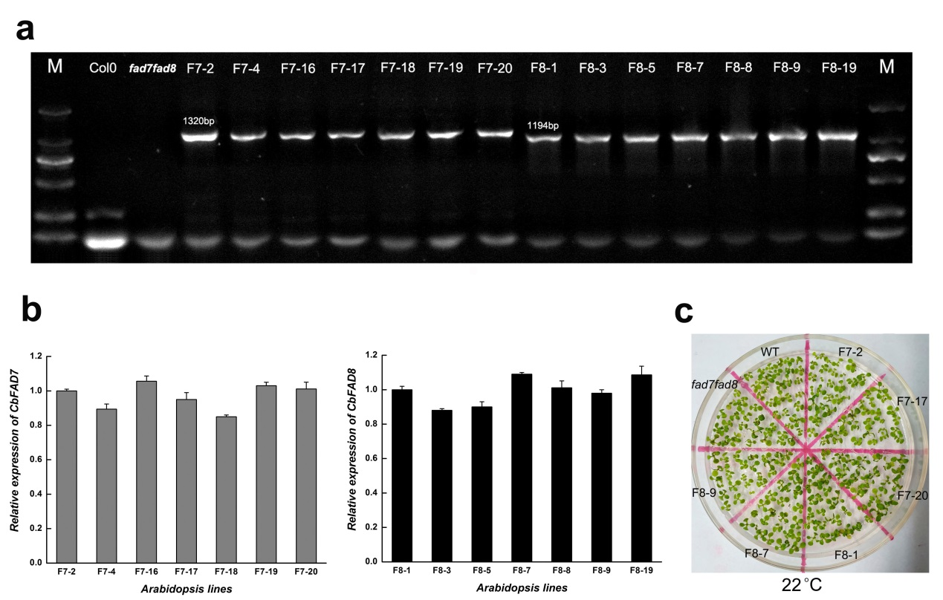
Fig. S1
Molecular and germination analyses of Arabidopsis lines. (a) PCR analysis of the coding region of CbFAD7 (1320bp) and CbFAD8 (1194bp) in WT plants, fad7fad8 mutants and complemented mutants. (b) Real-time PCR analysis of the expression of CbFAD7 and CbFAD8 in complemented mutants. (c) Germination of Arabidopsis lines under normal conditions. The photograph was taken 25 d after vernalization. The CbFAD7-complemented and the CbFAD8-complemented mutants were represented as F7 and F8, respectively. Each value represents the mean ± SE of three replicates.
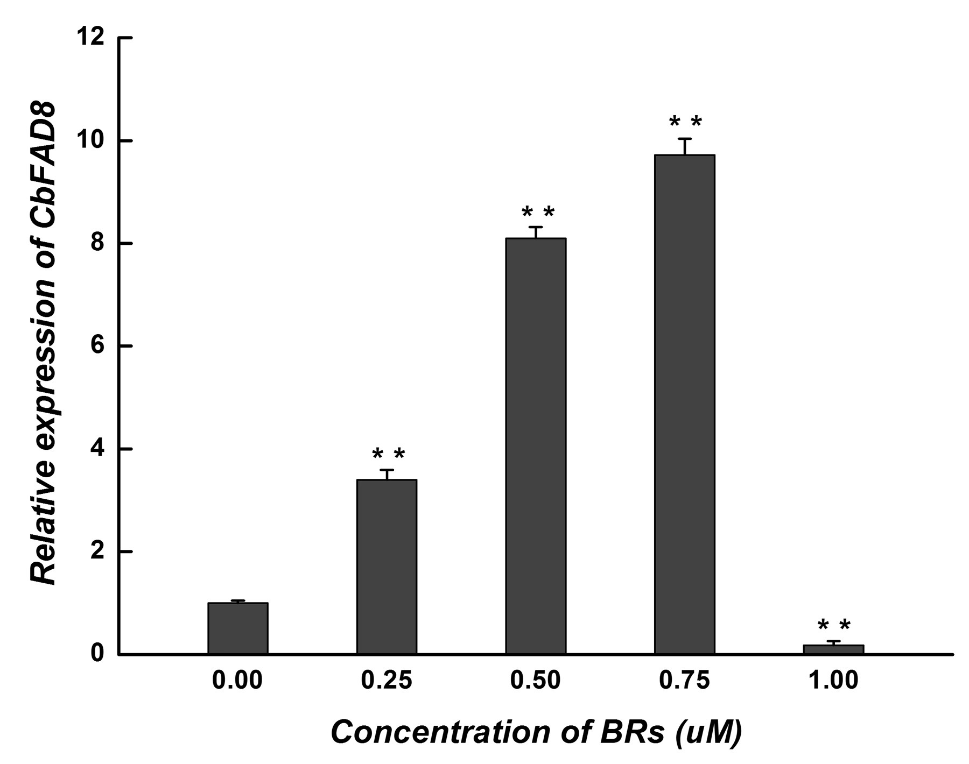
Fig. S2
Effect of the concentration of exogenous BRs on the expression of CbFAD8 in C. bungeana cell suspensions. The expressions of CbFAD8 were detected at being treated for 3 h. Data were presented as relative expression ratios being compared with the expression level of corresponding gene without BRs treatment, which were set at a value of 1. Each value represents the mean ± SE of three replicates.

