Supplementary Figures
Figure S1. Identified common and unique quantifiable proteins between TRY, PEP and PAP. For each comparison, total number of the quantified proteins per protease as well as common and unique proteins have been presented as number and percentage.
Figure S2. Gene ontology (GO) analysis of quantifiable proteins. Functional assignments of proteins’ corresponding associated biological processes, molecular function and cellular components are shown. The number of DEPs that could be assigned to the different categories was indicated. Blue column indicates TRY; green column indicates PEP; red column indicates PAP.
Figure S3. KEGG analysis of quantifiable proteins (Top10). Blue column indicates TRY; green column indicates PEP; red column indicates PAP. Under the x-axis are KEGG terms. Above each term show the number of quantifiable proteins.
Figure S4. Cluster analysis of DEPs. Trypsin group vs papain group (A); trypsin group vs pepsin group (B); papain group vs pepsin group (C). The hierarchical clustering results are represented by tree heat maps, in which each row represents a protein (that is, the ordinate is the protein with significant difference), and each column represents a group of samples (Abscissa is the sample information). The logarithmic values (Log₂Expression) of the protein expression of significant difference in different samples are shown in the heat map in different colors, in which red represents significantly up-regulated protein, blue represents significant down-regulated protein and gray part represents no protein quantitative information.
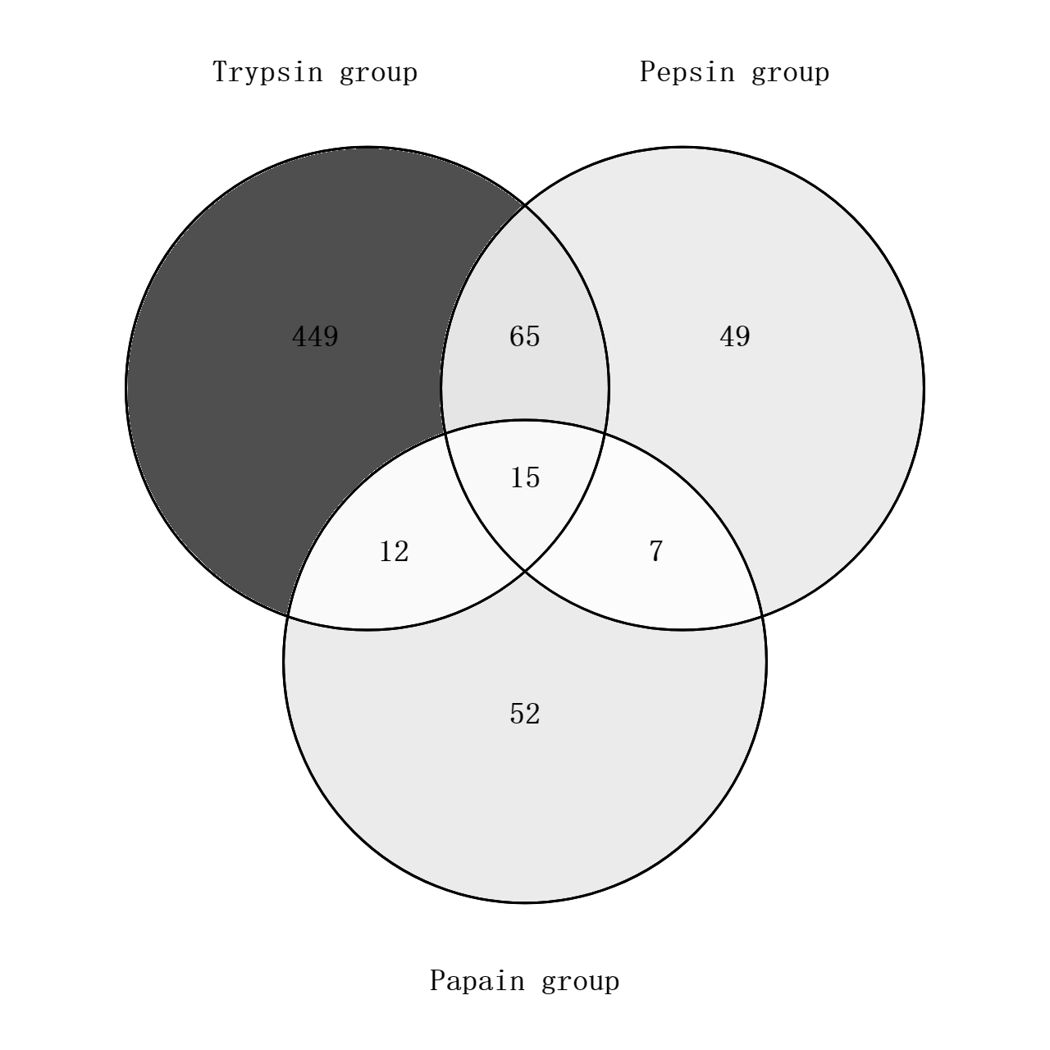
Figure S1. Identified common and unique quantifiable proteins between TRY, PEP and PAP.
Figure S2. Gene ontology (GO) analysis of quantifiable proteins.

Figure S3. KEGG analysis of quantifiable proteins (Top10).

Figure S4. Cluster analysis of DEPs.

