Appendix A: Correlation matrix of all environmental variables. Green circles represent positive correlations and red circles represent negative correlations; size of circle represents degree of correlation. See Appendix B for descriptions of variable names.
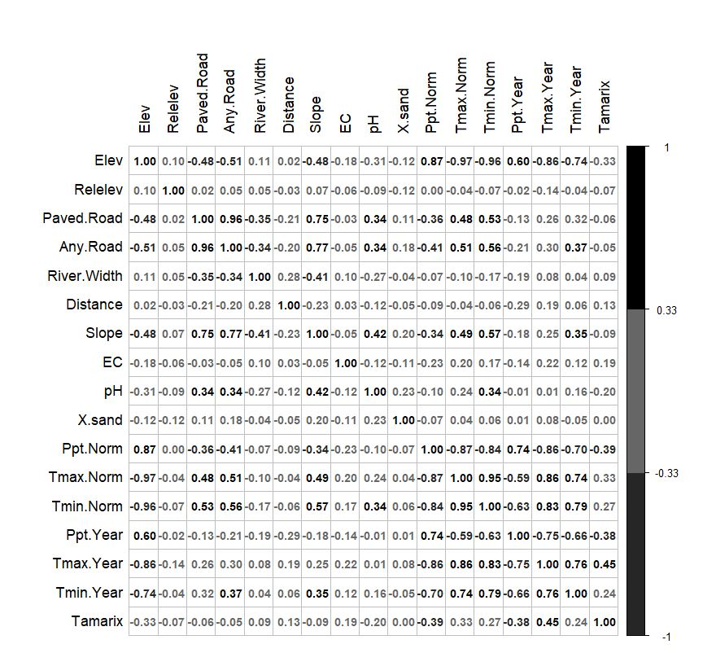

Appendix B: Descriptions of abbreviations for environmental variables in the models.
Variable abbreviation | Description
Tminyear | Minimum temperature year sampling
Tmaxyear | Maximum temperature year sampling
Tminnorm | Minimum average temperature, 30-year mean
Tmaxnorm | Maximum average temperature, 30-year mean
Pyear | Precipitation year sampling
Pnorm | Average precipitation, 30-year mean
Elevasl | Elevation above sea level
Relelev | Elevation above stream level
Dist_paved_rd | Distance to nearest paved road or railway
Anyrd | Distance to nearest road
Dist | Distance to water
Longslope | Longitudinal slope
pH | Soil pH
Sand | Soil percent sand
EC | Soil electrical conductivity
Herb_any | Any herbicide used yes/no
NewCode | Removal method/site type
Active_intro | Active introduction of desirable plants yes/no
ChTam | Change in Tamarix cover over time
Tam_pre | Tamarix cover prior to removal
SAEX_pre | S. exigua cover prior to Tamarix removal

Appendix C: Summary of all models using AIC. The starting variables column includes all combinations of factorially selected variables that resulted in the same model. Variable abbreviations are listed above table.
Data | Model | Unique starting variables (climate + road) | Variables in final model | AIC | Adjusted marginal R² | p
Final-year all- Salix cover | 1 | Elevasl + paved rd, Tminnorm + pavedrd, Tmaxnorm + pavedrd, Tmaxyear + pavedrd | dist_paved_rd, dist, pH, sand, Tamarix, NewCode | 559.99 | 0.3285173 | <.0001
 | 2 | Elevasl + anyrd, Tminnorm + anyrd, Tmaxnorm + anyrd, Tminyear + anyrd | dist_any_rd, dist, pH, sand, Tamarix, NewCode | 560.94 | 0.3280379 | <.0001
 | 3 | Elevasl + longslope, Tmaxnorm + longslope, Tminyear + longslope | dist, pH, sand, Tamarix, NewCode | 560.96 | 0.2736406 | <.0001
 | 4 | Tminnorm + longslope | tminnorm, dist, sand, Tamarix, NewCode | 560.53 | 0.3587238 | <.0001
 | 5 | Pnorm + pavedrd, Pnorm + anyrd, Pnorm + longslope | pnorm, dist, sand, Tamarix, NewCode | 559 | 0.3862473 | <.0001
 | 6 | Tmaxyear + anyrd, Tmaxyear + longslope | tmaxyear, dist, pH, sand, Tamarix, NewCode | 560.35 | 0.3389171 | <.0001
 | 7 | Tminyear + pavedrd | dist_paved_rd, tminyear, dist, sand, Tamarix, NewCode | 558.75 | 0.3818226 | <.0001
 | 8 | Pyear + pavedrd | pyear, dist_paved_rd, dist, sand, Tamarix, NewCode | 554.77 | 0.4450249 | <.0001
 | 9 | Pyear + anyrd, Pyear + longslope | pyear, dist, pH, sand, Tamarix, NewCode | 554.83 | 0.4168268 | <.0001
All-Salix cover change over time | 1 | Elevasl + dist_paved_rd | Elevasl, dist_paved_rd, pH, sand, Herb_any | 1385.97 | 0.3009011 | <.0001
 | 2 | Elevasl + anyrd, Elevasl + longslope, Tminnorm + anyrd, Tminnorm + longslope, Pnorm + anyrd, Pnorm + longslope, Tmaxnorm + anyrd, Tmaxnorm + longslope | Sand, Herb_any | 1386.49 | 0.256248 | <.0001
 | 3 | Tminnorm + dist_paved_rd | Tminnorm, sand, dist_paved_rd, herb_any | 1385.78 | 0.2902397 | <.0001
 | 4 | Pnorm + dist_paved_rd | Pnorm, dist_paved_rd, dist, pH, sand, Herb_any | 1385.47 | 0.3161065 | <.0001
 | 5 | Tmaxnorm + dist_paved_rd | Tmaxnorm, dist_paved_rd, pH, sand, Herb_any | 1385.54 | 0.3043107 | <.0001
S. exigua final cover | 1 | Elevasl + dist_paved_rd, Elevasl + anyrd, Elevasl + longslope, Tminnorm + dist_paved_rd, Tminnorm + anyrd, Tminnorm + longslope, Pnorm + dist_paved_rd, Pnorm + anyrd, Pnorm + longslope, Tmaxnorm + dist_paved_rd, Tmaxnorm + anyrd, Tmaxnorm + longslope, Tmaxyear + dist_paved_rd, Tmaxyear + anyrd, Tmaxyear + longslope, Tminyear + dist_paved_rd, Tminyear + anyrd, Tminyear + longslope | Herb_any, pH, dist, active_intro, sand, EC, NewCode | 496.42 | .5611725 | <.0001
 | 2 | Pyear + dist_paved_rd | Dist_paved_rd, pH, Herb_any, active_intro, pyear, sand, EC, NewCode | 494.35 | .576229 | <.0001
 | 3 | Pyear + anyrd | Dist, pH, Herb_any, pyear, active_intro, sand, EC, NewCode | 494.61 | .5753123 | <.0001
 | 4 | Pyear + longslope | Longslope, Herb_any, pH, active_intro, sand, pyear, EC, NewCode | 494.15 | .5769446 | <.0001
S. exigua change over time | 1 | Elevasl + dist_paved_rd + Tam_pre, Elevasl + anyrd + Tam_pre, Elevasl + longslope + Tam_pre, Tminnorm + longslope + Tam_pre, Tmaxnorm + dist_paved_rd + Tam_pre, Tmaxnorm + anyrd + Tam_pre, Tmaxnorm + longslope + Tam_pre, Tmaxyear + dist_paved_rd + Tam_pre, Tmaxyear + anyrd + Tam_pre, Tmaxyear + longslope + Tam_pre, Tminyear + anyrd + Tam_pre, Tminyear + longslope + Tam_pre, Pyear + dist_paved_rd + Tam_pre, Pyear + anyrd + Tam_pre, Pyear + longslope + Tam_pre, Tmaxnorm + anyrd + ChTam, Tminyear + anyrd + ChTam, Pyear + anyrd + ChTam, Pyear + longslope + ChTam, Pyear + longslope + ChTam | NewCode, EC, SAEX_pre | 995.02 | 0.557769 | <.0001
 | 2 | Pnorm + dist_paved_rd + Tam_pre, Pnorm + anyrd + Tam_pre, Pnorm + longslope + Tam_pre, Pnorm + dist_paved_rd + ChTam, Pnorm + anyrd + ChTam, Pnorm + longslope + ChTam, | Herb_any, EC, SAEX_pre, Pnorm | 992.83 | 0.5435349 | <.0001
 | 3 | Tminyear + dist_paved_rd + Tam_pre, Tminyear + dist_paved_rd + ChTam | Herb_any, EC, SAEX_pre, Tminyear | 993.40 | 0.5249782 | <.0001
 | 4 | Tminnorm, dist_paved_rd, Tam_pre, Tminnorm, anyrd, Tam_pre, Tminnorm + dist_paved_rd + ChTam, Tminnorm + anyrd + ChTam, Tminnorm + longslope + ChTam, | Herb_any, EC, SAEX_pre, Tminnorm | 994.52 | 0.5564946 | <.0001
 | 5 | Elevasl + dist_paved_rd + ChTam, Elevasl + anyrd + ChTam, Elevasl + longslope + ChTam, Tmaxnorm + pavedrd + ChTam, Tmaxnorm + longslope + ChTam, Tmaxyear + pavedrd + ChTam, Tmaxyear + anyrd + ChTam, Tmaxyear + longslope + ChTam, Tminyear + longslope + ChTam | Herb_any, EC, SAEX_pre | 994.93 | 0.5435349 | <.0001

Appendix D: Results of individual mixed models showing final-year log-transformed total Salix cover (%) as the dependent variable, using river reach as a random factor. Only variables found to be significant in the full models are shown; those not found to be significant in the models were also not significant individually. Significant relationships are denoted by a red trendline and 95% confidence interval shown in grey (for categorical variables, significance is denoted by a black bar, and error bars represent ±1 standard error of the mean).
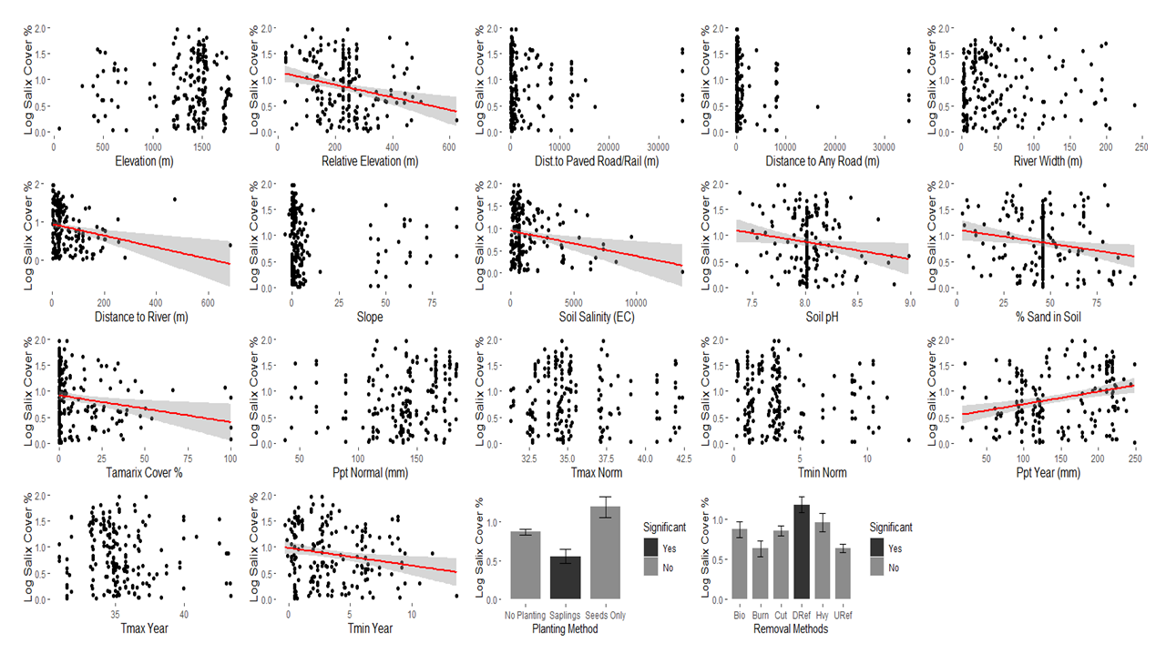

Appendix E: Results of individual mixed models showing total Salix cover change over time (%) as the dependent variable, using river reach as a random factor. Only variables found to be significant in the full models are shown; those not found to be significant in the model were also not significant individually. Significant relationships are denoted by a red trendline and 95% confidence interval shown in grey (for categorical variables, significance is denoted by a black bar, and error bars represent ±1 standard error of the mean).
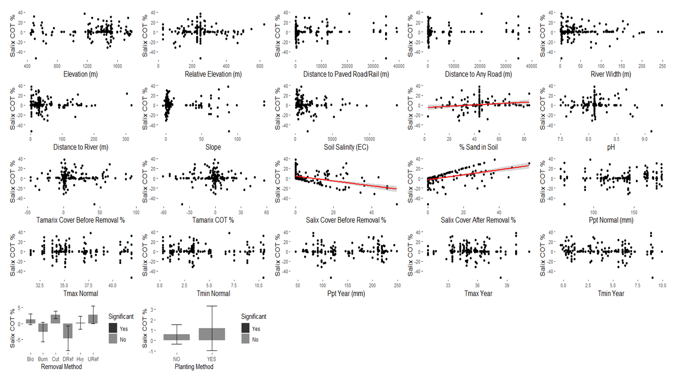

Appendix F: Results of individual mixed models showing final-year log-transformed S. exigua final cover (%) as the dependent variable. Only variables found to be significant in the full models are shown; those not found to be significant in the model were also not significant individually. Significant relationships are denoted by a red trendline and 95% confidence interval shown in grey (for categorical variables, significance is denoted by a black bar, and error bars represent ±1 standard error of the mean).
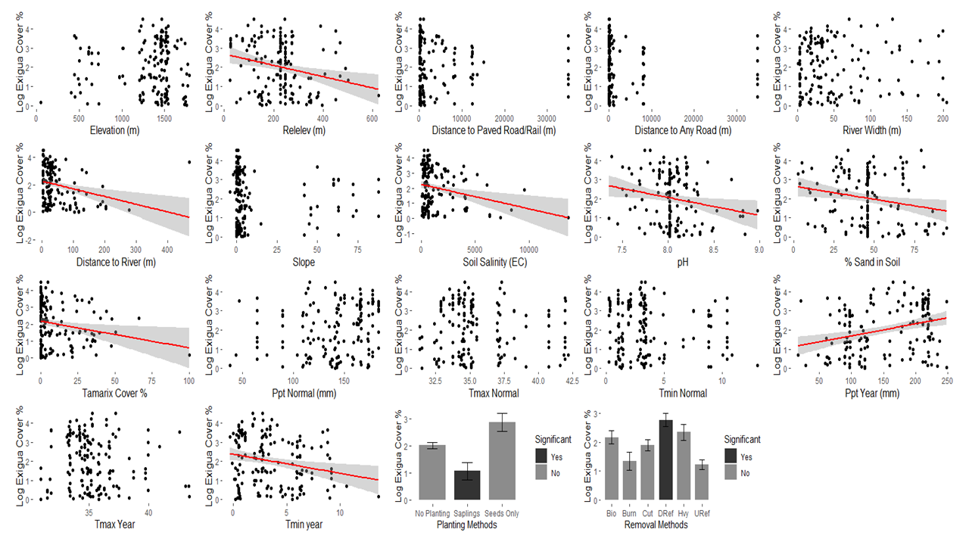

Appendix G: Results of individual mixed models showing S. exigua change over time (%) as the dependent variable. Only variables found to be significant in the full models are shown; those not found to be significant in the model were also not significant individually. Significant relationships are denoted by a red trendline and 95% confidence interval shown in grey (for categorical variables, significance is denoted by a black bar, and error bars represent ±1 standard error of the mean).
