Supplementary information

A Metabolomic Approach to Sustainable Pentacyclic Triterpene Acid Production. Insights into CYP450-mediated Biosynthesis in Cecropia angustifolia
Juan Esteban Vivas¹, Paula C. Muñoz¹, Laura Rodriguez¹, Adrián C. Rodriguez¹, and Guillermo Montoya^{1,2 *}
¹ Facultad Barberi de Ingeniería, Diseño y Ciencias Aplicadas. Departamento de Ciencias Farmacéuticas y Químicas, Universidad Icesi. Cali, Valle del Cauca 760031, Colombia.
² BioInc. Center for Biomass Valorization Research, Universidad Icesi. Cali, Valle del Cauca 760031, Colombia.

Table S1. List of primers used during PCR and RT-qPCR amplification.
No | Name | Sequence | Strand | Lenght | Tm | %GC | PCR product
1 | 716CF1 | TTCCCGCCGTTTACCTTC | + | 18 | 61.8 | 55.6 | 164 bp
1 | 716CR1 | GTGGGCATCATATCGCC  (GGCGATATGATGCCCAC) | - | 17 | 59.7 | 58.8 | 164 bp
2 | 716AF1 | TGTTCAACGGCTTCTCCATC | + | 20 | 62.4 | 50.8 | 243 bp
2 | 716AR1 | CGCTTGACGAGGTTGTG  (CACAACCTCGTCAAGCG) | - | 17 | 60.2 | 58.3 | 243 bp
3 | 72AF2 | TGCTTGTTTGGACAATG | + | 17 | 55.5 | 41.2 | 298 bp
3 | 72AR2 | GCATCATCACCCCATAGT  (ACTATGGGGTGATGATGC) | - | 18 | 58.7 | 50 | 298 bp
4 | 72AF3 | GCTCGGAAACTTGTCATTACCGGC | + | 24 | 60.5 | 54.1 | 84 bp
4 | 72AR3 | TCACCCCATAGTTCAGTGTCGTGGT  (ACCACGACACTGAACTATGGGGTGA) | - | 25 | 61.2 | 52 | 84 bp
5 | 71DF1 | ATTTGGCGCTGGAAGAAGG | + | 19 | 62.8 | 52.6 | 163 bp
5 | 71DR1 | TCCAACGCTGGCTCCAAA  (TTTGGAGCCAGCGTTGGA) | - | 18 | 64. | 55.6 | 163 bp
6 | TUBF1 | TCTTCCGCCCGGACAACTTCGT | + | 21 | 66. | 59.0 | 142 bp
6 | TUBR1 | TGCAAGCAGTCGCAGTTCTCGG | - | 22 | 65.7 | 59.0 | 142 bp
7 | EF1α F1 | CAGTGCTGGACTGCCACA | + | 18 | 62.8 | 61.1% | 159 bp
7 | EF1α R1 | CTCCACCACCATGGGCTT | - | 18 | 61.6 | 61.1% | 159 bp

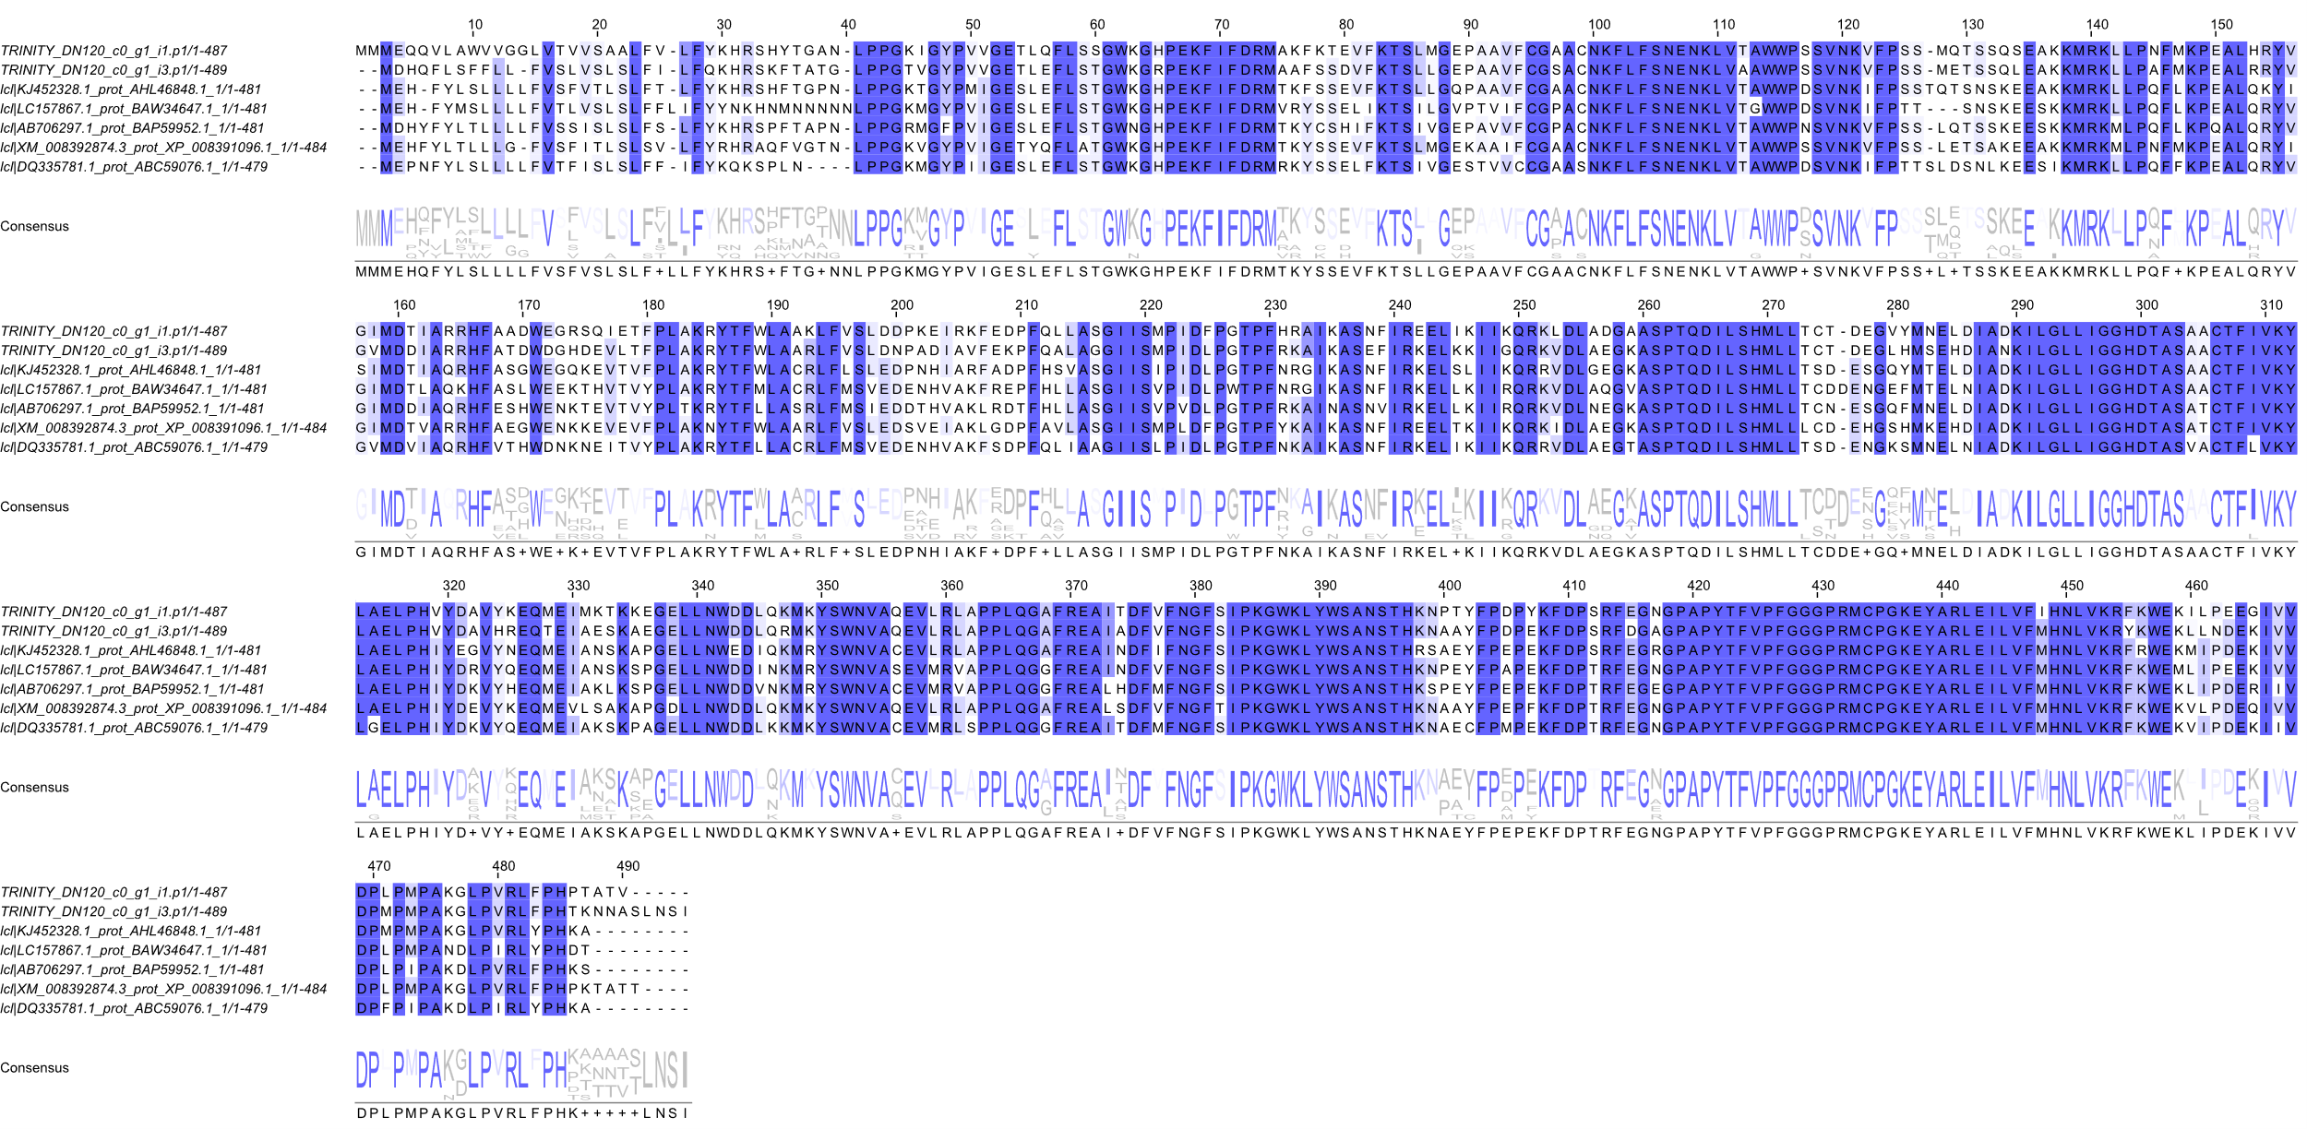
Fig. S1. Complete multiple alignments of the coding mRNA sequence for CYP716A with the reference sequences used. Multiple sequence alignment generated with JalView using ClustalW. Conservation percentage >60%.
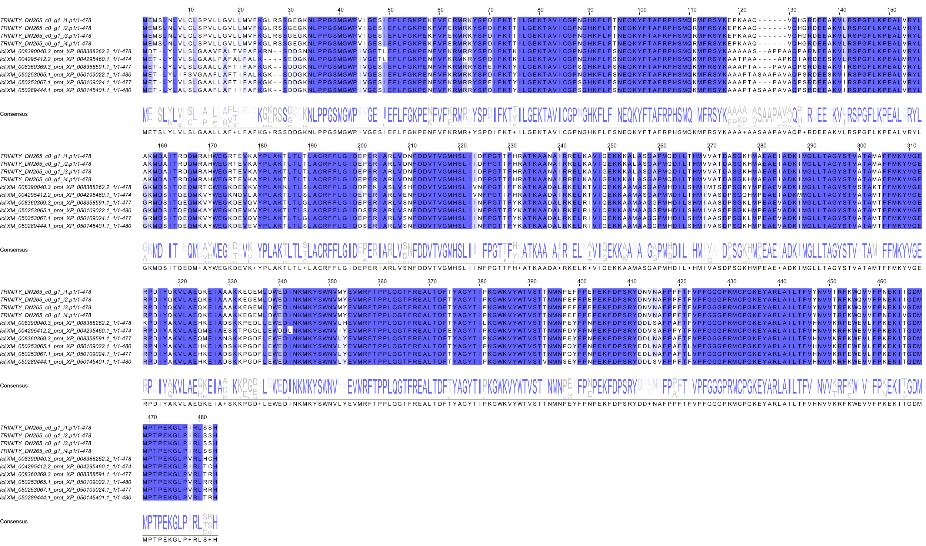
Fig. S2. Complete multiple alignments of the coding mRNA sequence for CYP716C with the reference sequences used. Multiple sequence alignment generated with JalView using ClustalW. Conservation percentage >60%.
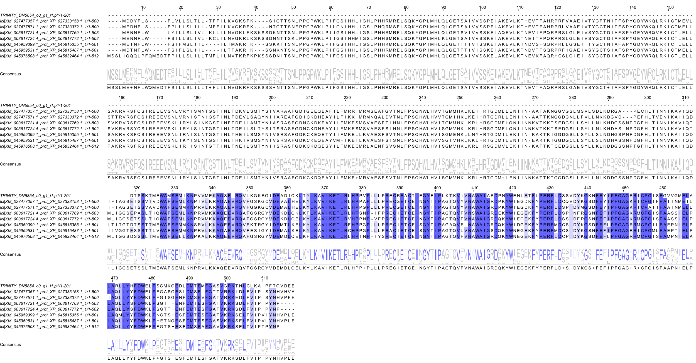
Fig. S3. Complete multiple alignments of the coding mRNA sequence for CYP71D with the reference sequences used. Multiple sequence alignment generated with JalView using ClustalW. Conservation percentage >60%.
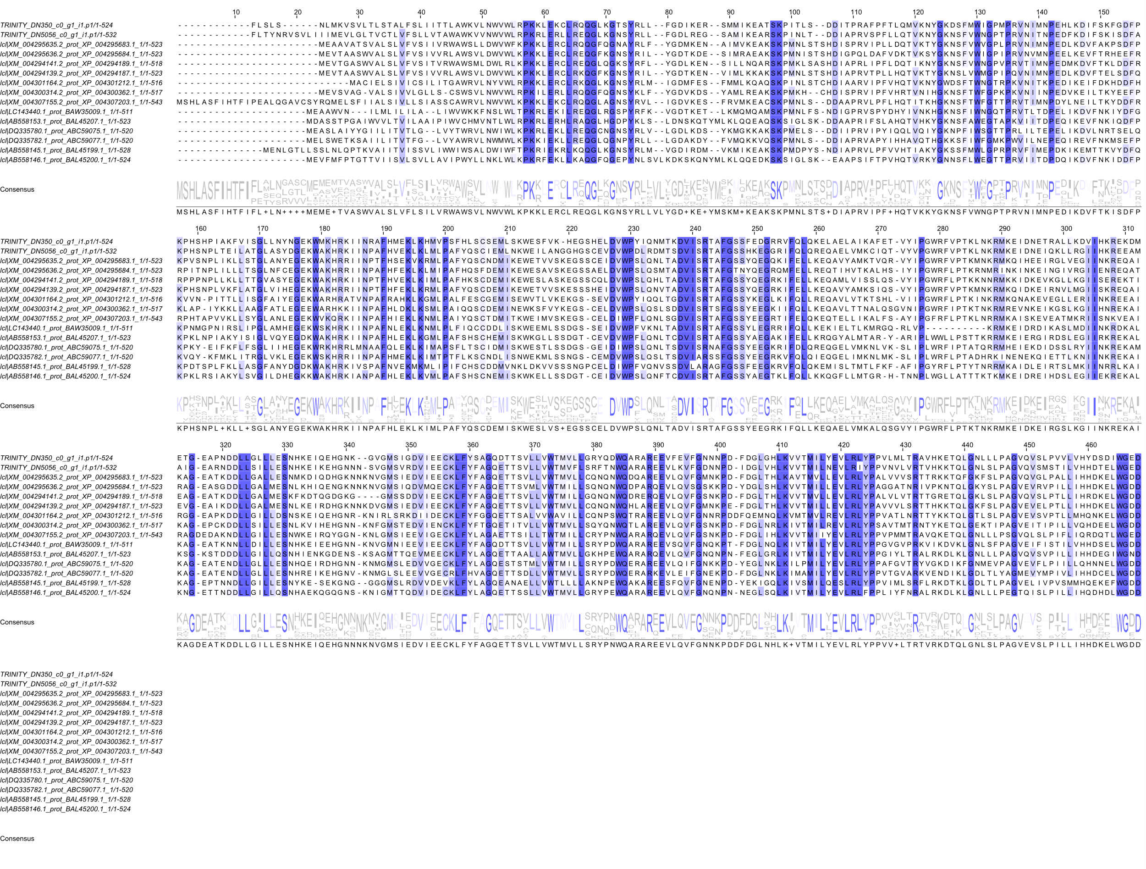
Fig. S4. Complete multiple alignments of the coding mRNA sequence for CYP72A with the reference sequences used. Multiple sequence alignment generated with JalView using ClustalW. Conservation percentage >60%.
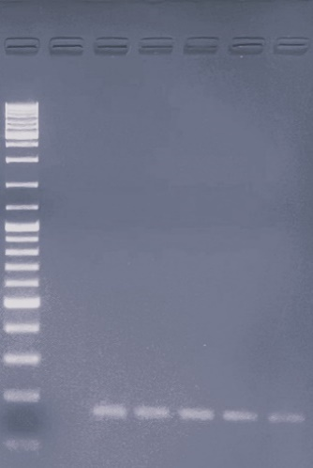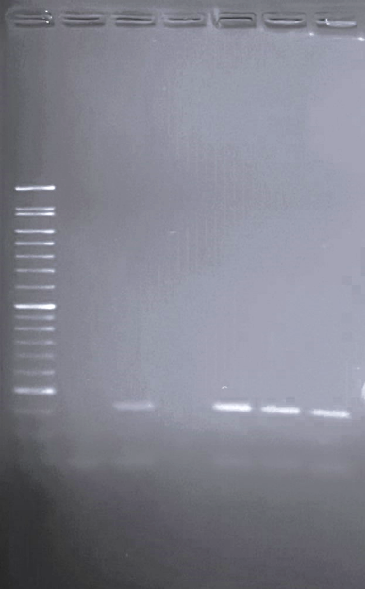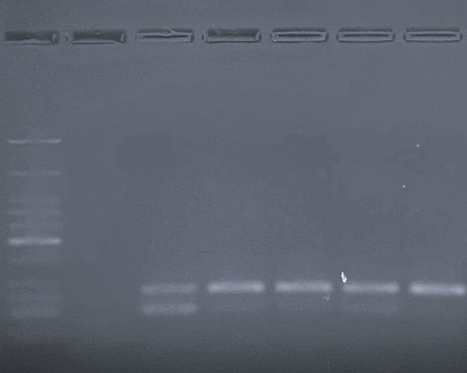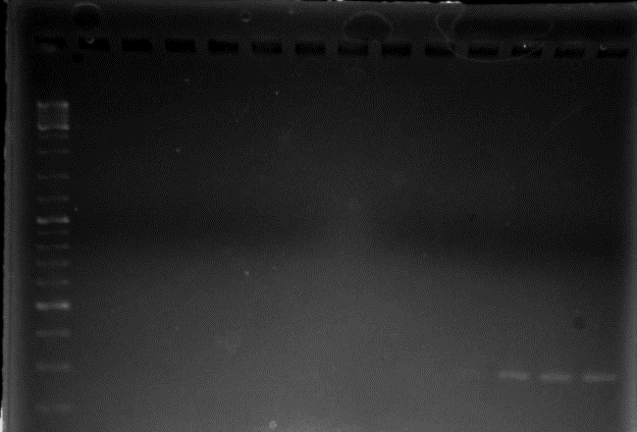
100
200
300
400
500
600
700
800
900
1000
1200
1500
2000
2500
WM
NTC
1
2
3
4
5
5
100
150
300
600
700
800
900
1000
1200
WM
NTC
1
2
3
4
200
400
500
25
50
75
100
150
200
250
300
350
500
766
5
WM
NTC
1
2
3
4
A
5
WM
NTC
1
2
3
4
9
6
7
8
10
NTC
200
300
400
500
600
700
800
900
1000
1200
1500
2000
2500
11
C
B
D
164 pb
163 pb
298 pb
84 pb
Fig. S5. Agarose gel electrophoresis (2%) of PCR products from the amplification of target genes. (A). Amplification of CYP716C using primers CYP716CF/R1. Lanes: WM, GeneRuler™ 1 kb DNA Ladder (Cat No. SM0311, ThermoFisher Scientific); NTC, no-template control. Primer annealing temperatures: 1. 60.0°C, 2. 58.8°C, 3. 56.8°C, 4. 54.3°C, 5.50.0°C. (B). Amplification of CYP71D using primers CYP71DF/R1. Lanes: WM, SmartCheck 50 bp DNA Ladder (Cat No. PR4005-100, Accuris); NTC, no-template control. Primer annealing temperatures: 1. 50.0°C, 2. 54.3°C, 3. 56.8°C, 4. 58.8°C, 5. 60.0°C.(C). Amplification of CYP716A and CYP72A using primers 716AF/R1 and 72AF/R2, respectively. Lanes: WM, GeneRuler™ 1 kb DNA Ladder (Cat No. SM0311, ThermoFisher Scientific); NTC, no-template control. Annealing temperatures for primers 716AF/R1: 1. 60.0°C, 2. 58.8°C, 3. 56.8°C, 4. 54.3°C, 5. 50.0°C; lane 6, empty. Annealing temperatures for primers 72AF/R2: 7. 60.0°C, 8. 58.8°C, 9. 56.8°C, 10. 54.3°C, 11. 50.0°C.(D). Amplification of CYP72A using primers 72AF/R3. Lanes: WM, Low Molecular Weight DNA Ladder (Cat No. N3233S, New England Biolabs); NTC, no-template control. Primer annealing temperatures: 1. 50.0°C, 2. 54.3°C, 3. 56.8°C, 4. 58.8°C, 5. 60.0°C.

