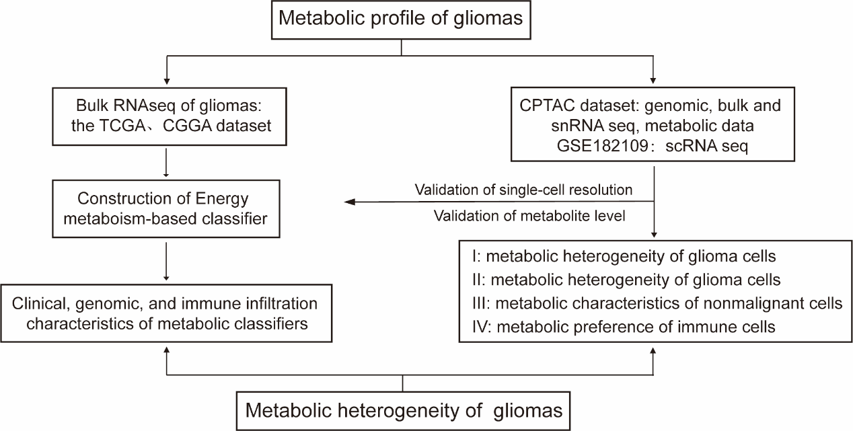
Figure S1. Schematic diagram illustrating the workflow of the energy metabolism-based classifier for gliomas.
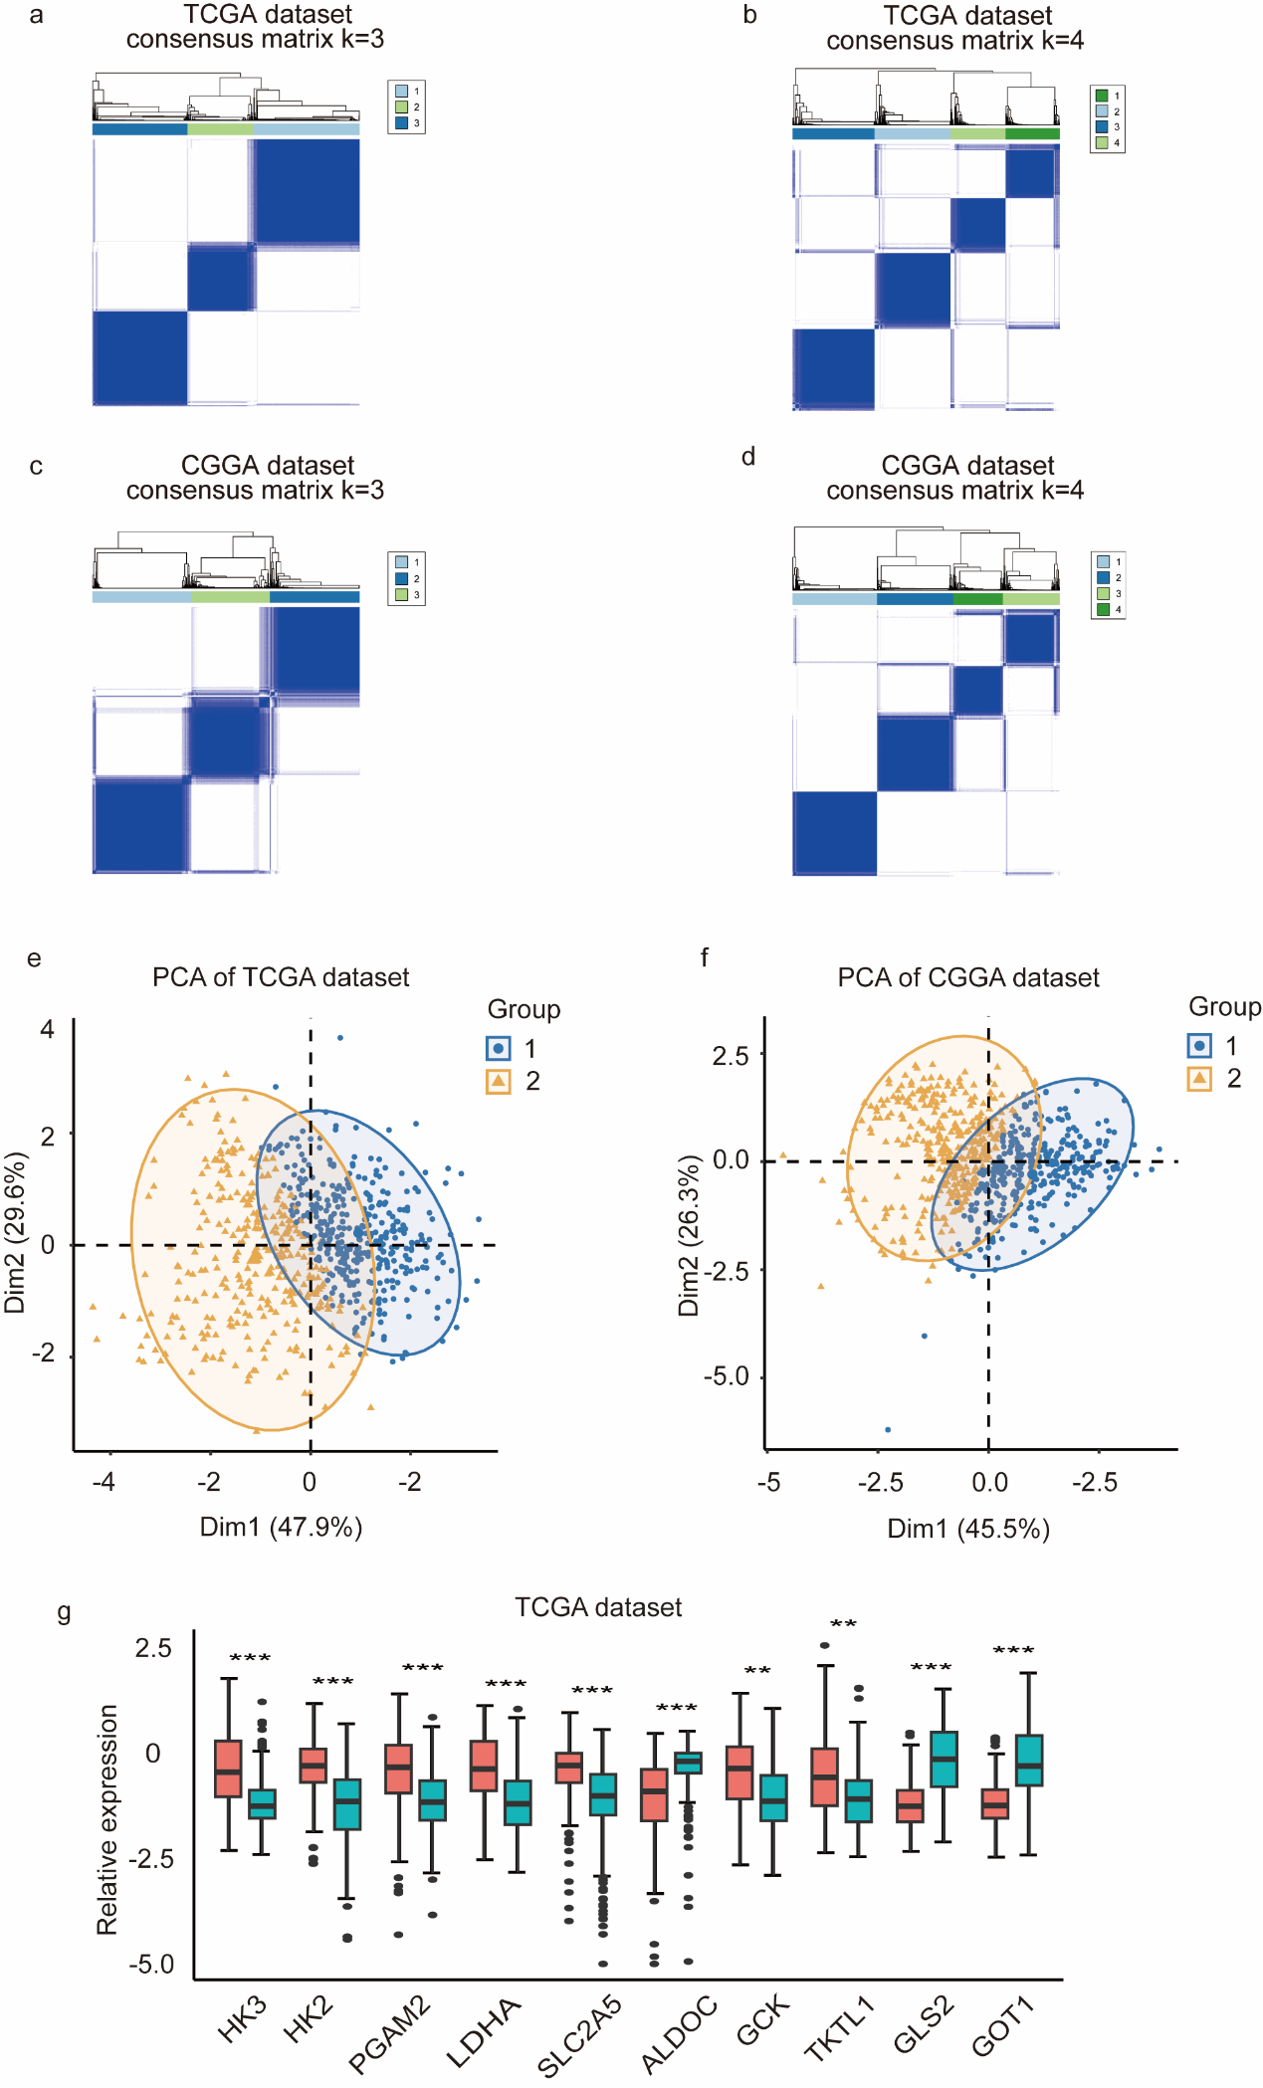
Figure S2. Consensus clustering and PCA of the TCGA and CGGA datasets.
(a, b) Heatmaps showing the consensus value matrices from three to four clusters (k) tested via the k-means algorithm in the TCGA dataset. Each row and column represents a sample. Consensus clustering was obtained through 1000 iterations and 80% resampling. The consensus values range from 0 (white) to 1 (dark blue): a value of 1 indicates that two samples always cluster together, whereas 0 indicates that they never cluster together. The bar chart below the dendrogram shows the consensus clustering obtained from the metadata.
(c, d) Heatmaps of the consensus value matrices when K=3 and 4 in the CGGA dataset.
(e) PCA scatter plots for the TCGA datasets when K=2.
(f) PCA scatter plots for the CGGA datasets when K=2.
(g) Box plots depict the relative mRNA expression levels of metabolism-related genes between metabolic clusters in the TCGA dataset
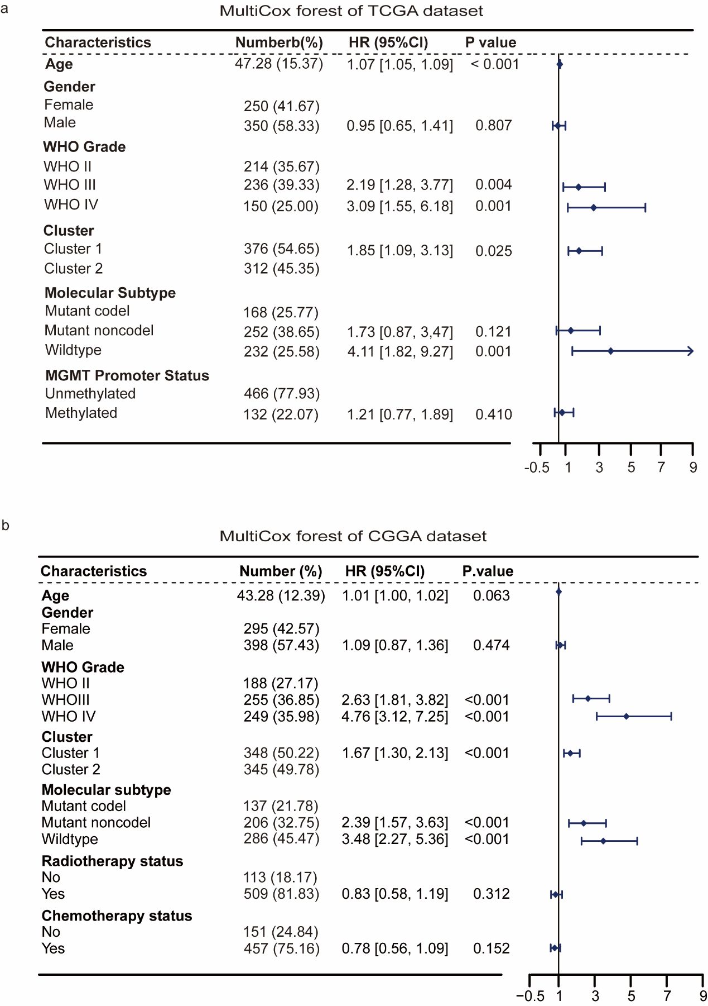
Figure S3. Forest plots of multivariate Cox regression analysis in the TCGA and CGGA datasets.
(a) Multivariate Cox regression analysis of the TCGA dataset, adjusted for age, sex, tumor grade, energy metabolism subtype, molecular pathology subtype, and MGMT promoter methylation.
(b) Multivariate Cox regression analysis of the CGGA dataset, adjusted for age, sex, tumor grade, energy metabolism subtype, molecular pathology subtype, radiotherapy, and chemotherapy.
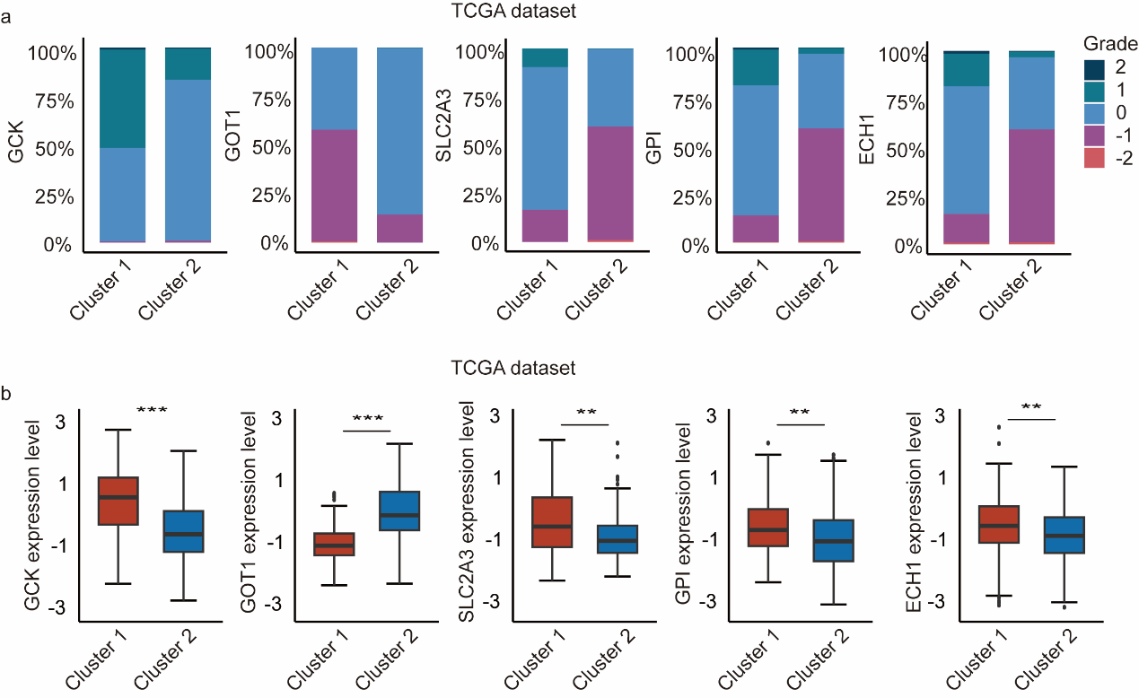
Figure S4. Comparison of CNV and mRNA levels of metabolism-related genes between metabolic clusters.
(a) Comparison of CNV amplification or deletion of metabolism-related genes between metabolic clusters.
(b) Comparison of the mRNA levels of metabolism-related genes between metabolic clusters.
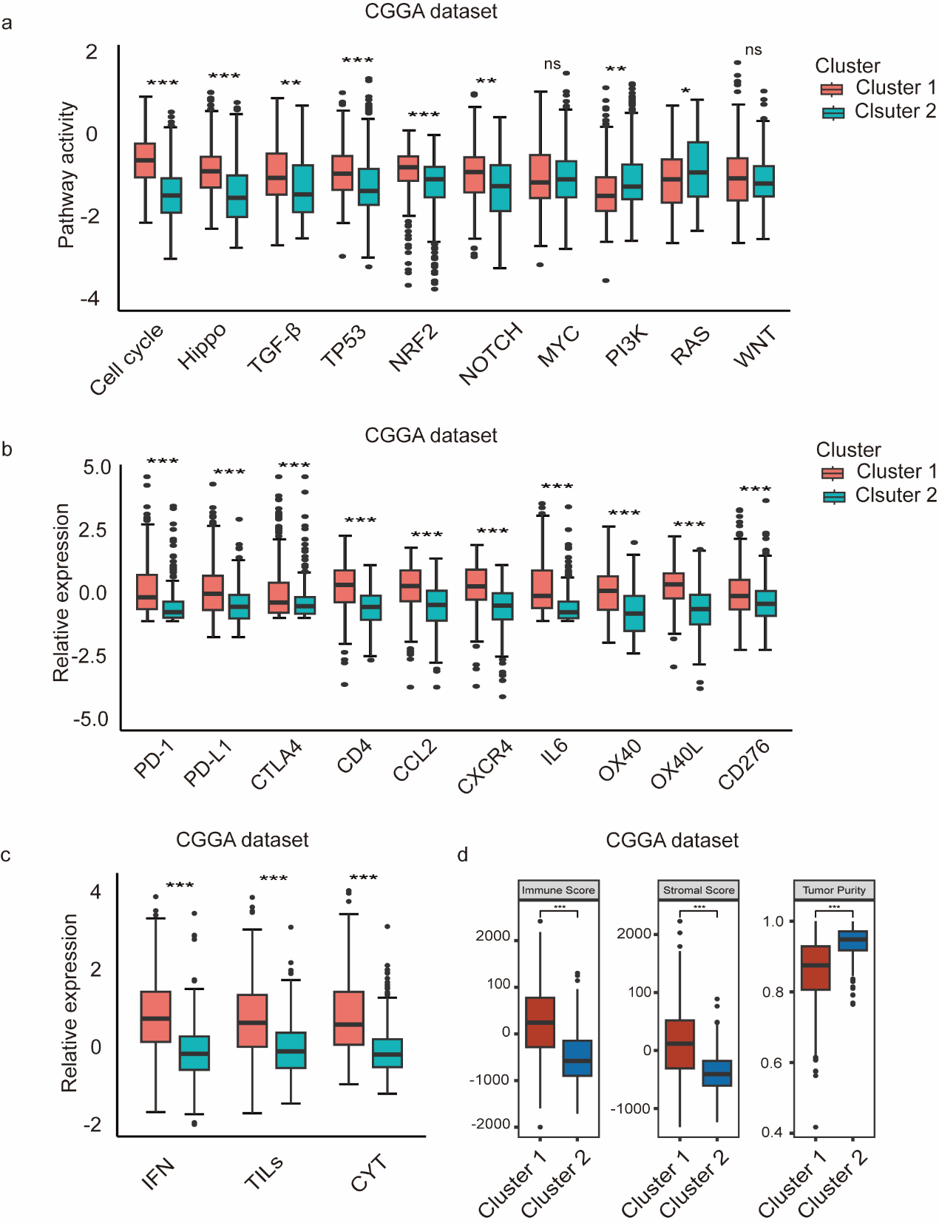
Figure S5. Performance of classical oncogenic pathways and immune features of energy metabolic clusters in the CGGA dataset.
(a) Quantitative analysis of ten classic oncogenic pathways between metabolic clusters in the CGGA dataset.
(b) Comparison of the mRNA levels of immune checkpoints between metabolic clusters in the CGGA dataset.
(c) Comparison of diverse immune signatures between metabolic clusters in the dataset.
(d) Comparison of scores calculated with the ESTIMATE algorithm between metabolic clusters in the dataset.
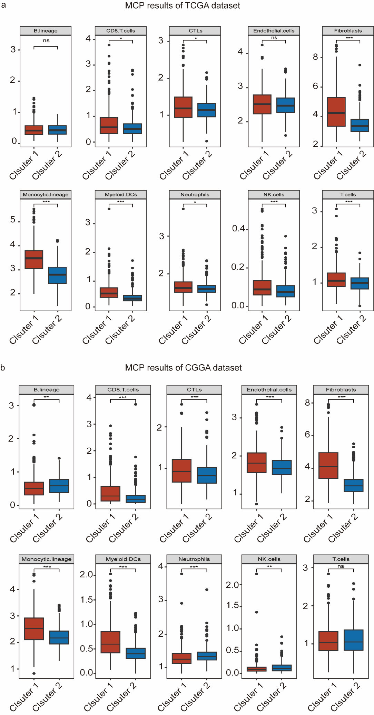
Figure S6. Abundances of immune cells and stromal cells calculated with the MCP-counter algorithm in the TCGA and CGGA datasets.
(a) Comparison of the abundance of immune and stromal cells between metabolic clusters in the TCGA dataset.
(b) Comparison of the abundance of immune and stromal cells between metabolic clusters in the CGGA dataset.
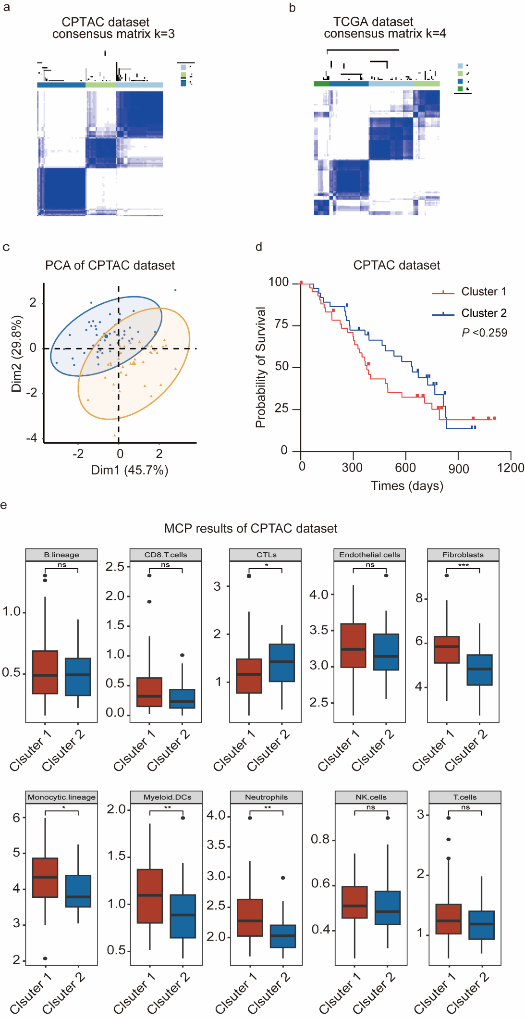
Figure S7. Validation of the energy metabolic classifier in the CPTAC dataset.
(a, b) Heatmaps of consensus value matrices when K=3 and 4 in the CPTAC dataset.
(c) Performance of metabolic classification of PCA in the CPTAC dataset.
(d) Kaplan-Meier curves of the metabolic classifier in the CPTAC dataset, with log-rank test P-values shown.
(e) Comparison of the abundance of immune and stromal cells between the metabolic clusters in the CPTAC dataset.
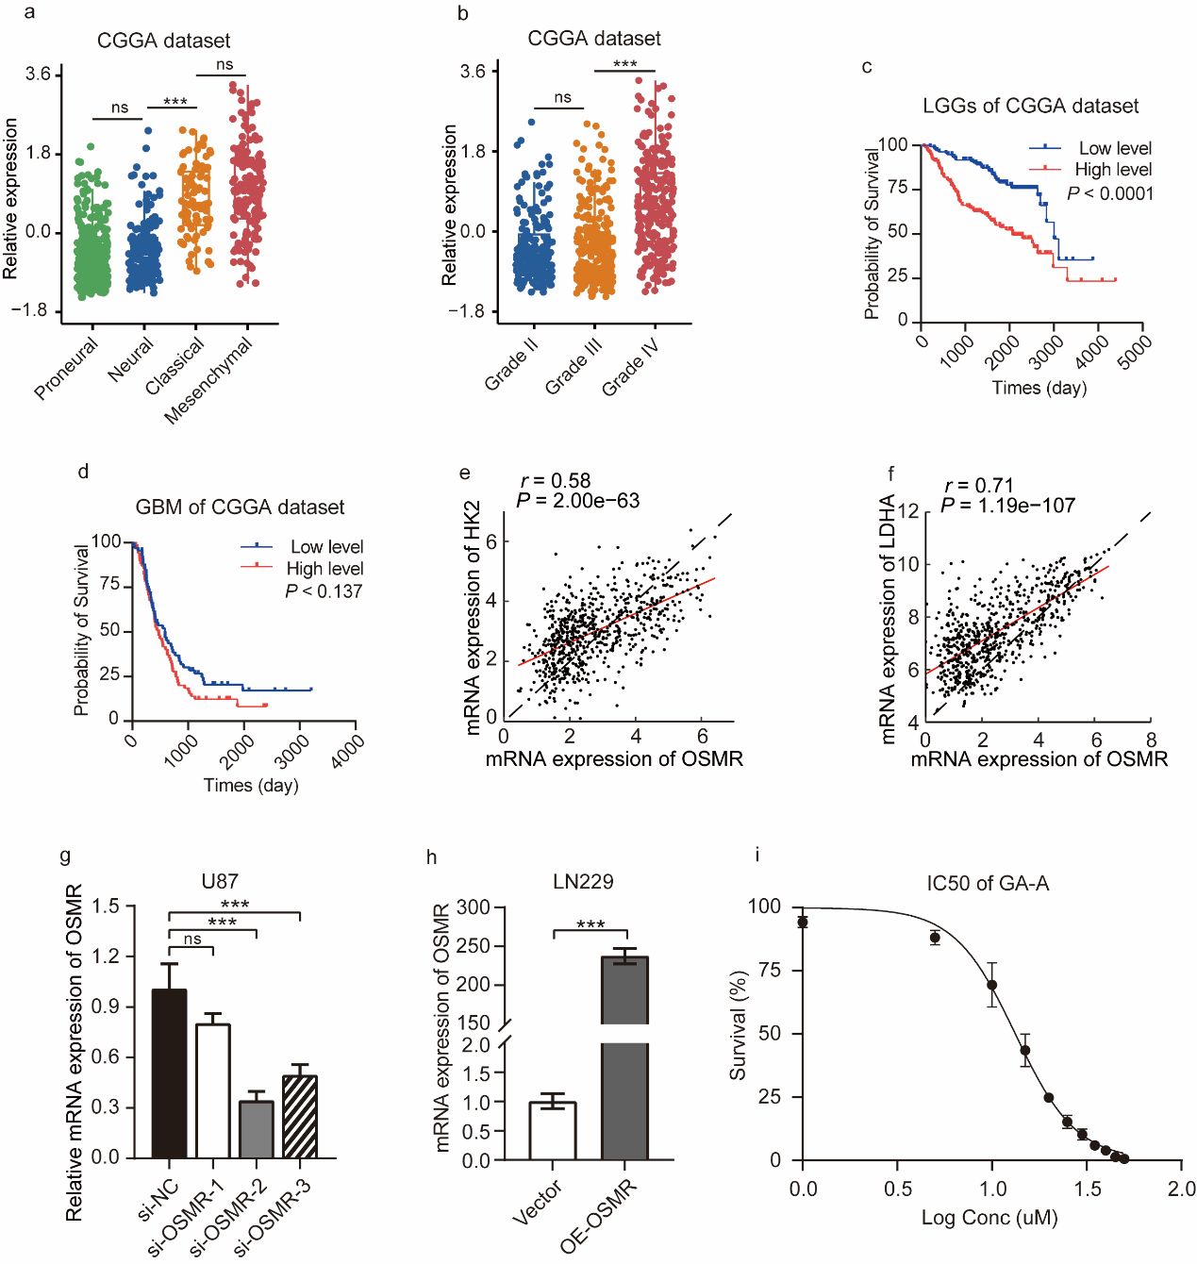
Figure S8. The supplementary profile of OSMR.
(a) The relative mRNA expression of OSMR across transcriptome subtypes of gliomas in the CGGA dataset.
(b) The relative mRNA expression of OSMR across all WHO grades of gliomas in the CGGA dataset.
(c) Kaplan-Meier curve analysis of low grade gliomas (LGGs) in CGGA dataset stratified by OSMR expression level.
(d) Kaplan-Meier curve analysis of glioblastomas (GBMs) in CGGA dataset stratified by OSMR expression level.
(e, f) The correlation analysis of OSMR mRNA expression with HK2 and LDHA mRNA levels in the TCGA dataset.
(g) OSMR gene silencing showed that the mRNA expression levels of siOSMR-2 and siOSMR-3 were significantly lower than those of the control group in U251 cell line (P<0.001, P<0.001).
(h) OE-OSMR significantly up-regulated the mRNA expression levels of OSMR compared with those in the control group in the LN229 cell line (P<0.001).
(i) Cell survival rate curve of U87 cells treated with different logarithmic concentrations of ganoderic acid A (GA-A).
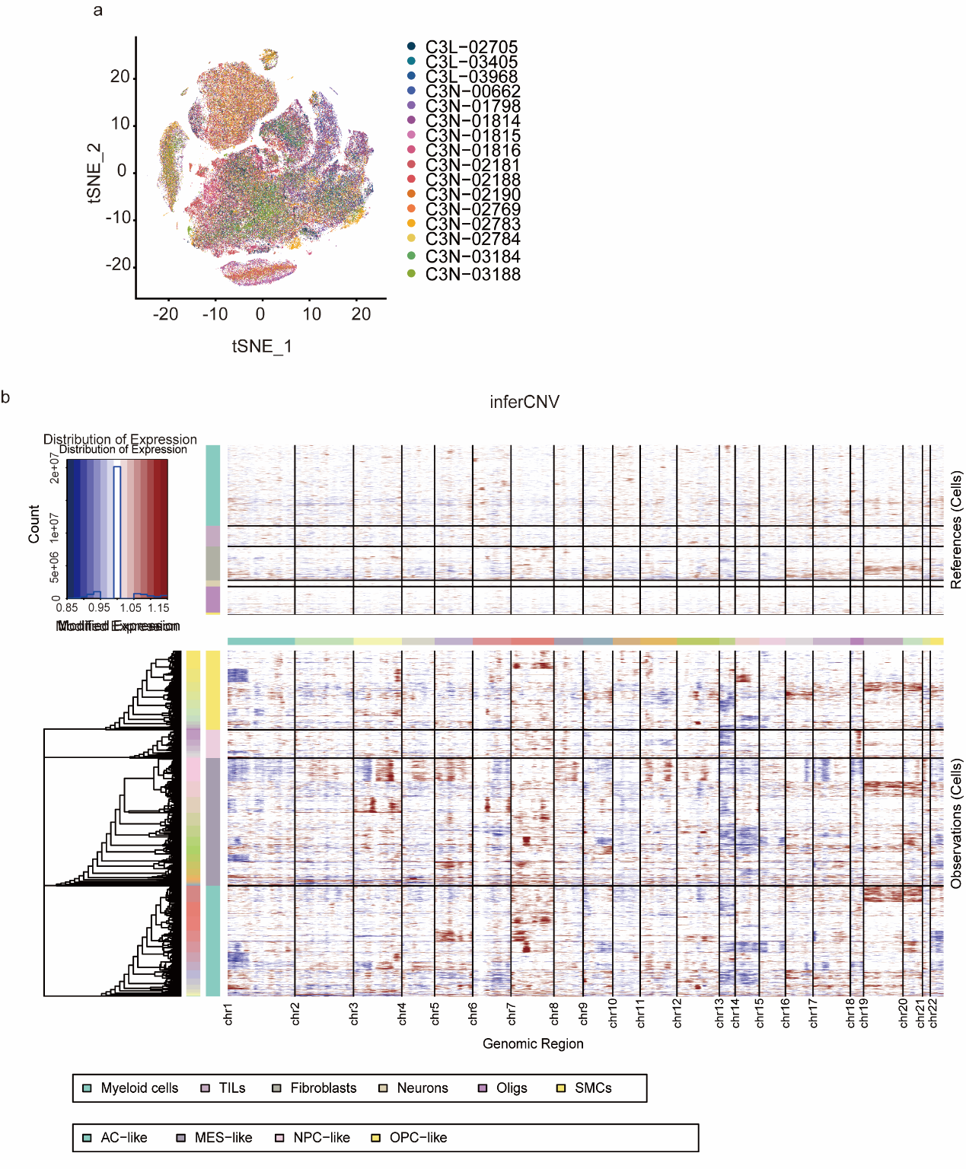
Figure S9. t-SNE plot and inferCNV plots of the CPTAC dataset.
(a) t-SNE projections of patients in the CPTAC dataset.
(b) CNV analysis based on scRNA-seq data, showing increased copy number variation on chromosome 7 (red) and loss on chromosome 10 (blue) in tumor cells compared with nonmalignant cells.

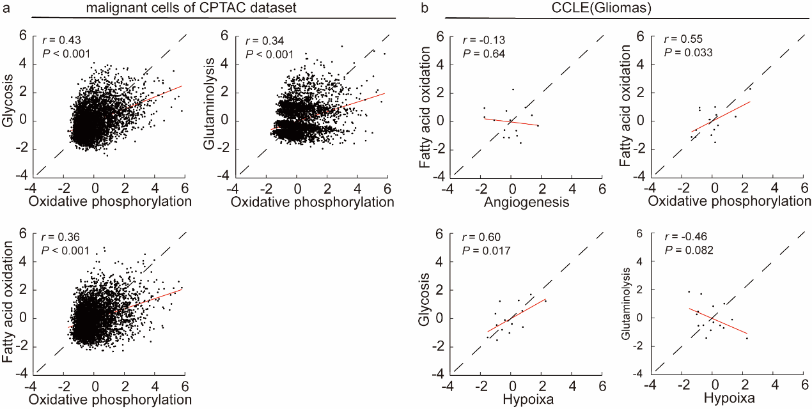
Figure S10. The correlation scatter plots of metabolic pathways of tumor cells in the CPTAC dataset.
(a) Correlation scatter plots of glycolysis, fatty acid oxidation, and glutaminolysis with oxidative phosphorylation in glioma cells.
(b) Correlation scatter plots of different metabolic pathways in glioma cell lines from the CCLE database.
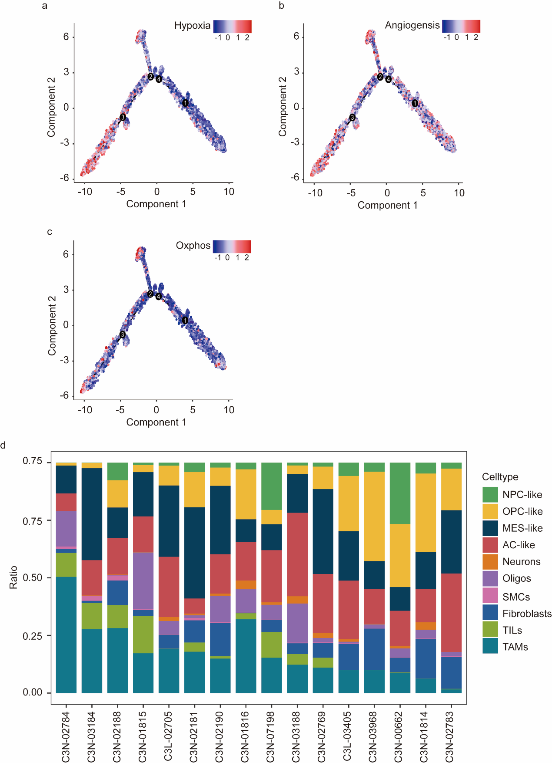
Figure S11. Pseudotime analysis and the proportions of various types of malignant cells.
(a, b, c) Alterations in hypoxia, angiogenesis, and oxidative phosphorylation pathway activities in tumor cells during the transition from PN to MES.
(d) Proportion chart showing the distribution of different cell types in each patient.

Tables
Table. S1 Four metabolic pathway-related genes.
pathways | Related genes
Glycolysis | HK1, HK2, HK3, GCK, GPI, PFKM, PFKP, PFKL, PFKFB, PFKFB2, PFKFB3, PFKFB4 ,ALDOA, ALDOB, ALDOC, TPI1, GAPDH, PGK1, PGK2, PGAM1, PGAM2, PGAM4,BPGM, ENO1, ENO2, ENO3, PKLR, PKM, LDHA, LDHB, LDHC, SLC2A1, SLC2A2, SLC2A3, SLC2A4, SLC2A5
Pentose phosphate pathway | G6PD, H6PD, PGLS, PGD, RPIA, RPE, RPELI, TKT, TKTL1, TKTL2, TALDO1
Fatty acid oxidation | ACADM, ACADVL, ACADS, ACADL, ACAD9, ACADSB, ACAD8, HADHA, HADHB, HADH, ECHS1, EHHADH, ECI1, ECI2, HSD17B10, ACAA1, ACAA2, ACAT1, CPT1A, CPT1B, CPT1C, CPT2, ADIPOR1, ADIPOR2, BDH2, PPARA, PPARD, ECH1
Glutaminolysis | GLS, GLS2, GLUD1, GLUD2, GPT, GOT1, GOT2

Table. S2 si-OSMR and OE-OSMR.
si-OSMR | Primers
si-OSMR-1 | Sense:GCGUCAGAGUUUGCACUUA  Antisense:UAAGUGCAAACUCUGACGC
si-OSMR-2 | Sense: GAUUCUACUGGACAGGAUA  Antisense:UAUCCUGUCCAGUAGAAUC
si-OSMR-3 | Sense: CUAUUGUGAGGCAAGUCAA  Antisense:UUGACUUGCCUCACAAUAG

Table. S3 Primers used for genes.
Genes | Primers
OSMR | Forward: GGAATGTGCCACACACTTTG  Reverse: ACATTGGTGCCTTCTTCCAC
GAPDH | Forward: TGACTTCAACAGCGACACCCA  Reverse: CACCCTGTTGCTGTAGCCAAA

