Design and Implementation of an Open-Access Arsenic Biosensor
Supplementary material

Authors
Javier Gasulla^{1,3}, Adrian I. Teijeiro², Ezequiel J. Alba Posse^{1,3}, Alejandro D. Nadra^{1,3*}

Supplementary material

Color analysis script, 3D STL files, Android app code, paper parts, plasmid sequence are available at https://github.com/SensAr-Biosensor

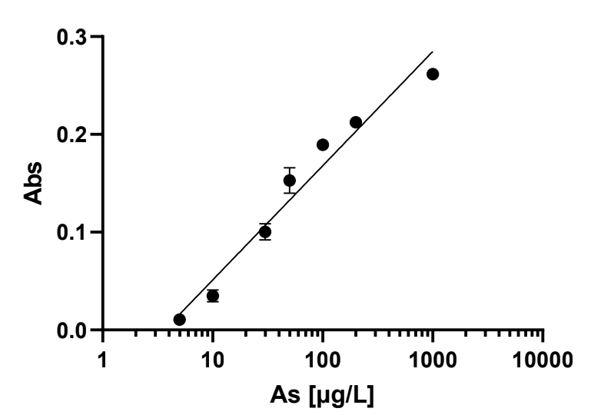
Fig S1. Response curve of biosensor plasmid 1595 to arsenic. Absorbance was registered at 595 nm (y-axis) after 4h induction of 20 μl of bacterial culture (OD=2) and 200 μL of sodium arsenite solution. The plate was incubated at 30°C. As μg.L⁻¹ (Log x-axis) is expressed in log10 (n=3).
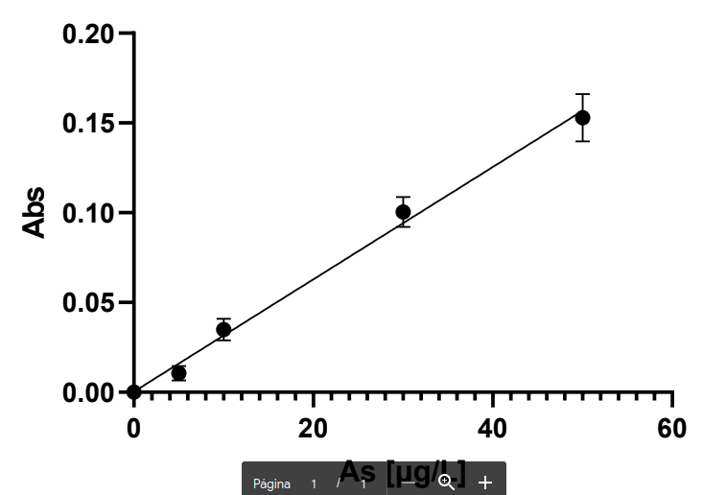
Fig S2.. Linear range of arsenic response. The assay was performed as in Fig S1. The linear range of the response was 0-50 μg.L-1, and a detection limit of 5 μg.L-1.

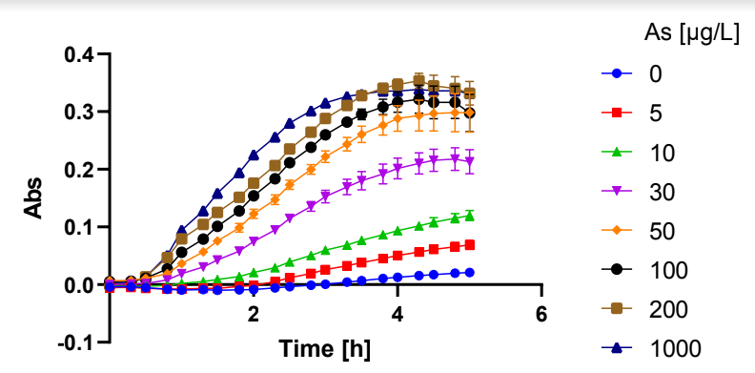
Fig S3. Time response curves for increasing arsenic levels. The assay was performed as in Fig S1. Abs (595 nm) was recorded every 30 min on triplicates.

Sample Number | Source | pH | CE (µS/cm) | Sodium | Fluoride | Nitrate | As | SensAr result (1)
1 | groundwater | 8.8 | - | 166 | 1.1 | 15 | 34.9 | pos
2 | groundwater | 8.1 | - | 46 | 0.31 | < 1,0 | 6.4 | pos
3 | groundwater | 8.03 | - | 158 | 0.92 | 5.6 | 26.7 | pos
4 | groundwater | 8.03 | - | 181 | 0.91 | ND | 37.8 | pos
5 | groundwater | 8.1 | - | 181 | 1.0 | < 1,0 | 43.2 | pos
6 | groundwater | 7.89 | - | 55 | 0.37 | 5.8 | 13.2 | pos
7 | groundwater | 7.6 | - | 55 | ND | 1.1 | nd | pos | FP
8 | groundwater | 8.56 | - | 189 | 0.72 | 5.9 | 30.0 | pos
9 | groundwater | 7.76 | - | 240 | 0.56 | < 1,0 | 33.6 | pos
10 | groundwater | 8.21 | - | 676 | 1.6 | 2.5 | 44.5 | pos
11 | groundwater | 8.35 | - | 80 | 0.38 | 2.2 | 10.7 | pos
12 | groundwater | 8.38 | - | 199 | 1.0 | 10 | 39.6 | pos
13 | groundwater | 8.44 | - | 199 | 1.0 | 10 | 39.0 | pos
14 | groundwater | 9.07 | - | 196 | 1.3 | ND | nd | neg
15 | groundwater | 8 | - | 156 | - | 15.0 | 15.9 | pos
16 | groundwater | 7.7 | - | 171 | 0.98 | ND | 16 | pos
17 | groundwater | 7.77 | - | 171 | 0.96 | 1.2 | 6.7 | pos
18 | groundwater | 8.53 | - | 277 | - | 4.8 | 33.3 | pos
19 | groundwater | 8.16 | - | 213 | 0.70 | 7.1 | 27.0 | pos
20 | groundwater | 8.3 | - | 256 | 0.73 | 15 | 24.1 | pos
21 | Freshwater | 7.7 | - | - | ND | - | nd | neg
22 | Freshwater | 7.38 | - | - | ND | - | nd | neg
23 | Freshwater | 8.35 | - | - | - | 2.1 | 47.2 | neg
24 | Freshwater | 7.58 | - | - | - | 1.8 | 29.8 | pos
25 | Freshwater | 8.2 | - | - | - | 0.94 | 14.0 | neg
26 | groundwater | 7.49 | 1,790 | 322.37 | 0.92 | 7.09 | 40.1 | pos
27 | groundwater | 7.47 | 2,650 | 450.24 | 1.13 | 9.58 | 58.2 | pos
28 | groundwater | 7.64 | 3,910 | 889.88 | 2.03 | 1.40 | 101.7 | pos
29 | groundwater | 7.24 | 5,700 | 1,184.68 | 1.19 | 3.32 | 51.2 | pos
30 | groundwater | 7.66 | 1,242 | 244.45 | 1.14 | 3.20 | 65.8 | pos
31 | groundwater | 7.29 | 3,700 | 661.09 | 1.06 | 8.84 | 50.2 | pos
32 | groundwater | 7.85 | 1,536 | 349.93 | 2.55 | < 1 | 84.6 | pos
33 | groundwater | 7.81 | 1,263 | 281.45 | 2.13 | < 1 | 86.1 | pos
34 | groundwater | 7.50 | 3,620 | 609.38 | 1.08 | 16.23 | 32.9 | pos
35 | groundwater | 7.67 | 1,539 | 296.64 | 1.05 | 3.29 | 50.3 | pos
36 | groundwater | 7.40 | 784 | 91.62 | 0.66 | 10.19 | 12.9 | pos
37 | groundwater | 7.43 | 1,003 | 136.64 | 0.50 | < 1 | 13.6 | pos
38 | groundwater | 7.73 | 688 | 132.45 | 1.91 | 3.51 | 26.3 | pos
39 | groundwater | 7.58 | 1,048 | 197.46 | 1.30 | 10.39 | 51.2 | pos
40 | groundwater | 7.60 | 1,086 | 192.89 | 1.40 | 6.73 | 41.0 | pos
41 | groundwater | 7.78 | 962 | 179.24 | 1.56 | 8.25 | 54.2 | pos
42 | groundwater | 7.37 | 2,850 | 521.38 | 1.10 | 1.83 | 32.3 | pos
43 | groundwater | 7.60 | 750 | 111.37 | 1.83 | 4.66 | 36.9 | pos
44 | groundwater | 7.48 | 1,012 | 174.09 | 1.31 | < 1 | 38.2 | pos
45 | groundwater | 7.44 | 3,690 | 682.71 | 1.81 | 19.23 | 39.7 | pos
46 | groundwater | 7.42 | 797 | 82.74 | 1.16 | 4.48 | 18.6 | neg | FN
47 | groundwater | 7.73 | 897 | 175.30 | 2.46 | 4.85 | 86.1 | pos
48 | groundwater | 7.50 | 761 | 93.67 | 0.94 | 25.67 | 17.3 | pos
49 | groundwater | 8.01 | - | - | - | - | 58.9 | pos
50 | groundwater | 7.65 | - | - | - | - | 19.4 | pos
51 | groundwater | 7.44 | - | - | - | - | 10.1 | pos
52 | groundwater | 7.33 | - | - | - | - | 8.1 | neg
53 | groundwater | 7.68 | - | - | - | - | 50.4 | pos
54 | groundwater | 7.93 | - | - | - | - | 67.1 | pos
55 | groundwater | - | - | - | - | - | 50.0 | pos
56 | groundwater | - | - | - | - | - | 74.0 | pos
57 | groundwater | - | - | - | - | - | 74.0 | pos
58 | groundwater | - | - | - | - | - | 71.0 | pos
59 | groundwater | - | - | - | - | - | 74.0 | pos
60 | freshwater | - | - | - | - | - | nd | neg
61 | freshwater | - | - | - | - | - | nd | neg

Table S1. Physico-chemical analysis of water samples used in biosensor validation.
(1) SensAr results are positive when color development is higher than a 10 μg.L-1 standard.
One false positive and one false negative were obtained and are indicated as FP and FN.

