Additional files
Validation of algorithms for identifying people living with HIV in French medico-administrative databases: implications for HIV surveillance
Marc-Florent Tassi, Adrien Lemaignen, Karl Stéfic, Leslie Grammatico-Guillon
Corresponding author: Marc-Florent Tassi, mf.tassi@chu-tours.fr, Public Health and Prevention Division, CHRU de Tours, Tours, France

Table of contents

Additional file 1. Checklist of reporting criteria for studies validating health administrative data algorithms. Benchimol et al. 2011. 3

Additional file 2: Prior predictive distribution for models evaluating the performance of algorithms on targeting the population of diagnosed PLHIV (red) and the performance of algorithms on targeting newly diagnosed people. 5

Additional file 3: Proportion of each group of individuals according to serological status, sex and country of birth used to compute weights for post-stratification 6

Additional file 4: Distribution of confirmed and invalidated HIV diagnoses by typology of information identified in the CHRU de Tours data warehouse 7

Additional file 5: Comparative description of characteristics among individuals based on the success of linkage to the SNDS data and serological status. 9

Additional file 6: specificity of algorithms for targeting the prevalent population of diagnosed PLHIV according to the relative weight assigned to false-positive individuals. 10

Additional file 7: Positive predictive value of algorithms for targeting the prevalent population of diagnosed PLHIV according to the relative weight assigned to false-positive individuals. 11

Additional file 8: Details of the healthcare consumption of individuals identified by the G11 algorithm for the year 2020 13

Additional file 9: specificity of algorithms for targeting the newly diagnosed PLHIV according to the relative weight assigned to false-positive individuals. 14

Additional file 10: Positive predictive value of algorithms for targeting the newly diagnosed PLHIV according to the relative weight assigned to false-positive individuals. 15

Additional file 11: Annual number of newly diagnosed subjects identified on the comprehensive SNDS database between 2017 and 2023 17

Additional file 1. Checklist of reporting criteria for studies validating health administrative data algorithms. Benchimol et al. 2011.
 | YES | NO | UNCERTAIN | NOT APPLICABLE
TITLE, KEYWORDS, ABSTRACT:
Identify article as study of assessing diagnostic accuracy
Identify article as study of administrative data
INTRODUCTION:
State disease identification & validation one of goals of study
METHODS:
Participants in validation cohort:
Describe validation cohort (Cohort of patients to which reference standard was applied)
- Age
- Disease
- Severity
- Location/Jurisdiction
Describe recruitment procedure of validation cohort
- Inclusion criteria
- Exclusion criteria
Describe patient sampling (random, consecutive, all, etc.)
Describe data collection
- Who identified patients and did selection adhere to patient recruitment criteria
- Who collected data
- A priori data collection form
- Disease classification
- Split sample (i.e. re-validation using a separate cohort)
Test Methods:
Describe number, training and expertise of persons reading reference standard
If >1 person reading reference standard, quote measure of consistency (e.g. kappa)
Blinding of interpreters of reference standard to results of classification by administrative data e.g. Chart abstractor blinded to how that chart was coded
Statistical Methods:
Describe methods of calculating/comparing diagnostic accuracy
RESULTS:
Participants:
Report when study done, start/end dates of enrolment
Describe number of people who satisfied inclusion/exclusion criteria
Study flow diagram
Test results:
Report distribution of disease severity
Report cross-tabulation of index tests by results of reference standard | (For prevalent PLHIV population)
Estimates:
Report at least 4 estimates of diagnostic accuracy
Diagnostic Accuracy Measures Reported:
- Sensitivity
- Specificity
- PPV
- NPV
- Likelihoods ratio
- Kappa
- Area under the ROC curve / c-statistic
- Accuracy/agreement
- Other (specify)
Report accuracy for subgroups (e.g. age, geography, different sex, etc.)
If PPV/NPV reported, ratio of cases/controls of validation cohort approximate prevalence of condition in the population | (predictive values estimated based on the disease prevalence/incidence)
Report 95% confidence intervals for each diagnostic measure | (credible intervals)
DISCUSSION:
Discuss the applicability of the validation findings

Additional file 2: Prior predictive distribution for models evaluating the performance of algorithms on targeting the population of diagnosed PLHIV (red) and the performance of algorithms on targeting newly diagnosed people.

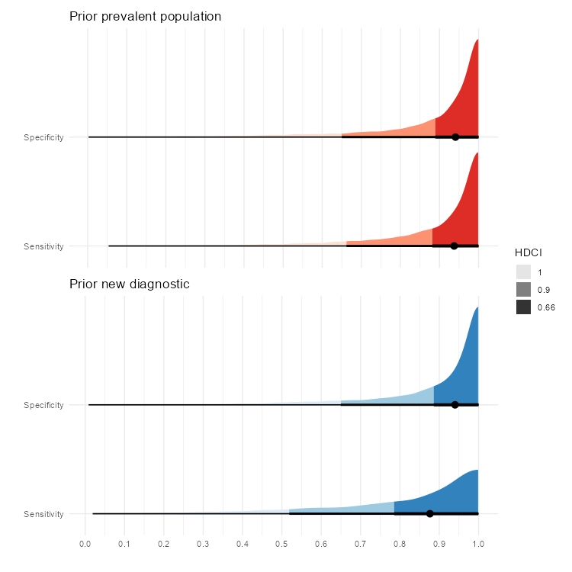
HDCI: highest density continuous interval

Additional file 3: Proportion of each group of individuals according to serological status, sex and country of birth used to compute weights for post-stratification

 | HIV-negative | HIV-positive  (prevalent population) | HIV-positive  (newly diagnosed infection)
French-born women | 46·5 % | 6·5% | 6·8%
Foreign-born women | 5·1% | 27·0 % | 24·8%
French-born men | 43·6% | 39·1% | 42·3%
Foreign-born men | 4.8% | 27.5% | 26.1%

Additional file 4: Distribution of confirmed and invalidated HIV diagnoses by typology of information identified in the CHRU de Tours data warehouse

The graph above illustrates the allocation of potentially seropositive individuals, as identified from the CHRU de Tours data warehouse, categorised according to the nature of information collected about them and the ultimate classification of their serological status. The diverse types of available data were divided into six groups.
- Medical report: all textual information was examined using regular expressions.
- Hospital discharge summary: details associated with the coding of hospital stays, encoded as part of the activity-based pricing for these stays.
- Negative HIV RNA quantification.
- Virological analysis: collections of virology laboratory findings related to HIV-positive individuals' diagnosis or monitoring (positive HIV RNA quantification, positive immunoblot, HIV serotyping, genotypic resistance test, and HIV tropism test)
- Antiretroviral medication dispensation
- Consistency: defined as the absence of negative HIV serology or textual documentation suggesting such serology, recorded after the date of the initial element that prompted the identification of the patient as potentially HIV-positive.
For illustrative purposes, all subjects were divided into four mutually exclusive groups defined according to the intersection of the types of information identified in their respective files.
- Group A includes all individuals with at least one virological analysis as defined above.
- Group B includes all individuals for whom at least one textual element was identified, and for whom all elements were temporally coherent.
- Group C includes all individuals for whom other types of elements were identified and for whom all these elements were temporally coherent.
- Group D includes all those for whom at least one element was identified, but for which there was a temporal consistency issue

Additional file 5: Comparative description of characteristics among individuals based on the success of linkage to the SNDS data and serological status.
 | PLHIV  N = 2,123 |  | HIV-negative  N = 107,093
Linkage with SNDS | Success  N = 2,068 | Failed  N = 55 | Succes  N = 104,084 | Failed  N = 3,009
Women, N (%) | 710 (34·3%) | 30 (54·5%) | 67,236 (64·6%) | 2,050 (68·1%)
Age* in 2020, median [Q1-Q3] | 51·5 [41·8-59·2] | 45·2 [35·9-59·7] | 42·1 [32·5-63·5] | 32·5 [24·0-51·2]
Born abroad N (%) | 685 (33·1%) | 16 (29·1%) | 15,241 (14·6%) | 425 (14·1%)
Time since diagnostic (years), median [Q1-Q3] | 14·7 [8·5-23·1] | 10·7 [4·7-16·0]
HIV transmission
Heterosexual | 706 (52·1%) | 14 (66·7%)
MSM | 506 (37·4%) | 6 (28·6%)
Injection drug use | 73 (5·4%)
Transfusion | 43 (3·2%)
Perinatal | 26 (1·9%) | 1 (4·8%)
unknown | 714 | 34

* The age of individuals in 2020 has been calculated by including individuals who were deceased prior to that year, owing to the inability to ascertain the vital status of persons for whom linkage with the SNDS could not be established.

Additional file 6: specificity of algorithms for targeting the prevalent population of diagnosed PLHIV according to the relative weight assigned to false-positive individuals.
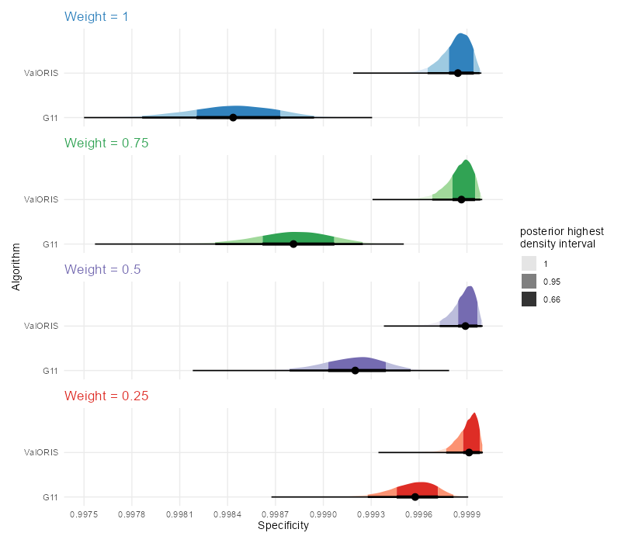

Additional file 7: Positive predictive value of algorithms for targeting the prevalent population of diagnosed PLHIV according to the relative weight assigned to false-positive individuals.
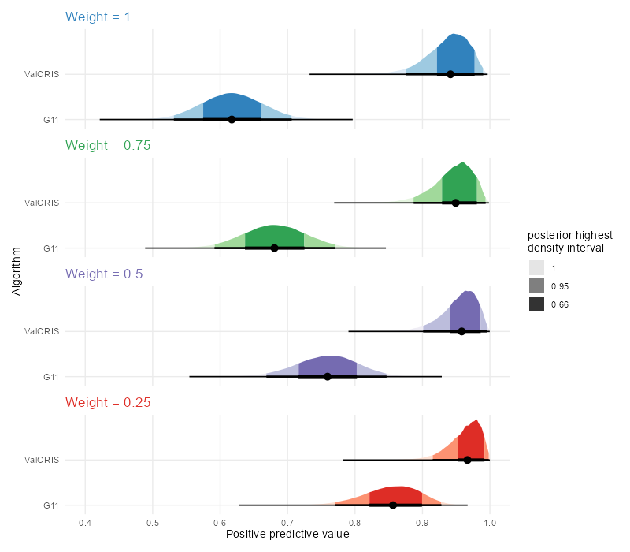

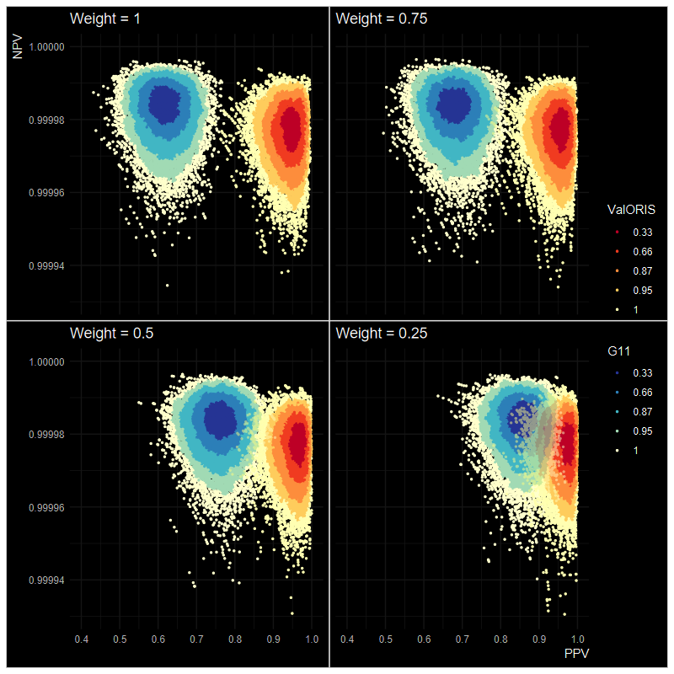

Additional file 8: Details of the healthcare consumption of individuals identified by the G11 algorithm for the year 2020
In 2020, the G11 algorithm identified 176,702 individuals as HIV-positive within the comprehensive SNDS database based on their healthcare consumption. A description of consumption profiles indicated that 31,562 (17.9%) of these individuals exhibited only one type of consumption among those depicted in the figure below. Specifically, 11,391 (6.45%) of individuals were identified solely based on a single HIV RNA quantification, while 10,062 (5.69%) of subjects were identified as having a long-term medical condition attributable to an HIV-related illness, without any other associated targeted care consumption. Additionally, among all identified individuals, 29,566 (16.7%) had not received any antiretroviral dispensation in 2020.

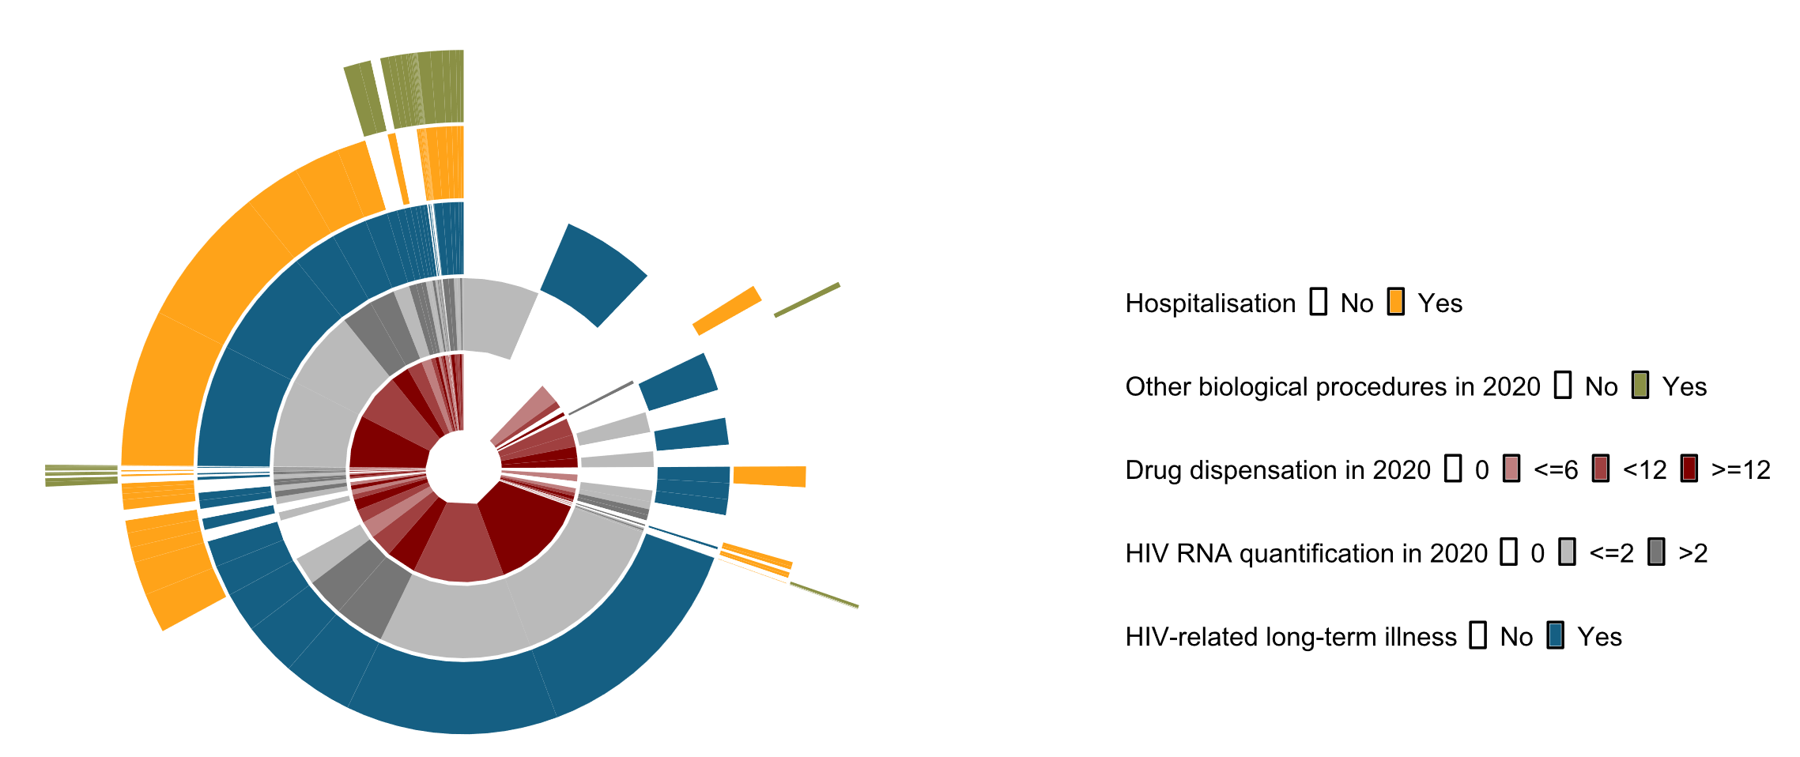
Sunburst graphic describing the consumption profiles of people identified as PLHIV in 2020 by the G11 algorithm

Additional file 9: specificity of algorithms for targeting the newly diagnosed PLHIV according to the relative weight assigned to false-positive individuals.
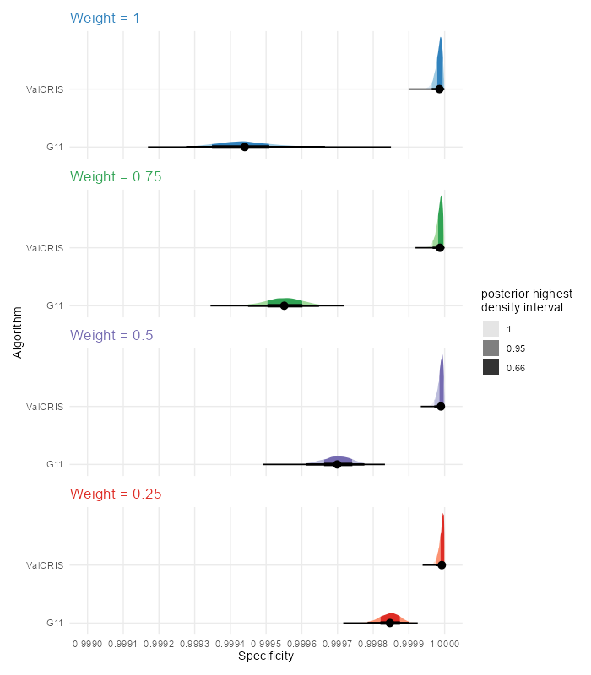

Additional file 10: Positive predictive value of algorithms for targeting the newly diagnosed PLHIV according to the relative weight assigned to false-positive individuals.
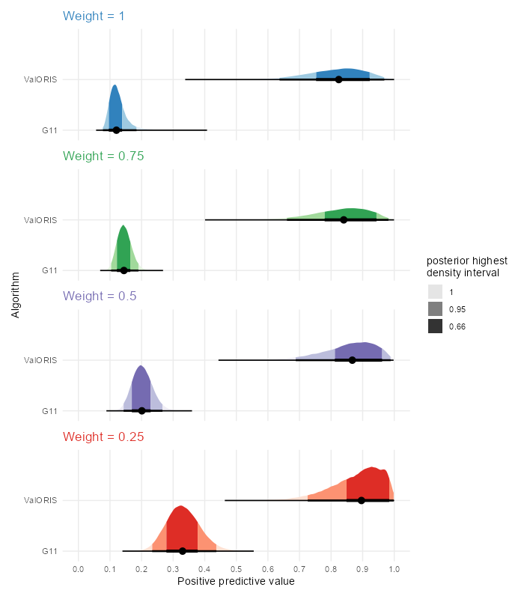

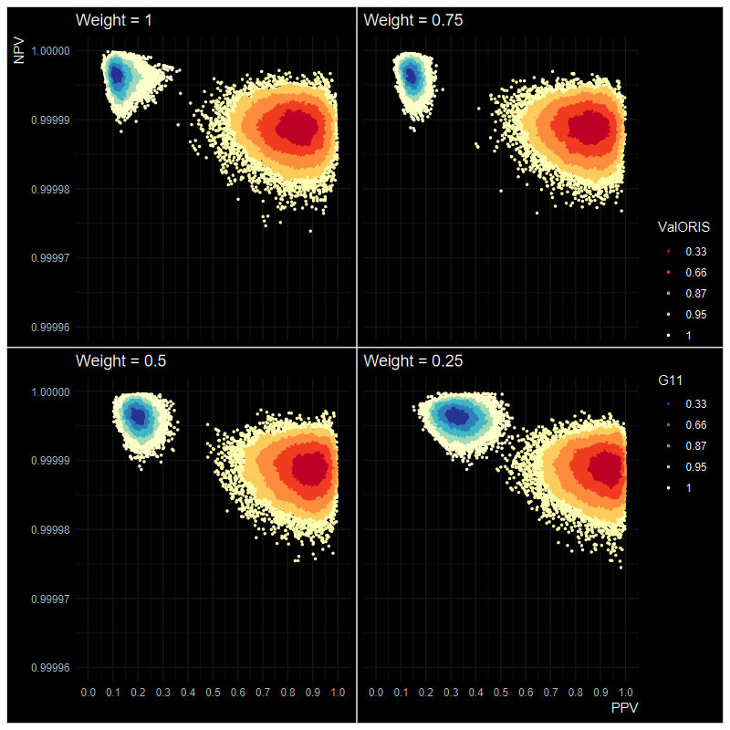

Additional file 11: Annual number of newly diagnosed subjects identified on the comprehensive SNDS database between 2017 and 2023
Algorithm | 2017 | 2018 | 2019 | 2020 | 2021 | 2022 | 2023
G11 | 16,394 | 16,374 | 17,662 | 16,162 | 20,493 | 22,660 | 19,447
ValORIS | 7,293 | 6,931 | 7,037 | 5,707 | 5,479 | 5,971 | 6,421

