Supporting information for
Ni-Mediated Cascade Synthesis of a Vinylene-Linked Terrylene Diimide Dimer with Symmetry-Breaking Charge Separation Character

Mengying Tian,^{†1} Xin Jin,^{†1} Jing Li,^{†2} Meng Huang,^{†3} Guogang Liu,*¹ Fanchuan Shi,^{†2} Chengxi Zhao,³ Wei Jiang,⁴ Lei Jiao,⁵ Jie Liu⁶, Jinquan Chen,*² and Zhaohui Wang*^{1,5}
¹ Key Laboratory for Advanced Materials and Joint International Research Laboratory of Precision Chemistry and Molecular Engineering, Feringa Nobel Prize Scientist Joint Research Center, Frontiers Science Center for Materiobiology and Dynamic Chemistry, Institute of Fine Chemicals, School of Chemistry and Molecular Engineering, East China University of Science and Technology, Shanghai 200237, China
² State Key Laboratory of Precision Spectroscopy, East China Normal University, Shanghai 200241
³ State Key Laboratory of Precision and Intelligent Chemistry, University of Science and Technology of China, He-fei, Anhui 230026, China
⁴ School of Chemical Sciences University of Chinese Academy of Sciences, Beijing 100084, China
⁵ Key Laboratory of Organic Optoelectronics and Molecular Engineering, Department of Chemistry, Tsinghua University, Beijing 100084, China
⁶ Hefei National Laboratory, University of Science and Technology of China, Hefei 230088, China
†Mengying Tian, Xin Jin, Jing Li, and Meng Huang contributed equally to this work.

Table of Contents
- Materials and Measurements ………….……………………………...…....….S3
- Synthesis and Characterization of FV-TDI
2.1. Synthesis ………………………………………………………...…....….S5
2.2. Steady-State Spectroscopy….....………………………………..……….S8
2.3. Chemical and Electrochemical Redox Properties.……….….....…….S10
2.4.Femtosecond Transient Absorption Spectroscopy......……...…….….S12
2.5. Single Crystal X-ray Diffraction Analysis…………………………..... S23
2.6. Theoretical Calculations……………………………………………..... S26
- Synthesis and Characterization of FV-PDI
3.1. Synthesis ……………………………………………………….…....….S30
3.2. Steady-State Spectroscopy….....…….……………………..……….….S31
3.3. Chemical and Electrochemical Redox Properties.………….…....….S32
3.4. Femtosecond Transient Absorption Spectroscopy......…….……..….S35
3.5. Theoretical Calculations……………………………………………..... S46
- NMR and MS Spectra…………………………………………….…...………S49
- References……………………………………………………………...………S52

1. Materials and Measurements
All chemicals and solvents were obtained from commercial suppliers (J&K, Aladin, Macklin, or Meryer) and used without further purification unless otherwise noted. All solvents were reagent grade, which were dried and distilled prior to use according to standard procedures. All deuterated solvents were purchased from Cambridge Isotope Laboratories. Flash column chromatography was performed on silica gel (Greagent, 200-300 mesh) to purify the crude products.
The ¹H NMR (400 or 600MHz), ¹³C NMR (100 or 150MHz) spectra were measured on Bruker ADVANCE Ⅲ and Bruker Ascend 600 spectrometer. Mass spectra (MS) were determined on ultrafleXtreme Matrix Assisted Laser Desorption Ionization Time of Flight Mass Spectrometry. High resolution mass spectra (HRMS) were determined on a SolariX 7.0T Fourier transform ion cyclotron resonance mass spectrometer. The UV-vis-NIR absorption spectra data were documented by a Shimadzu UV-3600 spectrophotometer. Fluorescence measurements were measured with Shimadzu FLS1000 fluorophotometer at room temperature.
Cyclic voltammetry (CV) was performed with a CHI720E electrochemical workstation using glassy carbon discs as the working electrode, Pt wire as the counter electrode, Ag/AgCl electrode as the reference electrode at a scanning rate of 50 mV/s. 0.1 M Tetrabutylammonium hexafluorophosphate (TBAPF₆) dissolved in dry dichloromethane was employed as the supporting electrolyte. The plot includes the signal of the ferrocene as an external potential marker.
The femtosecond transient absorption spectra were measured using a femtosecond transient absorption spectrometer (Helios). The spectrometer adopts pump-probe technology produced by Ultrafast Systems. In summary, the spectrometer uses a Ti: sapphire laser system (Astrella, Coherent Inc.) to generate a femtosecond pulse light with a central wavelength of 800 nm, a pulse width of 100 fs, and a repetition frequency of 1 kHz. The 800 nm femtosecond pulse light is divided into two beams by a beam splitter, one of which enters the optical parametric amplifier (OPerA Solo, Coherent Inc.) to generate the pump beam required for the experiment, which is ultimately used to excite the sample. The other beam passes through a 2 mm thick sapphire window and a 10 mm thick sapphire window to generate super continuum white light of 420-750 nm and 850-1500 nm as the probe pulse of the system. In the pump light path, the combination of the Glan-Thompson prism and half-wave plate is used to ensure that the polarization angle between the pump and the probe pulse is set to magic angle (54.7°) to eliminate the influence of anisotropic dynamics. The instrument response function (IRF) is determined to be 120 fs.
In addition, a spectrometer (EOS, Ultrafast Systems, USA) was used to measure the nanosecond TA spectra, where the pump pulse came from the same Ti:sapphire laser as the femtosecond experiment, and the probe pulse came from an broadband diode laser. The IRF of this system is 0.5 ns.
To further analyze the femtosecond (fs) and transient absorption data collected above, we used Surface Xplorer and Glotaran 1.5.1 software. These programs can effectively perform singular value decomposition and global fitting, providing kinetic information, decay associated different spectra (DADS) and evolution associated different spectra (EADS).

2. Synthesis and Characterization of FV-TDI
2.1 Synthesis
Scheme S1. Synthetic routes to (a) FV-TDI and Ch-TDI, (b) Cp-TDI.
2Cl-TDI: A 500 mL two-necked round-bottom flask, equipped with a reflux condenser, a dropping funnel, and a magnetic stir bar, was charged with 4Cl-TDI (2.77 g, 2.85 mmol), CuI (7.82 g, 41 mmol), N,N-dimethylglycine (4.94 g, 48 mmol), and DMF (462 mL). The mixture was stirred at 125 °C under an argon atmosphere for 24 h. After cooling to room temperature, the reaction mixture was poured into 1000 mL of dilute HCl(aq) (H₂O/HCl = 20:1, v/v). The resulting precipitate was collected by vacuum filtration, dried under reduced pressure, and purified by column chromatography (silica gel, petroleum ether/CH₂Cl₂ = 1:3, v/v) to yield 2Cl-TDI as a blue solid (1.11 g, 43%). ¹H NMR (400 MHz, CDCl₃, 298K) δ = 8.80 - 8.71 (m, 5H), 8.67 - 8.57 (m, 5H), 7.53 -7.50 (m, 2H), 7.38 - 7.36 (d, J = 8 Hz, 4H), 2.83 – 2.75 (m, 4H), 1.21 - 1.18 (m, 24H). (MALDI-TOF, 100%): calcd (%) for C₅₈H₄₄Cl₂N₂O₄: 902.3; found, 902.3.
FV-TDI: A 100 mL Schlenk flask was charged with Ni(cod)₂ (330 mg, 1.20 mmol), 4,4’-di-tert-butyl-2,2’-dipyridyl (322 mg, 1.20 mmol), and THF (20 mL) under an inert atmosphere in a glovebox. The mixture was stirred for 15 min, after which 2Cl-TDI (90 mg, 0.10 mmol) and chloroform (24 μL, 0.30 mmol) were added. The reaction was allowed to proceed at room temperature for 1 h. The solvent was then removed under reduced pressure, and the crude product was purified by column chromatography (silica gel, CH₂Cl₂/ethyl acetate = 100:1, v/v) to afford FV-TDI as a violet solid (26 mg, 30%).¹H NMR (600 MHz, C₂D₂Cl₄, 373K) δ = 9.50 (s, 2H), 8.78-8.77 (d, J = 6 Hz, 4H), 8.73 - 8.69 (m, 4H), 8.66 - 8.62 (m, 4H), 8.58 (s, 2H), 8.53 - 8.50 (m, 4H), 7.54-7.52 (m, 2H), 7.47 - 7.44 (m, 2H), 7.39 - 7.38 (d, J = 6 Hz, 4H), 7.33 - 7.30 (m, 8H), 2.79 - 2.73 (m, 8H), 1.26 - 1.17 (m, 24H). ¹³C NMR (150 MHz, C₂D₂Cl₄, 373K) δ = 164.56, 163.59, 163.47, 162.97, 146.12, 145.83, 142.97, 137.69, 137.12, 136.96, 132.26, 132.04, 131.66, 131.47, 130.91, 130.39, 129.49, 127.25, 126.82, 125.92, 125.80, 124.18, 122.20, 121.82, 29.47, 24.30, 24.15, 24.06, 24.01. (MALDI - TOF, 100%) : calcd (%) for C₁₁₈H₈₈N₄O₈: 1688.7; found: 1689.6.
Ch-TDI: A 100 mL Schlenk flask was charged with Ni(cod)₂ (330 mg, 1.20 mmol), 4,4’-di-tert-butyl-2,2’-dipyridyl (322 mg, 1.20 mmol), and anhydrous THF (20 mL) under an inert atmosphere in a glovebox. After stirring the mixture for 15 min at room temperature, 2Cl-TDI (90 mg, 0.10 mmol) and chloroform (80 μL, 1 mmol) were added sequentially. The reaction mixture was stirred for an additional 1 h at room temperature. Upon completion, the solvent was removed under reduced pressure, and the crude product was purified by column chromatography on silica gel (eluent: CH₂Cl₂/ethyl acetate = 100:1, v/v) to afford Ch-TDI as a bluish-purple solid (43 mg, 50% yield). ¹H NMR (600 MHz, C₂D₂Cl₄, 373K) δ = 9.50 (s, 1H), 9.46-9.45 (d, J = 6 Hz, 1H), 9.40 - 9.38 (d, J = 12 Hz, 1H), 9.36 (s, 1H), 9.19 - 9.16 (m, 2H), 8.97 - 8.96(d, J = 6 Hz, 1H), 8.87 - 8.86 (d, J = 6 Hz, 1H), 8.84 - 8.82 (m, 2H), 8.80 - 8.79 (d, J = 6 Hz, 1H), 8.75 - 8.74 (d, J = 6 Hz, 1H), 7.56 - 7.51 (m, 2H), 7.42 - 7.38 (m, 4H), 4.05 - 4.03 (m, 1H), 2.93 - 2.91 (m, 1H), 2.87 - 2.85(m, 2H), 1.28 - 1.24 (m, 24H). HR-MS (MALDI-TOF) m/z calcd. for C₆₀H₄₆N₂O₄ [M]⁺: 858.3458; found: 858.3484.
CO-TDI: A 10 mL Schlenk flask was charged with Br-TDI (161 mg, 0.18 mmol), Mo(CO)₆ (314 mg, 1.19 mmol), Pd(dppf)Cl₂ (14 mg, 0.02 mmol), and DBU (0.66 mL) in anhydrous toluene (4 mL) under an argon atmosphere. The reaction mixture was stirred at 60 °C for 48 h. After cooling to room temperature, the solvent was removed under reduced pressure. The crude product was purified by flash column chromatography (silica gel, CH₂Cl₂ as eluent) to afford CO-TDI as a violet solid (31 mg, 20%). ¹H NMR (400 MHz, CDCl₃, 298K) δ 8.79 - 8.78 (d, J = 4 Hz, 1H), 8.77 - 8.76 (d, J = 4 Hz, 1H), 8.61 - 8.60 (d, J = 4 Hz, 1H), 8.58 - 8.57 (d, J = 4 Hz, 4H), 8.54 - 8.52 (d, J = 8 Hz, 4H), 8.33-8.31 (d, J = 8 Hz, 1H), 8.23 - 8.21 (d, J = 8 Hz, 1H), 7.51 - 7.47 (m, 2H), 7.37 - 7.34 (m, 4H), 2.78 - 2.71 (m, 4H), 1.20 - 1.18 (d, J = 8 Hz, 24H). (MALDI - TOF, 100%) : calcd (%) for C₅₉H₄₄N₂O₅: 860.3; found: 860.2.
Cp-TDI: A 100 mL two-neck round-bottom flask equipped with a condenser, dropping funnel, and magnetic stir bar was charged with iodine (1.07 g, 4.30 mmol) under an argon atmosphere. To this was added a solution of hypophosphorous acid (50% aqueous, 15 mL, 168 mmol) in acetic acid (7.50 mL). The mixture was heated to reflux for 30 min, after which a solution of CO-PDI (52 mg, 0.06 mmol) in acetic acid (45 mL) was added dropwise over 1 h. The resulting mixture was maintained at reflux for 48 h, then cooled to room temperature. The reaction mixture was diluted with water (100 mL) and extracted with dichloromethane (3 × 50 mL). The combined organic phases were dried over anhydrous Na₂SO₄, filtered, and concentrated under reduced pressure. Purification by column chromatography (silica gel, CH₂Cl₂) afforded Cp-TDI as a blue solid (38 mg, 80%). ¹H NMR (400 MHz, CDCl₃, 298K) δ 8.94 (s, 1H), 8.94 (s, 1H), 8.91 (s, 1H), 8.80 - 8.74 (m, 4H), 8.69-8.65 (m, 3H), 8.60-8.58 (d, J = 8 Hz, 1H), 7.53 - 7.49 (m, 2H), 7.38 - 7.36 (m, 4H), 4.41 (s, 2H), 2.84 - 2.78 (m, 4H), 1.22 - 1.20 (d, J = 8 Hz, 24H). (MALDI - TOF, 100%) : calcd (%) for C₅₉H₄₆N₂O₄: 846.3; found: 846.3.

2.2. Steady-State Spectroscopy
Figure S1. Steady-state absorption spectra of FV-TDI in (a) DCM, Dioxane, THF, Benzonitrile, Tol (concentration: 10⁻⁵ M), and (b) neat film, 90% PS (10% FV-TDI/90% PS blended film), 99% PS (1% FV-TDI/99% PS blended film), 90% PMMA (10% FV-TDI/90% PMMA blended film), 99% PMMA (1% FV-TDI/99% PMMA blended film).
Figure S2. Fluorescence spectra of FV-TDI in (a) Tol and THF (concentration: 10⁻⁵ and 10⁻⁶ M), and (b) neat film, 90% PS (10% FV-TDI/90% PS blended film), 99% PS (1% FV-TDI/99% PS blended film), 90% PMMA (10% FV-TDI/90% PMMA blended film), and 99% PMMA (1% FV-TDI/99% PMMA blended film). All experiments were carried out at room temperature. Excitation wavelength: 850 nm, Excitation bandwidth:10.0 nm; Emission bandwidth: 8.0 nm.
Figure S3. Normalized steady-state absorption spectra and fluorescence spectra of Cp-TDI in Tol.
2.3. Chemical and Electrochemical Redox Properties
Figure S4. Cyclic voltammetry (CV) and differential pulse voltammetry (DPV) curves of (a) FV-TDI and (b) Cp-TDI. containing Bu₄NPF₆ (0.1 mol L⁻¹) in CH₂Cl₂.
Figure S5. Chemical oxidation titration UV-vis-NIR absorption spectra of (a) Cp-TDI in super-dry solution (CF/CAN, 1/1 v/v) using NOSbF₆. (b) Selective chemical oxidation absorption curves for analysis of Cp-TDI^{.+}. As shown in Figure S4b, the first oxidation peak of Cp-TDI at +0.72V corresponds to a two-electron oxidation process. This indicates that the oxidation potentials for forming the Cp-TDI^{.+} and Cp-TDI²⁺ are identical. Consequently, it is challenging to directly obtain the pure Cp-TDI^{.+} during chemical oxidation titration, as the neutral Cp-TDI, Cp-TDI^{.+}, and Cp-TDI²⁺ coexist throughout the titration process until complete oxidation to the Cp-TDI²⁺ is achieved. The absence of clear isosbestic points in the chemical oxidation titration absorption spectra (Figure S5a) further confirms the simultaneous presence of the neutral Cp-TDI, Cp-TDI^{.+}, and Cp-TDI²⁺ during the titration. However, we can definitively assign the UV-vis absorption spectrum at 0 equiv. of NOSbF₆ to the neutral Cp-TDI (violet curve A in Figure S5b), and the spectrum at 6 equiv. of NOSbF₆ to the Cp-TDI²⁺ (yellowish green curve C in Figure S5b). Therefore, we selected the UV-vis absorption spectrum at 0.5 equiv. of NOSbF₆ (light blue curve B in Figure S5b), where all three species (neutral Cp-TDI, Cp-TDI^{.+}, and Cp-TDI²⁺) coexist. As illustrated in Figure S5b, we derived the absorption spectrum of the Cp-TDI^{.+} (red curve D in Figure S5b) by subtracting the contributions from the neutral Cp-TDI and Cp-TDI²⁺ using the equation: D = B - 0.08 × C - 0.86 × A.
Figure S6. Chemical reduction titration UV-vis-NIR absorption spectra of Cp-TDI in super-dry Toluene using Cobaltocene. The Cp-TDI^{.-} absorption was obtained at 10 equivalents Cobaltocene.

2.4 Femtosecond Transient Absorption Spectroscopy
Figure S7. Transient absorption spectroscopy of FV-TDI with 606 nm pump in Tol. (a) Transient absorption spectra, (b) kinetic traces at selected wavelengths, (c) evolution-associated different spectra and (d) decay-associated different spectra for FV-TDI in Tol. The associated spectra are obtained from a global fitting analysis with a 606 nm excitation; Laser intensity: 30 $μw$.
Figure S8. Transient absorption spectroscopy of FV-TDI with 606 nm pump in THF. (a) Transient absorption spectra, (b) kinetic traces at selected wavelengths, (c) evolution-associated different spectra and (d) decay-associated different spectra for FV-TDI in THF. The associated spectra are obtained from a global fitting analysis with a 606 nm excitation; Laser intensity: 30 $μw$.
Figure S9. Transient absorption spectroscopy of FV-TDI with 606 nm pump in Film. (a) Transient absorption spectra, (b) kinetic traces at selected wavelengths, (c) evolution-associated different spectra and (d) decay-associated different spectra for FV-TDI in neat film. The associated spectra are obtained from a global fitting analysis with a 606 nm excitation; Laser intensity: 30 $μw$.
Figure S10. Transient absorption spectroscopy of FV-TDI with 606 nm pump in 90% PS. (a) Transient absorption spectra, (b) kinetic traces at selected wavelengths, (c) evolution-associated different spectra and (d) decay-associated different spectra for FV-TDI in 10% FV-TDI/90% PS blended film. The associated spectra are obtained from a global fitting analysis with a 606 nm excitation; Laser intensity: 30 $μw$.
Figure S11. Transient absorption spectroscopy of FV-TDI with 606 nm pump in 99% PS. (a) Transient absorption spectra, (b) kinetic traces at selected wavelengths, (c) evolution-associated different spectra and (d) decay-associated different spectra for FV-TDI in 1%FV-TDI/99% PS blended film. The associated spectra are obtained from a global fitting analysis with a 606 nm excitation; Laser intensity: 30 $μw$.
Figure S12. Transient absorption spectroscopy of FV-TDI with 606 nm pump in 90% PMMA. (a) Transient absorption spectra, (b) kinetic traces at selected wavelengths, (c) evolution-associated different spectra and (d) decay-associated different spectra for FV-TDI in 10% FV-TDI/90% PMMA blended film. The associated spectra are obtained from a global fitting analysis with a 606 nm excitation; Laser intensity: 30 $μw$.
Figure S13. Transient absorption spectroscopy of FV-TDI with 606 nm pump in 99% PMMA. (a) Transient absorption spectra, (b) kinetic traces at selected wavelengths, (c) evolution-associated different spectra and (d) decay-associated different spectra for FV-TDI in 1% FV-TDI/99% PMMA blended film. The associated spectra are obtained from a global fitting analysis with a 606 nm excitation; Laser intensity: 30 $μw$.
Figure S14. Transient absorption spectroscopy of FV-TDI with 800 nm pump in Tol. (a) Transient absorption spectra, (b) kinetic traces at selected wavelengths, (c) evolution-associated different spectra and (d) decay-associated different spectra for FV-TDI in Tol. The associated spectra are obtained from a global fitting analysis with 800 nm excitation; Laser intensity: 200 $μw$ in VIS; 100 $μw$ in NIR.

 | τ₁ (ps) | τ₂ (ps) | τ₃ (ps)
Tol | 0.5 | 7.4
THF | 0.4 | 6.6 | 890
Neat Film | 0.8 | 19 | Long-lived
90% PS | 0.7 | 11
99% PS | 0.7
90% PMMA | 0.9 | 17
99% PMMA | 1.0
Tol (800 nm) | 0.5 | 7.0
Table S1. Global fitting analysis with a 606 nm and 800 nm excitation for FV-TDI.

Figure S15. Transient absorption spectroscopy of Cp-TDI with 609 nm pump in Tol. (a) Transient absorption spectra, (b) kinetic traces at selected wavelengths, (c) evolution-associated different spectra and (d) decay-associated different spectra for Cp-TDI in Tol. The associated spectra are obtained from a global fitting analysis with 609 nm excitation; Laser intensity: 80 $μw$.
Figure S16. Comparison of Cp-TDI radical cation and anion spectrum with FV-TDI evolution-associated different spectra in THF, 99% PS (1% FV-TDI /99% PS blended film), 99%PMMA (1% FV-TDI/99% PMMA blended film). The pale bule band indicate the main radical cation signals of Cp-TDI (682 nm), The lake bule band indicate the main radical anion signals of Cp-PDI (671 nm).

Figure S17. Comparison of Cp-TDI radical cation and anion spectrum with FV-TDI (Add negative FV-TDI UV-vis absorption (GSB) into the raw Cp-TDI radical cation and anion spectrum) evolution-associated different spectra in THF, 99% PS (1% FV-TDI /99% PS blended film), 99%PMMA (1% FV-TDI/99% PMMA blended film)). The pale bule band indicate the main radical cation signals of Cp-TDI (554 and 673 nm), The lake bule band indicate the main radical anion signals of Cp-PDI (550nm and 677 nm).
2.5. Single Crystal X-ray Diffraction Analysis
Crystallographic data have deposited to the Cambridge Crystallographic Data Centre as supplementary publication no. CCDC 2239436 and 2239435 (FV-TDI and 2Cl-TDI). The measurements were made on a Bruker SMART CCD area detector with graphite monochromated CuK/α radiation (λ = 1.54178). All calculations were performed using the SHELXL-2018 or 2019 and the Crystal Structure crystallographic software package. The crystallographic data were summarized in the Table S2.

Figure S18. Single crystal structures of 2Cl-TDI with 50% capped sticks. The black-colored atoms represent carbon. The blue- and red-colored atoms represent nitrogen and oxygen. The green-colored atoms represent chlorine. Top view (a) and side views (b) of 2Cl-TDI.

Figure S19. Single crystal structures of FV-TDI with 50% capped sticks. The black-colored atoms represent carbon. The blue- and red-colored atoms represent nitrogen and oxygen. Top view (a), (c), (e) and side views (b), (d), (f) and packing arrangement (g) of FV-TDI.

 | 2Cl-TDI | FV-TDI
Chemical formula | C₅₈ H₄₄ Cl₂ N₂ O₄ | C₁₁₈H₈₈N₄O₈
Formula weight | 903.85 | 1689.92
Crystal system | monoclinic | triclinic
Space group | P21/c | P-1
Calculated density | 1.123 g/cm³ | 0.976 g/cm³
a (Å) | 15.6119(6) | 14.1622(18)
b (Å) | 16.2521(7) | 40.113(6)
c (Å) | 21.8143(8) | 44.706(6)
α (°) | 90 | 112.494(6)
β (°) | 104.986(3) | 92.089(5)
γ (°) | 90 | 99.573(5)
Unit cell volume (Å³) | 5346.6(4) | 22998(6)
Temperature (K) | 180(2) | 180(2)
No. of formula per unit cell | 4 | 8
No. of reflections measured | 8733 | 66478
No. of independent reflections | 6198 | 26939
Rint | 7.24% | 12.22%
R1 [I>2sigma(I)] | 11.80% | 11.86%
Table S2. Crystallographic data of 2Cl-TDI and FV-TDI.

2.6. Theoretical Calculations
Computational methodology. All quantum chemical calculations were carried out using the Gaussian 16 (C.01) software package except the vibronic coupling constants, which were evaluated using the Q-Chem 5.4 software package.¹ The initial molecular geometries were extracted from single-crystal X-ray diffraction structures and subsequently employed for Density Functional Theory (DFT) and Time-Dependent DFT (TD-DFT) calculations. Both ground-state and excited-state structure optimizations utilized the long-range corrected hybrid functional ωB97X-D in conjunction with the polarized double-ζ basis set 6-31g(d).²⁻⁴ Frequency analyses verified that all optimized structures correspond to genuine local minima on the potential energy surfaces (PES). For comprehensive electronic structure analysis, bond order analysis and hole-electron distribution analysis were performed using the Multiwfn 3.8 (dev) software,⁵ while molecular visualization was achieved using the Visual Molecular Dynamics (VMD) program.⁶

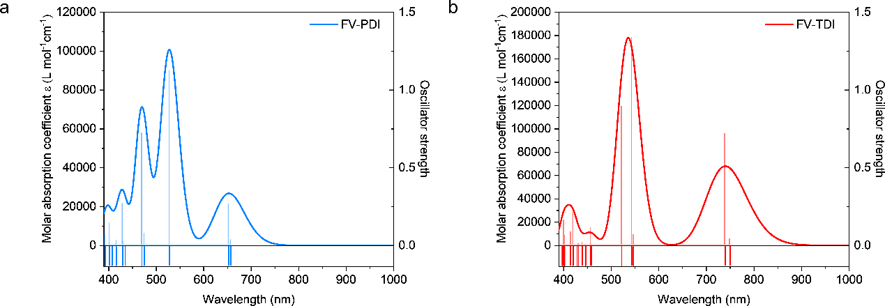
Figure S20. Simulated UV-vis absorption spectra (curves) and oscillator strengths (vertical line) of FV-TDI. A Gaussian function with a full width at half maximum (FWHM) of 0.30 eV was used to broaden the theoretically calculated data as spectral curves. To better compare with the experimental results, the spectra calculated at the (TD)ω-B97XD/6-31g(d) level were shifted by +100 nm.

Figure S21. Geometry optimizations of the S₀ and S₁ states of model FV-TDI at the (TD)ω-B97XD/6-31g(d) level.

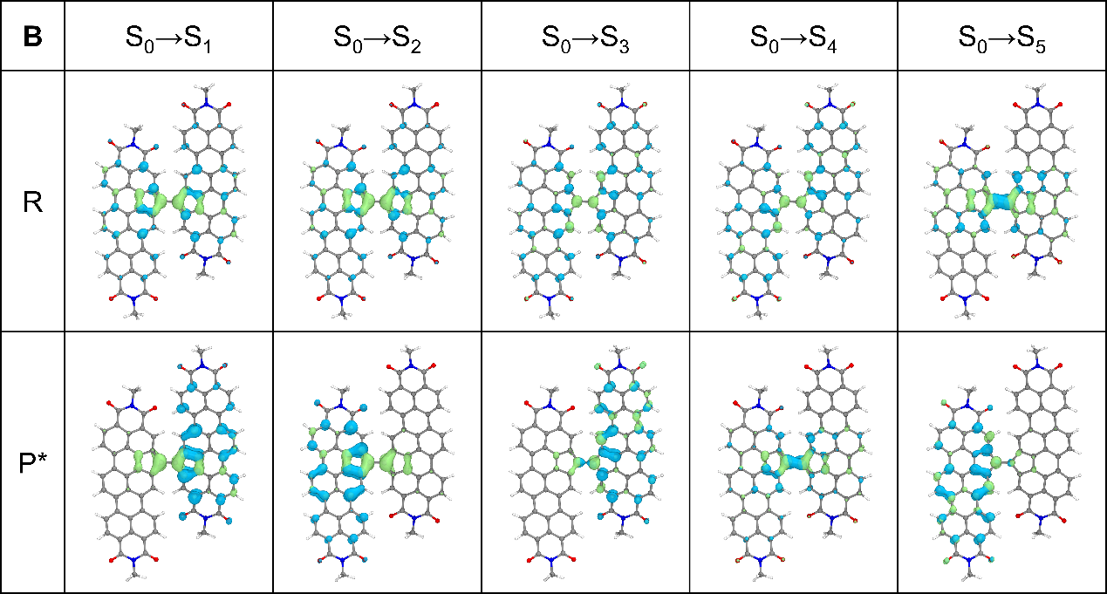
Figure S22. Electron and hole isosurfaces (Hole-Ele) of FV-TDI in S₁-S₅, calculated at the (TD)ω-B97XD/6-31g(d) level, and the equivalent value of the electron density isosurface was 0.001 au. R represents the calculation based on the molecular skeleton in the S₀ state; P* represents the calculation based on the molecular skeleton in the S₁ state.
Figure S23. Potential energy surface scan of FV-TDI.

3. Synthesis and Characterization of FV-PDI
3.1. Synthesis
Br-PDI was synthesized according to the literature,⁷ CO-PDI, FV-PDI and Cp-PDI were synthesized according to our previous literature.⁸
Scheme S2. Synthetic routes to FV-PDI and Cp-PDI.

3.2. Steady-State and Fluorescence Spectroscopy
Figure S24. Steady-state absorption spectra of FV-PDI (a) in DCM, Dioxane, THF, Benzonitrile, Tol (concentration: 10⁻⁵ M), and (b) neat film, 90% PS (10% FV-PDI/90% PS blended film), 99% PS (1% FV-PDI/99% PS blended film), 90% PMMA (10% FV-PDI/90% PMMA blended film), 99% PMMA (1% FV-PDI/99% PMMA blended film).
Figure S25. Fluorescence spectra of FV-PDI in (a) Tol and THF (concentration: 10⁻⁵ and 10⁻⁶ M), and (b) neat film, 90% PS (10% FV-PDI/90% PS blended film), 99% PS (1% FV-PDI/99% PS blended film), 90% PMMA (10% FV-PDI/90% PMMA blended film), and 99% PMMA (1% FV-PDI/99% PMMA blended film). All experiments were carried out at room temperature. Excitation wavelength: 750nm, Excitation bandwidth: 10.0 nm; Emission bandwidth: 8.0 nm.
Figure S26. Steady-state absorption spectra and Fluorescence spectra of Cp-PDI in Tol. In order to present and compare the data more clearly, all the curves have been normalized.

3.3. Chemical and Electrochemical Redox Properties
Figure S27. Cyclic voltammetry (CV) and differential pulse voltammetry (DPV) curves of (a) FV-PDI and (b) Cp-PDI containing Bu₄NPF₆ (0.1 mol L⁻¹) in CH₂Cl₂.

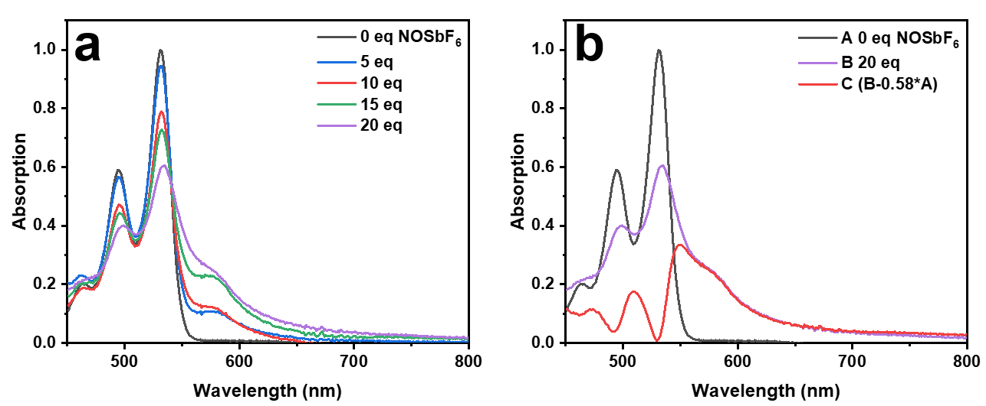
Figure S28. Change of the UV-vis-NIR absorption spectra of (a) Cp-PDI in super-dry solution (CF/CAN, 1/1 v/v) during chemical oxidation titration of NOSbF₆. (b) Selective chemical oxidation curves for analysis of Cp-PDI^{.+}. The chemical oxidation spectra of Cp-PDI exhibit only one isosbestic point at 540 nm (Figure S28a), indicating that the spectral changes are primarily governed by the neutral state and the radical cation species. To isolate the absorption spectrum of the Cp-PDI^{.+}, we subtracted the UV-vis spectrum of neutral Cp-PDI (Curve A, gray in Figure S28b) from the oxidized spectrum obtained with 20 equiv. of NOSbF₆ (Curve B, purple in Figure S28b). The resulting Cp-PDI^{.+} absorption spectrum is shown as the red curve C in Figure S28b.
Figure S29. Change of the UV-vis-NIR absorption spectra of (a) Cp-PDI in super-dry Tetrahydrofuran during chemical reduction titration of Cobaltocene. (b) Selective chemical oxidation curves for analysis of Cp-PDI^{.-}. Unlike Cp-PDI^{.+}, chemical reduction spectra of Cp-PDI exhibit two isosbestic point at 540 nm and 556 nm (Figure S29a). This suggests that the chemical reduction spectra of Cp-PDI consist of the UV-vis absorption of neutral Cp-PDI, Cp-PDI^{.-} and Cp-PDI²⁻. We speculate that the UV-vis absorption of neutral Cp-PDI has completely disappeared, when the isosbestic points shift from 540 nm to 556 nm. At this moment, only a mixture of Cp-PDI^{.-} and Cp-PDI²⁻ remains (green curve B in Figure S29b, 3 equiv. CoCp₂). And the 15 equiv. of Cobaltocene has basically reduced neutral Cp-PDI to the Cp-PDI²⁻ (light green curve C in Figure S29b). Therefore, Using the intensity ratio (0.48) of curves B and C at 647 nm as a scaling factor, we derived the UV-vis absorption of Cp-PDI^{.-} (red curve in Figure S29b) via the equation: D = B – 0.48 × C.

3.4. Femtosecond Transient Absorption Spectroscopy
Figure S30. Transient absorption spectroscopy of FV-PDI with 491 nm pump in Tol (a) Transient absorption spectra, (b) kinetic traces at selected wavelengths, (c) evolution-associated different spectra and (d) decay-associated different spectra for FV-PDI in Tol. The associated spectra are obtained from a global fitting analysis with a 491 nm excitation; Laser intensity: 30 $μw$.
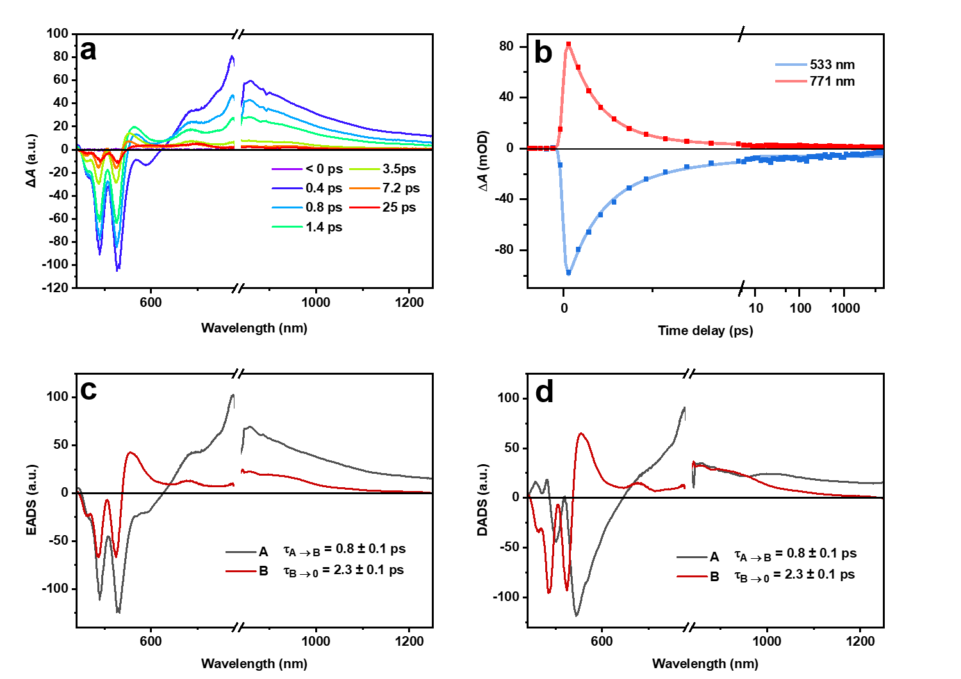
Figure S31. Transient absorption spectroscopy of FV-PDI with 491 nm pump in THF. (a) Transient absorption spectra, (b) kinetic traces at selected wavelengths, (c) evolution-associated different spectra and (d) decay-associated different spectra for FV-PDI in THF. The associated spectra are obtained from a global fitting analysis with a 491 nm excitation; Laser intensity: 30 $μw$.
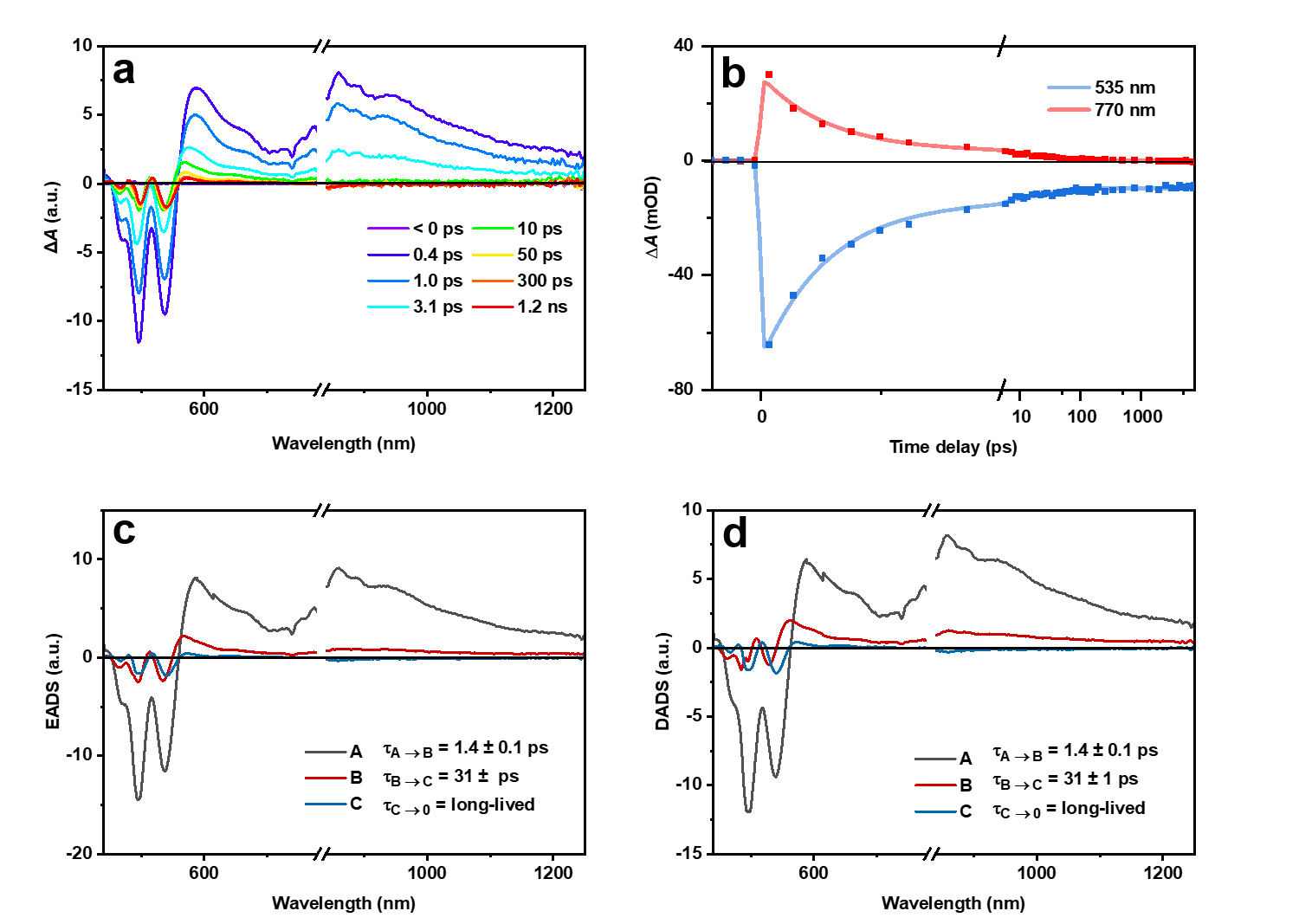
Figure S32. Transient absorption spectroscopy of FV-PDI with 491 nm pump in Film. (a) Transient absorption spectra, (b) kinetic traces at selected wavelengths, (c) evolution-associated different spectra and (d) decay-associated different spectra for FV-PDI in neat film. The associated spectra are obtained from a global fitting analysis with a 491 nm excitation; Laser intensity: 30 $μw$.
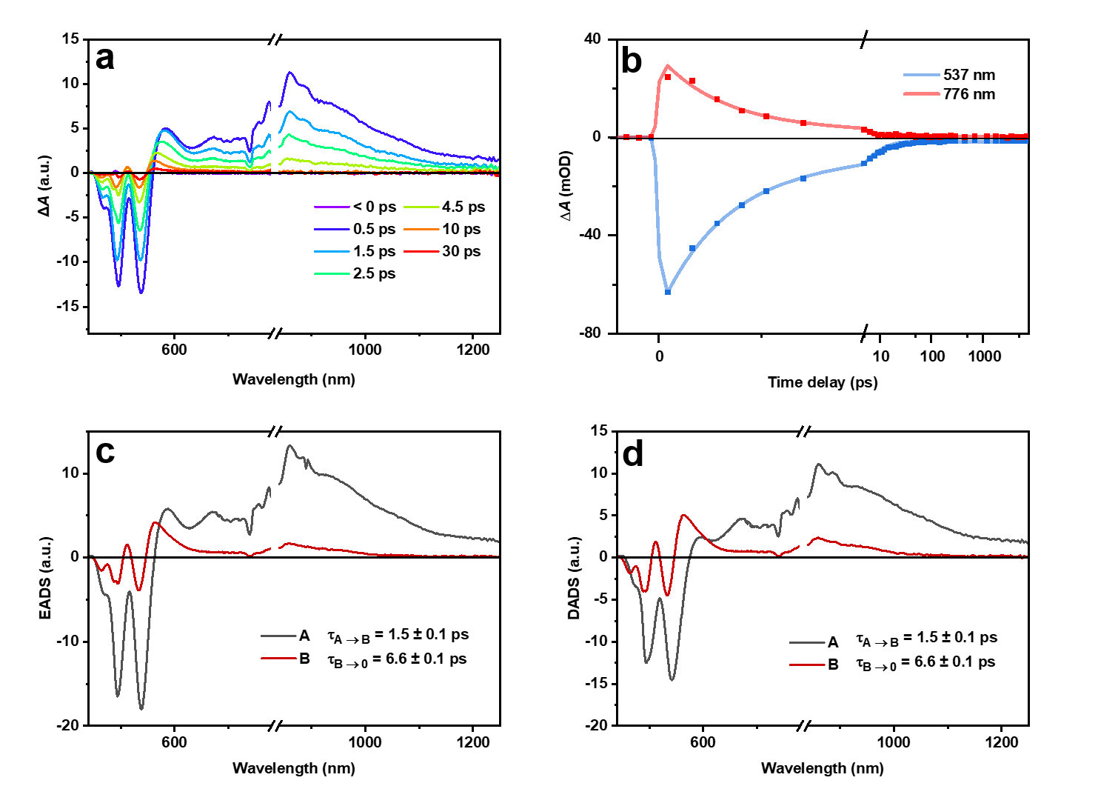
Figure S33. Transient absorption spectroscopy of FV-PDI with 491 nm pump in 90% PS. (a) Transient absorption spectra, (b) kinetic traces at selected wavelengths, (c) evolution-associated different spectra and (d) decay-associated different spectra for FV-PDI in 10% FV-PDI/90% PS blended film. The associated spectra are obtained from a global fitting analysis with a 491 nm excitation; Laser intensity: 30 $μw$.
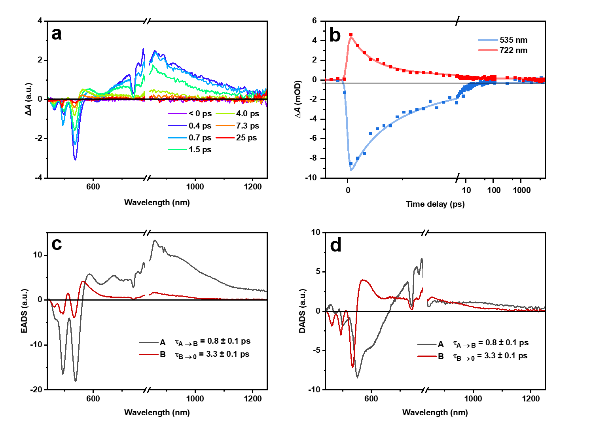
Figure S34. Transient absorption spectroscopy of FV-PDI with 491 nm pump in 99% PS. (a) Transient absorption spectra, (b) kinetic traces at selected wavelengths, (c) evolution-associated different spectra and (d) decay-associated different spectra for FV-PDI in 1% FV-PDI/99% PS blended film. The associated spectra are obtained from a global fitting analysis with a 491 nm excitation; Laser intensity: 30 $μw$.
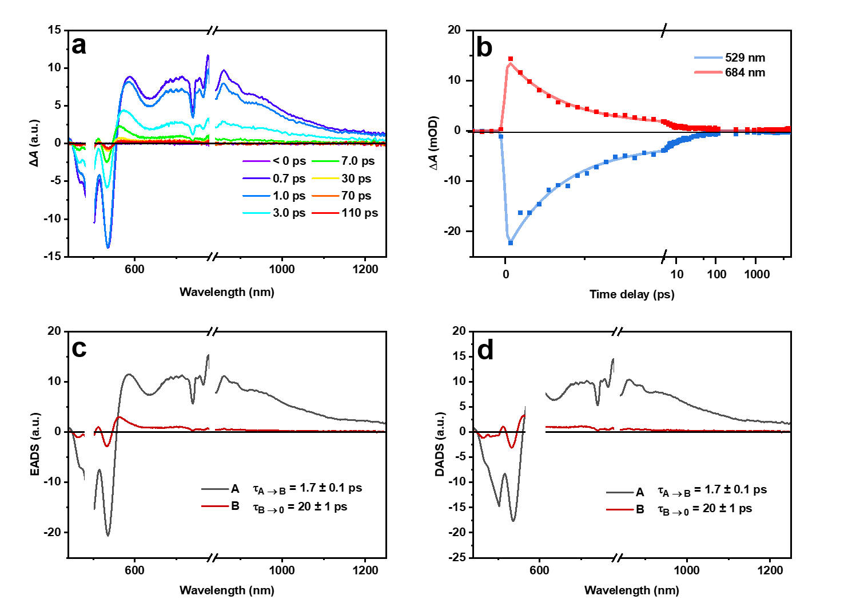
Figure S35. Transient absorption spectroscopy of FV-PDI with 491 m pump in 90% PMMA. (a) Transient absorption spectra, (b) kinetic traces at selected wavelengths, (c) evolution-associated different spectra and (d) decay-associated different spectra for FV-PDI in 10% FV-PDI/90% PMMA blended film. The associated spectra are obtained from a global fitting analysis with a 491 nm excitation; Laser intensity: 30 $μw$.
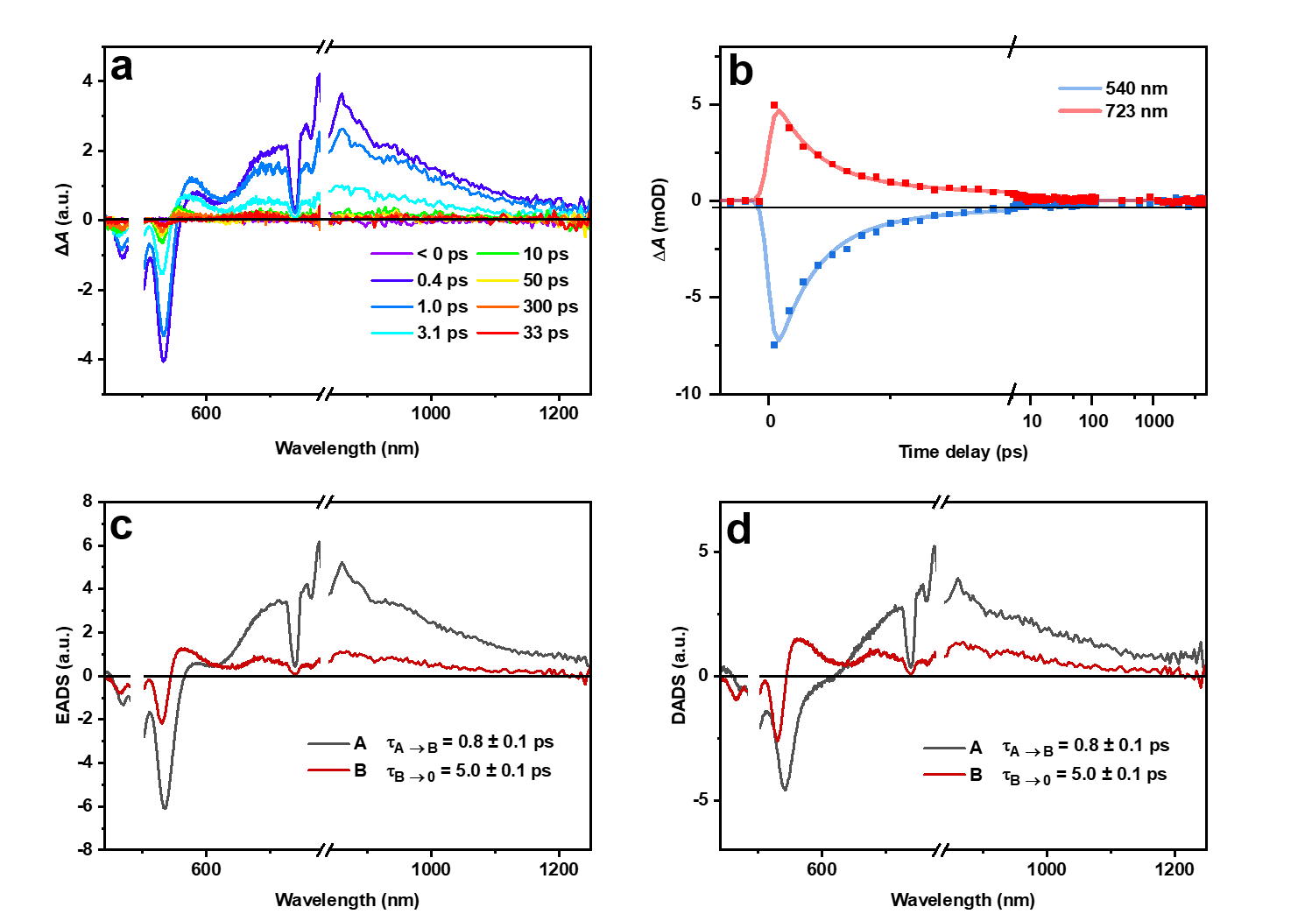
Figure S36. Transient absorption spectroscopy of FV-PDI with 491 nm pump in 99% PMMA. (a) Transient absorption spectra, (b) kinetic traces at selected wavelengths, (c) evolution-associated different spectra and (d) decay-associated different spectra for FV-PDI in 1% FV-PDI/99% PMMA blended film. The associated spectra are obtained from a global fitting analysis with a 491 nm excitation; Laser intensity: 30 $μw$.
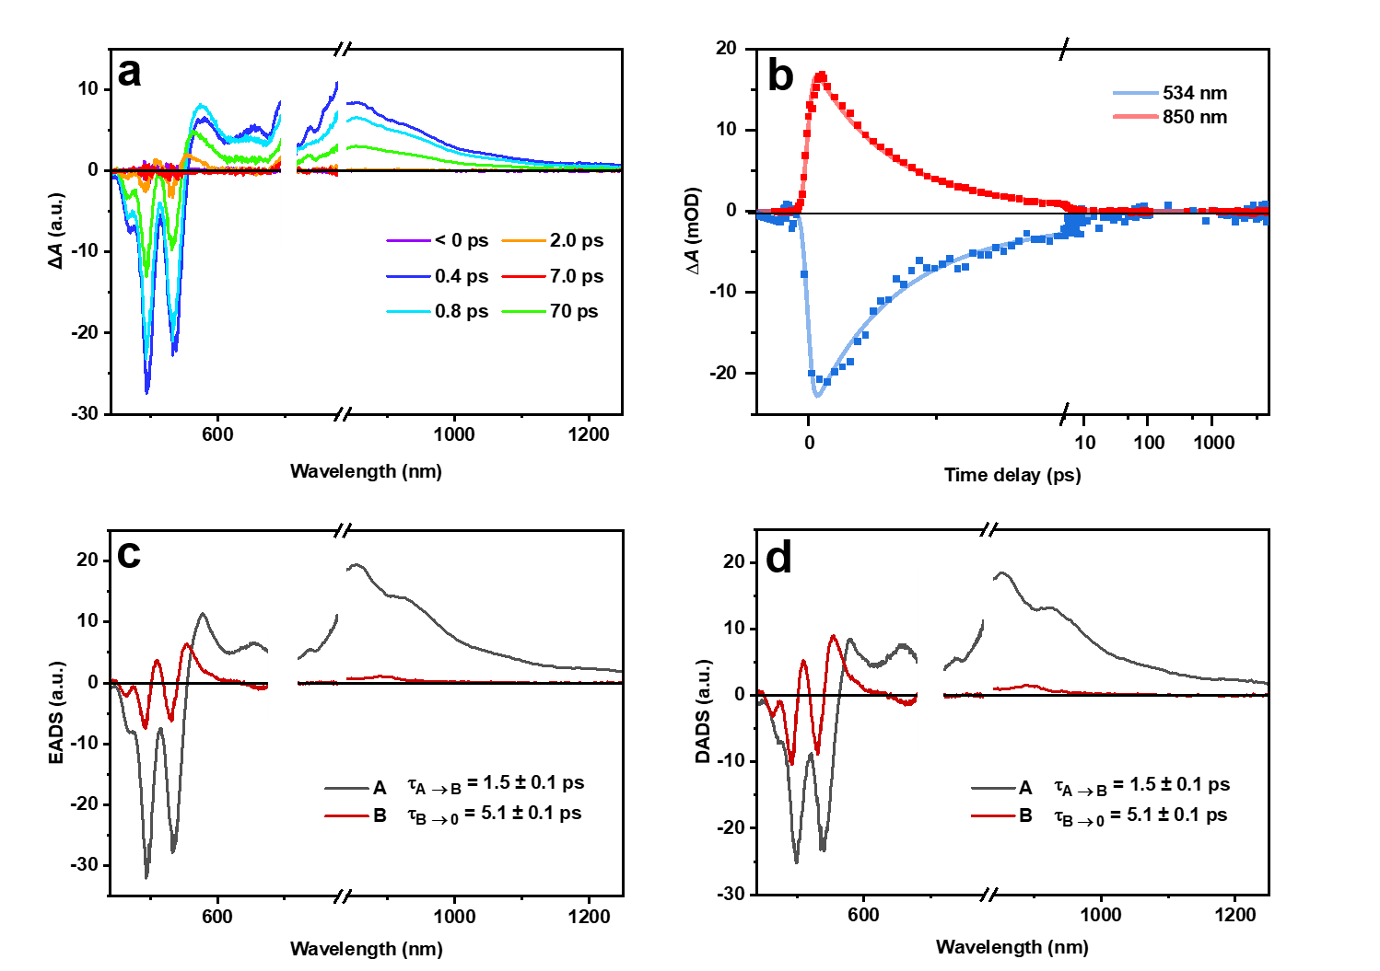
Figure S37. Transient absorption spectroscopy of FV-PDI with 700 nm pump in Tol. (a) Transient absorption spectra, (b) kinetic traces at selected wavelengths, (c) evolution-associated different spectra and (d) decay-associated different spectra for FV-PDI in Tol. The associated spectra are obtained from a global fitting analysis with 700 nm excitation; Laser intensity: 100 $μw$.

 | τ₁ (ps) | τ₂ (ps) | τ₃ (ps)
Tol | 0.5 | 1.1 | 7.7
THF | 0.8 | 2.3
Neat Film | 1.4 | 31 | Long-lived
90% PS | 1.5 | 6.6
99% PS | 0.8 | 3.3
90% PMMA | 1.7 | 20
99% PMMA | 0.8 | 5
Tol (700 nm) | 1.5 | 5.1
Table S3. Global fitting analysis with a 491 nm and 700 nm excitation for FV-PDI.

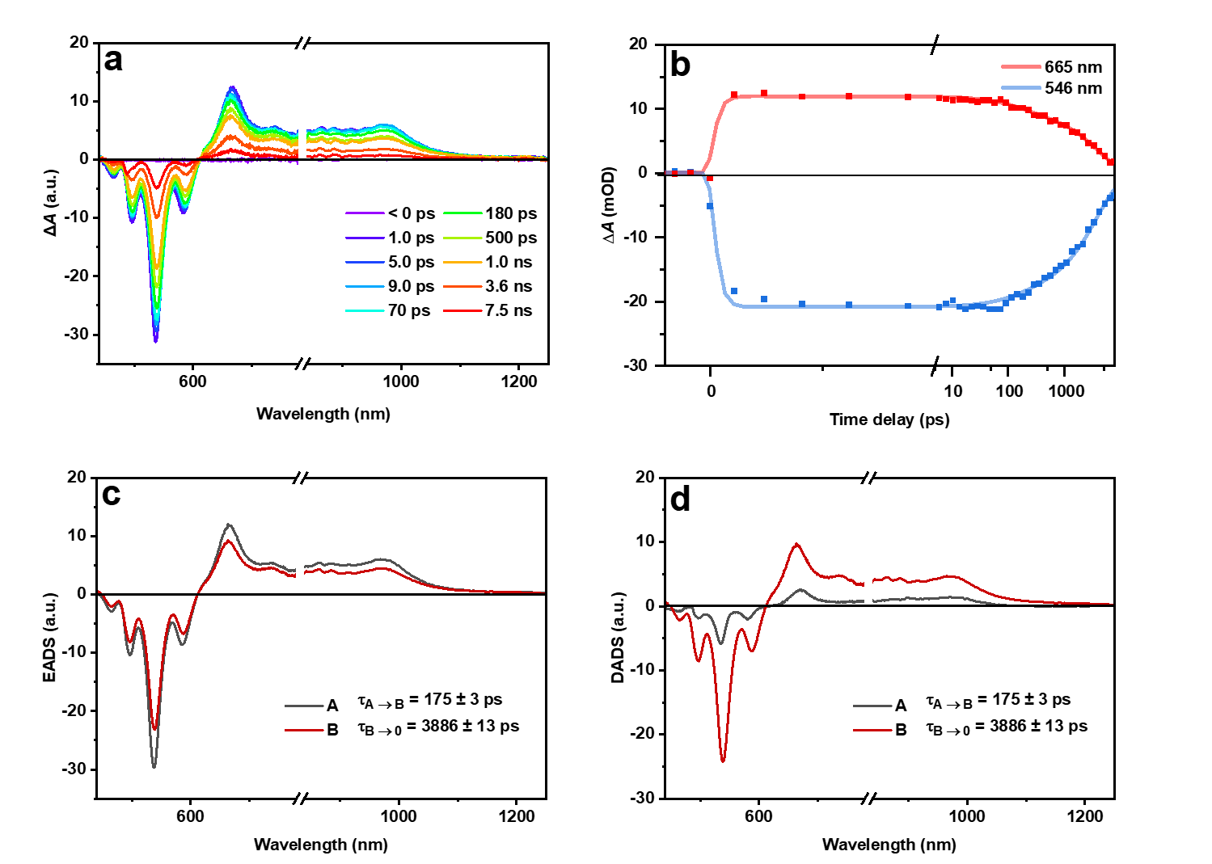
Figure S38. Transient absorption spectroscopy of Cp-PDI with 495 nm pump in Tol. (a) Transient absorption spectra, (b) kinetic traces at selected wavelengths, (c) evolution-associated different spectra and (d) decay-associated different spectra for Cp-PDI in Tol. The associated spectra are obtained from a global fitting analysis with 495 nm excitation; Laser intensity: 110 $μw$.
Figure S39. Comparison of Cp-PDI radical cation and anion spectrum with FV-PDI evolution-associated different spectra in THF, 99% PS (1% FV-PDI /99% PS blended film), 99%PMMA (1% FV-PDI/99% PMMA blended film). The yellow band indicate the main radical cation signals of Cp-PDI (473, 510 and 550 nm), The pink band indicate the main radical anion signals of Cp-PDI (444, 523, 545 nm).

Figure S40. Comparison of Cp-PDI radical cation and anion spectrum with FV-PDI (Add negative FV-PDI UV-vis absorption (GSB) into the raw Cp-PDI radical cation and anion spectrum) evolution-associated different spectra in THF, 99% PS (1% FV-PDI /99% PS blended film), 99%PMMA (1% FV-PDI/99% PMMA blended film). The yellow band indicate the main radical cation signals of Cp-PDI (444, 473, 512 and 565 nm), The pink band indicate the main radical anion signals of Cp-PDI (444, 475, 518 and 552nm).

3.5. Theoretical Calculations
Computational methodology. All quantum chemical calculations were carried out using the Gaussian 16 (C.01) software package except the vibronic coupling constants, which were evaluated using the Q-Chem 5.4 software package.¹ The initial molecular geometries were extracted from single-crystal X-ray diffraction structures and subsequently employed for Density Functional Theory (DFT) and Time-Dependent DFT (TD-DFT) calculations. Both ground-state and excited-state structure optimizations utilized the long-range corrected hybrid functional ωB97X-D in conjunction with the polarized double-ζ basis set 6-31g(d).²⁻⁴ Frequency analyses verified that all optimized structures correspond to genuine local minima on the potential energy surfaces (PES). For comprehensive electronic structure analysis, bond order analysis and hole-electron distribution analysis were performed using the Multiwfn 3.8 (dev) software,⁵ while molecular visualization was achieved using the Visual Molecular Dynamics (VMD) program.⁶
Figure S41. Simulated UV-Vis absorption spectra (curves) and oscillator strengths (vertical line) of (a) FV-PDI. A Gaussian function with a full width at half maximum (FWHM) of 0.30 eV was used to broaden the theoretically calculated data as spectral curves. To better compare with the experimental results, the spectra calculated at the (TD)ω-B97XD/6-31g(d) level were shifted by +100 nm.
Figure S42. Geometry optimizations of the S₀ and S₁ states of model FV-PDI at the (TD)ω-B97XD/6-31g(d) level.

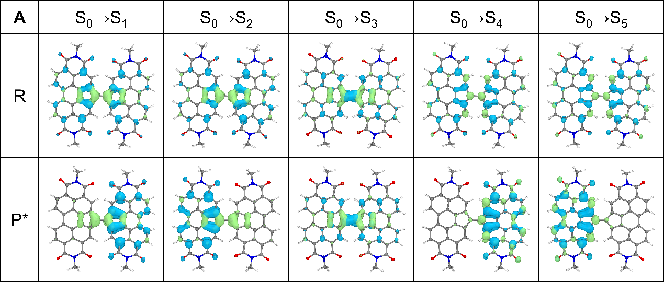
Figure S43. Electron and hole isosurfaces (Hole-Ele) of FV-PDI in S₁-S₅, calculated at the (TD)ω-B97XD/6-31g(d) level, and the equivalent value of the electron density isosurface was 0.001 au. R represents the calculation based on the molecular skeleton in the S₀ state; P* represents the calculation based on the molecular skeleton in the S₁ state.
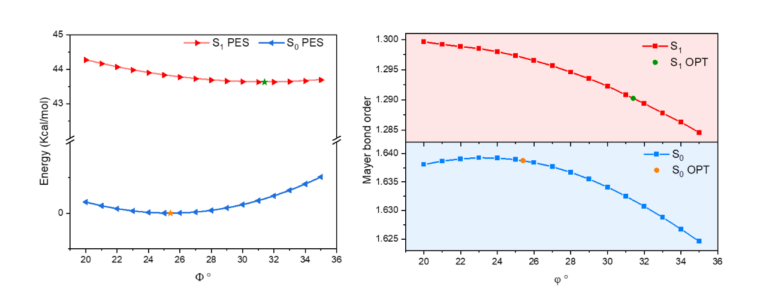
Figure S44. Potential energy surface scan of FV-PDI.

Figure S45. Theoretical calculations of NICS(1)_ZZ values and Electron (green), hole (blue) distributions of BN-TDI at different excited states.

4. NMR and MS Spectra
Figure S46. ¹H NMR spectrum of 2Cl -TDI (400 MHz, CDCl₃, 298 K).
Figure S47. ¹H NMR spectrum of FV-TDI (600 MHz, C₂D₂Cl₄, 373 K).
Figure S48. ¹³C NMR spectrum of FV-TDI (150 MHz, C₂D₂Cl₄, 373 K).
Figure S49. ¹H NMR spectrum of Ch-TDI (600 MHz, C₂D₂Cl₄, 373 K).
Figure S50. ¹H NMR spectrum of CO-TDI (400 MHz, CDCl₃, 298 K).
Figure S51. ¹H NMR spectrum of Cp-TDI (400 MHz, CDCl₃, 298 K).

5. References
- Epifanovsky, E. et al. Software for the frontiers of quantum chemistry: An overview of developments in the Q-Chem 5 package. J. Chem. Phys. 155, 084801 (2021).
- Frisch, M. J. et al. Gaussian 16 Rev. C.01, Wallingford, CT (2016).
- Chai, J.-D. & Head-Gordon, M. Long-range corrected hybrid density functionals with damped atom–atom dispersion corrections. Phys. Chem. Chem. Phys. 10, 6615-6620 (2008).
- Hariharan, P. C. & Pople, J. A. The Influence of Polarization Functions on Molecular Orbital Hydrogenation Energies. Theor. Chem. Acc. 28, 213-222 (1973).
- Lu, T.; Chen, F.; Multiwfn: A Multifunctional Wavefunction Analyzer. J. Comput. Chem. 33, 580-592 (2012).
- Humphrey, W.; Dalke, A.; Schulten, K. VMD: Visual Molecular Dynamics. J. Mol. Graph. 14, 33-38 (1996).
- Jiang, W. et al. Bay-linked perylene bisimides as promising non-fullerene acceptors for organic solar cells. Chem. Commun. 50, 1024-1026 (2014).
- Zhang, A., Jiang, W. & Wang, Z. Fulvalene-Embedded Perylene Diimide and Its Stable Radical Anion. Angew. Chem. Int. Ed. 59, 752-757 (2020).

