Scheme 1 Schematic diagram of synthesizing Cu-TPPE and CL detection of VSCs in human exhaled breath
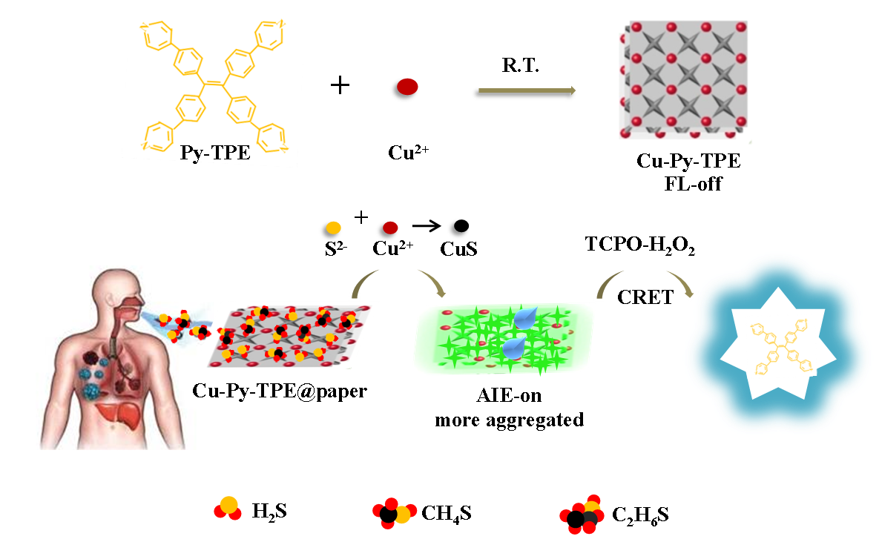
Scheme 2. Schematic diagram of the possible CL mechanism of TPPE-TCPO-H₂O₂ system.
