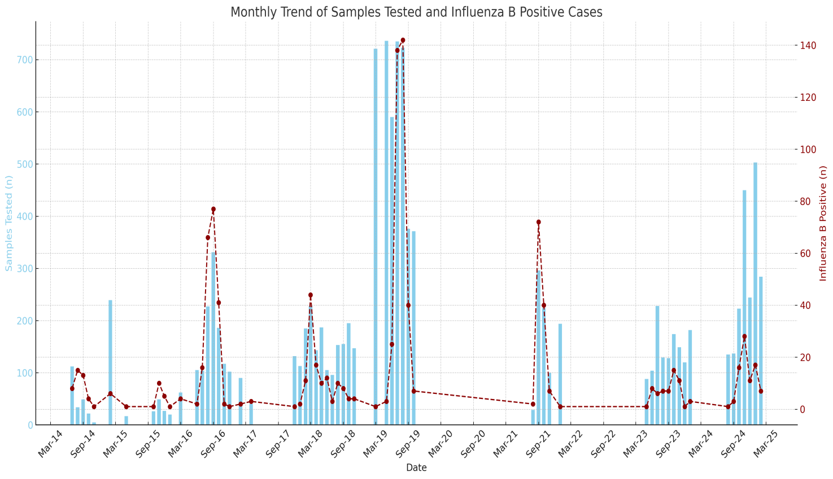
Supplemetary Figure 1. Monthly time series of influenza B virus positive cases and samples tested from Assam, Northeast India during 2014-2025.
Bars indicate the monthly numbers of Influenza B virus positive cases. The dashed line indicates the monthly number of sample tested.

