Table of content
Supplementary file 1. Detailed description of the statistical analyses, hypotheses and sample size calculation 2
Supplementary figures 1a, 1b, 2a and 2b. Scale structures tested using confirmatory factor analysis: EORTC PATSAT-C33 and OUT-PATSAT two-order and final first-order structure 6
Supplementary file 2. Patient selection for replication of CFA on a culturally balanced sampling 8
Supplementary file 3. Responses and compliance rate per item of the EORTC PATSAT-C33 and OUT-PATSAT7, and CFA factor loadings 9
Supplementary file 4. Responses to the debriefing questionnaire among patients who completed these questions by age, gender and cancer stage 12
Supplementary file 5. Robust fit estimates for the EORTC PATSAT-C33 confirmatory factor analyses in the full (N=675) and cross-culturally balanced (N=605) samples, and for the OUT-PATSAT7 confirmatory factor analyses in the full (N=526) and cross-culturally balanced (N=477) samples. 14
Supplementary file 6. EORTC PATSAT-C33 (N=675) and OUT-PATSAT7 (N=526) inter-scale correlations 15
Supplementary file 7. Convergent/divergent validity (Pearson’s product moment correlations) between the EORTC PATSAT-C33 (N=675) and OUT-PATSAT7 (N=526) and the EORTC QLQ-C30 and Oberst’s perception of care quality scales 16

Supplementary figures 1a, 1b, 2a and 2b. Hypothesized scale structure and final first-order structure of the EORTC PATSAT-C33 and OUT-PATSAT7 tested using confirmatory factor analysis

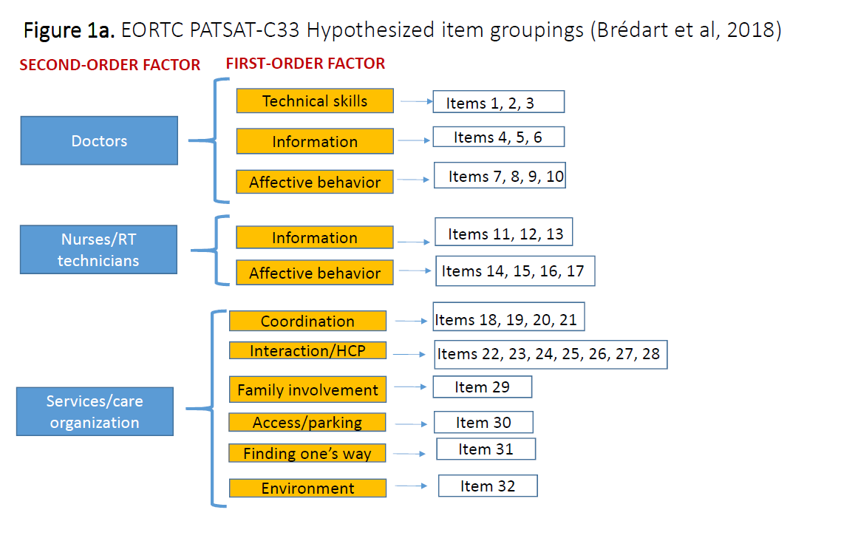
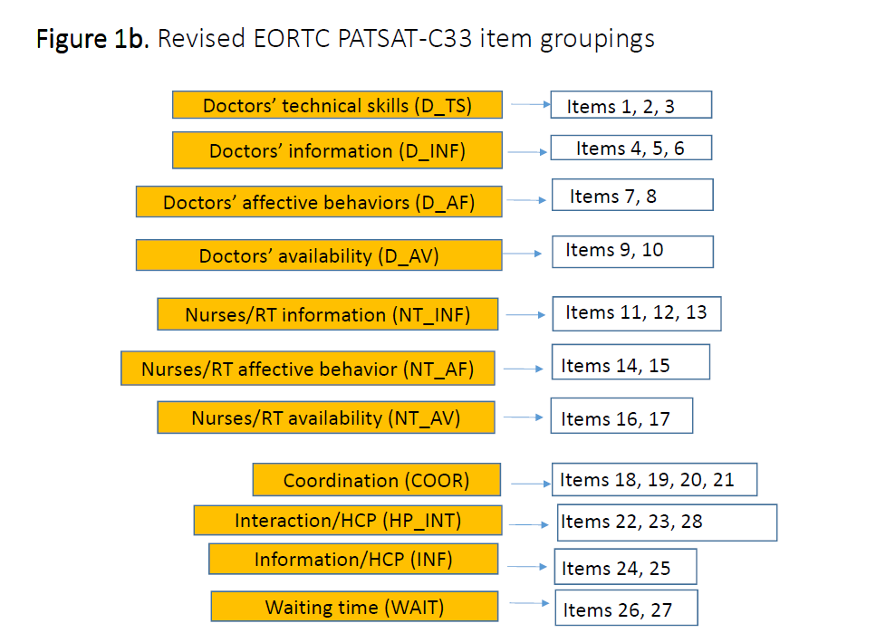
Abbreviations: RT= radiotherapy technicians; HCP= healthcare professionals.

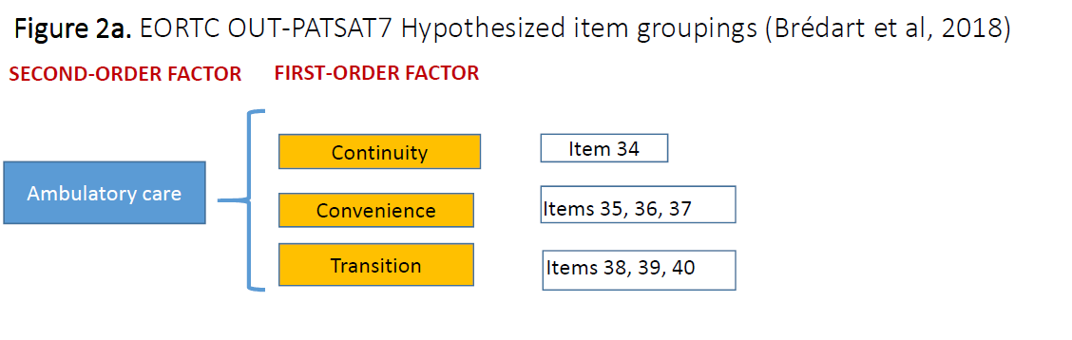
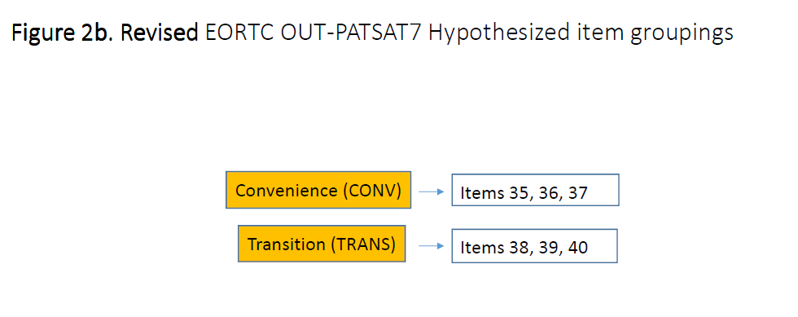

Supplementary table 1. Patient selection for replication of CFAs on a culturally balanced sampling

Overall, 690 patients were recruited between the 19th of November 2019 (date on which the Committee for the Protection of Persons gave its approval) and the 30th of November 2023. This cohort included 121 patients (17.5%) from English-speaking countries, 126 patients (18.3%) from French-speaking countries, 81 patients (11.7%) from West-Germanic and Scandinavian countries, 137 patients (19.9%) from Southern European countries, and 225 patients (32.6%) from other cultural or geographical regions.
The overall psychometric analyses are performed on the overall sample. However, we also replicated confirmatory factor analyses (CFAs) on a balanced sample across the five cultural/geographical areas. The proportion of patients recruited from the “Other” area exceeded those from the specified regions above. Specifically, the centers in Jordan and Turkey included a higher number of patients compared to other centers in their respective area, with 100 and 60 patients, respectively.
To minimize the discrepancy in patient proportions by geographical area, we removed the last patients included in these centers. To minimize the number of exclusions from the overall sample, we set the proportion of patients from the "Other" area at 25% (N=155) of the overall sample. To achieve 155 patients (calculated as 0.25 * (690 - 225) / (1-0.25)) in the “Other” area, we needed to remove 70 patients (225 - 155) from that area.
The center in Jordan initially represents 62.5% of the surplus patients (100 out of 160), so we needed to keep 56 patients, calculated as (160-70) * (100/160) = 56.25 (rounded to 56).
The center in Turkey initially represents 37.5% (60 out of 160), so we needed to keep 34 patients, calculated as (160-70) * (60/160) = 33.75 (rounded to 34).
The number of patients kept in the Jordan and Turkey centers was proportionate to the number included by study arm (0. Baseline, 1. Baseline + retest, 2. Baseline + responsiveness to change assessment, 3. Baseline + retest + responsiveness to change assessment).

Supplementary table 2. Detailed description of the statistical analyses and sample size calculation

The structural validity of the EORTC PATSAT-C33 and OUT-PATSAT7 was assessed using confirmatory factor analysis (CFA) techniques.

Since the EORTC PATSAT-C33 and OUT-PATSAT7 may both be used as standalone questionnaires and the patients responding to these questionnaires are not the same, CFAs were performed separately for each questionnaire.
Not applicable responses were considered as missing.
Missing data and not applicable responses were treated pairwise, meaning that correlations between items were calculated, for each pair of items, by taking into account all patients with valid data for these two items, leading to a variable number of observations for different correlations.
Models were estimated using the diagonally weighted least squares (DWLS) method on polychoric correlations, which is appropriate for the ordinal (not continuous) data generated by the PATSAT-C33 and OUT-PATSAT7. Using the DWLS, we considered robust fit indicators (sometimes referred to as the WLSWV method: weighted DWLS approach).
We tested the hypothesized the PATSAT-C33 and OUT-PATSAT7 two-factor order models suggested in phase 3 (Bredart et al., 2018).
For the PATSAT-C33 questionnaire, as the phase 3 hypothesized model led to unsatisfactory estimates, we proceeded with several adaptations to the model including splitting the ‘care organization’, ‘doctors’ and Nurses/radiotherapy technicians’ affective behaviors’ factors, excluding single items and testing only a first-order solution (see table below where model 1 is the originally proposed model) (see figures 2a and 2b below).
Model 1 based on hypothesized phase 3 structure |  | CFI | TLI | RMSEA | SRMR | Comments
1 | Hypothesized model phase 3: 7 first-order factors: D_TS (1,2,3), D_INF (4,5,6), D_AF (7,8,9,10), NT_INF (11,12,13), NT_AF (14,15,16,17), COOR (18,19,20,21), & HP_INT (22,23,24,25,26,27,28) and 3 second-order factors, 4 single items: DOC (D_TS, D_INF, D_AF), NT (NT_INF,NT_AF) et ORG (COOR,HP_INT + items 29,30,31,32) | 0.890 | 0.880 | 0.103 | 0.036
2 | With WAIT (26,27) on ORG |  |  |  |  | Estimation failed
3 | Successive exclusion of single items 29, 30, 31, 32 | Estimation failed (except when excluding item 31) |  |  |  | Too high loading of HP_INT on ORG
4 | Exclusion of all single items of ORG second order factor | 0.911 | 0.901 | 0.103 | 0.030
5 | Only first-order factors | 0.913 | 0.898 | 0.104 | 0.029
6 | Adding a factor INF (item 24/25) | 0.921 | 0.905 | 0.101 | 0.025
7 | D_AF divided in 2 factors (items 7/8 & items 9/10) | 0.929 | 0.912 | 0.097 | 0.024 | Satisfactory
8 | D_AF & N/RT divided in 2 factors (items 7/8 & items 9/10 and items 14/15 & items 16/17) | 0.935 | 0.916 | 0.094 | 0.024 | Satisfactory
REPLICATION ON REDUCED CULTURALLY BALANCED SAMPLE |  | 0.934 | 0.915 | 0.095 | 0.024 | Satisfactory
Abbr. D_TS=Doctors' technical skills, D_INF=Doctors' information, D_AF=Doctors' affective behaviors, DOC=Doctors' overall items, NT_INF=Nurses/Radiotherapy Technicians' information, NT_AF= Nurses/Radiotherapy Technicians' affective behaviors, NT= Nurses/Radiotherapy Technicians' overall items, COOR=Care coordination, HP_INT=Interaction with other healthcare professionals, ORG= service organization overall items, D_AF=Doctors' affective behaviors, D_AV=Doctors' availability, NT_AF= Nurses/Radiotherapy Technicians' affective behaviors, NT_AV= Nurses/Radiotherapy Technicians' availability, INF=Information from other healthcare professionals, WAIT=Waiting time.

For consistency with the adapted PATSAT-C33 model, instead of a two-factor model, we also tested a first-order model for the OUT-PATSAT7, which provided satisfactory estimates (see figures 1a, 1b, 2a and 2b below).
CFA were first performed on the overall sample (n=675) then replicated on the cross-culturally balanced sample, leading to satisfactory results (N=605).

Fit indicators
The comparative fit index (CFI) and Tucker–Lewis index (TLI) were calculated as measures of incremental model fit indexes (Kline, 2013). We considered the scale structure to have a satisfactory model fit if the indexes were >0.90 (Browne & Cudeck, 1992). In addition, a root mean square of approximation (RMSEA) of <0.10 was considered indicative of a reasonable fit (Browne & Cudeck, 1992) and a standardized root mean square residual (SRMR), a measure of the mean absolute correlation residual, of <0.06 was considered a good fit (Hu & Bentler, 1999). Correlations between residuals were fixed at 0.

Sample size considerations

Wolf et al (Wolf, Harrington, Clark, & Miller, 2013) suggested that 500 patients are adequate for factor analysis. The sample size was based on the accepted Tabachnick et al’s (Tabachnick, Fidell, & Ullman, 2013) ‘rule of thumb’ and the suggestion presented in the EORTC Quality of Life Guidelines for developing questionnaires (Wheelwright, 2021) to recruit at least 10-15 patients per item in the questionnaire. Therefore, based on 40 items in the core (33 items) and outpatient (7 items) questionnaires, a minimum of 450 patients was needed, considering 10 responses per item, a 15% expected missing response rate for paper-pencil questionnaires (Bredart et al., 2005) and 20% for online questionnaires (Winters et al., 2018). To ensure a sufficient number of patients across various cancer care settings and geographical areas, a 500-sample size target appeared reasonable for CFA.

Internal consistency of the multi-item scales, defined as the interrelatedness among the items in a multi-item scale, using Cronbach’s alpha or Mc Donald’s Omega coefficients (Zinbarg, Revelle, Yovel, & Li, 2005) on patient baseline data. A Cronbach’s alpha: <0.5 was considered ‘unacceptable’, between 0.5-0.59 as ‘poor’, between 0.60-0.69 as ‘questionable’, between 0.70-0.79 as ‘acceptable’, between 0.80-0.89 as ‘good’, and ≥ 0.90 as ‘excellent’ (Kline, 2000). We considered a Cronbach’s alpha of at least 0.70 as a requirement for sufficient internal consistency of a scale (Fayers & Machin, 2013).

Test-retest reliability to determine the consistency and reproducibility of the questionnaires scores was tested using the intra-class coefficient (ICC) based on patients’ baseline and the 2-week follow-up assessments. An ICC of at least 0.70 was considered ‘sufficient’ for test-retest reliability (Fayers & Machin, 2013). Cicchetti (Cicchetti, 1994) classifies ICCs as follows: <0.40 is poor, 0.40-0.59 is fair, 0.60-0.74 is good, and ≥0.75 is excellent.
A random sample of 103 subjects measured twice provides a two-sided 95% confidence interval with a width of 0.20 when the estimated ICC is 0.70. The data was analyzed using a one-way random-effects ANOVA model. Considering up to 20% attrition rate in prospective assessment, 125 patients were assessed for reproducibility.

Convergent and divergent validity was assessed using the Oberst perceived quality of care scales and the EORTC QLQ-C30, respectively.
It was expected that conceptually related scales (e.g. the PATSAT-C33 doctor’s information scale and the Oberst satisfaction with information about illness and treatment) would correlate substantially with one another (convergent validity). Conversely, scales with less in common (e.g. the EORTC PATSAT-C33 doctor’s technical skills items and the Oberst quality of nursing care visual analogue scale) were expected to exhibit lower correlations (divergent validity).
Correlation coefficients below than |0.30| were considered for divergent validity. For convergent validity, correlations below |0.40|, between |0.40|–|0.60| and |0.60| were considered weak, moderate and high, respectively.
Construct validity was assessed based on known-groups comparisons of the EORTC PATSAT-C33 and OUT-PATSAT7 scale scores and relevant patient subgroups. Hypotheses of differences were based on the following variables:
Patients’ socio-demographic characteristics: age (categorical <50, 50-70, ≥ 70 years) (Arraras et al., 2013; Lis, Rodeghier, Grutsch, & Gupta, 2009; Nguyen et al., 2011), education level (Barber, Bensen, Snavely, Gehrig, & Doll, 2016; Bredart et al., 2007);
Institution characteristics: cancer care setting (in- versus out-patient cancer care settings);
Patients’ clinical characteristics: disease stage (localized versus metastatic versus in remission) (de Rooij et al., 2018; Hervàs et al., 2021), treatment toxicity (yes/no), comorbidity (yes/no) and overall health status/quality of life (<70 versus ≥70 and over time Δ ≥+10 points vs. <+10 points) (Bredart et al., 2007; Hervàs et al., 2021; Jacobs et al., 2019; Lis et al., 2009; Nguyen et al., 2011);
Patients’ psychological characteristics: care expectations (Bredart et al., 2005), receipt of supportive care (at one-year FU) and intention to recommend the hospital to others (Bredart et al., 2005; Lis, Rodeghier, & Gupta, 2011).
Responsiveness to change assessment (RCA) was assessed by comparison to change between T1 and T3 on the QLQ-C30 global health scale (items 29 and 30). We expected that patients who would improve (≥+10 points on the global health scale) compared to those who would not improve (<+10) would also improve on the PATSAT-C33 and OUT-PATSAT7 scales, and those who would deteriorate ((<-10 points on the global health scale) compared to those who would not deteriorate (≥ -10) would also deteriorate on the PATSAT-C33 and OUT-PATSAT7 scales. RCA sample size was not calculated; we aimed to include as much patients as possible within a reasonable time frame for this study.

Known-groups and responsiveness to change comparisons were examined by means of mixed statistical models to determine if differences between groups were significant. We used mixed model with patients nested within institutions to account for correlations between patients within each institution. For known-group analyses of baseline characteristics, the dependent variables were each of the baseline PATSAT-C33 and OUT-PATSAT7 scale scores and the independent variables were the patients’ characteristics as fixed effect and the institution as random effect. For known-group analyses over the PATSAT-C33 and OUT-PATSAT7 scale score changes, the independent variables were, as fixed effects, the patients’ characteristics, the assessment time (baseline or one-year follow-up) and the interaction between them, and the institution (to account for the correlation between observed data in patients from a same institution) and the subject (to account for the effect of the repeated measure) as random effects on the intercept.
Effect sizes (Cohen’s d) for group differences were calculated with, in the numerator, the difference between the estimated marginal means of the mixed model and, in the denominator, the residual standard deviation of the mixed model. Cohen suggested that an effect size between 0.2-0.4 should be considered ‘small’, between 0.4-0.8 ‘medium’ and >0.8 ‘large’ (Cohen, 1988). Results were expected to align with the hypothesis.

Supplementary table 3. Responses and compliance rate per item of the EORTC PATSAT-C33 and OUT-PATSAT7, and CFA factor loadings

 |  | % missing | % not applicable | Mean | Standard deviation | Median | Minimum | Maximum | Confusing item  Yes (N=81)* | Upsetting item  Yes (N=3)* | Standardized Regression Weights (SRW)
EORTC PATSAT-C33 (N=675)
N° | Item
1 | Awareness of previous care and treatment | 2.8 | - | 4.39 | 0.80 | 5.0 | 1 | 5 | 11 | 1 | 0.91
2 | Attention to physical symptoms | 2.4 | 4.1 | 4.44 | 0.81 | 5.0 | 1 | 5 | 5 | 1 | 0.96
3 | Thoroughness treating physical symptoms | 2.8 | 4.1 | 4.44 | 0.81 | 5.0 | 1 | 5 | 6 | 0 | 0.98
4 | Information about illness | 2.4 | 2.1 | 4.34 | 0.93 | 5.0 | 1 | 5 | 4 | 0 | 0.92
5 | Information about medical tests & treatment | 2.7 | 1.6 | 4.34 | 0.92 | 5.0 | 1 | 5 | 2 | 0 | 0.92
6 | Attention to opinion about choice of treatment | 3.9 | 16.4 | 4.33 | 0.93 | 5.0 | 1 | 5 | 11 | 0 | 0.95
7 | Interest as a person | 2.7 | - | 4.39 | 0.84 | 5.0 | 1 | 5 | 4 | 0 | 0.96
8 | Comfort & support | 3.1 | - | 4.30 | 0.92 | 5.0 | 1 | 5 | 3 | 0 | 0.96
9 | Frequency visits | 4.3 | - | 4.19 | 0.97 | 4.0 | 1 | 5 | 5 | 0 | 0.91
10 | Time devoted | 3.1 | - | 4.24 | 0.92 | 4.0 | 1 | 5 | 3 | 0 | 0.97
11 | Attention to physical comfort | 3.0 | 1.3 | 4.48 | 0.78 | 5.0 | 1 | 5 | 2 | 0 | 0.95
12 | Information about care & treatment | 3.0 | 1.9 | 4.34 | 0.92 | 5.0 | 1 | 5 | 4 | 0 | 0.93
13 | Advice on managing physical symptoms | 3.1 | 5.3 | 4.26 | 0.98 | 5.0 | 1 | 5 | 5 | 0 | 0.92
14 | Interest as a person | 3.1 | 0.9 | 4.44 | 0.83 | 5.0 | 1 | 5 | 2 | 0 | 0.96
15 | Comfort & support | 3.3 | 2.2 | 4.39 | 0.87 | 5.0 | 1 | 5 | 4 | 0 | 0.97
16 | Promptness of response | 3.1 | 2.8 | 4.35 | 0.87 | 5.0 | 1 | 5 | 3 | 0 | 0.94
17 | Time devoted | 3.3 | 1.6 | 4.33 | 0.88 | 5.0 | 1 | 5 | 3 | 0 | 0.97
18 | Ease recognizing role & responsibilities of caregivers | 3.0 | - | 3.99 | 1.06 | 4.0 | 1 | 5 | 11 | 0 | 0.81
19 | Exchange of information between caregivers | 3.7 | - | 4.08 | 0.99 | 4.0 | 1 | 5 | 8 | 0 | 0.92
20 | Work together as a team | 3.4 | - | 4.25 | 0.93 | 5.0 | 1 | 5 | 6 | 0 | 0.94
21 | Exchange of information with community care | 5.9 | 25.5 | 4.02 | 1.07 | 4.0 | 1 | 5 | 11 | 0 | 0.89
22 | Kindness & helpfulness | 3.7 | - | 4.33 | 0.85 | 5.0 | 1 | 5 | 7 | 0 | 0.81
23 | Information on scheduling tests, treatment & care | 3.0 | - | 4.24 | 0.97 | 5.0 | 1 | 5 | 4 | 0 | 0.86
28 | Privacy | 2.8 | - | 4.39 | 0.83 | 5.0 | 1 | 5 | 4 | 0 | 0.84
24 | Information on supportive care | 6.2 | - | 3.78 | 1.21 | 4.0 | 1 | 5 | 6 | 0 | 0.80
25 | Information on things to improve health or prevent illness | 4.7 | - | 3.93 | 1.13 | 4.0 | 1 | 5 | 4 | 0 | 0.94
26 | Waiting time for test results | 3.6 | 7.9 | 3.84 | 1.13 | 4.0 | 1 | 5 | 3 | 0 | 0.90
27 | Waiting time for undergoing test or treatment | 3.7 | - | 3.88 | 1.11 | 4.0 | 1 | 5 | 2 | 0 | 0.91
29 | Family involved | 4.1 | 12.6 | 4.26 | 0.96 | 5.0 | 1 | 5 | 5 | 0
30 | Ease of access | 2.8 | - | 3.74 | 1.24 | 4.0 | 1 | 5 | 3 | 0
31 | Ease of finding one's way | 2.7 | - | 3.92 | 1.05 | 4.0 | 1 | 5 | 1 | 0
32 | Environment | 2.7 | - | 4.24 | 0.91 | 4.0 | 1 | 5 | 0 | 0
33 | Overall care | 2.5 | - | 4.49 | 0.73 | 5.0 | 1 | 5 | 5 | 0
EORTC OUT-PATSAT7 (patients reporting receiving ambulatory care) (N=526)
N° | Item
34 | See same caregivers | 1.5 | - | 4.03 | 1.01 | 4.0 | 1 | 5 | 11 | 1
35 | Ease arranging appointments | 0.6 | - | 4.04 | 1.00 | 4.0 | 1 | 5 | 3 | 0 | 0.89
36 | Waiting time for appointments | 1.5 | - | 4.01 | 1.01 | 4.0 | 1 | 5 | 2 | 0 | 0.91
37 | Ease of communicating with hospital from home | 1.9 | - | 3.92 | 1.11 | 4.0 | 1 | 5 | 2 | 0 | 0.84
38 | Information on what should/shouldn't do after discharge | 1.0 | - | 4.06 | 1.05 | 4.0 | 1 | 5 | 3 | 0 | 0.91
39 | Information who to contact in hospital | 1.3 | - | 4.09 | 1.05 | 4.0 | 1 | 5 | 4 | 0 | 0.91
40 | Follow-up care | 2.7 | - | 4.03 | 1.06 | 4.0 | 1 | 5 | 7 | 0 | 0.81
*Overall number of patients who indicated that an item among the PATSAT-C33 & OUT-PATSAT7 was found confusing or upsetting. Confirmatory factor analysis (CFA)

Supplementary table 4. Responses to the debriefing questionnaire among patients who completed these questions by age, gender and cancer stage (N=675)

Time to complete questionnaires (EORTC QLQ-C30, PATSAT-C33 & OUT-PATSAT7), in minutes
Less than 10 | 176 (29.2)
11-15 | 217 (36.0)
16-20 | 111 (18.4)
21-30 | 99 (16.4)
Missing | 72
Request for help to complete questionnaires, n (%)
No help required | 449 (71.3)
Practical help required (e.g. participants did not have their glasses on so the questionnaires had to be read, or they had shaky hands and difficulty writing) | 102 (16.2)
Supportive help required (e.g., the researcher remains seated with the patient completing the questionnaire) | 47 (7.5)
Help required with understanding the questionnaires | 32 (5.1)
Missing | 45
Having found an item confusing, n (%)*
Yes | 97 (15.6)
No | 524 (84.4)
Missing | 54
Having found an item upsetting, n (%)
Yes | 8 (1.3)
No | 617 (98.7)
Missing | 70
*Some patients reported ‘not clear who/what to evaluate if you have had several doctors, nurses or attended several departments’, ‘difficult to answer when you had experience that were good and bad some for instance’, ‘I have doubts regarding the medical questions, since not every doctors answer the questions about medical conditions’, ‘Item 34, I don’t know which is better to see same staff or not to see them’.
By age | <= 50 years | 51-70 years | > 70 years
Help required to complete the questionnaire | N=173 | N=283 | N=174
No | 122 (70.5) | 212 (74.9) | 115 (66.1)
Yes | 51 (29.5) | 71 (25.1) | 59 (33.9)
Item found difficult or confusing | N=173 | N=278 | N=170
No | 151 (87.3) | 233 (83.8) | 140 (82.4)
Yes | 22 (12.7) | 45 (16.2) | 30 (17.6)
Item found upsetting | Sample too small
By gender | Male | Female
Help required to complete the questionnaire | N=272 | N=358
No | 198 (72.8) | 251 (70.1)
Yes | 74 (27.2) | 107 (29.9)
Item found difficult or confusing | N=269 | N=352
No | 231 (85.9) | 293 (83.2)
Yes | 38 (14.1) | 59 (16.8)
Item found upsetting | Sample too small
By cancer stage | Localized | Metastatic | Remission
Help required to complete the questionnaire | N=330 | N=218 | N=79
No | 236 (71.5) | 156 (71.6) | 54 (68.4)
Yes | 94 (28.5) | 62 (28.4) | 25 (31.6)
Item found difficult or confusing* | N=323 | N=216 | N=79
No | 277 (85.8) | 173 (80.1) | 72 (91.1)
Yes | 46 (14.2) | 43 (19.9) | 7 (8.9)
Item found upsetting | Sample too small
By education level | Compulsory or less | Post-compulsory of less | University
Help required to complete the questionnaire**** | N=191 | N=200 | N=209
No | 109 (57.1) | 151 (75.5) | 161 (77.0)
Yes | 82 (42.9) | 49 (24.5) | 48 (23.0)
Item found difficult or confusing | N=187 | N=199 | N=205
No | 157 (84.0) | 168 (84.4) | 172 (83.9)
Yes | 30 (16.0) | 31 (15.6) | 33 (16.1)

*, **** Statistical difference at p<0.05, <0.000. Sample too small for items found upsetting.

Supplementary table 5. Robust fit estimates for the EORTC PATSAT-C33 confirmatory factor analyses in the full (N=675) and cross-culturally balanced (N=605) samples, and for the OUT-PATSAT7 in the full (N=526) and cross-culturally balanced (N=477) samples.

EORTC PATSAT-C33 | Factorial model  (N=675) | Factorial model  (N=605)
DWLS estimations
CFI robust | 0.935 | 0.934
TLI robust | 0.916 | 0.915
RMSEA robust | 0.094 | 0.095
SRMR | 0.024 | 0.024
Note: Diagonally weighted least squares (DWLS). Comparative fit index (CFI) and Tucker–Lewis index (TLI) >0.90 were considered to have a satisfactory model fit (Browne & Cudeck, 1992). A root mean square of approximation (RMSEA) of <0.10 was considered indicative of a reasonable fit (Browne & Cudeck, 1992) and a standardized root mean square residual (SRMR), a measure of the mean absolute correlation residual, of <0.06 was considered a good fit (Hu & Bentler, 1999).

EORTC OUT-PATSAT7 | Factorial model  (N=526) | Factorial model  (N=477)
DWLS estimation
CFI robust | 0.982 | 0.979
TLI robust | 0.966 | 0.960
RMSEA robust | 0.108 | 0.115
SRMR | 0.022 | 0.026
Note: Diagonally weighted least squares (DWLS). Comparative fit index (CFI) and Tucker–Lewis index (TLI) >0.90 were considered to have a satisfactory model fit (Browne & Cudeck, 1992). A root mean square of approximation (RMSEA) of <0.10 was considered indicative of a reasonable fit(Browne & Cudeck, 1992) and a standardized root mean square residual (SRMR), a measure of the mean absolute correlation residual, of <0.06 was considered a good fit (Hu & Bentler, 1999).

Supplementary table 5b. Covariances for the PATSAT-C33 and for the OUT-PATSAT7 scales
Covariances
PATSAT-C33
D_TS
D_INF | 0.907
D_AF | 0.863
D_AV | 0.846
NT_INF | 0.732
NT_AF | 0.721
NT_AV | 0.714
COOR | 0.741
HP_INT | 0.799
INF | 0.695
WAIT | 0.667
D_INF
D_AF | 0.891
D_AV | 0.859
NT_INF | 0.751
NT_AF | 0.705
NT_AV | 0.712
COOR | 0.763
HP_INT | 0.795
INF | 0.764
WAIT | 0.640
D_AF
D_AV | 0.917
NT_INF | 0.695
NT_AF | 0.699
NT_AV | 0.686
COOR | 0.750
HP_INT | 0.822
INF | 0.709
WAIT | 0.642
D_AV
NT_INF | 0.665
NT_AF | 0.647
NT_AV | 0.674
COOR | 0.731
HP_INT | 0.788
INF | 0.707
WAIT | 0.654
NT_INF
NT_AF | 0.948
NT_AV | 0.948
COOR | 0.763
HP_INT | 0.843
INF | 0.739
WAIT | 0.660
NT_AF
NT_AV | 0.961
COOR | 0.719
HP_INT | 0.854
INF | 0.678
WAIT | 0.664
NT_AV
COOR | 0.770
HP_INT | 0.870
INF | 0.713
WAIT | 0.691
COOR
HP_INT | 0.889
INF | 0.824
WAIT | 0.757
HP_INT
INF | 0.816
WAIT | 0.842
INF
WAIT | 0.686
OUT-PATSAT7
CONV
TRANS | 0.868

Supplementary table 6. EORTC PATSAT-C33 (N=675) and OUT-PATSAT7 (N=526) inter-scale correlations
 | PATSAT-C33 |  |  |  |  |  |  |  |  |  |  |  |  |  |  |  | OUT-PATSAT7
 | D_TS | D_INF | D_AF | D_AV | NT_INF | NT_AF | NT_AV | COOR | HP_INT | INF | WAIT | FAM | ACC | FW | ENV | ISAT | CONT | CONV
EORTC PATSAT-C33
D_TS | -
D_INF | 0.81***
D_AF | 0.78*** | 0.79***
D_AV | 0.73*** | 0.73*** | 0.80***
NT_INF | 0.60*** | 0.59*** | 0.55*** | 0.51***
NT_AF | 0.60*** | 0.54*** | 0.56*** | 0.49*** | 0.85***
NT_AV | 0.60*** | 0.55*** | 0.56*** | 0.53*** | 0.84*** | 0.86***
COOR | 0.62*** | 0.60*** | 0.62*** | 0.59*** | 0.63*** | 0.58*** | 0.63***
HP_INT | 0.66*** | 0.62*** | 0.66*** | 0.62*** | 0.68*** | 0.68*** | 0.70*** | 0.73***
WAIT | 0.54*** | 0.57*** | 0.53*** | 0.53*** | 0.57*** | 0.51*** | 0.53*** | 0.66*** | 0.61***
INF | 0.53*** | 0.48*** | 0.50*** | 0.52*** | 0.51*** | 0.51*** | 0.56*** | 0.62*** | 0.67*** | 0.52***
FAM | 0.54*** | 0.53*** | 0.55*** | 0.49*** | 0.47*** | 0.50*** | 0.50*** | 0.57*** | 0.61*** | 0.49*** | 0.53***
ACC | 0.35*** | 0.33*** | 0.36*** | 0.37*** | 0.33*** | 0.31*** | 0.35*** | 0.39*** | 0.39*** | 0.41*** | 0.36*** | 0.32***
FW | 0.45*** | 0.44*** | 0.45*** | 0.43*** | 0.45*** | 0.46*** | 0.50*** | 0.53*** | 0.58*** | 0.50*** | 0.54*** | 0.42*** | 0.52***
ENV | 0.49*** | 0.43*** | 0.47*** | 0.44*** | 0.42*** | 0.44*** | 0.47*** | 0.52*** | 0.61*** | 0.41*** | 0.53*** | 0.47*** | 0.41*** | 0.64***
ISAT | 0.67*** | 0.62*** | 0.65*** | 0.62*** | 0.64*** | 0.62*** | 0.67*** | 0.67*** | 0.71*** | 0.57*** | 0.59*** | 0.55*** | 0.36*** | 0.55*** | 0.57*** | -
EORTC OUT-PATSAT7
CONT | 0.53*** | 0.49*** | 0.51*** | 0.50*** | 0.46*** | 0.47*** | 0.51*** | 0.58*** | 0.57*** | 0.49*** | 0.50*** | 0.49*** | 0.32*** | 0.47*** | 0.44*** | 0.52***
CONV | 0.62*** | 0.54*** | 0.58*** | 0.58*** | 0.57*** | 0.59*** | 0.62*** | 0.66*** | 0.74*** | 0.54*** | 0.65*** | 0.56*** | 0.40*** | 0.56*** | 0.58*** | 0.63*** | 0.61***
TRANS | 0.60*** | 0.62*** | 0.59*** | 0.60*** | 0.65*** | 0.58*** | 0.64*** | 0.72*** | 0.68*** | 0.67*** | 0.57*** | 0.56*** | 0.39*** | 0.52*** | 0.47*** | 0.65*** | 0.62*** | 0.73***
Abbr: D_TS=Doctors' technical skills, D_INF=Doctors' information, D_AF=Doctors' affective behaviors, D_AV=Doctors' availability, NT_INF=Nurses/Radiotherapy Technicians' information, NT_AF=Nurses/ Radiotherapy Technicians' affective behaviors, NT_AV=Nurses/ Radiotherapy Technicians' availability, COOR=Care coordination, HP_INT=Interaction with other healthcare professionals, INF=Information from other healthcare professionals, WAIT=Waiting time; CONV=Convenience, TRANS=Transition; FAM= Family involvement (item 29), ACC=Access/parking (item 30), FW=Finding one’s way (item 31), ENV=Environment (item 32), ISAT==Overall quality of care (item 33),CONT=Care continuity (item 34). Note. Inter-scale correlations to establish scale convergence or divergence. Pearson's r < |0.40| = weak correlation, |0.40|–|0.60| = moderate, >|0.60| = high. Correlations >|0.60| are in blue.

Supplementary table 7. Convergent/divergent validity (Pearson’s product moment correlations) between the EORTC PATSAT-C33 (N=675) and OUT-PATSAT7 (N=526) and the EORTC QLQ-C30 and Oberst’s perception of care quality scales
 | D_TS | D_INF | D_AF | D_AV | NT_INF | NT_AF | NT_AV | COOR | HP_INT | INF | WAIT | FAM | ACC | FW | ENV | ISAT | CONT | CONV | TRANS
EORTC QLQ-C30
Physical functioning | 0.06ns | 0.06ns | 0.04ns | 0.02ns | 0.05ns | 0.02ns | 0.04ns | 0.05ns | 0.03ns | 0.05ns | -0.05ns | 0.02ns | 0.02ns | 0.04ns | 0.00ns | 0.03ns | -0.06ns | 0.01ns | 0.03ns
Role functioning | 0.03ns | 0.05ns | 0.02ns | -0.00ns | 0.05ns | 0.02ns | 0.05ns | 0.11** | 0.07ns | 0.05ns | 0.05ns | 0.02ns | 0.02ns | 0.06ns | 0.03ns | 0.04ns | 0.04ns | 0.12** | 0.07ns
Social functioning | 0.13*** | 0.14*** | 0.12** | 0.11** | 0.08* | 0.05ns | 0.11** | 0.17*** | 0.13** | 0.11** | 0.10** | 0.07ns | 0.12** | 0.15*** | 0.13** | 0.12** | 0.04ns | 0.13** | 0.11*
Emotional  functioning | 0.10* | 0.14*** | 0.09* | 0.08* | 0.14*** | 0.12** | 0.13** | 0.15*** | 0.11** | 0.09* | 0.08* | 0.12** | 0.12** | 0.11** | 0.04ns | 0.15*** | 0.08ns | 0.14** | 0.18***
Cognitive  functioning | 0.09* | 0.09* | 0.04ns | 0.06ns | 0.05ns | 0.04ns | 0.04ns | 0.08* | 0.04ns | 0.05ns | 0.06ns | 0.06ns | 0.11** | 0.07ns | 0.04ns | 0.05ns | 0.02ns | 0.05ns | 0.06ns
Global health status | 0.15*** | 0.14*** | 0.13*** | 0.12** | 0.15*** | 0.12** | 0.14*** | 0.16*** | 0.14*** | 0.14*** | 0.12** | 0.06ns | 0.10** | 0.15*** | 0.14*** | 0.20*** | 0.09* | 0.18*** | 0.16***
Oberst’s perception of care quality*
Meeting care expectations | -0.38*** | -0.35*** | -0.37*** | -0.39*** | -0.34*** | -0.31*** | -0.36*** | -0.34*** | -0.38*** | -0.34*** | -0.35*** | -0.32*** | -0.25*** | -0.34*** | -0.26*** | -0.41*** | -0.35*** | -0.36*** | -0.38***
Satisfaction with info. about caring for yourself | 0.29*** | 0.28*** | 0.26*** | 0.20*** | 0.22*** | 0.21*** | 0.22*** | 0.26*** | 0.24*** | 0.27*** | 0.19*** | 0.25*** | 0.13** | 0.17*** | 0.19*** | 0.23*** | 0.30*** | 0.25*** | 0.27***
Quality nursing or radiographer | -0.27*** | -0.25*** | -0.26*** | -0.29*** | -0.38*** | -0.36*** | -0.38*** | -0.32*** | -0.32*** | -0.26*** | -0.29*** | -0.29*** | -0.20*** | -0.25*** | -0.23*** | -0.32*** | -0.23*** | -0.27*** | -0.33***
Satisfaction with info. about illness & treatment | -0.39*** | -0.48*** | -0.42*** | -0.41*** | -0.29*** | -0.21*** | -0.23*** | -0.35*** | -0.32*** | -0.37*** | -0.30*** | -0.28*** | -0.23*** | -0.24*** | -0.23*** | -0.38*** | -0.29*** | -0.30*** | -0.43***
Quality medical care | -0.39*** | -0.38*** | -0.39*** | -0.39*** | -0.34*** | -0.32*** | -0.33*** | -0.36*** | -0.39*** | -0.36*** | -0.30*** | -0.34*** | -0.26*** | -0.26*** | -0.28*** | -0.39*** | -0.37*** | -0.35*** | -0.40***
Intention to recommend the hospital | 0.44*** | 0.38*** | 0.41*** | 0.40*** | 0.39*** | 0.35*** | 0.42*** | 0.40*** | 0.44*** | 0.33*** | 0.34*** | 0.33*** | 0.27*** | 0.36*** | 0.34*** | 0.50*** | 0.34*** | 0.41*** | 0.43***
*Higher scores means higher perceived care quality except item about satisfaction with information about caring for yourself
Abbr: D_TS=Doctors' technical skills, D_INF=Doctors' information, D_AF=Doctors' affective behaviors, D_AV=Doctors' availability, NT_INF=Nurses/Radiotherapy Technicians' information, NT_AF=Nurses/ Radiotherapy Technicians' affective behaviors, NT_AV=Nurses/ Radiotherapy Technicians' availability, COOR=Care coordination, HP_INT=Interaction with other healthcare professionals, INF=Information from other healthcare professionals, WAIT=Waiting time; CONV=Convenience, TRANS=Transition; FAM= Family involvement (item 29), ACC=Access/parking (item 30), FW=Finding one’s way (item 31), ENV=Environment (item 32), ISAT==Overall quality of care (item 33),CONT=Care continuity (item 34). Note: Correlation coefficients below than |0.30| were considered for divergent validity; correlations higher than |0.40|reflecting convergent validity are in blue. *, **, ***: p<0.05, 0.01, 0.001; ns=non-significant correlation. Shaded area corresponds to conceptually related PATSAT-C33 and OUT-PATSAT, and Oberst’s scales.

References

Arraras, J. I., Illarramendi, J. J., Viudez, A., Ibáñez, B., Lecumberri, M. J., de la Cruz, S., . . . Vera, R. (2013). Determinants of patient satisfaction with care in a Spanish oncology day hospital and its relationship with quality of life. Psycho-Oncology, 22(11), 2454-2461. doi:10.1002/pon.3307
Barber, E. L., Bensen, J. T., Snavely, A. C., Gehrig, P. A., & Doll, K. M. (2016). Who presents satisfied? Non-modifiable factors associated with patient satisfaction among gynecologic oncology clinic patients. Gynecologic Oncology, 142(2), 299-303. doi:10.1016/j.ygyno.2016.06.009
Bredart, A., Anota, A., Young, T., Tomaszewski, K. A., Arraras, J. I., Moura De Albuquerque Melo, H., . . . Group, E. Q. o. L. (2018). Phase III study of the European Organisation for Research and Treatment of Cancer satisfaction with cancer care core questionnaire (EORTC PATSAT-C33) and specific complementary outpatient module (EORTC OUT-PATSAT7). European Journal of Cancer Care (English Language Edition), 27(1). doi:10.1111/ecc.12786
Bredart, A., Bottomley, A., Blazeby, J. M., Conroy, T., Coens, C., D'Haese, S., . . . Quality of Life, U. (2005). An international prospective study of the EORTC cancer in-patient satisfaction with care measure (EORTC IN-PATSAT32). European Journal of Cancer, 41(14), 2120-2131. doi:10.1016/j.ejca.2005.04.041
Bredart, A., Coens, C., Aaronson, N., Chie, W. C., Efficace, F., Conroy, T., . . . Unit, E. Q. o. L. (2007). Determinants of patient satisfaction in oncology settings from European and Asian countries: preliminary results based on the EORTC IN-PATSAT32 questionnaire. European Journal of Cancer, 43(2), 323-330. doi:10.1016/j.ejca.2006.10.016
Browne, M. W., & Cudeck, R. (1992). Alternative ways of assessing model fit. Sociological methods & research, 21(2), 230-258.
Cicchetti, D. V. (1994). Guidelines, criteria, and rules of thumb for evaluating normed and standardized assessment instruments in psychology. Psychological Assessment, 6(4), 284-290. doi:10.1037/1040-3590.6.4.284
Cohen, J. (1988). Statistical power analysis for the behavioral sciences (0805802835). Retrieved from
de Rooij, B. H., Ikiz, H., Boll, D., Pijnenborg, J. M. A., Pijlman, B. M., Kruitwagen, R., . . . Ezendam, N. P. M. (2018). Recurrent Cancer Is Associated With Dissatisfaction With Care-A Longitudinal Analysis Among Ovarian and Endometrial Cancer Patients. International Journal of Gynecological Cancer, 28(3), 614-622. doi:10.1097/igc.0000000000001204
Fayers, P. M., & Machin, D. (2013). Quality of life: the assessment, analysis and interpretation of patient-reported outcomes: John Wiley & Sons.
Hervàs, A., Montraveta, R., Corral, S., Pintado, L., Baeza, T., Arnau, A., & Vall, A. (2021). Factors contributing to satisfaction with care in cancer outpatients. Supportive Care in Cancer, 29(8), 4575-4586. doi:10.1007/s00520-020-05978-w
Hu, L. t., & Bentler, P. M. (1999). Cutoff criteria for fit indexes in covariance structure analysis: Conventional criteria versus new alternatives. Structural equation modeling: a multidisciplinary journal, 6(1), 1-55.
Jacobs, J. M., Ream, M. E., Pensak, N., Nisotel, L. E., Fishbein, J. N., MacDonald, J. J., . . . Greer, J. A. (2019). Patient Experiences With Oral Chemotherapy: Adherence, Symptoms, and Quality of Life. Journal of the National Comprehensive Cancer Network, 17(3), 221-228. doi:10.6004/jnccn.2018.7098
Kline, P. (2000). The Handbook of Psychological Testing / P. Kline.
Kline, P. (2013). Handbook of psychological testing: Routledge.
Lis, C. G., Rodeghier, M., Grutsch, J. F., & Gupta, D. (2009). Distribution and determinants of patient satisfaction in oncology with a focus on health related quality of life. BMC Health Services Research, 9, 190. doi:10.1186/1472-6963-9-190
Lis, C. G., Rodeghier, M., & Gupta, D. (2011). The relationship between perceived service quality and patient willingness to recommend at a national oncology hospital network. BMC Health Services Research, 11, 46. doi:10.1186/1472-6963-11-46
Nguyen, T. V., Bosset, J. F., Monnier, A., Fournier, J., Perrin, V., Baumann, C., . . . Mercier, M. (2011). Determinants of patient satisfaction in ambulatory oncology: a cross sectional study based on the OUT-PATSAT35 questionnaire. BMC Cancer, 11, 526. doi:10.1186/1471-2407-11-526
Tabachnick, B. G., Fidell, L. S., & Ullman, J. B. (2013). Using multivariate statistics (Vol. 6): pearson Boston, MA.
Wheelwright, S., Bjordal, K., Bottomley, A., Gilbert, A., Martinelli, F., Pe, M., Sztankay, M., Cocks, K., Coens, C., Darlington, AS., Fayers, P., Giesinger, J., Koller, M., Kuliś, D., Petersen, MAa., Reijneveld, J., Singer, S., Tomaszewski, K., Fitzsimmons D. on behalf of the EORTC Quality of Life Group. (2021). EORTC Quality of Life Group Guidelines for developing questionnaire modiles, fifth edition.
Winters, Z. E., Afzal, M., Rutherford, C., Holzner, B., Rumpold, G., da Costa Vieira, R. A., . . . King, M. T. (2018). International validation of the European Organisation for Research and Treatment of Cancer QLQ-BRECON23 quality-of-life questionnaire for women undergoing breast reconstruction. British Journal of Surgery, 105(3), 209-222. doi:10.1002/bjs.10656
Wolf, E. J., Harrington, K. M., Clark, S. L., & Miller, M. W. (2013). Sample size requirements for structural equation models: An evaluation of power, bias, and solution propriety. Educational and Psychological Measurement, 73(6), 913-934.
Zinbarg, R. E., Revelle, W., Yovel, I., & Li, W. (2005). Cronbach’s α, Revelle’s β, and Mcdonald’s ωH: their Relations with Each Other and Two Alternative Conceptualizations of Reliability. Psychometrika, 70(1), 123-133. doi:10.1007/s11336-003-0974-7

