Supporting Information
A New Fluorescence Probe Based on Self-absorption for Detection of Co²⁺ and Viscosity
Huizhen WANG^{a*}, Dingxin QIUª, Pengbo WANG^{b}, Pei WU^{b}, Kezhen GOU^{c}, Yan TANGª, Guanjun CHANG^{d*}
1. Experimental method:
¹HNMR titration : Accurately weigh 3 portions of 20mg probe HDN and dissolve with 1.0mL DMSO-d6. Co2+ are 0.5, 1.0, and 1.5 equiv. of probe HDN, respectively.
Chitosan cross-linking reaction: 0.3 g of chitosan was dissolved in 90 mL 1.0% acetic acid solution. Then, 900 uL HDN (1.0 × 10⁻³ mol/L) was added and thoroughly stirred. Next, add 5.0 milliliters of this solution to each of the 9 beakers. Then, add 0.5, 1.0, 1.5, 2.0, 2.5, 3.0, 3.5, 4.0, and 4.5 mL of 10% glutaraldehyde aqueous solution to each beaker, stir until the crosslinking reaction is complete, and perform fluorescence testing separately.
2. The ¹H NMR、¹³C NMR、IR、HR-MS of compound HDN
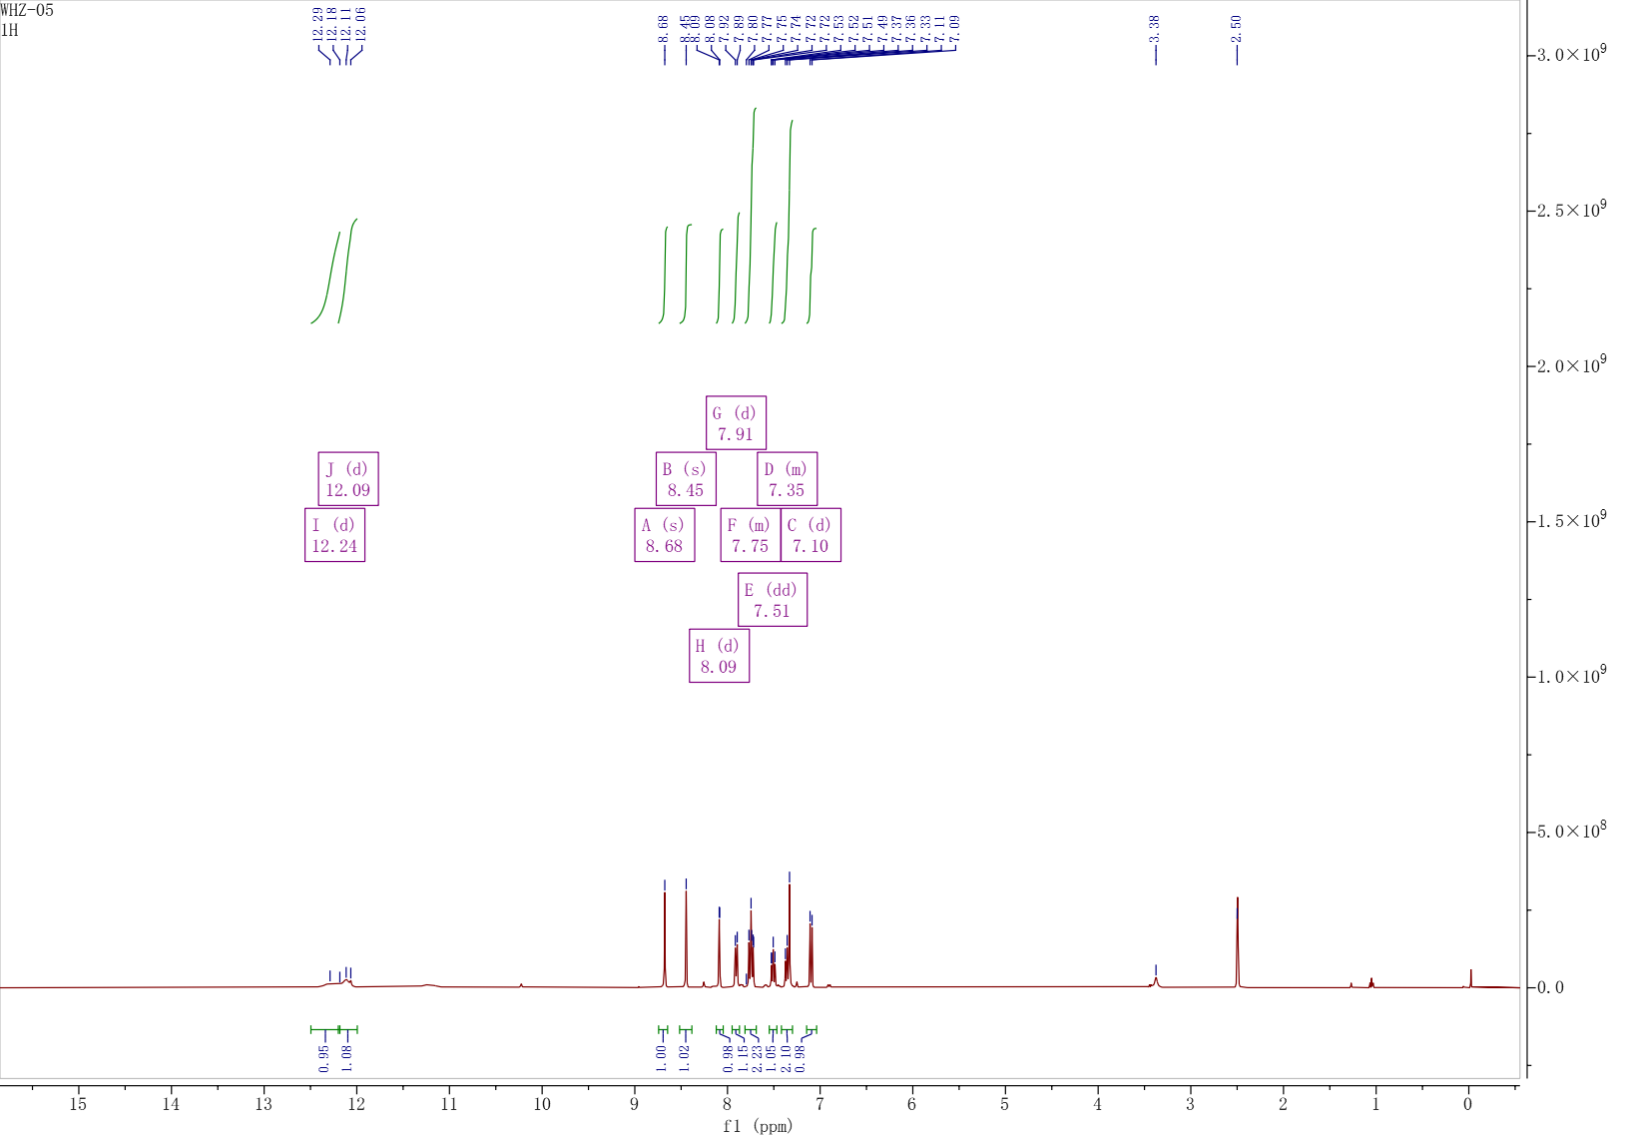
Fig. S1. ¹H NMR spectrum of probe HDN.
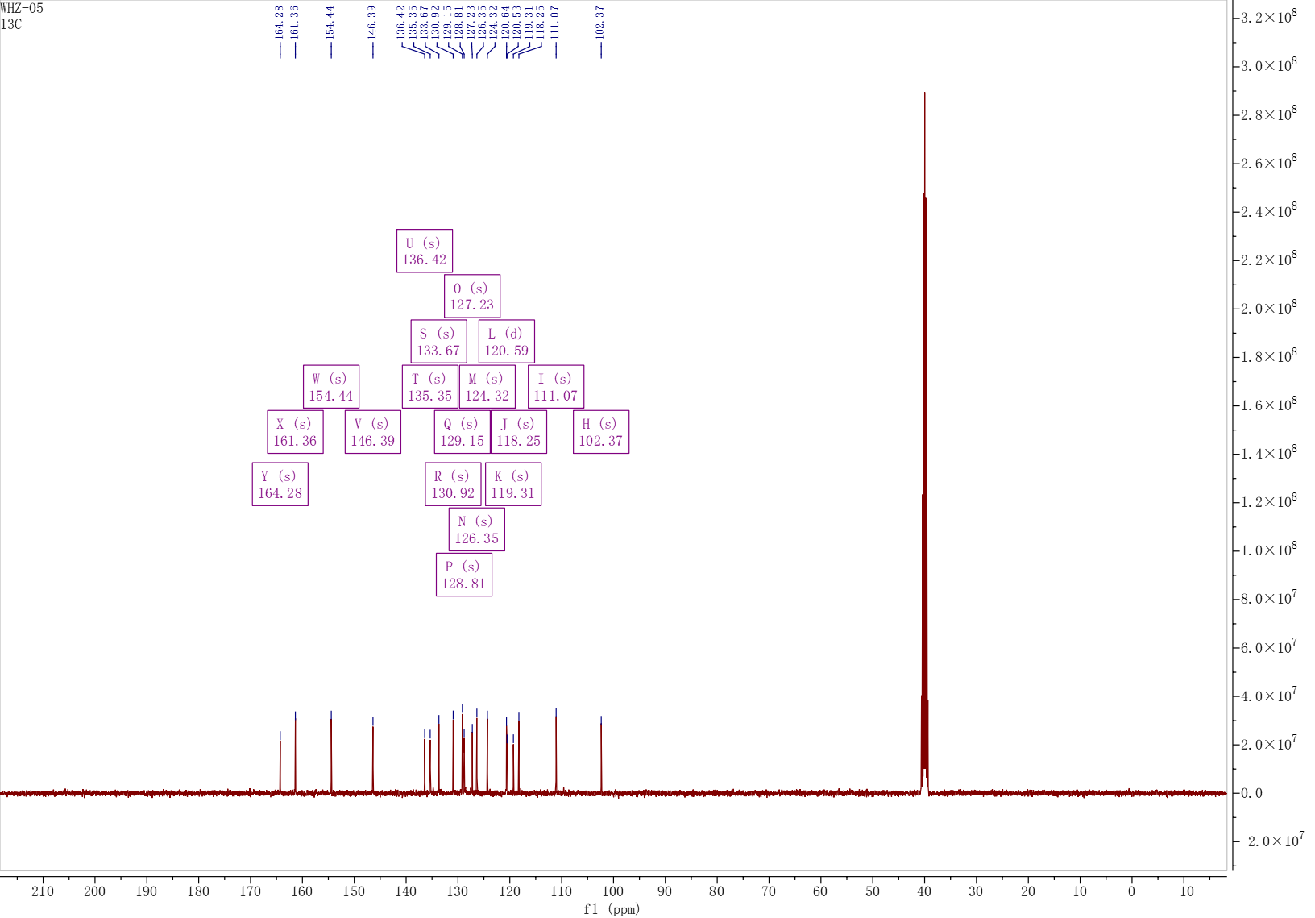

Fig. S2. ¹³C NMR spectrum of probe HDN.
Fig. S3. Infrared spectrum of probe HDN.

Fig. S4. Infrared spectrum of probe HDN+Co²⁺.

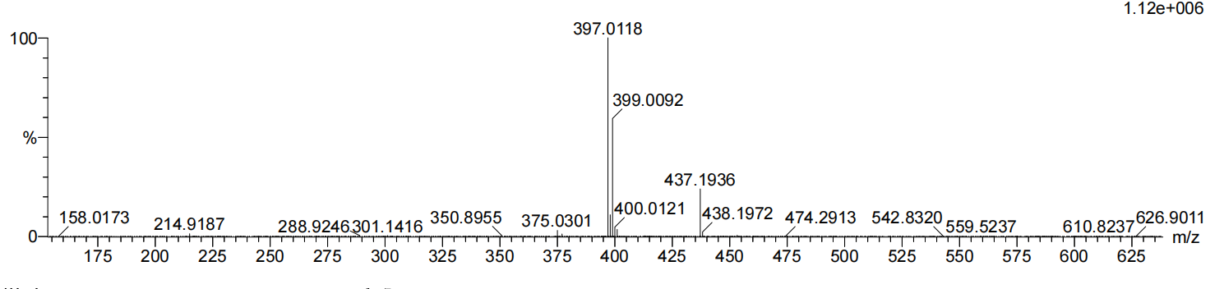
Fig. S5. The mass spectrum of probe HDN
2 Spectroscopic research
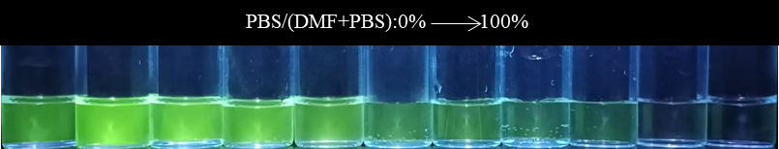
Fig. S6. Fluorescence (a) and Uv-vis (b) spectra of probe HDN in different PBS/DMF systems (PBS/DMF=4:6; λex=360 nm).
Fig. S7. The Uv-vis response of probe HDN by adding Co²⁺ and other anions. (λ_{ex} = 360 nm, PBS/DMF=4:6)
Fig.S8. Job’s plot of probe HDN-Co²⁺ (λ_{ex} = 360 nm, PBS/DMF=4:6)

