Table S1. Simulation results for the independent and joint models for ZINB model, Zero rate = (69% - 75%), Cure rate = (47% - 50%) under N=500 and N=800 sample size
N=800 |  |  |  |  |  |  |  | N=500
Independent model |  |  |  | Joint model |  |  |  | Independent model |  |  |  | Joint model
97.5% | 2.5% | SD | mean | 97.5% | 2.5% | SD | mean | 97.5% | 2.5% | SD | mean | 97.5% | 2.5% | SD | mean | True value | parameters
1.077 | 0.851 | 0.059 | 0.936 | 1.054 | 0.816 | 0.062 | 0.940 | 1.183 | 0.946 | 0.061 | 1.085 | 1.189 | 0.945 | 0.063 | 1.074 | 1 | $$β_{0}$$
-1.978 | -2.101 | 0.031 | -2.004 | -1.980 | -2.102 | 0.030 | -2.004 | -1.919 | -2.074 | 0.040 | -1.996 | -1.922 | -2.077 | 0.039 | -1.996 | -2 | $$β_{1}$$
1.601 | 1.419 | 0.045 | 1.537 | 1.605 | 1.418 | 0.048 | 1.515 | 1.567 | 1.360 | 0.052 | 1.462 | 1.579 | 1.358 | 0.055 | 1.463 | 1.5 | $$β_{2}$$
-0.783 | -1.069 | 0.732 | -0.924 | -0.777 | -1.068 | 0.073 | -0.933 | -0.644 | -0.986 | 0.087 | -0.817 | -0.670 | -0.999 | 0.085 | -0.831 | -1 | $$α_{0}$$
2.053 | 1.749 | 0.077 | 1.895 | 2.060 | 1.754 | 0.078 | 1.987 | 2.296 | 1.896 | 0.104 | 2.089 | 2.262 | 1.870 | 0.101 | 2.055 | 2 | $$α_{1}$$
1.193 | 0.878 | 0.080 | 1.037 | 1.188 | 0.867 | 0.082 | 1.032 | 1.016 | 0.649 | 0.094 | 0.836 | 0.770 | 0.642 | 0.097 | 0.835 | 1 | $$α_{2}$$
2.277 | 1.817 | 0.117 | 2.052 | 2.290 | 1.818 | 0.120 | 2.047 | 2.541 | 1.889 | 0.167 | 2.204 | 2.513 | 1.857 | 0.166 | 2.166 | 2 | $$τ$$
1.119 | 0.959 | 0.042 | 1.035 | 1.137 | 0.963 | 0.044 | 1.050 | 1.019 | 0.836 | 0.047 | 0.925 | 0.984 | 0.861 | 0.042 | 0.898 | 1 | $$σ_{b1}$$
1.090 | 0801 | 0.073 | 0.941 | 1.070 | 0.850 | 0.058 | 0.955 | 1.082 | 0.750 | 0.085 | 0.901 | 1.057 | 0.728 | 0.088 | 0.894 | 1 | $$σ_{b2}$$
0.536 | 0.241 | 0.074 | 0.391 | 0.505 | 0.244 | 0.067 | 0.429 | 0.543 | 0.211 | 0.085 | 0.380 | 0.554 | 0.242 | 0.082 | 0.405 | 0.5 | $$ρ$$
 |  |  |  | 0.936 | 0.488 | 0.113 | 0.716 |  |  |  |  | 1.136 | 0.510 | 0.188 | 0.664 | 0.6 | $$ν_{1}$$
 |  |  |  | 1.004 | 0.364 | 0.173 | 0.629 |  |  |  |  | 1.107 | 0.249 | 0.241 | 0.684 | 0.7 | $$ν_{2}$$
0.244 | 0.148 | 0.024 | 0.193 | 0.123 | 0.059 | 0.016 | 0.107 | 0.234 | 0.123 | 0.027 | 0.175 | 0.141 | 0.053 | 0.022 | 0.094 | 0.1 | $$ϑ$$
1.157 | 1.312 | 0.068 | 1.440 | 2.419 | 1.995 | 0.155 | 2.080 | 1.659 | 1.299 | 0.089 | 1.478 | 2.558 | 1.836 | 0.181 | 2.137 | 2 | $$ζ$$
0.505 | 0.197 | 0.079 | 0.347 | 0.541 | 0.213 | 0.082 | 0.374 | 0.333 | -0.044 | 0.099 | 0.144 | 0.337 | -0.048 | 0.093 | 0.243 | 0.4 | $$γ_{c1}$$
1.053 | 0.554 | 0.125 | 0.801 | 1.041 | 0.538 | 0.130 | 0.782 | 1.249 | 0.733 | 0.157 | 0.733 | 1.165 | 0.634 | 0.158 | 0.450 | 0.5 | $$γ_{c2}$$
0.488 | 0.189 | 0.076 | 0.333 | 0.893 | 0.488 | 0.104 | 0.635 | 0.661 | 0.292 | 0.092 | 0.477 | 0.835 | 0.389 | 0.111 | 0.668 | 0.6 | $$γ_{1}$$
0.621 | 0.077 | 0.125 | 0.801 | 0.819 | 0.147 | 0.048 | 0.515 | 0.739 | 0.108 | 0.163 | 0.422 | 1.579 | 1.358 | 0.221 | 0.526 | 0.5 | $$γ_{2}$$

Table S2. Simulation results for the independent and joint models for ZINB model, Zero rate = (43% - 50%), Cure rate = (59% - 66%) under N=500 and N=800 sample size
N=800 |  |  |  |  |  |  |  | N=500
Independent model |  |  |  | Joint model |  |  |  | Independent model |  |  |  | Joint model
97.5% | 2.5% | SD | mean | 97.5% | 2.5% | SD | mean | 97.5% | 2.5% | SD | mean | 97.5% | 2.5% | SD | mean | True value | parameters
0.558 | 0.356 | 0.052 | 0.461 | 0.573 | 0.378 | 0.048 | 0.473 | 0.647 | 0.430 | 0.054 | 0.540 | 0.633 | 0.433 | 0.054 | 0.540 | 0.5 | $$β_{0}$$
0.324 | 0.253 | 0.018 | 0.289 | 0.324 | 0.253 | 0.018 | 0.288 | 0.374 | 0.291 | 0.020 | 0.332 | 0.375 | 0.288 | 0.022 | 0.330 | 0.3 | $$β_{1}$$
0.716 | 0.587 | 0.033 | 0.650 | 0.712 | 0.582 | 0.034 | 0.646 | 0.688 | 0.535 | 0.039 | 0.614 | 0.687 | 0.533 | 0.039 | 0.611 | 0.6 | $$β_{2}$$
0.655 | 0.345 | 0.080 | 0.490 | 0.697 | 0.333 | 0.093 | 0.501 | 0.603 | 0.261 | 0.089 | 0.425 | 0.633 | 0.226 | 0.101 | 0.435 | 0.5 | $$α_{0}$$
0.870 | 0.662 | 0.052 | 0.764 | 0.878 | 0.662 | 0.056 | 0.760 | 0.826 | 0.596 | 0.057 | 0.705 | 0.809 | 0.588 | 0.057 | 0.700 | 0.7 | $$α_{1}$$
0.696 | 0.356 | 0.088 | 0.523 | 0.675 | 0.332 | 0.085 | 0.548 | 0.822 | 0.416 | 0.103 | 0.619 | 0.842 | 0.407 | 0.110 | 0.616 | 0.6 | $$α_{2}$$
2.085 | 1.672 | 0.102 | 1.873 | 2.055 | 1.665 | 0.101 | 1.899 | 2.356 | 1.840 | 0.131 | 2.089 | 2.385 | 1.839 | 0.140 | 2.007 | 2 | $$τ$$
1.057 | 0.919 | 0.035 | 0.987 | 1.058 | 0.906 | 0.038 | 0.977 | 1.167 | 0.990 | 0.045 | 1.076 | 1.163 | 0.986 | 0.046 | 1.072 | 1 | $$σ_{b1}$$
1.206 | 0.947 | 0.067 | 1.069 | 1.267 | 0.931 | 0.090 | 1.038 | 1.140 | 0.818 | 0.087 | 0.975 | 1.117 | 0.811 | 0.082 | 0.957 | 1 | $$σ_{b2}$$
0.558 | 0.311 | 0.062 | 0.428 | 0.538 | 0.262 | 0.071 | 0.451 | 0.794 | 0.427 | 0.090 | 0.605 | 0.735 | 0.426 | 0.078 | 0.598 | 0.5 | $$ρ$$
 |  |  |  | 1.013 | 0.434 | 0.149 | 0.721 |  |  |  |  | 1.017 | 0.098 | 0.230 | 0.568 | 0.6 | $$ν_{1}$$
 |  |  |  | 0.795 | 0.022 | 0.197 | 0.562 |  |  |  |  | 1.282 | -0.102 | 0.346 | 0.668 | 0.7 | $$ν_{2}$$
0.234 | 0.139 | 0.024 | 0.183 | 0.156 | 0.082 | 0.019 | 0.117 | 0.285 | 0.148 | 0.034 | 0.210 | 0.188 | 0.079 | 0.028 | 0.127 | 0.1 | $$ϑ$$
1.728 | 1.402 | 0.082 | 1.564 | 2.252 | 1.779 | 0.122 | 2.013 | 1.513 | 1.166 | 0.087 | 1.336 | 2.300 | 1.562 | 0.174 | 1.865 | 2 | $$ζ$$
0.840 | 0.480 | 0.0920 | 0.633 | 0.860 | 0.488 | 0.096 | 0.601 | 0.665 | 0.251 | 0.108 | 0.489 | 0.706 | 0.285 | 0.106 | 0.455 | 0.4 | $$γ_{c1}$$
0.998 | 0.374 | 0.166 | 0.772 | 1.005 | 0.372 | 0.160 | 0.678 | 0.911 | 0.6331 | 0.105 | 0.748 | 0.862 | 0.545 | 0.068 | 0.733 | 0.5 | $$γ_{c2}$$
0.650 | 0.352 | 0.076 | 0.502 | 0.875 | 0.499 | 0.094 | 0.677 | 0.511 | 0.072 | 0.111 | 0.296 | 0.777 | 0.246 | 0.135 | 0.506 | 0.6 | $$γ_{1}$$
0.432 | -0.188 | 0.158 | 0.229 | 0.793 | -0.044 | 0.189 | 0.427 | 1.128 | 0.290 | 0.215 | 0.711 | 1.012 | 0.047 | 0.241 | 0.538 | 0.5 | $$γ_{2}$$

Table S3. Simulation results for the independent and joint models for ZINB model, Zero rate = (43% - 50%), Cure rate = (47% - 50%) under N=500 and N=800 sample size
N=800 |  |  |  |  |  |  |  | N=500
Independent model |  |  |  | Joint model |  |  |  | Independent model |  |  |  | Joint model
97.5% | 2.5% | SD | mean | 97.5% | 2.5% | SD | mean | 97.5% | 2.5% | SD | mean | 97.5% | 2.5% | SD | mean | True value | parameters
0.563 | 0.374 | 0.048 | 0.466 | 0.575 | 0.386 | 0.047 | 0.488 | 0.560 | 0.311 | 0.063 | 0.436 | 0.527 | 0.312 | 0.054 | 0.443 | 0.5 | $$β_{0}$$
0.351 | 0.280 | 0.017 | 0.315 | 0.350 | 0.278 | 0.018 | 0.313 | 0.360 | 0.269 | 0.022 | 0.323 | 0.362 | 0.272 | 0.022 | 0.317 | 0.3 | $$β_{1}$$
0.680 | 0.551 | 0.032 | 0.624 | 0.683 | 0.551 | 0.033 | 0.619 | 0.633 | 0.491 | 0.043 | 0.575 | 0.667 | 0.496 | 0.044 | 0.580 | 0.6 | $$β_{2}$$
0.732 | 0.422 | 0.081 | 0.569 | 0.787 | 0.412 | 0.098 | 0.559 | 0.835 | 0.357 | 0.120 | 0.618 | 0.829 | 0.443 | 0.099 | 0.652 | 0.5 | $$α_{0}$$
0.811 | 0.615 | 0.051 | 0.719 | 0.814 | 0.608 | 0.051 | 0.711 | 0.819 | 0.567 | 0.063 | 0.689 | 0.820 | 0.586 | 0.060 | 0.700 | 0.7 | $$α_{1}$$
0.742 | 0.404 | 0.083 | 0.572 | 0.709 | 0.373 | 0.085 | 0.594 | 0.850 | 0.393 | 0.114 | 0.575 | 0.844 | 0.397 | 0.117 | 0.608 | 0.6 | $$α_{2}$$
2.201 | 1.796 | 0.101 | 1.990 | 2.211 | 1.806 | 0.103 | 2.002 | 2.164 | 1.661 | 0.128 | 1.900 | 2.131 | 1.649 | 0.122 | 1.923 | 2 | $$τ$$
1.149 | 0.997 | 0.038 | 1.072 | 1.158 | 0.996 | 0.042 | 1.013 | 1.139 | 0.930 | 0.053 | 1.028 | 1.143 | 0.943 | 0.050 | 1.037 | 1 | $$σ_{b1}$$
1.118 | 0.830 | 0.071 | 0.975 | 1.065 | 0.786 | 0.072 | 0.994 | 1.264 | 0.810 | 0.119 | 1.013 | 1.203 | 0.851 | 0.093 | 1.001 | 1 | $$σ_{b2}$$
0.586 | 0.331 | 0.066 | 0.475 | 0.600 | 0.297 | 0.079 | 0.471 | 0.575 | 0.138 | 0.112 | 0.396 | 0.536 | 0.191 | 0.091 | 0.458 | 0.5 | $$ρ$$
 |  |  |  | 0.632 | -0.046 | 0.175 | 0.537 |  |  |  |  | 0.999 | 0.425 | 0.145 | 0.703 | 0.6 | $$ν_{1}$$
 |  |  |  | 1.212 | 0.876 | 0.272 | 0.772 |  |  |  |  | 1.261 | 0.185 | 0.266 | 0.620 | 0.7 | $$ν_{2}$$
0.303 | 0.198 | 0.027 | 0.248 | 0.167 | 0.052 | 0.029 | 0.106 | 0.221 | 0.115 | 0.027 | 0.164 | 0.125 | 0.045 | 0.020 | 0.093 | 0.1 | $$ϑ$$
1.514 | 1.278 | 0.059 | 1.394 | 3.425 | 2.004 | 0.347 | 2.524 | 1.705 | 1.338 | 0.095 | 1.504 | 2.550 | 1.753 | 0.197 | 2.065 | 2 | $$ζ$$
0.564 | 0.249 | 0.077 | 0.405 | 0.577 | 0.265 | 0.078 | 0.404 | 0.332 | -0.049 | 0.091 | 0.321 | 0.388 | -0.023 | 0.093 | 0.355 | 0.4 | $$γ_{c1}$$
0.932 | 0.405 | 0.135 | 0.664 | 0.882 | 0.408 | 0.132 | 0.519 | 0.950 | 0.456 | 0.152 | 0.538 | 0.908 | 0.406 | 0.155 | 0.515 | 0.5 | $$γ_{c2}$$
0.571 | 0.300 | 0.069 | 0.436 | 1.320 | 0.604 | 0.165 | 0.624 | 0.351 | 0.062 | 0.073 | 0.209 | 0.776 | 0.338 | 0.116 | 0.557 | 0.6 | $$γ_{1}$$
0.620 | 0.086 | 0.137 | 0.357 | 0.673 | -0.139 | 0.203 | 0.563 | 0.959 | 0.250 | 0.176 | 0.608 | 1.171 | 0.594 | 0.221 | 0.616 | 0.5 | $$γ_{2}$$

Table S4. Simulation results for the independent and joint models for ZINB model, Zero rate = (69% - 75%), Cure rate = (0.59%-0.66%) under N=500 and N=800 sample size
N=800 |  |  |  |  |  |  |  | N=500
Independent model |  |  |  | Joint model |  |  |  | Independent model |  |  |  | Joint model
97.5% | 2.5% | SD | mean | 97.5% | 2.5% | SD | mean | 97.5% | 2.5% | SD | mean | 97.5% | 2.5% | SD | mean | True value | parameters
1.174 | 0.889 | 0.058 | 0.993 | 1.092 | 0.886 | 0.052 | 0.999 | 1.179 | 0.890 | 0.074 | 1.037 | 1.145 | 0.876 | 0.071 | 1.010 | 1 | $$β_{0}$$
-1.911 | -2.031 | 0.030 | -1.963 | -1.910 | -2.031 | 0.030 | -1.971 | -1.891 | -2.041 | 0.038 | -1.967 | -1.895 | -2.048 | 0.039 | -1.971 | -2 | $$β_{1}$$
1.627 | 1.453 | 0.045 | 1.542 | 1.628 | 1.460 | 0.042 | 1.542 | 1.598 | 1.369 | 0.057 | 1.480 | 1.611 | 1.373 | 0.060 | 1.490 | 1.5 | $$β_{2}$$
-1.002 | -1.283 | 0.069 | -1.139 | -1.000 | -1.298 | 0.070 | -1.012 | -0.746 | -1.122 | 0.097 | -0.924 | -0.796 | -1.176 | 0.095 | -0.978 | -1 | $$α_{0}$$
2.065 | 1.756 | 0.077 | 1.913 | 2.035 | 1.761 | 0.071 | 1.997 | 2.171 | 1.768 | 0.101 | 1.961 | 2.154 | 1.795 | 0.092 | 1.971 | 2 | $$α_{1}$$
1.174 | 0.877 | 0.076 | 1.046 | 1.199 | 0.884 | 0.072 | 1.036 | 1.335 | 0.926 | 0.106 | 1.130 | 1.288 | 0.875 | 0.104 | 1.073 | 1 | $$α_{2}$$
2.340 | 1.894 | 0.116 | 2.114 | 2.267 | 1.895 | 0.101 | 2.011 | 2.229 | 1.655 | 0.144 | 1.932 | 2.272 | 1.702 | 0.147 | 1.958 | 2 | $$τ$$
1.079 | 0.909 | 0.042 | 0.986 | 1.064 | 0.910 | 0.038 | 0.988 | 1.158 | 0.953 | 0.052 | 1.052 | 1.150 | 0.937 | 0.053 | 1.040 | 1 | $$σ_{b1}$$
1.115 | 0.835 | 0.070 | 0.969 | 1.073 | 0.829 | 0.062 | 0.991 | 1.227 | 0.891 | 0.087 | 1.052 | 1.182 | 0.824 | 0.087 | 0.986 | 1 | $$σ_{b2}$$
0.603 | 0.329 | 0.070 | 0.463 | 0.575 | 0.337 | 0.060 | 0.479 | 0.620 | 0.292 | 0.084 | 0.470 | 0.627 | 0.311 | 0.080 | 0.474 | 0.5 | $$ρ$$
 |  |  |  | 0.685 | 0.094 | 0.149 | 0.400 |  |  |  |  | 0.966 | 0.079 | 0.221 | 0.563 | 0.6 | $$ν_{1}$$
 |  |  |  | 1.599 | 0.591 | 0.252 | 1.024 |  |  |  |  | 1.418 | 0.615 | 0.495 | 1.098 | 0.7 | $$ν_{2}$$
0.239 | 0.143 | 0.024 | 0.187 | 0.134 | 0.059 | 0.019 | 0.094 | 0.310 | 0.163 | 0.037 | 0.229 | 0.150 | 0.035 | 0.030 | 0.092 | 0.1 | $$ϑ$$
1.488 | 1.226 | 0.067 | 1.356 | 2.475 | 1.788 | 0.170 | 2.079 | 1.520 | 1.180 | 0.085 | 1.343 | 3.107 | 1.866 | 0.406 | 2.276 | 2 | $$ζ$$
0.827 | 0.476 | 0.089 | 0.650 | 0.857 | 0.488 | 0.094 | 0.731 | 0.844 | 0.375 | 0.119 | 0.701 | 0.853 | 0.379 | 0.119 | 0.723 | 0.8 | $$γ_{c1}$$
2.299 | 1.688 | 0.161 | 1.990 | 2.115 | 1.683 | 0.162 | 1.604 | 2.206 | 1.572 | 0.201 | 1.772 | 2.061 | 1.484 | 0.197 | 1.664 | 1.5 | $$γ_{c2}$$
0.538 | 0.225 | 0.079 | 0.376 | 0.834 | 0.415 | 0.107 | 0.617 | 0.503 | 0.135 | 0.093 | 0.319 | 1.233 | 0.523 | 0.229 | 0.701 | 0.6 | $$γ_{1}$$
0.707 | 0.047 | 0.168 | 0.385 | 0.981 | 0.099 | 0.222 | 0.517 | 0.533 | -0.262 | 0.200 | 0.133 | 1.132 | -0.075 | 0.363 | 0.532 | 0.5 | $$γ_{2}$$

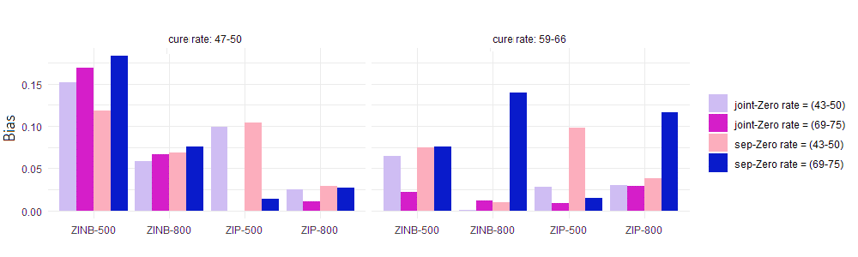
Figure A1: Absolute value of bias for $α_{0}$

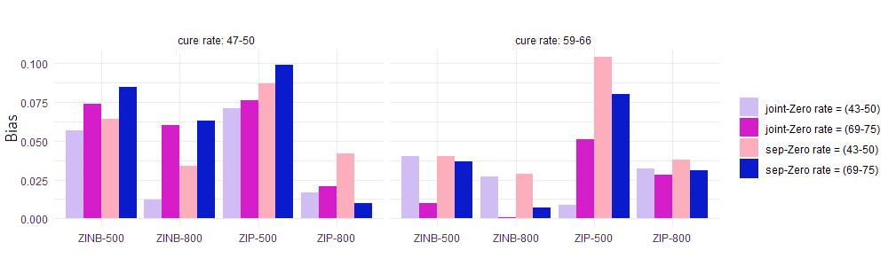
Figure A2: Absolute value of bias for $β_{0}$

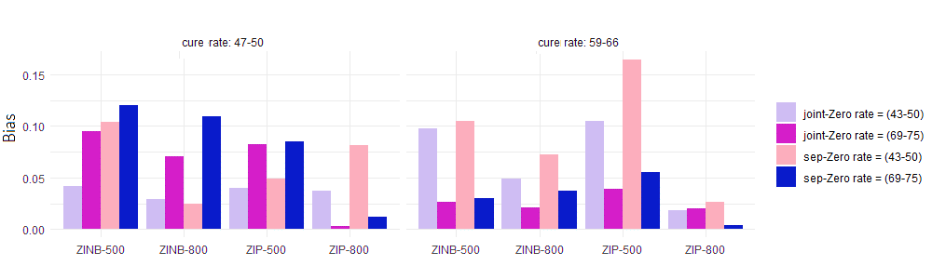
Figure A3: Absolute value of bias for $ρ$
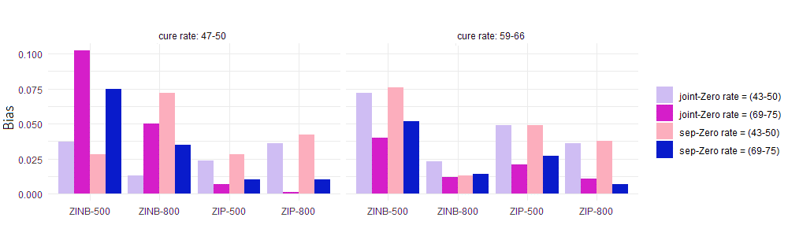
Figure A4: Absolute value of bias for $σ_{b1}^{2}$

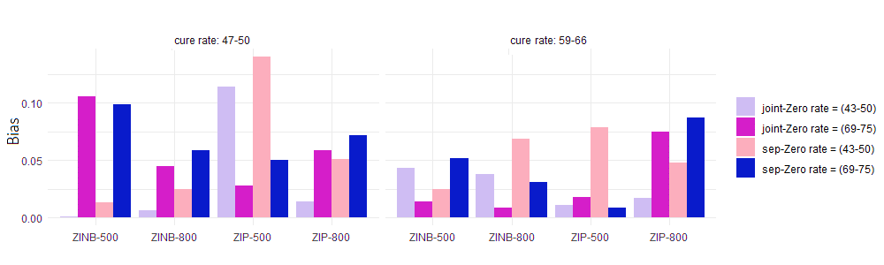

Figure A5: Absolute value of bias for $σ_{b2}^{2}$
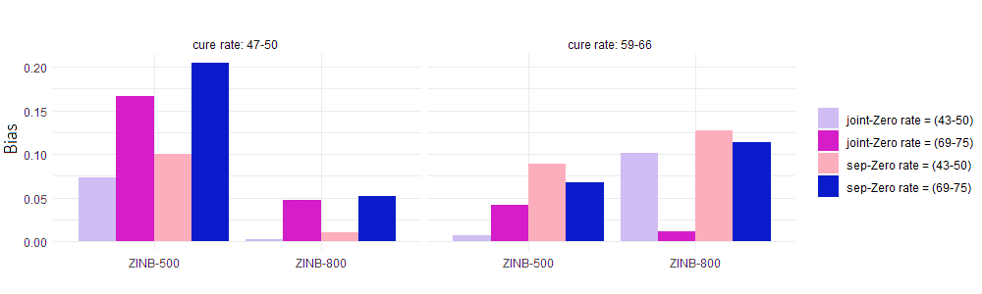
Figure A6: Absolute value of bias for $τ$
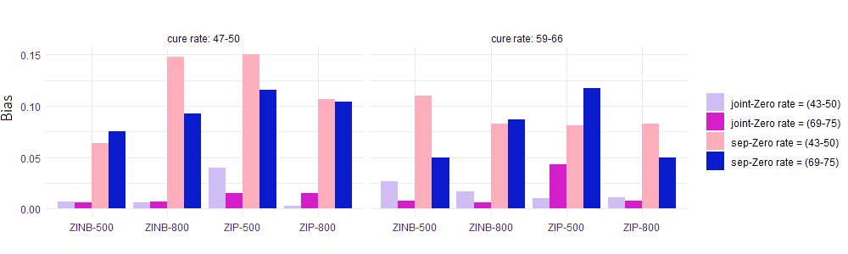
Figure A7: Absolute value of bias for $ϑ$
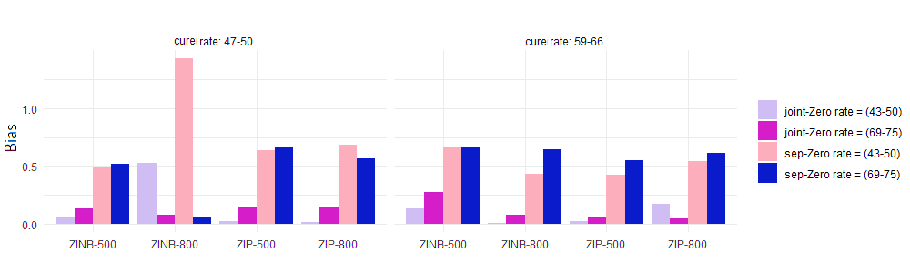
Figure A8: Absolute value of bias for $ζ$
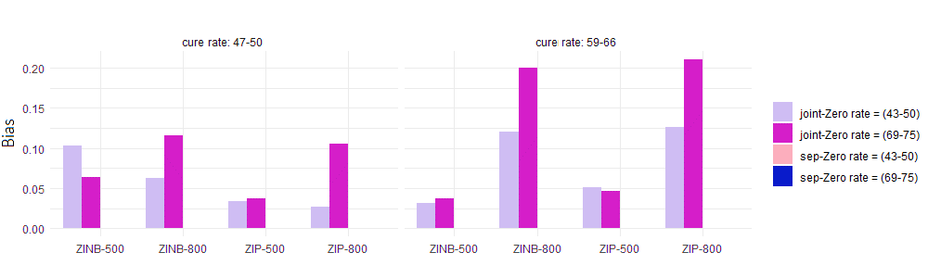
Figure A9: Absolute value of bias for $v_{1}$

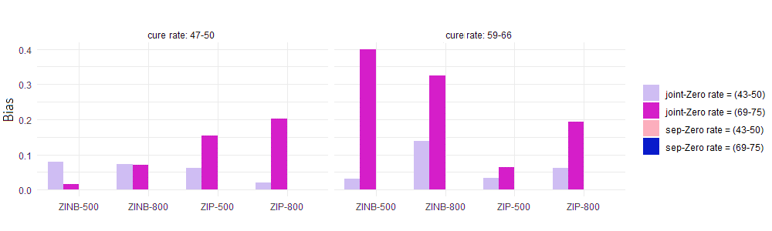
Figure A10: Absolute value of bias for $v_{2}$

