Supplementary information

Hyperpacked piezoelectric-powered capacitive sensor array for high-fidelity vibration detection

Kang Hyuk Cho†, Jeng-Hun Lee†, Seojin Yun, Siyoung Lee, Sein Chung, Woongji Kim, Yunsik Kim, Wonkyu Moon, Yoonyoung Chung and Kilwon Cho*

Table of Contents
Supplementary Note 1. 3
Supplementary Note 2. 5
Supplementary Figure 1. 6
Supplementary Figure 2. 7
Supplementary Figure 3. 8
Supplementary Figure 4. 9
Supplementary Figure 5. 10
Supplementary Figure 6. 11
Supplementary Figure 7. 12
Supplementary Figure 8. 13
Supplementary Figure 9. 14
Supplementary Figure 10. 15
Supplementary Figure 11. 16
Supplementary Figure 12. 17
Supplementary Figure 13. 18
Supplementary Figure 14. 19
Supplementary Figure 15. 20
Supplementary Figure 16. 21
Supplementary Figure 17. 22
Supplementary Figure 18. 23
Supplementary Figure 19. 24
Supplementary Figure 20. 25
Supplementary Figure 21. 26
Supplementary Figure 22. 27
Supplementary Figure 23. 28
Supplementary Figure 24. 29
Supplementary Figure 25. 30
Supplementary Figure 26. 31
Supplementary Figure 27. 32
Supplementary Figure 28. 33
Supplementary Figure 29. 34
Supplementary Figure 30. 35
Supplementary Figure 31. 36
Supplementary Figure 32. 37
Supplementary Figure 33. 38
Supplementary Figure 34. 39
Supplementary Figure 35. 40
Supplementary Figure 36. 41
Supplementary Table 1. 42
Supplementary Table 2. 43
Supplementary Table 3. 44
Supplementary References. 45
Supplementary Note 1 | Relationship between output voltage, capacitance, and charge.

The output voltage V of the sensor is governed by the fundamental relation: V=Q/C. To evaluate how variations in both charge Q and capacitance C contribute to the output voltage, we apply total differentiation:
 | $$dV=\left(\frac{∂V}{∂Q}\right)dQ+\left(\frac{∂V}{∂C}\right)dC$$ | (Suppl. Eq. 1)

The partial derivatives are given by:
 | $$\frac{∂V}{∂Q}=\frac{∂}{∂Q}\left(\frac{Q}{C}\right)=\frac{1}{C}$$ | (Suppl. Eq. 2)
 | $$\frac{∂V}{∂C}=\frac{∂}{∂C}\left(\frac{Q}{C}\right)=-\frac{Q}{C^{2}}$$ | (Suppl. Eq. 3)

Substituting into Supplementary Equation 1 gives:
 | $$dV=\frac{1}{C}dQ-\frac{Q}{C^{2}}dC$$ | (Suppl. Eq. 4)

During the sensor operation, the diaphragm exhibits dynamic behavior, inducing time-dependent variations in both charge and capacitance—denoted as ΔQ(t) and ΔC(t), respectively. The total charge Q(t) and capacitance C(t) can be expressed as:
$$Q\left(t\right)=Q_{0}+∆Q\left(t\right), C\left(t\right)=C_{0}+∆C(t)$$
where Q₀​ is the initial charge provided by the piezoelectric diaphragm (arising from remnant polarization), and C₀​ represents the initial capacitance in the absence of external vibration.

Given that both ΔQ(t) and ΔC(t) are small fluctuations around these quiescent values, and that the voltage expression involves nonlinear division, we linearize the relation V=Q/C around Q₀​ and C₀ using first-order Taylor expansion. This yields:
 | $$v_{out}(t)≈\frac{1}{C_{0}}∆Q(t)-\frac{Q_{0}}{C_{0}^{2}}∆C(t)$$ | (Suppl. Eq. 5)

Supplementary Equation 5 shows that the output voltage contains two contributions:
- a dynamic piezoelectric term, ΔQ(t)/C₀
- a capacitive term, (Q₀/C₀²)ΔC(t)

In our device, the primary role of the piezoelectric diaphragm is to supply the stable bias Q₀​ for capacitive sensing. The motion-induced piezoelectric charge ΔQ(t) is much smaller than Q₀​, so its effect on the output is secondary. From theoretical considerations, the capacitive term is therefore expected to dominate the output voltage, with the available charges from the piezoelectric diaphragm serving primarily to bias (i.e., power) the sensor. The relative phase between ΔQ(t) and ΔC(t) can still influence the net signal, with favorable alignment providing modest sensitivity enhancement.

Diaphragm motion produces coupled variations in ΔQ(t) and ΔC(t) because both arise from the same mechanical deformation. For example, if upward deflection leads to ΔC(t) < 0 and ΔQ(t) > 0, the opposite occurs during downward deflection: ΔC(t) > 0 and ΔQ(t) < 0. Likewise, if ΔQ(t) is negative during upward motion, it will reverse sign during downward motion. This consistent coupling ensures that v_{out}(t) remains symmetric over a full oscillation cycle, while allowing constructive or destructive interaction between the two contributions.
Supplementary Note 2 | Assessment of the air-gap capacitance and the diaphragm’s intrinsic capacitance on the total capacitance of the sensor.

The capacitance of a single sensor unit can be modeled as an equivalent circuit in which the support-layer capacitor (C_{sup}) and the air-gap capacitor (C_{air}​) are connected in parallel, with this combination connected in series to the diaphragm capacitor (C_{dia}​).

Accordingly, the total capacitance of the single sensor unit (C_{total}​) is given by (Supplementary Fig. 2a):
 | $$C_{total}=\frac{C_{dia}∙\left(C_{air}+C_{sup_total }\right)}{C_{air}+C_{sup_total}+C_{dia}}$$ | (Suppl. Eq. 6)

Each capacitance is calculated using the standard parallel-plate formula:
 | $$C=ε_{0}ε_{r}\frac{A}{d}$$ | (Suppl. Eq. 7)
where ε₀​ is the vacuum permittivity, ε_{r}​ is the relative permittivity, A is the area, and d is the thickness.

The specific parameters for our device are:
- Thicknesses: d_{air} = 40 µm, d_{sup} = 40 µm, d_{dia} = 14 µm
- Relative permittivities: ε_{air} ≈ 1, ε_{SU−8} ≈ 3.5, ε_{PVDF-TrFE} ≈ 14 (poled)
- Areas: A_{air} = 3.837 mm², A_{sup} = 0.5729 mm², A_{dia} = 4.41 mm²

Based on these parameters, the static total capacitance is calculated to be ≈ 1.2518 pF.

To compare sensitivities, we simulated a 1% increase in the permittivity of either the air gap or the diaphragm, keeping the other term constant:
- A 1% increase in ε_{air}​ (to 1.01) results in C_{total​} ≈ 1.2597 pF (change of 0.0079 pF).
- A 1% increase in ε_{PVDF−TrFE}​ (to 14.14) results in C_{total}​ ≈ 1.2521 pF (change of 0.0003 pF).

Therefore:
ΔC_{total} (from air gap) ≫ ΔC_{total} (from diaphragm).

This analysis demonstrates that the total capacitance is more than an order of magnitude more sensitive to air-gap capacitance changes than to equivalent relative changes in the diaphragm capacitance. This arises from the series connection in the equivalent circuit, which makes C_{total} more responsive to the component with the smaller capacitance—in this case, the air-gap-dominant part.

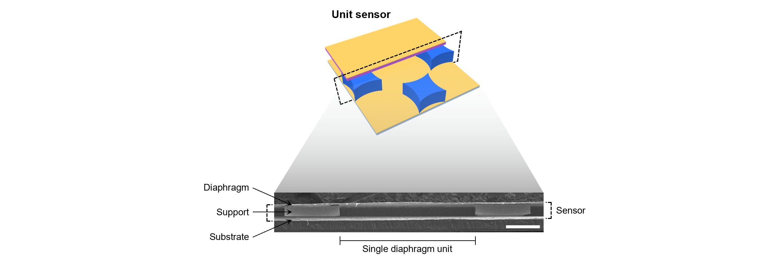
Supplementary Figure 1 | Schematic and cross-sectional SEM image of the unit vibration sensor. Each unit sensor consists of a piezoelectric diaphragm suspended by four star-shaped supports on a substrate. The SEM image highlights the layered structure, including the diaphragm, support, and substrate (scale bar: 400 µm).

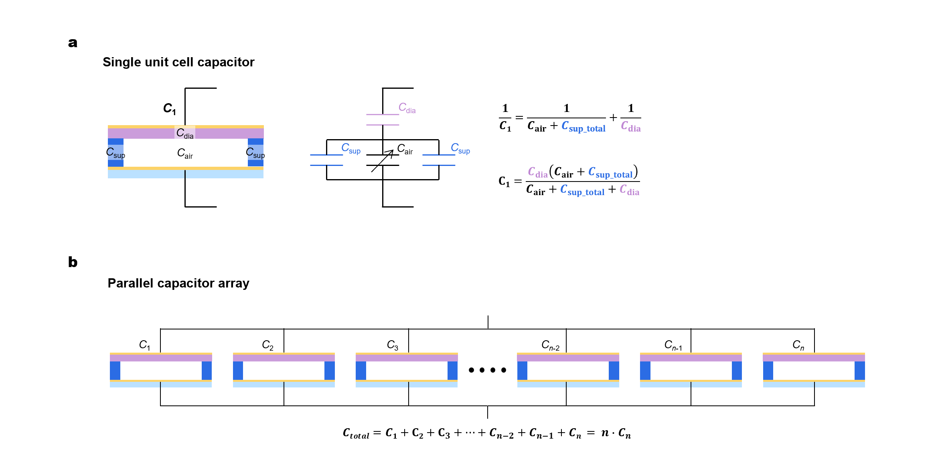
Supplementary Figure 2 | Single sensor unit capacitor and sensor array. a, Structure, equivalent circuit, and capacitance expression for a single sensor unit. b, Multiple capacitive vibration sensor units connected in parallel to form the hyperpacked vibration sensor array. The parallel configuration increases the total capacitance variation in proportion to the number of diaphragms, thereby enhancing overall sensitivity.

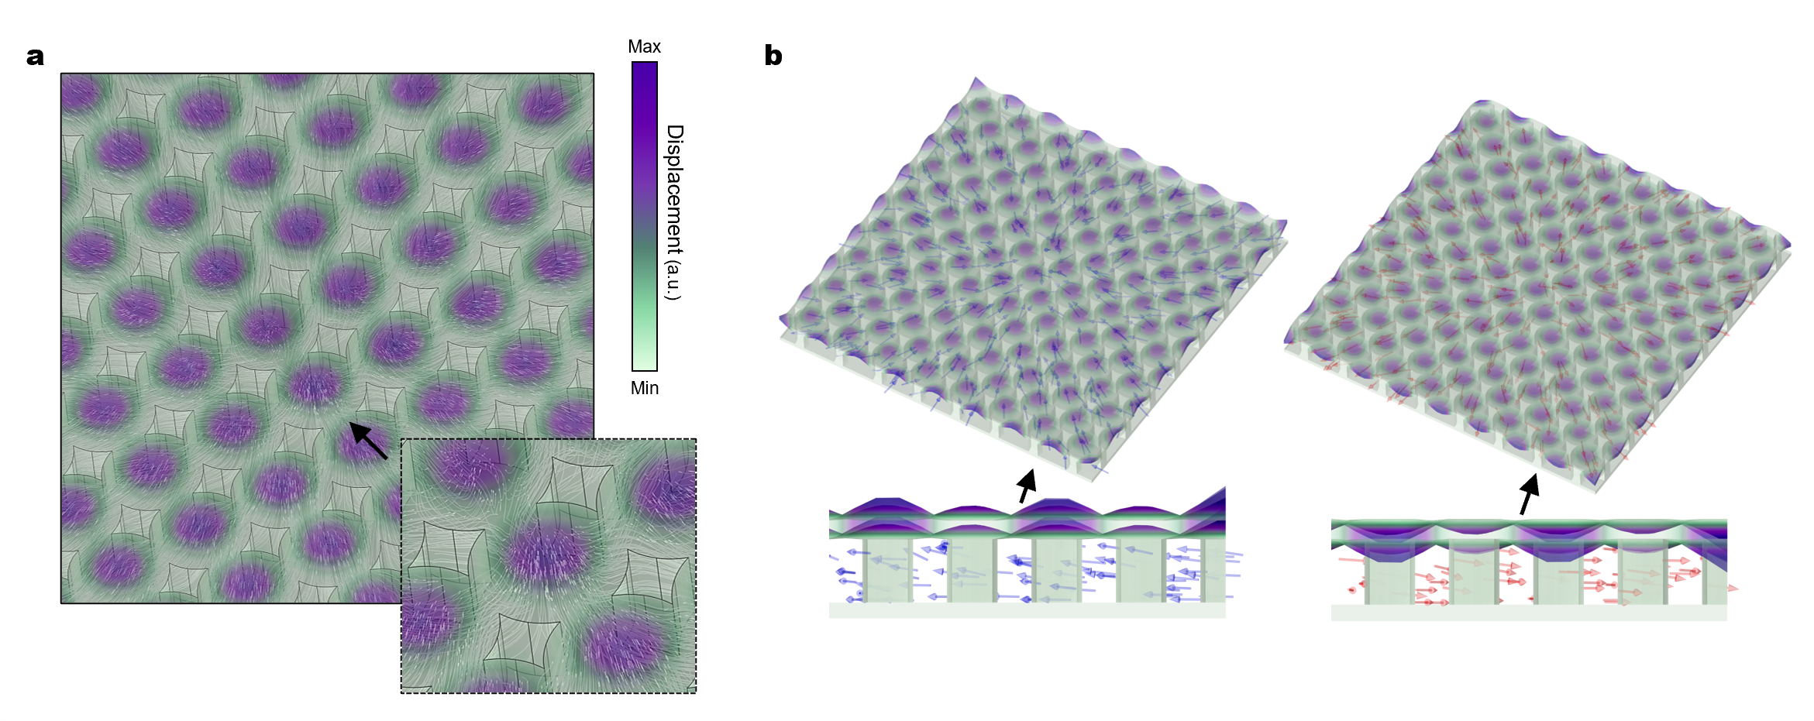
Supplementary Figure 3 | Numerical airflow simulation for the hyperpacked vibration sensor array. a, Simulated air streamlines (white) within the array during diaphragm oscillation. Inset: enlarged view of the central-most part of the array. b, Simulated airflow direction when the diaphragms are deflected upward (left) and downward (right). Arrows indicate the net airflow direction. For a clearer illustration of these airflow dynamics during oscillation, see Supplementary Video 1.

Our hyperpacked array architecture enables sufficient airflow through the side-vent holes of each unit cell. The simulated streamlines show smooth laminar flow without turbulence, even at the central-most part of the array (Supplementary Fig. 3a). The side-vent holes are wide enough to guide air along the star-shaped supports, ensuring proper circulation during diaphragm motion. We also examined the net airflow direction during diaphragm oscillation (Supplementary Fig. 3b and Supplementary Video 1). When the diaphragms deflected upward, air was drawn from the outermost side-vent holes toward the center of the array. When the diaphragms deflected downward, air from the central region was expelled toward the outermost side-vent holes. The simulations further revealed clear z-axis airflow: during upward motion, the net z-axis flow was positive, with air moving from the side channels upward toward the diaphragm; during downward motion, the net z-axis flow was negative, with air being pushed out from beneath the diaphragm through the side-vent holes. Together, these results confirm that the array’s ventilation paths provide effective and evenly distributed airflow across all unit cells.
Supplementary Figure 4 | Schematic illustration of the overall fabrication process. During the process, photolithography is performed only once to create the star-shaped support layer.

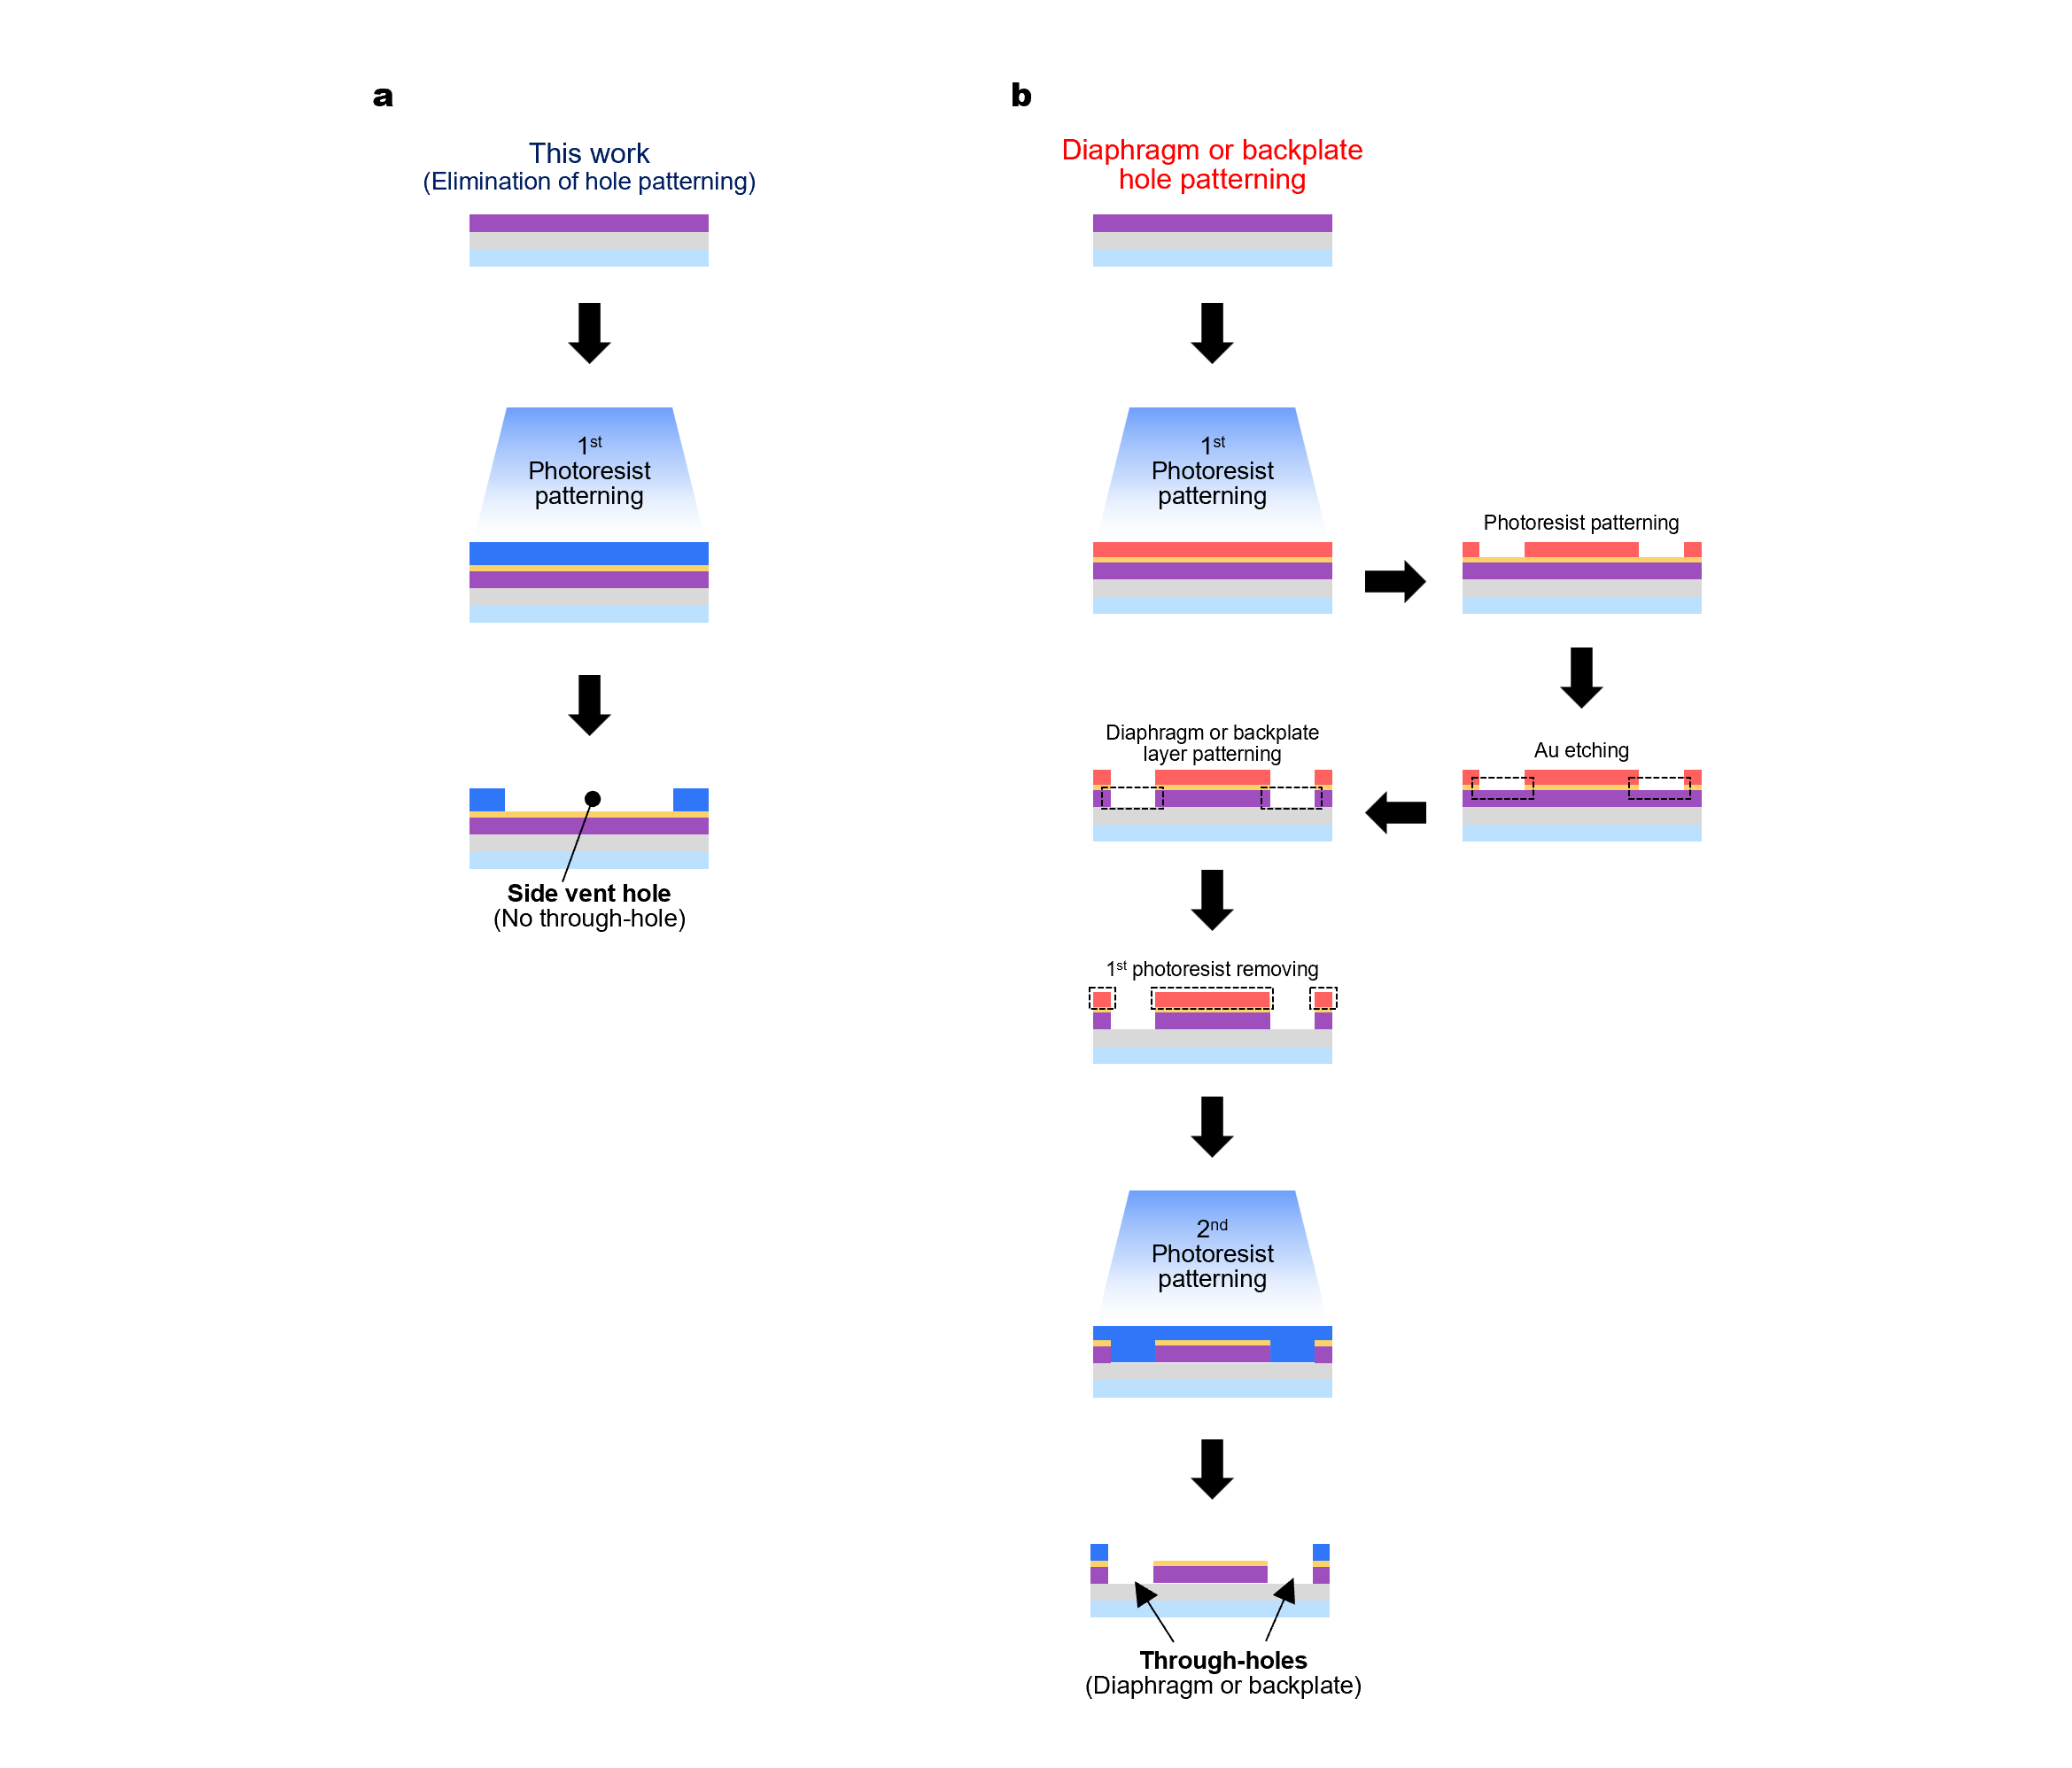
Supplementary Figure 5 | Comparison of the fabrication process for our design and conventional designs. Conventional designs incorporate through-holes in either the diaphragm or the backplate to enable air ventilation.
Supplementary Figure 6 | Schematic illustration comparing the moving and stationary components of conventional sensors versus our design. Our sensor maximizes the area of the moving component while minimizing that of the fixed component, thereby preventing overall sensing area loss and preserving the effective capacitive area.

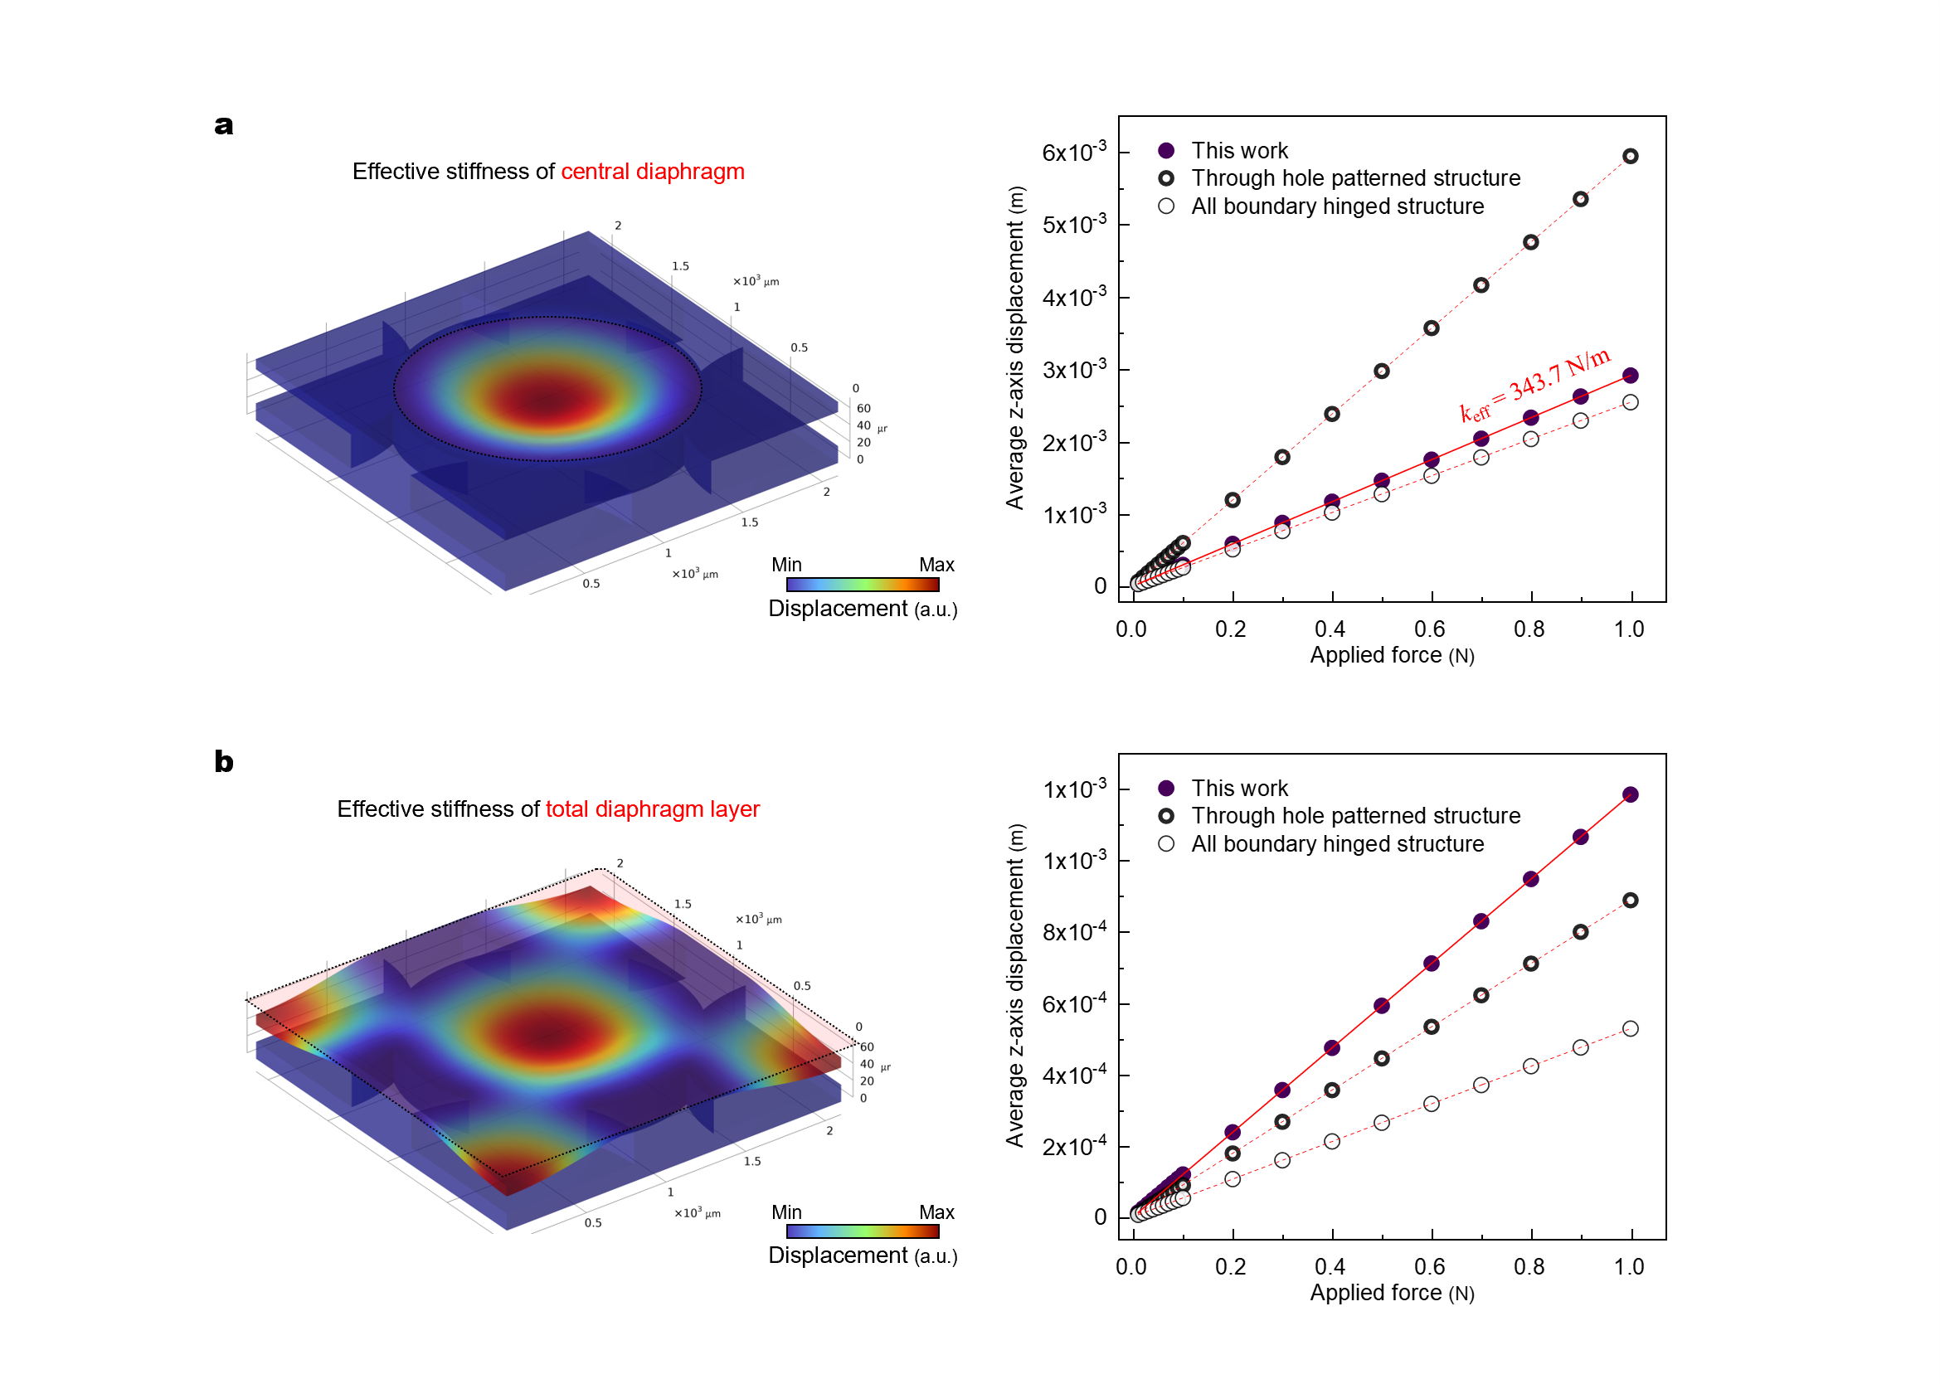
Supplementary Figure 7 | FEM simulation of effective stiffness for three diaphragm configurations. a, Simulated average z-axis displacement versus applied force for the central diaphragm region of our design, a through-hole patterned design, and a fully edge-hinged diaphragm design. b, Simulated average z-axis displacement versus applied force for the full diaphragm area within the sensor unit cell for the same three configurations.

In our design, the central diaphragm region exhibits higher effective stiffness than in a design with a through-hole patterned diaphragm (Supplementary Fig. 7a). However, the star-shaped support anchors only half of the diaphragm perimeter, reducing the effective stiffness relative to designs in which the entire diaphragm edge is fixed. This configuration partially offsets the stiffness increase caused by the absence of holes. More importantly, when considering the average displacement of the entire diaphragm layer within the unit cell, our design achieves greater vertical (z-axis) displacement across the full diaphragm area than both the through-hole patterned and fully edge-hinged diaphragm designs under the same simulated force (Supplementary Fig. 7b).
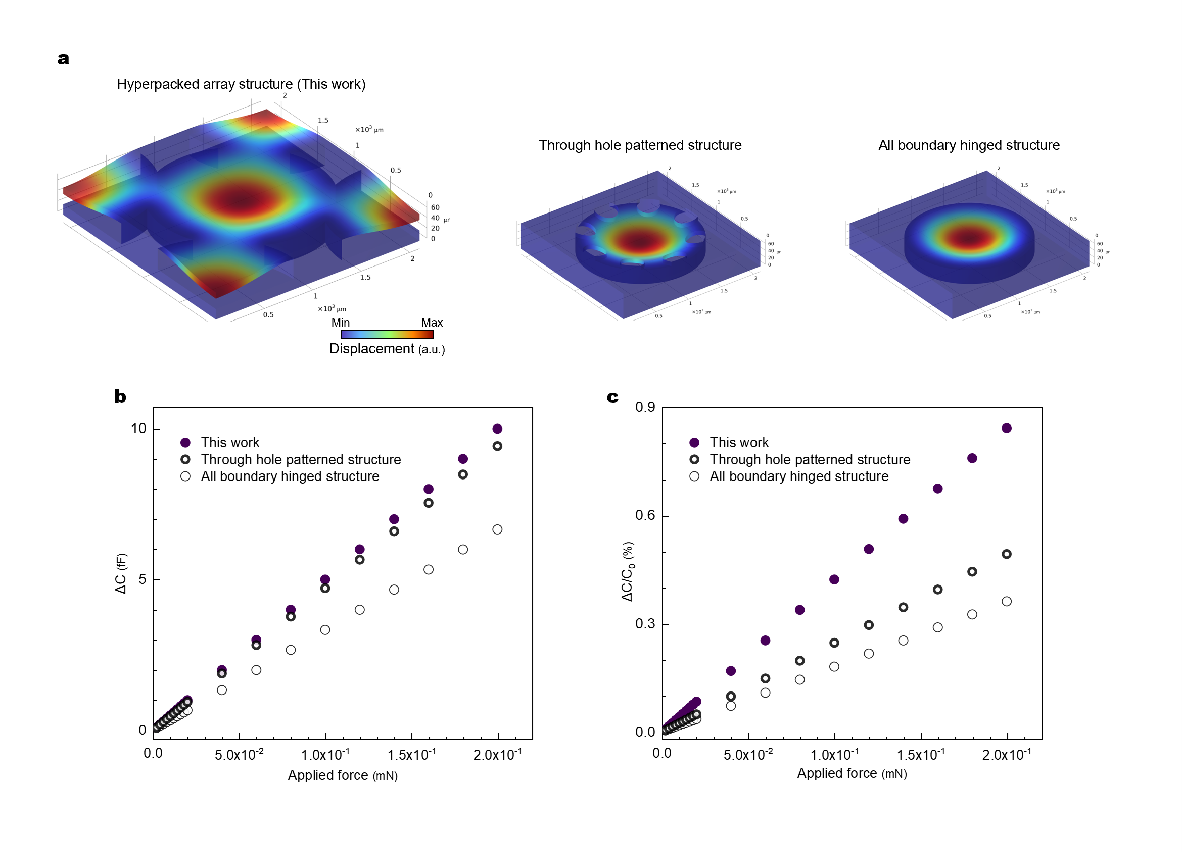
Supplementary Figure 8 | Simulation results of absolute and relative capacitance changes for the sensor unit cell with three diaphragm configurations. a, Simulated vertical displacement of the diaphragm layer within the unit cell for our design, a through-hole patterned structure, and a fully edge-hinged diaphragm design. b,c, Simulated absolute and relative capacitance variations as a function of applied force for the same three configurations.

The absolute capacitance change in our design is slightly larger than that of the through-hole patterned structure (Supplementary Fig. 8b). Although the circular diaphragm region in our structure exhibits higher local stiffness, the star-shaped support configuration—and resulting hyperpacked layout—allows a greater fraction of the diaphragm layer to deform, producing larger overall vertical displacement within the sensor unit cell (Supplementary Fig. 8a). More importantly, the relative capacitance change is greater in our design than in both the through-hole patterned and fully edge-hinged structures (Supplementary Fig. 8c). This improvement arises from the combination of modestly larger absolute capacitance change and, more critically, lower initial capacitance. The latter stems from the support layer in our design containing a higher proportion of air (ε_{air} ≈ 1) compared with SU-8 (ε_{SU−8} ≈ 3.5). The enhanced relative capacitance change directly translates into improved sensitivity.

Supplementary Figure 9 | Superior flexibility of our sensor. a, Schematic illustration showing the design rationale behind the enhanced flexibility. b, Photograph demonstrating the excellent mechanical flexibility of the sensor (scale bar: 1 cm).

Supplementary Figure 10 | Interface circuit for sensor operation. The signal readout circuit comprises a JFET-based preamplifier (LMV1012, Texas Instruments) and a low-noise operational amplifier (TLV9361, Texas Instruments), configured to convert small capacitance variations from the sensor into readable voltage signals. The circuit operates at 3.7 V, supplied by a small pouch cell.

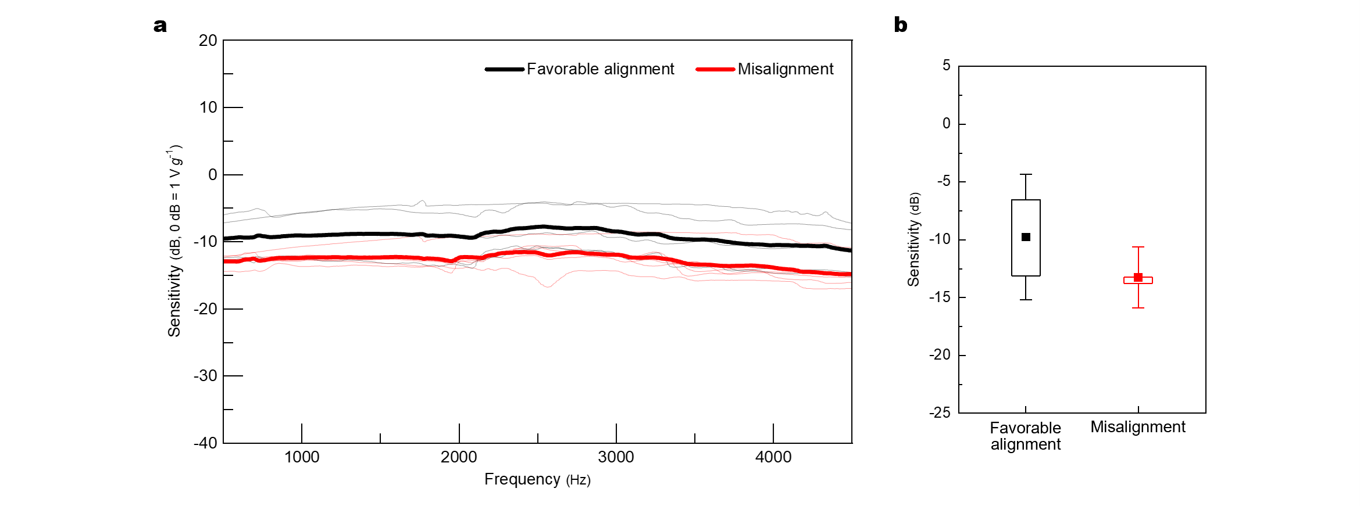
Supplementary Figure 11 | Sensitivity dependence on the relative phase between ΔQ(t) and ΔC(t).
a, Frequency responses for favorable alignment and misalignment of the phase relationship (bold lines indicate the mean). b, Sensitivity comparison for the two phase conditions (n = 10 sensors; 5 per group). For a fair comparison, all sensors had an identical layout consisting of a single diaphragm (D = 3 mm).

The sensor showed slightly higher sensitivity when the relative phase between ΔQ(t) and ΔC(t) was favorably aligned, with a mean improvement of approximately 3 dB. The phase relationship was adjusted by controlling the poling direction of the PVDF-TrFE diaphragm, which in turn altered the phase of ΔQ(t) relative to ΔC(t). This modest change in sensitivity is consistent with our interpretation in Supplementary Note 1, where the capacitive term is expected to dominate and the dynamic piezoelectric term acts as a secondary enhancement when constructively aligned.
Supplementary Figure 12 | Comparison of PVDF-TrFE solubility in DMF and PA. PA, the solvent used in this study, effectively dissolves PVDF-TrFE, demonstrating comparable solubility to that of the commonly used polar solvent DMF.
Supplementary Figure 13 | 1D XRD spectra of unpoled and poled PVDF-TrFE films. The peak intensity changes of the (110)/(200) β-phase diffraction near 20° and the (021) diffraction near 40.8° are not pronounced, limiting the precision in evaluating the α-to-β phase transition and the alignment of β-phase crystals following poling.
Supplementary Figure 14 | Crystallization process, lattice structure, and TrWAXS measurement setup for PVDF-TrFE films. a, Schematic of PVDF-TrFE film morphology evolution during spin-coating, thermal annealing, and corona poling. b, Schematic of representative crystalline planes in PVDF. c, Schematic of vertical and horizontal TrWAXS measurement setups.

Following spin-coating and thermal annealing, the PVDF-TrFE film exhibits a mixture of α- and β-phase crystalline domains. Upon corona poling, the residual α-phase crystals undergo an α-to-β phase transition, and the β-phase chains align along the direction of the applied electric field. In the PVDF crystalline lattice (with TrFE units omitted for clarity), both the (200) and (110) planes contribute to the scattering profile due to their similar periodicities^{1,2}. In TrWAXS analysis, the vertical geometry primarily probes in-plane structural ordering, whereas the horizontal geometry captures both in-plane and out-of-plane orientation, offering comprehensive insights into molecular alignment.
Supplementary Figure 15 | Structural analysis of PVDF-TrFE films from vertical TrWAXS measurements. a, 2D TrWAXS patterns of poled (left) and unpoled (right) PVDF-TrFE films. b, Azimuthal intensity profiles of the β-phase (left) and α-phase (right) scattering peaks. c, 1D scattering intensity profiles (vertical geometry) for poled and unpoled PVDF-TrFE films.

All TrWAXS images were contrast-enhanced on a logarithmic scale for azimuthal analysis; the original images are provided in the main figure. In the vertical measurement geometry, distinct chain alignment was not observed. However, a clear phase transition from α-phase to β-phase is evident after poling, as seen by the reduced α-phase intensity and enhanced β-phase signal³. These results confirm that the corona poling process effectively promotes phase transformation in PVDF-TrFE films.

Supplementary Figure 16 | Structural analysis of PVDF-TrFE films from horizontal TrWAXS measurements. a, 2D TrWAXS patterns of poled (left) and unpoled (right) PVDF-TrFE films. b, Azimuthal intensity profiles of the β-phase scattering peak. c, 1D scattering intensity profiles (horizontal geometry) for poled and unpoled PVDF-TrFE films.

All horizontal TrWAXS images were also contrast-enhanced on a logarithmic scale for azimuthal analysis; the original data are presented in the main figure. In the horizontal measurement geometry, pronounced out-of-plane chain alignment is observed after poling^{4,5}. This arises from the measurement technique, in which the X-ray beam is incident parallel to the film surface and traverses the entire film thickness, enabling detection of molecular orientation along the out-of-plane direction (beam size: 250 μm × 300 μm).

In addition to orientation effects, a clear α-to-β phase transition is also confirmed, as evidenced by the reduced α-phase peak and the enhanced β-phase scattering intensity from 1D scattering profile. These results demonstrate that the corona poling process induces both phase transformation and preferential chain alignment perpendicular to the film surface.

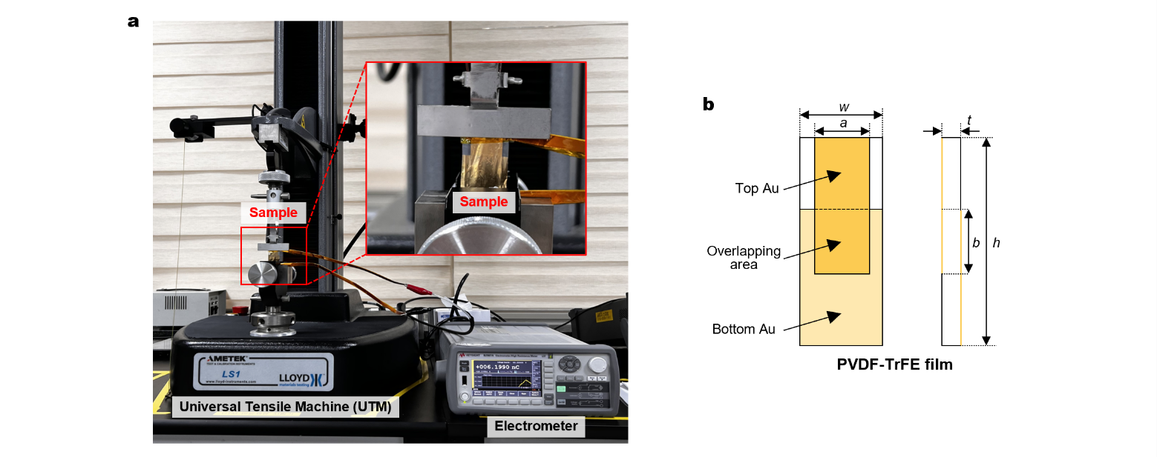
Supplementary Figure 17 | Characterization of the piezoelectric coefficient (d₃₁). a, Photograph of the d₃₁ measurement setup. b, Schematic of the sample used for measurement: front view (left) and side view (right).

The d₃₁ was calculated as:
 | $d_{31}=\frac{{Q_{piezo}}/{(ab)}}{F/{(wt)}}$ | (Suppl. Eq. 8)
where Q_{piezo} is the obtained electrometer reading, F is the applied force, and a, b, w, and t are the dimensional parameters of the PVDF-TrFE sample (Supplementary Fig. 13b)⁶.

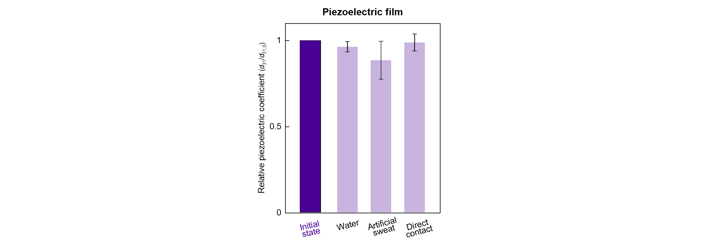
Supplementary Figure 18 | Relative d₃₁ of the piezoelectric PVDF-TrFE film after exposure to different contact conditions. Stability was assessed after direct contact with deionized water, artificial sweat, and human skin, with measurements taken two hours after contact removal.
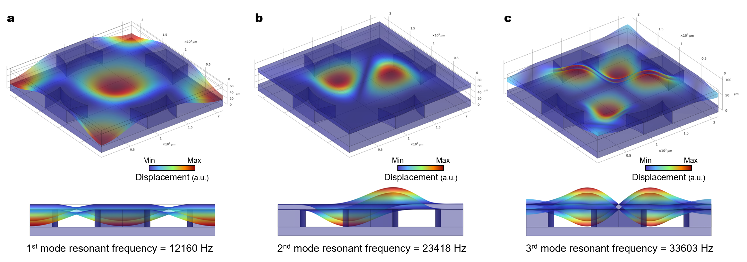
Supplementary Figure 19 | Resonant frequencies of our sensor. a, First-; b, second-; and c, third-mode resonant frequencies of the sensor. Below the first-mode resonant frequency, each diaphragm oscillates in phase across its surface.
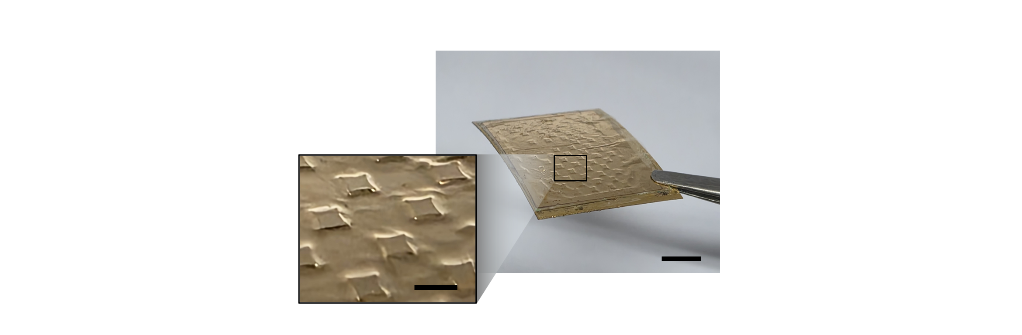
Supplementary Figure 20 | Sensor damaged during fabrication due to reduced support layer thickness. Shown is a sensor with a 20 μm-thick support layer (scale bar: 5 mm; inset: 1 mm).

When laminating the electrode/diaphragm/support top stack to the electrode/substrate bottom stack, an ultrathin adhesive layer was applied to the bottom stack. The two stacks were then aligned and laminated together on a hot plate at 60 °C to promote curing of the adhesive layer, which could result in slight thermal softening and minor non-planarity. More critically, while heated, mechanical pressing was applied to ensure strong bonding. Under these conditions, a diaphragm with an insufficiently thick support layer could contact the adhesive before it fully cured; in some cases, electrostatic attraction caused it to remain adhered. When this occurred, the diaphragm did not return to its original position, resulting in extremely low production yield.
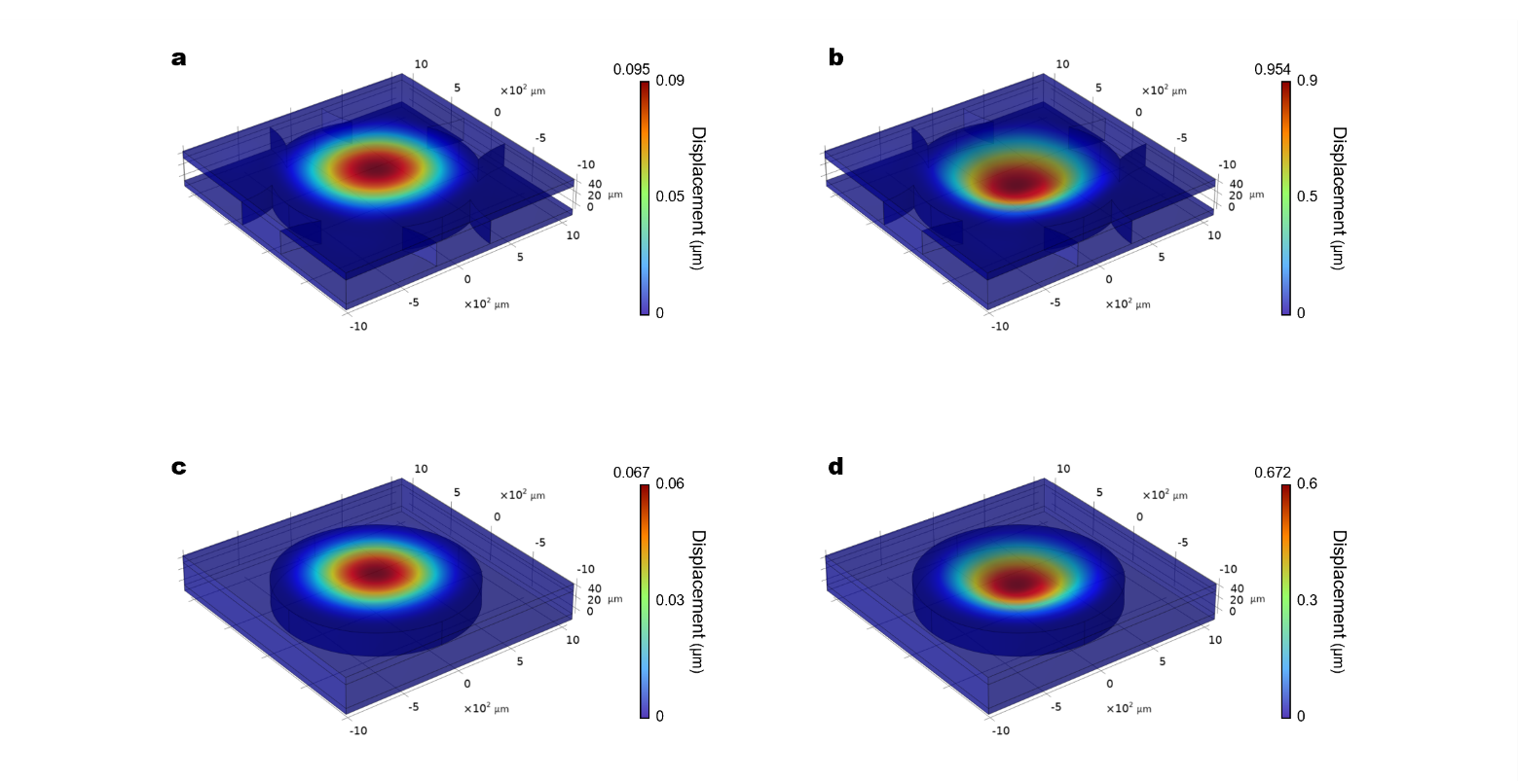
Supplementary Figure 21 | FEM simulation of diaphragm displacement under different vibration amplitudes and boundary constraints. a-b, Simulated vertical displacement of the diaphragm with fixed boundaries defined by four star-shaped supports under applied accelerations of 0.1 g (a) and 1 g (b). c-d, Diaphragm displacement with fully fixed circumferential boundaries under the same acceleration conditions of 0.1 g (c) and 1 g (d).

In both cases, diaphragm displacement increases linearly with acceleration, consistent with vibration amplitude. The star-shaped support configuration yields larger displacement under identical loading, highlighting its effectiveness in enhancing diaphragm mobility and, consequently, device sensitivity.
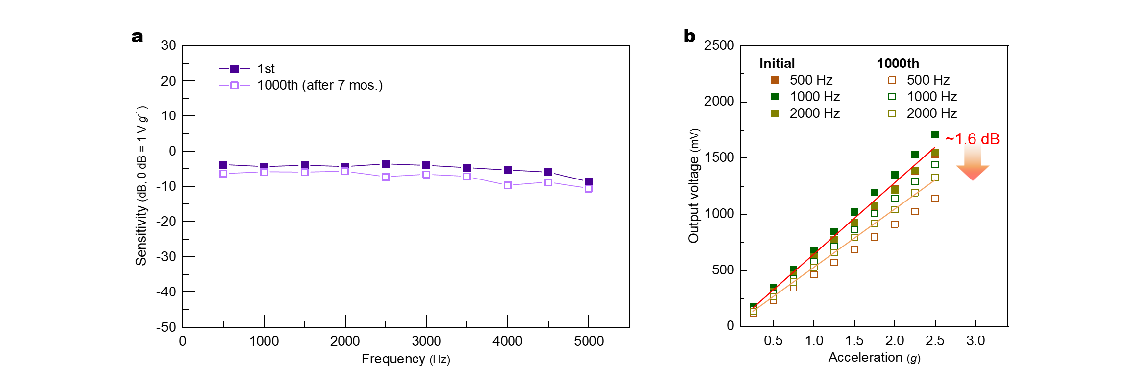
Supplementary Figure 22 | Long-term stability and durability of our sensor. a, Frequency response of the sensor measured initially and after 1,000 cycles over a 7-month period. b, Vₒᵤₜ as a function of acceleration, measured at 500, 1,000, and 2,000 Hz for both the initial and 1,000th cycles. A sensitivity degradation of approximately 1.6 dB is observed after long-term use.

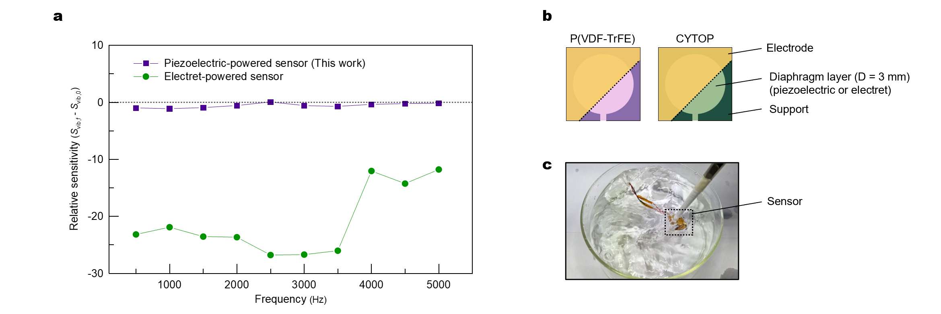
Supplementary Figure 23 | Environmental stability of the sensor. a, Relative sensitivity as a function of frequency for sensors comprising piezoelectric PVDF-TrFE and electret CYTOP diaphragms, measured after water immersion and drying for 30 min. b, Schematic of the sensor layout used for testing. For a fair comparison, all sensors shared an identical layout consisting of a single diaphragm (D = 3 mm) with a side air-vent channel. c, Photograph of sensors submerged in water and dynamically stirred to simulate real-life wet conditions, such as exposure to heavy rain.

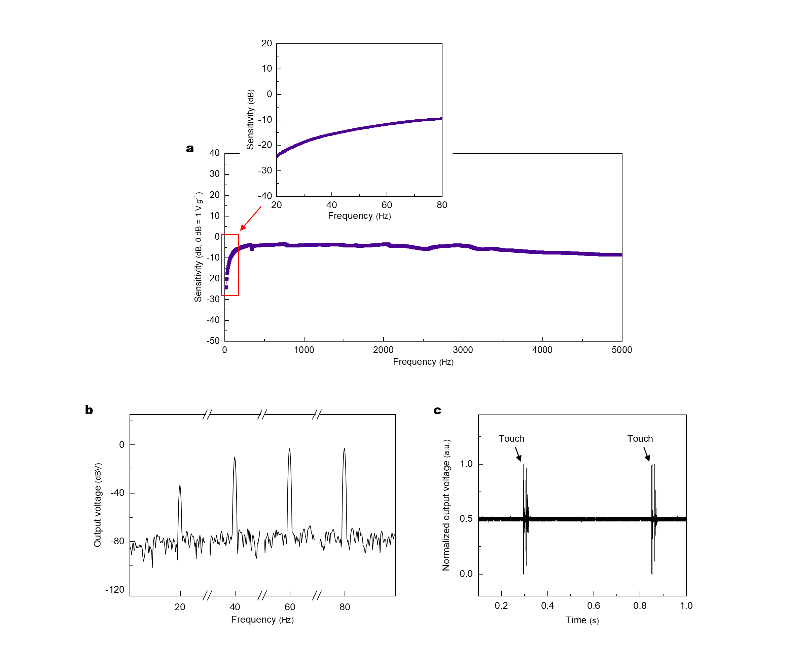
Supplementary Figure 24 | Static and low-frequency response of the sensor. a, Frequency response from 20 to 5000 Hz, with the inset showing the expanded view from 20 to 80 Hz. b, Fast Fourier transform (FFT) outputs of the sensor at 20, 40, 60, and 80 Hz under a 1 g input vibration, showing clearly distinguishable signal peaks. c, Normalized output voltage of the sensor under ~ 2 Hz static stimuli (generated by touching the sensor at approximately 0.5 s intervals).

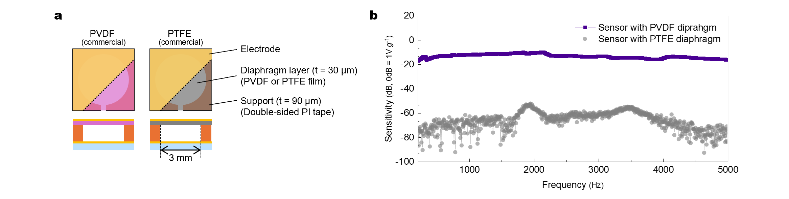
Supplementary Figure 25 | Assessment of triboelectric contributions to vibration sensitivity. a, Schematic of the sensor layout used for testing. b, Frequency response of sensors incorporating PVDF and PTFE diaphragms.

For a controlled comparison, all aspects of the sensor layout were identical except for the diaphragm material. To eliminate potential effects of diaphragm non-planarity during fabrication, commercially sourced films with excellent flatness were used; both PVDF and PTFE films had an identical thickness of 30 µm. PTFE was selected as it is among the most tribonegative materials. The PVDF-diaphragm sensor exhibited a flat frequency response with strong output signals, whereas the PTFE-diaphragm sensor produced unstable outputs near the noise level, confirming that triboelectric effects are not the dominant sensing mechanism.
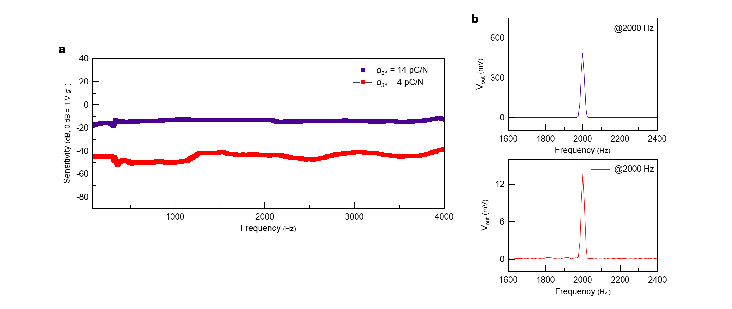
Supplementary Figure 26 | Effect of d₃₁ on vibration sensitivity. a, Frequency response of sensors comprising PVDF-TrFE diaphragms with d₃₁ values of 4 and 14 pC N⁻¹. b, FFT output of the same sensors at 2,000 Hz under a 2 g input vibration, showing clearly distinguishable signal peaks. For a fair comparison, all sensors used an identical layout consisting of a single diaphragm (D = 3 mm) with a side air-vent channel.
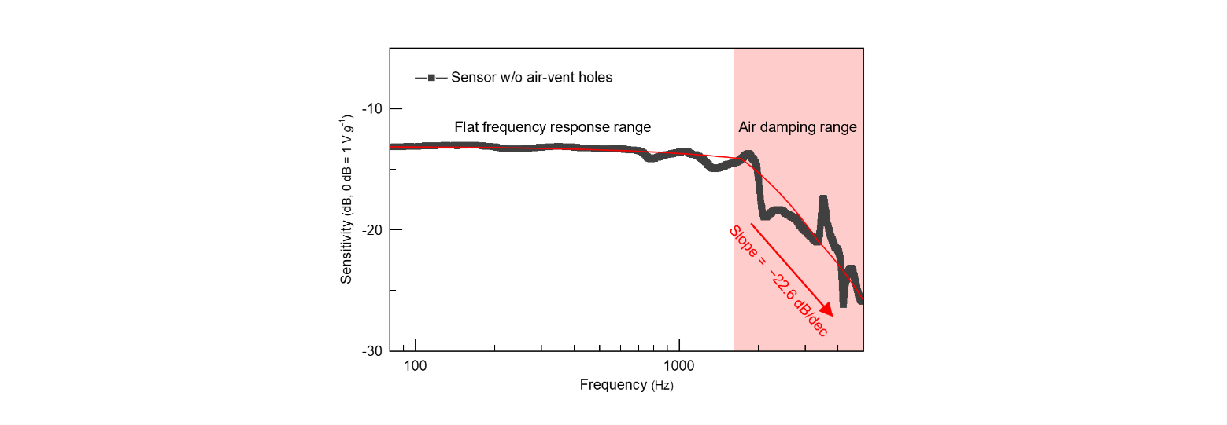
Supplementary Figure 27 | Frequency response of the vibration sensor without air-vent holes.
The sensor exhibits a flat frequency response up to approximately 2 kHz, beyond which a pronounced decrease in sensitivity is observed due to air damping effects. In the high-frequency region, the sensitivity rolls off with a slope of approximately –22.6 dB/decade, indicating significant acoustic damping within the sealed cavity.

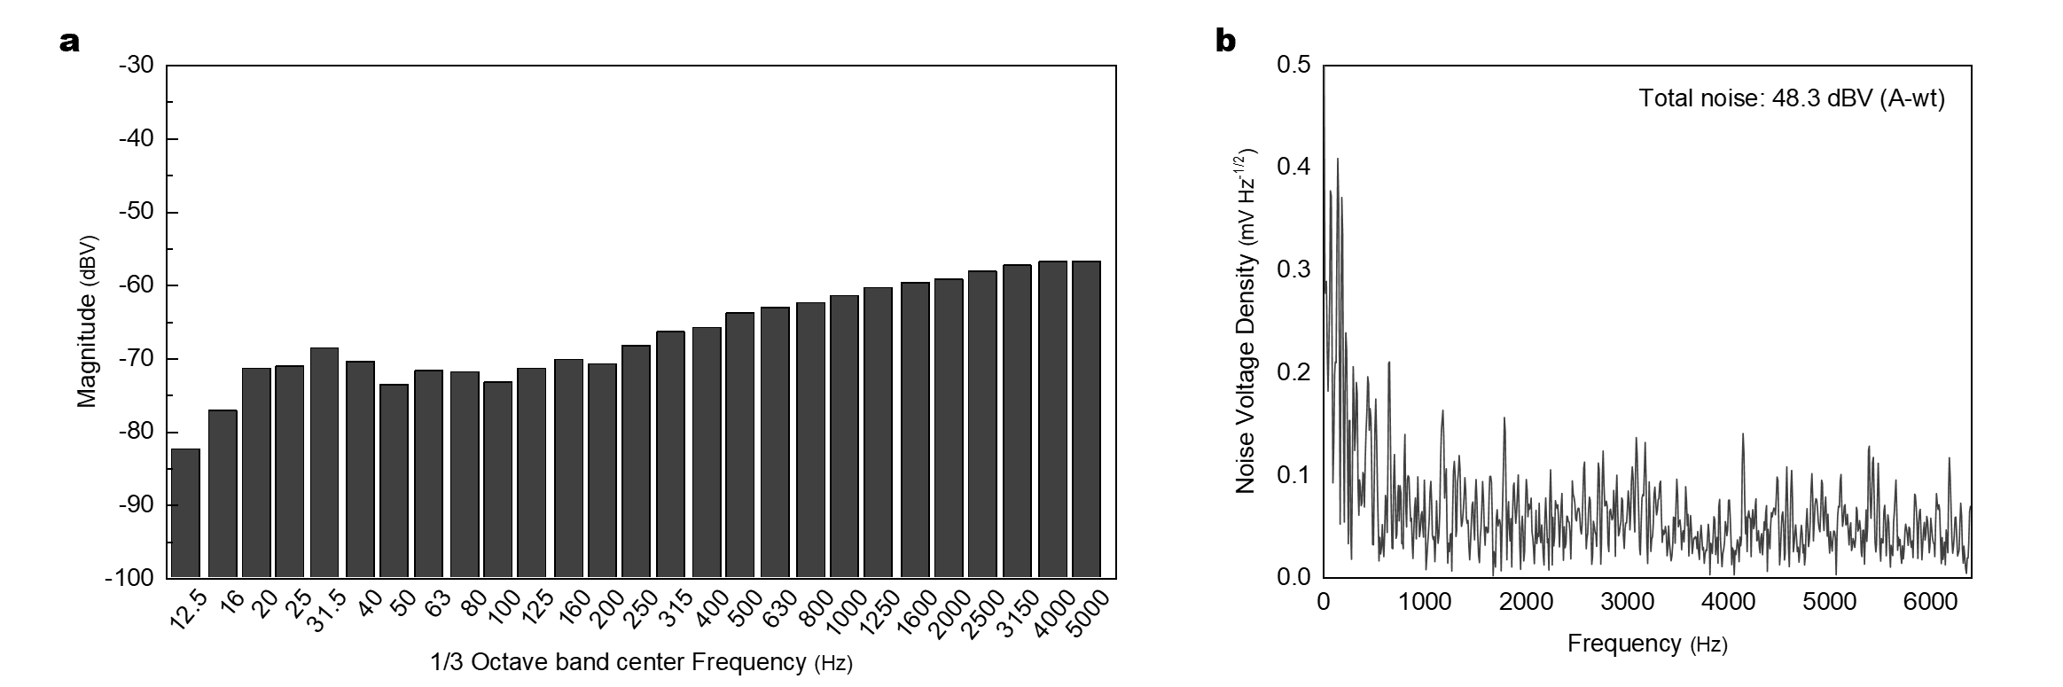
Supplementary Figure 28 | Noise characterization of the sensor under idle (no-excitation) conditions. a, Noise magnitude measured across 1/3 octave band center frequencies. b, Power spectral density (PSD) of the sensor noise. All measurements were conducted in the absence of mechanical excitation, with the sensor powered and connected to the interface circuit. The total A-weighted integrated noise level was measured to be 48.3 dB(A).


Supplementary Figure 29 | Experimental setup for high-fidelity audio recording via vibration sensing. Photographs of the sensor (left) and a commercial accelerometer (right) mounted on a vibration speaker for performance comparison. The sensor was packaged with a flexible EMI shielding case and attached directly to the speaker surface for vibration-coupled audio signal acquisition.

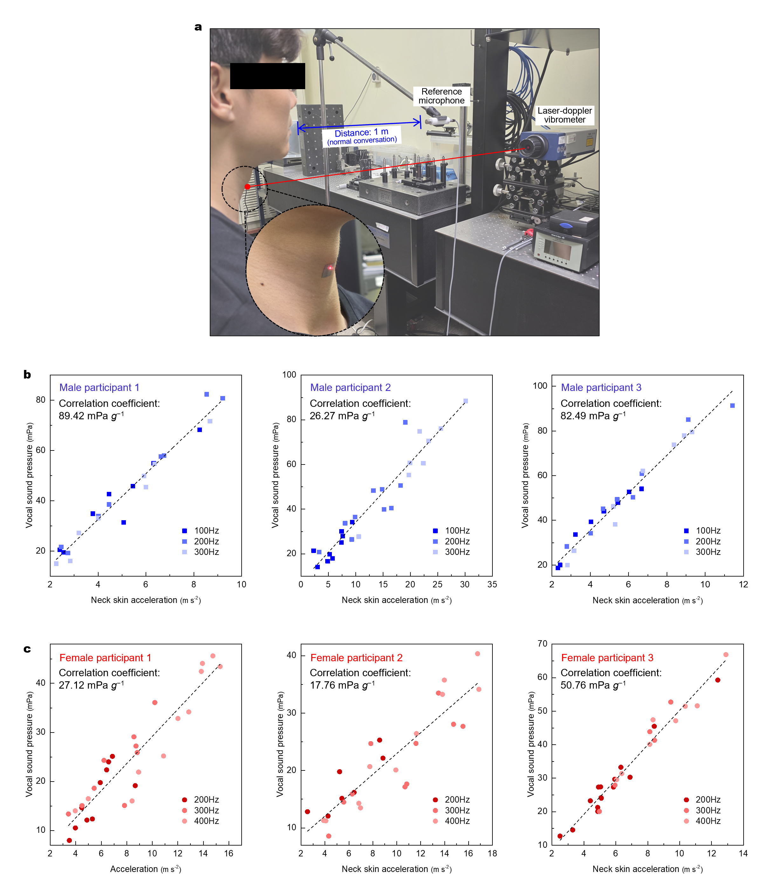
Supplementary Figure 30 | Correlation between neck-skin vibration and vocal sound pressure. a, Photograph of the experimental setup. b,c, Vocal sound pressure versus neck-skin acceleration for male (b) and female (c) participants, measured at three vocal fundamental frequencies. Dotted lines indicate the trend for all data in each graph. The lower bound of the measured correlation corresponds to male participant 1, which yielded the lowest inferred acoustic sensitivity when converting the sensor’s vibration sensitivity to an inferred acoustic sensitivity.
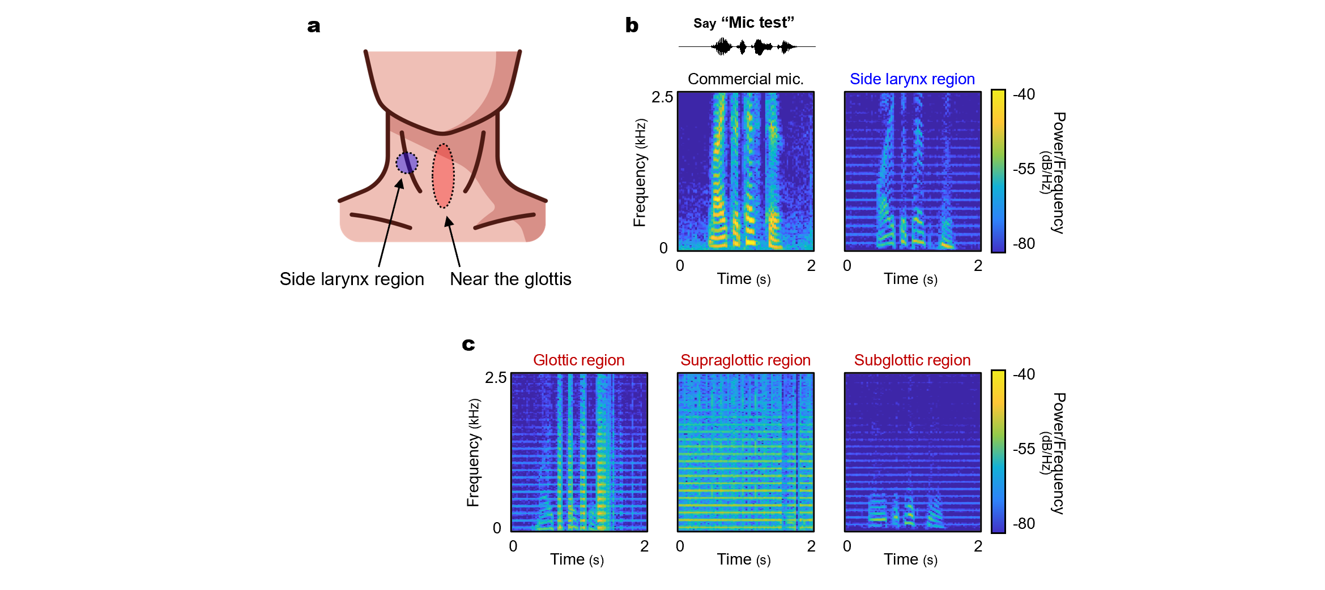
Supplementary Figure 31 | Comparison of recorded speech signals and sensor placement locations on the neck. a, Schematic of sensor placement locations: side larynx region and near the glottis. b, Short-time Fourier transform (STFT) spectrograms of the spoken phrase “mic test,” recorded using a commercial microphone (left) and the sensor placed on the side larynx region (right). c, STFT spectrograms of speech signals recorded from the sensor attached to three distinct regions near the glottis: glottic, supraglottic, and subglottic.
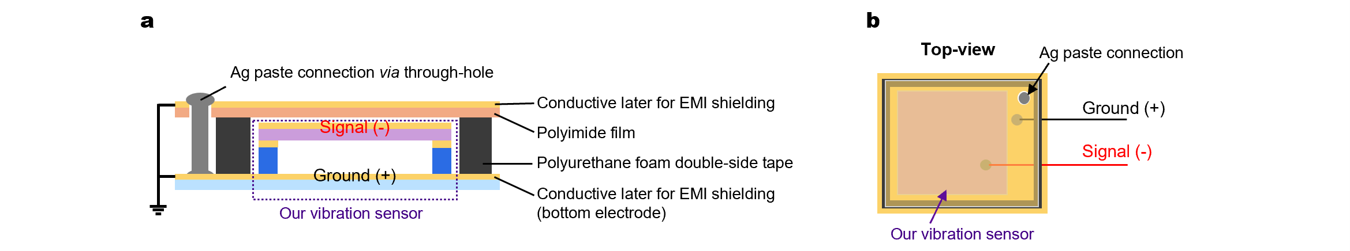Supplementary Figure 32 | Schematic of the flexible EMI shielding case for the sensor. a, Cross-sectional view of the EMI shielding configuration. The sensor is encapsulated between conductive layers connected via silver (Ag) paste through-holes, with polyimide film and polyurethane foam providing passivation and mechanical support. b, Top-view layout showing the signal (−) and ground (+) routing, along with the Ag paste connections.
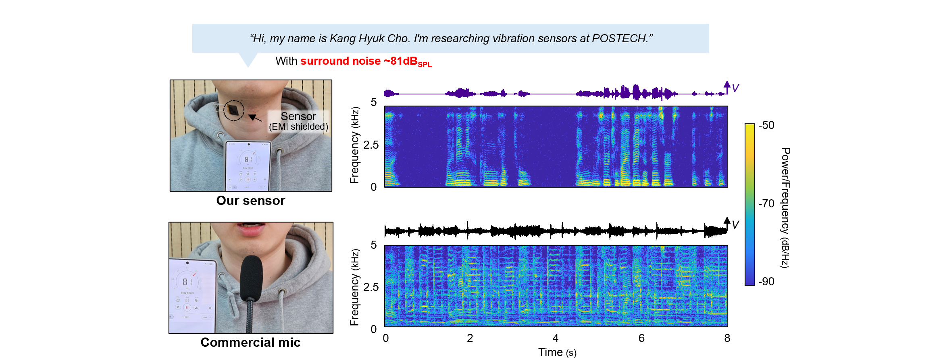
Supplementary Figure 33 | Comparison of speech detection performance of the sensor and a commercial microphone in a noisy environment. Speech waveform and STFT spectrogram of the sentence: “Hi, my name is Kang Hyuk Cho. I’m researching vibration sensors at POSTECH,” recorded simultaneously using the proposed vibration sensor (top) and a commercial microphone (bottom), under a surround noise level of approximately 81 dB_{SPL}. The vibration sensor was EMI shielded and mounted on the side larynx region of the neck.

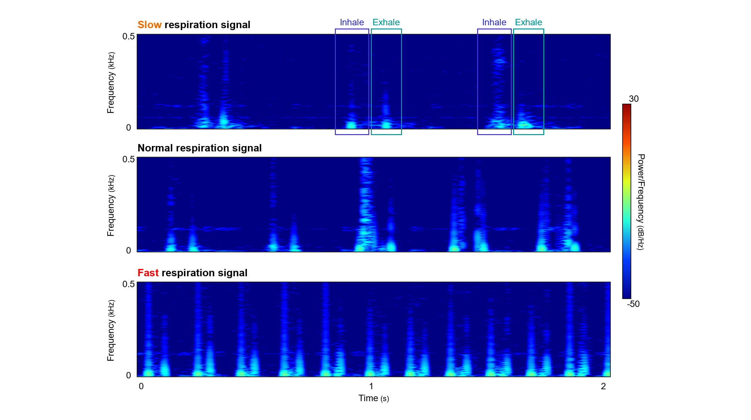
Supplementary Figure 34 | Monitoring breathing sounds at different respiration rates (slow, normal, and fast). Different respiration rates are clearly distinguishable, with all STFT spectrograms showing well-defined inhale and exhale phases.
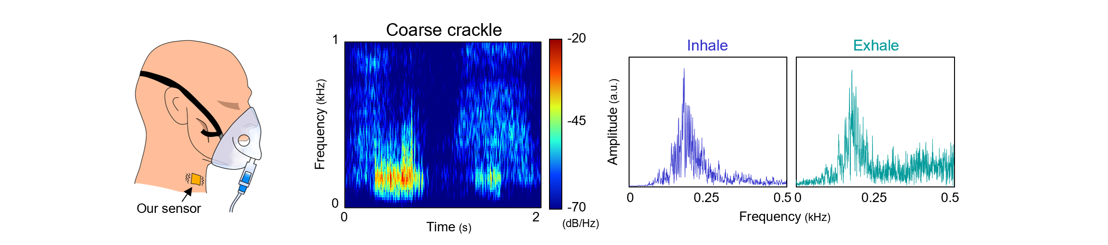
Supplementary Figure 35 | Spectral characteristics of coarse crackles during a single breathing cycle. Time–frequency and spectral analyses were performed using STFT and PSD, respectively. The results reveal broadband energy bursts and strong low-frequency components (< 300 Hz)⁷, which are characteristic of coarse crackles associated with abnormal respiratory activity.

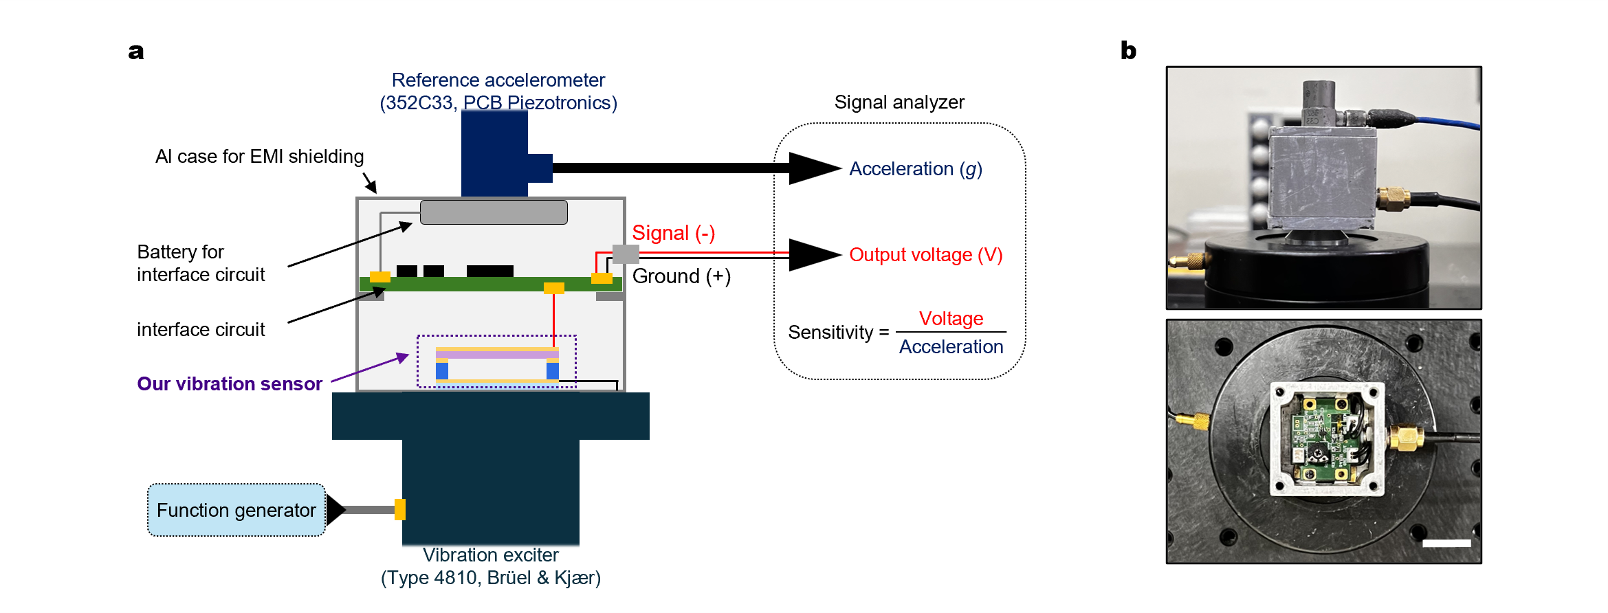
Supplementary Figure 36 | Experimental setup for vibration sensitivity measurement. a, Schematic of the experimental setup. b, Photographs of the experimental setup. Top: side view showing the reference accelerometer and aluminum Faraday cage mounted on the vibration exciter. Bottom: top view revealing the internal circuitry and sensor placement (scale bar: 1 cm).

The measurement setup is based on the back-to-back calibration method using a reference accelerometer⁸. A sinusoidal signal generated by a function generator drives the vibration exciter, which in turn oscillates the mounted sensor and reference accelerometer. The accelerometer outputs acceleration data (g), while the sensor outputs a voltage signal (V_{out}), both of which are recorded by a signal analyzer. Sensitivity is calculated as the ratio of the sensor output voltage to the measured acceleration:
 | $sensitivity=\frac{V_{out}}{g}$ | (Suppl. Eq. 9)

This calibration method is valid only when the motion of both the accelerometer and sensor is in the vertical direction. To maintain this condition and ensure accurate measurement, the applied acceleration was limited to a maximum of 2.5 g.

Supplementary Table 1 | Comparison of out-of-plane d-spacing values for unpoled and poled PVDF-TrFE films, obtained from vertical TrWAXS measurements.
d-spacing (out-of-plane) | α-phase | β-phase
Unpoled PVDF-TrFE | 4.92 Å | 4.59 Å
Poled PVDF-TrFE | N/A | 4.57 Å
Supplementary Table 2 | Comparison of d₃₁ between the PVDF-TrFE film presented in this work and those reported in previous studies.
Author  (Year) | PVDF-TrFE morphology | d₃₁ (pC N⁻¹)
This work | Film | 15
Wang et al.  (2020) ^{[59]} | Film | 15
Ducrot et al.  (2016) ^{[60]} | Film | 11
Wang et al.  (1993) ^{[61]} | Film | 10.7
Yan et al.  (2022) ^{[58]} | Fiber | 20

Supplementary Table 3 | Comparison of key performance metrics between the proposed vibration sensor and state-of-the-art soft vibration/acoustic sensors reported in the literature. Metrics include sensitivity, dynamic range, SNR, flat frequency response, and linearity.
Author  (Year) | Transduction mechanism | Sensitivity (V Pa⁻¹) | Dynamic range (dB) | SNR (dB) | SNR frequency  range (Hz) | Flat frequency response (Y/N) | Linearity (Y/N)
This work | Capacitive | 6.07 | 20-90 | 80 | 80-5000 | Y | Y
Kang et al.*  (2024) ^{[68]} | Triboelectric | 0.85 | 68.5-86.7 | 41.6 | 150 | N | Y
Lee et al.  (2022) ^{[32]} | Capacitive | 2.2 | 50-80 | 20 | 80-3000 | Y | Y
Lee et al.  (2019) ^{[31]} | Capacitive | 5.5 | 40-70 | 10 | 80-3400 | Y | Y
Yang et al.  (2014) ^{[20]} | Triboelectric | 9.54 | 70-110 | N/A | NA | N | N
Yu et al.  (2022) ^{[21]} | Triboelectric/  Piezoelectric hybrid | 3.37 | 95-125 | N/A | NA | N | Y
Hui et al.*  (2024) ^{[16]} | Triboelectric | 1.22 | 50-80 | 56 | NA | N | Y
Shen et al.*  (2025) ^{[11]} | Triboelectric | 4.4 | 70-105 | 14 | 200 | N | N
Jiang et al.  (2022) ^{[43]} | Triboelectric | 0.25 | 40-103 | N/A | N/A | N | N
Shao et al.  (2020) ^{[24]} | Piezoelectric | 1.68 | 60-120 | N/A | N/A | N | N
Wang et al.  (2025) ^{[15]} | Piezoelectric | 0.2 | 70-95 | N/A | N/A | N | N
Gong et al.**  (2020) ^{[26]} | Resistive | 4.26 | 82–98 | N/A | N/A | N | N
Gong et al.  (2023) ^{[81]} | Resistive | 0.33 Pa⁻¹ | N/A | 13 | N/A | N | Y
Qiao et al.  (2024) ^{[17]} | Triboelectric | 3.17 | N/A | 56.37 | 1000 | N | Y
Jin et al.*  (2025) ^{[22]} | Piezoelectric | 3.69 | N/A | 81 | 1409 | N | Y
Jung et al.**  (2022) ^{[77]} | Piezoelectric | 0.065  (@ 0.65 kHz) | N/A | 94, 83, 82,  80, 77, 75,  72, 53, 60 | 650, 1080, 1310, 2000, 3000, 4000, 5000, 6000, 7000 | N | N/A
Wang et al.**  (2021) ^{[27]} | Piezoelectric | 52  (@ 0.83 kHz) | N/A | 92, 85, 78 | 830, 1840, 2890 | N | Y
Park et al.**  (2022) ^{[46]} | Triboelectric/  Piezoelectric hybrid | 0.61 | N/A | 33 | 200 | N | Y
Lan et al.**  (2023) ^{[18]} | Piezoelectric | 0.025 | 75-98 | 54 | 230 | N | Y
Xiang et al.**  (2023) ^{[19]} | Piezoelectric | 0.15 | 70-120 | 60 | 250 | N | N
* Measured at the resonant frequency to evaluate peak sensing performance.
** Devices based on multi-resonant frequency array structures.
Supplementary References
1. Bellet-Amalric, E. & Legrand, J. F. Crystalline structures and phase transition of the ferroelectric P(VDF-TrFE) copolymers, a neutron diffraction study. Eur. Phys. J. B - Condens. Matter Complex Syst. 3, 225–236 (1998).
2. Apelt, S. et al. Poly(vinylidene fluoride-co-trifluoroethylene) thin films after dip- and spin-coating. Macromol. Mater. Eng. 307, (2022).
3. Bargain, F., Panine, P., Domingues Dos Santos, F. & Tencé-Girault, S. From solvent-cast to annealed and poled poly(VDF-co-TrFE) films: New insights on the defective ferroelectric phase. Polymer (Guildf) 105, 144–156 (2016).
4. Lee, J. S., Prabu, A. A. & Kim, K. J. Annealing effect upon chain orientation, crystalline morphology, and polarizability of ultra-thin P(VDF-TrFE) film for nonvolatile polymer memory device. Polymer (Guildf) 51, 6319–6333 (2010).
5. Park, Y. J. et al. Molecular and crystalline microstructure of ferroelectric poly(vinylidene fluoride-co-trifluoroethylene) ultrathin films on bare and self-assembled monolayer-modified Au substrates. Macromolecules 41, 109–119 (2008).
6. Yan, W. et al. Single fibre enables acoustic fabrics via nanometre-scale vibrations. Nature 603, 616–623 (2022).
7. Mori, M. et al. Waveform and spectral analysis of crackles. Thorax 35, 843–850 (1980). https://doi.org/10.1136/thx.35.11.843
8. Payne, B. F. The application of back-to-back accelerometers to precision vibration measurements. J. Res. Natl. Bur. Stand. 88, (1983).

