Supplementary materials
Supplementary Figure 1. EDX, DLS, and FTIR spectrum of the plastic particles used for the aging.
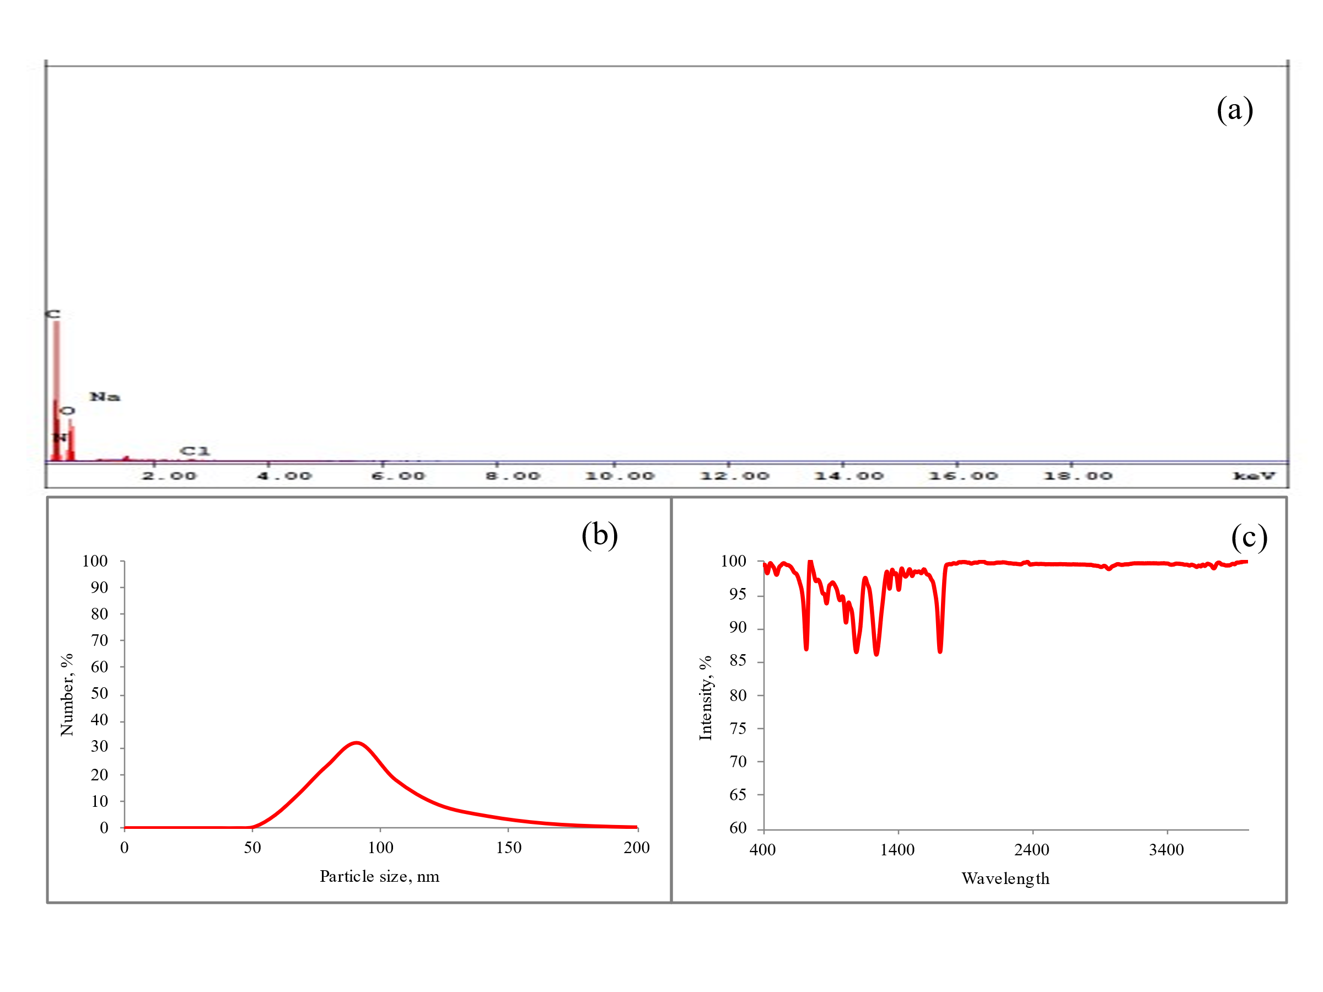

Supplementary Table 1. Chemical composition of in vitro solutions (Kastury et al. 2018, Stefeniak et al. 2005; Hu et al. 2013)
Chemical (g/L) | ALF | PSF | Saliva | GS
Sodium chloride | 3.21 | 6.65 | 0.3978 | 8.0
Sodium hydroxide | 6.00 | - | - | -
Citric acid | 20.8 | - | - | -
Calcium chloride (dihydrate) | 0.128 | 0.029 | 0.5992 | 0.185
Sodium phosphate | - | - | - | 0.0479
Sodium hydrogen phosphate dibasic (anhydrous) | 0.071 | 0.142 | - | -
Sodium dihydrogen phosphate | - | - | 0.5999 | -
Sodium sulphate | 0.039 | 0.071 | - | -
Sodium sulphur | - | - | 0.0023 | -
Sodium hydrogen carbonate | - | - | - | 0.35
Magnesium chloride (anhydrous) | 0.05 | - | - | -
Magnesium sulfate (anhydrous) | - | - | - | 0.0977
Glycine | 0.059 | 0.45 | - | -
Sodium citrate (dihydrate) | 0.077 | - | - | -
Sodium tartrate (dihydrate) | 0.09 | - | - | -
Sodium lactate | 0.085 | - | - | -
Sodium pyruvate | 0.086 | - | - | -
Potassium chloride | - | - | 0.4080 | 0.4
Potassium dihydrogen phosphate | - | - | - | 0.06
Potassium hydrogen phthalate | - | 4.085 | - | -
Benzalkonium chloride | 0.05 | 0.05
Urea |  |  | 1.02
pH | 4.5 | 4.5 | 6.7 | 7.4

