Table S1 Joint association of blood cadmium and inflammatory markers with CVD-mortality among cancer survivors.
Subgroups | Case | Model I |  | Model II |  | Model III
Subgroups | Case | HR (95% CI) | P value | HR (95% CI) | P value | HR (95% CI) | P value
Cd and PIV
Group 1 | 581 (23.71) | 1.00 (ref) |  | 1.00 (ref) |  | 1.00 (ref)
Group 2 | 542 (22.12) | 2.10 (0.92-4.85) | 0.079 | 2.01 (0.85-4.75) | 0.114 | 1.64 (0.69-3.88) | 0.263
Group 3 | 631 (25.76) | 2.07 (0.96-4.47) | 0.064 | 2.13 (0.99-4.58) | 0.052 | 2.06 (0.93-4.58) | 0.076
Group 4 | 696 (28.41) | 3.51（1.70-7.27） | 0.001 | 2.97 (1.44-6.17) | 0.003 | 2.85 (1.26-6.43) | 0.012
P for trend |  |  | < 0.001 |  | < 0.001 |  | 0.002
Cd and PLR
Group 1 | 561 (22.90) | 1.00 (ref) |  | 1.00 (ref) |  | 1.00 (ref)
Group 2 | 562 (22.94) | 0.91 ( 0.46-1.79) | 0.788 | 0.84 (0.42-1.65) | 0.604 | 0.81 (0.42-1.57) | 0.532
Group 3 | 690 (28.16) | 1.24 (0.67-2.28) | 0.496 | 1.16 (0.65-2.09) | 0.614 | 1.18 (0.63-2.23) | 0.609
Group 4 | 637 (26.00) | 2.43 (1.42-4.13) | 0.001 | 2.10 (1.21-3.66) | 0.009 | 2.26 (1.20-4.25) | 0.012
P for trend |  |  | < 0.001 |  | 0.001 |  | 0.003
Cd and MLR
Group 1 | 566 (23.10) | 1.00 (ref) |  | 1.00 (ref) |  | 1.00 (ref)
Group 2 | 557 (22.73) | 3.02 (1.32-6.89) | 0.009 | 2.44 (1.06-5.60) | 0.036 | 2.14 (0.90-5.09) | 0.084
Group 3 | 653 (26.65) | 1.77 (0.97-3.21) | 0.063 | 1.78 (0.94-3.35) | 0.076 | 1.78 (0.92-3.45) | 0.086
Group 4 | 674 (27.51) | 5.82(3.13-10.82) | < 0.001 | 4.12 (2.13-7.98) | < 0.001 | 3.99 (2.00-7.97) | < 0.001
P for trend |  |  | < 0.001 |  | < 0.001 |  | < 0.001
Cd and NLR
Group 1 | 545 (22.24) | 1.00 (ref) |  | 1.00 (ref) |  | 1.00 (ref)
Group 2 | 578 (23.59) | 2.21 (0.94-5.21) | 0.071 | 1.78 (0.76-4.19) | 0.187 | 1.52 (0.63-3.67) | 0.356
Group 3 | 643 (26.24) | 1.60 (0.71-3.60) | 0.256 | 1.44 (0.65-3.18) | 0.361 | 1.46 (0.61-3.50) | 0.394
Group 4 | 684 (27.92) | 4.65(2.12-10.21) | < 0.001 | 3.62 (1.65-7.96) | 0.001 | 3.32 (1.34-8.25) | 0.01
P for trend |  |  | < 0.001 |  | < 0.001 |  | < 0.001
Cd and SII
Group 1 | 555 (22.6)5 | 1.00 (ref) |  | 1.00 (ref) |  | 1.00 (ref)
Group 2 | 568 (23.19) | 1.40 (0.72-2.73) | 0.327 | 1.27 (0.64-2.52) | 0.504 | 1.06 (0.54-2.05) | 0.869
Group 3 | 650 (26.53) | 1.56 (0.77-3.16) | 0.215 | 1.51 (0.76-3.01) | 0.237 | 1.46 (0.72-2.97) | 0.300
Group 4 | 677 (27.63) | 2.90 (1.51-5.56) | 0.001 | 2.44 (1.27-4.70) | 0.007 | 2.37 (1.11-5.03) | 0.025
P for trend |  |  | < 0.001 |  | < 0.001 |  | 0.007
Cd and SIRI
Group 1 | 570 (23.27) | 1.00 (ref) |  | 1.00 (ref) |  | 1.00 (ref)
Group 2 | 553 (22.57) | 2.37 (1.03-5.49) | 0.044 | 1.94 (0.82-4.59) | 0.131 | 1.64 (0.66-4.09) | 0.288
Group 3 | 617 (25.18) | 1.70 (0.80-3.61) | 0.166 | 1.70 (0.80-3.64) | 0.171 | 1.76 (0.74-4.17) | 0.200
Group 4 | 710 (28.98) | 4.28 (2.10-8.72) | < 0.001 | 3.23 (1.58-6.61) | < 0.001 | 3.04 (1.32-7.02) | 0.009
P for trend |  |  | < 0.001 |  | < 0.001 |  | < 0.001

Model I: non-adjusted; Model II: adjusted for age, gender, race,PIR,education level, marital status; Model III: further adjusted for BMI,sleep disorder,smoking status, alcohol status, Hypertension, Diabetes.Group 1 refers to Low blood cadmium levels & CBC-derived inflammatory biomarkers ≤ median; Group 2 refers to Low blood cadmium levels & CBC-derived inflammatory biomarkers ≥ median; Group 3 refers to High blood cadmium levels & CBC-derived inflammatory biomarkers ≤ median; Group 4 refers to High blood cadmium levels & CBC-derived inflammatory biomarkers ≥ median.
PIV: platelet-immune inflammation value; NLR:neutrophil-to-lymphocyte ratio; MLR:monocyte-to-lymphocyte ratio;PLR:platelet-to-lymphocyte ratio;SII:systemic immune-inflammation index;SIRI:systemic inflammation response index;Cd:blood cadmium
Table S2 Joint association of blood cadmium and inflammatory markers with cancer-specific mortality among cancer survivors.

Subgroups | Case | Model I |  | Model II |  | Model III
Subgroups | Case | HR (95% CI) | P value | HR (95% CI) | P value | HR (95% CI) | P value
Cd and PIV
Group 1 | 581 (23.71) | 1.00 (ref) |  | 1.00 (ref) |  | 1.00 (ref)
Group 2 | 542 (22.12) | 0.87 (0.50-1.53) | 0.627 | 0.84 (0.47-1.51) | 0.562 | 0.78 (0.42-1.41) | 0.405
Group 3 | 631 (25.76) | 1.07 (0.61-1.87) | 0.823 | 1.10 (0.62-1.95) | 0.747 | 0.60 (1.14-1.88) | 0.835
Group 4 | 696 (28.41) | 1.38 (0.83-2.31) | 0.218 | 1.24 (0.72-2.13) | 0.434 | 1.15 (0.69-1.93) | 0.593
P for trend |  |  | 0.155 |  | 0.304 |  | 0.408
Cd and PLR
Group 1 | 561 (22.90) | 1.00 (ref) |  | 1.00 (ref) |  | 1.00 (ref)
Group 2 | 562 (22.94) | 1.22 (0.71-2.09) | 0.479 | 1.18 (0.70-1.99) | 0.530 | 1.15 (0.66-1.99) | 0.626
Group 3 | 690 (28.16) | 1.28 (0.73-2.24) | 0.397 | 1.25 (0.71-2.21) | 0.443 | 1.20 (0.70-2.07) | 0.517
Group 4 | 637 (26.00) | 1.67 (0.99-2.82) | 0.056 | 1.55 (0.91-2.65) | 0.106 | 1.50 (0.85-2.65) | 0.161
P for trend |  |  | 0.052 |  | 0.103 |  | 0.141
Cd and MLR
Group 1 | 566 (23.10) | 1.00 (ref) |  | 1.00 (ref) |  | 1.00 (ref)
Group 2 | 557 (22.73) | 1.91 (1.04-3.53) | 0.038 | 1.62 (0.87-3.01) | 0.127 | 1.59 (0.84-3.03) | 0.157
Group 3 | 653 (26.65) | 0.97 (0.53-1.77) | 0.915 | 0.98 (0.53-1.81) | 0.938 | 0.95 (0.53-1.72) | 0.865
Group 4 | 674 (27.51) | 2.93 (3.02-5.14) | < 0.001 | 2.29 (1.27-4.12) | 0.006 | 2.19 (1.19-4.04) | 0.012
P for trend |  |  | 0.001 |  | 0.012 |  | 0.015
Cd and NLR
Group 1 | 545 (22.24) | 1.00 (ref) |  | 1.00 (ref) |  | 1.00 (ref)
Group 2 | 578 (23.59) | 1.30 (0.69-2.44) | 0.421 | 1.09 (0.59-2.01) | 0.789 | 1.01 (0.54-1.89) | 0.987
Group 3 | 643 (26.24) | 1.24 (0.70-2.18) | 0.467 | 1.15 (0.65-2.02) | 0.630 | 1.10 (0.64-1.89) | 0.730
Group 4 | 684 (27.92) | 1.81 (1.08-3.03) | 0.024 | 1.52 (0.90-2.56) | 0.117 | 1.40 (0.81-2.41) | 0.232
P for trend |  |  | 0.027 |  | 0.107 |  | 0.159
Cd and SII
Group 1 | 555 (22.6)5 | 1.00 (ref) |  | 1.00 (ref) |  | 1.00 (ref)
Group 2 | 568 (23.19) | 0.78 (0.46-1.35) | 0.374 | 0.74 (0.43-1.30) | 0.563 | 0.69 (0.39-1.23) | 0.204
Group 3 | 650 (26.53) | 1.12 (0.65-1.96) | 0.680 | 1.11 (0.62-1.96) | 0.053 | 1.06 (0.61-1.83) | 0.850
Group 4 | 677 (27.63) | 1.21 (0.71-2.04) | 0.483 | 1.11 (0.64-1.91) | < 0.001 | 1.03 (0.61-1.74) | 0.923
P for trend |  |  | 0.283 |  | 0.451 |  | 0.597
Cd and SIRI
Group 1 | 570 (23.27) | 1.00 (ref) |  | 1.00 (ref) |  | 1.00 (ref)
Group 2 | 553 (22.57) | 1.30 (0.71-2.38) | 0.389 | 1.12 (0.61-2.08) | 0.716 | 1.04 (0.55-1.98) | 0.901
Group 3 | 617 (25.18) | 1.05 (0.64-1.74) | 0.845 | 1.07 (0.64-1.76) | 0.807 | 1.04 (0.62-1.74) | 0.877
Group 4 | 710 (28.98) | 1.91 (1.13-3.25) | 0.016 | 1.57 (0.90-2.75) | 0.113 | 1.46 (0.82-2.60) | 0.198
P for trend |  |  | 0.027 |  | 0.114 |  | 0.165

Model I: non-adjusted; Model II: adjusted for age, gender, race,PIR,education level, marital status; Model III: further adjusted for BMI,sleep disorder,smoking status, alcohol status, Hypertension, Diabetes.
Group 1 refers to Low blood cadmium levels & CBC-derived inflammatory biomarkers ≤ median; Group 2 refers to Low blood cadmium levels & CBC-derived inflammatory biomarkers ≥ median; Group 3 refers to High blood cadmium levels & CBC-derived inflammatory biomarkers ≤ median; Group 4 refers to High blood cadmium levels & CBC-derived inflammatory biomarkers ≥ median.
PIV:platelet-immune inflammation value; NLR:neutrophil-to-lymphocyte ratio; MLR:monocyte-to-lymphocyte ratio;PLR:platelet-to-lymphocyte ratio;SII:systemic immune-inflammation index;SIRI:systemic inflammation response index;Cd:blood cadmium

Table S3 Association of inflammatory markers and blood cadmium markers with all-cause among cancer survivors.

Subgroups | Case | Model I |  | Model II |  | Model III
Subgroups | Case | HR (95% CI) | P value | HR (95% CI) | P value | HR (95% CI) | P value
PIV
Low | 1212 (49.5) | 1.00 (ref) |  | 1.00 (ref) |  | 1.00 (ref)
High | 1238 (50.5) | 1.50 (1.22-1.85) | < 0.001 | 1.36 (1.11-1.65) | 0.003 | 1.24 (1.03-1.49) | 0.024
PLR
Low | 1251 (51.1) | 1.00 (ref) |  | 1.00 (ref) |  | 1.00 (ref)
High | 1199 (48.9) | 1.30 ( 1.03-1.64) | 0.027 | 1.22 (0.97-1.53) | 0.088 | 1.18 (0.93-1.50) | 0.175
MLR
Low | 1219 (49.8) | 1.00 (ref) |  | 1.00 (ref) |  | 1.00 (ref)
High | 1231 (50.2) | 2.60 (2.07-3.27) | < 0.001 | 2.08 (1.66-2.61) | < 0.001 | 1.97 (1.58-2.47) | < 0.001
NLR
Low | 1188 (48.5) | 1.00 (ref) |  | 1.00 (ref) |  | 1.00 (ref)
High | 1262 (51.5) | 1.81 (1.46-2.27) | < 0.001 | 1.60 (1.27-2.00) | < 0.001 | 1.45 (1.16-1.83) | 0.001
SII
Low | 1205 (49.2) | 1.00 (ref) |  | 1.00 (ref) |  | 1.00 (ref)
High | 1245 (50.8) | 1.35 (1.10-1.66) | 0.004 | 1.24 (1.00-1.55) | 0.049 | 1.15 (0.93-1.42) | 0.200
SIRI
Low | 1187 (48.4) | 1.00 (ref) |  | 1.00 (ref) |  | 1.00 (ref)
High | 1263 (51.6) | 2.19 (1.74-2.75) | < 0.001 | 1.83 (1.46-2.29) | < 0.001 | 1.65 (1.33-2.06) | < 0.001
Cr
Low | 1123 (45.8) | 1.00 (ref) |  | 1.00 (ref) |  | 1.00 (ref)
High | 1327 (54.2) | 1.68 (1.39-2.02) | < 0.001 | 1.55 (1.26-1.89) | < 0.001 | 1.54 (1.26-1.89) | < 0.001

Model I: non-adjusted; Model II: adjusted for age, gender, race,PIR,education level, marital status; Model III: further adjusted for BMI,sleep disorder,smoking status, alcohol status, Hypertension, Diabetes.
Low: blood cadmium levels or CBC-derived inflammatory biomarkers ≤ median;
High: blood cadmium levels or CBC-derived inflammatory biomarkers ≥ median;
PIV:platelet-immune inflammation value; NLR:neutrophil-to-lymphocyte ratio; MLR:monocyte-to-lymphocyte ratio;PLR:platelet-to-lymphocyte ratio;SII:systemic immune-inflammation index;SIRI:systemic inflammation response index;Cd:blood cadmium

Table S4 Subgroup Analysis of Joint Associations of Blood Cadmium and PIV with Mortality in Cancer Survivors.
Cd AND PIV | Count | Percent | Levels | HR (95%CI) | P for interaction
Education level |  |  |  |  | 0.066
Less than high school | 1092 | 44.57 | Group1 | Reference
 |  |  | Group2 | 1.05 (0.67,1.66)
 |  |  | Group3 | 2.12 (1.32,3.39)
 |  |  | Group4 | 2.41 (1.44,4.04)
High school or equivalent | 725 | 29.59 | Group1 | Reference
 |  |  | Group2 | 0.89 (0.47,1.68)
 |  |  | Group3 | 1.46 (0.82,2.60)
 |  |  | Group4 | 1.37 (0.69,2.73)
College or above | 633 | 25.84 | Group1 | Reference
 |  |  | Group2 | 1.86 (0.87,4.00)
 |  |  | Group3 | 1.27 (0.57,2.86)
 |  |  | Group4 | 3.69 (1.80,7.56)
PIR |  |  |  |  | 0.756
＜3.5 | 1606 | 65.55 | Group1 | Reference
 |  |  | Group2 | 1.23 (0.87,1.72)
 |  |  | Group3 | 1.76 (1.23,2.52)
 |  |  | Group4 | 2.05 (1.48,2.85)
≥3.5 | 844 | 34.45 | Group1 | Reference
 |  |  | Group2 | 1.29 (0.67,2.51)
 |  |  | Group3 | 1.20 (0.63,2.32)
 |  |  | Group4 | 1.88 (1.01,3.50)
Race |  |  |  |  | 0.099
Mexican American | 175 | 7.14 | Group1 | Reference
 |  |  | Group2 | 0.54 (0.05,5.31)
 |  |  | Group3 | 1.95 (0.44,8.55)
 |  |  | Group4 | 2.02 (0.47,8.59)
Other Hispanic | 147 | 6.00 | Group1 | Reference
 |  |  | Group2 | 0.67 (0.21,2.09)
 |  |  | Group3 | 1.09 (0.11,11.31)
 |  |  | Group4 | 0.80 (0.20,3.22)
Non-Hispanic White | 1645 | 67.14 | Group1 | Reference
 |  |  | Group2 | 1.12 (0.80,1.57)
 |  |  | Group3 | 1.50 (1.08,2.10)
 |  |  | Group4 | 1.94 (1.42,2.64)
Non-Hispanic Black | 670 | 27.35 | Group1 | Reference
 |  |  | Group2 | 2.02 (0.85,4.80)
 |  |  | Group3 | 2.41 (1.02,5.69)
 |  |  | Group4 | 3.15 (1.30,7.66)
Other Race | 138 | 5.63 | Group1 | Reference
 |  |  | Group2 | 3.63 (0.51,25.93)
 |  |  | Group3 | 0.20 (0.00,34.65)
 |  |  | Group4 | 12.88 (0.43,389.76)
Marital status, n (%) |  |  |  |  | 0.861
Married/Living with partner | 1395 | 56.94 | Group1 | Reference
 |  |  | Group2 | 1.15 (0.71,1.86)
 |  |  | Group3 | 1.22 (0.76,1.95)
 |  |  | Group4 | 1.84 (1.15,2.96)
Widowed / Divorced / Separated | 1055 | 43.06
 |  |  | Group1 | Reference
 |  |  | Group2 | 1.34 (0.83,2.16)
 |  |  | Group3 | 2.16 (1.37,3.41)
 |  |  | Group4 | 2.11 (1.40,3.20)

PIR, poverty income ratio; PIR, poverty income ratio; Cd:blood cadmium;P-value of <0.05 was considered statistically significant.

Table S5 Subgroup Analysis of Joint Associations of Blood Cadmium and PLR with Mortality in Cancer Survivors.
Cd AND PLR | Count | Percent | Levels | HR (95%CI) | P for interaction
Education level |  |  |  |  | 0.378
Less than high school | 1092 | 44.57 | Group1 | Reference
 |  |  | Group2 | 0.81 (0.48,1.37)
 |  |  | Group3 | 1.34 (0.93,1.92)
 |  |  | Group4 | 1.78 (1.14,2.79)
High school or equivalent | 725 | 29.59 | Group1 | Reference
 |  |  | Group2 | 0.65 (0.34,1.25)
 |  |  | Group3 | 1.08 (0.60,1.95)
 |  |  | Group4 | 1.37 (0.70,2.69)
College or above | 633 | 25.84 | Group1 | Reference
 |  |  | Group2 | 1.44 (0.66,3.14)
 |  |  | Group3 | 1.52 (0.71,3.25)
 |  |  | Group4 | 2.94 (1.35,6.41)
PIR |  |  |  |  | 0.796
＜3.5 | 1606 | 65.55 | Group1 | Reference
 |  |  | Group2 | 0.89 (0.60,1.33)
 |  |  | Group3 | 1.43 (0.99,2.06)
 |  |  | Group4 | 1.84 (1.27,2.66)
≥3.5 | 844 | 34.45 | Group1 | Reference
 |  |  | Group2 | 0.86 (0.43,1.70)
 |  |  | Group3 | 0.78 (0.43,1.43)
 |  |  | Group4 | 1.76 (0.90,3.45)
Race |  |  |  |  | 0.190
Mexican American | 175 | 7.14 | Group1 | Reference
 |  |  | Group2 | 0.08 (0.01,0.57)
 |  |  | Group3 | 0.83 (0.16,4.32)
 |  |  | Group4 | 2.10 (0.49,9.05)
Other Hispanic | 147 | 6.00 | Group1 | Reference
 |  |  | Group2 | 1.90 (0.80,4.5)
 |  |  | Group3 | 1.72 (0.13,22.32)
 |  |  | Group4 | 2.13 (0.46,9.77)
Non-Hispanic White | 1645 | 67.14 | Group1 | Reference
 |  |  | Group2 | 0.88 (0.58,1.34)
 |  |  | Group3 | 1.25 (0.88,1.79)
 |  |  | Group4 | 1.82 (1.23,2.69)
Non-Hispanic Black | 670 | 27.35 | Group1 | Reference
 |  |  | Group2 | 0.68 (0.26,1.78)
 |  |  | Group3 | 1.16 (0.57,2.33)
 |  |  | Group4 | 2.28 (1.20,4.32)
Other Race | 138 | 5.63 | Group1 | Reference
 |  |  | Group2 | 2.57 (0.26,25.34)
 |  |  | Group3 | 2.11 (0.07,63.40)
 |  |  | Group4 | 6.40 (0.26,154.92)
Marital status, n (%) |  |  |  |  | 0.273
Married/Living with partner | 1395 | 56.94 | Group1 | Reference
 |  |  | Group2 | 0.85 (0.52,1.39)
 |  |  | Group3 | 1.11 (0.69,1.75)
 |  |  | Group4 | 1.59 (0.95,2.65)
Widowed / Divorced / Separated | 1055 | 43.06
 |  |  | Group1 | Reference
 |  |  | Group2 | 0.98 (0.64,1.48)
 |  |  | Group3 | 1.50 (1.01,2.23)
 |  |  | Group4 | 2.11 (1.49,2.99)

PIR, poverty income ratio; PLR:platelet-to-lymphocyte ratio;Cd:blood cadmium;P-value of <0.05 was considered statistically significant.

Table S6 Subgroup Analysis of Joint Associations of Blood Cadmium and MLR with Mortality in Cancer Survivors.
Cd AND MLR | Count | Percent | Levels | HR (95%CI) | P for interaction
Education level |  |  |  |  | 0.696
Less than high school | 1092 | 44.57 | Group1 | Reference
 |  |  | Group2 | 1.75 (0.87,3.51)
 |  |  | Group3 | 1.79 (1.03,3.10)
 |  |  | Group4 | 2.93 (1.57,5.47)
High school or equivalent | 725 | 29.59 | Group1 | Reference
 |  |  | Group2 | 3.23 (1.69,6.15)
 |  |  | Group3 | 2.04 (1.02,4.09)
 |  |  | Group4 | 4.36 (2.09,9.11)
College or above | 633 | 25.84 | Group1 | Reference
 |  |  | Group2 | 1.66 (0.76,3.63)
 |  |  | Group3 | 1.08 (0.44,2.64)
 |  |  | Group4 | 3.31 (1.56,7.02)
PIR |  |  |  |  | 0.919
＜3.5 | 1606 | 65.55 | Group1 | Reference
 |  |  | Group2 | 2.30 (1.42,3.73)
 |  |  | Group3 | 2.12 (1.40,3.23)
 |  |  | Group4 | 3.37 (2.14,5.31)
≥3.5 | 844 | 34.45 | Group1 | Reference
 |  |  | Group2 | 1.87 (0.93,3.78)
 |  |  | Group3 | 0.99 (0.45,2.19)
 |  |  | Group4 | 2.97 (1.48,5.95)
Race |  |  |  |  | 0.586
Mexican American | 175 | 7.14 | Group1 | Reference
 |  |  | Group2 | 0.00 (0.00,0.00)
 |  |  | Group3 | 0.99 (0.20,4.90)
 |  |  | Group4 | 3.18 (0.68,14.97)
Other Hispanic | 147 | 6.00 | Group1 | Reference
 |  |  | Group2 | 6.01 (1.14,31.61)
 |  |  | Group3 | 3.49 (0.88,13.75)
 |  |  | Group4 | 4.11 (0.59,28.77)
Non-Hispanic White | 1645 | 67.14 | Group1 | Reference
 |  |  | Group2 | 2.19 (1.37,3.53)
 |  |  | Group3 | 1.76 (1.18,2.64)
 |  |  | Group4 | 3.44 (2.18,5.43)
Non-Hispanic Black | 670 | 27.35 | Group1 | Reference
 |  |  | Group2 | 2.35 (0.81,6.88)
 |  |  | Group3 | 2.45 (0.99,6.10)
 |  |  | Group4 | 3.12 (1.43,6.83)
Other Race | 138 | 5.63 | Group1 | Reference
 |  |  | Group2 | 2.47 (0.26,23.91)
 |  |  | Group3 | 0.31 (0.00,26.88)
 |  |  | Group4 | 3.96 (0.32,48.97)
Marital status, n (%) |  |  |  |  | 0.884
Married/Living with partner | 1395 | 56.94 | Group1 | Reference
 |  |  | Group2 | 2.14 (1.26,3.63)
 |  |  | Group3 | 1.42 (0.89,2.27)
 |  |  | Group4 | 3.09 (1.85,5.18)
Widowed / Divorced / Separated | 1055 | 43.06
 |  |  | Group1 | Reference
 |  |  | Group2 | 2.25 (1.38,3.66)
 |  |  | Group3 | 2.22 (1.41,3.49)
 |  |  | Group4 | 3.48 (2.22,5.45)

PIR, poverty income ratio;MLR:monocyte-to-lymphocyte ratio;Cd:blood cadmium;P-value of <0.05 was considered statistically significant.

Table S7 Subgroup Analysis of Joint Associations of Blood Cadmium and NLR with Mortality in Cancer Survivors.

Cd AND NLR | Count | Percent | Levels | HR (95%CI) | P for interaction
Education level |  |  |  |  | 0.911
Less than high school | 1092 | 44.57 | Group1 | Reference
 |  |  | Group2 | 1.65 (1.03,2.63)
 |  |  | Group3 | 1.79 (1.12,2.86)
 |  |  | Group4 | 2.80 (1.71,4.59)
High school or equivalent | 725 | 29.59 | Group1 | Reference
 |  |  | Group2 | 1.05 (0.49,2.27)
 |  |  | Group3 | 1.31 (0.65,2.64)
 |  |  | Group4 | 1.88 (0.81,4.35)
College or above | 633 | 25.84 | Group1 | Reference
 |  |  | Group2 | 1.27 (0.58,2.80)
 |  |  | Group3 | 1.07 (0.44,2.58)
 |  |  | Group4 | 2.74 (1.26,5.96)
PIR |  |  |  |  | 0.949
＜3.5 | 1606 | 65.55 | Group1 | Reference
 |  |  | Group2 | 1.33 (0.80,2.22)
 |  |  | Group3 | 1.58 (0.96,2.60)
 |  |  | Group4 | 2.43 (1.54,3.82)
≥3.5 | 844 | 34.45 | Group1 | Reference
 |  |  | Group2 | 1.37 (0.66,2.83)
 |  |  | Group3 | 1.15 (0.54,2.46)
 |  |  | Group4 | 2.16 (1.06,4.40)
Race |  |  |  |  | 0.145
Mexican American | 175 | 7.14 | Group1 | Reference
 |  |  | Group2 | 0.42 (0.03,5.95)
 |  |  | Group3 | 1.78 (0.37,8.58)
 |  |  | Group4 | 1.30 (0.18,9.25)
Other Hispanic | 147 | 6.00 | Group1 | Reference
 |  |  | Group2 | 1.49 (0.41,5.37)
 |  |  | Group3 | 1.45 (0.16,12.77)
 |  |  | Group4 | 1.34 (0.20,9.07)
Non-Hispanic White | 1645 | 67.14 | Group1 | Reference
 |  |  | Group2 | 1.21 (0.73,2.00)
 |  |  | Group3 | 1.34 (0.84,2.15)
 |  |  | Group4 | 2.32 (1.47,3.67)
Non-Hispanic Black | 670 | 27.35 | Group1 | Reference
 |  |  | Group2 | 1.52 (0.62,3.76)
 |  |  | Group3 | 2.03 (0.87,4.73)
 |  |  | Group4 | 2.98 (1.26,7.05)
Other Race | 138 | 5.63 | Group1 | Reference
 |  |  | Group2 | 4.53 (0.31,65.81)
 |  |  | Group3 | 0.00 (0.00,0.00)
 |  |  | Group4 | 14.64 (0.11,1874.2)
Marital status, n (%) |  |  |  |  | 0.923
Married/Living with partner | 1395 | 56.94 | Group1 | Reference
 |  |  | Group2 | 1.20 (0.69,2.08)
 |  |  | Group3 | 1.09 (0.60,1.98)
 |  |  | Group4 | 2.10 (1.18,3.74)
Widowed / Divorced / Separated | 1055 | 43.06
 |  |  | Group1 | Reference
 |  |  | Group2 | 1.22 (0.75,2.00)
 |  |  | Group3 | 1.73 (1.10,2.71)
 |  |  | Group4 | 2.39 (1.50,3.79)

PIR, poverty income ratio;NLR:neutrophil-to-lymphocyte ratio;Cd:blood cadmium;P-value of <0.05 was considered statistically significant.

Table S8 Subgroup Analysis of Joint Associations of Blood Cadmium and SII with Mortality in Cancer Survivors.
Cd AND SII | Count | Percent | Levels | HR (95%CI) | P for interaction
Education level |  |  |  |  | 0.201
Less than high school | 1092 | 44.57 | Group1 | Reference
 |  |  | Group2 | 0.97 (0.58,1.64)
 |  |  | Group3 | 1.57 (0.98,2.52)
 |  |  | Group4 | 1.84 (1.21,2.81)
High school or equivalent | 725 | 29.59 | Group1 | Reference
 |  |  | Group2 | 0.64 (0.32,1.27)
 |  |  | Group3 | 1.06 (0.58,1.95)
 |  |  | Group4 | 1.38 (0.64,2.97)
College or above | 633 | 25.84 | Group1 | Reference
 |  |  | Group2 | 1.72 (0.76,3.87)
 |  |  | Group3 | 1.46 (0.66,3.23)
 |  |  | Group4 | 3.20 (1.49,6.90)
PIR |  |  |  |  | 0.699
＜3.5 | 1606 | 65.55 | Group1 | Reference
 |  |  | Group2 | 0.96 (0.68,1.35)
 |  |  | Group3 | 1.54 (1.02,2.32)
 |  |  | Group4 | 1.83 (1.31,2.56)
≥3.5 | 844 | 34.45 | Group1 | Reference
 |  |  | Group2 | 1.08 (0.54,2.16)
 |  |  | Group3 | 0.97 (0.50,1.89)
 |  |  | Group4 | 1.84 (0.96,3.54)
Race |  |  |  |  | 0.076
Mexican American | 175 | 7.14 | Group1 | Reference
 |  |  | Group2 | 0.32 (0.05,2.09)
 |  |  | Group3 | 1.82 (0.44,7.59)
 |  |  | Group4 | 1.14 (0.26,5.02)
Other Hispanic | 147 | 6.00 | Group1 | Reference
 |  |  | Group2 | 0.67 (0.2,2.24)
 |  |  | Group3 | 0.70 (0.05,10.36)
 |  |  | Group4 | 1.21 (0.32,4.65)
Non-Hispanic White | 1645 | 67.14 | Group1 | Reference
 |  |  | Group2 | 0.95 (0.65,1.39)
 |  |  | Group3 | 1.35 (0.93,1.96)
 |  |  | Group4 | 1.81 (1.27,2.59)
Non-Hispanic Black | 670 | 27.35 | Group1 | Reference
 |  |  | Group2 | 0.84 (0.30,2.35)
 |  |  | Group3 | 1.38 (0.64,2.96)
 |  |  | Group4 | 2.70 (1.19,6.15)
Other Race | 138 | 5.63 | Group1 | Reference
 |  |  | Group2 | 3.07 (0.13,70.28)
 |  |  | Group3 | 1.46 (0.00,1306.86)
 |  |  | Group4 | 11.85 (0.09,1549.81)
Marital status, n (%) |  |  |  |  | 0.526
Married/Living with partner | 1395 | 56.94 | Group1 | Reference
 |  |  | Group2 | 0.93 (0.58,1.48)
 |  |  | Group3 | 1.18 (0.71,1.98)
 |  |  | Group4 | 1.57 (0.95,2.58)
Widowed / Divorced / Separated | 1055 | 43.06
 |  |  | Group1 | Reference
 |  |  | Group2 | 1.02 (0.61,1.73)
 |  |  | Group3 | 1.62 (1.00,2.64)
 |  |  | Group4 | 2.07 (1.35,3.17)

PIR, poverty income ratio;SII:systemic immune-inflammation index;Cd:blood cadmium;P-value of <0.05 was considered statistically significant.

Table S9 Subgroup Analysis of Joint Associations of Blood Cadmium and SIRI with Mortality in Cancer Survivors.

Cd AND SIRI | Count | Percent | Levels | HR (95%CI) | P for interaction
Education level |  |  |  |  | 0.282
Less than high school | 1092 | 44.57 | Group1 | Reference
 |  |  | Group2 | 2.03 (1.17,3.5)
 |  |  | Group3 | 2.10 (1.29,3.41)
 |  |  | Group4 | 2.77 (1.71,4.50)
High school or equivalent | 725 | 29.59 | Group1 | Reference
 |  |  | Group2 | 1.22 (0.63,2.34)
 |  |  | Group3 | 1.35 (0.76,2.39)
 |  |  | Group4 | 2.11 (1.00,4.46)
College or above | 633 | 25.84 | Group1 | Reference
 |  |  | Group2 | 1.79 (0.78,4.11)
 |  |  | Group3 | 0.71 (0.28,1.80)
 |  |  | Group4 | 4.06 (1.87,8.79)
PIR |  |  |  |  | 0.741
＜3.5 | 1606 | 65.55 | Group1 | Reference
 |  |  | Group2 | 1.83 (1.11,3.02)
 |  |  | Group3 | 2.01 (1.31,3.08)
 |  |  | Group4 | 2.69 (1.74,4.17)
≥3.5 | 844 | 34.45 | Group1 | Reference
 |  |  | Group2 | 1.51 (0.73,3.11)
 |  |  | Group3 | 0.91 (0.41,2.00)
 |  |  | Group4 | 2.48 (1.26,4.87)
Race |  |  |  |  | 0.098
Mexican American | 175 | 7.14 | Group1 | Reference
 |  |  | Group2 | 0.15 (0.02,1.37)
 |  |  | Group3 | 1.18 (0.24,5.81)
 |  |  | Group4 | 0.80 (0.13,5.05)
Other Hispanic | 147 | 6.00 | Group1 | Reference
 |  |  | Group2 | 3.11 (1.17,8.25)
 |  |  | Group3 | 2.55 (0.27,24.13)
 |  |  | Group4 | 1.60 (0.28,9.27)
Non-Hispanic White | 1645 | 67.14 | Group1 | Reference
 |  |  | Group2 | 1.56 (0.99,2.45)
 |  |  | Group3 | 1.52 (1.06,2.17)
 |  |  | Group4 | 2.60 (1.75,3.86)
Non-Hispanic Black | 670 | 27.35 | Group1 | Reference
 |  |  | Group2 | 2.23 (0.78,6.36)
 |  |  | Group3 | 2.21 (0.91,5.37)
 |  |  | Group4 | 4.13 (1.66,10.26)
Other Race | 138 | 5.63 | Group1 | Reference
 |  |  | Group2 | 3.63 (0.33,40.02)
 |  |  | Group3 | 0.00 (0.00,0.00)
 |  |  | Group4 | 8.52 (0.16,465.09)
Marital status, n (%) |  |  |  |  | 0.483
Married/Living with partner | 1395 | 56.94 | Group1 | Reference
 |  |  | Group2 | 1.35 (0.78,2.33)
 |  |  | Group3 | 1.19 (0.73,1.93)
 |  |  | Group4 | 2.16 (1.32,3.53)
Widowed / Divorced / Separated | 1055 | 43.06
 |  |  | Group1 | Reference
 |  |  | Group2 | 1.87 (1.19,2.94)
 |  |  | Group3 | 2.13 (1.37,3.30)
 |  |  | Group4 | 2.99 (1.98,4.53)

PIR, poverty income ratio;SIRI:systemic inflammation response index;Cd:blood cadmium;P-value of <0.05 was considered statistically significant.

Figure S1 Weighted K-M curve of cancer-specific mortality in cancer survivors based on blood cadmium levels combined with inflammatory indicators.

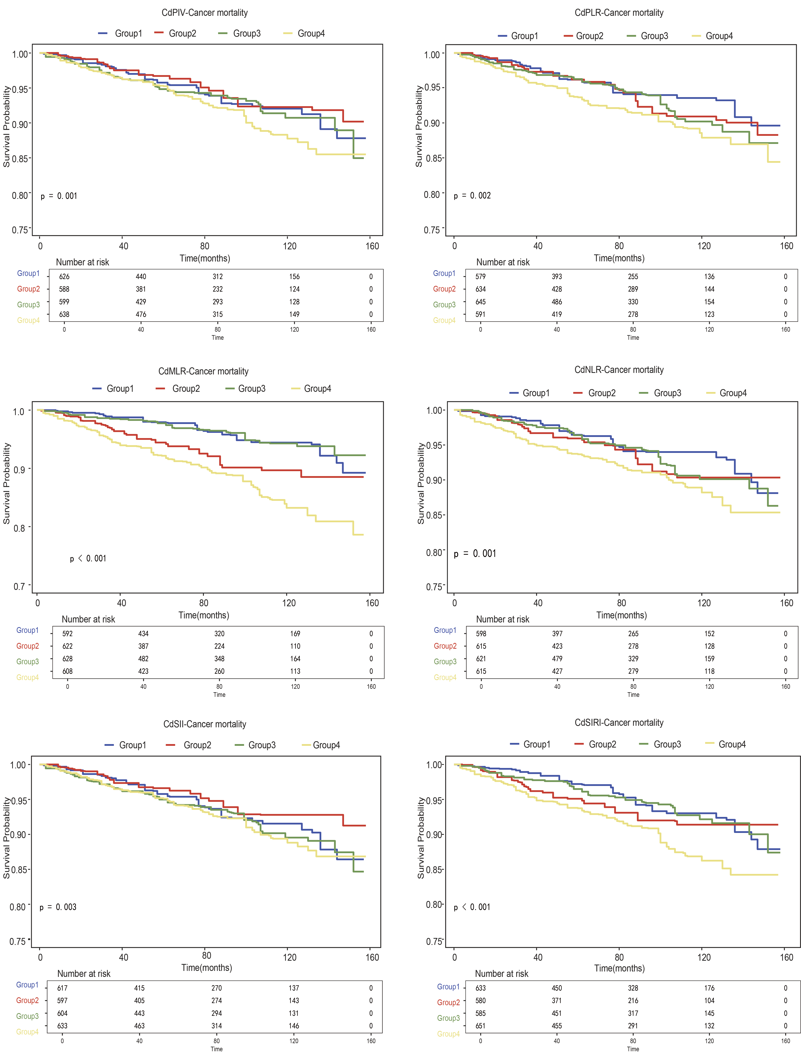
Group 1 refers to Low blood cadmium levels & CBC-derived inflammatory biomarkers ≤ median; Group 2 refers to Low blood cadmium levels & CBC-derived inflammatory biomarkers ≥ median; Group 3 refers to High blood cadmium levels & CBC-derived inflammatory biomarkers ≤ median; Group 4 refers to High blood cadmium levels & CBC-derived inflammatory biomarkers ≥ median.
PIV:platelet-immune inflammation value; NLR:neutrophil-to-lymphocyte ratio; MLR:monocyte-to-lymphocyte ratio;PLR:platelet-to-lymphocyte ratio;SII:systemic immune-inflammation index;SIRI:systemic inflammation response index;Cd:blood cadmium.

Figure S2 Weighted K-M curve of CVD mortality in cancer survivors based on blood cadmium levels combined with inflammatory indicators.
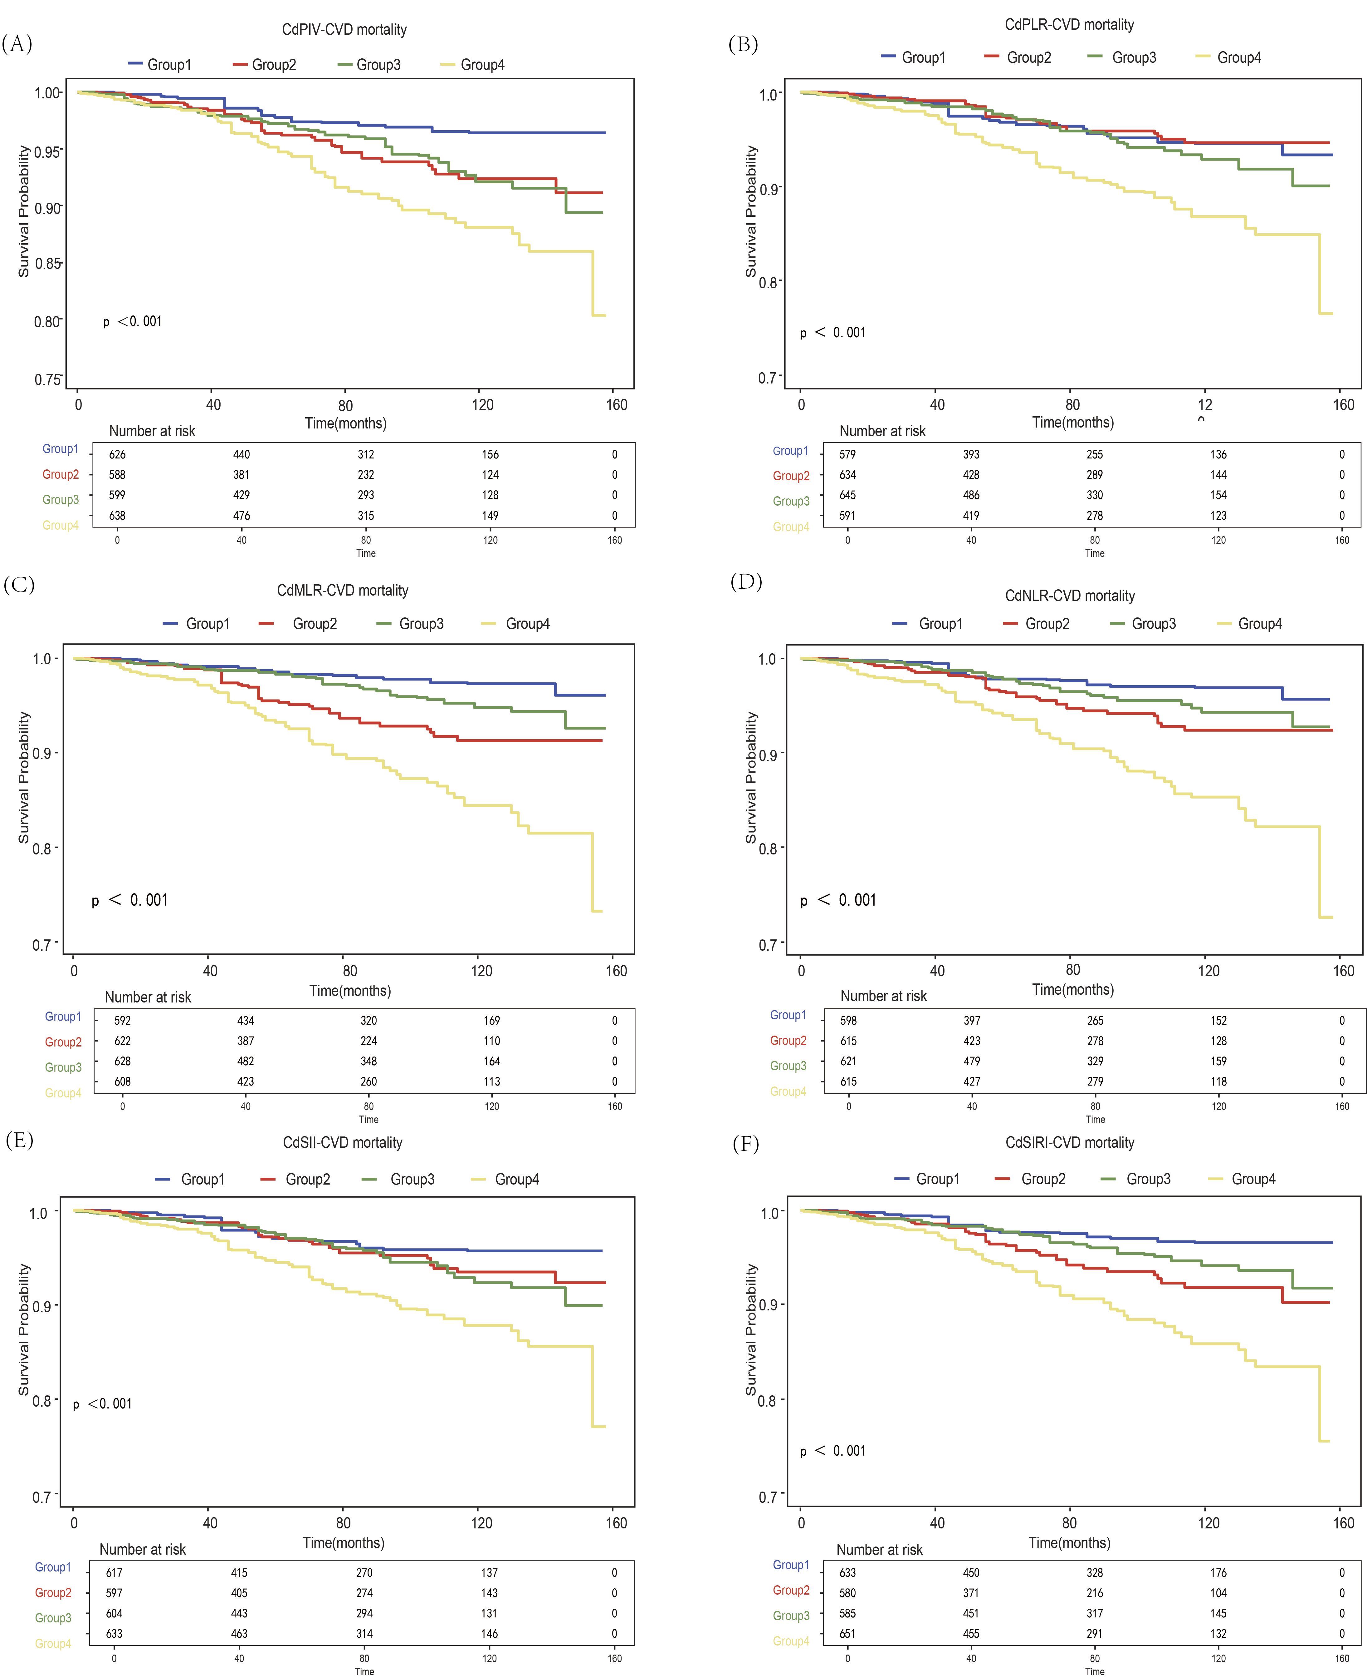

Group 1 refers to Low blood cadmium levels & CBC-derived inflammatory biomarkers ≤ median; Group 2 refers to Low blood cadmium levels & CBC-derived inflammatory biomarkers ≥ median; Group 3 refers to High blood cadmium levels & CBC-derived inflammatory biomarkers ≤ median; Group 4 refers to High blood cadmium levels & CBC-derived inflammatory biomarkers ≥ median.
PIV:platelet-immune inflammation value; NLR:neutrophil-to-lymphocyte ratio; MLR:monocyte-to-lymphocyte ratio;PLR:platelet-to-lymphocyte ratio;SII:systemic immune-inflammation index;SIRI:systemic inflammation response index;Cd:blood cadmium.

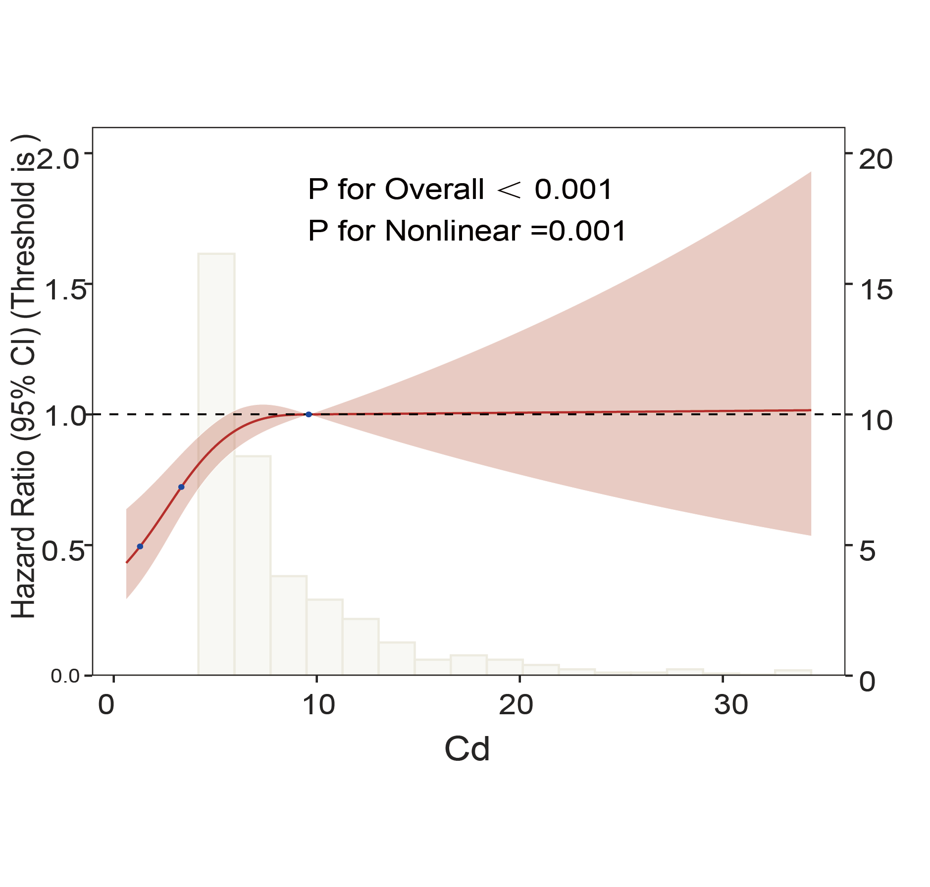
Figure S3 The independent blood cadmium levels on the all-cause mortality of cancer survivors

The spline analysis was adjusted based on factors such as age, gender, education level, poverty level, marital status, BMI, smoking status, drinking status, sleep disorder status, hypertension, and diabetes.
Cd:blood cadmium.

