Supplementary Materials

Supplementary methods:
Survey Design
- Information about you (9 items)
Included items to ascertain basic participant demographic data including gender, age, education and rural status.
- About your heart condition (9 items)
Participants were asked a series of questions about their heart condition including the name of their heart condition, if anyone had discussed possible causes with them, if anyone else in their family had a similar heart condition and if they had seen a geneticist for their heart condition. Additionally, a series of statements asked participants to rate the impact their/their child’s heart condition would have on various aspects of their/their child’s life from “very likely” to “very unlikely”.
- Your understanding of heart disease causes (6 items)
Adolescents and parents were asked to respond to the statement “I believe I have a heart condition because…” as a free text response. Multiple choice questions then assessed participants understanding of CHD causes, including genetic and environmental causes, and recurrence risks. Participant interest in learning more about CHD causes and the importance of this was also assessed.
- Your preferences for a genetics education program (6 items)
This section comprised participant preferences and interest in a genetics education program, including topic preferences, the age this information should be introduced, family member and clinician involvement, and preferred information delivery and settings. Participants could also indicate their interest to be contacted should a program become available in the future

Supplementary Figures

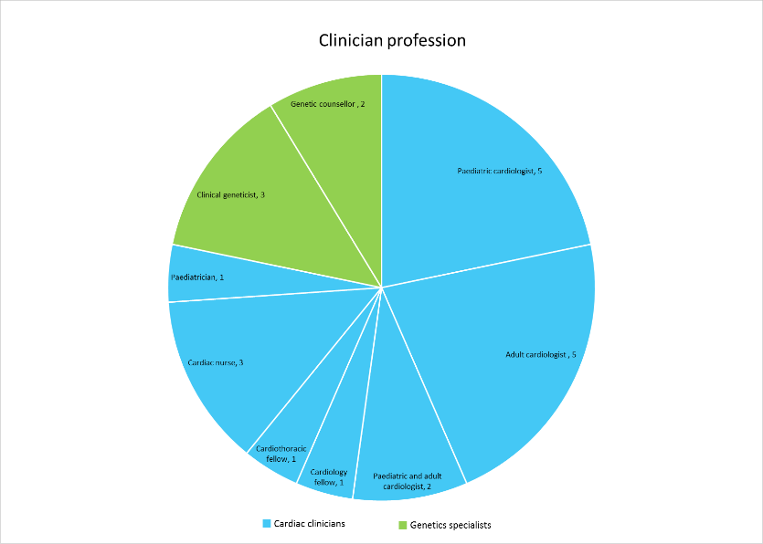
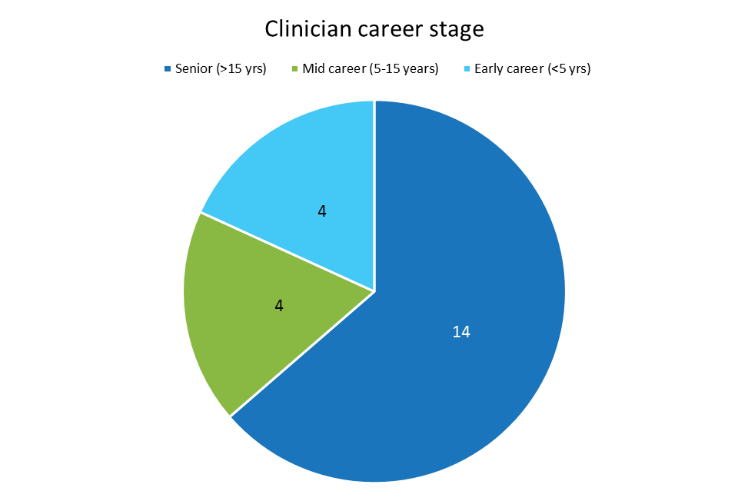
Supplementary Figure 1: Clinician demographics

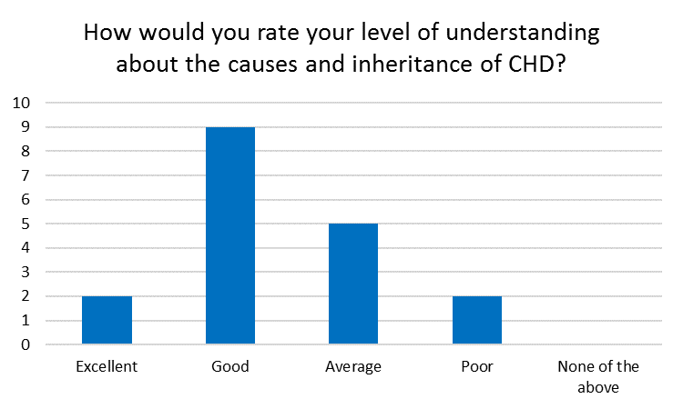
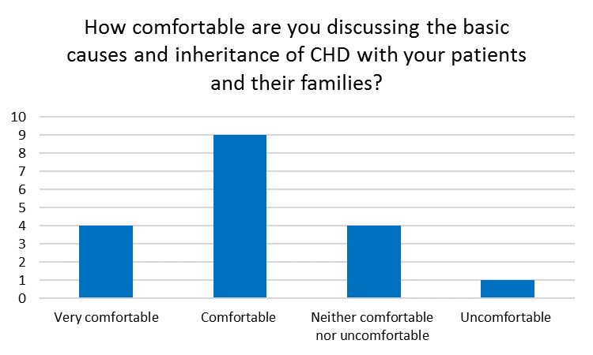
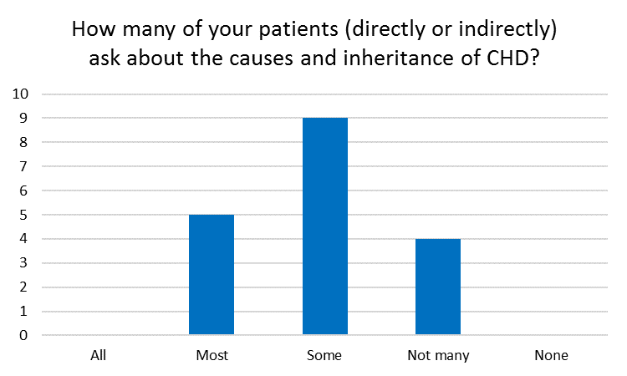
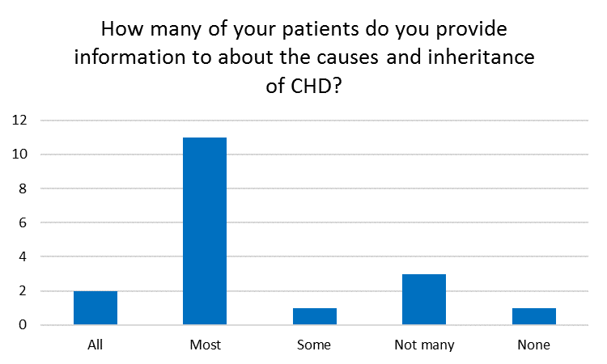
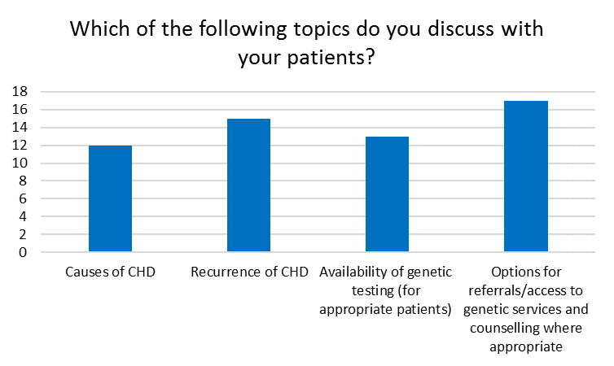
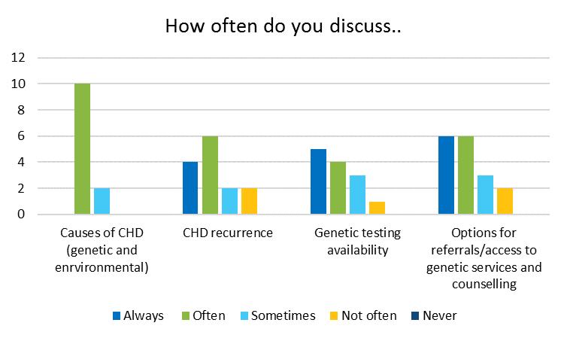
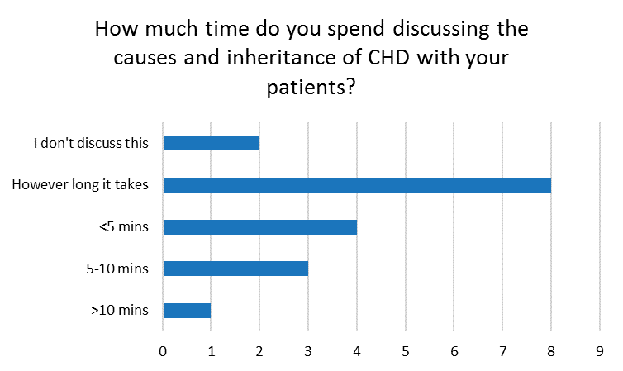
Supplementary Figure 2: Cardiac clinician current practices on the content and delivery of genetics-related information in CHD.

