Phase-Transition-Induced Ferroelectric and Magnetic Switching in Two-Dimensional CuMnP₂Se₆ under Ultra-Low Electric Fields
Jingyan Chen,¹ Meiling Xu,^{1, 2,*} Yuntao Jie,¹ Jiaqi Feng¹, Xiaodong Zhou,^{3,†}
Yanchao Wang,^{2,‡} and Yinwei Li^{1,§}
¹Laboratory of Quantum Functional Materials Design and Application, School of Physics and Electronic Engineering, Jiangsu Normal University, Xuzhou 221116, China
²Key Laboratory of Material Simulation Methods & Software of Ministry of Education, College of Physics, Jilin University, Changchun 130012, China
³School of Physical Science and Technology, Tiangong University, Tianjin 300387, China

*xml@calypso.cn
†xdzhou323@gmail.com
‡wyc@calypso.cn
§yinwei_li@jsnu.edu.cn

Polarization direction governed by orbital configuration
The polarization behavior of XMnP₂(S/Se)₆ (X=Cu, Au) contrasts sharply with most previously reported 2D BMTP multiferroics, which typically exhibit out-of-plane polarization. The distinct polarization direction is likely governed by the d-orbital occupancy of the Y cation. According to the Jahn–Teller theorem, a partially filled e_{g} orbitals induces strong Jahn–Teller effect, which tend to stabilize in-plane displacement of the X cation, thereby promoting in-plane polarization. In contrast, fully occupied e_{g} or t_{2g} orbitals suppress Jahn–Teller distortions, while partially filled t_{2g} orbitals result in only weak Jahn–Teller activity. The latter cases favor out-of-plane displacements of the X cation, leading to out-of-plane polarization. This trend is consistent with the contrasting behaviors observed in CuMnP₂Se₆, CuFeP₂Se₆ [1], CuCrP₂Se₆ [2, 3], and CuVP₂Se₆[2, 3]. Mn³⁺ (3d⁴, t_{2g}³e_{g}¹) with a singly occupied e_{g} orbital exhibits strong Jahn–Teller effect and stabilizes in-plane polarization. In contrast, Fe³⁺ (3d⁵, t_{2g}³e_{g}²), Cr³⁺ (3d³, t_{2g}³e_{g}⁰), and V³⁺ (3d², t_{2g}²e_{g}⁰) either have fully filled or partially filled e_{g} orbitals, resulting in suppressed or weak Jahn–Teller distortions, which favor out-of-plane polarization.
Potential energy calculations for Cu displacements
To examine the ferroelectric properties of 2D CuMnP₂Se₆, we explored the potential energy surface associated with polar displacements, focusing on the displacement of Cu atoms. Starting from the nonpolar reference structure, in which the Cu atoms occupy the center of their octahedra, we systematically displaced the Cu atoms along the out-of-plane (z) direction. Two computational approaches were employed: (a) fully self-consistent total energy calculations at each displacement step, and (b) constrained structural relaxations, in which the z-coordinates of Cu atoms were fixed at specific displacements while all other atomic positions were fully relaxed. The results reveal that out-of-plane polarization is energetically unfavorable in CuMnP₂Se₆, in contrast to the behavior observed in other 2D BMTPs.
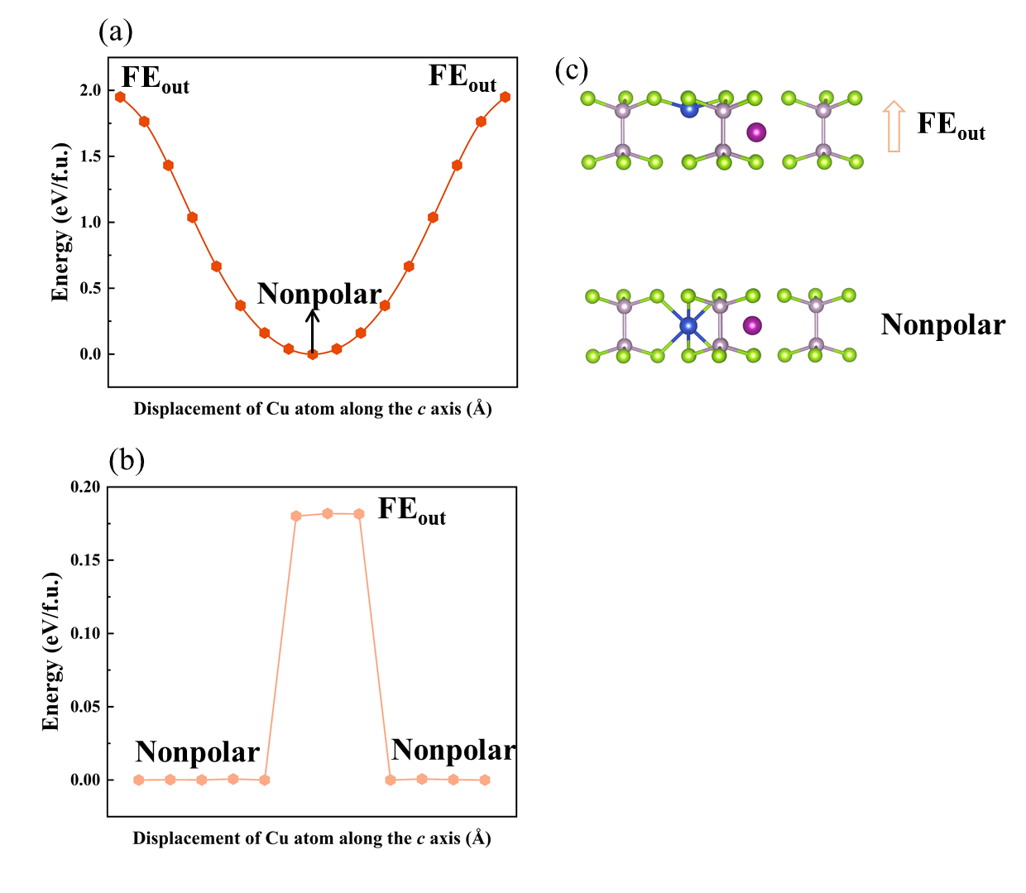
Figure S1. Energy evolution as a function of Cu ion displacement in 2D CuMnP₂Se₆ calculated using two methods: (a) full self-consistent calculations, and (b) fixed Cu z-coordinate with relaxation of all other degrees of freedom.

Dynamical stability of 2D XMnP₂S(Se)₆ (X=Cu, Au)
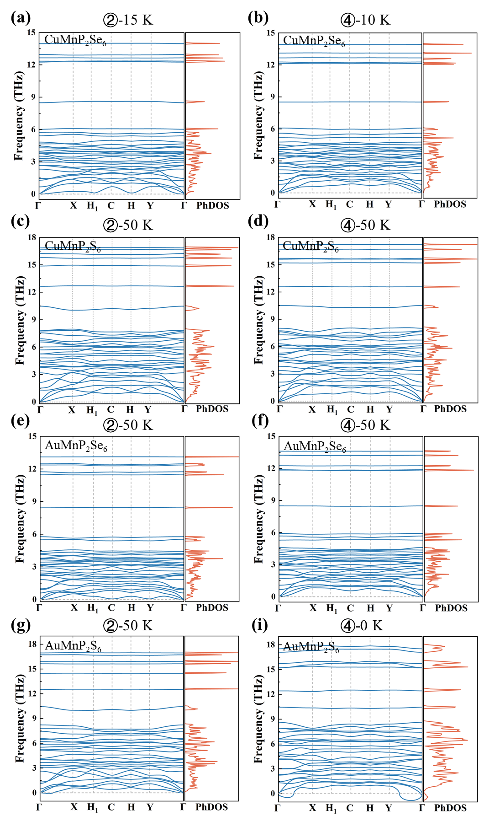
Figure S2. Phonon spectra of 2D (a, b) CuMnP₂Se₆, (c, d) CuMnP₂S₆, (e, f) AuMnP₂Se₆, and (g, h) AuMnP₂S₆.

Magnetic properties of 2D XMnP₂S(Se)₆ (X=Cu, Au)
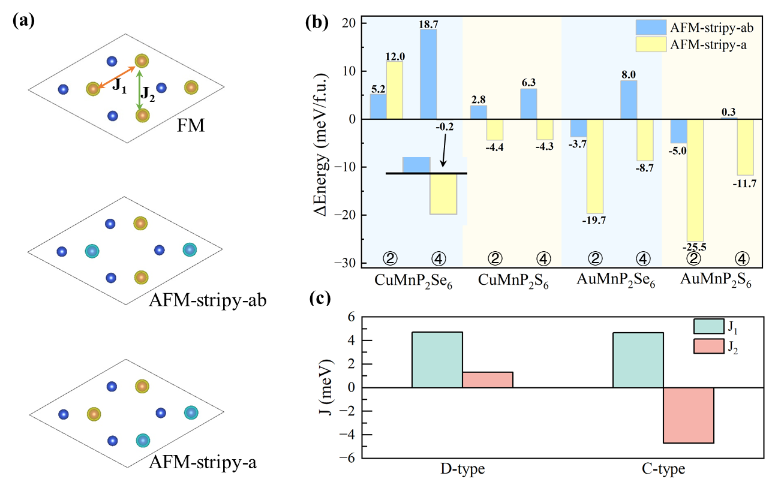
Figure S3. (a) Possible magnetic configurations of 2D XMnP₂S(Se)₆ (X=Cu, Au). Yellow and blue spheres indicate spin-up and spin-down states, respectively. (b) The calculated energies of different magnetic configurations relative to the FM state. (c) The nearest-neighbor and next-nearest neighbor magnetic exchange parameters between Mn ions of 2D CuMnP₂Se₆.
Thermal stability of 2D CuMnP₂Se₆
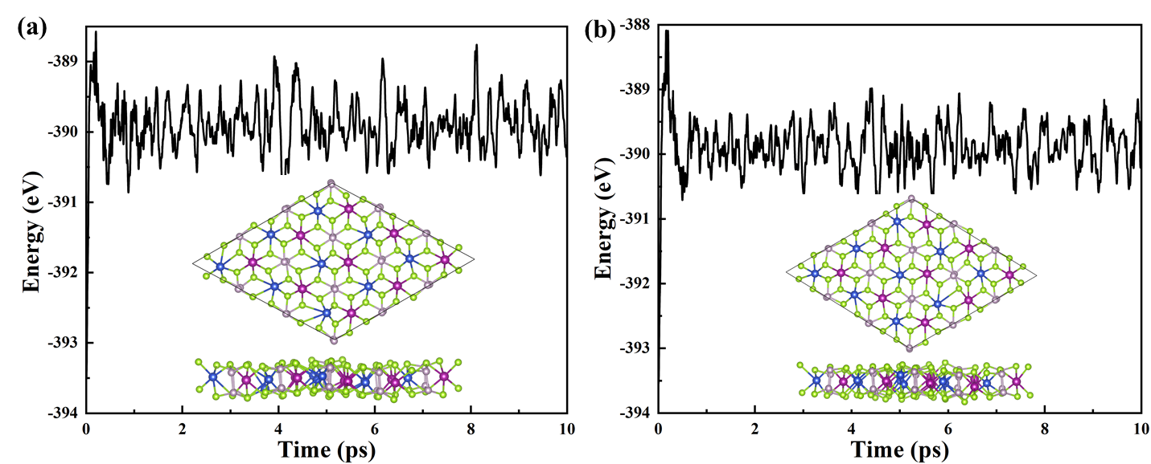
Figure S4. The evolution of energies during AIMD simulations at 300 K of (a) D-type and (b) C-type phases. The insets show structural snapshots captured at the end of the 10-ps simulation period. Blue and purple spheres represent Cu and Mn atoms, respectively, while pink and green spheres represent P and Se atoms, respectively.

Electronic and magnetic properties of 2D CuMnP₂Se₆
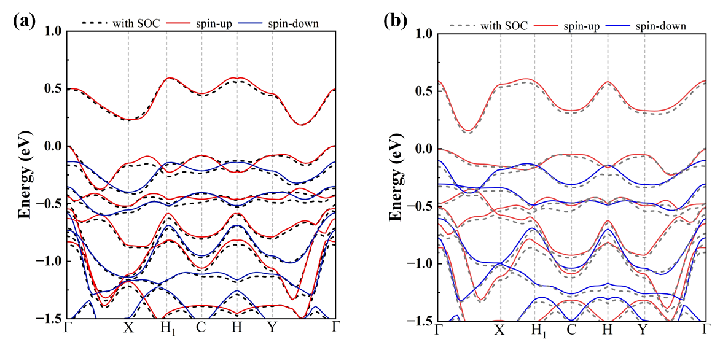
Figure S5. Band structures calculated using the standard PBE method with and without the inclusion of the SOC effect of the (a) D-type and (b) C-type phases.

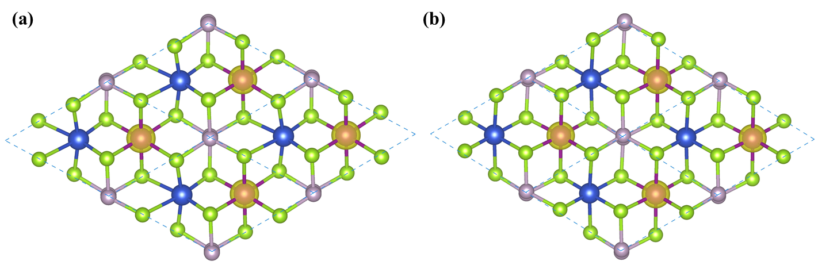
Figure S6. Spin density with an iso-value of 0.06 e/bohr³ for the (a) D-type and (b) C-type phases.
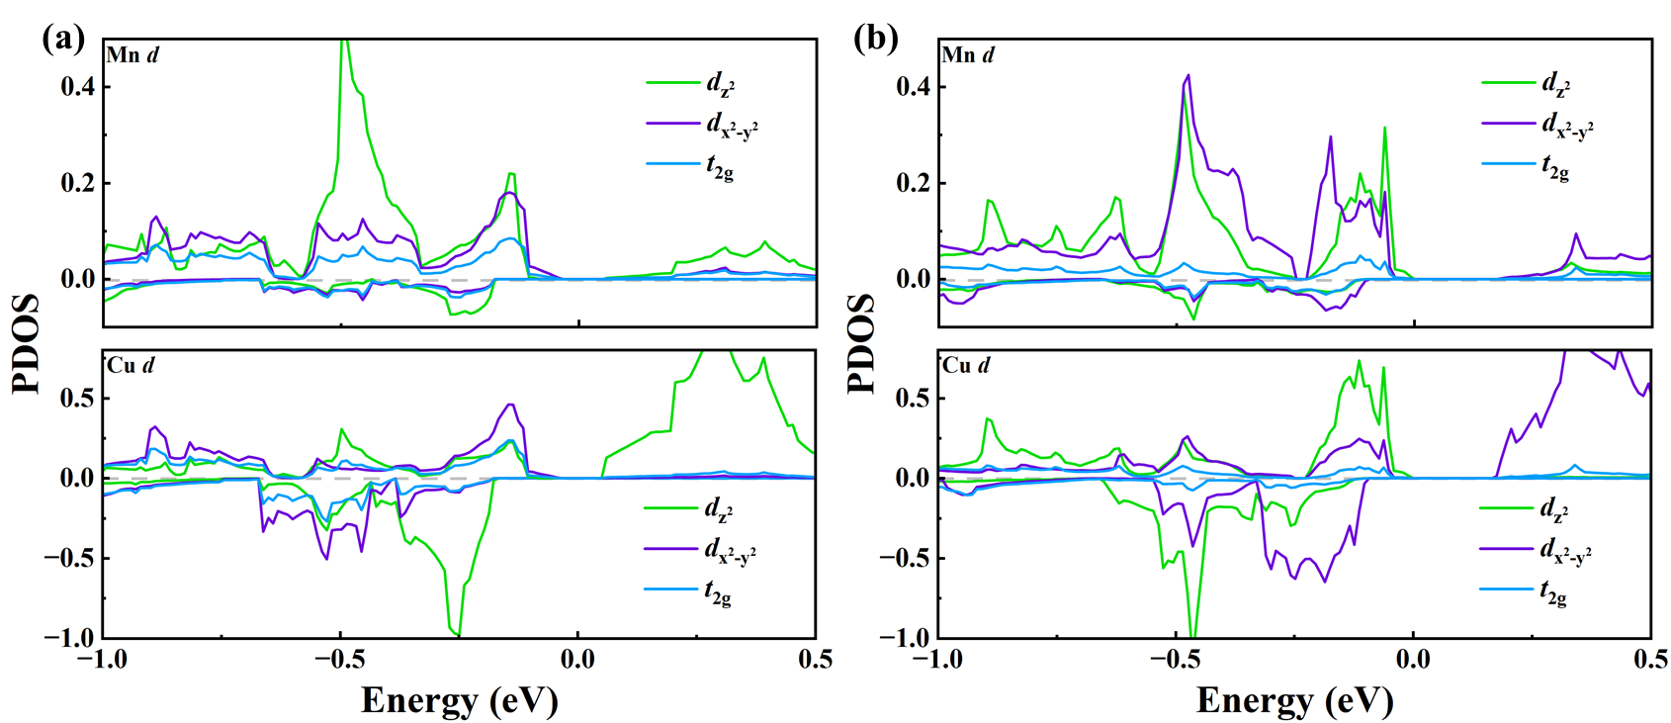
Figure S7. Projected density of states (PDOS) of the Mn/Cu d orbitals for the (a) D-type and (b) C-type phases.

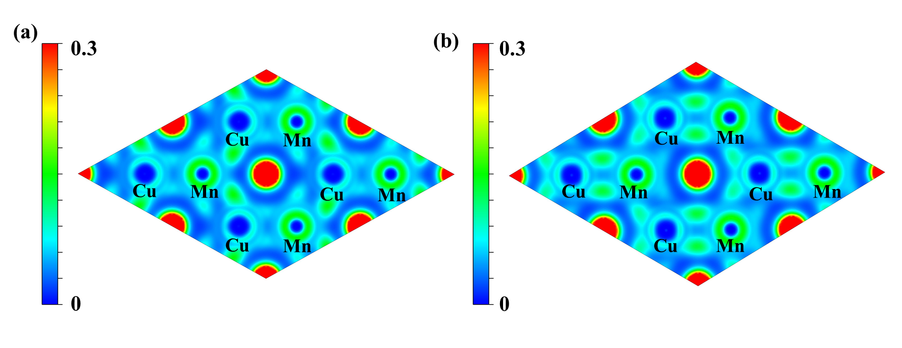
Figure S8. Maps of 2D electron localization function with a scale bar from 0 to 0.3 for the (a) D-type and (b) C-type phases.
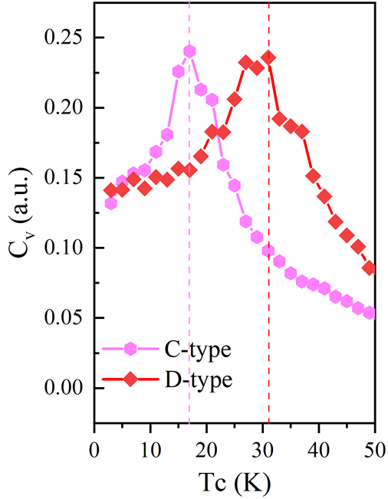
Figure S9. Specific heat as a function of temperature for the D-type and C-type phases.
Ferroelectric properties of 2D CuMnP₂Se₆
Electric polarization calculations
Unlike conventional ferroelectrics, where polarization reverses continuously under an applied electric field, the polarization switching in 2D CuMnP₂Se₆ involves a phase transition between the D-type and C-type phases. During this transition, the dipole moment does not evolve continuously. Additionally, some intermediate structures along the transition path are found to be metallic, precluding a well-defined polarization. Thus, we estimate the spontaneous polarization of the C- and D-type phases relative to a nonpolar reference structure near the transition state, which adopts a nonpolar D₃-symmetry phase. Note: the polarization quantum is calculated to be ~0.51 × 10⁻⁹ C/m.

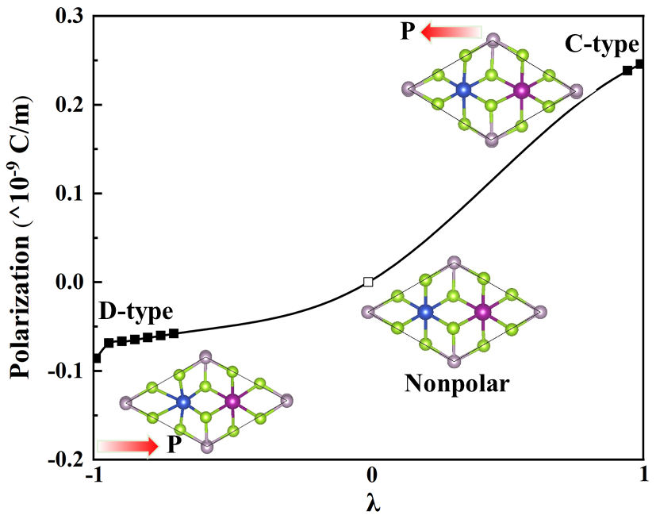
Figure S10. Electric polarization of C₂-CuMnP₂Se₆ evaluated using the Berry phase method. We start from the D-type phase and construct a path to the C-type phase by introducing a dimensionless parameter λ. The dimensionless parameter represents the normalized amplitude of the displacive path which connects D-type (λ=-1) and C-type (λ=1) phases.

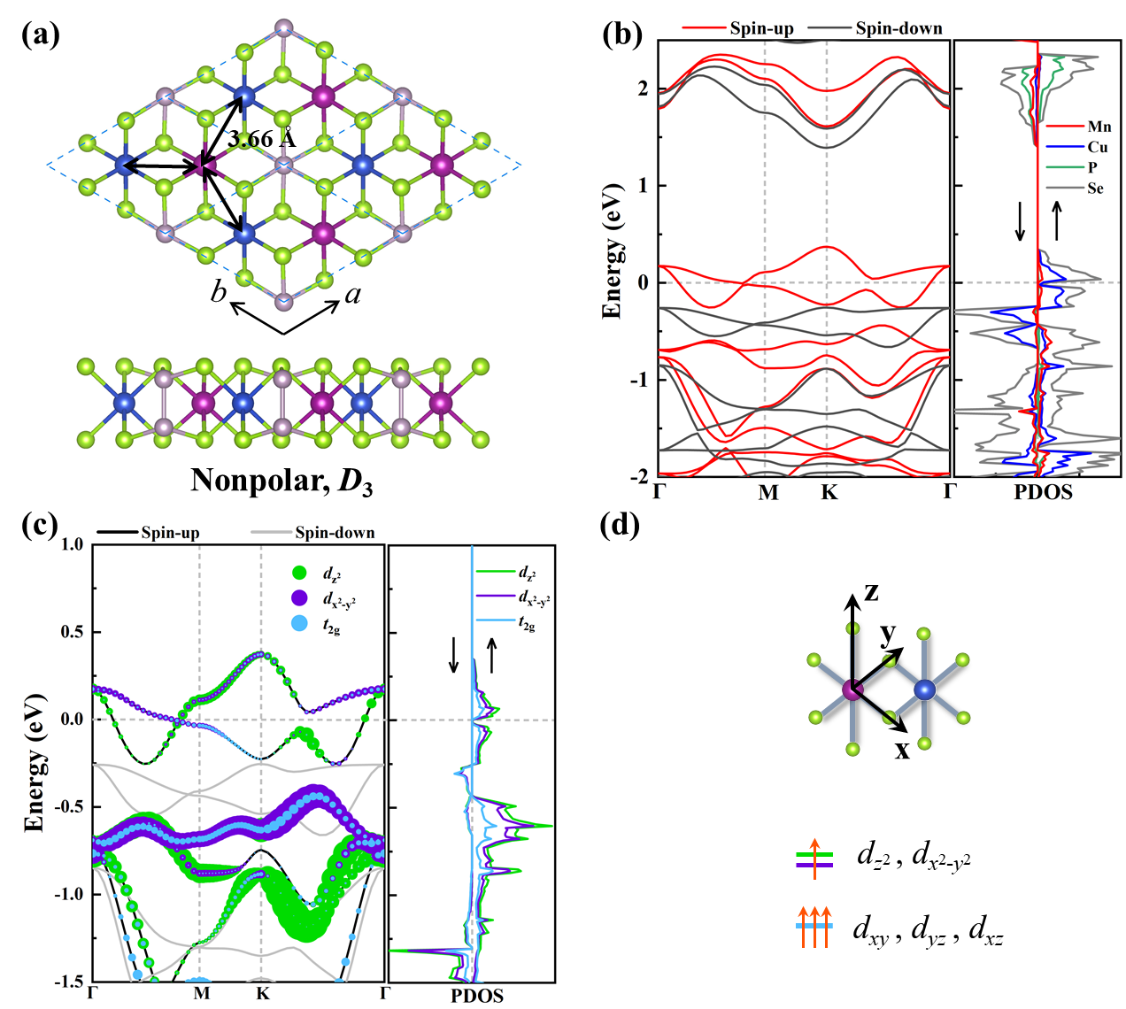
Figure S11. (a) Top and side view of the crystal structures of the nonpolar phase CuMnP₂Se₆, shown in a 2 × 2 supercell. (b) Spin-polarized band structures and projected density of states (PDOS) for the nonpolar phase. (c) Orbital-resolved band structures projected onto Mn d orbitals. (d) On-site Mn d orbital energy levels.

Biaxial strain effect on 2D CuMnP₂Se₆
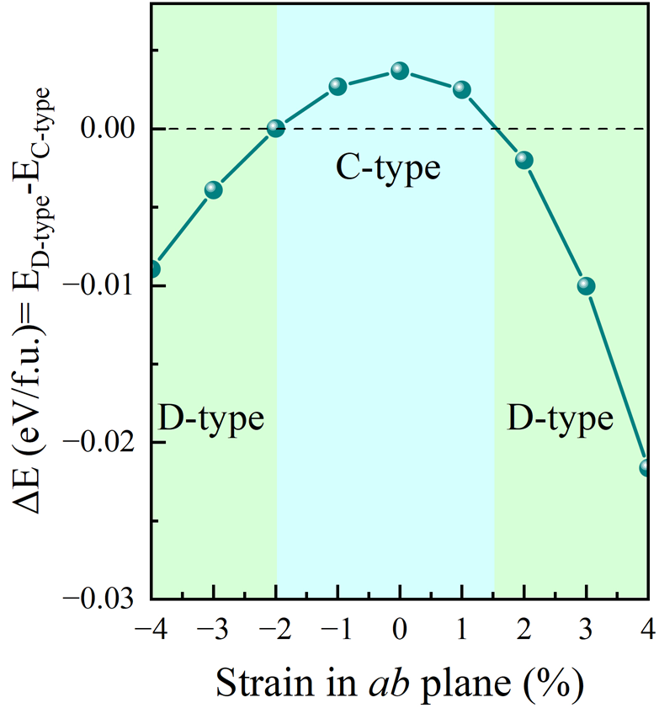
Figure S12. The calculated energies of C-type and D-type phases as a function of biaxial strain relative to the C-type phase.

Relative on-site energies calculations
Table SI. Relative on-site energies for Mn-d orbitals of CuMnP₂Se₆ monolayer derived from the Maximumly Localized Wannier Functions (MLWFs) constructed by using the Wannier90 package.
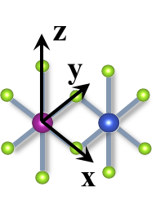
Mn | D-type | C-type
Mn | ↑ | ↑
d_{x}2_{-y}2 | -7.646668 | -1.212646
d_{z}2 | -1.394782 | -7.736580
d_{xz} | -7.639762 | -7.744565
d_{yz} | -7.498499 | -7.529285
d_{xy} | -7.543701 | -7.404928

The consistency of band structures obtained by MLWFs interpolation and first-principles calculations
A comparison of band structures obtained through MLWF interpolation with those calculated by first-principles calculations is shown in Fig. S15. The Wannier interpolated band structures (the blue lines) show excellent agreement with those obtained by first-principles calculations (the red lines). This forms a solid foundation for subsequent calculations on on-site energies for Mn-d orbitals.
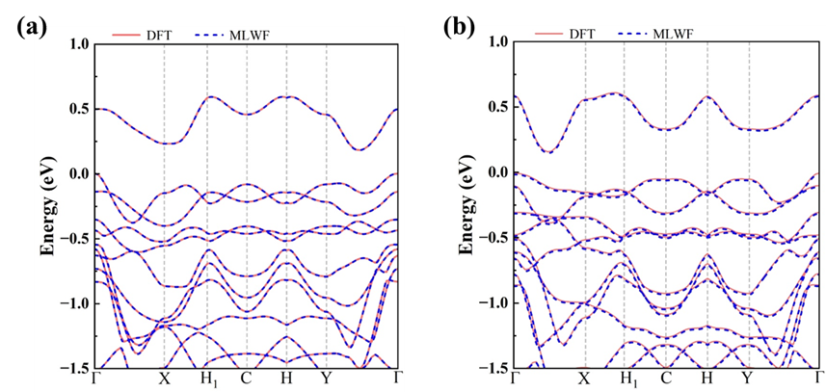
Figure S13. The calculated band structures of (a) D-type and (b) C-type phases of 2D CuMnP₂Se₆ calculated by MLWFs interpolation and first-principles calculations.
The POSCAR files of 2D C₂-CuMnP₂Se₆ used by VASP
D-type:
1.0
3.1252274758788996 -5.6143135762236716 0.0000000000000000
3.1252274758788996 5.6143135762236716 0.0000000000000000
0.0000000000000018 0.0000000000000000 30.0000000000000000
Mn Cu P Se
1 1 2 6
Direct
0.6620825576895810 0.3379174423104190 0.5000000000000000
0.3570924930399481 0.6429075069600521 0.5000000000000000
0.0083800623171617 0.0105347720124145 0.4626914809598364
0.9894652279875855 0.9916199376828383 0.5373085190401636
0.0294463618809418 0.3621527151498375 0.4469095122671729
0.6661617246129048 0.6779083811879383 0.4407298048094290
0.3326980948806637 0.0053124872670864 0.4419720097803017
0.6378472848501624 0.9705536381190583 0.5530904877328271
0.3220916188120618 0.3338382753870952 0.5592701951905710
0.9946875127329136 0.6673019051193363 0.5580279902196983

C-type:
1.0
3.2307407168539433 -5.4181331662227796 0.0000000000000000
3.2307407168539433 5.4181331662227796 0.0000000000000000
0.0000000000000018 0.0000000000000000 30.0000000000000000
Mn Cu P Se
1 1 2 6
Direct
0.6782330243244012 0.3217669756755989 0.5000000000000000
0.3319617800973719 0.6680382199026282 0.5000000000000000
0.9936428441963356 0.9858272925847636 0.4627459148226510
0.0141727074152364 0.0063571558036643 0.5372540851773491
0.9961805382010829 0.3151803359264693 0.4393157583145651
0.6496297726818924 0.6558178821630265 0.4465714456887362
0.3251360399923101 0.9645386493191475 0.4441203839843969
0.0354613506808525 0.6748639600076899 0.5558796160156031
0.3441821178369735 0.3503702273181076 0.5534285543112638
0.6848196640735307 0.0038194617989171 0.5606842416854350

The effect of Hubbard U terms on energy ordering
Table SII. Relative energies of different magnetic orders with respect to the ferromagnetic state, calculated for both D-type and C-type phases using various Hubbard U values. Although the energy differences between competing magnetic configurations are small, they are not very insensitive to the choice of Hubbard U parameters, confirming the robustness of the magnetic ground state ordering.

Relative energy (meV/f.u.) |  | U_{Mn}=4, U_{Cu}= 3 | U_{Mn}=4, U_{Cu}= 4 | U_{Mn}=4, U_{Cu}= 5 | U_{Mn}=3, U_{Cu}= 3
D-type | FM | 0 | 0 | 0 | 0
D-type | AFMa | 11.9 | 12 | 13.2 | 19.1
D-type | AFMab | 5.2 | 5.2 | 7.1 | 9.6
C-type | FM | 0 | 0 | 0 | 0
C-type | AFMa | -0.01 | -0.2 | 0.5 | -0.1
C-type | AFMab | 13.7 | 18.7 | 14.3 | 14.5

Table SIII. Relative total energies of the D-type and C-type phases with ferromagnetic ordering, referenced to the C-type phase, calculated using different Hubbard U values. The energy difference between D-type and C-type is unchanged at different Hubbard U terms.

Relative energy (meV/f.u.) | U_{Mn}=4, U_{Cu}= 3 | U_{Mn}=4, U_{Cu}= 4 | U_{Mn}=4, U_{Cu}= 5 | U_{Mn}=3, U_{Cu}= 3
FM D-type | 2.8 | 3.9 | 4.1 | 2.2
FM C-type | 0 | 0 | 0 | 0

Reference
[1] Qingyang Wang, Mengmeng Niu, Weikang Zhou, Yicheng Ma, Chun Huang, Gege Yang, Yan Shao, Xu Wu, Cong Wang, Wei Ji, et al., “Magnetic and multiferroic properties of two-dimensional FePX₃ and CuFeP₂X₆ (X= S, Se, and Te),” ACS Applied Electronic Materials (2025).
[2] Xunkai Duan, Hua Wang, Xiaofang Chen, and Jingshan Qi, “Multiple polarization phases and strong magnetoelectric coupling in the layered transition metal phosphorus chalcogenides TMP₂X₆ (T= Cu, Ag; M= Cr, V; X= S, Se) by controlling the interlayer interaction and dimension,” Physical Review B 106, 115403 (2022).
[3] Dehe Zhang, Aolin Li, Xincheng Chen, Wenzhe Zhou, and Fangping Ouyang, “Tuning valley splitting and magnetic anisotropy of multiferroic CuMP₂X₆ (M= Cr, V; X= S, Se) monolayer,” Physical Review B 105, 085408 (2022).

