Supplemental Materials
Table S1: Input DNA concentration of eDNA samples from the GRP. The following values are post-inhibitor removal. Sample ID represents the pond collected from, followed by collection month/year and input DNA as measured on a Qubit fluorometer using a high sensitivity assay.
Sample ID | Date Sampled | Input DNA (ng/uL)
Long Pond | May 2022 | 10.6
Grove Pond | May 2022 | 11.9
Twin Pond | May 2022 | 1.6
Yellow Flower Pond | May 2022 | 3.7
Cabin Pond | May 2022 | 3.0
Knob Pond | May 2022 | 22.0
Long Pond | August 2022 | 0.7
Grove Pond | August 2022 | 14.3
Yellow Flower Pond | August 2022 | 5.6
Cabin Pond | August 2022 | 10.7
Twin Pond | August 2022 | 0.3
Knob Pond | August 2022 | 0.5
Luccio’s Pond | August 2022 | >50.0
Vinegar Ridge | August 2022 | 16.3
Long Pond | November 2022 | 0.3
Grove Pond | November 2022 | 0.4
Cabin Pond | November 2022 | 0.6
Knob Pond | November 2022 | 43.0
Vinegar Ridge | November 2022 | 44.2
Luccio’s Pond | November 2022 | 18.6
Long Pond | February 2023 | 1.2
Grove Pond | February 2023 | 0.4
Twin Pond | February 2023 | 5.9
Cabin Pond | February 2023 | 0.6
Knob Pond | February 2023 | 2.3
Luccio’s Pond | February 2023 | 8.5
Vinegar Ridge | February 2023 | 4.0
Long Pond | May 2023 | 1.4
Grove Pond | May 2023 | 0.6
Knob Pond | May 2023 | 2.9
Cabin Pond | May 2023 | 16.5
Luccio’s Pond | May 2023 | 1.7
Vinegar Ridge | May 2023 | 4.7

Table S2: List of primers utilized in library preparation. Blue text represents locus-specific 12S primers, green text represents Illumina Read 1/Read 2 sites, red text represents Illumina P1/P2 flow cell bindings sites, and purple N’s represent the sample-specific barcode sites (index 1/index2). The human blocking primer is abbreviated as “batra_blk.” The batra assay was designed to amplify amphibian DNA by Valentini et al., 2016 – internal indexes followed the methods described by Glenn et al., 2019; which is also where the annealing of the iTru adapters is described for amplicon libraries.
Primer ID | Sequence
batra_F | 5'- ACACTCTTTCCCTACACGACGCTCTTCCGATCT – NNNNNN – ACACCGCCCGTCACCCT - 3'
batra_R | 5' - GTGACTGGAGTTCAGACGTGTGCTCTTCCGATCT– NNNNNN – GTAYACTTACCATGTTACGACTT - 3'
batra_blk | 5’ - TCACCCTCCTCAAGTATACTTCAAAGGCA-SPC3I - 3’
iTru5 set 13 | 5' - AATGATACGGCGACCACCGAGATCTACAC - NNNNNNNN - ACACTCTTTCCCTAC - 3'
iTru7 set 107 | 5' - CAAGCAGAAGACGGCATACGAGAT - NNNNNNNN - GTGACTGGAGTTCAG - 3'

Table S3: PCR 1 reaction conditions. Each sample was run in duplicate. PCR products were checked via gel electrophoresis on a 1.5% agarose gel.
Step | Temperature | Duration | Cycles
Initial denaturation | 98 °C | 30 seconds | 1
Denaturation | 98 °C | 10 seconds | 40
Annealing | 57 °C | 75 seconds | 40
Extension | 65 °C | 75 seconds | 40
Final extension | 65 °C | 5 minutes | 1

Table S4: PCR 1 reaction components. NEBNext Q5 Hot Start HiFi Master Mix (2X) is sourced via New England BioLabs #M0543L, Ipswich, MA. The human blocking primer was developed by Osman et al. 2022.
Component | Volume (μL) | Final Concentration
NEBNext Q5 Hot Start HiFi Master Mix (2X) | 12.5 | 1X
Forward primer (10 μM) | 0.5 | 0.2 μM
Reverse primer (10 μM) | 0.5 | 0.2 μM
Human blocking primer (10 μM) | 2.5 | 1.0 μM
Template DNA (eDNA) | 9.0 | —
*For mock community reactions, template DNA = 1.0 μL; nuclease-free water = 8.0 μL.

Table S5: Mock community composition and dilution scale. Each sample was normalized to a 10 ng/uL concentration and was diluted accordingly, so that each of the six species were equally represented.
GB accession # | Species | Starting conc. (ng/uL)
PQ816554 | Dryophytes versicolor | 11.1
PQ816554 | Anaxyrus fowleri | 16.3
PQ816557 | Lithobates clamitans | 28.1
PQ816567 | Notophthalmus viridescens | 22.9
PQ816544 | Ambystoma tigrinum | 43.9
PQ816553 | Hemidactylium scutatum | 44.4
Dilution factor | uL DNA | uL H₂O
1.0 | 5 | 5
0.5 | 10 of previous | 10
0.1 | 4 of previous | 16
0.01 | 2 of previous | 18
0.001 | 2 of previous | 18

Table S6: PCR 2 reaction conditions. Six replicate reactions were run and pooled prior to final bead purification and library QC.
Step | Temperature | Duration | Cycles
Initial denaturation | 98 °C | 30 seconds | 1
Denaturation | 98 °C | 10 seconds | 15
Annealing/Extension | 65 °C | 75 seconds | 15
Final extension | 65 °C | 5 minutes | 1

Table S7: PCR 2 reaction components
Component | Volume (μL) | Final Concentration
NEBNext Q5 Hot Start HiFi Master Mix (2X) | 12.5 | 1X
Forward primer (10 μM) | 0.63 | 0.25 μM
Reverse primer (10 μM) | 0.63 | 0.25 μM
Cleaned PCR 1 product | 2.5 | —
Nuclease-free water | 8.74 | —

Table S8: Amphibian ASV assignments. Taxonomic assignments were made using a local version of the full nucleotide database from NCBI (December 2024) and blastn in the blast+suite. The top hit was considered the most likely candidate and therefore used in downstream analyses. A minimum identity threshold of 97% was used in assignments; this allowed us to make genera level assignments in ASVs from species like Ambystoma that lack reference data for likely candidates, such as Ambystoma maculatum and Ambystoma opacum and is reflected in lower identity scores. Note that the vast majority of ASVs were filtered out due to non-target amplification, such as algae, bacteria, other vertebrates, etc.
ASV | Source | Accession | Identity | Length (bp) | E-value | Score | Description
ASV2 | gb | GU989082.1 | 100 | 68 | 6.48E-25 | 126 | Hyla chrysoscelis voucher KEK HCH61 12S ribosomal RNA gene, partial sequence; tRNA-Val gene, complete sequencel; and 16S ribosomal RNA gene,partial sequence; mitochondrial
ASV3 | gb | KY677802.1 | 100 | 70 | 5.30E-26 | 130 | Lithobates clamitans isolate NWHC 4824-454 12S ribosomal RNA gene, partial sequence; tRNA-Val gene, complete sequence; and 16S ribosomal RNA gene, partial sequence; mitochondrial
ASV4 | ref | NC_006887.1 | 98.571 | 70 | 2.47E-24 | 124 | Ambystoma tigrinum tigrinum mitochondrion, complete genome
ASV5 | gb | FJ882827.1 | 100 | 71 | 1.52E-26 | 132 | Anaxyrus americanus voucher CAS 207258 12S ribosomal RNA, tRNA-Val, 16S ribosomal RNA, tRNA-Leu, NADH dehydrogenase subunit 1, tRNA-Ile, tRNA-Gln, tRNA-Met, and NADH dehydrogenase subunit 2-like gene, partial sequence; mitochondrial
ASV5 | gb | DQ158451.1 | 100 | 71 | 1.52E-26 | 132 | Anaxyrus fowleri voucher USNM 314864 12S ribosomal RNA gene, partial sequence; tRNA-Val gene, complete sequence; and 16S ribosomal RNA gene, partial sequence; mitochondrial
ASV12 | gb | MN241124.1 | 100 | 70 | 5.30E-26 | 130 | Aquarana catesbeiana mitochondrion, complete genome
ASV20 | gb | DQ283120.1 | 100 | 66 | 7.89E-24 | 122 | Hemidactylium scutatum voucher UMFS 11564 12S ribosomal RNA gene, partial sequence; tRNA-Val gene, complete sequence; and 16S ribosomal RNA gene, partial sequence; mitochondrial
ASV25 | gb | EF472007.1 | 97.059 | 68 | 1.40E-21 | 115 | Pseudacris crucifer isolate TNHC62221 12S ribosomal RNA, partial sequence; tRNA-Val, complete sequence; and 16S ribosomal RNA gene, partial sequence; mitochondrial
ASV26 | gb | EF472007.1 | 98.529 | 68 | 3.01E-23 | 121 | Pseudacris crucifer isolate TNHC62221 12S ribosomal RNA, partial sequence; tRNA-Val, complete sequence; and 16S ribosomal RNA gene, partial sequence; mitochondrial
ASV30 | gb | GU989082.1 | 100 | 69 | 1.91E-25 | 128 | Hyla chrysoscelis voucher KEK HCH61 12S ribosomal RNA gene, partial sequence; tRNA-Val gene, complete sequencel; and 16S ribosomal RNA gene,partial sequence; mitochondrial
ASV35 | gb | DQ283421.1 | 100 | 70 | 5.30E-26 | 130 | Notophthalmus viridescens voucher AMCC 106084 12S ribosomal RNA gene, partial sequence; tRNA-Val gene, complete sequence; and 16S ribosomal RNA gene, partial sequence; mitochondrial
ASV67 | gb | MN241124.1 | 100 | 72 | 4.33E-27 | 134 | Aquarana catesbeiana mitochondrion, complete genome
ASV69 | gb | FJ882827.1 | 100 | 73 | 1.23E-27 | 135 | Anaxyrus americanus voucher CAS 207258 12S ribosomal RNA, tRNA-Val, 16S ribosomal RNA, tRNA-Leu, NADH dehydrogenase subunit 1, tRNA-Ile, tRNA-Gln, tRNA-Met, and NADH dehydrogenase subunit 2-like gene, partial sequence; mitochondrial
ASV69 | gb | DQ158451.1 | 100 | 73 | 1.23E-27 | 135 | Anaxyrus fowleri voucher USNM 314864 12S ribosomal RNA gene, partial sequence; tRNA-Val gene, complete sequence; and 16S ribosomal RNA gene, partial sequence; mitochondrial
ASV72 | gb | DQ283120.1 | 100 | 68 | 6.48E-25 | 126 | Hemidactylium scutatum voucher UMFS 11564 12S ribosomal RNA gene, partial sequence; tRNA-Val gene, complete sequence; and 16S ribosomal RNA gene, partial sequence; mitochondrial
ASV77 | gb | KY677802.1 | 100 | 72 | 4.33E-27 | 134 | Lithobates clamitans isolate NWHC 4824-454 12S ribosomal RNA gene, partial sequence; tRNA-Val gene, complete sequence; and 16S ribosomal RNA gene, partial sequence; mitochondrial
ASV85 | ref | NC_006887.1 | 98.611 | 72 | 2.01E-25 | 128 | Ambystoma tigrinum tigrinum mitochondrion, complete genome
ASV131 | gb | EF472007.1 | 98.571 | 70 | 2.47E-24 | 124 | Pseudacris crucifer isolate TNHC62221 12S ribosomal RNA, partial sequence; tRNA-Val, complete sequence; and 16S ribosomal RNA gene, partial sequence; mitochondrial
ASV149 | gb | KY677785.1 | 100 | 72 | 4.33E-27 | 134 | Lithobates sylvaticus isolate NWHC 4766-047 12S ribosomal RNA gene, partial sequence; tRNA-Val gene, complete sequence; and 16S ribosomal RNA gene, partial sequence; mitochondrial
ASV172 | gb | EF472007.1 | 97.143 | 70 | 1.15E-22 | 119 | Pseudacris crucifer isolate TNHC62221 12S ribosomal RNA, partial sequence; tRNA-Val, complete sequence; and 16S ribosomal RNA gene, partial sequence; mitochondrial
ASV183 | gb | KY677785.1 | 100 | 70 | 5.30E-26 | 130 | Lithobates sylvaticus isolate NWHC 4766-047 12S ribosomal RNA gene, partial sequence; tRNA-Val gene, complete sequence; and 16S ribosomal RNA gene, partial sequence; mitochondrial
ASV197 | gb | KY885249.1 | 98.485 | 66 | 3.67E-22 | 117 | Eurycea cirrigera mitochondrion, complete genome
ASV340 | gb | DQ283421.1 | 100 | 72 | 4.33E-27 | 134 | Notophthalmus viridescens voucher AMCC 106084 12S ribosomal RNA gene, partial sequence; tRNA-Val gene, complete sequence; and 16S ribosomal RNA gene, partial sequence; mitochondrial
ASV372 | gb | PQ816550 | 98.039 | 51 | 9.00E-14 | 89.8 | Eurycea lucifuga isolate JRJ-9193 small subunit ribosomal RNA gene, partial sequence; mitochondrial
ASV420 | ref | NC_006887.1 | 100 | 70 | 5.30E-26 | 130 | Ambystoma tigrinum tigrinum mitochondrion, complete genome
ASV462 | ref | NC_006887.1 | 100 | 72 | 4.33E-27 | 134 | Ambystoma tigrinum tigrinum mitochondrion, complete genome
ASV606 | gb | KX269207.1 | 97.222 | 72 | 9.37E-24 | 122 | Lithobates palustris isolate ROM21658 12S ribosomal RNA gene, partial sequence; tRNA-Val gene, complete sequence; and 16S ribosomal RNA gene, partial sequence; mitochondrial
ASV667 | gb | EU880323.1 | 98.551 | 69 | 8.63E-24 | 122 | Notophthalmus viridescens mitochondrion, partial genome
ASV697 | gb | AY843559.1 | 97.059 | 68 | 1.40E-21 | 115 | Acris crepitans 12S ribosomal RNA gene, partial sequence; tRNA-Val gene, complete sequence; and 16S ribosomal RNA gene, partial sequence; mitochondrial

Table S9: Longitudinal metadata associated with positive hits for both visual encounter surveys (VES) and metabarcoding (MB), including sample (site + sampling time), date sampled, site abbreviation, species observed (note the exception to species-level observations in the MB data for Ambystoma and Anaxyrus), survey type, pond hydrology, and total number of species observed.

Sample |  | Date |  | Site |  | Species Observed |  | Survey Type |  | Pond Type |  | # Species
 | CA5 |  | May-22 |  | CA |  | Acris crepitans, Lithobates catesbeiana, Lithobates sphenocephala |  | VES |  | PER |  | 3
 | GR5 |  | May-22 |  | GR |  | Acris crepitans, Ambystoma maculatum, Anaxyrus fowleri, Dryophytes chrysoscelis, Notophthalmus viridescens, Pseudacris crucifer, Lithobates sphenocephala |  | VES |  | EPH |  | 7
 | KN5 |  | May-22 |  | KN |  | Ambystoma maculatum, Notophthalmus viridescens, Pseudacris crucifer |  | VES |  | PER |  | 3
 | LO5 |  | May-22 |  | LO |  | Acris crepitans, Dryophytes chrysoscelis, Lithobates clamitans |  | VES |  | PER |  | 3
 | TW6 |  | May-22 |  | TW |  | Acris crepitans, Ambystoma maculatum, Dryophytes chrysoscelis, Pseudacris crucifer, Lithobates sphenocephala, Lithobates sylvatica |  | VES |  | EPH |  | 6
 | YE6 |  | May-22 |  | YE |  | Acris crepitans, Dryophytes chrysoscelis, Notophthalmus viridescens, Pseudacris crucifer, Lithobates clamitans |  | VES |  | EPH |  | 5
 | CA8 |  | Aug-22 |  | CA |  | Notophthalmus viridescens |  | VES |  | PER |  | 1
 | GR8 |  | Aug-22 |  | GR |  | Acris crepitans, Lithobates sphenocephala |  | VES |  | EPH |  | 2
 | KN8 |  | Aug-22 |  | KN |  | Notophthalmus viridescens |  | VES |  | PER |  | 1
 | LO8 |  | Aug-22 |  | LO |  | Pseudacris crucifer |  | VES |  | PER |  | 1
 | LU8 |  | Aug-22 |  | LU |  | Notophthalmus viridescens |  | VES |  | PER |  | 1
 | TW8 |  | Aug-22 |  | TW |  | Dryophytes chrysoscelis |  | VES |  | EPH |  | 1
 | VR8 |  | Aug-22 |  | VR |  | Notophthalmus viridescens |  | VES |  | EPH |  | 1
 | YE8 |  | Aug-22 |  | YE |  | none |  | VES |  | EPH |  | 0
 | CA11 |  | Nov-22 |  | CA |  | Lithobates clamitans |  | VES |  | PER |  | 1
 | GR11 |  | Nov-22 |  | GR |  | Lithobates catesbeiana, Lithobates clamitans |  | VES |  | EPH |  | 2
 | KN11 |  | Nov-22 |  | KN |  | Notophthalmus viridescens, Plethodon dorsalis, Lithobates clamitans |  | VES |  | PER |  | 3
 | LO11 |  | Nov-22 |  | LO |  | Notophthalmus viridescens, Lithobates clamitans |  | VES |  | PER |  | 2
 | LU11 |  | Nov-22 |  | LU |  | Notophthalmus viridescens |  | VES |  | PER |  | 1
 | VR11 |  | Nov-22 |  | VR |  | Acris crepitans, Notophthalmus viridescens, Lithobates clamitans |  | VES |  | EPH |  | 3
 | CA2 |  | Feb-23 |  | CA |  | Notophthalmus viridescens, Lithobates catesbeiana, Lithobates clamitans, Lithobates sphenocephala |  | VES |  | PER |  | 4
 | GR2 |  | Feb-23 |  | GR |  | Notophthalmus viridescens, Pseudacris crucifer |  | VES |  | EPH |  | 2
 | KN2 |  | Feb-23 |  | KN |  | Notophthalmus viridescens, Plethodon dorsalis, Lithobates clamitans |  | VES |  | PER |  | 3
 | LO2 |  | Feb-23 |  | LO |  | Notophthalmus viridescens |  | VES |  | PER |  | 1
 | LU2 |  | Feb-23 |  | LU |  | Ambystoma opacum, Notophthalmus viridescens, Plethodon dorsalis |  | VES |  | PER |  | 3
 | TW2 |  | Feb-23 |  | TW |  | Ambystoma jeffersonianum, Ambystoma maculatum, Notophthalmus viridescens, Lithobates sylvatica |  | VES |  | EPH |  | 5
 | YE2 |  | Feb-23 |  | YE |  | Ambystoma jeffersonianum, Ambystoma maculatum |  | VES |  | EPH |  | 2
 | VR2 |  | Feb-23 |  | VR |  | Ambystoma opacum, Ambystoma maculatum, Notophthalmus viridescens, Lithobates clamitans |  | VES |  | EPH |  | 4
 | CA6 |  | May-23 |  | CA |  | Acris crepitans, Notophthalmus viridescens, Lithobates catesbeiana, Lithobates clamitans, Lithobates pipiens, Lithobates sphenocephala |  | VES |  | PER |  | 6
 | GR6 |  | May-23 |  | GR |  | Acris crepitans, Notophthalmus viridescens, Pseudacris crucifer, Lithobates clamitans |  | VES |  | EPH |  | 4
 | KN6 |  | May-23 |  | KN |  | Ambystoma maculatum, Ambystoma opacum, Notophthalmus viridescens, Pseudacris crucifer, Lithobates clamitans |  | VES |  | PER |  | 5
 | LO6 |  | May-23 |  | LO |  | Acris crepitans, Notophthalmus viridescens, Lithobates clamitans |  | VES |  | PER |  | 3
 | LU5 |  | May-23 |  | LU |  | Acris crepitans, Notophthalmus viridescens, Lithobates catesbeiana, Lithobates clamitans |  | VES |  | PER |  | 4
 | VR5 |  | May-23 |  | VR |  | Acris crepitans, Ambystoma maculatum, Notophthalmus viridescens, Plethodon glutinosus, Lithobates clamitans |  | VES |  | EPH |  | 5
 | YE5 |  | May-23 |  | YE |  | Acris crepitans, Notophthalmus viridescens |  | VES |  | EPH |  | 2
 | CA5 |  | May-22 |  | CA |  | Dryophytes chrysoscelis, Pseudacris crucifer |  | MB |  | PER |  | 2
 | GR5 |  | May-22 |  | GR |  | Ambystoma, Anaxyrus, Dryophytes chrysoscelis, Lithobates clamitans, Pseudacris crucifer |  | MB |  | EPH |  | 5
 | KN5 |  | May-22 |  | KN |  | Ambystoma, Dryophytes chrysoscelis, Pseudacris crucifer |  | MB |  | PER |  | 3
 | LO5 |  | May-22 |  | LO |  | Ambystoma, Anaxyrus, Dryophytes chrysoscelis, Lithobates clamitans, Pseudacris crucifer |  | MB |  | PER |  | 5
 | TW6 |  | May-22 |  | TW |  | Ambystoma, Anaxyrus, Dryophytes chrysoscelis, Lithobates clamitans |  | MB |  | EPH |  | 4
 | YE6 |  | May-22 |  | YE |  | Anaxyrus, Dryophytes chrysoscelis, Lithobates clamitans, Pseudacris crucifer |  | MB |  | EPH |  | 4
 | CA8 |  | Aug-22 |  | CA |  | Ambystoma, Anaxyrus, Lithobates catesbeiana, Lithobates clamitans |  | MB |  | PER |  | 4
 | GR8 |  | Aug-22 |  | GR |  | Dryophytes chrysoscelis, Lithobates clamitans, Pseudacris crucifer |  | MB |  | EPH |  | 3
 | KN8 |  | Aug-22 |  | KN |  | Ambystoma, Dryophytes chrysoscelis, Lithobates clamitans, Notophthalmus viridescens |  | MB |  | PER |  | 4
 | LO8 |  | Aug-22 |  | LO |  | none |  | MB |  | PER |  | 0
 | LU8 |  | Aug-22 |  | LU |  | Dryophytes chrysoscelis, Lithobates catesbeiana, Notophthalmus viridescens |  | MB |  | PER |  | 3
 | TW8 |  | Aug-22 |  | TW |  | Acris crepitans, Ambystoma, Anaxyrus, Dryophytes chrysoscelis, Hemidactylium scutatum, Lithobates clamitans |  | MB |  | EPH |  | 6
 | VR8 |  | Aug-22 |  | VR |  | Dryophytes chrysoscelis, Lithobates catesbeiana, Pseudacris crucifer |  | MB |  | EPH |  | 3
 | YE8 |  | Aug-22 |  | YE |  | Anaxyrus, Dryophytes chrysoscelis, Lithobates clamitans |  | MB |  | EPH |  | 3
 | CA11 |  | Nov-22 |  | CA |  | Ambystoma, Lithobates catesbeiana |  | MB |  | PER |  | 2
 | GR11 |  | Nov-22 |  | GR |  | Ambystoma, Anaxyrus, Dryophytes chrysoscelis, Lithobates catesbeiana |  | MB |  | EPH |  | 4
 | KN11 |  | Nov-22 |  | KN |  | Lithobates catesbeiana, Lithobates clamitans |  | MB |  | PER |  | 2
 | LO11 |  | Nov-22 |  | LO |  | Ambystoma, Dryophytes chrysoscelis, Lithobates catesbeiana, Lithobates clamitans |  | MB |  | PER |  | 4
 | LU11 |  | Nov-22 |  | LU |  | Anaxyrus, Dryophytes chrysoscelis |  | MB |  | PER |  | 2
 | VR11 |  | Nov-22 |  | VR |  | Anaxyrus, Dryophytes chrysoscelis, Lithobates catesbeiana, Lithobates clamitans |  | MB |  | EPH |  | 4
 | CA2 |  | Feb-23 |  | CA |  | Lithobates catesbeiana |  | MB |  | PER |  | 1
 | GR2 |  | Feb-23 |  | GR |  | Ambystoma, Anaxyrus, Dryophytes chrysoscelis, Lithobates clamitans, Notophthalmus viridescens |  | MB |  | EPH |  | 5
 | KN2 |  | Feb-23 |  | KN |  | none |  | MB |  | PER |  | 0
 | LO2 |  | Feb-23 |  | LO |  | Anaxyrus, Dryophytes chrysoscelis |  | MB |  | PER |  | 2
 | LU2 |  | Feb-23 |  | LU |  | Lithobates clamitans, Pseudacris crucifer |  | MB |  | PER |  | 2
 | TW2 |  | Feb-23 |  | TW |  | Ambystoma, Pseudacris crucifer |  | MB |  | EPH |  | 2
 | YE2 |  | Feb-23 |  | YE |  | n/a |  | MB |  | EPH |  | 0
 | VR2 |  | Feb-23 |  | VR |  | Ambystoma, Anaxyrus, Dryophytes chrysoscelis, Lithobates clamitans |  | MB |  | EPH |  | 4
 | CA6 |  | May-23 |  | CA |  | Ambystoma, Anaxyrus, Dryophytes chrysoscelis, Lithobates catesbeiana, Lithobates clamitans |  | MB |  | PER |  | 5
 | GR6 |  | May-23 |  | GR |  | Anaxyrus, Lithobates clamitans, Lithobates sylvaticus |  | MB |  | EPH |  | 3
 | KN6 |  | May-23 |  | KN |  | Ambystoma, Anaxyrus, Dryophytes chrysoscelis, Lithobates clamitans |  | MB |  | PER |  | 4
 | LO6 |  | May-23 |  | LO |  | Anaxyrus, Dryophytes chrysoscelis, Lithobates clamitans |  | MB |  | PER |  | 3
 | LU6 |  | May-23 |  | LU |  | Ambystoma, Eurycea cirrigera, Pseudacris crucifer |  | MB |  | PER |  | 3
 | TW6 |  | May-23 |  | TW |  | n/a |  | MB |  | EPH |  | 0
 | VR6 |  | May-23 |  | VR |  | Ambystoma, Anaxyrus, Dryophytes chrysoscelis, Lithobates clamitans, Pseudacris crucifer |  | MB |  | EPH |  | 5
 | YE6 |  | May-23 |  | YE |  | n/a |  | MB |  | EPH |  | 0

Table S10: Relative abundance values of cleaned ASV data.
Sample | Date | AcCr | Am | An | DrCr | EuCi | HeSc | LiCa | LiCl | LiPa | LiSy | NoVi | PsCr
CA11 | 22-Nov | 0.00 | 0.98 | 0.00 | 0.00 | 0.00 | 0.00 | 0.03 | 0.00 | 0.00 | 0.00 | 0.00 | 0.00
CA2 | 23-Feb | 0.00 | 0.00 | 0.00 | 0.00 | 0.00 | 0.00 | 1.00 | 0.00 | 0.00 | 0.00 | 0.00 | 0.00
CA5 | 22-May | 0.00 | 0.00 | 0.00 | 0.11 | 0.00 | 0.00 | 0.00 | 0.00 | 0.00 | 0.00 | 0.00 | 0.89
CA6 | 23-May | 0.00 | 0.19 | 0.12 | 0.16 | 0.00 | 0.00 | 0.53 | 0.01 | 0.00 | 0.00 | 0.00 | 0.00
CA8 | 22-Aug | 0.00 | 0.40 | 0.09 | 0.00 | 0.00 | 0.00 | 0.10 | 0.40 | 0.00 | 0.00 | 0.00 | 0.00
GR11 | 22-Nov | 0.00 | 0.20 | 0.04 | 0.28 | 0.00 | 0.00 | 0.47 | 0.00 | 0.00 | 0.00 | 0.00 | 0.00
GR2 | 23-Feb | 0.00 | 0.15 | 0.04 | 0.70 | 0.00 | 0.00 | 0.00 | 0.07 | 0.00 | 0.00 | 0.04 | 0.00
GR5 | 22-May | 0.00 | 0.01 | 0.02 | 0.05 | 0.00 | 0.00 | 0.00 | 0.05 | 0.00 | 0.00 | 0.01 | 0.85
GR6 | 23-May | 0.00 | 0.00 | 0.26 | 0.00 | 0.00 | 0.00 | 0.00 | 0.40 | 0.00 | 0.33 | 0.00 | 0.00
GR8 | 22-Aug | 0.00 | 0.00 | 0.00 | 0.58 | 0.00 | 0.00 | 0.00 | 0.30 | 0.00 | 0.00 | 0.00 | 0.13
KN11 | 22-Nov | 0.00 | 0.00 | 0.00 | 0.00 | 0.00 | 0.00 | 0.97 | 0.03 | 0.00 | 0.00 | 0.00 | 0.00
KN2 | 23-Feb | NA | NA | NA | NA | NA | NA | NA | NA | NA | NA | NA | NA
KN5 | 22-May | 0.00 | 0.50 | 0.00 | 0.18 | 0.00 | 0.00 | 0.00 | 0.00 | 0.00 | 0.00 | 0.00 | 0.32
KN6 | 23-May | 0.00 | 0.27 | 0.22 | 0.28 | 0.00 | 0.00 | 0.00 | 0.23 | 0.00 | 0.00 | 0.00 | 0.00
KN8 | 22-Aug | 0.00 | 0.26 | 0.00 | 0.30 | 0.00 | 0.00 | 0.00 | 0.40 | 0.00 | 0.00 | 0.04 | 0.00
LO11 | 22-Nov | 0.00 | 0.21 | 0.00 | 0.34 | 0.00 | 0.00 | 0.31 | 0.13 | 0.00 | 0.00 | 0.00 | 0.00
LO2 | 23-Feb | 0.00 | 0.00 | 0.22 | 0.78 | 0.00 | 0.00 | 0.00 | 0.00 | 0.00 | 0.00 | 0.00 | 0.00
LO5 | 22-May | 0.00 | 0.26 | 0.08 | 0.37 | 0.00 | 0.00 | 0.00 | 0.22 | 0.00 | 0.00 | 0.00 | 0.07
LO6 | 23-May | 0.00 | 0.00 | 0.11 | 0.63 | 0.00 | 0.00 | 0.00 | 0.26 | 0.00 | 0.00 | 0.00 | 0.00
LO8 | 22-Aug | NA | NA | NA | NA | NA | NA | NA | NA | NA | NA | NA | NA
LU11 | 22-Nov | 0.00 | 0.00 | 0.80 | 0.20 | 0.00 | 0.00 | 0.00 | 0.00 | 0.00 | 0.00 | 0.00 | 0.00
LU2 | 23-Feb | 0.00 | 0.00 | 0.00 | 0.00 | 0.00 | 0.00 | 0.00 | 0.07 | 0.00 | 0.00 | 0.00 | 0.93
LU5 | 23-May | 0.00 | 0.21 | 0.00 | 0.00 | 0.73 | 0.00 | 0.00 | 0.00 | 0.00 | 0.00 | 0.00 | 0.05
LU8 | 22-Aug | 0.00 | 0.00 | 0.00 | 0.16 | 0.00 | 0.00 | 0.79 | 0.00 | 0.00 | 0.00 | 0.06 | 0.00
TW2 | 23-Feb | 0.00 | 0.30 | 0.00 | 0.00 | 0.00 | 0.00 | 0.00 | 0.00 | 0.00 | 0.00 | 0.00 | 0.70
TW6 | 22-May | 0.00 | 0.47 | 0.19 | 0.08 | 0.00 | 0.00 | 0.00 | 0.26 | 0.00 | 0.00 | 0.00 | 0.00
TW8 | 22-Aug | 0.03 | 0.23 | 0.12 | 0.21 | 0.00 | 0.06 | 0.00 | 0.35 | 0.00 | 0.00 | 0.00 | 0.00
VR11 | 22-Nov | 0.00 | 0.00 | 0.07 | 0.32 | 0.00 | 0.00 | 0.53 | 0.09 | 0.00 | 0.00 | 0.00 | 0.00
VR2 | 23-Feb | 0.00 | 0.22 | 0.26 | 0.34 | 0.00 | 0.00 | 0.00 | 0.18 | 0.00 | 0.00 | 0.00 | 0.00
VR5 | 23-May | 0.00 | 0.02 | 0.04 | 0.13 | 0.00 | 0.00 | 0.00 | 0.12 | 0.00 | 0.00 | 0.00 | 0.69
VR8 | 22-Aug | 0.00 | 0.00 | 0.00 | 0.09 | 0.00 | 0.00 | 0.62 | 0.00 | 0.00 | 0.00 | 0.00 | 0.29
YE6 | 22-May | 0.00 | 0.00 | 0.13 | 0.34 | 0.00 | 0.00 | 0.00 | 0.39 | 0.00 | 0.00 | 0.00 | 0.14
YE8 | 22-Aug | 0.00 | 0.00 | 0.06 | 0.80 | 0.00 | 0.00 | 0.00 | 0.14 | 0.00 | 0.00 | 0.00 | 0.00

Table S11: GenBank accession numbers of 12S sequence fragments from target tissue of southeastern U.S. amphibians (* = one fish exception commonly found in ponds). Sequences were generated using the Batr01 assay (Valentini et al., 2016). Forward and reverse reads were sequenced via Illumina NGS sequencing on the NovaSeq and then aligned and trimmed in Geneious Prime.

Species | JRJ Voucher | GenBank Accession #
Acris crepitans | JRJ-1088 | PQ816538
Ambystoma barbouri | n/a | PQ816539
Ambystoma jeffersonianum | JRJ-5392 | PQ816540
Ambystoma maculatum | JRJ-9157 | PQ816541
Ambystoma opacum | JRJ-5500 | PQ816542
Ambystoma talpoideum | n/a | PQ816543
Ambystoma tigrinum | JRJ-106633 | PQ816544
Anaxyrus americanus | JRJ-5400 | PQ816545
Anaxyrus fowleri | JRJ-5379 | PQ816546
Cryptobranchus alleganiensis | n/a | PQ816547
Eurycea cirrigera | JRJ-106632 | PQ816548
Eurycea longicauda | JRJ-9186 | PQ816549
Eurycea lucifuga | JRJ-9193 | PQ816550
Gambusia affinis* | n/a | PQ816551
Gastrophryne carolinensis | JRJ-106564 | PQ816552
Hemidactylium scutatum | JRJ-5394 | PQ816553
Dryophytes chrysoscelis | JRJ-5377 | PQ816554
Dryophytes versicolor | JRJ-0819 | PQ816555
Aquarana catesbeiana | JRJ-9180 | PQ816556
Lithobates clamitans | JRJ-106630 | PQ816557
Lithobates palustris | JRJ-9202 | PQ816558
Lithobates pipiens | n/a | PQ816559
Lithobates sphenocephalus | n/a | PQ816560
Lithobates sylvaticus | JRJ-106607 | PQ816561
Pseudacris crucifer | JRJ-9187 | PQ816562
Pseudacris feriarum | n/a | PQ816563
Pseudacris triseriata | JRJ-9223 | PQ816564
Pseudotriton ruber | JRJ-5362 | PQ816565
Siren intermedia | JRJ-5378 | PQ816566
Notophthalmus viridescens | JRJ-106631 | PQ816567

Table S12: Comparative mean reported values of Shannon and Simpson alpha diversity metrics of species counts within the metabarcoding data (MB) versus the visual encounter data (VES). Data represents independent samples by site (e.g., CA) and time (e.g., 11).
Sample | Shannon_VES | Simpson_VES | Shannon_MB | Simpson_MB
CA11 | 0.000 | 0.000 | 0.767 | 0.499
CA2 | 1.386 | 0.750 | 0.000 | 0.000
CA5 | 1.099 | 0.667 | 0.349 | 0.198
CA6 | 1.792 | 0.833 | 1.262 | 0.647
CA8 | 0.000 | 0.000 | 1.185 | 0.656
GR11 | 0.693 | 0.500 | 1.309 | 0.680
GR2 | 0.693 | 0.500 | 1.027 | 0.483
GR5 | 1.946 | 0.857 | 0.690 | 0.268
GR6 | 1.386 | 0.750 | 1.489 | 0.745
GR8 | 0.693 | 0.500 | 1.379 | 0.708
KN11 | 1.099 | 0.667 | 0.126 | 0.054
KN2 | 1.099 | 0.667 | 0.000 | 1.000
KN5 | 1.099 | 0.667 | 1.018 | 0.614
KN6 | 1.609 | 0.800 | 1.474 | 0.759
KN8 | 0.000 | 0.000 | 1.215 | 0.683
LO11 | 0.693 | 0.500 | 1.327 | 0.722
LO2 | 0.000 | 0.000 | 1.067 | 0.647
LO5 | 1.099 | 0.667 | 1.445 | 0.738
LO6 | 1.099 | 0.667 | 1.321 | 0.722
LO8 | 0.000 | 0.000 | 0.000 | 1.000
LU11 | 0.000 | 0.000 | 0.500 | 0.320
LU2 | 1.099 | 0.667 | 0.890 | 0.559
LU5 | 1.386 | 0.750 | 0.770 | 0.423
LU8 | 0.000 | 0.000 | 1.158 | 0.640
TW2 | 1.609 | 0.800 | 0.612 | 0.421
TW6 | 1.792 | 0.833 | 1.230 | 0.673
TW8 | 0.000 | 0.000 | 1.547 | 0.758
VR11 | 1.099 | 0.667 | 1.094 | 0.607
VR2 | 1.386 | 0.750 | 1.517 | 0.765
VR5 | 1.609 | 0.800 | 1.014 | 0.495
VR8 | 0.000 | 0.000 | 1.050 | 0.559
YE6 | 1.609 | 0.800 | 1.370 | 0.706
YE8 | 0.000 | 0.000 | 0.623 | 0.338

Table S13: Results of Bray-Curtis based PERMANOVA analysis of time using adonis2 in R, analyzing differences in community composition amongst the amphibian visual encounter survey (VES) presence/absence data over time with 999 permutations. Site explained approximately 26.4% of the variation (pseudo-F = 1.33, R² = 0.264, p = 0.18). Time explained approximately 28.5% of the variation (pseudo-F = 2.88, R² = 0.285, p = 0.001). Site + Time explained approximately 49.6% of the variation (pseudo-F = 1.97, R² = 0.496, p = 0.003). While site does not significantly contribute to variation, time and site + time do significantly contribute to variance, indicating the potential for time and site + time to impact community composition within the VES dataset.
Factor | Df | Sum of Squares | R² | F | p-value
Site Analysis
Site | 7 | 2.164 | 0.264 | 1.335 | 0.185
Residual | 26 | 6.020 | 0.736 | – | –
Total | 33 | 8.184 | 1.000 | – | –
Time Analysis
Date | 4 | 2.328 | 0.285 | 2.883 | 0.001
Residual | 29 | 5.855 | 0.715 | – | –
Total | 33 | 8.184 | 1.000 | – | –
Site + Time Analysis
Site + Date | 11 | 4.059 | 0.496 | 1.968 | 0.003
Residual | 22 | 4.125 | 0.504 | – | –
Total | 33 | 8.184 | 1.000 | – | –
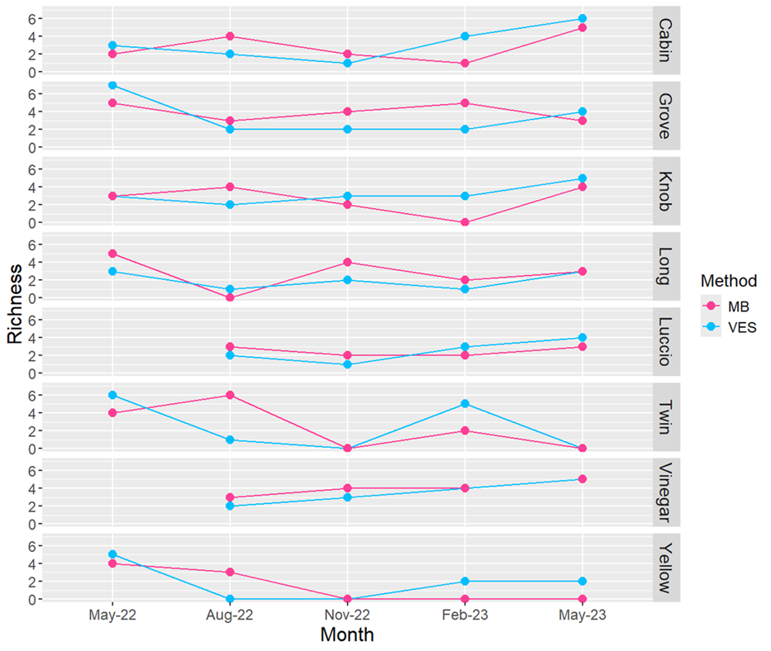
Fig. S1: Richness data by pond site over the course of the year-long sampling period for both sampling methods. The highest trending time period is February of 2023, matching the spring breeding season of most amphibians. Contrarily, the lowest numbers of species observed were in August of 2022, a time when many ponds were dry and harsh conditions encouraged amphibians to seek shelter from desiccation.
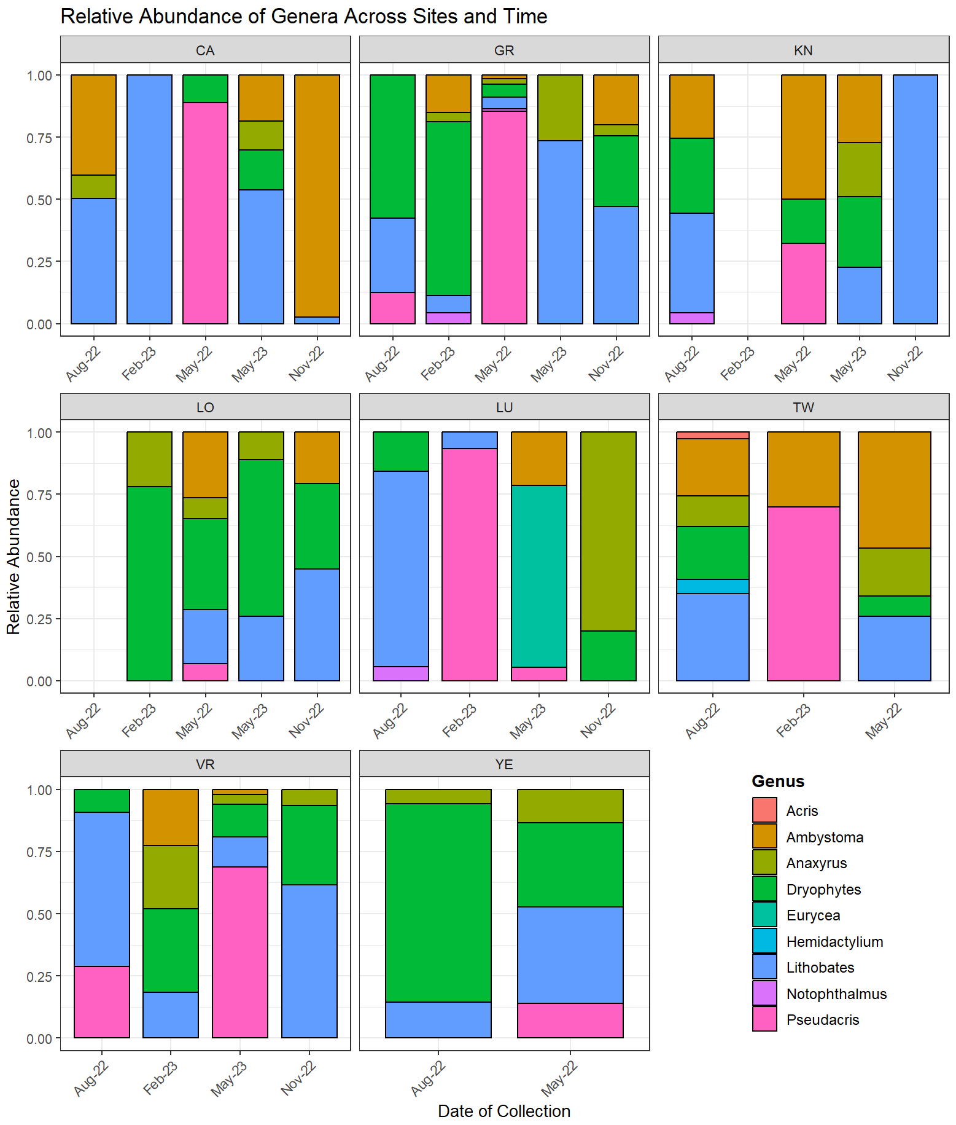
Fig. S2: Relative abundance of community genera.

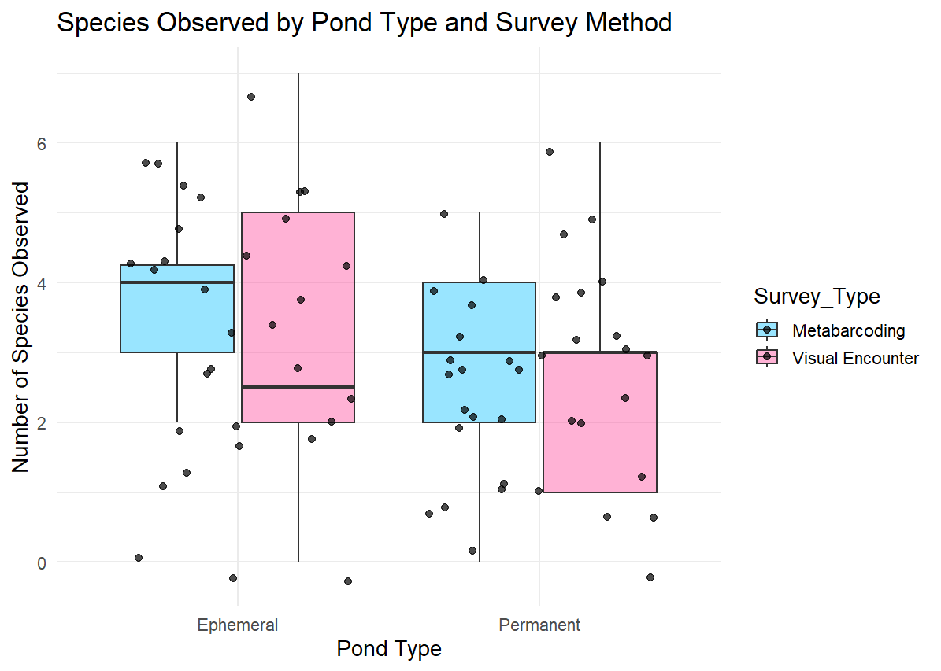
Fig. S3: Comparison of Survey Type effect on Species Observed amongst MB and VES data. Examination of influence of pond type on the number of species observed (note: all ponds could be considered Ephemeral depending on the year and rainfall, but some ponds are more permanently rooted than others – as determined by hydroperiods observed, fish presence, visual depth, etc.). Boxes indicate the interquartile range with median lines, and points represent individual samples. An aligned-rank transform ANOVA indicated no significant difference (all p > 0.05) in median species counts across pond types or survey methods, nor any interaction effect (see Table 25).

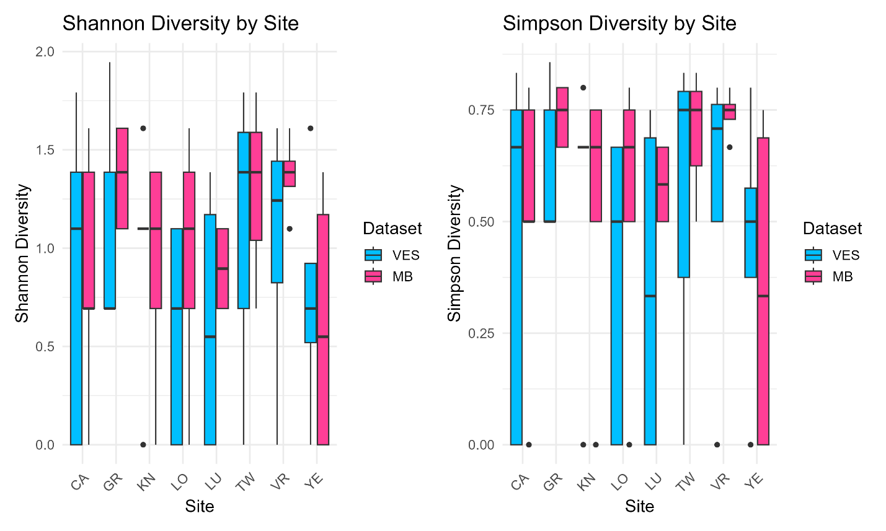
Fig. S4: Shannon and Simpson diversity site metric comparisons between methods (VES vs. MB) using species as input. Shannon tests are on the left-hand side plots, while Simpson are on the right.

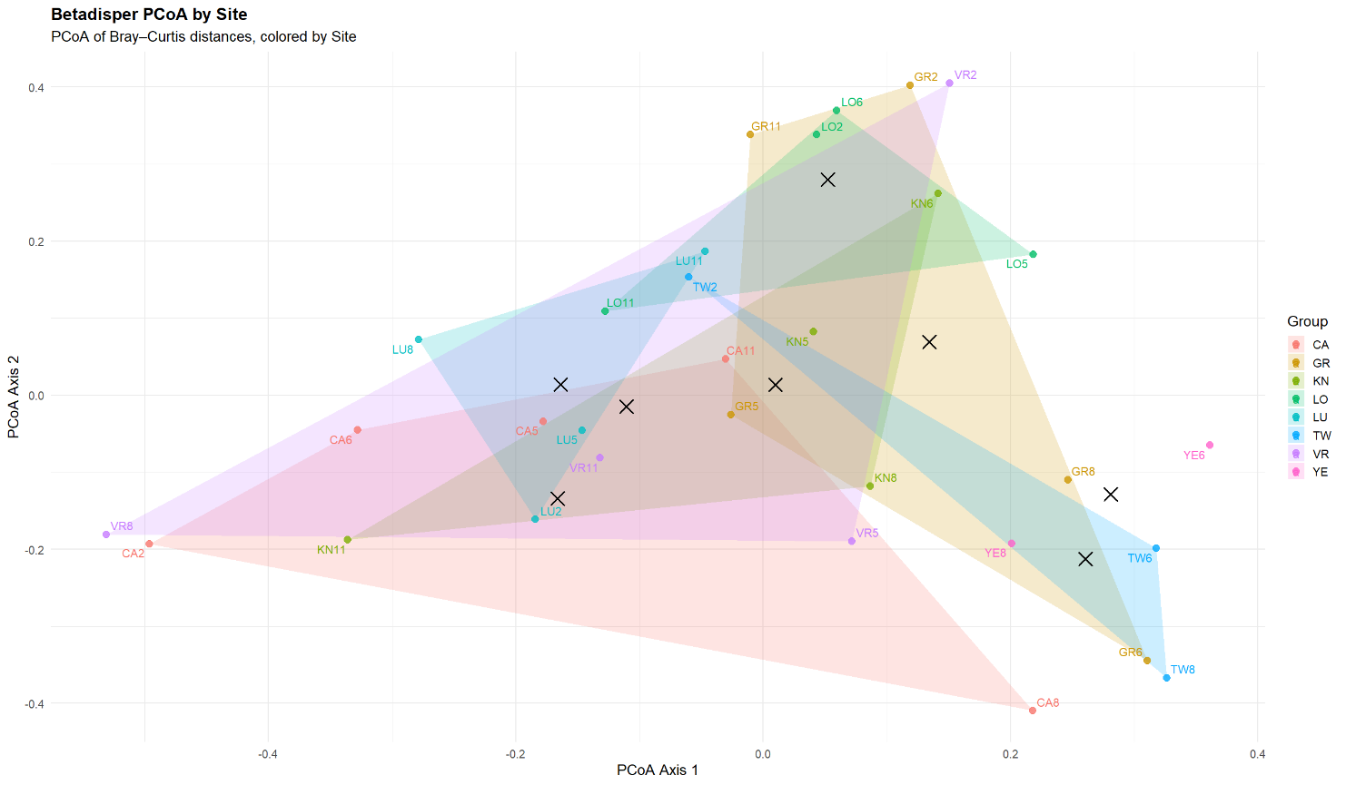
Fig. S5: Betadisper PCoA ordination by Site of ASV data. Points represent individual samples (labeled by ID) projected onto the first two principal coordinate axes derived from a Bray–Curtis distance matrix. Each colored polygon is the convex hull of all samples from a given Site, and the black “X” symbols indicate the group centroids. The betadisper analysis (ANOVA of distances to centroids) found no significant difference in dispersion among Sites (p > 0.05), suggesting that while some Sites appear more spread out visually, these differences in within-group variance are not statistically significant. The betadisper test is a baseline parameter analysis that allows us to proceed with the PERMANOVA analysis. The betadisper parameter test was utilized prior to all PERMANOVA tests across ASV, MB, and VES data and consequently determined PERMANOVA was a valid test for all – therefore, this is deemed the only necessary graphic representation simply to provide a basis of knowledge of parameter testing.

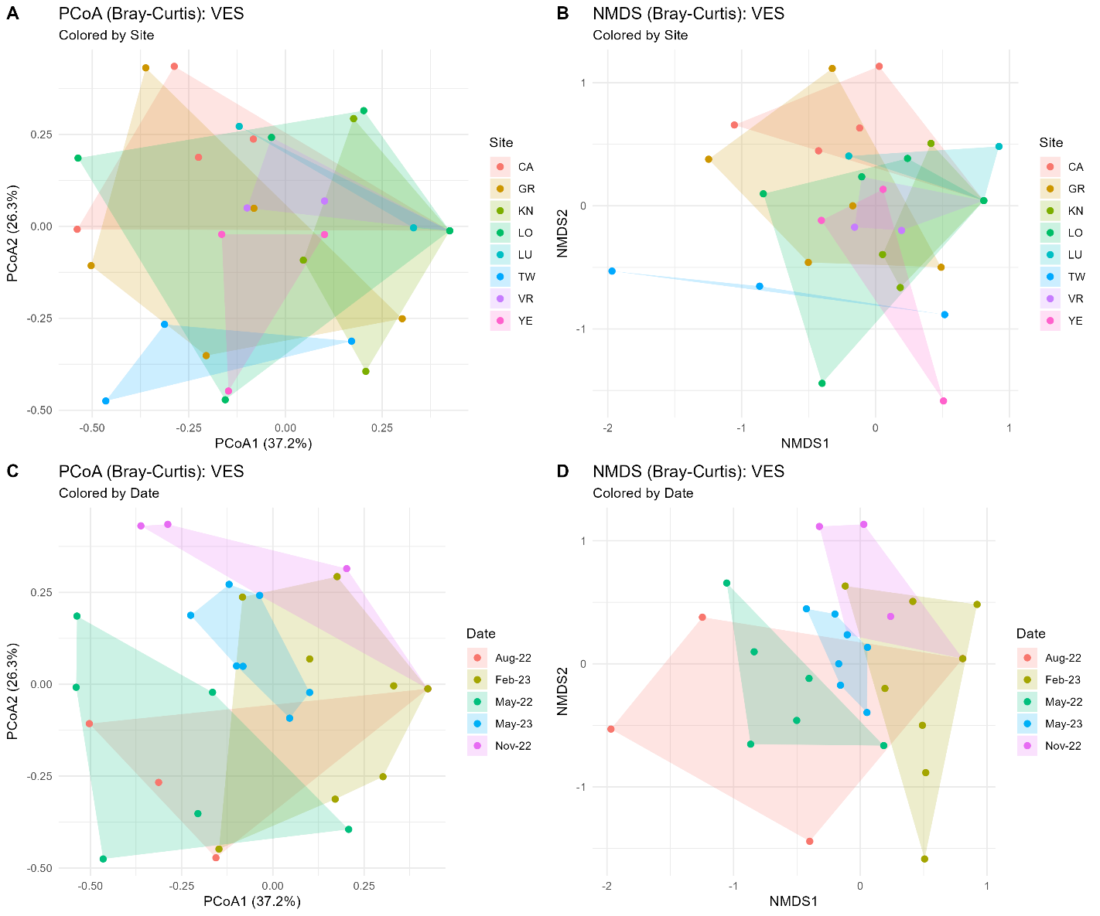

Fig. S6: Beta‐diversity ordinations of amphibian VES communities using Bray–Curtis distances. (A) PCoA by Site, with polygons representing the convex hull of points for each site. Axis labels indicate the percentage of total variance explained by each axis. (B) NMDS by Site, plotted similarly with polygons enclosing each site’s samples. (C) PCoA by Date, with polygons for date groups. (D) NMDS by Date. The spread or overlap of polygons highlights how sites or time points differ (or overlap) in their amphibian community composition based on the ASV data

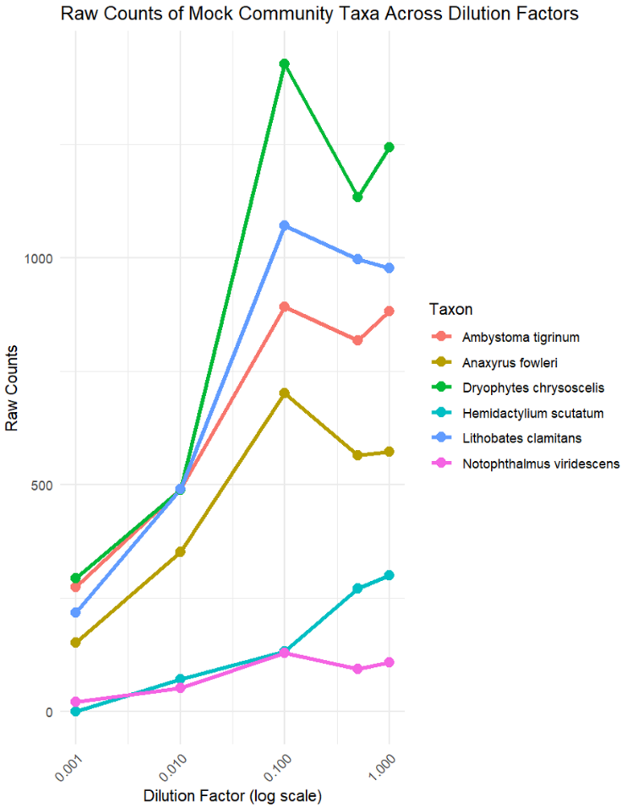
Fig. S7: Log-scaled raw counts of the five mock communities in serially diluted factors. The five dilution factors are 0.001, 0.01, 0.1, 0.5, and 1.0; starting at 10 ng/uL at 1 and diluting as per the dilution table. While an unexpected spike occurs at 0.1 (MC3), the general trend demonstrates that lower concentrations amplify at lower rates than higher concentrations. Yet this also demonstrates that the primer set Batr01 is capable of low-concentration detections; the signal may just be swamped depending on other DNA present.

References
Glenn, T. C., T. W. Pierson, N. J. Bayona-Vásquez, C. R. Kieran, M. C. Kingan, R. L. Mandell & J. C. Faircloth, 2019. Adapterama II: Universal amplicon sequencing on Illumina platforms (TaggiMatrix). PeerJ 7: e7786. https://doi.org/10.7717/peerj.7786
Osman, O. A., J. Andersson, P. M. Martin-Sanchez & A. Eiler, 2022. National eDNA-based monitoring of Batrachochytrium dendrobatidis and amphibian species in Norway. Metabarcoding and Metagenomics 6: 305–317. https://doi.org/10.3897/mbmg.6.85199
Valentini, A., P. Taberlet, C. Miaud, R. C. Coffin, N. Mège & E. Bellemain, 2016. Next-generation monitoring of aquatic biodiversity using environmental DNA metabarcoding. Molecular Ecology 25: 929–942. https://doi.org/10.1111/mec.13428

