Online Appendix
Article title: Development and Spatial Validation of a Random Forest Prediction Model for Firearm-Related Injury Risk in Chicago Census Tracts
Journal name: Applied Spatial Analysis and Policy
Supplementary Table 1
Data Sources and Measurement used in the study
Variable | Measurement Description | Source / Link or Notes | How the Measure Was Created
Percent Black Population | Percentage of the population with race identified as Black or African American alone in 2018. | American Community Survey (2018) | The number of persons identifying as Black or African American Alone was divided by the total population within census tracts
Percent White Population | Percentage of the population with race identified as White alone in 2018. | American Community Survey (2018) | The number of persons identifying as White Alone was divided by the total population within census tracts
Tree Canopy Cover (2017) | Percent tree canopy cover | Chicago Region Trees Initiative (CRTI) | Aggregated census tracts from 1-meter grid using 2017 CRTI data
Tree Canopy Change | Change in canopy cover 2010–2017 | Chicago Region Trees Initiative (CRTI) | Difference between 2010 and 2017 CRTI layers, aggregated to tracts
Vegetation Index (NDVI) | Mean NDVI from satellite imagery | USGS Landsat 8 (2017–2019) | Mean summer NDVI calculated from Landsat 8 Tier 1 TOA Reflectance, 10m grid
Surface Temperature | Land surface temperature | NASA Moderate Resolution Imaging Spectroradiometer (MODIS) | MODIS-derived 1km land surface temperature data from 2018
Urban Flood Susceptibility | Tract-level flood risk | Chicago Metropolitan Agency for Planning (CMAP) | Regional flood risk model aggregated
Traffic Volume | Modeled street-level traffic volume | Illinois Department of Transportation and Center for Spatial Data Science | Modeled traffic volume by CSDS using IDOT data, aggregated to tracts
Modeled PM2.5 | Fine particulate matter concentration | Weather Research and Forecasting Community Multiscale Air Quality model (WRF-CMAQ 2018–2019) | Simulated using climate-air quality models, census tract resolution
Lead Poisoning Rate | Childhood lead exposure | Chicago Health Atlas (2023), via DePaul University | Percentages of children aged 1-5 with blood lead levels at or above five micrograms per deciliter (µg/dL)
CRA Loans to Non-White Borrowers | Lending | Housing Mortgage Disclosure Act data 2019 | The total number of loans made to non-white borrowers within a census tract
Proportion of CRA Loans to Non-White Borrowers | Lending | Housing Mortgage Disclosure Act data 2019 | The number of loans to non-white borrowers by the total number of loans originated in the tract.
Job Accessibility | Number of jobs accessible within a 45-minute commute by car | TransitCenter Equity Dashboard | Computed using GTFS data, travel-time decay functions, and block-group-level aggregation to estimate job accessibility per tract
Urgent Care Facilities | Number of the three nearest urgent care facilities accessible within a 45-minute commute by care time | TransitCenter Equity Dashboard | Computed using GTFS data, travel-time decay functions, and block-group-level aggregation to estimate job accessibility per tract
Urban Heat Index | Average perceived neighborhood heat | Cool Chi/Heat Watch Chicago 2023 | The average morning, afternoon, and evening temperatures in Fahrenheit taken on July 28th, 2023. Heat Index refers to an approximation of actual heat felt when the presence of humidity is combined with air temperature.
Social Vulnerability Index | CDC composite measure of social vulnerability | Center for Disease Control Social Vulnerability Index | Direct from the CDC, census tract-level measure
Hardship Index | Index of neighborhood socioeconomic hardship | ACS (2018), processed by HeRoP Lab | Composite scores of poverty, unemployment, education, and income from ACS
Percent Foreign-Born | Percent foreign-born residents | American Community Survey (2018) | Tract-level ACS estimate processed by HeRoP Lab
Percent Children | Percent of population under 18 | American Community Survey (2018) | Tract-level ACS estimate processed by HeRoP Lab
Percent Overcrowded Housing | Percent of overcrowded housing units | American Community Survey (2018) | Percentage of households with >1 occupant per room
Housing Cost Burden | Households spending >30% of income on housing | American Community Survey (2018) | The housing cost burden rate is calculated by dividing the number of households that spend more than 30% of their total income on housing by the total number of households in the area, and then multiplying by 100 to get a percentage.
Median Rent | Median gross rent | American Community Survey (2018) | Median rent of census tracts
GEOID Crosswalk | Crosswalk from 2010 to 2020 census tracts | Census Relationship Files | Used to harmonize datasets with differing tract vintages
Non-Fatal Shootings | Incident-level gun violence (2020–2024) | Chicago Open Data Portal | Geocoded point locations, aggregated to tracts for analysis
Alcohol Outlets | Locations of licensed alcohol outlets | Chicago Open Data Portal | Joined to tracts; outlet count, and density calculated using land area
Investment Data | Lending by sector (e.g., small business, public, non-residential, single and multi-family) | Urban Institute Capital Flows | Percent investment by asset class calculated per tract
Housing Wealth & CRA Lending | Homeownership and lending equity by race | Home Mortgage Disclosure Act (HMDA) data 2019 | Housing wealth ratio = ownership share divided by household share for different racial groups
Population Data | Total population per tract | ACS 2020 5-year estimates | Used to calculate per capita shooting rates and log offsets
2020 Tract Boundaries (Cook County) | Census tract boundaries | TIGER/Line via tigris | Used to filter analysis to tracts within Chicago neighborhoods

Supplementary Table 2
Predictor Means and Standard Deviations Across Training and Test Sets
Variable | Combined Training and Validation Set | Test Set | p
 | (n = 642 Census Tracts) | (n = 164 Census Tracts)
 | Mean (SD) | Mean (SD)
Social Vulnerability Index | 62.72 (29.50) | 58.73 (30.37) | 0.134
Job Accessibility | 847,996.71 (899,247.12) | 936,796.49 (1,044,649.97) | 0.321
Percent White Population | 45.55 (32.69) | 44.99 (32.40) | 0.847
Percent Black Population | 36.16 (39.94) | 35.93 (39.48) | 0.947
Percent Foreign-Born | 18.11 (15.07) | 17.56 (14.72) | 0.671
Percent Children | 21.64 (8.40) | 20.63 (7.91) | 0.151
Lead Poisoning Rate | 1.52 (1.10) | 1.56 (1.15) | 0.688
Economic Hardship Index | 24.72 (11.74) | 23.49 (11.24) | 0.217
Traffic Volume | 4.83 (1.27) | 4.61 (1.49) | 0.092
Modeled PM2.5 | 10.50 (0.48) | 10.49 (0.25) | 0.622
Percent Investment in Single Family | 49.72 (28.22) | 50.77 (29.24) | 0.681

Supplementary Table 3
Spatial Cross-Validation Model Performance Metrics
Metric | Median | MAD | Min | Max
R² (spatial folds) | 0.402 | 0.243 | 0.114 | 0.635
RMSE | 15.85 | 5.4 | 11.67 | 27.21
Normalized RMSE | 0.849 | 0.447 | 0.521 | 3.028
Pseudo R² (spatial folds) | 0.634 | 0.215 | 0.338 | 0.797
AUC (risk classification) | 0.536 | 0.173 | 0.391 | 0.794

Supplementary Table 9
Predicted Versus Actual Shootings Per Census Tract by Index Decile in Chicago from 2020 to 2023
Firearm Index Decile | Predicted Firearm-related injuries per 1,000 | Actual Firearm-related injuries per 1,000
.1 | 0.3 | 0.08
.2 | 0.73 | 0.45
.3 | 1.12 | 0.71
.4 | 1.67 | 1.26
.5 | 2.56 | 2.2
.6 | 3.93 | 3.28
.7 | 6.64 | 6.08
.8 | 10.6 | 9.94
.9 | 16.9 | 16.3
1 | 32.4 | 32.8

Supplementary Fig. 1
Spatial Cross-Validation Folds
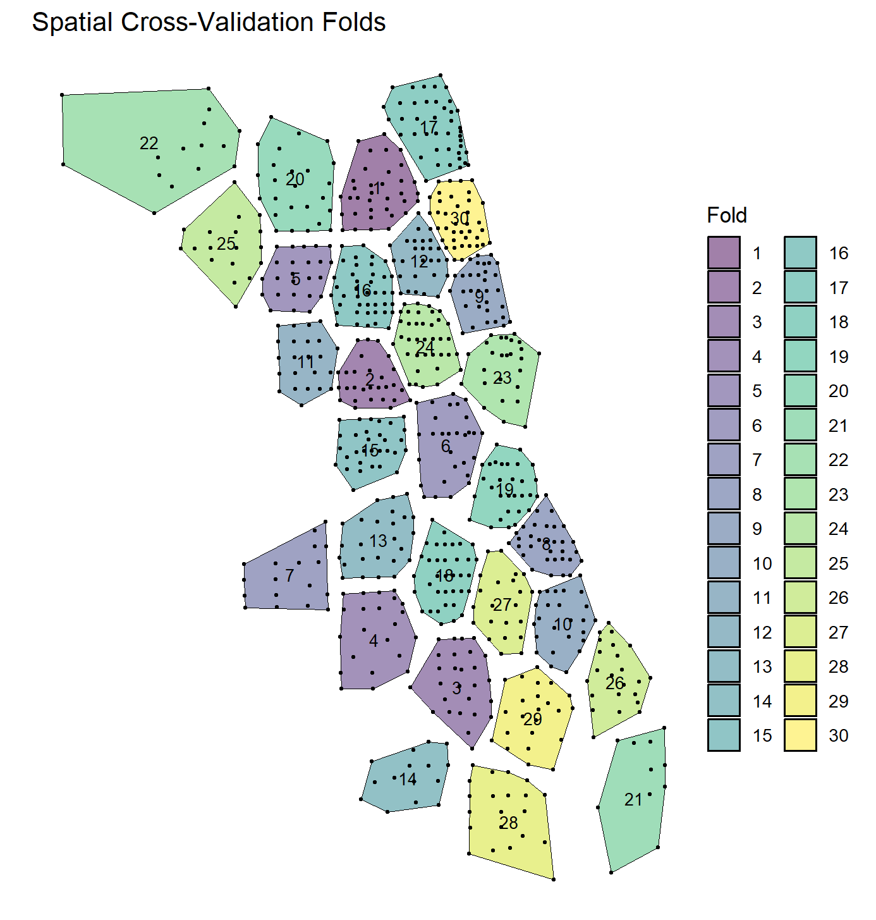
Notes. Spatial cross-validation folds used to evaluate the SRFM's ability to predict firearm injury risk across Chicago census tracts. Each fold consists of geographically contiguous tracts, grouped to preserve spatial structure and prevent overlaps between training and test data.

Supplementary Fig. 2

Comparison of Variable Importance in Non-Spatial vs. Spatial Random Forest Models

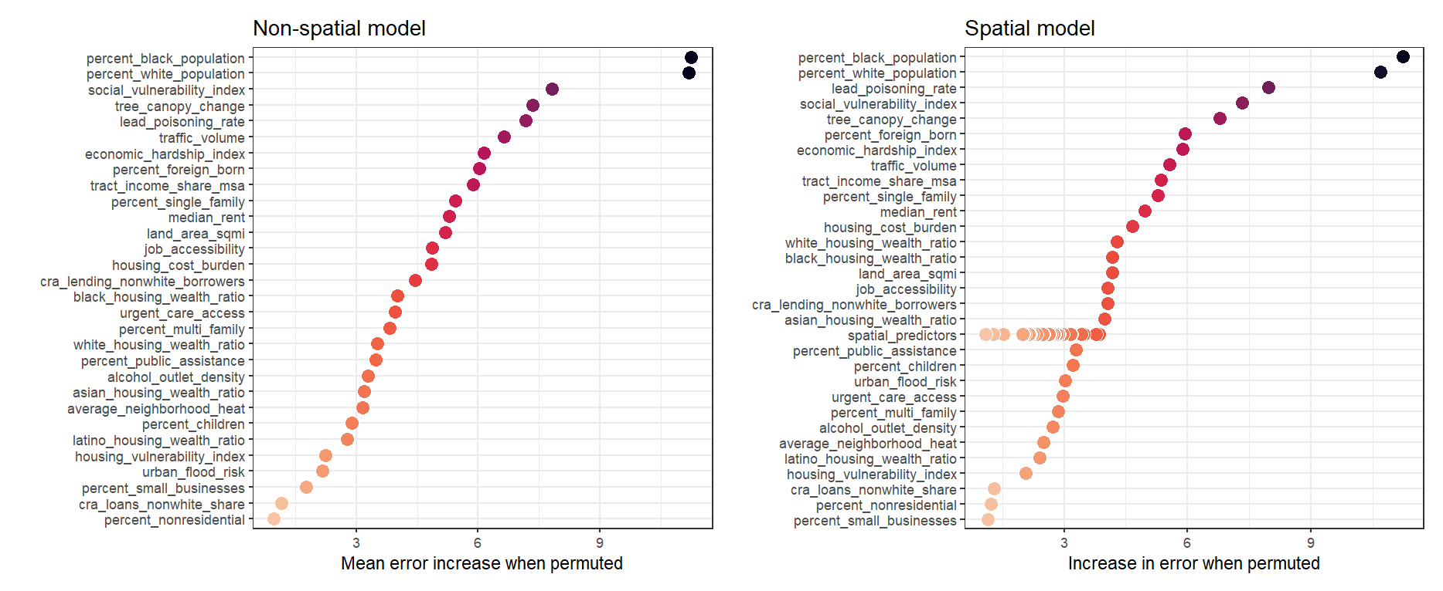
Notes. Comparison of the permutation-based variable importance scores for the non-spatial model (left) and the spatial random forest model (SRFM) (right). Importance is measured as the increase in prediction error (e.g., RMSE) when each variable is randomly permuted. Higher values indicate greater predictive influence.

Supplementary Fig. 3
Relationship Between Predictor Importance and Spatial Transferability
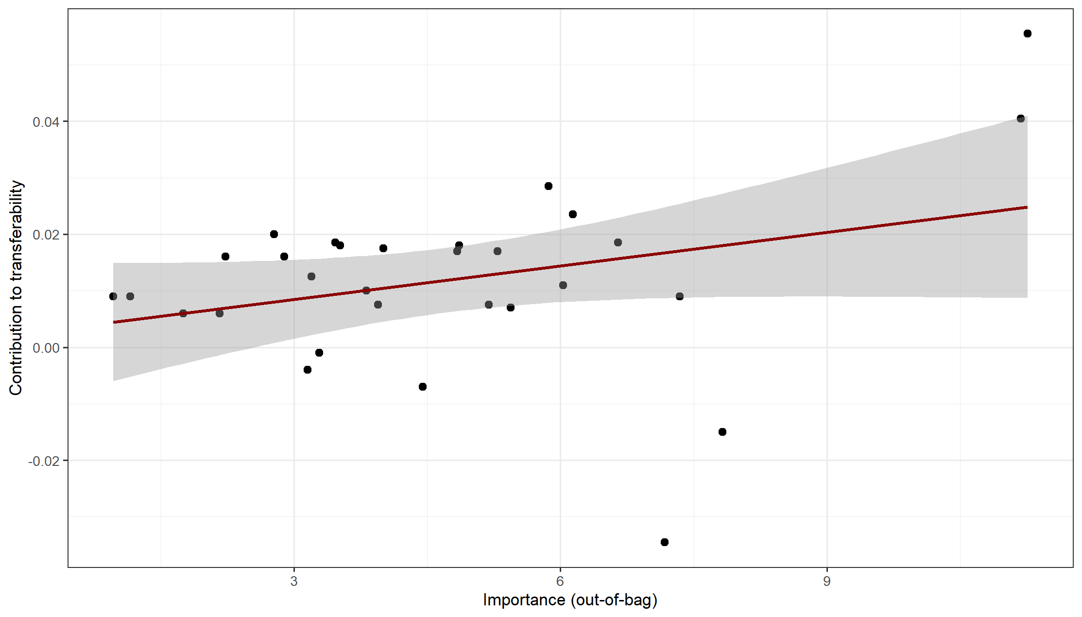
Notes. Relationship Between Predictor Importance and Spatial Transferability. This scatterplot illustrates the relationship between the overall importance of each predictor (measured by out-of-bag error reduction on the y-axis) and its contribution to model transferability (measured as the median change in R² across spatial cross-validation folds on the x-axis). Each point represents a single predictor variable. The red line indicates the linear trend, and the shaded region shows the 95% confidence interval.

Supplementary Fig. 4
Median Contribution of Predictors to Model Transferability Across 30 Spatial Cross-Validation Repetitions.

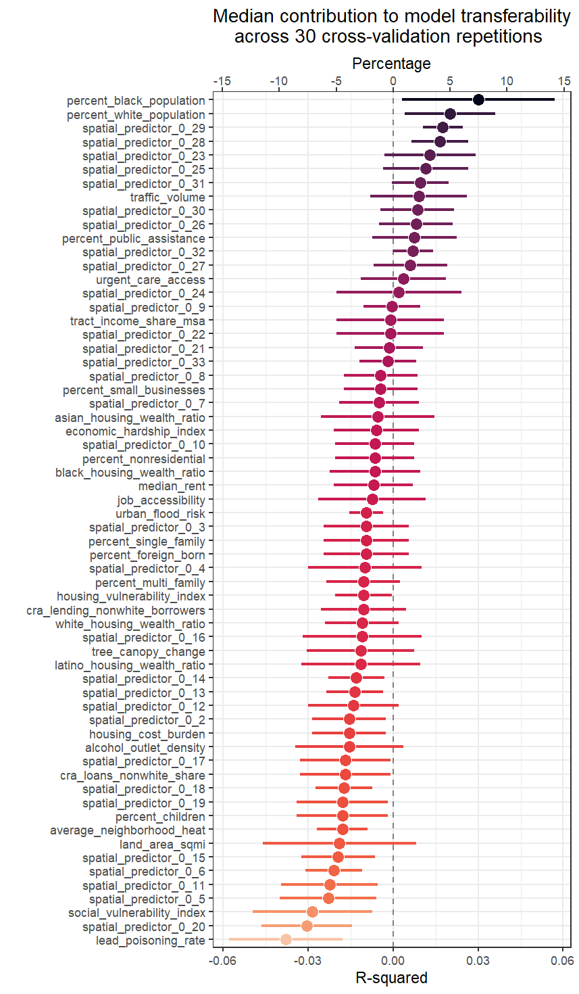
Notes. This figure displays the median change in R² associated with each predictor variable across 30 spatial cross-validation folds. Positive values indicate improved model performance (i.e., increased R²) when the variable is included, while negative values reflect reduced performance. Each dot represents the median R² contribution of a variable, and the horizontal lines indicate variability across folds (e.g., interquartile range).

Supplementary Fig. 5
Bivariate Relationships Between Key Predictors and Firearm-Related Injuries
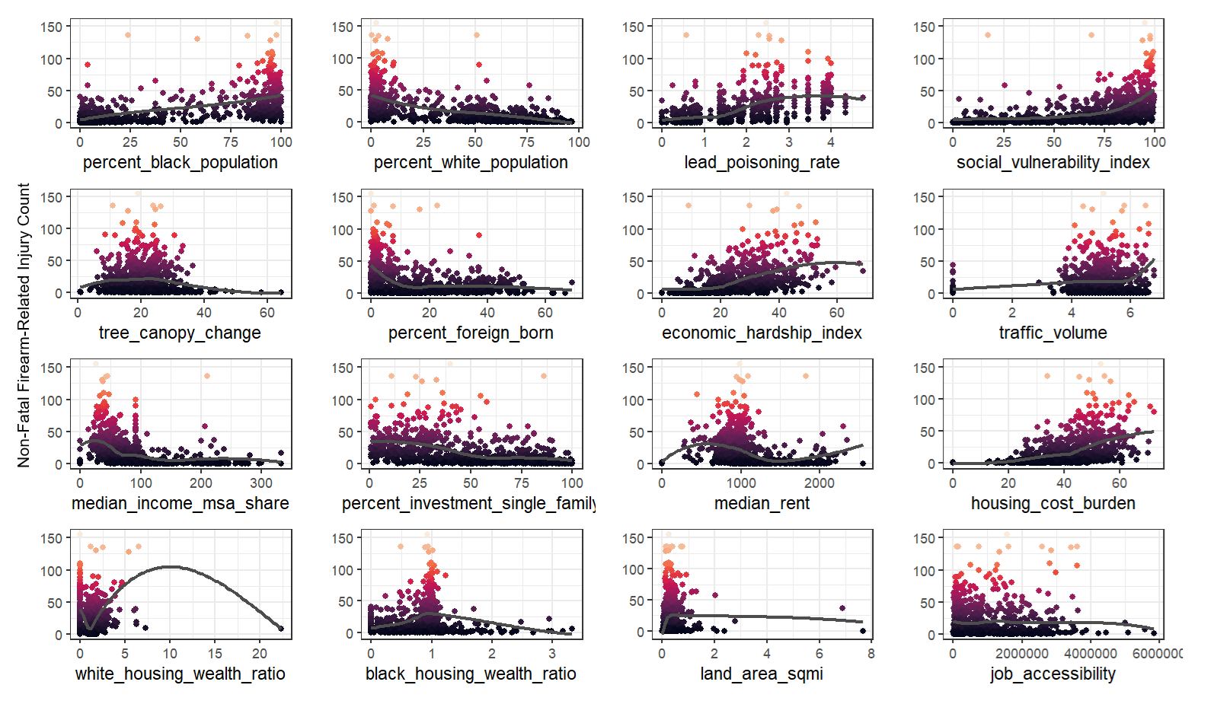
Notes. This figure presents scatterplots of observed non-fatal firearm-related injuries (y-axis) against selected predictor variables (x-axis) across Chicago census tracts. Each dot represents a single tract, and colors indicate injury intensity, with darker tones denoting higher density of observations. Clear nonlinear and threshold patterns are visible for several predictors. For example, firearm injuries rise sharply at high levels of lead poisoning, percent Black residents, and social vulnerability. In contrast, higher percentages of White and foreign-born residents are associated with markedly lower injury counts. Other predictors, such as tree cover, traffic volume, and single-family housing, exhibit more diffuse relationships, with potential context-specific effects.

Supplementary Fig. 6
Partial Dependence Plots (PDPs)
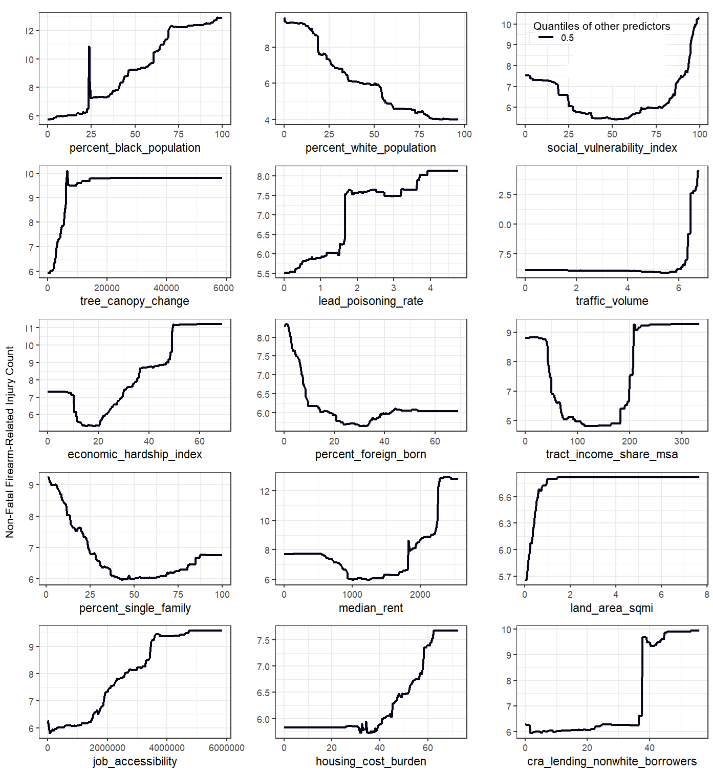
Notes. Marginal effect of a single predictor variable (x-axis) on the expected firearm injury count, holding all other variables constant at their median (0.5 quantile) in the spatial random forest model.

