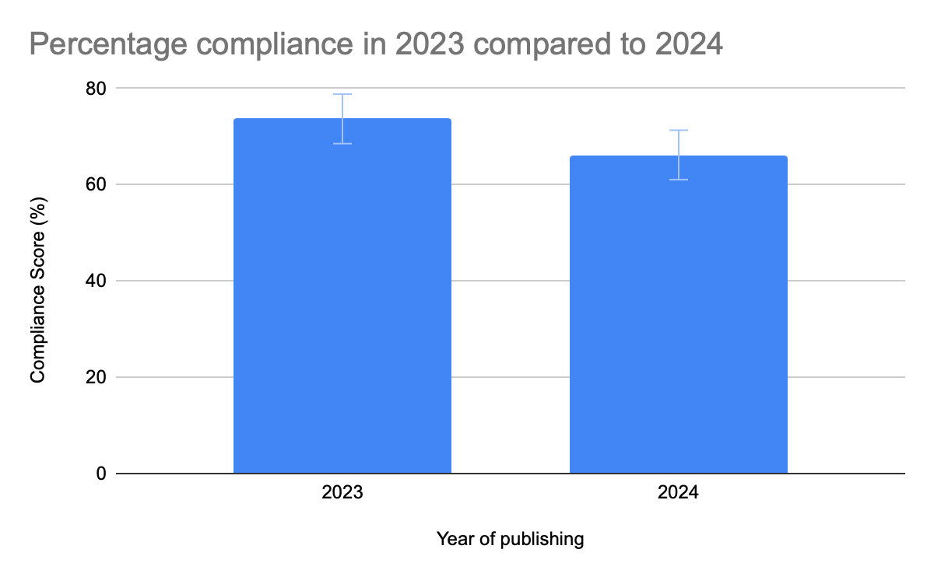 Supplementary Digital Content 4: Percentage CONSORT-NPT compliance between papers published in 2023 and 2024.

