Aroma-Enhancing Strategies in Mead: A Metabolomics- and Machine Learning-Guided Additive Approach

Ziwei Liuª, Jingyu Zhangª, Duanhao Wang^{b*}, Xuening Tangª, Wenlin Sunª, Xian Liª, Haoan Zhao ª, Meijing Guoª, Tiantian Zhang^{h}, Wenjie Liª, Di Wang^{e}, Wushuang Baiª, Yue Cao^{fg}, Binglin Li^{ad*}, Wei Cao^{ac*}

a College of Food Science and Engineering, Northwest University, Xi’an 710069,
China
b College of Biology and Food Engineering, Huanghuai University, Zhumadian, China
c Bee Product Research Center of Shaanxi Province, Xi’an 710065, China
d Cangzhou Academy of Agriculture and Forestry Sciences, Cangzhou 061001, China
e College of Ecology, Lishui University, Lishui 323000, China
f Western BaoDe Technologies Co., Ltd
g National Local Joint Engineering Research Center of Filtration and Separation Technology
h College of Petroleum and Chemical Engineering, Longdong University, Qingyang, Gansu 745000, China

Duanhao Wang
Email: wangdh1969@163.com
Binglin Li
Email: libinglin@nwu.edu.cn, ORCID: 0000-0002-6409-0784
Wei Cao
Email: caowei@nwu.edu.cn

Eq. A The most pleasant acidity.
The most pleasant acidity was observed when the score was at 5. Thus, the pleasant acidity was used to replace the acidity in the sensory evaluation form.
$$Pleasant acidity=10-|Acidity -5| (A)$$
Fig. S1. Effects of yeasts and nitrogen sources on the alcohol content of meads (p < 0.05).
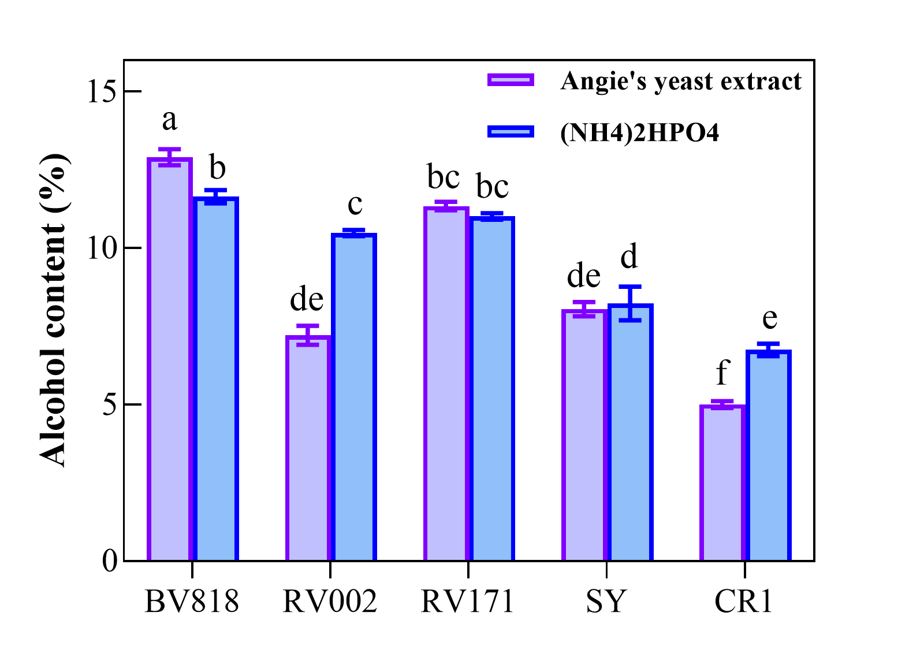

Fig. S2. OPLS-DA analysis of 45 samples (including 15 honey solutions, 15 semi-sweet meads and 15 dry meads) (A). Validation plot of 200 permutation tests for the OPLS-DA model; Slope of R2 is greater than 0, and intercept of Q2 on the y-axis (-0.265) is less than 0.05, indicating a valid model. (B). Score plot of OPLS-DA. Green represents honey solutions (HS); blue represents semi-sweet meads (SSM); red represents dry meads (DM).
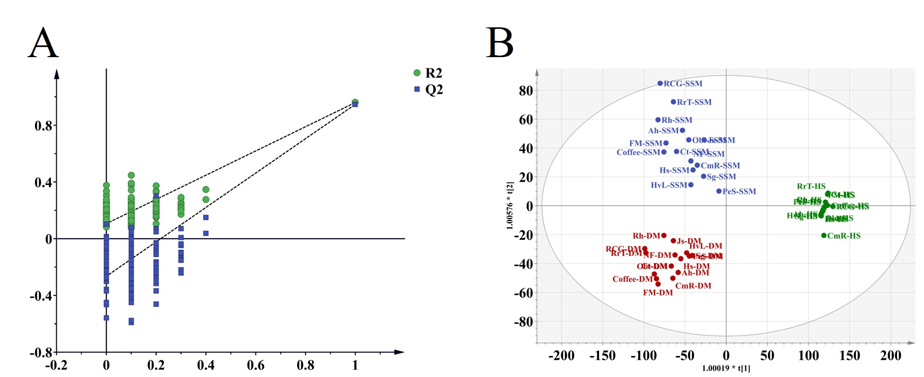

Fig. S3. OPLS-DA analysis of 19 meads.
