Supplemental Materials:

Dose of Aspirin Taken | Patients on Aspirin Prior to Discussion | N (%)¹
81 mg | 2 | 41 (49.4)
250 mg | 1 | 1 (1.2)
325 mg | 0 | 35 (42.2)
Approx. 600 mg | 0 | 3 (3.6)
650 mg | 0 | 3 (3.6)
Supplemental Table 1. Breakdown of varying doses of aspirin taken by study subjects
¹N representing number of patients and (%) indicating percentage of patients taking aspirin at each respective dose
Lynch Gene Mutation | Cumulative Risk of Diagnosis Through Age 80¹ | Aspirin Use (%)²
MLH1 | 46-61% | 11 (47.8)
MSH2 | 33-52% | 18 (39.1)
MSH6 | 10-44% | 35 (57.4)
PMS2 | 8.7-20% | 19 (51.4)
Supplemental Table 2. Aspirin usage for each specific Lynch gene mutations with the associated cumulative risk through age 80 years of age.
¹Estimated cumulative incidence of colorectal cancer development among Lynch Syndrome pathogenic variant carriers based on available cohort studies from NCCN guidelines [14]
²Number of patients and (%) indicating percentage of all patients with corresponding mutation taking aspirin
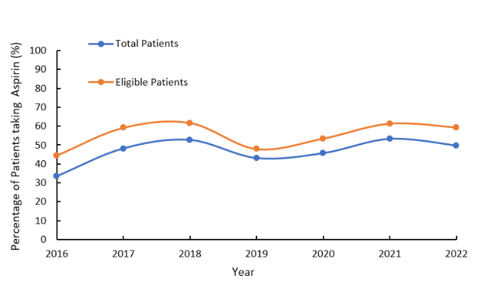
Supplemental Figure 1. The percentage of the total and eligible patients taking ASA between 2016 and 2022
Year | Total Patients | Aspirin Use N¹(%) | Not recommended | Not discussed | No reason given | Eligible Aspirin Use N²(%)
2016 | 12 | 4 (33.3) | 3 | 0 | 5 | 4 (44.4)
2017 | 27 | 13 (48.1) | 5 | 0 | 9 | 13 (59.1)
2018 | 55 | 29 (52.7) | 8 | 0 | 18 | 29 (61.7)
2019 | 79 | 34 (43.0) | 8 | 0 | 37 | 34 (47.9)
2020 | 103 | 47 (45.6) | 14 | 1 | 41 | 47 (53.4)
2021 | 137 | 73 (53.3) | 17 | 1 | 46 | 73 (61.3)
2022 | 167 | 83 (49.7) | 25 | 2 | 57 | 83 (58.5)
Supplemental Table 3. The total and eligible patients taking ASA between 2016 and 2022
¹N representing total number of patients and (%) indicating percentage of the total sample size
²Number of patients and (%) indicating percentage of eligible patients who have taken ASA excluding patients in which aspirin was not recommended or not discussed

