Supplementary information: Navigating the climate consequences of irrigation-led rice intensification

Laura Arenas-Calle^{1*};
Hari Sankar Nayak^{1*};
Sonam Sherpa²;
Virender Kumar^{3,1};
Petra Schmitter⁴;
Anton Urfels^{3,5,1};
Shishpal Poonia⁶;
Ayan Sarkar⁷;
Amit Kumar Srivastava⁸;
Avinash Kishore⁹;
Chiter Mal Parihar⁷;
Amaresh Kumar Nayak¹⁰;
Andrew McDonald¹

- School of Integrative Plant Science, Cornell University, Ithaca, NY, USA
- International Maize and Wheat Improvement Center (CIMMYT), South Asia Regional Office, Lalitpur, Nepal National Plant Breeding and Genetics Center, NARC Research Station Nepal 44700
- International Rice Research Institute (IRRI), Los Baños, Philippine
- International Water Management Institute (IWMI), HQ, P.O Box 2075, Colombo, Sri Lanka.
- Water Resources Management Group, Wageningen University and Research, Wageningen, the Netherlands
- International Maize and Wheat Improvement Center (CIMMYT), National Agricultural Science Complex (NASC), New Delhi, India
- ICAR-Indian Agricultural Research Institute (IARI), New Delhi, India

- International Rice Research Institute (IRRI) – South Asia Regional Centre, Varanasi, Uttar Pradesh, India
- International Food Policy Research Institute (IFPRI), New Delhi, India
- Indian Council of Agricultural Research (ICAR), New Delhi

*Corresponding authors: la397@cornell.edu (Laura Arenas-Calle); hsn28@cornell.edu (Hari Sankar Nayak)

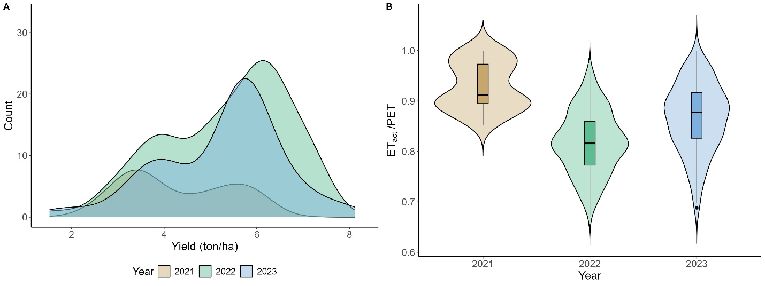

Supplementary Information 1 | A) Density plot of baseline yields in the three years; B) Violin plot of the ratio of actual to potential evapotranspiration (ET_{a}/ET_{p}), also referred to as the ‘water stress index’ (WSI), for the three study years.

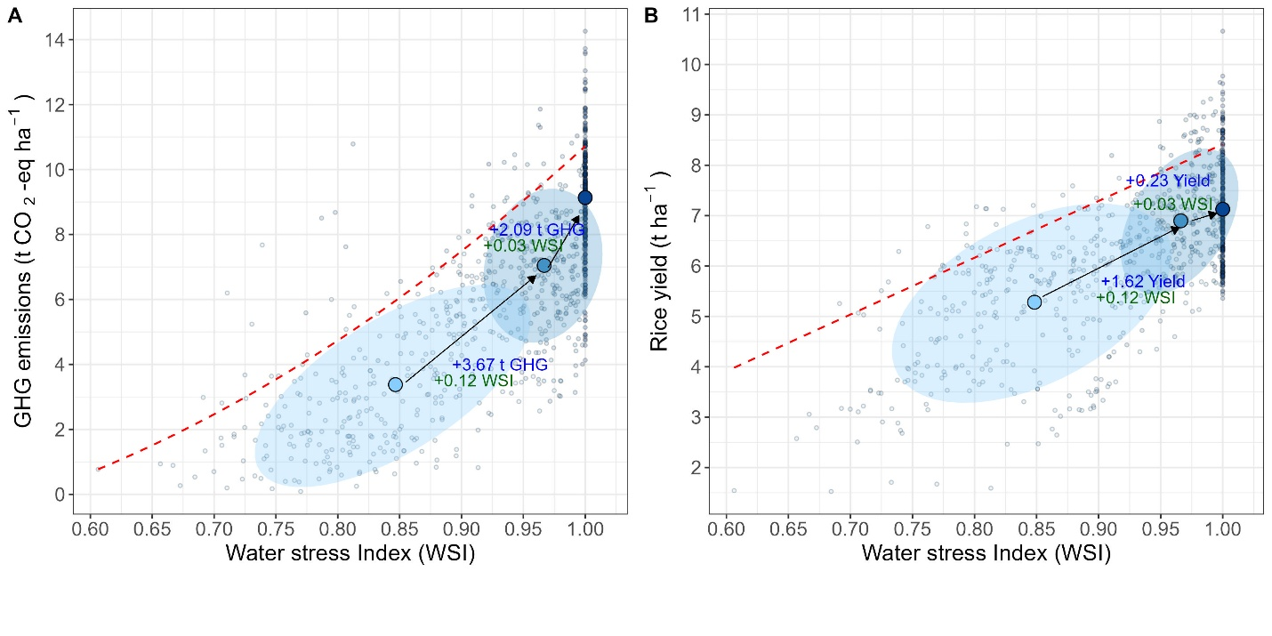
Supplementary Information 2 | Relationship between GHG emissions (A) and rice yield (B) as a function of the Water Stress Index (WSI) across different irrigation-led intensification scenarios. The color-coded ellipses represent the density distribution of data points for each scenario, while the shapes indicate the centroids. Arrows connecting the centroids highlight the shifts between scenarios, with labels quantifying the changes in GHG emissions, WSI, and rice yield.

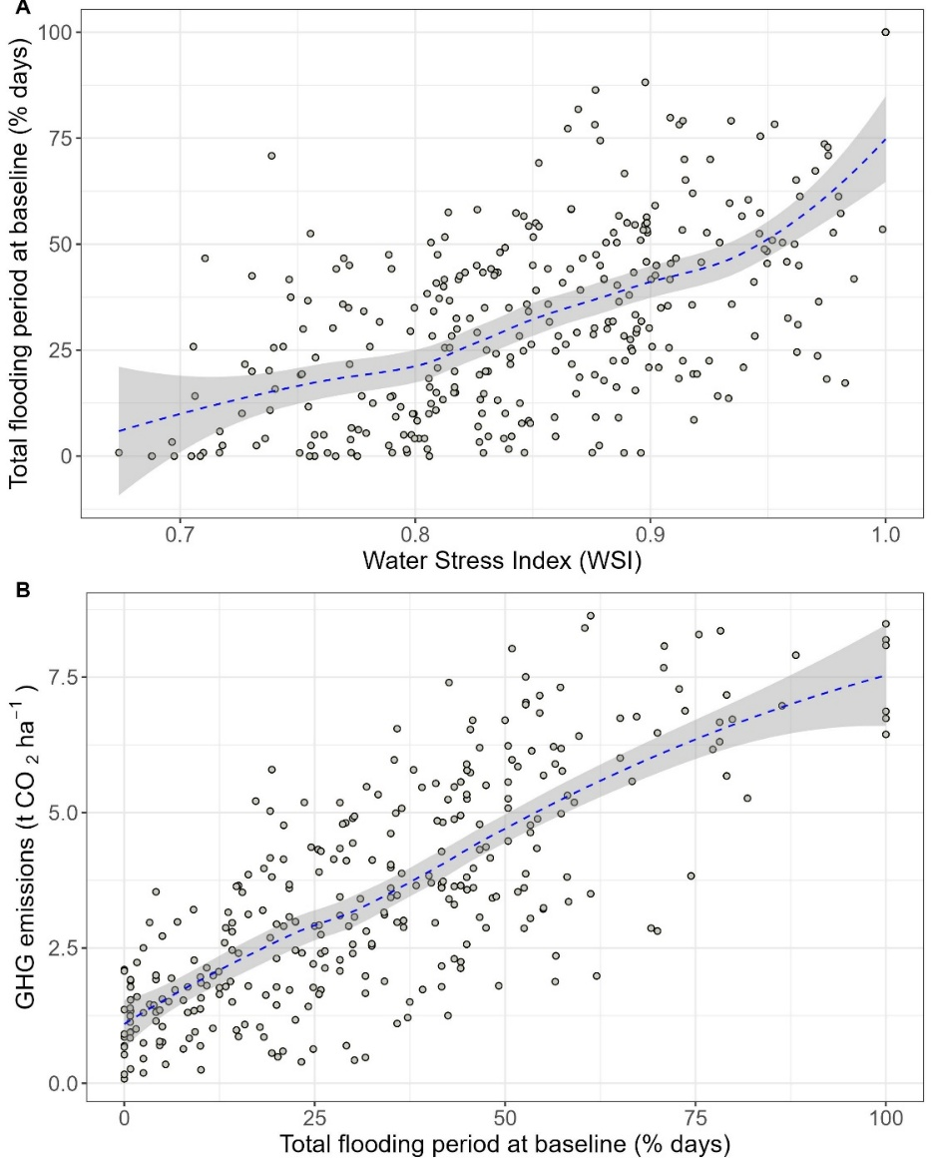
Supplemental Information 3 | Relationship between A) Water Stress Index with percentage of flooding conditions at baseline (as the total flooded days during the season (%)) and B) flooding conditions at baseline (as the total flooded days during the season (%)) with GHG emissions

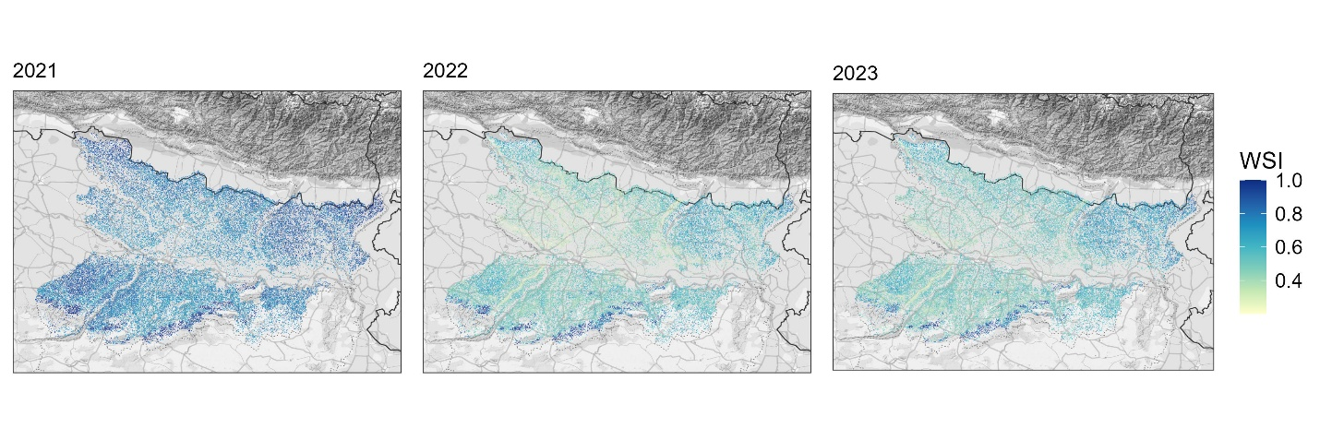Supplementary Information 4 | Mapping of seasonal Water Stress Index by production year.

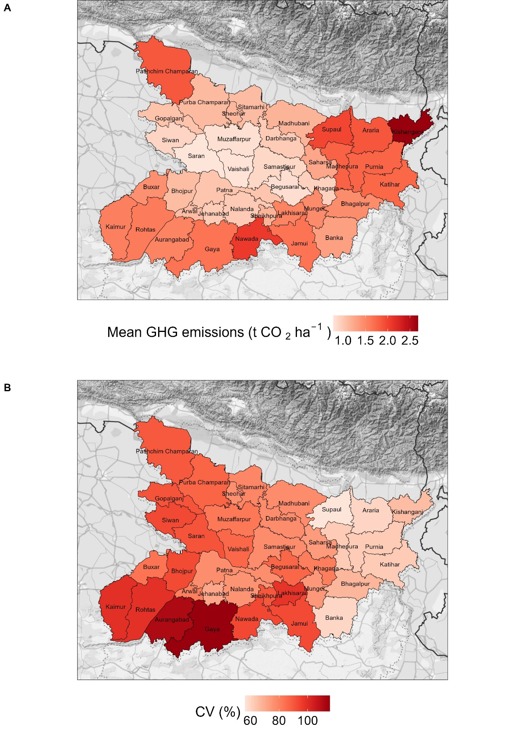

Supplementary Information 5 | Panel A) 3-years district average GHG emissions (t CO₂-eq ha⁻¹) and Panel B) within-district coefficient of variation (%) of emissions.

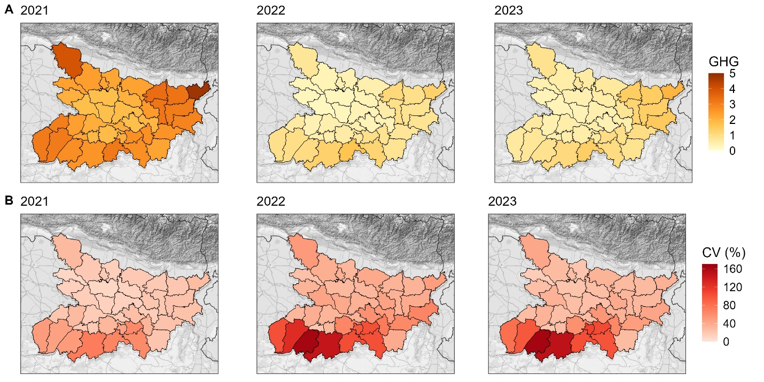
Supplementary Information 6 | District wise A) mean and B) CV of baseline GHG emission (t CO₂-eq ha⁻¹) as estimated from WSI.

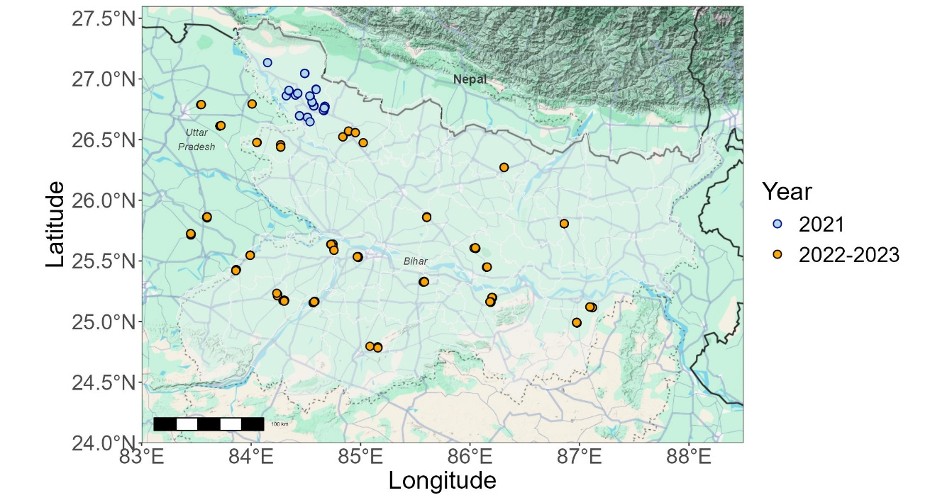
Supplementary Information 7 | Eastern India study region and location of field observation clusters (between 1 to 5 fields per cluster) where hydrology and agronomic information was collected during the 2021, 2022, and 2023 rice production seasons.

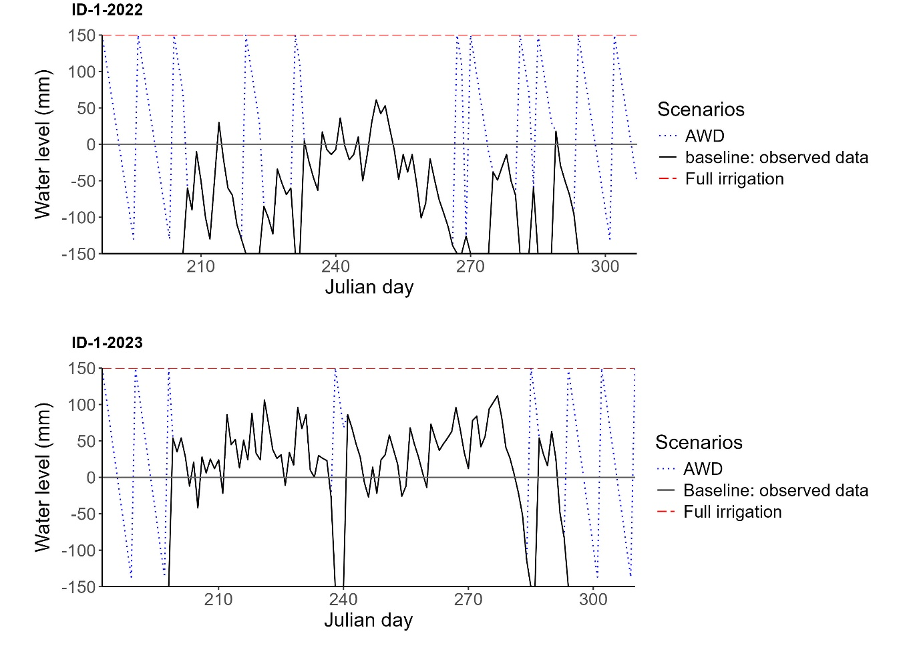
Supplementary Information 8 | Observed daily water levels (‘baseline’ - black solid line) and water levels for the two scenarios of irrigation-led intensification: continuous flooding (CF - red dashed line) and alternate wetting and drying (AWD – blue dotted line). For the same production field, the upper panel depicts water dynamics in 2022 and bottom panel for 2023.

