Supplementary Information

In Vitro and In Silico Evaluation of the Efficacy and Safety of a Ghanaian Herbal Medicine for the Treatment of Onchocerciasis and Trypanosomiasis

Barbara Zenabu Anibea#, Daniel Moscoh Ayine-Tora#, Theresa Manful Gwira^{$γ}, Dorcas Osei-Safo#‡

#Department of Chemistry, University of Ghana
$West African Centre for Cell Biology of Infectious Pathogens, University of Ghana
γDepartment of Biochemistry, Cell and Molecular Biology, University of Ghana

‡Corresponding author: dosei-safo@ug.edu.gh; +233208169376

Table of Contents

Figure S1: ¹H NMR spectrum of bis(4-methylheptyl) phthalate ……….…3
Figure S2: ¹³C NMR spectrum of bis(4-methylheptyl) phthalate) ……...…3
Figure S3: DEPT 135 spectrum of bis(4-methylheptyl) phthalate ………..4
Figure S4: MS of bis(4-methylheptyl) phthalate …………………………4
Figure S5: ¹³C NMR spectrum of ent-kaur-16-en-19-oic acid ……..……5
Figure S6: DEPT 135 spectrum of ent-kaur-16-en-19-oic acid …………5
Figure S7: ¹H NMR spectrum of ent-kaur-16-en-19-oic acid ………..…6
Figure S8: ¹³C-NMR Spectrum of Xylopic acid………………………..6
Figure S9: ¹H-NMR Spectrum of Xylopic acid……………………….7
Figure S10: ¹³C-NMR Spectrum of ent-kaur-16-en-15-one-19-oic acid……………7
Figure S11: ¹H-NMR Spectrum of ent-kaur-16-en-15-one-19-oic acid…………….8
Figure S12: ¹³C-NMR spectrum of BL2……………………………………………8
Figure S13: ¹H-NMR spectrum of BL2…………………………………………….9
Figure S14: ¹³C-NMR spectrum of BL4……………………………………………9
Figure S15: ¹H-NMR spectrum of BL4…………………………………………….10
Table S1: Results of physicochemical descriptors for the isolated compounds…………10
Table S2: Definition of lead-like, drug-like and Known drug space (KDS) in terms of molecular descriptors. The values given are the maxima for each descriptor for the volumes of chemical space used………………………………………………………………………………………….11
Figure S16: Modelling against glutathione S-transferase (Onchocerciasis), Ribbon (A) and Cell phase (B) of Glutathione S-transferase………………………………………………………11
Table S3: RSMD values for heavy atoms between the co-crystallized ligand and the docked molecule…………………………………………………………………………………..…11
Table S4: Results of the binding score function for the ligands………………………...……11
Figure S17: Modelling against glutamate-gated chloride channel, Ribbon (A) and Cell phase (B) of Glutamate-gated chloride ion channel……………………………………………………12
Table S5: RSMD values for heavy atoms between the co-crystallized ligand and the docked molecule……………………………………………………………………………….……13
Table S6: Results of the binding score function for the ligands……………………….……13
Figure S18: Modelling against Ornithine Decarboxylase (ODC) (Trypanosomiasis), Ribbon (A) and Cell phase (B) of Ornithine decarboxylase………………………………………….14
Table S7: RSMD values for heavy atoms between the co-crystallized ligand and the docked molecule…………………………………………………………………………….……14
Table S8: Results of the binding score function for the ligands…………………….……15

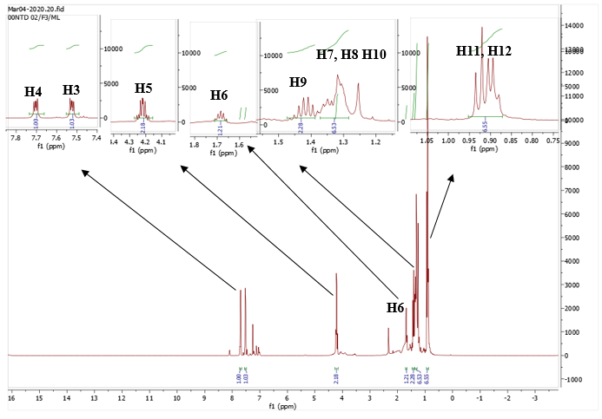
Figure S1: ¹H-NMR Spectrum of bis(4-methylheptyl) phthalate

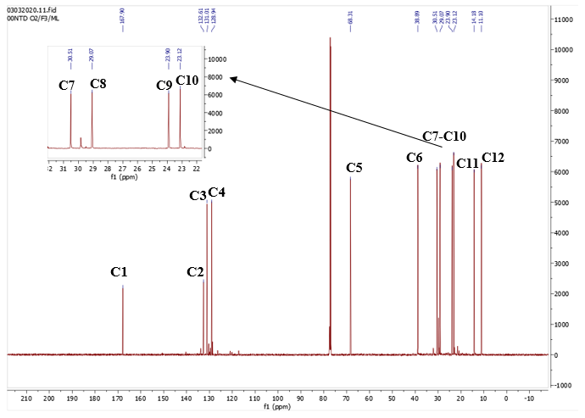
Figure S2: ¹³C-NMR Spectrum of bis(4-methylheptyl) phthalate

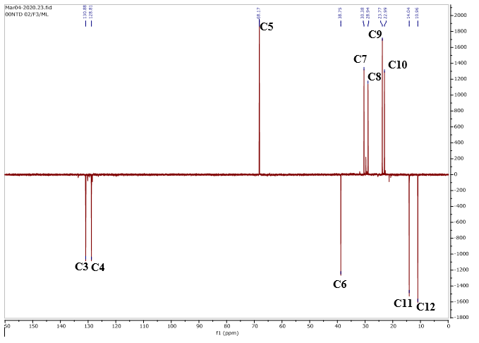

Figure S3: DEPT 135 spectrum of bis(4-methylheptyl) phthalate

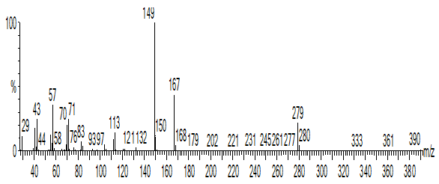

Figure S4: MS of bis(4-methylheptyl) phthalate

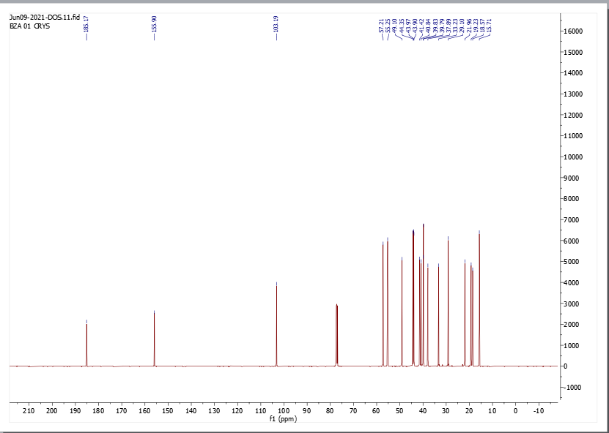

Figure S5: ¹³C-NMR Spectrum of ent-kaur-16-en-19-oic acid

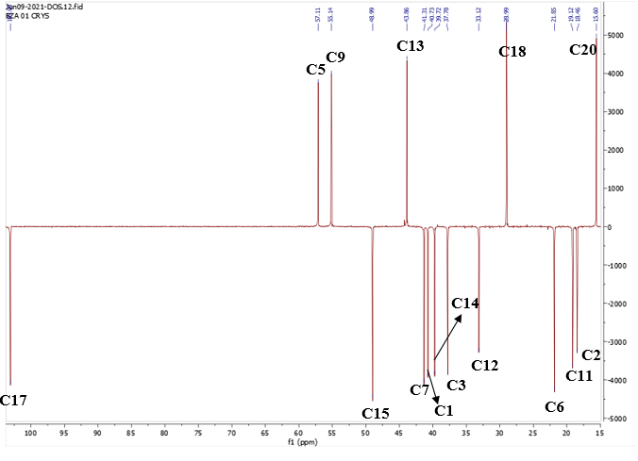

Figure S6: DEPT 135 spectrum of ent-kaur-16-en-19-oic acid

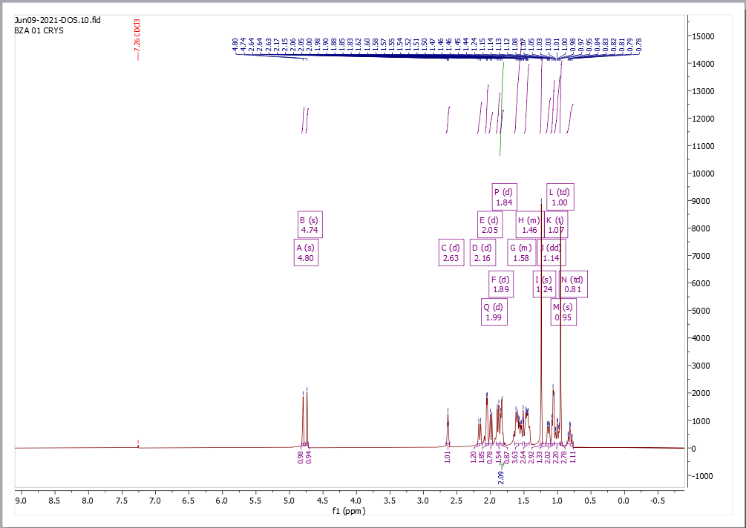

Figure S7: ¹H-NMR Spectrum of ent-kaur-16-en-19-oic acid

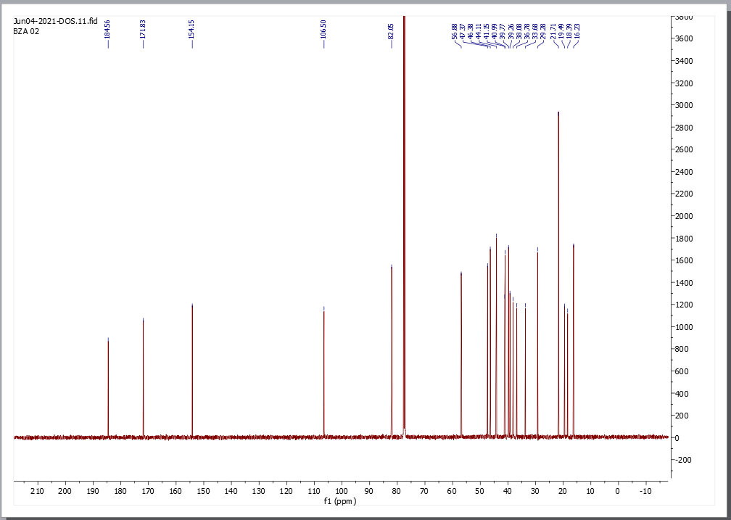

Figure S8: ¹³C-NMR Spectrum of Xylopic acid

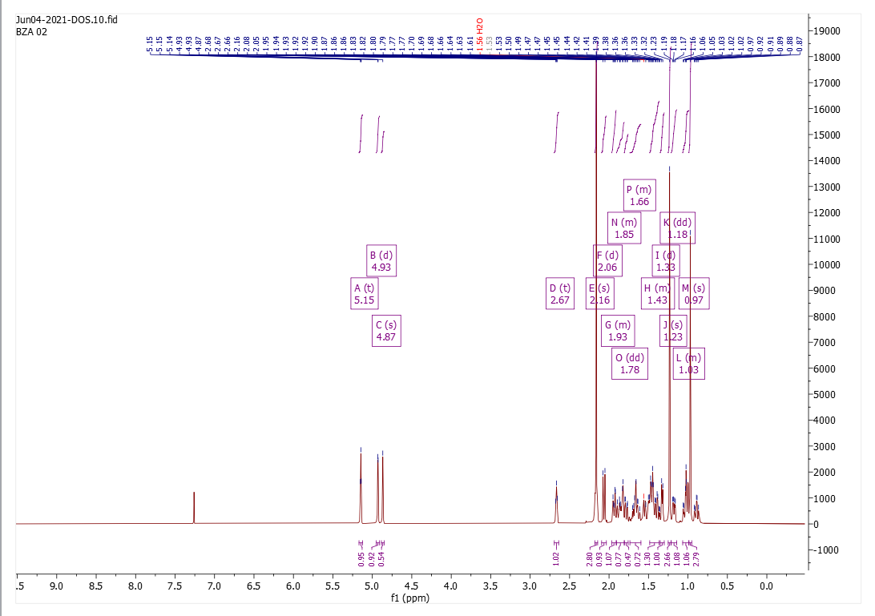

Figure S9: ¹H-NMR Spectrum of Xylopic acid

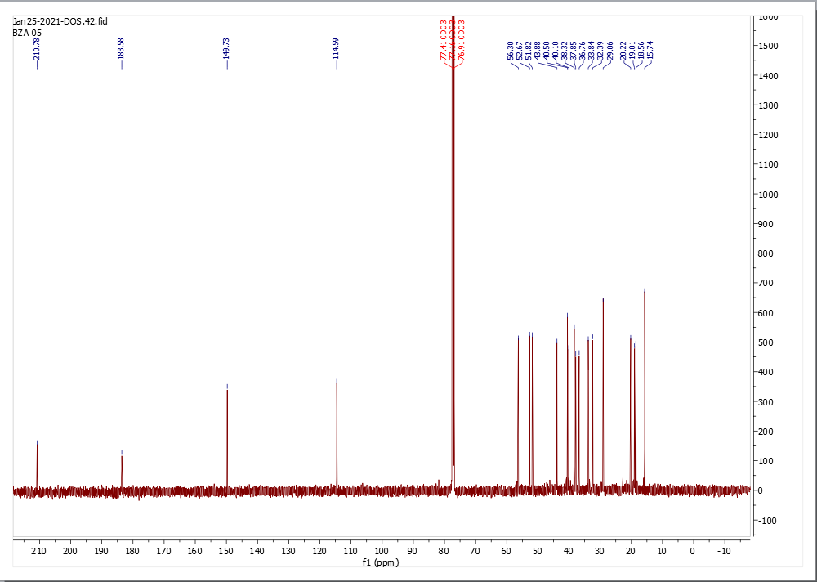

Figure S10: ¹³C-NMR Spectrum of ent-kaur-16-en-15-one-19-oic acid

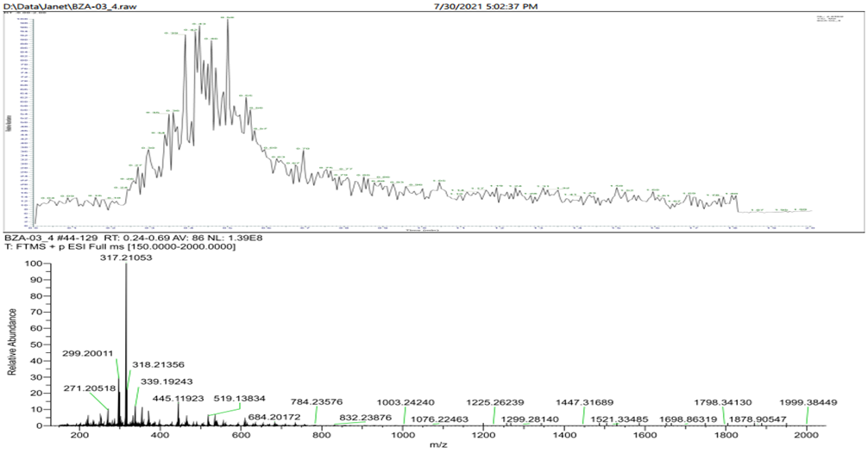
Figure S11: MS of ent-kaur-16-en-15-one-19-oic acid
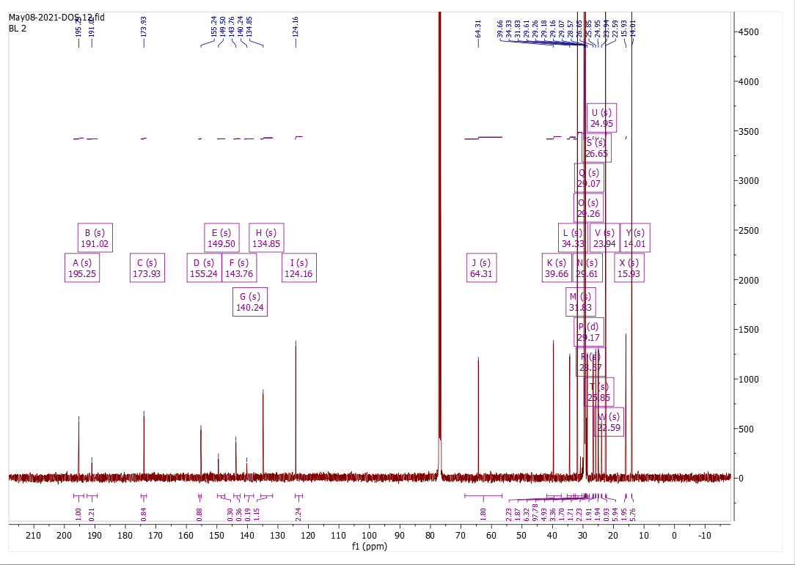
Figure S12: ¹³C-NMR spectrum of BL2

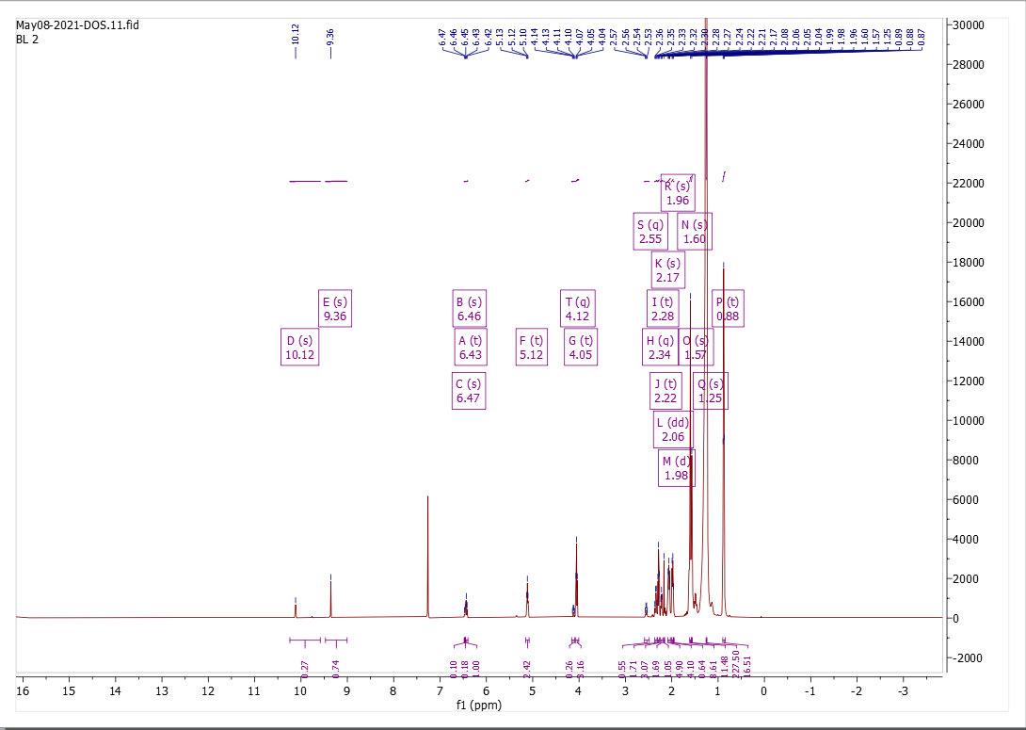

Figure S13: ¹H-NMR spectrum of BL2

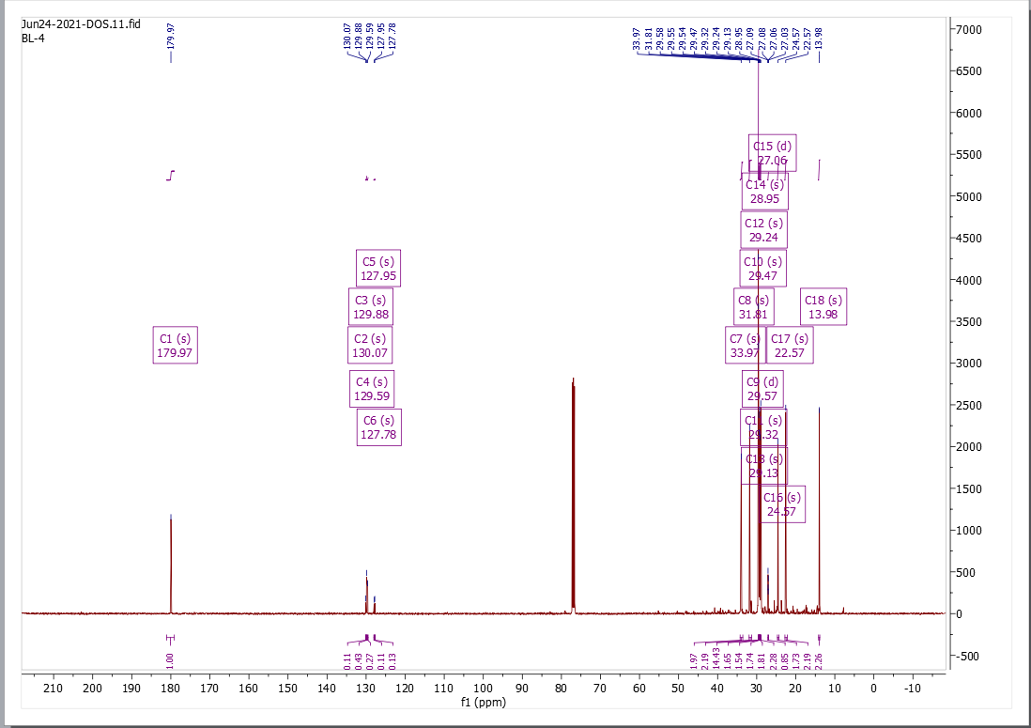

Figure S14: ¹³C-NMR spectrum of BL4

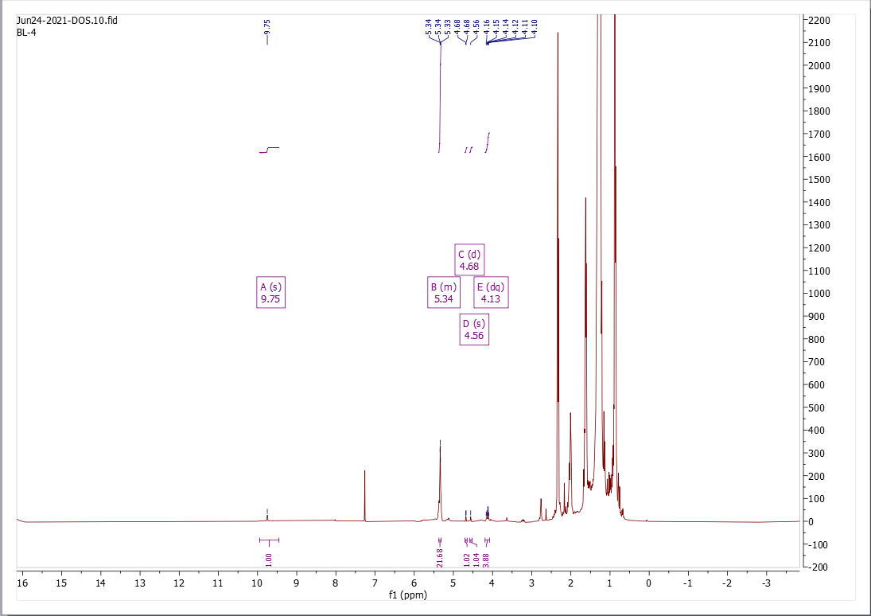

Figure S15: ¹H-NMR spectrum of BL4

Table S1. Results of physicochemical descriptors for the isolated compounds.
Name | MW | RB | HA | HD | Solubility | log P | Lipinski | Ghose | Veber
Bis(4-methylheptyl) phthalate | 390.56 | 6 | 4 | 0 | Poorly soluble | 6.44 | Yes, 1 viol | No | No
Kaurenoic Acid | 302.45 | 1 | 2 | 1 | Mod. soluble | 4.47 | Yes, 1 viol | Yes | Yes
Xylopic Acid | 360.49 | 3 | 4 | 1 | Mod. soluble | 4.05 | Yes, 0 viol | Yes | Yes
Ent-16-kauren-19-oic acid | 316.43 | 1 | 3 | 1 | Mod. soluble | 3.77 | Yes,0 viol | Yes | Yes
*viol = violation, *Mod. = Moderately

Table S2. Definition of lead-like, drug-like and Known drug space (KDS) in terms of molecular descriptors. The values given are the maxima for each descriptor for the volumes of chemical space used.
 | Lead-like Space | Drug-like Space | Known Drug Space
Molecular weight (g mol⁻¹) | 300 | 500 | 800
Lipophilicity (Log P) | 3 | 5 | 6.5
Hydrogen bond donors (HD) | 3 | 5 | 7
Hydrogen bond acceptors (HA) | 3 | 10 | 15
Rotatable bonds (RB) | 3 | 10 | 17

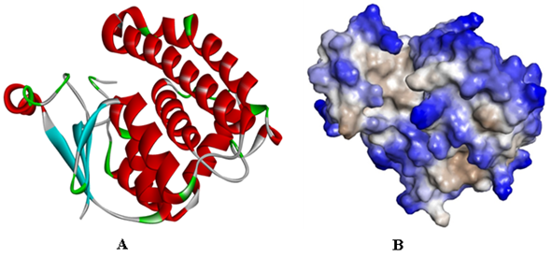
Figure S16: Modelling against glutathione S-transferase (Onchocerciasis), Ribbon (A) and Cell phase (B) of Glutathione S-transferase

Table S3. RSMD values for heavy atoms between the co-crystallized ligand and the docked molecule.
pose | ASP | PLP | CS | GS
1 | 2.5945 | 5.0325 | 1.3231 | 2.0448
2 | 1.2473 | 8.1221 | 2.0395 | 2.2427
3 | 2.5680 | 2.2701 | 1.5045 | 1.5275
Mean | 2.1366 | 5.1415 | 1.6223 | 1.9300

Table S4. Results of the binding score function for the ligands X = 2.570 Y = 0.814 Z = 49.968
Ligand | ASP | PLP | CS | GS
2-Hydroxy-4-methylbenzoic acid | 17.68 | 39.27 | 20.91 |  | 37.03
3- Carene | 15.87 | 34.74 | 21.27 |  | 30.27
3,4',5-trihydroxy-6'',6''-dimethylpyrano | 39.3 | 64.41 | 30.01 |  | 49.67
3,21-Dihydroxypregnan-20-one | 28.17 | 51.89 | 32.54 |  | 43.7
3-O-β-sitosterol ́lβ-D-glucopyranoside | 35.03 | 67.74 | 33.97 |  | 49.07
5-feruloylquinic acid | 32.31 | 59.42 | 18.5 |  | 48.25
Abietic acid | 25.51 | 50.03 | 29.37 |  | 39.11
Apigenin BL | 35.04 | 54.8 | 28.54 |  | 46.14
Beta-Pinene | 14.16 | 34.38 | 20.49 |  | 26.83
Bis(4-methylheptyl) phthalate | 34.98 | 80.5 | 35.71 |  | 65.19
Kaurenoic acid | 23.7 | 47.38 | 26.02 |  | 37.56
Xylopic acid | 23.71 | 46.02 | 26.93 |  | 41.98
En-16-kauren-19-oic acid | 22.4 | 45.36 | 24.37 |  | 39.75
Cassiaoccidentalin | -2.28 | -2.01 | -20.43 |  | 0
Doxycycline | 37.01 | 56.07 | 23 |  | 52.04
Eucalyptol | 15.86 | 33.16 | 21.84 |  | 25.54
Farobin B | 39.26 | 67.37 | 20.8 |  | 51.43
Farobin A | -37.03 | 0.14 | 0 |  | 0
Fructose | 16.01 | 45.26 | 15.17 |  | 36.98
Gamma-terpinene | 16.22 | 38.89 | 19.83 |  | 29.4
Glucose | 18.78 | 39.61 | 18.11 |  | 33.15
Homoorientin | 41.17 | 57.99 | 22.96 |  | 52.39
isotetrandrine | -9024.4 | -12517 | -12342.54 |  | 0
Isovitexin | 36.28 | 68.18 | 24.73 |  | 55.63
Ivermectin | 31.11 | 66.22 | 29.8 |  | 34.47
Kaempferol | 34.85 | 55.98 | 26.28 |  | 44.79
Lupeol | 25.6 | 54.01 | 32.27 |  | 46.14
Luteolin | 36.67 | 56.4 | 25.97 |  | 47.63
Orientin BL | 42.25 | 63.92 | 21.17 |  | 61.15
Para cymene | 17.16 | 40.08 | 19.61 |  | 31.4
Quercetin | 36.13 | 55.65 | 26.73 |  | 47.25
Trans-Pinocarveol | 15.69 | 33.36 | 20.76 |  | 26.41
trans-tiliroside | -547.37 | -1907.6 | -1971.39 |  | 0
Tricin 5-O-glucoside | 42.52 | 71.7 | 26.06 |  | 57.98
Tricin | 36.29 | 51.71 | 27.36 |  | 48.92

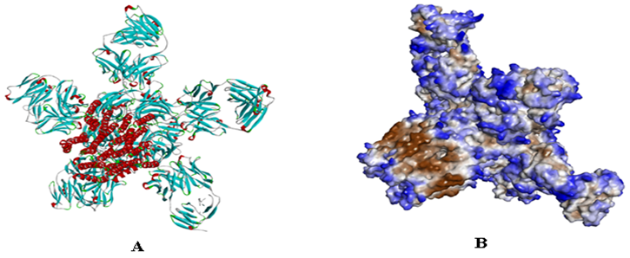

Figure S17: Modelling against glutamate-gated chloride channel, Ribbon (A) and Cell phase (B) of Glutamate-gated chloride ion channel

Table S5. RSMD values for heavy atoms between the co-crystallized ligand and the docked molecule.
pose | ASP | PLP | CS | GS
1 | 3.7443 | 1.4694 | 1.0874 | 1.4094
2 | 3.7443 | 1.5464 | 1.7139 | 2.0167
3 | 2.9338 | 1.4627 | 1.4683 | 1.8703
Mean | 3.4741 | 1.4928 | 1.4232 | 1.7654

Table S6. Results of the binding score function for the ligands. X = 12.675 Y = 95.052 Z = 24.998
Ligand | ASP | PLP | CS | GS
2-Hydroxy-4-methylbenzoic acid | 16.6 | 45.15 | 22.83 |  | 31.96
3- Carene | 12.5 | 35.78 | 20.61 |  | 30.92
3,4',5-trihydroxy-6'',6''-dimethylpyrano | 30.43 | 65.25 | 30.85 |  | 48.67
3,21-Dihydroxypregnan-20-one | 22.4 | 65.64 | 33.19 |  | 38.44
3-O-β-sitosterol ́β-D-glucopyranoside | 24.34 | 82.75 | 34.38 |  | 60.47
5-feruloylquinic acid | 29.86 | 71.49 | 23.59 |  | 53.19
Abietic acid | 24.04 | 62.6 | 31.91 |  | 48.71
Apigenin BL | 28.89 | 60.94 | 26.12 |  | 48.67
Beta-Pinene | 11.15 | 33.68 | 19.42 |  | 28.78
Bis(4-methylheptyl) phthalate | 29.84 | 81.12 | 32.44 |  | 70.51
Kaurenoic acid | 15.56 | 49.31 | 29.47 |  | 33.13
Xylopic acid | 16.19 | 47.27 | 25.07 |  | 35.78
En-16-kauren-19-oic acid | 16.23 | 48.17 | 26.4 |  | 36.89
Cassiaoccidentalin | -72.67 | -94.43 | -47.15 |  | 0
5-hexyl Glutathione | 38.41 | 95.74 | 41.1 |  | 83.81
Doxycycline | 32.38 | 82.28 | 20.11 |  | 70.06
Eucalyptol | 30.33 | 54.6 | 29.88 |  | 51.64
Farobin B | 28.42 | 57.8 | 24.5 |  | 45.41
Farobin A | 11.61 | 32.97 | 22.21 |  | 33.72
Fructose | 34.59 | 77.71 | 20.88 |  | 62.39
Gamma-terpinene | -159.5 | -117.98 | -91.07 |  | 0
Glucose | 14.52 | 42.6 | 17.81 |  | 37.56
Homoorientin | 13.79 | 36.18 | 18.02 |  | 31.38
isotetrandrine | 16.97 | 47.71 | 21.62 |  | 39.12
Isovitexin | 33.13 | 55.94 | 21.75 |  | 55.02
Kaempferol | 33.47 | 59.36 | 26.1 |  | 55.13
Lupeol | 28.95 | 79.76 | 33.9 |  | 45.39
Luteolin | 28.59 | 56.34 | 26.02 |  | 48.16
Orientin BL | 15.07 | 51.88 | 32.51 |  | 21.42
Para-Cymene | 30.1 | 57.73 | 27.6 |  | 49.86
Quercetin | 29.57 | 66.36 | 19.58 |  | 52.37
Trans-Pinocarveol | 14.87 | 36.94 | 18.13 |  | 31.21
trans-tiliroside | 30.56 | 57.93 | 26.81 |  | 49.06
Tricin 5-O-glucoside | 12.43 | 36.88 | 20.31 |  | 33.58
Tricin | -561.36 | -1907.89 | -1980.08 |  | 0

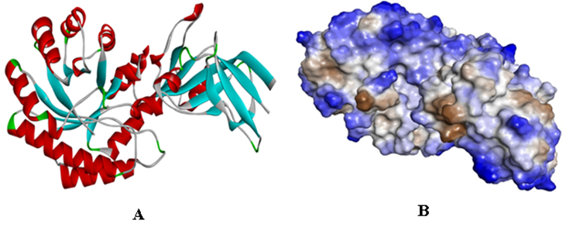

Figure S18: Modelling against Ornithine Decarboxylase (ODC) (Trypanosomiasis), Ribbon (A) and Cell phase (B) of Ornithine decarboxylase

Table S7. RSMD values for heavy atoms between the co-crystallized ligand and the docked molecule.
pose | ASP | PLP | CS | GS
1 | 0.2397 | 2.1389 | 6.2047 | 0.4523
2 | 0.5307 | 0.4928 | 6.1801 | 0.5147
3 | 0.6624 | 2.1559 | 6.4241 | 0.9416
Mean | 0.4776 | 1.595867 | 6.269633 | 0.6362

Table S8. Results of the binding score function for the ligands, X = 26.206 Y = -15.614 Z = 3.8
Ligand | ASP | PLP | CS | GS
2-Hydroxy-4-methylbenzoic acid | 21.57 | 42.02 | 21.32 | 41.71
3- Carene | 12.99 | 32.19 | 19.31 | 32.51
3,4',5-trihydroxy-6'',6''-dimethylpyrano | 35.16 | 60.32 | 26.34 | 54.07
3,21-Dihydroxypregnan-20-one | 22.34 | 53.49 | 25.62 | 38.75
3-O-β-sitosterol ́β-D-glucopyranoside | 30.82 | 65.8 | 25.8 | 52.83
5-feruloylquinic acid | 31.54 | 58.67 | 21.01 | 40.67
Abietic acid | 22.98 | 39.65 | 24.06 | 31.04
Apigenin BL | 32.09 | 53.25 | 25.59 | 58.22
Beta-Pinene | 11.06 | 32.84 | 18.39 | 28.83
Bis(4-methylheptyl) phthalate | 31.09 | 69.99 | 28.34 | 66.41
Kaurenoic acid | 22.43 | 51.33 | 26.66 | 34.96
Xylopic acid | 22.37 | 44.07 | 22.3 | 40.04
En-16-kauren-19-oic acid | 21.39 | 48.6 | 24.89 | 33.04
Cassiaoccidentalin | -6.97 | 1.1 | 0 | 0
Pyridoxal-5́-phosphate | 32.66 | 51.68 | 17.92 | 59.59
Doxycycline | 31.04 | 51.06 | 29.53 | 56.27
Eucalyptol | 33.34 | 53.41 | 22.58 | 51.66
Farobin B | 12.85 | 31.65 | 19.33 | 26.6
Farobin A | 33.06 | 61.23 | 15.09 | 60.71
Fructose | -248.49 | -424.96 | -163.07 | 0
Gamma-terpinene | 16.64 | 39.95 | 17.3 | 44.02
Glucose | 13.9 | 35.54 | 17.07 | 34.87
Homoorientin | 19.96 | 46.27 | 17.3 | 44.46
isotetrandrine | 37.78 | 64.64 | 18.89 | 59.08
Isovitexin | -10995.2 | -13399.1 | -12340.01 | 0
Kaempferol | 31.28 | 52.15 | 24.55 | 48.85
Lupeol | 23.49 | 49.09 | 30.2 | 44.9
Luteolin | 33.4 | 53.74 | 24.87 | 56.13
Orientin BL | 36.18 | 64.31 | 19.71 | 64.74
Para cymene | 14.34 | 35.71 | 17.68 | 34.62
Quercetin | 34.35 | 58.36 | 25.37 | 55.6
Trans-Pinocarveol | 11.88 | 30.93 | 18.68 | 26.21
trans-tiliroside | 21.57 | 42.02 | 21.32 | 41.71
Tricin 5-O-glucoside | 12.99 | 32.19 | 19.31 | 32.51
Tricin | 35.16 | 60.32 | 26.34 | 54.07

