Supplementary material
Mapping high-impact groups across dietary sustainability and nutrition

Contents
1.1 MATILDA datasets 2
1.12 The Food and Agriculture Biomass Input–Output Model (FABIO) 3
1.13 Alternative Healthy Eating Index (AHEI) 3
1.14 MATILDA modelling approach 4
1.15 Sensitivity analysis 7
1.2 Multilevel regression model 10
Supplementary Table 1 – Environmental indicators integrated into FABIO for diet-related footprinting 13
Supplementary Table 2. Scoring thresholds for AHEI components 13
Supplementary Table 3. Mapping of food categories between FABIO and GDD classifications 14
Supplementary Table 4. Diet-related environmental impacts (logarithmic transformation) as related to the AHEI-score in Multilevel regression models† 15
Supplementary Table 5. Diet-related environmental impacts (logarithmic transformed) as related to the AHEI-score in general linear regression model† 16
Supplementary Table 6. Relative comparison of dietary GHG emissions (FAO energy-adjusted) vs. GDD-based GHG emissions 17
Supplementary Figure 1. Proportion of dietary GHG emissions, Water Use, and Land Use by food group and demographic subgroup 23
Supplementary Figure 2. Distribution of Water Use, and Land Use across AHEI score deciles by socio-demographic subgroups 24
Supplementary Figure 3. Distribution of total dietary GHG emissions across demographic subgroups, weighted by population size 24

1.1 MATILDA datasets
MATILDA (Micro-Macro Assessment Tool to Identify Low-impact Dietary Actions) integrates three datasets—GDD (dietary intake), GLOPOP-S (population structure), and FABIO (environmental footprinting)—to enable dietary environmental impact analysis and nutritional assessment across 70+ socio-demographic subgroups in 150+ countries. This section details the datasets used to construct MATILDA.
1.11 Global Dietary Database (GDD)
The Global Dietary Database (GDD) is a comprehensive global dietary intake database that systematically collects, harmonises, and models dietary consumption data from 171 countries, covering 95% of the world's population¹. The database aims to provide standardised and comparable estimates of food and nutrient intake across different populations and demographic groups. The GDD is developed using 1,248 dietary food intake surveys, primarily based on individual-level 24-hour dietary recalls, food frequency questionnaires (FFQs), and demographic health surveys².
The GDD reports dietary intake data for 54 foods, beverages, and nutrients, including fruits, non-starchy vegetables, whole grains, sugar-sweetened beverages, legumes/nuts, unprocessed red and processed meats, seafood omega-3 fat, polyunsaturated fatty acids (PUFAs), sodium, coffee, tea, refined grains, potatoes, other starchy vegetables, total milk, and total seafoods in grams³. These dietary factors are analysed using Bayesian hierarchical models, accounting for variation in dietary survey methodologies, demographic characteristics, and national food availability data. To enhance data quality and comparability, GDD applies energy-adjusted intake estimations, ensuring dietary patterns are evaluated independently of total calorie consumption⁴. Dietary intake data were aggregated across age groups using median values. Missing values were clearly flagged using placeholder values of 999 to preserve data structure during harmonisation. Further, the GDD does not report direct intake values for food groups such as sugar, vegetable oils, or animal fats. Instead, it provides nutrient-level indicators (e.g. omega-3 and omega-6 fatty acids, added sugars) that are derived from various source foods.
The database provides detailed stratifications of food intake based on age (20 age groups), sex (male or female), education level (low: 0-6 years formal education, middle: 6-12 years, high: 12+ years), and area (urban/rural). We stratify our results into 72 subgroups based on these variables. For example, females aged 15–24 years living in rural areas with a low education level were considered one specific subgroup.

1.12 The Food and Agriculture Biomass Input–Output Model (FABIO)
FABIO is a global input-output model capture of domestic and global food flows which builds on FAOSTAT data to map global food supply chains for 187 regions (186 countries + 1 Rest of World) and 123 sectors⁵. This model is integrated with environmental extensions (Supplementary Table 1) to enable consumption-based environmental footprinting of dietary intake, in which upstream production impacts related to country-specific sourcing pathways of food products can be calculated across the entire supply chain. This distinguishes environmental impacts of identical food products consumed in different countries. Such an approach is preferable to employing food LCIA for several reasons. First, it offers a more precise estimate of environmental footprinting related to national consumption when compared with global and regional average impacts from LCIA. Second, it can be used to estimate the composition of products consumed within the coarse food groups of GDD and sectorally coarse LCIA estimates (e.g. apples and oranges in fruit consumption), which differ greatly by impact and country. Third, it enables the possibility for trade-specific analysis of dietary change, e.g. domestic sourcing of foods or preferential sourcing of foods from low-impact areas.

1.13 Alternative Healthy Eating Index (AHEI)
The Alternative Healthy Eating Index (AHEI) was originally proposed by McCullough et al.⁶, based on foods and nutrients most predictive of chronic disease risk. The AHEI focuses on evaluating the quality of dietary patterns and is designed to reflect long-term health outcomes, such as cardiovascular disease, type 2 diabetes, and certain cancers.
The AHEI includes nine dietary components based on epidemiological evidence linking them to chronic disease prevention. Among these, six components are considered protective and are scored positively with increasing intake: non-starchy vegetables, fruit, whole grains, nuts and legumes, polyunsaturated fatty acids (PUFAs), and long-chain n-3 PUFAs. Conversely, three components are scored negatively, meaning lower consumption is associated with better health outcomes: sugar-sweetened beverages and fruit juice (due to high free sugar content and low fibre), red and processed meats (linked to cancer and cardiovascular risk), and sodium (due to its association with hypertension and cardiovascular disease).
Each component receives a score ranging from 0 to 10, where 0 indicates the least healthy intake and 10 represents optimal intake. The scoring system is continuous, and proportional intake between the minimum and maximum thresholds are assigned intermediate values accordingly (Supplementary Table 2). The optimal intake levels for each component were established via a combination of current dietary guidelines and a substantial body of evidence from cohort studies and meta-analyses linking dietary factors to disease risk.

1.14 MATILDA modelling approach
After establishing the correspondence between GDD food groups and FABIO product categories, we estimated the environmental footprint associated with the consumption of one tonne of each GDD product. Subsequently, dietary footprints per capita were computed for each subgroup by combining these footprint intensities with subgroup-specific daily dietary intake data (in grams per day) from the GDD. Finally, to enable comparisons of absolute environmental impacts across subgroups, these per capita estimates were scaled using population data from GLOPOP.
The MATILDA database encompasses a regional coverage of 165 countries. For the present analysis, only countries with overlapping data availability across the three core datasets—FABIO, GDD, and GLOPOP—were included. Additionally, Bahrain, Brunei Darussalam, Eritrea, Qatar, Singapore, South Sudan were excluded due to the absence of final demand records in the FABIO dataset. Regarding temporal concordance, data from FABIO and GDD correspond to the year 2018, while GLOPOP population estimates reflect the year 2015.

FABIO
For this analysis we utilise the FABIO V1.2, which provides data on GHG emissions, water use and land use, and the trade relations. The underlying data are available upon reasonable request. FABIO V1.1 is available at: https://doi.org/10.5281/zenodo.2577067.
Product-group concordance
To obtain the environmental footprint of the GDD consumption levels per subgroup per country, we integrated GDD with FABIO. To achieve this, we construct a concordance table between GDD’s 16 food groups and 72 of the food products in FABIO (Supplementary Table 3). The country-specific sourcing patterns in the FABIO final demand (Y) matrix and the concordance table allows for estimation of the country-specific product composition and sourcing pattern for the consumption of one tonne of a GDD product group with the following equation:
$${\overset{⃑}{\hat{y}}}_{C, fg}= \frac{{\overset{⃑}{y}}_{C, P_{fg} }}{\sum{{\overset{⃑}{y}}_{C, P_{fg} }}}$$
Where ${\overset{⃑}{\hat{y}}}_{C, fg}$ gives the contributions of FABIO products and their producing countries for the final demand of country 𝐶 of one tonne of GDD food group 𝑓𝑔. This is based on ${\overset{⃑}{\hat{y}}}_{C, fg}$, the final demand of country 𝐶 and food group 𝑓𝑔, the final demand is scaled to one tonne through division by the sum $\sum{{\overset{⃑}{y}}_{C, P_{fg} }}$.
In cases where the sum of a country's final demand in FABIO (Y) was zero for all products related to a GDD product group, no sourcing pattern could be deduced, and the total global sourcing pattern for the respective GDD product group was imputed. The same equation was used to calculate the global sourcing patterns, except that instead of the final demand of one country, the final demand across all countries was accounted for.
GDD
In this analysis the GDD median country-level estimates for the year 2018 were used. We focus on groups aged above 15 years with a standardised dietary intake at 2,000 kcal/day, as socio-demographic data (e.g. on education, population size) and energy requirements are difficult to source and disaggregate for younger individuals. Therefore, the early age levels were dropped from the GDD data. On top of that, to ensure concordance with the GLOPOP database, some of the other age groups were merged based on median values.
To address data gaps in the GDD, a stepwise imputation approach was applied using lower-resolution information. First, missing values were filled by aggregating across educational strata to identify representative groups. Subsequently, values were further imputed by generalizing across residential location (urban vs. rural). Initially, following the harmonization and consolidation of certain age categories, 2.46% of the dataset was incomplete. After imputing by education, the proportion of missing data was reduced to 0.15%. The remaining gaps were fully resolved after imputation by location.
In order to link the GDD product groups to FABIO, the GDD product groups Cheese, Yoghurt, Sugar-sweetened beverages, and Fruit juices were transformed to the primary commodities groups Total Milk, Sugar, and Fruits. The technical conversion factors for the transformation were provided by FAO⁷ and for sugar-sweetened beverages by the USDA⁸S. Furthermore, the Tea and Coffee product groups' units were converted from cups to grams^{9,10}. Following these transformations, the number of product groups was reduced from 19 to 16.
Environmental accounts
We used three environmental indicators: water use, land use, and GHG emissions. These indicators were integrated into the FABIO from external sources. A detailed overview of the environmental indicators and their data sources is provided in Supplementary Table 1. Water use data comprising green and blue water use were sourced from Hoekstra & Mekonnen (2012)¹¹. Land use data, defined as agricultural land area, were obtained from FAOSTAT¹². GHG emissions were calculated using multiple components, including on-farm emissions from FAOSTAT¹², land use change emissions from LUH2¹³, and up- and down-stream emissions beyond the farm gate from Exiobase¹⁴ and IEA¹⁵. GHG emissions were expressed in CO₂-equivalents using a 100-year global warming potential horizon, in alignment with the IPCC’s time horizon for reporting GHG emissions¹⁶. This includes amortisation of land use change emissions over the same period. Direct emission coefficients were derived by dividing total production-related emissions by total output.

There is a large variance in the direct emission coefficients for food products, typically due to low incidental total output leading to a high resultant coefficient. Such outliers were identified based on product-specific boundaries calculated with the interquartile range (1.5 times the interquartile range above and below the median) and re-assigned to their respective lower or higher boundary. For some products the emissions are zero across all countries, e.g., there are no land use emissions for fishing. Missing coefficients were estimated by the global product-specific median value, based on all non-zero values.

Environmental footprinting
Environmental footprints of GDD food groups were calculated per country via FABIO, using a Leontief demand-pull consumption-based analysis, incorporating the sourcing pathways of direct and indirect production volumes embodied in national consumption:
$${\hat{EF}}_{C, fg}=\vec{e} ×L ×{\overset{⃑}{\hat{y}}}_{C, fg}$$
Where ${\hat{EF}}_{C, fg}$is the consumption-based environmental footprint for the final demand, ${\overset{⃑}{\hat{y}}}_{C, fg}$, of one tonne of food group 𝑓𝑔 in country 𝐶; $\vec{e}$ is the direct emission coefficient vector; 𝐿 is the Leontief inverse matrix. After these footprint calculations the outliers were again re-assigned to their respective lower or higher boundary (1.5 times the interquartile range above and below the median)¹⁷. The final consumption-based environmental impact intensities can be found in Figure 1.
The resultant environmental footprint per person per day (2,000 kcal) were then scaled by the per capita food consumption in GDD as follows:
$$EF_{per capita,C,fg,imp}={GDD}_{C, fg }× {\hat{EF}}_{C, fg}$$
Where $EF_{per capita,C,fg,imp}$ represents the country- (𝐶) and food-specific (𝑓𝑔) per capita environmental footprint; ${GDD}_{C, fg }$ refers to consumption of food group 𝑓𝑔, in each country 𝐶, in tonnes/day/2,000 kcal.
Population scaling
To estimate total dietary environmental footprints of each socio-demographic group, per capita environmental footprints were multiplied by the subpopulation size from GLOPOP. Since GDD captures per capita impacts, this scaling process was applied to estimate population-level impacts of specific sub-groups and their role within national environmental footprints, a common procedure in dietary environmental footprints:
$$EF_{total,C}=\sum_{ }^{ }{EF_{per capita,C,fg,imp}}. Population_{C }$$
Where $EF_{total,C}$ represents national dietary environmental footprints of each country, $Population_{C }$refers to the total population of each country. This accounts for the total impact of dietary pattern across different age, gender, and socioeconomic groups¹⁸. Although the GDD does not provide dietary data disaggregated by income or wealth, we extended subgroup analyses to include these dimensions to explore broader inequality-related patterns in environmental impacts. Some of the GLOPOP age groups have been aggregated in order to match with those listed in the GDD.

1.15 Sensitivity analysis
To assess how changes in product contributions influence the environmental impacts of product groups, a sensitivity analysis was conducted. This analysis is based on the allocation of GDD product groups to multiple FABIO products. For each country, the share of each product is estimated by dividing its final demand by the total final demand of all related products (see Section 4.1).
The sensitivity analysis makes incremental changes to the product composition per product group per country. This produces an alternative sourcing pattern related to a product group. The country-specific product composition of GDD food groups in FABIO was treated as a baseline for all calculations generated by MATILDA; in the sensitivity analysis, these were varied by a 0 to 10% increase or decrease. The product-specific food group compositions are calculated using the Latin Hypercube Sampling method¹⁹. The analysis covers 165 countries and includes 16 GDD product groups that are linked to 72 FABIO products. Of these, five GDD product groups have a direct one-to-one correspondence with FABIO categories and are therefore excluded from the sensitivity analysis.
The number of samples is estimated based on the maximum change in IQR that we observe across all parameters. The number of samples should be sufficient to limit the change in IQR across all parameters to 5%. As shown in Figure 2, this is achieved after 78 runs. As such, 200 samples were deemed sufficient to robustly assess the variability in environmental impacts of food consumption, accounting for variability in product composition of GDD food groups (Figure 2). For some product group-country pairs, it is impossible to calculate the related sourcing pattern as final demand data is missing. In such cases, missing data were replaced by global sourcing patterns just like in the main analysis.
The results of the sensitivity analysis are plotted in Figure 3 for all three impacts. The variation in impacts between product groups can partially be explained by the number of products related to one product group. Overall, we find minimal variations in the environmental footprints of food groups in response to a moderate (<|10%|) variation in the product composition of food group consumption.

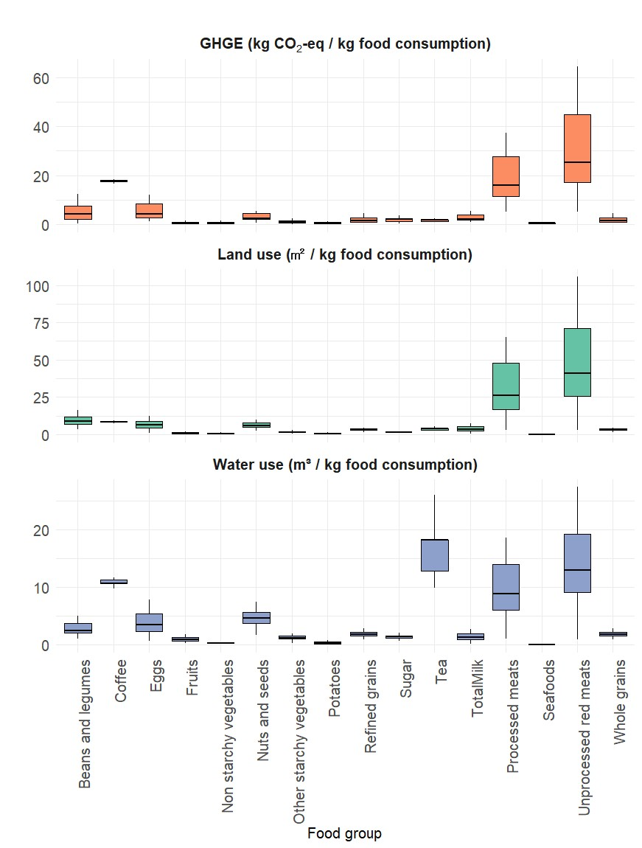

Figure 1. Consumption-based environmental impact intensities in FABIO.

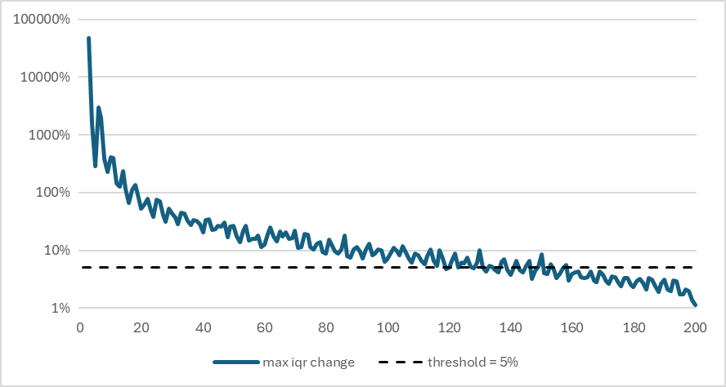
Figure 2: The maximum inter-quartile range (IQR) expansion after each additional sample across all 13,464 parameters included in the sensitivity analysis. The baseline is not included. Hence, the first sample has an IQR of 0, which makes the IQR expansion of the 2nd sample infinitely high. As such, the plot is visible from sample 3 onwards.

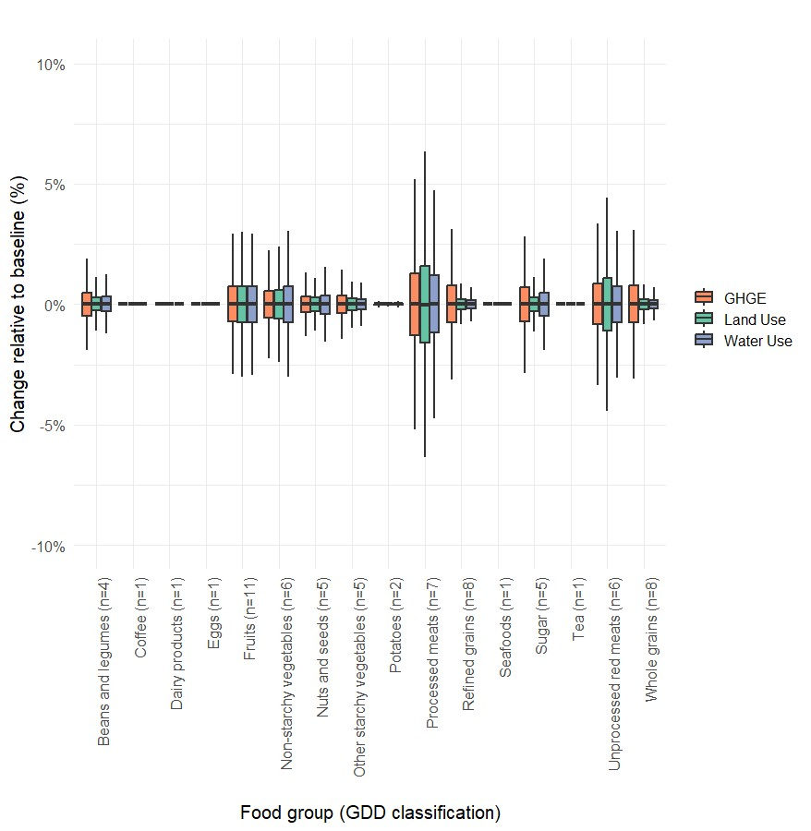
Figure 3: The relative change of environmental impacts per product group compared to the baseline composition due to varying underlying product compositions (n). For every product group, the data points are cut off at an IQR of 1.5 to improve readability. Note that for GDD product groups with a single corresponding product in FABIO (n=1), such as coffee, eggs, tea, total milk, and total seafoods, no variation was implemented.

1.2 Multilevel regression model
We use multilevel regression models with random intercepts and slopes to examine the association between the AHEI and the dietary environmental impacts of population subgroups. A likelihood ratio (LR) test was used to assess the statistical significance of the differential associations between AHEI and environmental footprints across population subgroups.
The grouping variable was modelled as a second-level hierarchical factor (random effect), while the remaining three demographic variables were treated as fixed effects. The grouping variable was modelled as a second-level hierarchical factor (random effect), while the remaining three demographic variables were treated as fixed effects. Specifically, when age was the grouping variable, sex, education level, and residence were included as fixed effects; similarly, when sex (male/female), education level (low, middle, high), or residence (urban/rural) was the grouping variable, the other three variables were included as fixed effects.
The combined slope for each subgroup consisted of a fixed-effect slope plus a random-effect slope. The models included two levels of variance: individuals (level 1, n = 12,312) and the selected grouping variable (level 2, with 6 age groups, 2 sexes, 3 education levels, or 2 residence categories). The slope and intercept of AHEI were allowed to vary randomly across subgroups. Dietary environmental footprints (densities) were included as the dependent variable (logarithmic transformation), with AHEI as the independent variable, adjusted for the fixed effects of age, sex, education level, and residence. The Akaike Information Criterion (AIC) and Bayesian Information Criterion (BIC) were used to assess model fit. A p-value < 0.05 was considered statistically significant.
References
1. Welcome to the Global Dietary Database | Global Dietary Database. https://globaldietarydatabase.org/.
2. Del Gobbo, L. C. et al. Assessing global dietary habits: a comparison of national estimatesfrom the FAO and the Global Dietary Database23. Am. J. Clin. Nutr. 101, 1038–1046 (2015).
3. Miller, V. et al. Global Dietary Database 2017: data availability and gaps on 54 major foods, beverages and nutrients among 5.6 million children and adults from 1220 surveys worldwide. BMJ Glob. Health 6, (2021).
4. Miller, V. et al. Global, regional, and national consumption of animal-source foods between 1990 and 2018: findings from the Global Dietary Database. Lancet Planet. Health 6, e243–e256 (2022).
5. Bruckner, M. et al. FABIO—The Construction of the Food and Agriculture Biomass Input–Output Model. Environ. Sci. Technol. 53, 11302–11312 (2019).
6. McCullough, M. L. & Willett, W. C. Evaluating adherence to recommended diets in adults: the Alternate Healthy Eating Index. Public Health Nutr. 9, 152–157 (2006).
7. FAO (Food & Nations), A. O. of the U. Technical conversion factors for agricultural commodities. (2000).
8. Agriculture, U. S. D. of. USDA Database for the Added Sugars Content of Selected Foods, Release 1. (2006).
9. Santini, A. et al. Influence of different coffee drink preparations on ochratoxin A content and evaluation of the antioxidant activity and caffeine variations. Food Control 22, 1240–1245 (2011).
10. Azapagic, A., Bore, J., Cheserek, B., Kamunya, S. & Elbehri, A. The global warming potential of production and consumption of Kenyan tea. J. Clean. Prod. 112, 4031–4040 (2016).
11. Hoekstra, A. Y. & Mekonnen, M. M. The water footprint of humanity. Proc. Natl. Acad. Sci. 109, 3232–3237 (2012).
12. FAOSTAT. https://www.fao.org/faostat/en/#home.
13. Hurtt, G. C. et al. Harmonization of global land use change and management for the period 850–2100 (LUH2) for CMIP6. Geosci. Model Dev. 13, 5425–5464 (2020).
14. Stadler, K. et al. EXIOBASE 3: Developing a Time Series of Detailed Environmentally Extended Multi-Regional Input-Output Tables. J. Ind. Ecol. 22, 502–515 (2018).
15. Guilhoto, J. M. et al. Methodology for estimation of Energy Physical Supply and Use Tables based on IEA’s World Energy Balances. OECD Sci. Technol. Ind. Work. Pap. 2021, 1–29 (2021).
16. Mukherji, A. Climate change 2023 synthesis report. (2023).
17. Dawson, R. How Significant is a Boxplot Outlier? J. Stat. Educ. 19, (2011).
18. Payró, C., Taherzadeh, O., van Oorschot, M., Koch, J. & Marselis, S. Consumer resistance diminishes environmental gains of dietary change. Environ. Res. Lett. 19, 054033 (2024).
19. Mckay, M. D., Beckman, R. J. & Conover, W. J. A Comparison of Three Methods for Selecting Values of Input Variables in the Analysis of Output From a Computer Code. Technometrics 42, 55–61 (2000).

Supplementary Table 1 – Environmental indicators integrated into FABIO for diet-related footprinting
Environmental dimension | Indicator | Source
Water use | Green and blue water use (m³) | Hoekstra & Mekonnen (2012)¹¹
Land use | Agricultural land area (ha) | FAOSTAT¹²
Emissions | Greenhouse gas emissions eq. Ammortisation 100 years - "Primary (100 years)","Secondary (100 years)","Emissions (CH4) (Fires in organic soils)","Emissions (CO2) (Fires in organic soils)","Emissions (N2O) (Fires in humid tropical forests)","Emissions (CH4) (Fires in humid tropical forests)" | On-farm emissions: FAOSTAT¹², Land use change emissions: LUH2¹³, up- and downstream emissions beyond the  farm-gate: Exiobase¹⁴ & IEA¹⁵

Supplementary Table 2. Scoring thresholds for AHEI components
Component | Score 0 | Score 10
Fruit (servings/day) | 0.0 | 4.0
Non-starchy vegetables (servings/day) | 0.0 | 5.0
Whole grains (women, g/day) | 0.0 | 75.0
Whole grains (men, g/day) | 0.0 | 90.0
Sugar-sweetened beverages and fruit juice (servings/day) | 1.0 | 0.0
Legumes and nuts (servings/day) | 0.0 | 1.0
Unprocessed red meat and processed meat (servings/day) | 1.5 | 0.0
Seafood omega-3 fat (mg/day) | 0.0 | 250.0
PUFAs (% energy/day) | 2.0 | 10.0
Sodium* (mg/day) | 10292.65 | 1657.16
*Sodium values are based on dietary intake thresholds.

Supplementary Table 3. Mapping of food categories between FABIO and GDD classifications
GDD food group | Corresponding FABIO food commodity
Fruits | Coconuts - Incl Copra; Oranges, Mandarines; Lemons, Limes and products; Grapefruit and products; Citrus, Other; Bananas; Apples and products; Pineapples and products; Dates; Grapes and products (excl wine); Fruits, Other
Non-starchy vegetables | Olives (including preserved); Tomatoes and products; Onions; Vegetables, Other; Pepper; Pimento
Potatoes | Potatoes and products; Sweet potatoes
Other starchy vegetables | Maize and products; Cassava and products; Roots, Other; Yams; Plantains
Beans and legumes | Beans; Peas; Pulses, Other and products; Soyabeans
Nuts and seeds | Nuts and products; Groundnuts; Sunflower seed; Rape and Mustardseed; Sesame seed
Refined grains | Rice and products; Wheat and products; Barley and products; Rye and products; Oats; Millet and products; Sorghum and products; Cereals, Other
Whole grains | Rice and products; Wheat and products; Barley and products; Rye and products; Oats; Millet and products; Sorghum and products; Cereals, Other
Processed meats | Bovine Meat; Mutton & Goat Meat; Pigmeat; Poultry Meat; Meat, Other; Offals, Edible; Fats, Animals, Raw
Unprocessed red meats | Bovine Meat; Mutton & Goat Meat; Pigmeat; Meat, Other; Offals, Edible; Fats, Animals, Raw
Seafood | Fish, Seafood
Eggs | Eggs
Sugar | Sugar cane ; Sugar beet; Sugar non-centrifugal; Sugar (Raw Equivalent); Sweeteners, Other
Coffee | Coffee and products
Tea | Tea (including mate)
Dairy products | Milk - Excluding Butter

Supplementary Table 4. Diet-related environmental impacts (logarithmic transformation) as related to the AHEI-score in Multilevel regression models†
 | GHG emissions  (Kg CO₂-eq/2000 kcal ) | TWU  (M³/2000 kcal) | LU  (M²/2000 kcal)
Education level
Fix effects
1-point increment in AHEI score (95% CI) | -0.067*  (-0.088, -0.054) | -0.023*  (-0.032, -0.015) | -0.105** (-0.128, -0.082)
Random effects*
SD of intercept | 0.055 | 0.036 | 0.001
SD of slope | 0.004 | 0.002 | 0.003
Gender
Fix effects
1-point increment in AHEI score (95% CI) | -0.066*** (-0.072,  -0.061) | -0.024*** (-0.031, -0.015) | -0.104*** (-0.127, -0.081)
Random effects*
SD of intercept | 0.009 | 0.001 | 0.009
SD of slope | 0.001 | 0.001 | 0.001
Age
Fix effects
1-point increment in AHEI score (95% CI) | -0.066* (-0.082, -0.051) | -0.023* (-0.034, -0.011) | -0.104*** (-0.137, -0.071)
Random effects*
SD of intercept | 0.679 | 0.263 | 0.525
SD of slope | 0.009 | 0.004 | 0.007
Area
Fix effects
1-point increment in AHEI score (95% CI) | -0.066*** (-0.081, -0.051) | -0.023*** (-0.028, -0.018) | -0.125* (-0.127, -0.081)
Random effects*
SD of intercept | 0.144 | 0.119 | 0.148
SD of slope | 0.001 | 0.001 | 0.001
†Regression coefficients are all back-transformed from analysis on the log scale. Models were repeated in different demographic subgroups by gender, age, educational level, and area.
*Random effect of the model included intercept and slope, and other covariates were fitted as fixed effects. SD: Standard deviation. p < 0.05, **p < 0.01, ***p < 0.001.

Supplementary Table 5. Diet-related environmental impacts (logarithmic transformed) as related to the AHEI-score in general linear regression model†
 | GHG emissions  (Kg CO₂-eq/2000 kcal ) | TWU  (M³/2000 kcal) | LU  (M²/2000 kcal)
AHEI (95% CI) | -0.066***  (-0.072, -0.061) | -0.023***  (-0.026, -0.021) | -0.105***  (-0.113, -0.096)
Education (reference to high level)
Low level | -0.803***  (-0.872, -0.732) | -0.453***  (-0.491, -0.416) | -1.257***  (-1.366, -1.145)
Medium level | -0.451***  (-0.526, -0.374) | -0.263***  (-0.302, -0.224) | -0.745***  (-0.863, -0.625)
Gender
(reference to Male)
Female | -0.006  (-0.075, 0.065) | -0.019  (-0.017, 0.056) | -0.013  (-0.123, 0.098)
Age
(reference to age 15-34 y)
35-54y | -0.543***  (-0.616, -0.469) | -0.351***  (-0.388, -0.313) | -0.966***  (-1.078, -0.852)
55+y | 0.181***  (0.091, 0.272) | 0.065**  (0.021, 0.111) | 0.166**  (0.028, 0.307)
Area
(reference to Rural)
Urban | 0.646***  (0.565, 0.729) | 0.336***  (0.295, 0.377) | 1.004***  (0.877, 1.134)
†Regression coefficients are back-transformed after the model regression on the log scale. Models were repeated in different demographic subgroups by gender, age, educational level, and area.
*Random effect of the model included intercept and slope, and other covariates were fitted as fixed effects. SD: Standard deviation. p < 0.05, **p < 0.01, ***p < 0.001.

Supplementary Table 6. Relative comparison of dietary GHG emissions (FAO energy-adjusted) vs. GDD-based GHG emissions
We used the country-specific average energy intake levels provided by the FAO to adjust the calculation of dietary GHG emissions and compared the results with dietary GHG emissions based on GDD.
Country | FAO vs. GDD (%)
Ireland | 96.9%
United States of America | 91.2%
Belgium | 90.0%
Turkey | 89.4%
Austria | 87.7%
Israel | 85.1%
Iceland | 82.8%
Romania | 81.0%
Germany | 80.3%
Canada | 80.0%
Denmark | 78.7%
Italy | 77.5%
France | 75.5%
Norway | 74.4%
Bahrain | 74.1%
Qatar | 74.1%
Australia | 73.5%
Portugal | 73.4%
Poland | 73.2%
Montenegro | 73.0%
Kuwait | 71.6%
Morocco | 70.6%
Luxembourg | 70.4%
Tunisia | 69.9%
Switzerland | 69.5%
Serbia | 69.4%
Greece | 69.3%
Cuba | 69.3%
Republic of Korea | 69.2%
Algeria | 69.1%
Spain | 68.5%
Russian Federation | 67.7%
Albania | 67.6%
Kazakhstan | 67.5%
United Kingdom | 67.2%
Bosnia and Herzegovina | 66.3%
Netherlands | 65.9%
Finland | 65.9%
Czech Republic | 65.3%
Hungary | 64.7%
China, mainland | 64.0%
Lithuania | 63.9%
Brazil | 63.8%
Latvia | 62.4%
Belarus | 62.1%
Uruguay | 62.1%
Argentina | 61.9%
Mexico | 61.6%
United Arab Emirates | 61.4%
Saudi Arabia | 60.7%
Uzbekistan | 60.6%
Estonia | 60.0%
New Zealand | 59.7%
Slovenia | 59.7%
Armenia | 58.9%
Sweden | 58.7%
Lao People's Democratic Republic | 57.7%
Azerbaijan | 57.5%
Libya | 57.3%
Croatia | 57.2%
Guyana | 56.6%
Egypt | 56.0%
Paraguay | 55.2%
Oman | 53.8%
Colombia | 53.6%
Panama | 52.2%
Samoa | 51.9%
North Macedonia | 51.5%
Chile | 51.1%
Republic of Moldova | 50.6%
Costa Rica | 50.2%
Dominican Republic | 50.0%
Saint Vincent and the Grenadines | 49.5%
Ukraine | 49.5%
Mauritius | 49.4%
Georgia | 48.9%
Cyprus | 48.9%
Trinidad and Tobago | 48.3%
Ghana | 47.2%
Dominica | 47.2%
Mauritania | 47.1%
Malaysia | 47.0%
Viet Nam | 46.3%
Lebanon | 46.2%
Indonesia | 45.9%
Slovakia | 45.3%
Jamaica | 44.5%
Turkmenistan | 44.3%
Bulgaria | 43.6%
Mongolia | 42.7%
South Africa | 42.3%
Iran (Islamic Republic of) | 41.9%
Vanuatu | 41.7%
Nepal | 40.4%
Djibouti | 39.4%
Thailand | 39.4%
Côte d'Ivoire | 39.0%
Sri Lanka | 38.7%
Belize | 38.5%
Peru | 38.4%
Myanmar | 38.4%
Kyrgyzstan | 38.3%
Cameroon | 38.2%
El Salvador | 38.0%
Guinea | 37.8%
Philippines | 37.6%
Mali | 37.5%
Cambodia | 35.9%
Tajikistan | 34.0%
Japan | 33.6%
Suriname | 33.1%
Gabon | 32.8%
Burkina Faso | 32.7%
Senegal | 32.4%
Jordan | 32.1%
Niger | 32.1%
Iraq | 31.8%
Benin | 31.7%
Honduras | 31.2%
Malawi | 30.7%
Bahamas | 29.8%
Cabo Verde | 29.6%
Guatemala | 29.3%
Sudan | 29.3%
Nicaragua | 28.8%
Maldives | 28.3%
Bangladesh | 27.9%
Syrian Arab Republic | 27.9%
Ecuador | 27.4%
Grenada | 26.8%
India | 26.6%
Botswana | 26.6%
Nigeria | 26.3%
Namibia | 26.2%
Eswatini | 24.9%
Pakistan | 24.2%
Antigua and Barbuda | 23.8%
Angola | 22.6%
Ethiopia | 22.5%
Gambia | 22.1%
Solomon Islands | 20.7%
Bolivia (Plurinational State of) | 19.7%
Togo | 18.2%
Sao Tome and Principe | 17.6%
South Sudan | 17.1%
Sierra Leone | 17.0%
United Republic of Tanzania | 16.8%
Chad | 15.8%
Timor-Leste | 13.8%
Guinea-Bissau | 13.8%
Central African Republic | 13.7%
Afghanistan | 13.2%
Zambia | 13.1%
Kenya | 11.9%
Rwanda | 9.9%
Papua New Guinea | 9.7%
Venezuela (Bolivarian Republic of) | 9.7%
Lesotho | 9.1%
Democratic Republic of the Congo | 8.6%
Liberia | 7.1%
Uganda | 7.0%
Haiti | 6.4%
Congo | 5.6%
Zimbabwe | 3.4%
Mozambique | 2.8%
Madagascar | 1.1%
Yemen | -0.3%
Brunei Darussalam | -2.0%
Singapore | -6.0%
Burundi | -10.7%
Eritrea | -12.0%

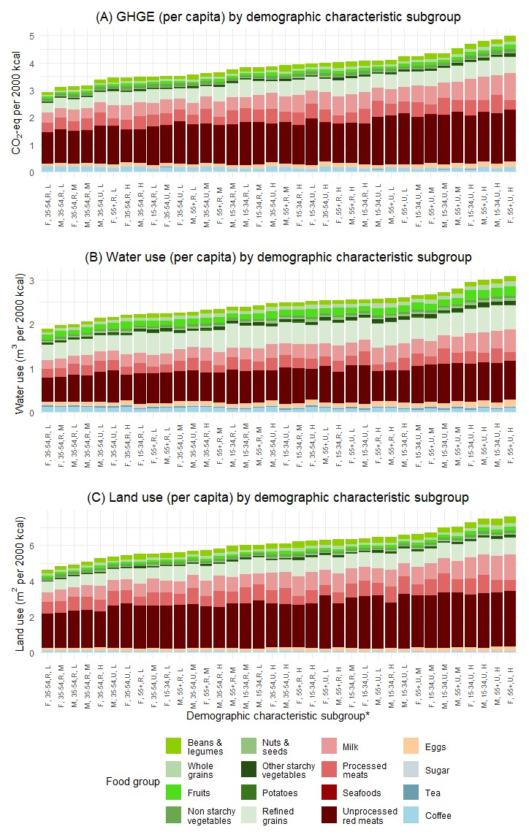

Supplementary Figure 1. Proportion of dietary GHG emissions, Water Use, and Land Use by food group and demographic subgroup
X-axis labels are for Gender (M = Male, F = Female), Age (15–34 y, 35–54 y, 55+ y), Area (R = Rural, U = Urban), and Education (L = Low, M = Medium, H = High).
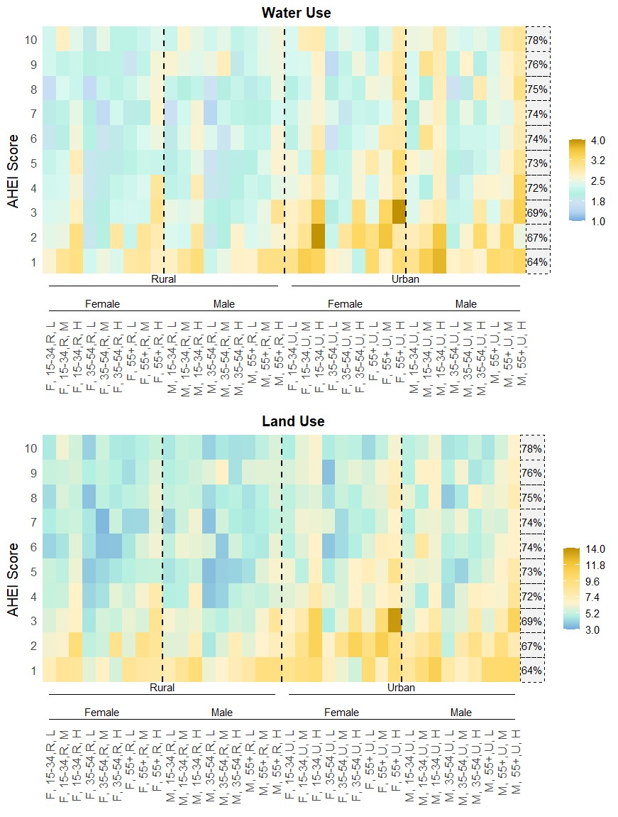

Supplementary Figure 2. Distribution of Water Use, and Land Use across AHEI score deciles by socio-demographic subgroups
AHEI scores were stratified into ten deciles from lowest to highest.

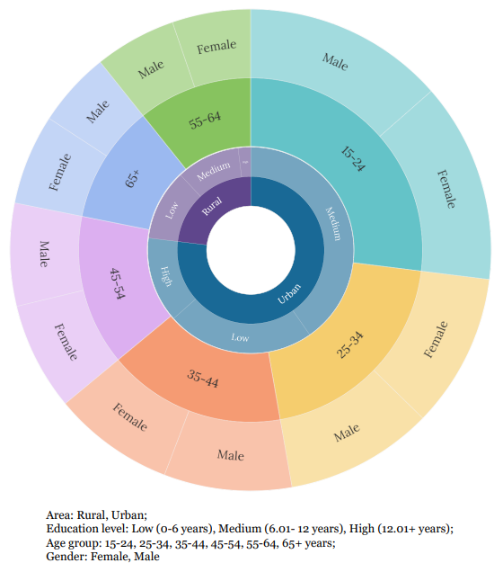

Supplementary Figure 3. Distribution of total dietary GHG emissions across demographic subgroups, weighted by population size

