Table 1. Optimization of reaction conditionsª
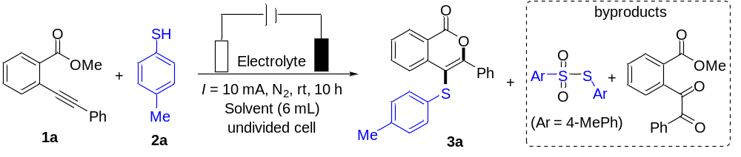
Entry | Electrode | Electrolyte | Solvent | 3a (%)^{b}
1 | Pt (+) /Pt (-) | Bu₄NBF₄ | CH₃CN | trace
2 | GF (+)/Pt (-) | Bu₄NBF₄ | CH₃CN | 24
3 | RVC (+)/Pt (-) | Bu₄NBF₄ | CH₃CN | 12
4 | Carbon rod (+)/Pt (-) | Bu₄NBF₄ | CH₃CN | 25
5 | C100 (+)/Pt (-) | Bu₄NBF₄ | CH₃CN | 45
6 | C200 (+)/Pt (-) | Bu₄NBF₄ | CH₃CN | 70
7 | C200 (+)/C100 (-) | Bu₄NBF₄ | CH₃CN | 46
8 | C100 (+)/C100 (-) | Bu₄NBF₄ | CH₃CN | 14
9 | C200 (+)/Pt (-) | Bu₄NBF₄ | THF | trace
10 | C200 (+)/Pt (-) | Bu₄NBF₄ | HFIP | 20
11 | C200 (+)/Pt (-) | Bu₄NBF₄ | EtOH | 0
12 | C200 (+)/Pt (-) | Bu₄NBF₄ | Acetone | 25
13 | C200 (+)/Pt (-) | Bu₄NBF₄ | DMSO | 0
14 | C200 (+)/Pt (-) | Bu₄NBF₄ | CH₃CN-acetone (10:1) | 45
15 | C200 (+)/Pt (-) | Bu₄NBF₄ | CH₃CN-H₂O (10:1) | 38
16 | C200 (+)/Pt (-) | Bu₄NBF₄ | CH₃CN-HFIP (10:1) | 82
17 | C200 (+)/Pt (-) | Bu₄NClO₄ | CH₃CN-HFIP (10:1) | 24
18 | C200 (+)/Pt (-) | Bu₄NPF₆ | CH₃CN-HFIP (10:1) | 15
19 | C200 (+)/Pt (-) | Bu₄NBr | CH₃CN-HFIP (10:1) | trace
20 | C200 (+)/Pt (-) | CF₃SO₃Li | CH₃CN-HFIP (10:1) | 30
21 | C200 (+)/Pt (-) | LiClO₄ | CH₃CN-HFIP (10:1) | 66
22^{c} | C200 (+)/Pt (-) | Bu₄NBF₄ | CH₃CN-HFIP (10:1) | 70
23^{d} | C200 (+)/Pt (-) | Bu₄NBF₄ | CH₃CN-HFIP (10:1) | 80
24e | C200 (+)/Pt (-) | Bu₄NBF₄ | CH₃CN-HFIP (10:1) | 48
ªReaction conditions: Pt plate (10 × 10 × 1 mm), Reticulated vitreous carbon (RVC) (100 PPI, 1 cm × 1 cm × 1 cm), carbon rod (Ф 6 mm), C200 or C100 plate (10 × 12 mm), undivided cell, constant current = 10 mA, isolated yield. 1a (0.2 mmol), 2a (0.8 mmol), electrolyte (0.4 mmol), and solvent (6 mL), stirred at room temperature under an N₂ atmosphere in a 25 mL three-necked flask for 10 h (18.6 F mol⁻¹). ^{b} Isolated yield. ^{c} Constant current = 5 mA.
^{d}Constant current = 15 mA. ^{e}Under an air atmosphere. HFIP= 1,1,1,3,3,3-hexafluoropropan-2-ol.

Table 2. Substrate scope of o-alkynylbenzoates and thiophenols ª
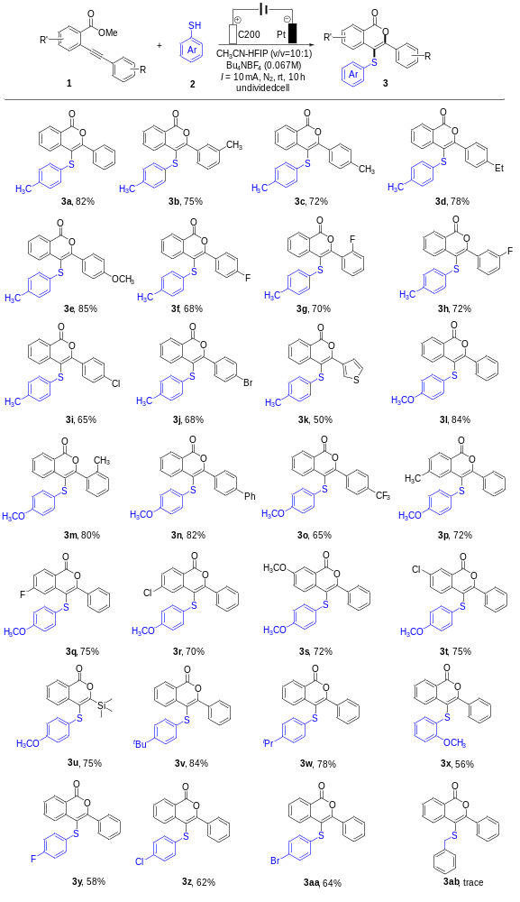
ªReaction conditions: Pt plate (10 × 10 × 1 mm), C200 plate (10 × 12 mm), undivided cell, constant current = 10 mA, isolated yield. 1 (0.2 mmol), 2a (0.8 mmol), Bu₄NBF₄ (0.4 mmol, 0.067 M), and CH₃CN-HFIP (6 mL, v/v=10:1) (6 mL), stirred at room temperature under an N₂ atmosphere in a 25 mL three-necked flask for 10 h.

Table 3. Gram-scale synthesis and synthetic transformation
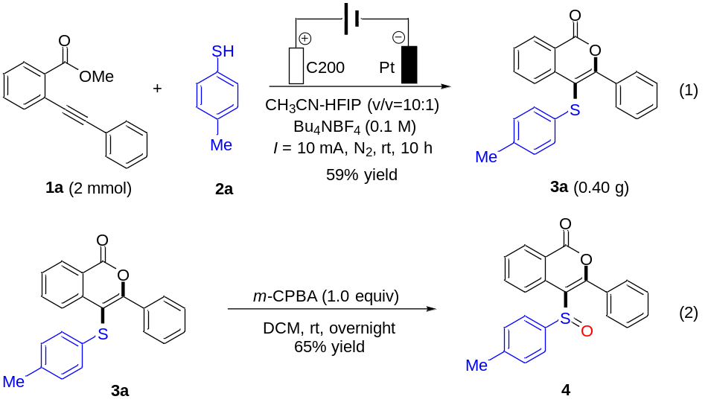
Table 4. Mechanistic investigations and proposed mechanism
