Supplementary Information
Synthesis of 4-Sulfenylisocoumarins via Radical Cascade Annulation of o-Alkynylbenzoates with Thiophenols
Chao Ma,ª Xiaoling Xu,ª Xiang Luo,ª Ruijuan Lu,ª Hualiang Shen,^{ab} Guoqi Yu,^{b} and Tao Cai,^{*ab}
^{a.}College of Chemistry and Chemical Engineering, Shaoxing University, Shaoxing, 312000, China.
^{b.}Zhejiang Engineering Research Center of Fat-Soluble Vitamin, Shaoxing University, 312000, China.
E-mail: yuguoqi@usx.edu.cn; cait361@usx.edu.cn

Contents
I General Information 2
II General Procedure for the Electrochemical Synthesis of 4-Sulfenylisocoumarins 2
III Cyclic Voltammograms Experiments 3
IV Radical trapping experiment 3
V Gram-scale synthesis and synthetic transformation 5
VI Spectra Data of Products 5
VII References 14
VIII The ¹H-, ¹³C{¹H}-, ¹⁹F{¹H} Spectra of Products 16

I General Information
All reactions were carried out under an air atmosphere. ¹H NMR (400 MHz), ¹⁹F NMR (376 MHz) and ¹³C NMR (101 MHz) spectra were measured on Bruker AVⅢ 400M and 500M spectrometers with CDCl₃ as solvent and tetramethylsilane (TMS) as internal standard. Chemical shifts were reported in units (ppm) by assigning TMS resonance in the ¹H spectrum as 0.00 ppm and CDCl₃ resonance in the ¹³C spectrum as 77.16 ppm. All coupling constants (J values) were reported in Hertz (Hz). Column chromatography was performed on silica gel 300-400 mesh. Unless otherwise noted, all reagents, solvents and materials were commercially available and used without any further purification unless specified. The staring materials 1a-1u were synthesized following the known procedures.^{[S1]} Thiophenols were purchased from Macklin, Sigma-Aldrich, or TCI and used without further purification.

II General Procedure for the Electrochemical Synthesis of 4-Sulfenylisocoumarins
A 25 mL three-necked flask-type cell was charged with o-alkynylbenzoate 1 (0.2 mmol, 1.0 equiv), thiophenols 2 (0.8 mmol, 4.0 equiv), and Bu₄NBF₄ (0.4 mmol, 2.0 equiv). The cell was equipped with a platinum plate (1.0 cm x 1.0 cm x 0.1 mm) anode and a C200 plate (1.2 cm x 1.0 cm x 6.5 mm) cathode (Figure S1). Then mixture of CH₃CN-HFIP (6 mL, v/v=10:1) was added and the electrolysis was carried out at room temperature using a constant current of 10 mA for 10 hours. Upon completion, the reaction mixture was concentrated and purified by silica gel column chromatography using petroleum ether/EA (v/v=20:1) as the eluent to give the corresponding products.
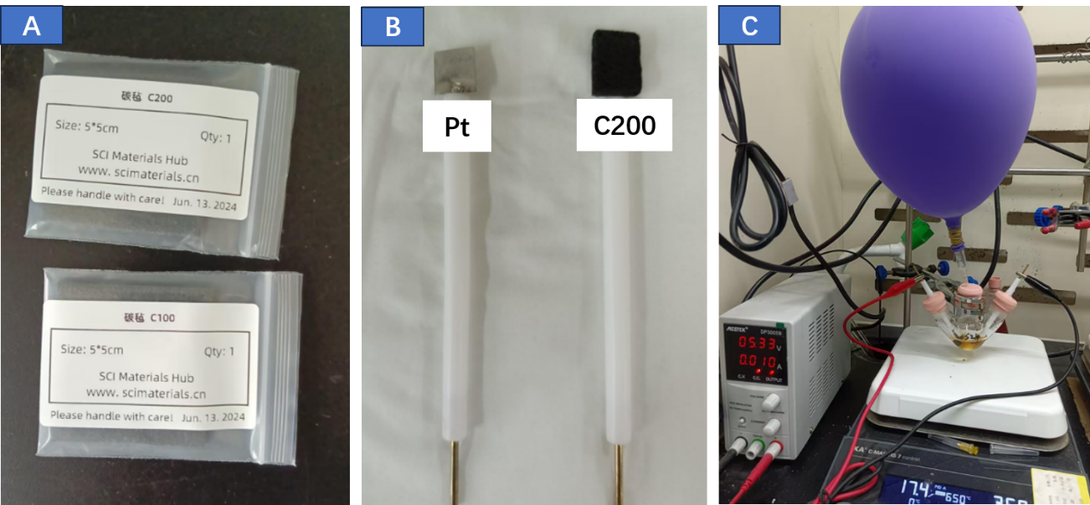
Figure S1. The electrolysis setup

III Cyclic Voltammograms Experiments
Cyclic voltammetry was performed in a three-electrode cell connected to a schlenk line at room temperature. The working electrode was a platinum disk electrode, and the counter electrode a platinum wire. The reference was an Ag/AgCl electrode submerged in a saturated aqueous KCl solution. In all experiments, 10 mL of CH3CN-HFIP containing 0.076 M ^{n}Bu₄NBF₄ was poured into the electrochemical cell. The scan rate is 0.05 V/s, ranging from 0 V to 2.5 V. The peak potentials vs. Ag/AgCl for use. The oxidation peak of methyl 2-(phenylethynyl)benzoate 1a was observed at 2.05 V (red line), and the oxidation peaks of 4-methoxybenzenethiol 2b were 1.26 V and 1.97 V (green line), respectively (Figure S2).
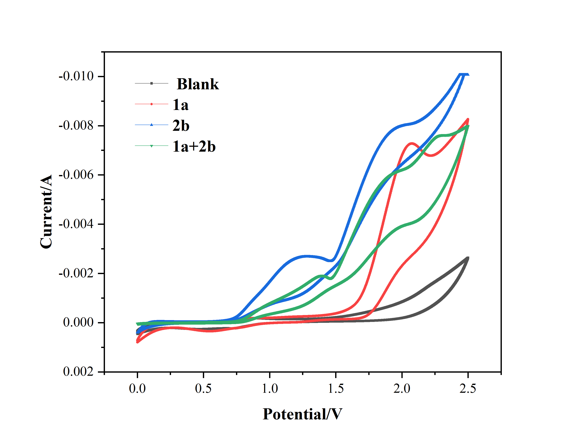
Figure S2. The cyclic voltammetry (CV) experiments

IV Radical trapping experiment
A 25 mL three-necked flask-type cell was charged with o-alkynylbenzoate 1a (0.2 mmol, 1.0 equiv), thiophenols 2b (0.8 mmol, 4.0 equiv), and Bu₄NBF₄ (0.4 mmol, 2.0 equiv), TEMPO (0.4 mmol, 2.0 equiv). The cell was equipped with a platinum plate (1.0 cm x 1.0 cm x 0.1 mm) anode and a C200 plate (1.2 cm x 1.0 cm x 6.5 mm) cathode. Then a mixture of CH₃CN-HFIP (6 mL, v/v=10:1) was added, and the electrolysis was carried out at room temperature using a constant current of 10 mA for 10 hours. Upon completion, the reaction mixture was concentrated and detected by GC-MS (Figure S3).
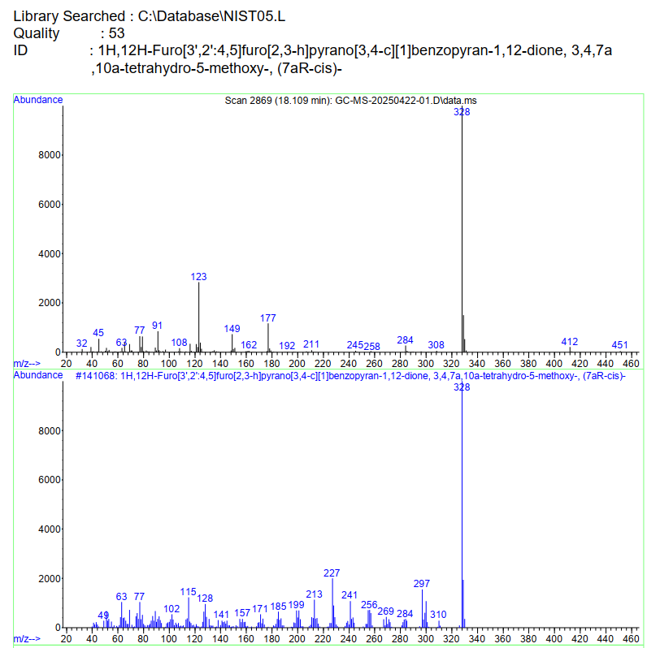
Figure S3. GC-MS analysis

V Gram-scale synthesis and synthetic transformation
Step 1: A 100 mL three-necked flask-type cell was charged with 3a (2 mmol, 1.0 equiv), thiophenols 2 (8 mmol, 4.0 equiv), and Bu₄NBF₄ (4 mmol, 2.0 equiv). The cell was equipped with a platinum plate (1.0 cm x 1.0 cm x 0.2 mm) anode and a C200 plate (1.2 cm x 1.0 cm x 6.5 mm) cathode. Then, a mixture of CH₃CN-HFIP (40 mL, v/v=10:1) was added and the electrolysis was carried out at room temperature using a constant current of 10 mA for 10 hours. Upon completion, the reaction mixture was concentrated and purified by silica gel column chromatography using petroleum ether/EA (v/v=20:1) as the eluent to give the corresponding product 3a in 59% yield (0.4g).
Step 2: A 25 mL dry Schlenk was charged with 3-phenyl-4-(p-tolylthio)-1H-isochromen-1-one 3a (0.5 mmol, 1.0 equiv) and 3-chloroperoxybenzoic acid (0.5 mmol, 1.0 equiv) under an N₂ atmosphere. Then, 10 mL of dry DCM was added and stirred at room temperature for overnight. Upon completion, the reaction mixture was concentrated and purified by silica gel column chromatography using petroleum ether/EA (v/v=5:1 to 3:1) as the eluent to give the corresponding product 4 in 65% yield.

VI Spectra Data of Products
3-phenyl-4-(p-tolylthio)-1H-isochromen-1-one (3a) ^{[S2]}
White solid. ¹H NMR (500 MHz, Chloroform-d) δ 8.28 (dd, J = 7.9, 1.4 Hz, 1H), 7.90 (dd, J = 7.9, 1.4 Hz, 1H), 7.70 – 7.65 (m, 2H), 7.62 (ddd, J = 7.9, 7.2, 1.4 Hz, 1H), 7.48 – 7.42 (m, 1H), 7.40 – 7.27 (m, 3H), 7.00 – 6.90 (m, 4H), 2.19 (s, 3H). ¹³C NMR (126 MHz, CDCl₃) δ 161.53, 159.99, 138.08, 135.71, 135.37, 132.95, 132.86, 130.31, 130.14, 129.79, 129.48, 128.72, 127.97, 126.17, 126.14, 120.91, 106.91, 20.94.
3-(m-tolyl)-4-(p-tolylthio)-1H-isochromen-1-one (3b) ^{[S3]}
White solid. ¹H NMR (500 MHz, Chloroform-d) δ 8.28 (dd, J = 7.9, 1.4 Hz, 1H), 7.99 – 7.84 (m, 1H), 7.63 (ddd, J = 7.9, 7.3, 1.4 Hz, 1H), 7.52 – 7.34 (m, 3H), 7.26 – 7.10 (m, 2H), 7.03 – 6.86 (m, 4H), 2.29 (s, 3H), 2.20 (s, 3H).¹³C NMR (126 MHz, CDCl₃) δ 161.63, 160.22, 138.16, 137.73, 135.65, 135.36, 133.07, 132.74, 131.12, 130.09, 130.02, 129.77, 128.64, 127.77, 126.66, 126.20, 126.13, 120.85, 106.85, 21.45, 20.95.

3-(p-tolyl)-4-(p-tolylthio)-1H-isochromen-1-one (3c) ^{[S2]}
White solid. ¹H NMR (500 MHz, Chloroform-d) δ 8.28 (dd, J = 7.8, 1.4 Hz, 1H), 7.94 – 7.82 (m, 1H), 7.73 – 7.53 (m, 3H), 7.51 – 7.35 (m, 1H), 7.13 (d, J = 7.9 Hz, 2H), 7.00 – 6.79 (m, 4H), 2.31 (s, 3H), 2.20 (s, 3H).¹³C NMR (126 MHz, CDCl₃) δ 161.66, 160.20, 140.68, 138.21, 135.60, 135.33, 133.07, 130.12, 129.97, 129.75, 129.41, 128.69, 128.55, 126.07, 126.05, 120.83, 106.31, 21.55, 20.95.

3-(4-ethylphenyl)-4-(p-tolylthio)-1H-isochromen-1-one (3d) ^{[S3]}
White solid. ¹H NMR (500 MHz, Chloroform-d) δ 8.28 (dd, J = 8.2, 1.4 Hz, 1H), 7.89 (dd, J = 8.2, 1.4 Hz, 1H), 7.73 – 7.55 (m, 3H), 7.44 (ddd, J = 8.2, 7.4, 1.4 Hz, 1H), 7.16 (d, J = 8.2 Hz, 2H), 7.03 – 6.82 (m, 4H), 2.61 (q, J = 7.6 Hz, 2H), 2.20 (s, 3H), 1.17 (t, J = 7.6 Hz, 3H).¹³C NMR (126 MHz, CDCl₃) δ 161.64, 160.19, 146.86, 138.23, 135.60, 135.33, 133.10, 130.17, 130.11, 129.74, 129.51, 128.54, 127.49, 126.08, 126.06, 120.83, 106.26, 28.81, 20.95, 15.23.
3-(4-methoxyphenyl)-4-(p-tolylthio)-1H-isochromen-1-one (3e) ^{[S2]}
Pale yellow solid. ¹H NMR (400 MHz, Chloroform-d) δ 8.37 (ddd, J = 7.8, 1.4, 0.6 Hz, 1H), 7.98 (ddd, J = 7.8, 1.4, 0.6 Hz, 1H), 7.82 – 7.74 (m, 2H), 7.71 (ddd, J = 8.2, 7.3, 1.5 Hz, 1H), 7.53 (ddd, J = 8.2, 7.3, 1.4 Hz, 1H), 7.13 – 7.00 (m, 4H), 6.98 – 6.87 (m, 2H), 3.86 (s, 3H), 2.30 (s, 3H).¹³C NMR (101 MHz, CDCl₃) δ 161.66, 161.16, 159.92, 138.43, 135.59, 135.29, 133.12, 131.18, 130.12, 129.71, 128.37, 126.01, 125.99, 125.16, 120.72, 113.36, 105.65, 55.37, 20.91.

3-(4-fluorophenyl)-4-(p-tolylthio)-1H-isochromen-1-one (3f) ^{[S3]}
Pale yellow solid. ¹H NMR (500 MHz, Chloroform-d) δ 8.28 (dd, J = 8.3, 1.4 Hz, 1H), 7.97 – 7.84 (m, 1H), 7.76 – 7.56 (m, 3H), 7.47 (td, J = 7.6, 1.4 Hz, 1H), 7.04 – 6.95 (m, 4H), 6.93 (d, J = 8.3 Hz, 2H), 2.20 (s, 3H).¹³C NMR (126 MHz, Chloroform-d) δ 163.74 (d, J = 251.1 Hz), 161.38, 158.94, 137.99, 135.85, 135.46, 132.70, 131.68 (d, J = 8.4 Hz), 130.22, 129.82, 128.93 (d, J = 3.7 Hz), 128.83, 126.14, 126.07, 120.84, 115.15 (d, J = 21.8 Hz), 106.91, 20.95.¹⁹F NMR (471 MHz, CDCl₃) δ -109.23.

3-(2-fluorophenyl)-4-(p-tolylthio)-1H-isochromen-1-one (3g) ^{[S3]}
Pale yellow solid. ¹H NMR (500 MHz, Chloroform-d) δ 8.37 (dd, J = 7.9, 1.4 Hz, 1H), 7.94 (dd, J = 7.9, 1.4 Hz, 1H), 7.71 (ddd, J = 7.9, 7.3, 1.4 Hz, 1H), 7.56 (td, J = 7.3, 1.4 Hz, 1H), 7.54 – 7.36 (m, 2H), 7.24 – 7.06 (m, 2H), 7.00 (s, 4H), 2.25 (s, 3H).¹³C NMR (126 MHz, Chloroform-d) δ 161.44, 160.03 (d, J = 251.0 Hz), 154.96, 137.29, 135.95, 135.35, 132.12, 132.10 (d, J = 8.3 Hz), 131.20 (d, J = 8.3 Hz), 129.95, 129.08, 126.91, 126.09, 123.86 (d, J = 3.6 Hz), 121.50 (d, J = 14.6 Hz), 121.23, 116.07, 115.90, 110.68, 20.95.¹⁹F NMR (376 MHz, CDCl₃) δ -111.12.

3-(3-fluorophenyl)-4-(p-tolylthio)-1H-isochromen-1-one (3h) ^{[S3]}
White solid. ¹H NMR (500 MHz, Chloroform-d) δ 8.37 (dd, J = 8.3, 1.4 Hz, 1H), 8.08 – 7.92 (m, 1H), 7.73 (td, J = 8.3, 7.8, 1.4 Hz, 1H), 7.62 – 7.51 (m, 2H), 7.48 (dt, J = 8.4, 2.1 Hz, 1H), 7.37 (td, J = 8.4, 5.8 Hz, 1H), 7.15 (td, J = 8.4, 2.1 Hz, 1H), 7.07 – 6.98 (m, 4H), 2.28 (s, 3H).¹³C NMR (126 MHz, Chloroform-d) δ 162.08 (d, J = 246.4 Hz), 161.22, 158.31, 137.83, 135.95, 135.48, 134.69 (d, J = 8.3 Hz), 132.50, 130.22, 129.86, 129.58 (d, J = 8.3 Hz), 129.03, 126.27, 126.23, 125.34 (d, J = 3.4 Hz), 120.96, 117.30 (d, J = 21.1 Hz), 116.65 (d, J = 23.7 Hz), 107.76, 20.95.¹⁹F NMR (471 MHz, CDCl₃) δ -111.60.

3-(4-chlorophenyl)-4-(p-tolylthio)-1H-isochromen-1-one (3i) ^{[S3]}
White solid.¹H NMR (500 MHz, Chloroform-d) δ 8.36 (dd, J = 7.9, 1.4 Hz, 1H), 7.98 (dd, J = 7.9, 1.4 Hz, 1H), 7.80 – 7.65 (m, 3H), 7.55 (td, J = 7.9, 1.4 Hz, 1H), 7.43 – 7.34 (m, 2H), 7.14 – 6.90 (m, 4H), 2.28 (s, 3H).¹³C NMR (126 MHz, CDCl₃) δ 161.31, 158.74, 137.89, 136.44, 135.90, 135.49, 132.60, 131.20, 130.85, 130.23, 129.85, 128.94, 128.29, 126.18, 126.06, 120.88, 107.27, 20.95.

3-(4-bromophenyl)-4-(p-tolylthio)-1H-isochromen-1-one (3j) ^{[S3]}
White solid. ¹H NMR (500 MHz, Chloroform-d) δ 8.36 (dd, J = 8.2, 1.1 Hz, 1H), 7.98 (dd, J = 8.2, 1.1 Hz, 1H), 7.77 – 7.67 (m, 1H), 7.66 – 7.60 (m, 2H), 7.59 – 7.50 (m, 3H), 7.11 – 6.92 (m, 4H), 2.28 (s, 3H).¹³C NMR (126 MHz, CDCl₃) δ 161.27, 158.79, 137.89, 135.91, 135.49, 132.59, 131.67, 131.25, 131.04, 130.24, 129.85, 128.95, 126.19, 126.08, 124.87, 120.89, 107.31, 20.95.

3-(furan-3-yl)-4-(p-tolylthio)-1H-isochromen-1-one (3k) ^{[S3]}
White solid. ¹H NMR (400 MHz, Chloroform-d) δ 8.36 (dd, J = 7.9, 1.4 Hz, 1H), 8.20 (dd, J = 7.9, 1.4 Hz, 1H), 8.08 – 8.01 (m, 1H), 7.81 (dd, J = 5.2, 1.4 Hz, 1H), 7.72 (ddd, J = 8.3, 7.3, 1.4 Hz, 1H), 7.54 (ddd, J = 8.3, 7.3, 1.4 Hz, 1H), 7.34 (dd, J = 5.2, 3.1 Hz, 1H), 7.08 (s, 4H), 2.30 (s, 3H).¹³C NMR (101 MHz, CDCl₃) δ 161.25, 155.32, 141.94, 138.60, 135.86, 135.35, 133.49, 132.38, 130.25, 129.73, 129.61, 128.48, 126.10, 126.04, 125.11, 120.69, 105.63, 20.91.

4-((4-methoxyphenyl)thio)-3-phenyl-1H-isochromen-1-one (3l) ^{[S2]}
White solid. ¹H NMR (500 MHz, Chloroform-d) δ 8.35 (dd, J = 7.9, 1.4 Hz, 1H), 8.10 – 8.01 (m, 1H), 7.84 – 7.65 (m, 3H), 7.54 (ddd, J = 7.9, 7.2, 1.4 Hz, 1H), 7.46 – 7.40 (m, 3H), 7.06 (d, J = 7.9 Hz, 2H), 6.79 – 6.74 (m, 2H), 3.74 (s, 3H).¹³C NMR (126 MHz, CDCl₃) δ 161.55, 159.70, 158.33, 138.12, 135.31, 132.89, 130.28, 129.80, 129.62, 128.68, 128.43, 127.97, 126.88, 126.15, 120.95, 115.04, 107.95, 55.35.

4-((4-methoxyphenyl)thio)-3-(o-tolyl)-1H-isochromen-1-one (3m) ^{[S3]}
White solid. ¹H NMR (400 MHz, Chloroform-d) δ 8.39 (dd, J = 8.0, 1.3 Hz, 1H), 8.09 (dt, J = 8.1, 1.0 Hz, 1H), 7.78 (ddd, J = 8.3, 7.3, 1.4 Hz, 1H), 7.59 (ddd, J = 8.3, 7.4, 1.2 Hz, 1H), 7.43 – 7.33 (m, 2H), 7.35 – 7.19 (m, 2H), 7.04 – 6.97 (m, 2H), 6.85 – 6.69 (m, 2H), 3.75 (s, 3H), 2.30 (s, 3H).¹³C NMR (101 MHz, CDCl₃) δ 161.66, 160.29, 158.52, 137.88, 137.17, 135.28, 132.96, 130.27, 129.98, 129.92, 129.86, 129.60, 128.74, 126.37, 125.96, 125.39, 121.08, 114.79, 110.33, 55.33, 19.80.

3-([1,1'-biphenyl]-4-yl)-4-((4-methoxyphenyl)thio)-1H-isochromen-1-one (3n) ^{[S3]}
White solid. ¹H NMR (500 MHz, Chloroform-d) δ 8.29 (dd, J = 8.2, 1.2 Hz, 1H), 7.97 (dd, J = 8.2, 1.2 Hz, 1H), 7.82 – 7.77 (m, 2H), 7.65 (ddd, J = 8.2, 7.3, 1.2 Hz, 1H), 7.60 – 7.53 (m, 4H), 7.46 (td, J = 7.6, 1.2 Hz, 1H), 7.38 (t, J = 7.6 Hz, 2H), 7.33 – 7.27 (m, 1H), 7.05 – 6.99 (m, 2H), 6.74 – 6.68 (m, 2H), 3.66 (s, 3H).¹³C NMR (126 MHz, CDCl₃) δ 161.52, 159.42, 158.36, 142.99, 140.16, 138.19, 135.32, 131.69, 130.12, 129.81, 128.92, 128.67, 128.35, 127.91, 127.21, 126.91, 126.61, 126.17, 120.95, 115.11, 107.85, 55.36.

4-((4-methoxyphenyl)thio)-3-(4-(trifluoromethyl)phenyl)-1H-isochromen-1-one (3o) ^{[S3]}
White solid. ¹H NMR (500 MHz, Chloroform-d) δ 8.29 (dd, J = 8.3, 1.2 Hz, 1H), 7.99 (dd, J = 8.3, 1.2 Hz, 1H), 7.81 (d, J = 8.3 Hz, 2H), 7.68 (ddd, J = 8.3, 7.2, 1.2 Hz, 1H), 7.61 (d, J = 8.3 Hz, 2H), 7.50 (td, J = 7.2, 1.2 Hz, 1H), 6.99 – 6.93 (m, 2H), 6.73 – 6.67 (m, 2H), 3.67 (s, 3H). ¹³C NMR (126 MHz, Chloroform-d) δ 161.08, 158.54, 157.88, 137.71, 136.26, 135.48, 132.01, 131.75, 130.04, 129.92, 129.18, 128.47, 126.30, 124.97 (q, J = 3.7 Hz), 122.70, 121.07, 115.19, 109.29, 55.36.¹⁹F NMR (471 MHz, CDCl₃) δ -62.86.

4-((4-methoxyphenyl)thio)-6-methyl-3-phenyl-1H-isochromen-1-one (3p) ^{[S2]}
White solid. ¹H NMR (400 MHz, Chloroform-d) δ 8.26 (d, J = 8.0 Hz, 1H), 7.87 (dt, J = 1.6, 0.7 Hz, 1H), 7.80 – 7.73 (m, 2H), 7.51 – 7.40 (m, 3H), 7.37 (ddd, J = 8.0, 1.6, 0.7 Hz, 1H), 7.15 – 7.02 (m, 2H), 6.89 – 6.69 (m, 2H), 3.77 (s, 3H), 2.46 (s, 3H).¹³C NMR (101 MHz, CDCl₃) δ 161.57, 159.85, 158.30, 146.52, 138.20, 133.06, 130.15, 130.03, 129.84, 129.60, 128.44, 127.91, 127.12, 126.10, 118.50, 115.02, 107.91, 55.33, 22.35.

6-fluoro-4-((4-methoxyphenyl)thio)-3-phenyl-1H-isochromen-1-one (3q) ^{[S3]}
White solid. ¹H NMR (500 MHz, Chloroform-d) δ 8.29 (dd, J = 8.3, 5.6 Hz, 1H), 7.69 (dt, J = 5.6, 2.5 Hz, 2H), 7.63 (dd, J = 10.1, 2.5 Hz, 1H), 7.51 – 7.29 (m, 3H), 7.14 (td, J = 8.3, 2.5 Hz, 1H), 7.01 – 6.94 (m, 2H), 6.77 – 6.67 (m, 2H), 3.67 (s, 3H). ¹³C NMR (126 MHz, Chloroform-d) δ 167.26 (d, J = 256.5 Hz), 160.94, 160.58, 158.57, 141.57 (d, J = 10.7 Hz), 133.19 (d, J = 10.1 Hz), 132.59, 130.54, 129.64, 128.70, 128.03, 126.13, 117.36, 116.99 (d, J = 23.7 Hz), 112.44, 112.24, 107.62 (d, J = 2.8 Hz), 55.36.¹⁹F NMR (471 MHz, CDCl₃) δ -99.97.

6-chloro-4-((4-methoxyphenyl)thio)-3-phenyl-1H-isochromen-1-one (3r) ^{[S2]}
White solid. ¹H NMR (400 MHz, Chloroform-d) δ 8.29 (d, J = 8.4 Hz, 1H), 8.08 (d, J = 8.4 Hz, 1H), 7.81 – 7.74 (m, 2H), 7.54 – 7.39 (m, 4H), 7.12 – 7.03 (m, 2H), 6.84 – 6.76 (m, 2H), 3.77 (s, 3H).¹³C NMR (101 MHz, CDCl₃) δ 160.89, 160.73, 158.61, 142.36, 139.91, 132.58, 131.46, 130.53, 129.66, 129.19, 128.86, 128.02, 126.16, 125.91, 119.23, 115.17, 107.48, 55.36.

7-methoxy-4-((4-methoxyphenyl)thio)-3-phenyl-1H-isochromen-1-one (3s) ^{[S3]}
White solid. ¹H NMR (500 MHz, Chloroform-d) δ 7.87 (d, J = 8.9 Hz, 1H), 7.68 (td, J = 5.4, 2.7 Hz, 3H), 7.34 (tdd, J = 8.9, 5.4, 2.7 Hz, 3H), 7.21 (dd, J = 8.9, 2.7 Hz, 1H), 7.02 – 6.93 (m, 2H), 6.75 – 6.63 (m, 2H), 3.84 (s, 3H), 3.66 (s, 3H).¹³C NMR (126 MHz, CDCl₃) δ 161.73, 159.86, 158.29, 157.59, 132.87, 131.69, 130.04, 129.60, 128.35, 127.96, 127.94, 127.00, 124.71, 122.13, 115.03, 110.26, 107.73, 55.87, 55.34.

7-chloro-4-((4-methoxyphenyl)thio)-3-phenyl-1H-isochromen-1-one (3t) ^{[S2]}
White solid. ¹H NMR (500 MHz, Chloroform-d) δ 8.25 – 8.22 (m, 1H), 7.90 (d, J = 8.3 Hz, 1H), 7.68 (d, J = 8.3 Hz, 2H), 7.60 – 7.55 (m, 1H), 7.41 – 7.34 (m, 3H), 6.97 (d, J = 8.3 Hz, 2H), 6.70 (d, J = 8.3 Hz, 2H), 3.67 (s, 3H).¹³C NMR (126 MHz, CDCl₃) δ 160.40, 159.78, 158.51, 136.65, 135.56, 134.68, 132.51, 130.48, 129.63, 129.14, 128.58, 128.02, 127.97, 126.35, 122.16, 115.14, 107.60, 55.36.
4-((4-methoxyphenyl)thio)-3-(trimethylsilyl)-1H-isochromen-1-one (3u) ^{[S2]}
Pale yellow oil. ¹H NMR (400 MHz, Chloroform-d) δ 8.32 (dd, J = 8.0, 1.4 Hz, 1H), 7.74 (dd, J = 8.0, 1.4 Hz, 1H), 7.65 (ddd, J = 8.0, 7.3, 1.4 Hz, 1H), 7.52 (td, J = 7.3, 1.4 Hz, 1H), 7.12 – 7.03 (m, 2H), 6.85 – 6.77 (m, 2H), 3.77 (s, 3H), 0.43 (s, 9H).¹³C NMR (101 MHz, CDCl₃) δ 170.17, 162.84, 158.15, 136.53, 134.86, 129.59, 129.05, 127.61, 126.78, 125.08, 121.98, 119.43, 114.97, 55.32, -0.71.

4-((4-(tert-butyl)phenyl)thio)-3-phenyl-1H-isochromen-1-one (3v) ^{[S4]}
White solid. ¹H NMR (400 MHz, Chloroform-d) δ 8.40 (dd, J = 8.0, 1.5 Hz, 1H), 8.06 – 8.00 (m, 1H), 7.81 – 7.70 (m, 3H), 7.57 (ddd, J = 8.0, 7.3, 1.5 Hz, 1H), 7.53 – 7.39 (m, 3H), 7.31 – 7.24 (m, 2H), 7.12 – 7.04 (m, 2H), 1.29 (s, 9H). ¹³C NMR (101 MHz, CDCl₃) δ 161.57, 159.99, 148.95, 138.14, 135.41, 132.90, 132.84, 130.30, 129.78, 129.55, 128.72, 127.96, 126.42, 126.25, 125.88, 120.87, 106.90, 34.43, 31.26.

4-((4-isopropylphenyl)thio)-3-phenyl-1H-isochromen-1-one (3w) ^{[S4]}
White solid. ¹H NMR (500 MHz, Chloroform-d) δ 8.28 (dd, J = 8.0, 1.4 Hz, 1H), 7.92 (dd, J = 8.0, 1.4 Hz, 1H), 7.70 – 7.66 (m, 2H), 7.63 (ddd, J = 8.0, 7.3, 1.4 Hz, 1H), 7.49 – 7.42 (m, 1H), 7.39 – 7.29 (m, 3H), 7.11 – 6.89 (m, 4H), 2.75 (p, J = 6.9 Hz, 1H), 1.11 (d, J = 6.9 Hz, 6H).¹³C NMR (126 MHz, CDCl₃) δ 161.53, 159.98, 146.69, 138.14, 135.37, 133.18, 132.87, 130.28, 129.77, 129.54, 128.70, 127.96, 127.52, 126.22, 120.90, 107.00, 33.57, 23.88.

4-((2-methoxyphenyl)thio)-3-phenyl-1H-isochromen-1-one (3x) ^{[S3]}
White solid. ¹H NMR (500 MHz, Chloroform-d) δ 8.30 (dd, J = 8.0, 1.4 Hz, 1H), 7.84 (dd, J = 8.0, 1.4 Hz, 1H), 7.69 – 7.57 (m, 3H), 7.51 – 7.42 (m, 1H), 7.32 (dddd, J = 14.7, 8.7, 6.3, 2.1 Hz, 3H), 7.06 (ddd, J = 8.7, 6.3, 2.1 Hz, 1H), 6.86 – 6.78 (m, 1H), 6.76 – 6.62 (m, 2H), 3.84 (s, 3H).¹³C NMR (126 MHz, CDCl₃) δ 161.56, 160.23, 155.60, 138.03, 135.35, 132.82, 130.28, 129.76, 129.34, 128.72, 127.97, 126.45, 126.12, 125.96, 125.09, 121.55, 120.88, 110.60, 105.59, 55.90.

4-((4-fluorophenyl)thio)-3-phenyl-1H-isochromen-1-one (3y) ^{[S4]}
White solid. ¹H NMR (500 MHz, Chloroform-d) δ 8.30 (dd, J = 7.9, 1.4 Hz, 1H), 7.89 (dd, J = 8.1, 1.1 Hz, 1H), 7.66 (ddd, J = 8.4, 7.1, 1.6 Hz, 3H), 7.36 (dddd, J = 14.5, 8.6, 6.1, 2.1 Hz, 3H), 7.08 – 6.99 (m, 2H), 6.90 – 6.82 (m, 2H).¹³C NMR (126 MHz, Chloroform-d) δ 161.35 (d, J = 246.2 Hz), 161.33, 160.20, 137.79, 135.42, 132.71, 131.45 (d, J = 3.6 Hz), 130.43, 129.94, 129.49, 128.86, 128.13 (d, J = 8.2 Hz), 128.03, 125.91, 120.95, 116.53 (d, J = 22.1 Hz), 107.08. ¹⁹F NMR (471 MHz, CDCl₃) δ -116.19.

4-((4-chlorophenyl)thio)-3-phenyl-1H-isochromen-1-one (3z) ^{[S4]}
White solid. ¹H NMR (400 MHz, Chloroform-d) δ 8.40 (dt, J = 7.8, 0.9 Hz, 1H), 7.94 (dt, J = 7.8, 0.9 Hz, 1H), 7.83 – 7.67 (m, 3H), 7.59 (ddd, J = 8.3, 7.8, 0.9 Hz, 1H), 7.55 – 7.32 (m, 3H), 7.26 – 7.18 (m, 2H), 7.11 – 7.03 (m, 2H). ¹³C NMR (101 MHz, CDCl₃) δ 161.26, 160.47, 137.64, 135.49, 135.13, 132.63, 131.72, 130.50, 129.97, 129.49, 129.37, 128.93, 128.05, 127.26, 125.82, 120.91, 106.21.

4-((4-bromophenyl)thio)-3-phenyl-1H-isochromen-1-one (3aa) ^{[S4]}
White solid. ¹H NMR (400 MHz, Chloroform-d) δ 8.40 (dd, J = 8.3, 1.2 Hz, 1H), 7.97 – 7.90 (m, 1H), 7.79 – 7.72 (m, 3H), 7.59 (ddd, J = 8.3, 7.3, 1.2 Hz, 1H), 7.52 – 7.41 (m, 3H), 7.39 – 7.34 (m, 2H), 7.05 – 6.97 (m, 2H).¹³C NMR (101 MHz, CDCl₃) δ 161.25, 160.52, 137.59, 135.86, 135.52, 132.62, 132.39, 130.52, 129.98, 129.36, 128.96, 128.07, 127.49, 125.81, 120.90, 119.47, 105.99.

3-phenyl-4-(p-tolylsulfinyl)-1H-isochromen-1-one (4) ^{[S4]}
White solid. ¹H NMR (400 MHz, Chloroform-d) δ 8.33 (d, J = 8.0 Hz, 1H), 8.15 (d, J = 8.0 Hz, 1H), 7.79 (dd, J = 8.0, 1.6 Hz, 2H), 7.63 – 7.46 (m, 7H), 7.29 (d, J = 8.0, 2H), 2.38 (s, 3H). ¹³C NMR (101 MHz, CDCl₃) δ 160.53, 160.15, 140.91, 139.72, 134.97, 132.95, 131.41, 130.82, 130.21, 130.01, 129.14, 128.60, 125.19, 124.78, 121.15, 117.85, 21.29.

VII References
[S1] T. Yao, R. C. Larock, J. Org. Chem. 2003, 68, 5936-5942.
[S2] A. B. Dapkekar, G. Satyanarayana, Org. Biomol. Chem. 2024, 22, 7111-7116.
[S3] .Z. Li, J. Hong, L. Weng, X. Zhou, Tetrahedron 2012, 68, 1552-1559.
[S4] A. Saha, E. Ramesh, A. K. Sahoo, Adv. Synth. Catal. 2022, 364, 3496-3500.

VIII The ¹H-, ¹³C{¹H}-, ¹⁹F{¹H} Spectra of Products
¹H Spectra of 3a
¹³C{¹H} Spectra of 3a

¹H Spectra of 3b
¹³C{¹H} Spectra of 3b

¹H Spectra of 3c
¹³C{¹H} Spectra of 3c

¹H Spectra of 3d
¹³C{¹H} Spectra of 3d

¹H Spectra of 3e
¹³C{¹H} Spectra of 3e

¹H Spectra of 3f
¹³C{¹H} Spectra of 3f

¹⁹F{¹H} Spectra of 3f
¹H Spectra of 3g

¹³C{¹H} Spectra of 3g
¹⁹F{¹H} Spectra of 3g

¹H Spectra of 3h
¹³C{¹H} Spectra of 3h

¹⁹F{¹H} Spectra of 3h
¹H Spectra of 3i

¹³C{¹H} Spectra of 3i
¹H Spectra of 3j

¹³C{¹H} Spectra of 3j
¹H Spectra of 3k

¹³C{¹H} Spectra of 3k
¹H Spectra of 3l

¹³C{¹H} Spectra of 3l
¹H Spectra of 3m

¹³C{¹H} Spectra of 3m
¹H Spectra of 3n

¹³C{¹H} Spectra of 3n
¹H Spectra of 3o

¹³C{¹H} Spectra of 3o
¹⁹F{¹H} Spectra of 3o
¹H Spectra of 3p
¹³C{¹H} Spectra of 3p

¹H Spectra of 3q
¹³C{¹H} Spectra of 3q

¹⁹F{¹H} Spectra of 3q
¹H Spectra of 3r
¹³C{¹H} Spectra of 3r
¹H Spectra of 3s

¹³C{¹H} Spectra of 3s
¹H Spectra of 3t

¹³C{¹H} Spectra of 3t
¹H Spectra of 3u

¹³C{¹H} Spectra of 3u
¹H Spectra of 3v

¹³C{¹H} Spectra of 3v
¹H Spectra of 3w

¹³C{¹H} Spectra of 3w
¹H Spectra of 3x

¹³C{¹H} Spectra of 3x
¹H Spectra of 3y

¹³C{¹H} Spectra of 3y
¹⁹F{¹H} Spectra of 3y

¹H Spectra of 3z
¹³C{¹H} Spectra of 3z

¹H Spectra of 3aa
¹³C{¹H} Spectra of 3aa

¹H Spectra of 4
¹³C{¹H} Spectra of 4

