Supporting Information

Supplemental Methods
Pollinator visitation surveys at the Hopland Extension Center took place on 4/4/2023, 5/19/2023, 7/12/2023, 4/29/2024, 5/14/2024, and 7/16/2024. Pollinator visitation surveys at the Sierra Foothills Extension Center took place on 4/18/2023-4/19/2023, 5/22/2023-5/23/2023, 6/7/2023-6/8/2023, 4/17/2024-4/18/2024, 5/20/2024-5/21/2024, and 6/27/2024.Pollinator visitation surveys at the UC McLaughlin Reserve took place on 5/7/2023, 5/18/2023, 5/27/2023, 7/3/2023, 4/27/2024, 5/10/2024, and 7/9/2024. At the Hopland Extension Center, forb abundance surveys took place on 4/25/2023, 5/3/2023, 5/19/2023, 7/12/2023, 4/29/2024, 5/14/2024, and 7/16/2024. At the Sierra Foothills Extension Center, forb abundance surveys took place on 4/12/2023, 4/18/2023-4/19/2023, 5/22/2023-5/23/2023, 6/7/2023-6/8/2023, 4/17/2024-4/18/2023, 5/20/2024-5/21/2024, 6/27/2024. At the UC McLaughlin-Reserve, forb abundance surveys took place on 4/13/2023, 4/29/2023, 5/18/2023, 5/27/2023, 7/4/2023, 4/26/2024, 5/7/2024, 5/10/2024, and 7/8/2024. All insect voucher specimens associated this research will be archived at the Michigan State University Kellogg Biological Station entomological collections.
Using taxonomic and morphological information from existing literature (LeBuhn 2013), we grouped native pollinator data by pollinator functional group (long-tongued bees, short-tongued bees, beetles, butterflies and moths, kleptoparasitic bees, and flies) and then compared how treatment, family, and local provenance affect native pollinator functional group abundance using differential multivariate generalized linear models with the mvabund package (Wang et al. 2012).
To test for whether overall pollinator community composition (including both exotic and native pollinator morphospecies) differed between site, treatment, plant species, and local provenance, we used the adonis and vegan packages in R to run PERMANOVAs with Bray-Curtis dissimilarity indices and multivariate abundance analyses using the mvabund package.

Supplemental Results
Native pollinator abundance differed by wildflower provenance (Figure 2A-B) (mvabund, deviance=28.16, p=0.001) and plant taxonomic family (mvabund, deviance =208.2, p=0.001). For native pollinators, abundance of beetles (mvabund, deviance =23.38, p=0.038), butterflies and moths (mvabund, deviance =26.214, p= 0.024), long-tongued bees (mvabund, deviance =49.947, p= 0.001), short-tongued bees (mvabund, deviance=40.786, p= 0.002), and flies (mvabund, deviance =36.57, p= 0.002) all differed by plant family. At the pairwise level, Asparagaceae strongly differed in pollinator functional group abundance from Iridaceae (mvabund, deviance = 36.084, p=0.016), Asteraceae (mvabund, deviance=31.092, p=0.040), and marginally Fabaceae (mvabund, deviance =29.396, p=0.053).
For the full pollinator community including native pollinators and honeybees, pollinator community composition differed between native and exotic wildflowers (PERMANOVA F= 3.2297, p=0.001; mvabund deviance=176.7, p=0.001) and by wildflower family (PERMANOVA F=2.1438, p=0.001; mvabund deviance = 616.7, p=0.001) but not by treatment (PERMANOVA F=1.0236, p= 0.386; mvabund deviance =214.5, p=0.0061) (Figure 4). The native pollinator yellow-faced bumblebees (Bombus vosnesenskii) (deviance =27.185, p=0.036) showed strong plant family-level differences in their foraging. Pollinator species composition on asters (Asteraceae) differed strongly from Iridaceae (deviance =118.772, p=0.001), Boraginaceae (deviance =78.820, p=0.014), Gerianacae (deviance =77.506, p= 0.015), and Asparagacae (deviance = 74.233, p=0.016). Iridacae also showed strong differences in pollinator species composition relative to Fabaceae (deviance =61.311, p=0.044) and marginally with asters (deviance =60.641, p=0.056). When an interaction of treatment and local provenance were included, pollinator species composition did differ by treatment (deviance 214.52, p=0.049) in addition to provenance (deviance =167.15, p=0.0001), and their interaction (deviance =66.47, p=0.006).

Supplemental Figures and Tables

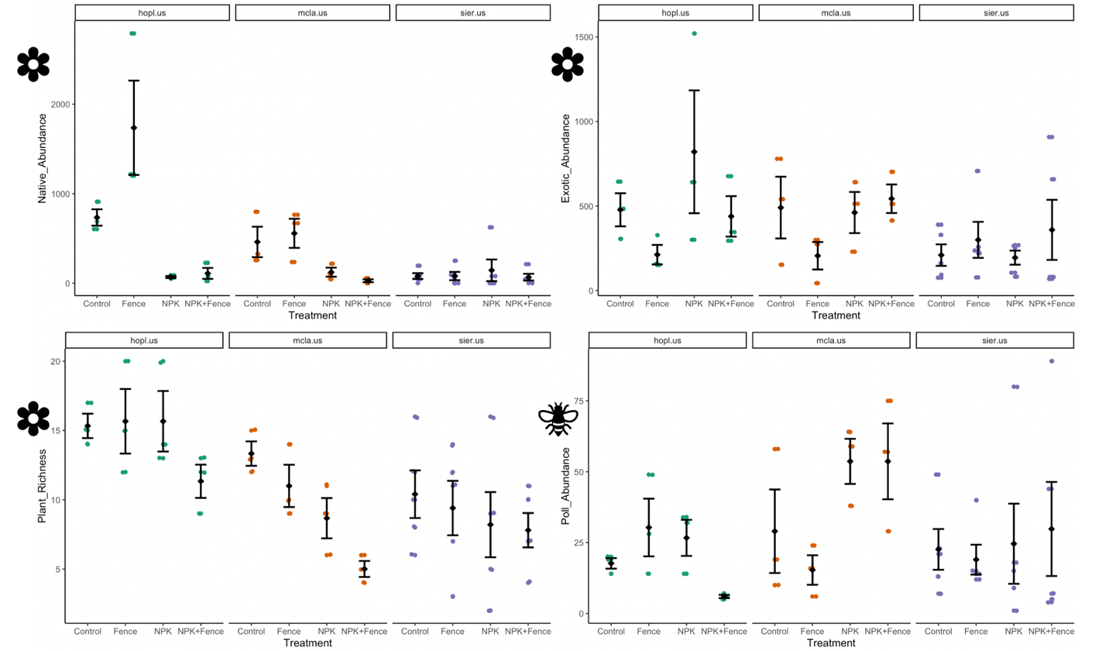

Figure S1. The effects of fertilization and large herbivore exclusion treatments on (A) native floral abundance, (B) exotic floral abundance, (C) floral species richness, and (D) total floral visits by pollinators by site. Hopl.us corresponds to Hopland, mcla.us corresponds to McLaughlin, and sier.us corresponds to Sierra Foothills. Sites are depicted from left to right in order of increasing aridity.

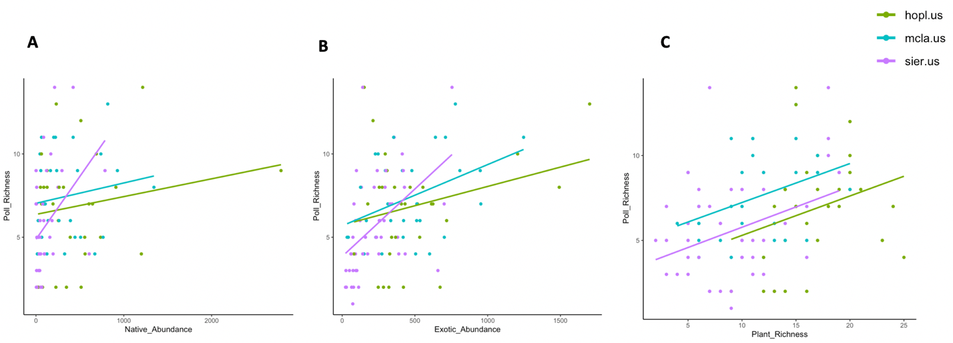
Figure S2. The effects of (A) native floral abundance, (B) exotic floral abundance, and (C) floral species richness on pollinator morphospecies richness by site. Hopl.us corresponds to Hopland, mcla.us corresponds to McLaughlin, and sier.us corresponds to Sierra Foothills.

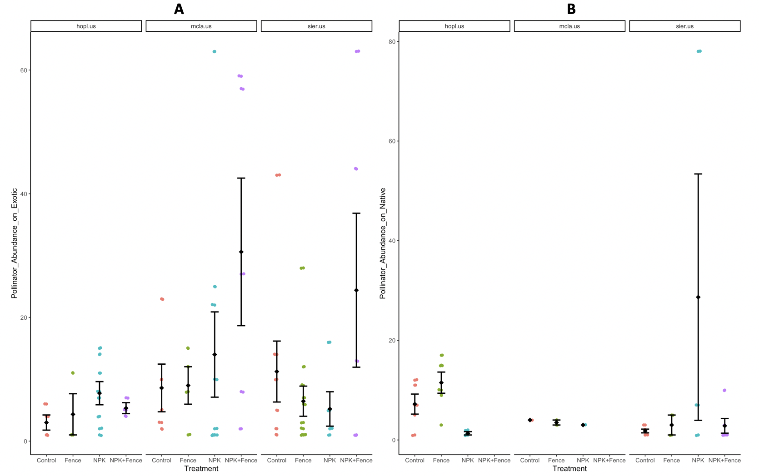
Figure S3. Pollinator abundance (total # of pollinator visits) on (A) exotic flowers and (B) native flowers by fencing and fertilization treatments by site. Hopl.us corresponds to Hopland, mcla.us corresponds to McLaughlin, and sier.us corresponds to Sierra Foothills. Sites are depicted from left to right in order of increasing aridity.

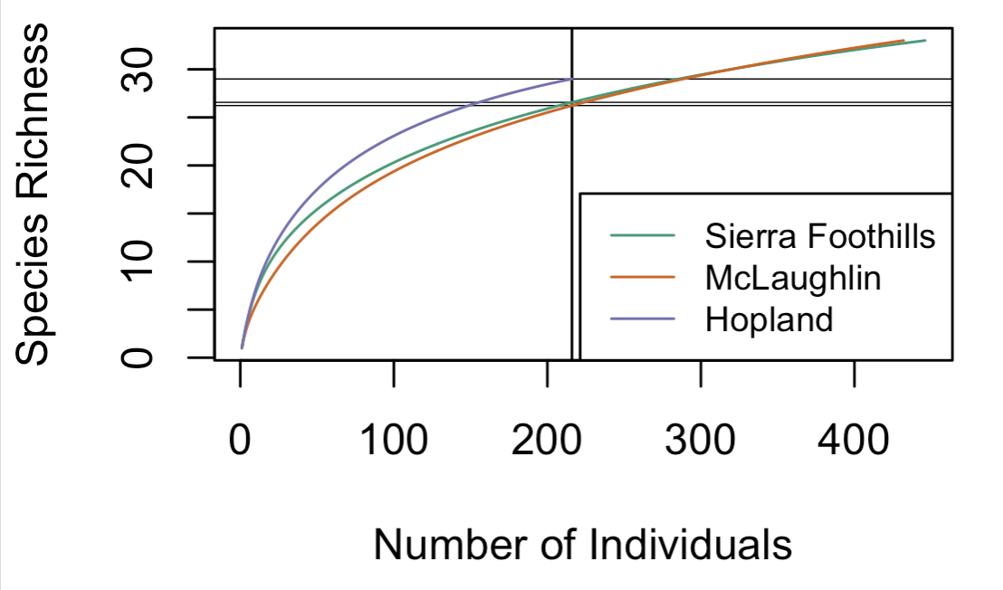
Figure S4. Species rarefaction curve by site for pollinator visitation data. Hopland is represented by purple, Sierra Foothills by teal, and McLaughlin by orange.

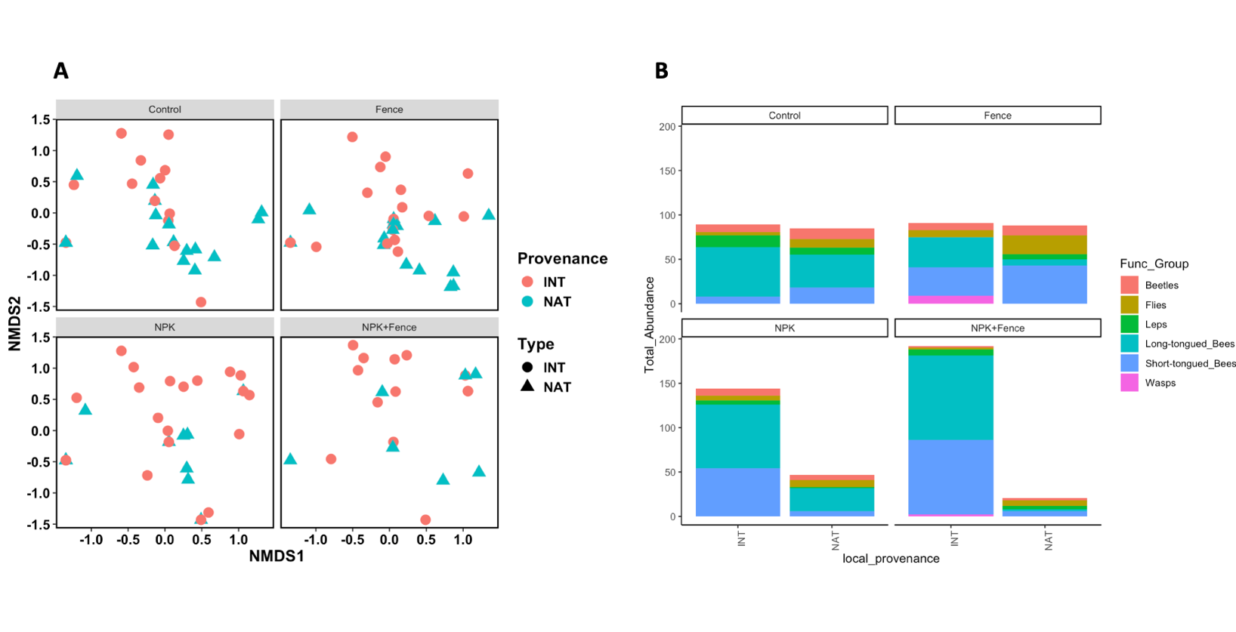
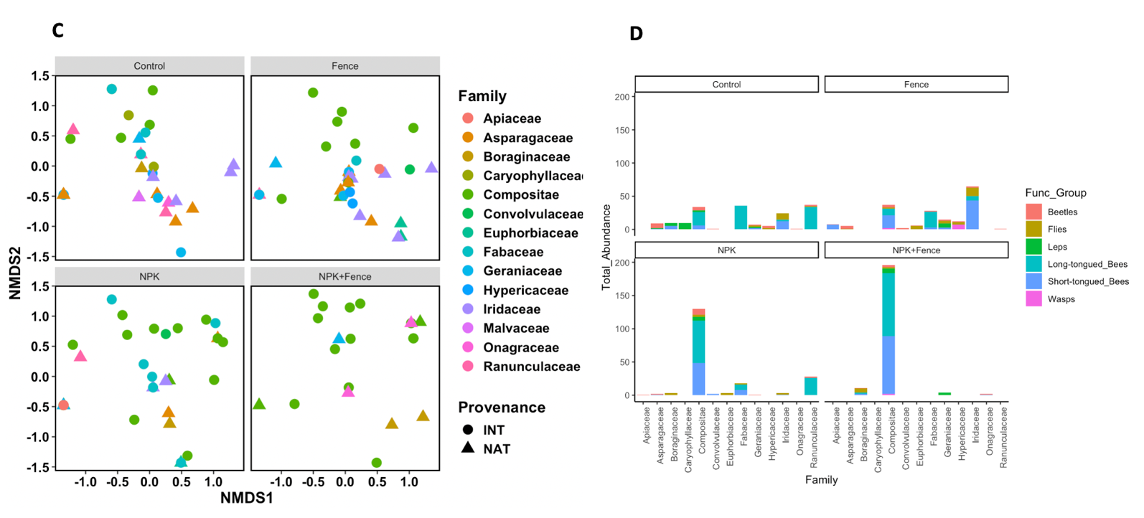
Figure S5. Across fencing by fertilization treatments, the effects of wildflower provenance (type) on (A) native pollinator community composition, (B) native pollinator visitation by functional group, and wildflower taxonomic family on (C) native pollinator community composition and (D) native pollinator visitation by functional group. Type INT refers to exotic wildflower species, while NAT refers to native wildflower species.
Table S1. Plant species list of the 72 wildflower species documented in floral resource surveys. Information is provided on taxonomic family, provenance, season of flowering, and plant species. Compositae is used synonymously here with Asteraceae.
Family | local provenance | Season | Plant Species
Compositae | Native | Mid-Spring | Achyrachaena mollis
Fabaceae | Native | Mid-Spring | Acmispon americanus
Compositae | Native | Mid-Spring | Agoseris heterophylla
Boraginaceae | Native | Mid-Spring | Amsinckia menziesii
Primulaceae | Introduced | Mid-Spring | Anagallis arvensis
Compositae | Unknown | Mid-Spring | Asteraceae sp.
Asparagaceae | Native | Late-Spring | Brodiaea elegans
Asparagaceae | Native | Mid-Spring | Brodiaea sp.
Montiaceae | Native | Mid-Spring | Calandrinia menziesii
Liliaceae | Native | Late-Spring | Calochortus venutus
Compositae | Native | Summer | Calycadenia pauciflora
Brassicaceae | Native | Mid-Spring | Cardamine oligosperma
Compositae | Introduced | Late-Spring | Carduus pycnocephalus
Scrophulariaceae | Native | Mid-Spring | Castilleja attenuata
Compositae | Introduced | Summer | Centaurea solstitialis
Caryophyllaceae | Introduced | Mid-Spring | Cerastium glomerium
Hyacinthaceae | Native | Late-Spring | Chlorogalum pomeridianum
Onagraceae | Native | Late-Spring | Clarkia purpurea
Montiaceae | Native | Mid-Spring | Claytonia perfoliate
Convolvulaceae | Introduced | Late-Spring | Convolvulus arvensis
Ranunculaceae | Native | Late-Spring | Delphinium hesperium
Asparagaceae | Native | Mid-Spring | Dichelostemma capitatum
Asparagaceae | Native | Mid-Spring | Dichelostemma congestum
Asparagaceae | Native | Late-Spring | Dichelostemma multiflorum
Geraniaceae | Introduced | Mid-Spring | Erodium botrys
Geraniaceae | Introduced | Mid-Spring | Erodium cicutarium
Euphorbiaceae | Native | Mid-Spring | Euphorbia spathulate
Rubiaceae | Introduced | Mid-Spring | Galium parisiense
Rubiaceae | Unknown | Mid-Spring | Gallium sp.
Geraniaceae | Native | Mid-Spring | Geranium carolinianum
Geraniaceae | Introduced | Early-Spring | Geranium dissectum
Geraniaceae | Introduced | Early-Spring | Geranium molle
Hypericaceae | Introduced | Summer | Hypericum perforatum
Iridaceae | Native | Mid-Spring | Iris macrosiphon
Compositae | Introduced | Summer | Lactuca serriola
Compositae | Native | Late-Spring | Lagophylla minor
Compositae | Native | Mid-Spring | Lasthenia californica
Polemoniaceae | Native | Mid-Spring | Leptosiphon bicolor
Apiaceae | Native | Mid-Spring | Lomatium hooverii
Fabaceae | Native | Mid-Spring | Lupinus bicolor
Compositae | Native | Late-Spring | Madia gracilis
Fabaceae | Introduced | Mid-Spring | Medicago polymorpha
Polemoniaceae | Native | Late-Spring | Navarretia intertexta
Boraginaceae | Native | Early-Spring | Nemophila pedunculata
Caryophyllaceae | Introduced | Mid-Spring | Petrorhagia dubia
Boraginaceae | Native | Mid-Spring | Plagiobothrys nothofulvus
Ranunculaceae | Native | Mid-Spring | Ranunculus californicus
Polygonaceae | Unknown | Mid-Spring | Rhumex sp.
Compositae | Native | Early-Spring | Rigiopappus leptocladus
Apiaceae | Native | Early-Spring | Sanicula bipinnata
Apiaceae | Unknown | Early-Spring | Sanicula sp.
Compositae | Introduced | Mid-Spring | Senecio vulgaris
Rubiaceae | Introduced | Mid-Spring | Sherardia arvensis
Malvaceae | Native | Late-Spring | Sidalcea sp.
Iridaceae | Native | Mid-Spring | Sisyrinchium bellum
Compositae | Introduced | Mid-Spring | Sonchus asper
Caryophyllaceae | Introduced | Early-Spring | Stellaria media
Compositae | Introduced | Late-Spring | Taraxacum officinale
Apiaceae | Introduced | Late-Spring | Torilis arvensis
Compositae | Introduced | Late-Spring | Tragopogon dubius
Fabaceae | Native | Mid-Spring | Trifolium bifidum
Fabaceae | Native | Mid-Spring | Trifolium ciliolatum
Fabaceae | Introduced | Mid-Spring | Trifolium dubium
Fabaceae | Native | Mid-Spring | Trifolium fucatum
Fabaceae | Native | Mid-Spring | Trifolium gracilentum
Fabaceae | Introduced | Mid-Spring | Trifolium hirtum
Orobanchaceae | Native | Mid-Spring | Triphysaria eriantha
Asparagaceae | Native | Late-Spring | Triteleia hyacinthina
Asparagaceae | Native | Mid-Spring | Triteleia laxa
Fabaceae | Native | Mid-Spring | Vicia americana
Fabaceae | Introduced | Mid-Spring | Vicia sativa
Fabaceae | Introduced | Mid-Spring | Vicia villosa

Table S2. Pollinator morphospecies. ‘ARTH’ refers to morphospecies code in data with ‘Description’ providing a description of each morphospecies. ‘Sites’ lists which sites a morphospecies was observed at with ‘sier.us’ referring to Sierra Foothills, ‘mcla.us’ referring to McLaughlin, and ‘hopl.us’ referring to Hopland. ‘N_Plant_Spp’ lists the total number of wildflower species a given morphospecies was observed visiting. ‘Functional_Group’ lists whether each morphospecies was classified as Leps (butterflies and moths), short-tongued bees, long-tongued bees, lacewings, ants, wasps, beetles or flies. ‘Provenance’ indicates whether a given pollinator species visited exotic wildflowers (INT), native wildflowers (NAT) or both. If a wildflower provenance or pollinator functional group was unknown, it was left blank. ‘Visited_Asteraceae’ indicates whether or not a given pollinator species visited wildflowers of any provenance in the family Asteraceae (Compositae).

ARTH | Description | Sites | N_Plant_Spp | Functional_Group | Provenances | Visited_Asteraceae
Adela trigrapha | Adela trigrapha | sier.us | 1 | Leps | NAT | No
Andrena lewisorum | Andrena lewisorum | mcla.us | 1 | Short-tongued_Bees | INT | No
Andrena plana | Andrena plana | mcla.us | 1 | Short-tongued_Bees | INT | No
Andrena sp. | Unknown Andrena sp. | hopl.us, mcla.us | 2 | Short-tongued_Bees | INT, NAT | No
Anthophila | Other bee species that did not match any of the other morphospecies. | hopl.us, mcla.us, sier.us | 10 |  | INT, NAT | No
Anthophora californica | Anthophora californica | hopl.us | 1 | Long-tongued_Bees | NAT | No
Anthrenus verbasci | Anthrenus verbasci | hopl.us | 1 | Beetles | INT | No
Apis mellifera | Apis mellifera | hopl.us, mcla.us, sier.us | 9 | Long-tongued_Bees | INT, NAT | No
BF1 | Black Fly 1 (tiny black Dipteran). | mcla.us | 1 | Flies | INT | No
Battus philenor | Battus philenor | sier.us | 2 | Leps | INT | No
Bombus californicus | Bombus californicus | mcla.us, sier.us | 4 | Long-tongued_Bees | INT, NAT | No
Bombus crotchii | Bombus crotchii | mcla.us | 2 | Long-tongued_Bees | INT, NAT | No
Bombus melanopygus | Bombus melanopygus | hopl.us, sier.us | 3 | Long-tongued_Bees | INT | No
Bombus sp. | Unidentified Bombus sp. | mcla.us | 1 | Long-tongued_Bees |  | No
Bombus vosnesenskii | Bombus vosnesenskii | hopl.us, mcla.us, sier.us | 4 | Long-tongued_Bees | INT, NAT | No
Bombyliidae | Unknown Bombyliidae species, gray and fuzzy | hopl.us, mcla.us, sier.us | 3 | Flies | INT, NAT | No
Bombylius major | Bombylius major | hopl.us, sier.us | 2 | Flies | NAT | No
Brachysomida californica | Brachysomida californica | hopl.us | 1 | Short-tongued_Bees | NAT | No
Buprestidae | Buprestidae | sier.us | 4 | Beetles | INT, NAT | No
Cerambycidae | Cerambycidae | hopl.us | 1 | Beetles | NAT | No
Chrysopidae | Chrysopidae | sier.us | 1 | Lacewings | INT | No
Coenonympha tullia | Coenonympha tullia | hopl.us, sier.us | 4 | Leps | INT, NAT | No
Coleoptera | Other beetle species that did not match any of the other morphospecies. | hopl.us, mcla.us, sier.us | 9 | Beetles | INT, NAT | No
Colias eurytheme | Colias eurytheme | mcla.us | 1 | Leps | INT | No
Diadasia nigrifrons | Diadasia nigrifrons | mcla.us | 1 | Long-tongued_Bees | INT | No
Diptera | Other fly species that did not match any of the other morphospecies. | mcla.us | 2 | Flies | INT, NAT | No
Epicauta puncticollis | Epicauta puncticollis | sier.us | 1 | Beetles | INT | No
Erynnis sp. | Erynnis sp. | sier.us | 1 | Leps | INT | No
Eucera actuosa | Eucera actuosa | mcla.us | 1 | Long-tongued_Bees | INT | No
Eucera frater albopilosa | Eucera frater albopilosa | sier.us | 1 | Long-tongued_Bees | NAT | No
Formicidae | Formicidae | mcla.us | 1 | Ants | NAT | No
Habropoda sp. | Habropoda sp. | sier.us | 1 | Long-tongued_Bees | INT | No
Halictus ligatus | Halictus ligatus | mcla.us | 1 | Short-tongued_Bees | INT | No
Halictus tripartitus | Halictus tripartitus | hopl.us, mcla.us, sier.us | 3 | Short-tongued_Bees | INT, NAT | No
Heliothodes diminutivus | Heliothodes diminutivus | sier.us | 1 | Leps | NAT | No
Hidalgo sp. | Hidalgo sp. | mcla.us | 1 | Wasps | INT | No
Hippodamia convergens | Hippodamia convergens | mcla.us, sier.us | 5 | Beetles | INT, NAT | No
Icaricia acmon | Icaricia acmon | hopl.us | 1 | Leps | INT | No
Lasioglossum incompletum | Lasioglossum incompletum | hopl.us, mcla.us, sier.us | 5 | Short-tongued_Bees | INT, NAT | No
Listrus sp. | Medium, dark gray Listrus sp. | hopl.us, mcla.us, sier.us | 4 | Beetles | NAT | No
Megachile sp. | Megachile apicalis | hopl.us, mcla.us | 1 | Short-tongued_Bees | INT | No
Melissodes lupina | Melissodes lupina | mcla.us | 1 | Short-tongued_Bees | INT | No
Mellisodes sp. | Unknown Mellisodes sp. | mcla.us | 3 | Short-tongued_Bees | INT | No
Mordellidae | Mordellidae | hopl.us | 1 | Beetles | INT | No
Muscidae | Muscidae | hopl.us, sier.us | 3 | Flies | INT, NAT | No
Nomada hesperia | Nomada Hesperia | mcla.us | 2 | Kleptobees | INT | No
Osmia cara | Large blue Osmia spp. (Osmia cara/Osmia atrocyanea/Osmia trevoris) | hopl.us, sier.us | 4 | Short-tongued_Bees | INT, NAT | No
Osmia gabrielis | Osmia gabrielis | hopl.us | 1 | Short-tongued_Bees | NAT | No
Osmia sp. | Unknown shiny Osmia sp. | hopl.us, sier.us | 4 | Short-tongued_Bees | NAT | No
Panurginus sp. | Panurginus sp. | mcla.us | 1 | Short-tongued_Bees | INT | No
Phycoides mytilla | Phycoides mytilla | hopl.us | 1 | Leps | NAT | No
Scaeva affinis | Scaeva affinis | hopl.us | 1 | Flies | NAT | No
Syrphidae | Unknown Syrphidae species that did not match any existing morphospecies. | hopl.us, mcla.us | 5 | Flies | INT, NAT | No
Tachinidae | Tachinidae | sier.us | 1 | Flies | NAT | No
Trichoda ornatus | Trichoda ornatus | hopl.us, sier.us | 3 | Beetles | NAT | No
Vanessa virginiensis | Vanessa virginiensis | sier.us | 1 | Leps | INT | No
Xylocopa sp. | Xylocopa sp. | sier.us | 1 | Long-tongued_Bees | INT | No
beetle_1 | Small black Listrus sp. | mcla.us | 1 | Beetles | INT | No
big_black_wasp | Large black Sphex sp. | sier.us | 1 | Wasps | INT | No
black_gold_paperwasp | Polistes aurifer | mcla.us | 1 | Wasps | INT | No
blue_black_Osmia | Blue black Osmia spp. (Osmia cyanonitiens/Osmia colarodensis) | hopl.us, sier.us | 6 | Short-tongued_Bees | INT, NAT | No
small_red_moth | Small red moth (Lepidoptera) sp. | sier.us | 1 | Leps | NAT | No

Table S3. Plant responses to nutrient and herbivore exclusion treatments. All models are negative binomial with a nested random effect of block in site and infinite degrees of freedom. 95% Confidence intervals are Wald Type. The alpha level for significance is 0.05.
Model | Contrast | Estimate | SE | z | p-value | CI.lower | CI.upper
Exotic_Abundance | Control / Fence | 1.42 | 0.44 | 1.13 | 0.674 | 0.64 | 3.17
Exotic_Abundance | Control / NPK | 0.89 | 0.28 | -0.37 | 0.983 | 0.40 | 1.99
Exotic_Abundance | Control / (NPK+Fence) | 0.87 | 0.27 | -0.46 | 0.968 | 0.40 | 1.91
Exotic_Abundance | Fence / NPK | 0.63 | 0.20 | -1.46 | 0.463 | 0.28 | 1.43
Exotic_Abundance | Fence / (NPK+Fence) | 0.61 | 0.19 | -1.61 | 0.375 | 0.28 | 1.34
Exotic_Abundance | NPK / (NPK+Fence) | 0.97 | 0.30 | -0.08 | 1.000 | 0.44 | 2.14
Native_Richness | Control / Fence | 1.03 | 0.17 | 0.20 | 0.997 | 0.68 | 1.58
Native_Richness | Control / NPK | 1.14 | 0.20 | 0.74 | 0.879 | 0.72 | 1.80
Native_Richness | Control / (NPK+Fence) | 1.97 | 0.42 | 3.18 | 0.008 | 1.14 | 3.41
Native_Richness | Fence / NPK | 1.10 | 0.20 | 0.55 | 0.946 | 0.69 | 1.76
Native_Richness | Fence / (NPK+Fence) | 1.91 | 0.41 | 2.99 | 0.015 | 1.09 | 3.33
Native_Richness | NPK / (NPK+Fence) | 1.73 | 0.39 | 2.43 | 0.071 | 0.97 | 3.08
Native_Abundance | Control / Fence | 0.57 | 0.23 | -1.38 | 0.514 | 0.20 | 1.64
Native_Abundance | Control / NPK | 1.96 | 0.93 | 1.42 | 0.486 | 0.58 | 6.61
Native_Abundance | Control / (NPK+Fence) | 2.99 | 1.45 | 2.27 | 0.105 | 0.87 | 10.36
Native_Abundance | Fence / NPK | 3.46 | 1.71 | 2.52 | 0.057 | 0.98 | 12.27
Native_Abundance | Fence / (NPK+Fence) | 5.29 | 2.64 | 3.33 | 0.005 | 1.47 | 19.08
Native_Abundance | NPK / (NPK+Fence) | 1.53 | 0.76 | 0.86 | 0.826 | 0.43 | 5.44
Native_Aster_Abundance | Control / Fence | 0.77 | 0.45 | -0.45 | 0.969 | 0.17 | 3.44
Native_Aster_Abundance | Control / NPK | 1.93 | 1.28 | 0.99 | 0.757 | 0.35 | 10.62
Native_Aster_Abundance | Control / (NPK+Fence) | 2.55 | 1.68 | 1.43 | 0.484 | 0.47 | 13.84
Native_Aster_Abundance | Fence / NPK | 2.51 | 1.56 | 1.48 | 0.452 | 0.51 | 12.42
Native_Aster_Abundance | Fence / (NPK+Fence) | 3.32 | 1.94 | 2.06 | 0.167 | 0.74 | 14.87
Native_Aster_Abundance | NPK / (NPK+Fence) | 1.33 | 0.89 | 0.42 | 0.975 | 0.24 | 7.40
Exotic_Aster_Abundance | Control / Fence | 0.78 | 0.34 | -0.57 | 0.940 | 0.25 | 2.41
Exotic_Aster_Abundance | Control / NPK | 0.26 | 0.11 | -3.31 | 0.005 | 0.09 | 0.74
Exotic_Aster_Abundance | Control / (NPK+Fence) | 0.18 | 0.07 | -4.23 | <0.001 | 0.06 | 0.51
Exotic_Aster_Abundance | Fence / NPK | 0.33 | 0.14 | -2.53 | 0.055 | 0.11 | 1.02
Exotic_Aster_Abundance | Fence / (NPK+Fence) | 0.23 | 0.09 | -3.66 | 0.001 | 0.08 | 0.65
Exotic_Aster_Abundance | NPK / (NPK+Fence) | 0.70 | 0.27 | -0.93 | 0.788 | 0.26 | 1.89

Table S4. The effects of treatment on pollinator response variables. Inf indicates infinite degrees of freedom for negative binomial models. 95% confidence intervals.
Model | Contrast | DF | Estimate | SE | z/t | p-value | CI.lower | CI.upper
Native Richness on Native | Control - Fence | Inf | -0.10 | 0.38 | -0.27 | 0.993 | -1.07 | 0.87
Native Richness on Native | Control - NPK | Inf | 0.18 | 0.41 | 0.45 | 0.969 | -0.87 | 1.24
Native Richness on Native | Control - (NPK+Fence) | Inf | 0.73 | 0.45 | 1.61 | 0.373 | -0.44 | 1.90
Native Richness on Native | Fence - NPK | Inf | 0.28 | 0.41 | 0.69 | 0.902 | -0.78 | 1.35
Native Richness on Native | Fence - (NPK+Fence) | Inf | 0.83 | 0.46 | 1.81 | 0.266 | -0.35 | 2.01
Native Richness on Native | NPK - (NPK+Fence) | Inf | 0.55 | 0.49 | 1.12 | 0.675 | -0.70 | 1.80
Native Richness on Exotic | Control - Fence | Inf | 0.13 | 0.39 | 0.33 | 0.988 | -0.88 | 1.14
Native Richness on Exotic | Control - NPK | Inf | -0.28 | 0.38 | -0.75 | 0.878 | -1.26 | 0.69
Native Richness on Exotic | Control - (NPK+Fence) | Inf | -0.02 | 0.39 | -0.06 | 1.000 | -1.02 | 0.97
Native Richness on Exotic | Fence - NPK | Inf | -0.41 | 0.39 | -1.07 | 0.710 | -1.40 | 0.58
Native Richness on Exotic | Fence - (NPK+Fence) | Inf | -0.15 | 0.39 | -0.39 | 0.980 | -1.16 | 0.85
Native Richness on Exotic | NPK - (NPK+Fence) | Inf | 0.26 | 0.38 | 0.69 | 0.902 | -0.71 | 1.23
Abundance Native Polls on Native | Control - Fence | Inf | -0.22 | 0.61 | -0.36 | 0.984 | -1.77 | 1.34
Abundance Native Polls on Native | Control - NPK | Inf | -0.37 | 0.84 | -0.44 | 0.971 | -2.53 | 1.78
Abundance Native Polls on Native | Control - (NPK+Fence) | Inf | 1.25 | 0.70 | 1.80 | 0.274 | -0.54 | 3.04
Abundance Native Polls on Native | Fence - NPK | Inf | -0.16 | 0.95 | -0.16 | 0.998 | -2.59 | 2.28
Abundance Native Polls on Native | Fence - (NPK+Fence) | Inf | 1.47 | 0.75 | 1.96 | 0.202 | -0.45 | 3.39
Abundance Native Polls on Native | NPK - (NPK+Fence) | Inf | 1.62 | 0.78 | 2.07 | 0.164 | -0.39 | 3.64
Abundance Native Polls on Exotic | Control - Fence | Inf | 0.32 | 0.61 | 0.53 | 0.953 | -1.24 | 1.88
Abundance Native Polls on Exotic | Control - NPK | Inf | -0.42 | 0.63 | -0.66 | 0.911 | -2.03 | 1.19
Abundance Native Polls on Exotic | Control - (NPK+Fence) | Inf | -0.68 | 0.61 | -1.12 | 0.680 | -2.23 | 0.88
Abundance Native Polls on Exotic | Fence - NPK | Inf | -0.74 | 0.66 | -1.11 | 0.681 | -2.43 | 0.96
Abundance Native Polls on Exotic | Fence - (NPK+Fence) | Inf | -1.00 | 0.60 | -1.66 | 0.344 | -2.54 | 0.54
Abundance Native Polls on Exotic | NPK - (NPK+Fence) | Inf | -0.26 | 0.65 | -0.40 | 0.978 | -1.93 | 1.41
Native Polls on Exotic Asters | Control - Fence | Inf | 0.38 | 0.71 | 0.54 | 0.949 | -1.44 | 2.21
Native Polls on Exotic Asters | Control - NPK | Inf | -1.80 | 0.76 | -2.38 | 0.082 | -3.75 | 0.15
Native Polls on Exotic Asters | Control - (NPK+Fence) | Inf | -1.86 | 0.69 | -2.69 | 0.036 | -3.63 | -0.09
Native Polls on Exotic Asters | Fence - NPK | Inf | -2.19 | 0.78 | -2.80 | 0.026 | -4.19 | -0.18
Native Polls on Exotic Asters | Fence - (NPK+Fence) | Inf | -2.24 | 0.73 | -3.08 | 0.011 | -4.11 | -0.37
Native Polls on Exotic Asters | NPK - (NPK+Fence) | Inf | -0.05 | 0.68 | -0.08 | 1.000 | -1.80 | 1.69
Native Polls on Native Asters | Control - Fence | Inf | -2.32 | 2.27 | -1.02 | 0.737 | -8.14 | 3.51
Native Polls on Native Asters | Control - NPK | Inf | -2.81 | 2.24 | -1.26 | 0.591 | -8.55 | 2.94
Native Polls on Native Asters | Control - (NPK+Fence) | Inf | -2.39 | 2.31 | -1.04 | 0.728 | -8.32 | 3.54
Native Polls on Native Asters | Fence - NPK | Inf | -0.49 | 1.13 | -0.43 | 0.973 | -3.40 | 2.42
Native Polls on Native Asters | Fence - (NPK+Fence) | Inf | -0.08 | 1.25 | -0.06 | 1.000 | -3.29 | 3.14
Native Polls on Native Asters | NPK - (NPK+Fence) | Inf | 0.42 | 1.23 | 0.34 | 0.987 | -2.75 | 3.58
Visits per Plant (Exotic) | Control - Fence | 74 | 0.06 | 0.04 | 1.74 | 0.313 | -0.03 | 0.16
Visits per Plant (Exotic) | Control - NPK | 74 | 0.05 | 0.04 | 1.47 | 0.462 | -0.04 | 0.15
Visits per Plant (Exotic) | Control - (NPK+Fence) | 74 | 0.04 | 0.04 | 1.23 | 0.610 | -0.05 | 0.14
Visits per Plant (Exotic) | Fence - NPK | 74 | -0.01 | 0.04 | -0.27 | 0.993 | -0.10 | 0.09
Visits per Plant (Exotic) | Fence - (NPK+Fence) | 74 | -0.02 | 0.04 | -0.50 | 0.958 | -0.11 | 0.08
Visits per Plant (Exotic) | NPK - (NPK+Fence) | 74 | -0.01 | 0.04 | -0.24 | 0.995 | -0.10 | 0.09
Visits per Plant (Native) | Control - Fence | 60 | 0.03 | 0.03 | 1.03 | 0.730 | -0.05 | 0.12
Visits per Plant (Native) | Control - NPK | 61 | 0.00 | 0.03 | 0.10 | 1.000 | -0.09 | 0.09
Visits per Plant (Native) | Control - (NPK+Fence) | 62 | -0.02 | 0.03 | -0.58 | 0.939 | -0.11 | 0.07
Visits per Plant (Native) | Fence - NPK | 60 | -0.03 | 0.04 | -0.86 | 0.823 | -0.12 | 0.06
Visits per Plant (Native) | Fence - (NPK+Fence) | 60 | -0.05 | 0.04 | -1.51 | 0.436 | -0.15 | 0.04
Visits per Plant (Native) | NPK - (NPK+Fence) | 60 | -0.02 | 0.04 | -0.63 | 0.921 | -0.12 | 0.07

Table S5. Relationships between plant and pollinator variables. DF are infinite. CI is 95%. Pollinator Abundance, Pollinator Richness, and Visits Per Capita (per individual floral unit) are for native pollinators.

Response | Term | Estimate | SE | z | p-value | CI.lower | CI.upper
Pollinator Abundance | (Intercept) | 0.687 | 0.448 | 1.53 | 0.125 | -0.19 | 1.56
Pollinator Abundance | Exotic_Plant_Abundance | 0.005 | 0.001 | 3.88 | <0.001 | 0.00 | 0.01
Pollinator Abundance | (Intercept) | 1.253 | 0.300 | 4.18 | <0.001 | 0.66 | 1.84
Pollinator Abundance | Exotic_Aster_Abundance | 0.005 | 0.001 | 3.69 | <0.001 | 0.00 | 0.01
Pollinator Richness | (Intercept) | -0.102 | 0.223 | -0.46 | 0.648 | -0.54 | 0.33
Pollinator Richness | Exotic_Plant_Abundance | 0.003 | 0.001 | 3.93 | <0.001 | 0.00 | 0.00
Pollinator Richness | (Intercept) | 0.166 | 0.152 | 1.09 | 0.277 | -0.13 | 0.46
Pollinator Richness | Exotic_Aster_Abundance | 0.003 | 0.001 | 3.43 | <0.001 | 0.00 | 0.00
Visits Per Capita | (Intercept) | 0.057 | 0.020 | 2.83 | 0.005 | 0.02 | 0.10
Visits Per Capita | Exotic_Plant_Abundance | -0.000 | 0.000 | -0.37 | 0.712 | -0.00 | 0.00
Visits Per Capita | (Intercept) | 0.047 | 0.018 | 2.60 | 0.009 | 0.01 | 0.08
Visits Per Capita | Exotic_Aster_Abundance | 0.000 | 0.000 | 0.61 | 0.541 | -0.00 | 0.00
Pollinator Abundance | (Intercept) | 0.134 | 0.349 | 0.38 | 0.701 | -0.55 | 0.82
Pollinator Abundance | Native_Plant_Abundance | 0.004 | 0.001 | 4.42 | <0.001 | 0.00 | 0.01
Pollinator Abundance | (Intercept) | 1.505 | 0.247 | 6.10 | <0.001 | 1.02 | 1.99
Pollinator Abundance | Native_Aster_Abundance | 0.001 | 0.010 | 0.14 | 0.888 | -0.02 | 0.02
Pollinator Richness | (Intercept) | -0.282 | 0.212 | -1.33 | 0.185 | -0.70 | 0.13
Pollinator Richness | Native_Plant_Abundance | 0.002 | 0.000 | 3.98 | <0.001 | 0.00 | 0.00
Pollinator Richness | (Intercept) | 0.113 | 0.188 | 0.60 | 0.547 | -0.25 | 0.48
Pollinator Richness | Native_Aster_Abundance | 0.009 | 0.006 | 1.54 | 0.125 | -0.00 | 0.02
Visits Per Capita | (Intercept) | 0.055 | 0.028 | 2.01 | 0.044 | 0.00 | 0.11
Visits Per Capita | Native_Plant_Abundance | -0.000 | 0.000 | -0.59 | 0.557 | -0.00 | 0.00
Visits Per Capita | (Intercept) | 0.051 | 0.028 | 1.82 | 0.069 | -0.00 | 0.11
Visits Per Capita | Native_Aster_Abundance | -0.000 | 0.001 | -0.54 | 0.588 | -0.00 | 0.00
Visits per Capita | (Intercept) | 0.084 | 0.042 | 2.01 | 0.044 | 0.00 | 0.17
Visits per Capita | Native_Wildflower_Richness | -0.011 | 0.010 | -1.03 | 0.303 | -0.03 | 0.01
Pollinator Richness | (Intercept) | -0.604 | 0.318 | -1.90 | 0.057 | -1.23 | 0.02
Pollinator Richness | Native_Wildflower_Richness | 0.230 | 0.078 | 2.94 | 0.003 | 0.08 | 0.38
Pollinator Abundance | (Intercept) | 1.346 | 0.432 | 3.11 | 0.002 | 0.50 | 2.19
Pollinator Abundance | Native_Wildflower_Richness | 0.051 | 0.112 | 0.46 | 0.649 | -0.17 | 0.27

Table S6. Honeybee (Apis mellifera) visit responses by treatment.

Contrast | DF | Estimate | SE | z | p-value | CI.lower | CI.upper
Control / Fence | Inf | 2.36 | 1.21 | 1.67 | 0.340 | 0.63 | 8.85
Control / NPK | Inf | 0.99 | 0.36 | -0.02 | 1.000 | 0.39 | 2.50
Control / (NPK+Fence) | Inf | 0.62 | 0.23 | -1.28 | 0.577 | 0.24 | 1.62
Fence / NPK | Inf | 0.42 | 0.21 | -1.70 | 0.323 | 0.11 | 1.56
Fence / (NPK+Fence) | Inf | 0.26 | 0.14 | -2.59 | 0.047 | 0.07 | 0.99
NPK / (NPK+Fence) | Inf | 0.63 | 0.21 | -1.40 | 0.499 | 0.26 | 1.48

