Supplementary Material for
A Streamlined Integration Method for Lightweight Composite Foams with Intelligently Thermal-Adjustable Electromagnetic Shielding Effectiveness
Junxing Zhang^{1§}, Wenjing Qi^{2§}, Lingjun Zeng², Bai Xue^{1,2,3}*, Lan Xie^{2,3*}, Yixiong Feng⁴
1. Key Laboratory of Advanced Manufacturing Technology of the Ministry of Education, Guizhou University, Guiyang 550025, China.
2. Department of Polymer Materials and Engineering, College of Materials and Metallurgy, Guizhou University, Guiyang 550025, China.
3. State Key Laboratory of Public Big Data, Guizhou University, Guiyang 550025, China.
4. School of Mechanical Engineering, Zhejiang University, Hangzhou 310027, China.

The number of pages: 4
The number of figures: 3
The number of tables: 1

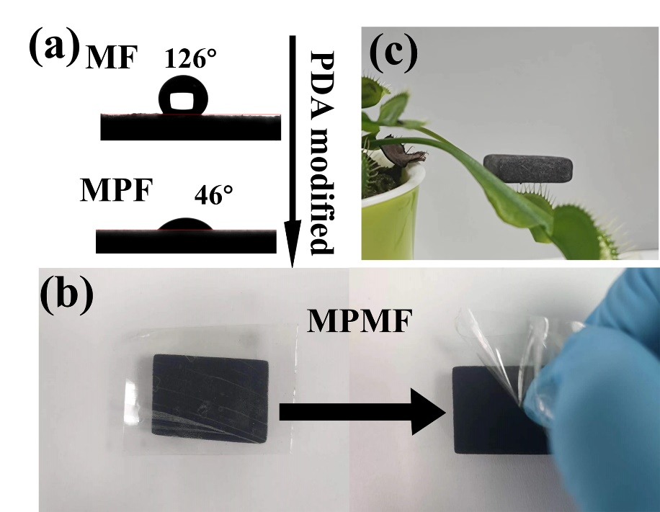
Fig. S1. (a) Hydrophobicity of MF and MPF. (b) Plastic tape adhesion test of MPMF, and (c) MPMF/TPI foam placed on Venus Flytrap.
Fig. S2. Hydrophobic effects of MPMF/TPI composites with different MXene loads.

Significantly, the natural hydrophobic characteristics of TPI stems from its low surface energy properties. When strategically utilized to envelop MPMF foam, TPI can establish a dense and durable protective barrier that efficiently prevents moisture from reaching MPMF foam substrate, resulting in the remarkable hydrophobic effects. Illustrated in Fig. S2, irrespective of MXene contents, the contact angle of MPMF/TPI composite foams consistently exceeds 138°, demonstrating exceptional hydrophobic performance.

Fig. S3. (a) XRD patterns, (b) resistivity and conductivity, (c) average SE_{R}, SE_{A} and SE_{T}, and (d) A-R power coefficients of GP.

Table. S1. The loading process of MPMF/TPI foams.
Number of dips | MF (g) | MPF (g) | MPMF (g) | MPMF/TPI (g) | MXene load ratio  (wt%) | TPI  load ratio  (wt%)
1 | 0.0501 | 0.0511 | 0.0629 | 0.2195 | 5.4 | 71.3
2 | 0.0548 | 0.0556 | 0.0893 | 0.2721 | 12.4 | 67.2
3 | 0.0547 | 0.0558 | 0.1039 | 0.2792 | 17.2 | 62.8
4 | 0.0542 | 0.0551 | 0.1316 | 0.3036 | 25.2 | 56.7
5 | 0.0553 | 0.0565 | 0.1385 | 0.3148 | 26.0 | 56.0

