Appendices
Appendix A. Food Donations per item with volumes and weights for summer and winter
Food Items | Summer Volume | Summer Weight (kg) | Food Items | Winter Volume | Winter Weight (kg)
Vegetables
Lettuce | 130 heads | 78 | Lettuce | 79 heads | 47.4
Carrots | 165 pieces | 16.5 | Carrots | 169 pieces | 16.9
Broccoli | 115 pieces | 46 | Broccoli | 41 pieces | 20.4
Green Beans | assorted | 26.4 | Green Beans | assorted | 18
Broad Beans | assorted | .5 | Sour Cabbage | 48 packs | 24
Mung beans | 50 packs | 10 | Mung beans | 25 packs | 5
Coriander | 12 packs and 6 plants | 2.5 | Coriander | 5 packs | 1
Artichokes | 74 7 pieces | 14.8 | Artichokes | 7 pieces | 1.4
Mixed Salad | 122 packs | 42.7 | Mixed Salad | 128 packs | 44.8
Onions | assorted | 7.5 | Onions | assorted | .4
Fennel | 152 pieces | 60.8 | Fennel | 13 pieces | 5.2
Potatoes | assorted | 1 | Potatoes | assorted | .5
Garlic | assorted | .2 | Sweet Potatoes | assorted | 10.5
Rainbow Chard | assorted | 12 | Rainbow Chard | assorted | .4
Aubergine | 109 pieces | 21.8 | Aubergine | 54 pieces | 10.8
Turnips | 28 pieces | 5.6 | Turnips | 42 pieces | 4.2
Celery | 16 pieces | 6.4 | Celery | assorted | 1
Radishes | assorted | 1.4 | Radishes | assorted | .7
Mushrooms | 3 boxes | .6 | Mushrooms | 9 boxes | 1.8
Beetroot | 28 pieces | 5.6 | Beetroot | 15 pieces | 3
Ginger | 6 pieces | .06 | Spinach | assorted | 12
Tomatoes | 7 packs | 2.1 | Tomatoes | 27 packs | 10.8
 |  |  | Mixed Sprouts | 3 packs | .3
 |  |  | Cauliflower | 4 pieces | 2.4
 |  |  | Kale | 1 pack | 1
 |  |  | Paprika | 6 pieces | .9
 |  |  | Cucumbers | 32 pieces | 9.6
Fruit
Bananas | 97 pieces | 19.4 | Bananas | 93 pieces | 18.6
Oranges | 91 pieces | 22.75 | Oranges | 99 pieces | 24.75
Apples | 180 pieces | 36 | Apples | 96 pieces | 19.2
Strawberries | assorted | 1.5 | Strawberries | 7 boxes | 1.4
Kiwis | 48 pieces | 4.8 | Kiwis | 16 pieces | 1.6
Figs | 6 boxes | .3 | Figs | 4 boxes | .2
Blueberries | assorted | 3.8 | Blueberries | assorted | 2.2
Mangoes | 24 pieces | 6 | Blackberries | assorted | 4
Grapes | 6 packs | 3 | Passion Fruit | 16 pieces | .4
Melons | 16 pieces | 32 | Melons | 1 piece | 2
Peaches | 118 pieces | 17.7 | Peaches | 26 pieces | 3.9
Pears | 20 pieces | 3 | Pears | 25 pieces | 3.75
Lemons | 60 pieces | 7.2 | Lemons | 38 pieces | 4.56
Limes | 86 pieces | 10.32 | Limes | 22 pieces | 2.64
Passion Fruit | 48 pieces | 2.4
Pineapple | 8 pieces | 16
Dairy
Milk | 49 bottles | 49 | Milk | 19 bottles | 19
Yoghurt | 57 tubs | 17.1 | Yoghurt | 85 tubs | 25.5
Stracciatella | 10 tubs | 5 | Stracciatella | 10 tubs | 5
 |  |  | Cheese | 19 pieces | 7.6
 |  |  | Kefir | 3 tubs | 1.5
Grains
Bread | 80 loaves | 36 | Bread | 172 loaves | 68.8
Muesli | 16 boxes | 1 | Muesli | 18 boxes | 18
 |  |  | Small Pastries | 145 | 36.25
Protein
Beef | 12 packs | 6 | Beef | 23 packs | 11.5
Pork | 16 packs of sausages | 8 | Pork | 52 sausages | 15.6
Chicken | 18 packs | 9 | Chicken | 7 packs | 3.5
Fish | 12 packs | 3 | Fish | 10 | 4
Vegan Mince | 55 packs | 22.5 | Vegan Mince | 26 packs | 13
 |  |  | Tofu | 13 packs | 6.5
 |  |  | Tempeh | 31 packs | 10.85
 |  |  | Soya | 6 packs | 2.1
 |  |  | Ready Meals | 4 packs | 2.2
Non perishables
Chocolate | 875 bars of dark choc and sea salt | 78.75 | Prosecco | 4 bottles | 4
 |  |  | Coffee | 4 bags | 2
 |  |  | Jam | 4 jars | 2

Appendix B. Ethics, Safety and Responsibility Review

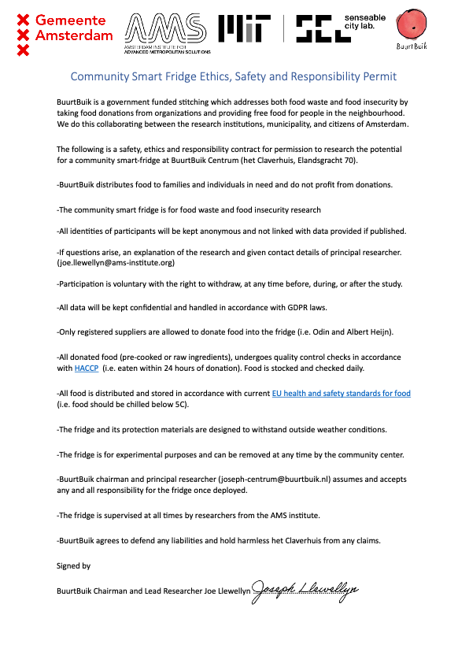
Appendix C. Community Smart Fridge Guidelines and Information
